Oecophylla smaragdina (Hymenoptera: Formicidae): A Biological Control Agent of the Invasive Bagworms Metisa plana (Lepidoptera: Psychidae)

Moïse Pierre Exélis^{1, 2}

¹Institute of Biological Sciences, Faculty of Science, Universiti Malaya, Lembah Pantai, 50603 Kuala Lumpur, Malaysia
²Direction de l'Enseignement Supérieur et de la Recherche Espace Etudiants, Hôtel de la Collectivité Territoriale de la Martinique (CTM), Rue Gaston Defferre - Cluny - CS 30137 - 97201 Fort-de-France, Martinique

Supplementary materials (tables & figures)

Tables

Table 1. Occupancy level strength – Foliar injury level
Occupancy strength level* | Number of Occupied Palm | Nest average/colony
0 | 0 | 0
1 | 1 | 1-3
2 | 2-3 | 4-11
3 | 4-6 | 12-20
4 | 7-12 | ≥21
M. plana injury level | Palm tree canopy condition
0 | Healthy and green – an absence of lesions (Figure 1 E-F)
1 | Some small dried spots on the leaflet surface- low (Figure 1 D)
2 | Many holes - moderate lesions (Figure 2 C)
3 | Severe lesions –critical (Figure 1 B)
4 | Necrosis leaving fronds as a skeleton – extreme (Figure 1 A)
*O. smaragdina occupation (see Figs. 1 A-F in main manuscript text)

Table 2. Associated host plants

Estates: names – locations | Colloquial / local names | Scientific names | References-citations /current surveys (CS)
Felda Gunung Besout  Perak | Mango – Key lime –  Calamansi – Durian | Mangifera indica – Citrus  aurantiifolia-Citrofortunella microcarpa - Durio zibethinus | Lim et al., 2008- CS
MPOB Teluk Intan Perak | Watery rose apple | Syzygium aqueum | Exélis & Idris,  2013
¹UM plantations Kota Tinggi, johor | Rambutan – langsat –Coconut, mango, key lime – range of diverse medicinal plants | Nephelium lappaceum - lancium  Domesticum - Cocos nucifera – C. aurantiifolia | Lim, 2007-CS
Felcra Johor | Mangosteen | Garcinia mangostana | CS
Felda Keratong/Pekan Pahang | Rambutan, mango | N. lappaceum – M. indica - | CS
¹Possessing same plants as Felda Perak

Table 3. Surveys-Census of O. smaragdina versus M. plana
Census | Felda Gunung Besout 03 Rahim Mohammad Lot - Plantation area surface: 4 ha  Total number of planted palms: 550; Age: 7 by 2020;  Genetic variety: DP- Dura Pisifera; Height: 3-7 m
Foliar injury level | 0ª | 0ª | 2 | 3 | 4
Pest density level | 0ª | 0ª | 2 | 3 | 4
Foliar condition | Healthy | Healthy | Small holes | Necrosis from late instar larvae chewing | Skeleton view with total absence of green
Average healthy palms % | 11.63 | 11.27 | 0 | 0 | 0
Average Number of palms | 84 | 62 | 67 | 326 | 21
Average % occupied/unoccupied palms by ants* | 11.63 | 13.1 | 12.18* | 59.27* | 3.81*
Strength level of occupation** | 4 | 4 & 3 | 0 | 0 | 0
Total number of matured colony | 8 | 6  2 pre-matured | 0 | 0 | 0
Average occupied* palms range by ants | 7-10 | 5-8 | none | none | none
Average nest number range per palm | 1-7 | 1-7 | 0 | 0 | 0
Average nest number range per colony | 38-46 | 20-35 | 0 | 0 | 0
Host plant species density | Durian: 1, Citrus: 2, mango: 1 unidentified plants: 5 | Citrus: 1  Unidentified plants: 3 | 0 | 0 | 0
Antagonistic ant species  Solenopsis spp. presence | Nil | Nil | Active | Active | Active
Antagonistic ant species  D. thoracicus presence  Other species*** | No ground/tree activity detection | No activity detected | Nil  Odontoponera denticulata***  Solenopsis geminata | Nil  O. denticulata  S. geminata | Nil  O. denticulata  S. geminata
Note: *Corresponds to unoccupied oil palm trees. **O. smaragdina occupation strength ranging from 0 to 4. ***Many nest holes entrance/exit detected with a significant presence for O. denticulata; Tunnel passages made of soils characteristic of S. geminata. ªAntagonistic ants absent under foliar injury and a bagworm density level of 0 and 1 (no activity detected).

Table 4. Performance summary – Year 2019 - 2022

Descriptive analysis
Overall
> summary(dt)
Year Months TCI Average_Yield_permth_ha
Min. :2019 Length:240 Length:240 Min. : 2.930
1st Qu.:2020 Class :character Class :character 1st Qu.: 4.077
Median :2020 Mode :character Mode :character Median : 6.445
Mean :2020 Mean : 8.000
3rd Qu.:2021 3rd Qu.:10.928
Max. :2022 Max. :21.650
OER_percent Total_Yield_ton_perhectar Incomes_RM
Min. :17.05 Min. :11.72 Min. : 5064
1st Qu.:18.63 1st Qu.:16.31 1st Qu.: 8611
Median :18.95 Median :25.78 Median :24771
Mean :18.79 Mean :32.04 Mean :25529
3rd Qu.:19.19 3rd Qu.:43.71 3rd Qu.:35130
Max. :20.01 Max. :86.60 Max. :94134

> summary(dt_bc_ant)
Year Months TCI Average_Yield_permth_ha
Min. :2019 Length:48 Length:48 Min. :12.54
1st Qu.:2020 Class :character Class :character 1st Qu.:15.34
Median :2020 Mode :character Mode :character Median :15.93
Mean :2020 Mean :16.05
3rd Qu.:2021 3rd Qu.:16.24
Max. :2022 Max. :21.65
OER_percent Total_Yield_ton_perhectar Incomes_RM
Min. :19.41 Min. :50.16 Min. :21370
1st Qu.:19.61 1st Qu.:61.42 1st Qu.:28629
Median :19.68 Median :63.74 Median :36532
Mean :19.69 Mean :64.45 Mean :48403
3rd Qu.:19.78 3rd Qu.:65.31 3rd Qu.:62027
Max. :20.01 Max. :86.60 Max. :94134

> summary(dt_tci_1)
Year Months TCI Average_Yield_permth_ha
Min. :2019 Length:48 Length:48 Min. : 3.480
1st Qu.:2020 Class :character Class :character 1st Qu.: 4.725
Median :2020 Mode :character Mode :character Median : 5.855
Mean :2020 Mean : 6.503
3rd Qu.:2021 3rd Qu.: 8.045
Max. :2022 Max. :11.790
OER_percent Total_Yield_ton_perhectar Incomes_RM
Min. :17.05 Min. :13.92 Min. : 5874
1st Qu.:18.05 1st Qu.:18.90 1st Qu.: 9949
Median :18.85 Median :23.42 Median :15125
Mean :18.57 Mean :26.01 Mean :21065
3rd Qu.:19.02 3rd Qu.:32.18 3rd Qu.:31593
Max. :19.31 Max. :47.16 Max. :45038

> summary(dt_tci_2)
Year Months TCI Average_Yield_permth_ha
Min. :2019 Length:48 Length:48 Min. : 3.080
1st Qu.:2020 Class :character Class :character 1st Qu.: 4.595
Median :2020 Mode :character Mode :character Median : 6.195
Mean :2020 Mean : 6.721
3rd Qu.:2021 3rd Qu.: 8.660
Max. :2022 Max. :11.860
OER_percent Total_Yield_ton_perhectar Incomes_RM
Min. :17.05 Min. :12.32 Min. : 5199
1st Qu.:18.05 1st Qu.:18.38 1st Qu.: 9402
Median :18.85 Median :24.78 Median :16661
Mean :18.57 Mean :26.89 Mean :22296
3rd Qu.:19.02 3rd Qu.:34.64 3rd Qu.:35621
Max. :19.31 Max. :47.44 Max. :45306

> summary(dt_tci_3)
Year Months TCI Average_Yield_permth_ha
Min. :2019 Length:48 Length:48 Min. : 3.000
1st Qu.:2020 Class :character Class :character 1st Qu.: 3.650
Median :2020 Mode :character Mode :character Median : 4.090
Mean :2020 Mean : 5.657
3rd Qu.:2021 3rd Qu.: 7.715
Max. :2022 Max. :11.790
OER_percent Total_Yield_ton_perhectar Incomes_RM
Min. :17.05 Min. :12.00 Min. : 5064
1st Qu.:18.05 1st Qu.:14.60 1st Qu.: 7419
Median :18.85 Median :16.36 Median :12670
Mean :18.57 Mean :22.61 Mean :18952
3rd Qu.:19.02 3rd Qu.:30.86 3rd Qu.:30732
Max. :19.31 Max. :47.16 Max. :45038

> dt_tci_4 <- subset(dt, TCI == "TCI OPP IV")
> summary(dt_tci_4)
Year Months TCI Average_Yield_permth_ha
Min. :2019 Length:48 Length:48 Min. : 2.930
1st Qu.:2020 Class :character Class :character 1st Qu.: 3.260
Median :2020 Mode :character Mode :character Median : 3.630
Mean :2020 Mean : 5.065
3rd Qu.:2021 3rd Qu.: 6.810
Max. :2022 Max. :11.470
OER_percent Total_Yield_ton_perhectar Incomes_RM
Min. :17.05 Min. :11.72 Min. : 5127
1st Qu.:18.05 1st Qu.:13.04 1st Qu.: 6690
Median :18.85 Median :14.52 Median :10443
Mean :18.57 Mean :20.26 Mean :16927
3rd Qu.:19.02 3rd Qu.:27.24 3rd Qu.:26941
Max. :19.31 Max. :45.88 Max. :43815

Table 5. Generalised additive model (GAM) of second degree polynomial
# Fit GAM with a Gamma Distribution and Log Link Function
y <- dt$Incomes_RM
x1 <- dt$Average_Yield_permth_ha
x2 <- dt$Total_Yield_ton_perhectar
x3 <- dt$OER_percent

## Fitting GAM with gamma and log link function
model_gam1 <- gam(y ~ s(x1) , family = Gamma(link = "log"), data = dt)
model_gam2 <- gam(y ~ s(x2) , family = Gamma(link = "log"), data = dt)
model_gam3 <- gam(y ~ s(x3), family = Gamma(link = "log"), data = dt)
model_gam4 <- gam(y ~ s(x1) + s(x2), family = Gamma(link = "log"), data = dt)
model_gam5 <- gam(y ~ s(x1) + s(x3), family = Gamma(link = "log"), data = dt)
model_gam6 <- gam(y ~ s(x2) + s(x3), family = Gamma(link = "log"), data = dt)
model_gam7 <- gam(y ~ s(x1) + s(x2) + s(x3), family = Gamma(link = "log"), data = dt)
> summary(model_gam1)
Family: Gamma
Link function: log

Formula:
y ~ s(x1)

Parametric coefficients:
Estimate Std. Error t value Pr(>|t|)
(Intercept) 9.90447 0.02053 482.4 <2e-16 ***
---
Signif. codes: 0 ‘***’ 0.001 ‘**’ 0.01 ‘*’ 0.05 ‘.’ 0.1 ‘ ’ 1

Approximate significance of smooth terms:
edf Ref.df F p-value
s(x1) 6.002 7.17 172.5 <2e-16 ***
---
Signif. codes: 0 ‘***’ 0.001 ‘**’ 0.01 ‘*’ 0.05 ‘.’ 0.1 ‘ ’ 1

R-sq.(adj) = 0.838 Deviance explained = 84.4%
GCV = 0.095639 Scale est. = 0.10116 n = 240
> summary(model_gam2)

Family: Gamma
Link function: log

Formula:
y ~ s(x2)

Parametric coefficients:
Estimate Std. Error t value Pr(>|t|)
(Intercept) 9.90596 0.02068 479.1 <2e-16 ***
---
Signif. codes: 0 ‘***’ 0.001 ‘**’ 0.01 ‘*’ 0.05 ‘.’ 0.1 ‘ ’ 1

Approximate significance of smooth terms:
edf Ref.df F p-value
s(x2) 5.071 6.168 197.3 <2e-16 ***
---
Signif. codes: 0 ‘***’ 0.001 ‘**’ 0.01 ‘*’ 0.05 ‘.’ 0.1 ‘ ’ 1

R-sq.(adj) = 0.811 Deviance explained = 83.8%
GCV = 0.098023 Scale est. = 0.1026 n = 240
> summary(model_gam3)

Family: Gamma
Link function: log

Formula:
y ~ s(x3)

Parametric coefficients:
Estimate Std. Error t value Pr(>|t|)
(Intercept) 9.98073 0.03087 323.3 <2e-16 ***
---
Signif. codes: 0 ‘***’ 0.001 ‘**’ 0.01 ‘*’ 0.05 ‘.’ 0.1 ‘ ’ 1

Approximate significance of smooth terms:
edf Ref.df F p-value
s(x3) 1.43 1.735 221.5 <2e-16 ***
---
Signif. codes: 0 ‘***’ 0.001 ‘**’ 0.01 ‘*’ 0.05 ‘.’ 0.1 ‘ ’ 1

R-sq.(adj) = 0.556 Deviance explained = 57.9%
GCV = 0.24766 Scale est. = 0.2287 n = 240
> summary(model_gam4)

Family: Gamma
Link function: log

Formula:
y ~ s(x1) + s(x2)

Parametric coefficients:
Estimate Std. Error t value Pr(>|t|)
(Intercept) 9.90445 0.02058 481.4 <2e-16 ***
---
Signif. codes: 0 ‘***’ 0.001 ‘**’ 0.01 ‘*’ 0.05 ‘.’ 0.1 ‘ ’ 1

Approximate significance of smooth terms:
edf Ref.df F p-value
s(x1) 6.024 7.191 34.025 <2e-16 ***
s(x2) 1.000 1.001 0.012 0.915
---
Signif. codes: 0 ‘***’ 0.001 ‘**’ 0.01 ‘*’ 0.05 ‘.’ 0.1 ‘ ’ 1

R-sq.(adj) = 0.838 Deviance explained = 84.4%
GCV = 0.096445 Scale est. = 0.1016 n = 240
> summary(model_gam5)

Family: Gamma
Link function: log

Formula:
y ~ s(x1) + s(x3)

Parametric coefficients:
Estimate Std. Error t value Pr(>|t|)
(Intercept) 9.89066 0.01687 586.3 <2e-16 ***
---
Signif. codes: 0 ‘***’ 0.001 ‘**’ 0.01 ‘*’ 0.05 ‘.’ 0.1 ‘ ’ 1

Approximate significance of smooth terms:
edf Ref.df F p-value
s(x1) 8.198 8.833 66.284 <2e-16 ***
s(x3) 8.706 8.966 9.972 <2e-16 ***
---
Signif. codes: 0 ‘***’ 0.001 ‘**’ 0.01 ‘*’ 0.05 ‘.’ 0.1 ‘ ’ 1

R-sq.(adj) = 0.844 Deviance explained = 89.1%
GCV = 0.073024 Scale est. = 0.068307 n = 240
> summary(model_gam6)

Family: Gamma
Link function: log

Formula:
y ~ s(x2) + s(x3)

Parametric coefficients:
Estimate Std. Error t value Pr(>|t|)
(Intercept) 9.89185 0.01712 577.9 <2e-16 ***
---
Signif. codes: 0 ‘***’ 0.001 ‘**’ 0.01 ‘*’ 0.05 ‘.’ 0.1 ‘ ’ 1

Approximate significance of smooth terms:
edf Ref.df F p-value
s(x2) 8.183 8.824 63.874 <2e-16 ***
s(x3) 8.736 8.971 9.761 <2e-16 ***
---
Signif. codes: 0 ‘***’ 0.001 ‘**’ 0.01 ‘*’ 0.05 ‘.’ 0.1 ‘ ’ 1

R-sq.(adj) = 0.817 Deviance explained = 88.7%
GCV = 0.075793 Scale est. = 0.070324 n = 240
> summary(model_gam7)

Family: Gamma
Link function: log

Formula:
y ~ s(x1) + s(x2) + s(x3)

Parametric coefficients:
Estimate Std. Error t value Pr(>|t|)
(Intercept) 9.8906 0.0169 585.1 <2e-16 ***
---
Signif. codes: 0 ‘***’ 0.001 ‘**’ 0.01 ‘*’ 0.05 ‘.’ 0.1 ‘ ’ 1

Approximate significance of smooth terms:
edf Ref.df F p-value
s(x1) 8.202 8.835 11.314 <2e-16 ***
s(x2) 1.000 1.000 0.290 0.591
s(x3) 8.717 8.968 9.967 <2e-16 ***
---
Signif. codes: 0 ‘***’ 0.001 ‘**’ 0.01 ‘*’ 0.05 ‘.’ 0.1 ‘ ’ 1

R-sq.(adj) = 0.843 Deviance explained = 89.2%
GCV = 0.073561 Scale est. = 0.068581 n = 240
## AIC and degrees of freedom values
round(AIC(model_gam1,model_gam2,model_gam3,model_gam4,
model_gam5,model_gam6,model_gam7),3)

round(BIC(model_gam1,model_gam2,model_gam3,model_gam4,
model_gam5,model_gam6,model_gam7),3)

> round(AIC(model_gam1,model_gam2,model_gam3,model_gam4,
+ model_gam5,model_gam6,model_gam7),3)
df AIC
model_gam1 8.002 4857.652
model_gam2 7.071 4863.224
model_gam3 3.430 5090.171
model_gam4 9.025 4859.745
model_gam5 18.904 4789.762
model_gam6 18.919 4798.618
model_gam7 19.918 4791.485
> round(BIC(model_gam1,model_gam2,model_gam3,model_gam4,
+ model_gam5,model_gam6,model_gam7),3)
df BIC
model_gam1 8.002 4885.504
model_gam2 7.071 4887.834
model_gam3 3.430 5102.110
model_gam4 9.025 4891.156
model_gam5 18.904 4855.560
model_gam6 18.919 4864.470
model_gam7 19.918 4860.814

Figures

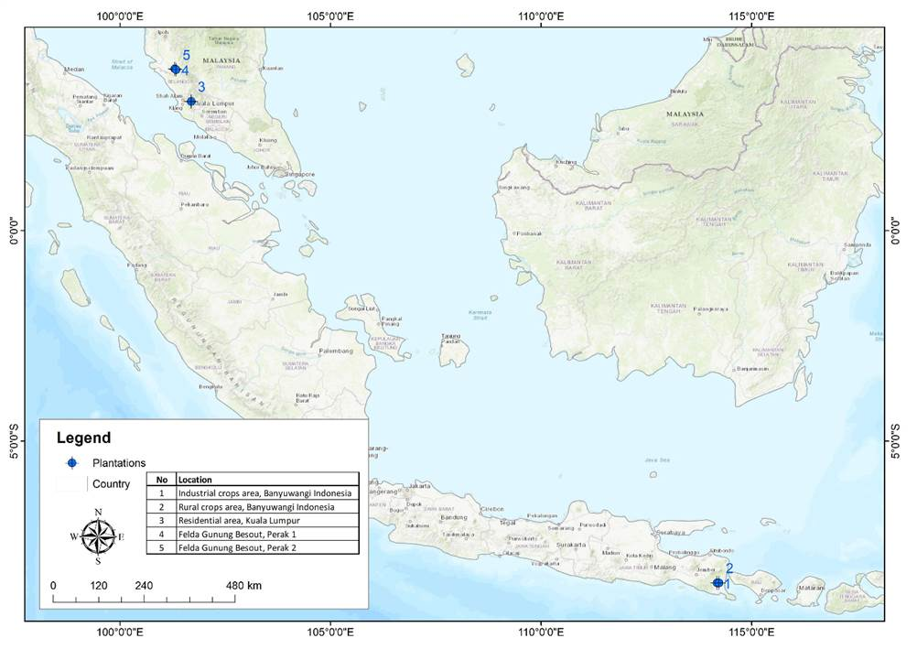
Fig. 1. Map location of the studied site showing the diverse overall sampling points and the main focus study in Felda Gunung Besout Perak, North Peninsular Malaysia, and Indonesia Banyuwangi East Java. Source: Associate Professor Sr Ts. Gs. Dr. Khairul Nizam Abdul Maulud, Head, Earth Observation Centre, Institute of Climate Change, Universiti Kebangsaan Malaysia.

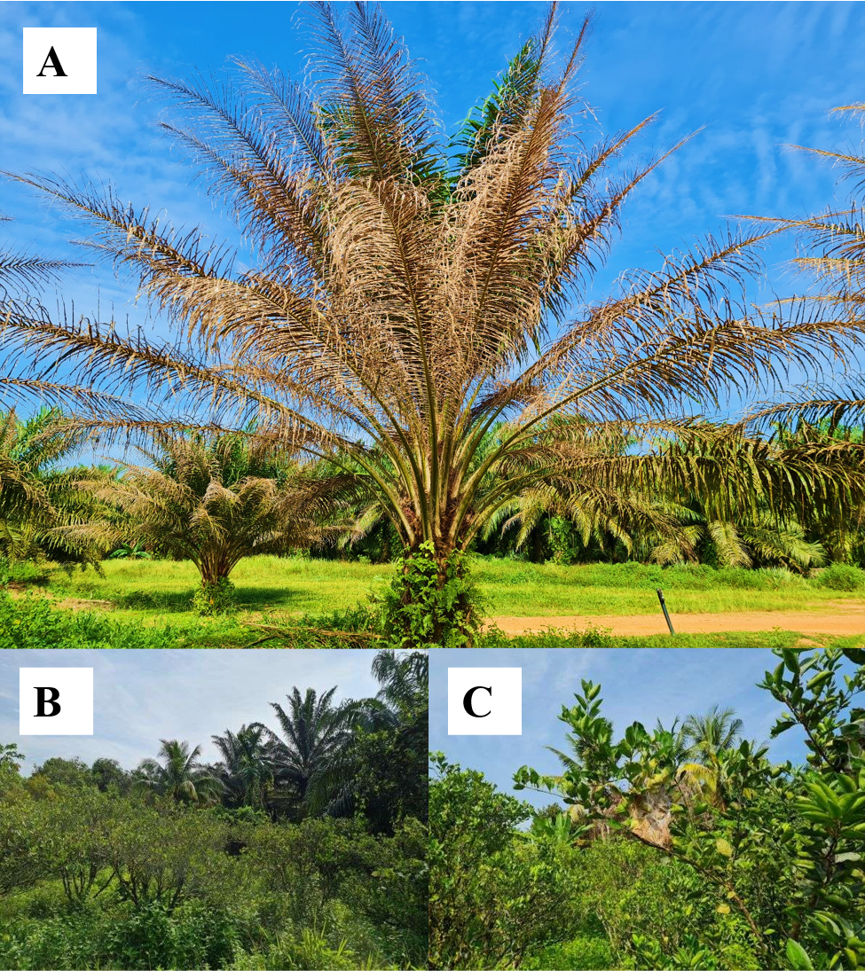
Fig. 2A-C. Affected short palm tree canopies (A). Occupied Calamansi orchard trees within the oil palm plantation blocks (B). Brood nest translocate to nearby infested palm canopies (C).

Foliar Injury - Occupancy Level Strength. Foliar injury and occupancy level strength follow Exélis & Azarae’s method (2013). The foliar injury is defined following the symptoms of the lesion affecting palm tree canopies, detected by visual direct observation, determined by an index ranging from zero to four (Supplementary Table 1). The presence of weaver ant colonies was categorized into four levels of strength (Way & Khoo, 1991) per palm (Supplementary Table 1); under an occupancy level strength of 3 and 4, oil palm tree canopies exhibited healthy foliage with the absence of bagworms, while unoccupied and low levels of occupancy featured a critical to skeleton foliar injury condition (Fig. 2 A-F; Supplementary Table 2). Economic threshold level (ETL) represents the point at which intervention is warranted to prevent pest populations from reaching damaging levels exceeding the cost of implementing control measures. Economic injury level (EIL) refers to the lowest pest population density level that requires the immediate initiation of pest management actions.
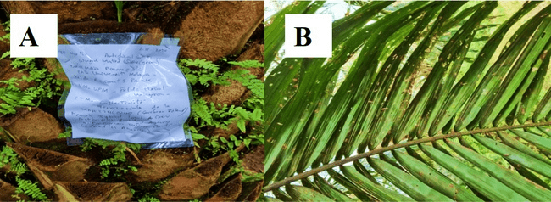 Fig. 3A-B. Setting up artificial nests to lure mated green winged queens in Felda Gunung Besout, Perak. A: Tagged ID plot. B: Foliar injury level 2. Photo Credit (Moïse Pierre Exélis).

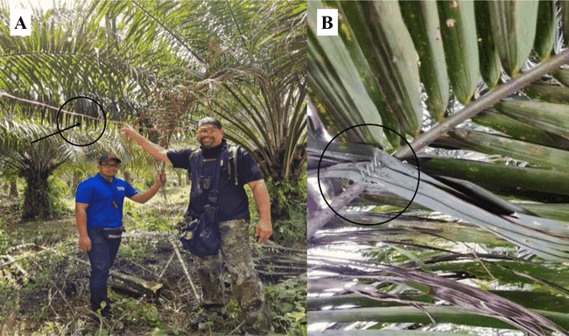 Fig. 4A-B. A: Artificial line bridge network setup (black circle arrow) helps the colonies' expansion. B: Fixed artificial nest on rachis by industrial staple tacker (black circle). Photo Credit (Moïse Pierre Exélis).

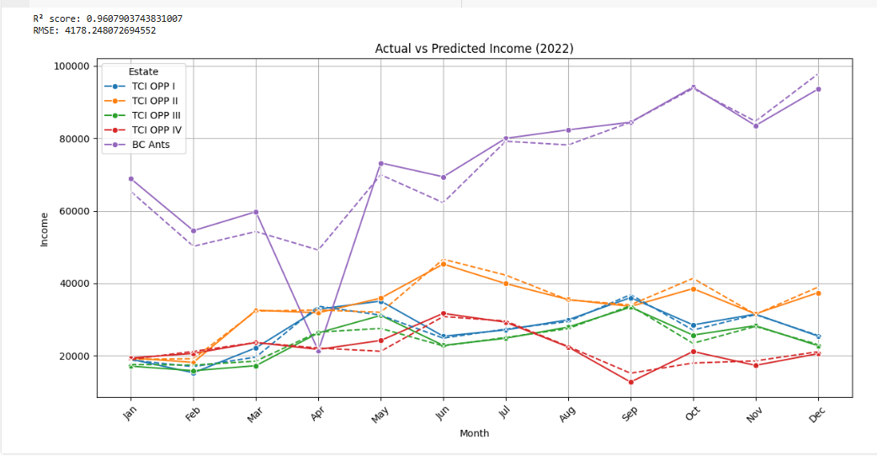
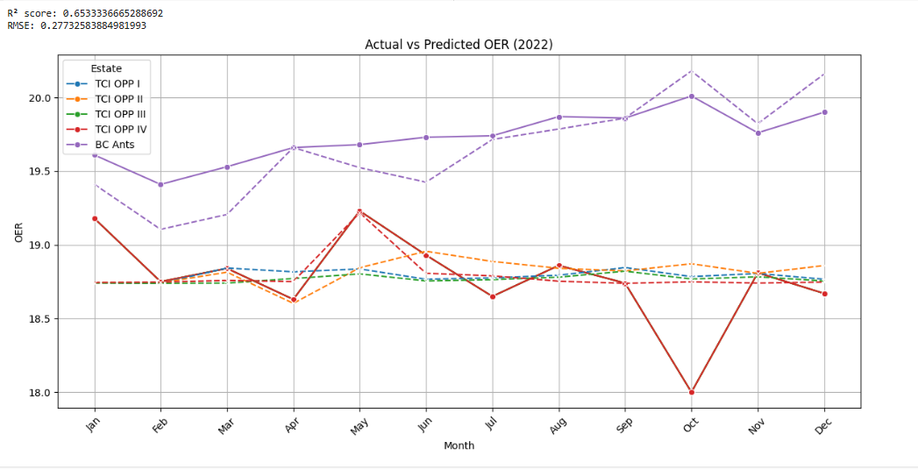

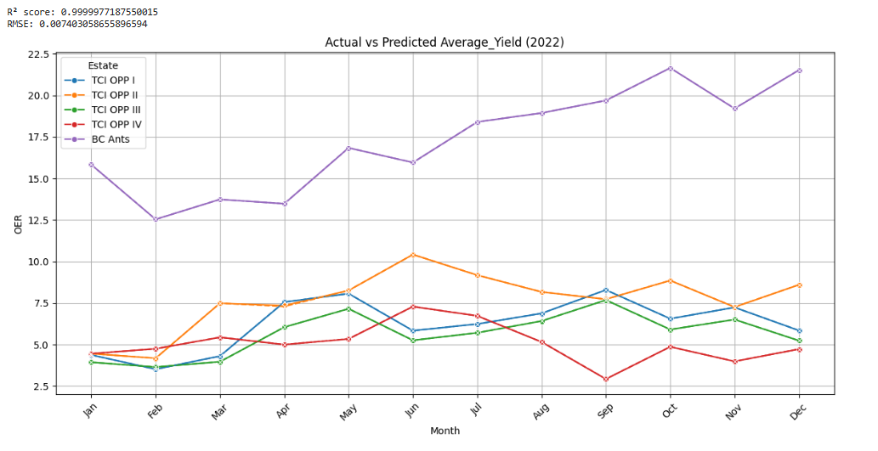
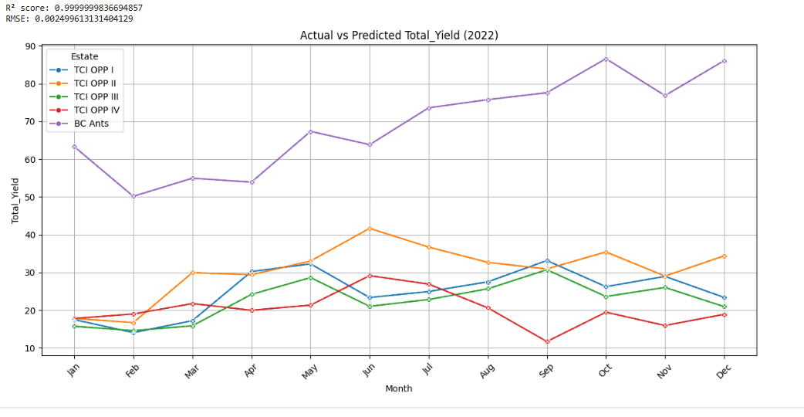Fig. 5A-D (2022). Graphics describing incomes, OER, average and total yield differences between trunk chemical injection (TCI) and biological control ants (BC Ants).

a.

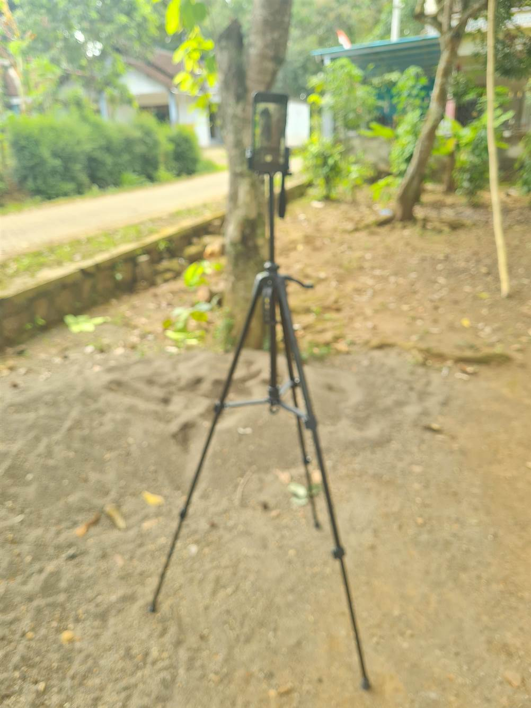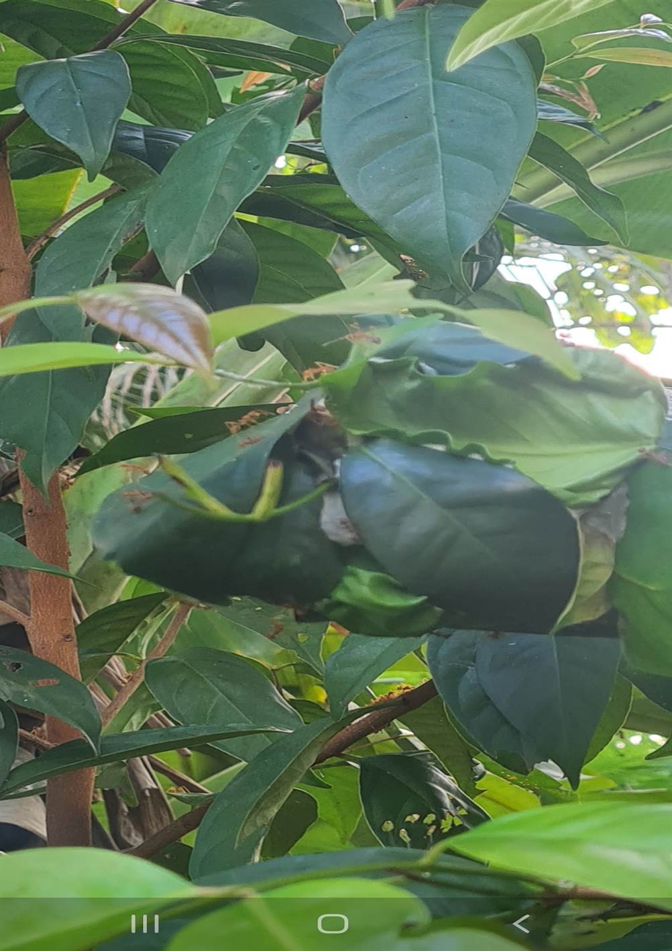Fig. 6a-c. O. smaragdina major worker's aggressive stance exhibiting mandible widely open in pre-attack behavior (a). Galaxy Samsung camera recorder (b). “Pohon Salam” Syzygium polyanthum plant, weaver ant colony occupied and used for the repelling test effect of the tea tree essence oil pure extract (c). Photo Credit (Moïse Pierre Exélis).
c.
d.
b.
B

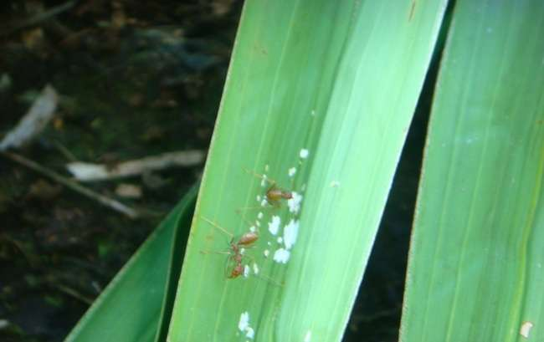
Fig. 7. Foraging for predation by distance detection. Foragers adopt a systematic aggressive behavior by raising their abdomen at 90°. Photo Credit (Moïse Pierre Exélis).

