Antarctic Greening and Its Drivers

Hangkai You¹; Taejin Park^{2,3}; Christian Che-Castaldo⁴; Dalei Hao⁵; Abhishek Chatterjee⁶; Fa Li^{1,7}; Zhuosen Wang^{8,9}; Fujiang Ji¹; Bilgecan Sen^{10,11}; Matthew A. Lazzara^{12,13}; Yanlan Liu^{14,15}; Thomas Kurosu⁶; Min Chen*¹.

¹ Department of Forest and Wildlife Ecology, University of Wisconsin–Madison, Madison, Wisconsin, USA.
² NASA Ames Research Center, Moffett Field, California, USA.
³ Bay Area Environmental Research Institute, Moffett Field, California, USA.
⁴ U.S. Geological Survey, Wisconsin Cooperative Wildlife Research Unit, Department of Forest and Wildlife Ecology, University of Wisconsin-Madison, Madison, Wisconsin, USA
⁵ Atmospheric, Climate, & Earth Sciences Division, Pacific Northwest National Laboratory, United States
⁶ Jet Propulsion Laboratory, California Institute of Technology, Pasadena, CA, USA
⁷ Department of Earth System Science, Stanford University, Stanford, California, USA
⁸ Earth System Science Interdisciplinary Center, University of Maryland College Park, College Park, MD, USA
⁹ Terrestrial Information Systems Laboratory, NASA Goddard Space Flight Center, Greenbelt, MD, USA
¹⁰ Biology, Woods Hole Oceanographic Institution, 86 Water St, Woods Hole, MA, USA
¹¹ Institute for Advanced Computational Science, Stony Brook University, Stony Brook, New York, NY, USA
¹² Antarctic Meteorological Research and Data Center, Space Science and Engineering Center, University of Wisconsin-Madison, Madison, WI, USA
¹³ Department of Physical Sciences, School of Engineering, Science, and Mathematics, Madison Area Technical College, Madison, WI, USA
¹⁴ School of Environment and Natural Resources, The Ohio State University, Columbus, OH, USA
¹⁵ School of Earth Sciences, The Ohio State University, Columbus, OH, USA

Email address: min.chen@wisc.edu (Min Chen)

This draft manuscript is distributed solely for purposes of scientific peer review. Its content is deliberative and predecisional, so it must not be disclosed or released by reviewers. Because the manuscript has not yet been approved for publication by the U.S. Geological Survey (USGS), it does not represent any official USGS finding or policy.

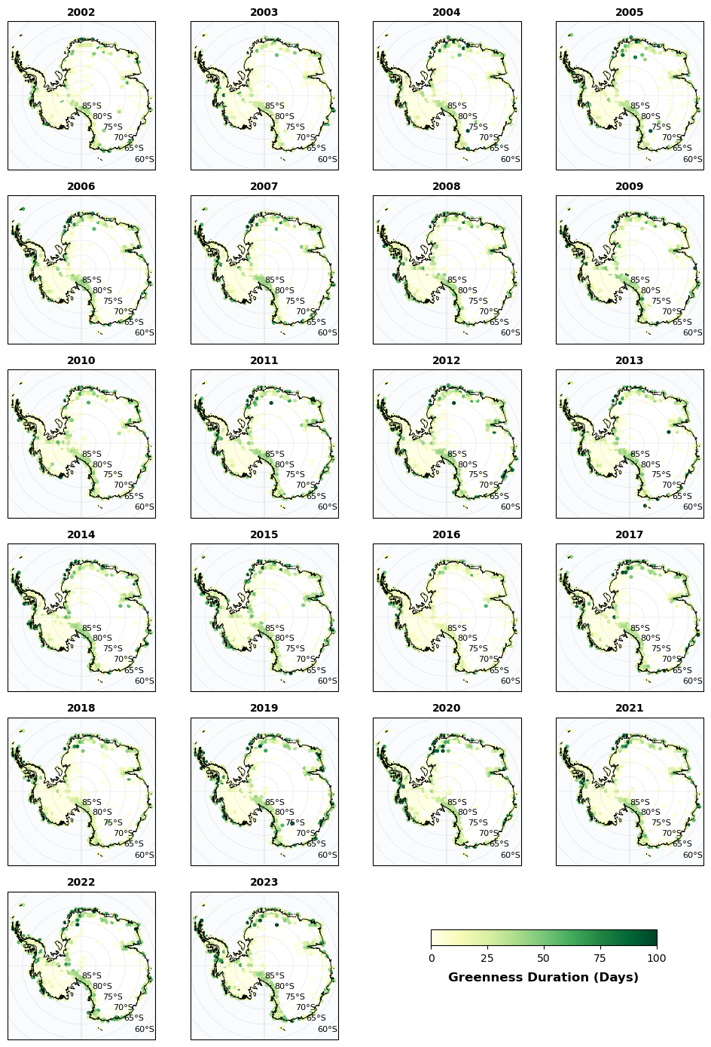
Figure S1. Annual Greenness Duration Across Antarctica (2002–2023). Each panel shows the spatial distribution of greenness duration during the defined growing season for each year from 2002 to 2023. Greenness duration is calculated as the average number of days that NDVI exceeded 0.2 within each hexagon during the corresponding defined growing season. The color scale represents the magnitude of greenness duration, with darker green indicating longer periods of sustained greenness. The year labels refer to the first year of each defined growing season, which would extend into the following calendar year.
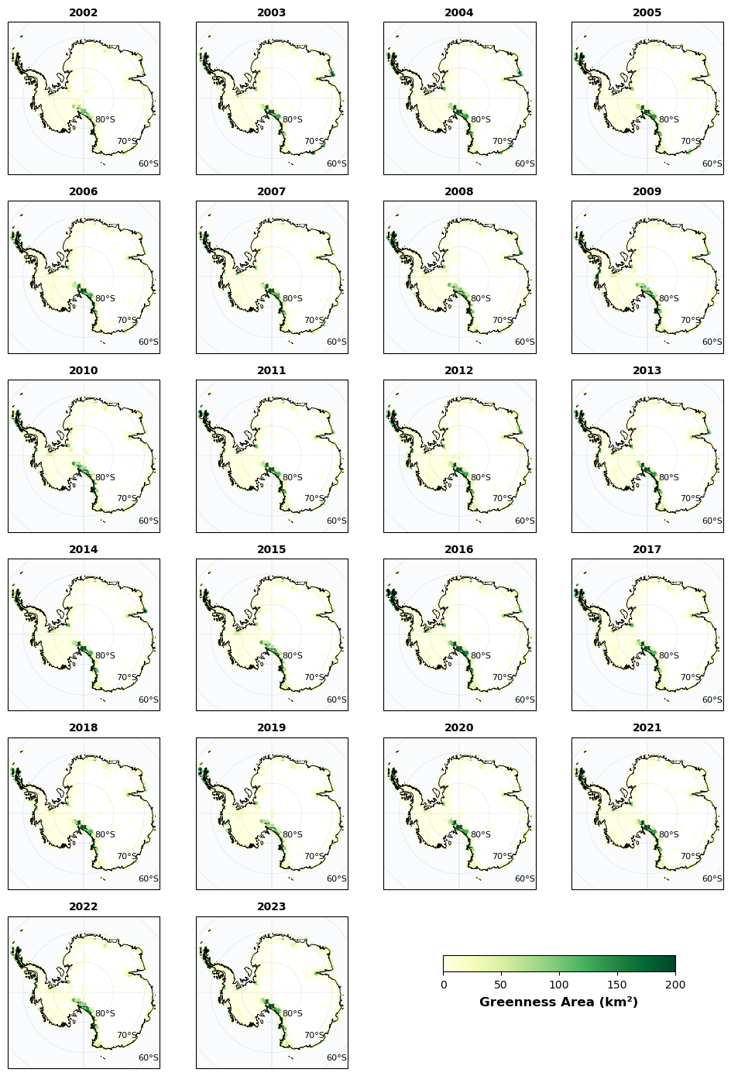
Figure S2. Annual Greenness Distribution Across Antarctica (2002–2023). Each panel shows the spatial distribution of greenness during the defined growing season, labeled by its starting year. Each hexagon represents the total area (km²) where the maximum NDVI exceeded 0.2. Darker green indicates greater green area per hexagon. The year labels refer to the first year of each defined growing season, which would extend into the following calendar year.
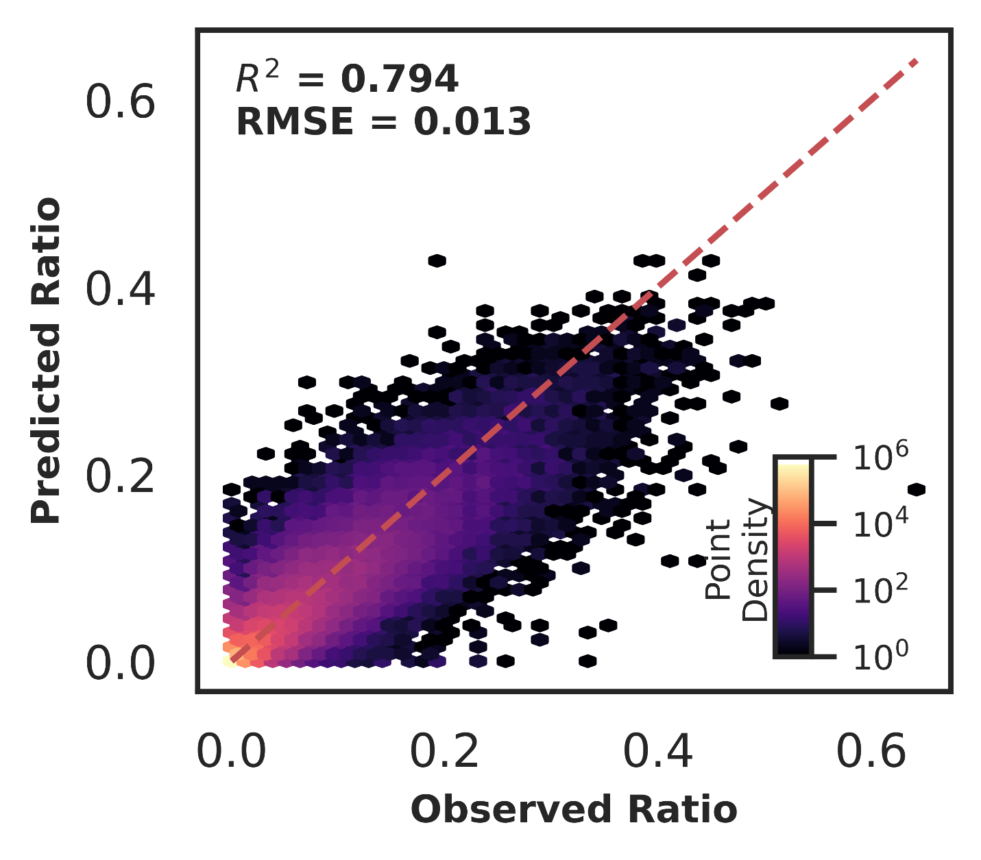
Figure S3. Random Forest Model Performance for Predicting Antarctic Greenness Area Ratio. The figure represents the predicted versus actual green area fraction, defined as the proportion of green area within each 0.1° grid cell, based on aggregated 500 m observations (see “Machine Learning Modeling and Analysis” section). Each hexagon represents the logarithmically scaled point density, and the red dashed line denotes the 1:1 reference line. Model performance was evaluated using 5-fold spatiotemporal cross-validation, and the plot includes predictions from all test folds. The reported coefficient of determination (R²) and root mean squared error (RMSE) represent the mean values across the five folds. All data points represent annual observations from 2002 to 2023 across the Antarctic continent.

`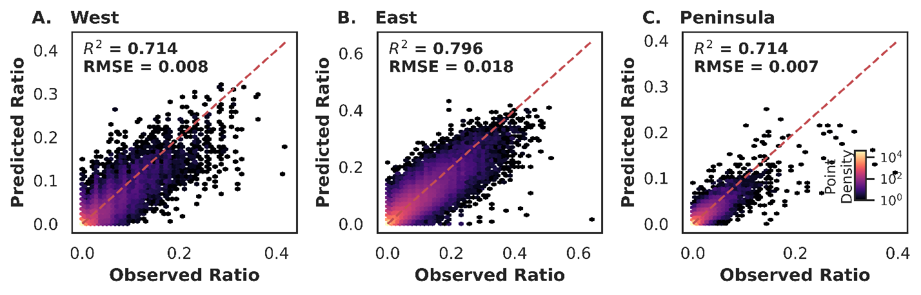
Figure S4. Random Forest Model Performance for Predicting Antarctic Greenness Area Ratio Across Antarctic Regions. Panels A, B, and C represent the predicted versus actual greenness area ratio by random forest trained on three regions, which is defined as the proportion of vegetated area within each 0.1° grid cell, based on aggregated 500 m satellite observations (see “Explainable Machine Learning Analysis” section). Each hexagon represents the logarithmically scaled point density. All three panels share the same color bar, and the red dashed line indicates the 1:1 reference line. Model performance was evaluated using 5-fold spatiotemporal cross-validation, and the plots include predictions from all test folds. Reported coefficients of determination (R²) and root mean squared errors (RMSE) are the average values across the five test folds, reflecting model performance in each Antarctic region. All data points represent annual observations from 2002 to 2023 across the Antarctic region.

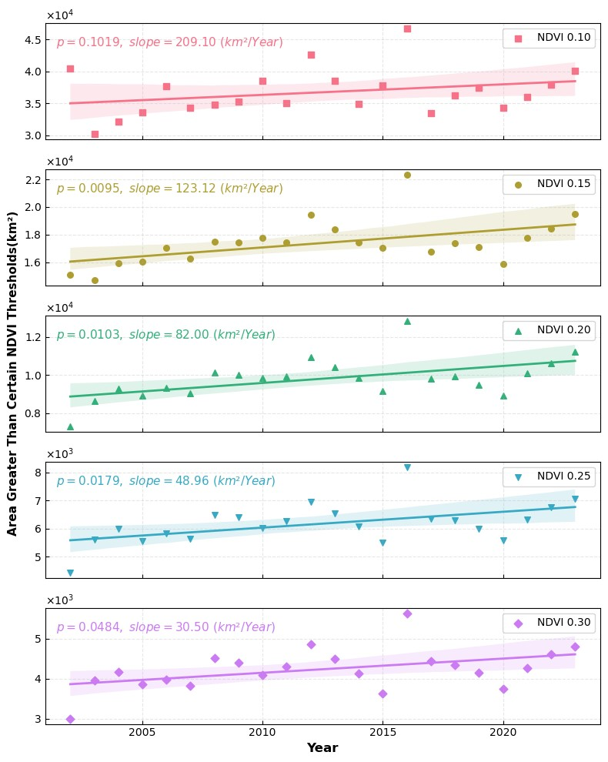
Figure S5. Sensitivity Analysis of Greenness Area Using Different NDVI Thresholds. This figure shows the total green area from 2002 to 2023, calculated using NDVI thresholds ranging from 0.10 to 0.30 in increments of 0.05. Each data point represents the green area (km²) identified for a given threshold, using the first year of each defined growing season as the time label. Colored lines indicate fitted linear trends from ordinary least squares regression; shaded bands indicate 95% confidence intervals for linear fits. The legend displays the slope from the linear regression and the p-value from the Mann-Kendall test, assessing the significance of the green area trend for each threshold.
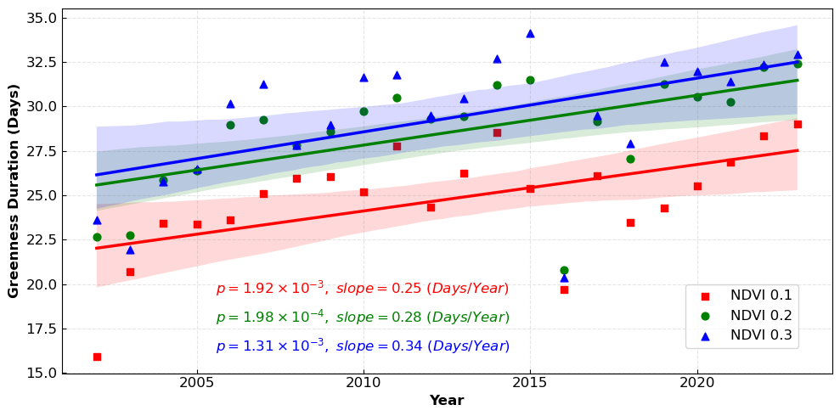
Figure S6. The sensitive test of the trend of mean greenness duration using different NDVI thresholds. This figure shows the continent-scale mean greenness duration from 2002 to 2023, calculated using NDVI thresholds of 0.1, 0.2, and 0.3 (shown in red, green, and blue, respectively). Each data point represents the area-weighted mean greenness duration for a given threshold, using the first year of each defined growing season as the time label. Colored lines indicate fitted linear trends from ordinary least squares regression; shaded bands indicate 95% confidence intervals for linear fits. The legend reports the slope from the linear regression and the p-value from the Mann-Kendall test for each threshold.

Table S1. Permutation Importance Values for Random Forest Models Across Regions. See attached file.

