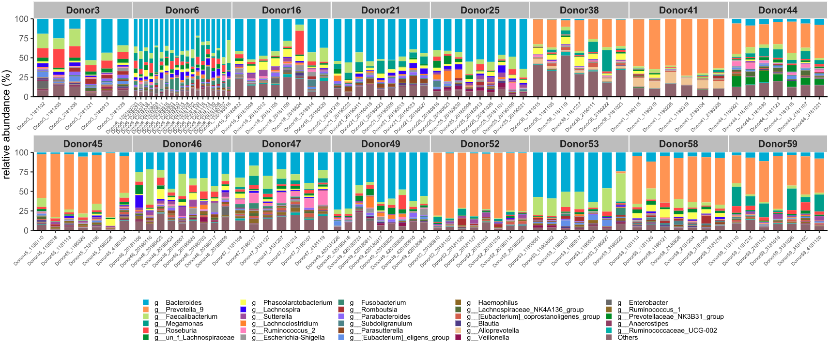
Supplementary Figure 1. The top 30 dominant genera of the 16 frequently-donating donors. Bacteria genera are represented in different colors. The horizontal axis represents the sample number and the vertical axis represents the relative abundance of the genera

