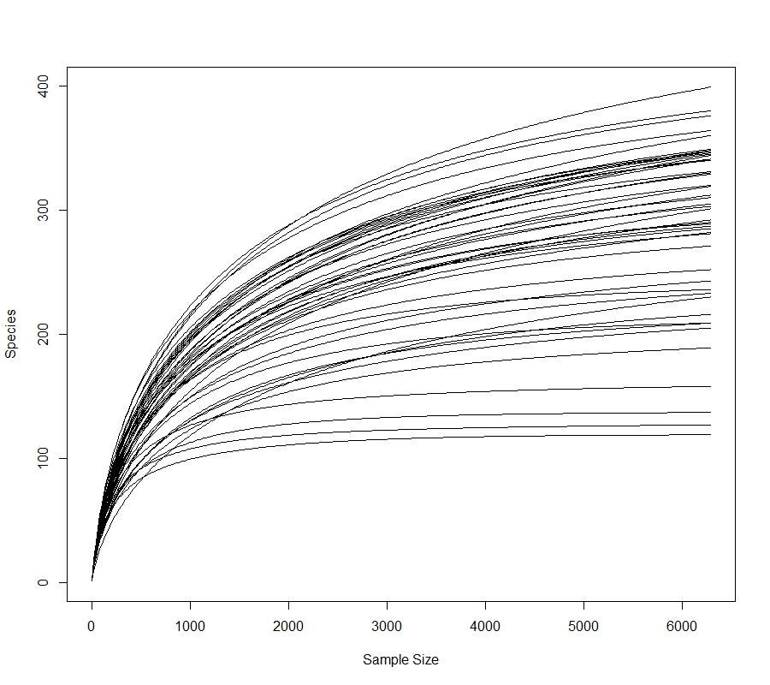
Figure S1 Rarefaction curves for the current study

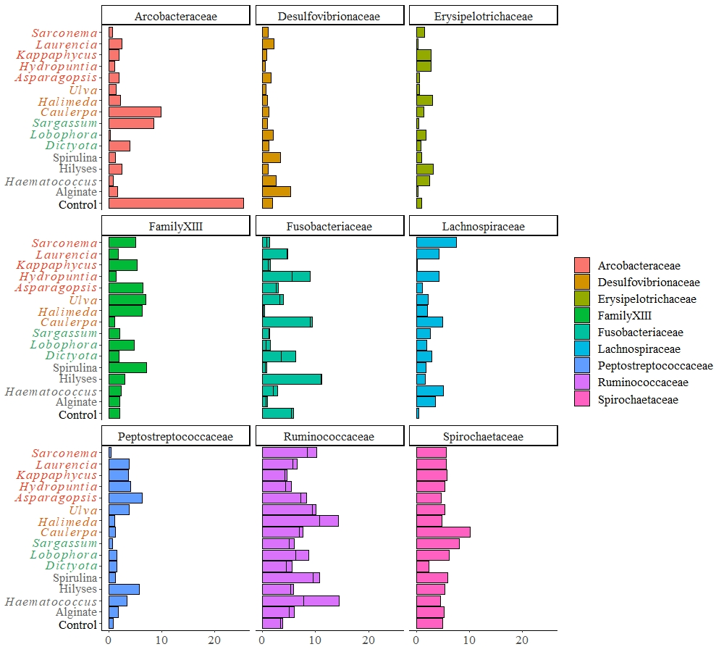
Figure S2 Proportion of the assigned families contributing to >1% abundance to the microbial communities of the hindgut of Siganus fuscescens fed the unsupplemented fish pellets (Native) or pellets supplemented with seaweeds or existing ‘aquafeed’ supplements. On y-axes, red text indicates that diets were supplemented with a species of red seaweed, green text indicates green seaweed and brown text indicates supplementation with brown seaweed. ‘Aquafeed’ supplements are indicated in light grey with unsupplemented controls in black.

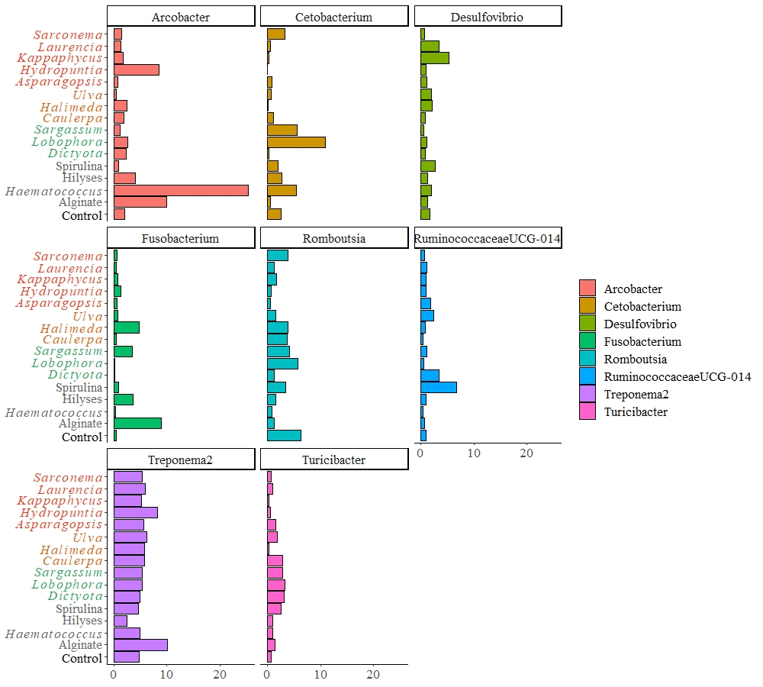

Figure S3 Proportion of the assigned genera contributing to >1% abundance to the microbial communities of the hindgut of Siganus fuscescens fed the unsupplemented fish pellets (Native) or pellets supplemented with seaweeds or existing ‘aquafeed’ supplements. On y-axes, red text indicates that diets were supplemented with a species of red seaweed, green text indicates green seaweed and brown text indicates supplementation with brown seaweed. ‘Aquafeed’ supplements are indicated in light grey with unsupplemented controls in black.
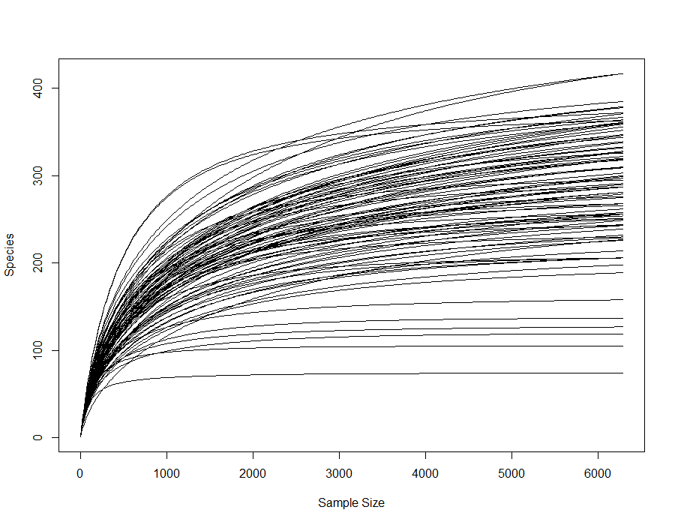
Figure S4 Rarefaction curves for the current study and the two wild S. fuscescens studies

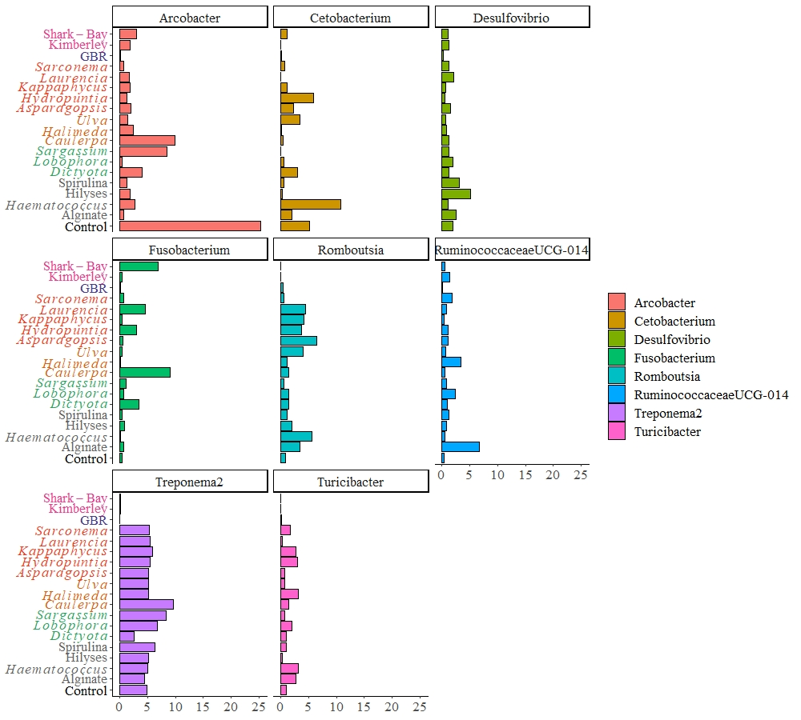
Figure S5 Proportion of the assigned genera contributing to >1% abundance to the microbial communities of the hindgut of Siganus fuscescens fed the control diet or diets supplemented with seaweeds or existing aquafeed supplements. On y-axes, red text indicates that diets were supplemented with a species of red seaweed, green text indicates green seaweed and brown text indicates supplementation with brown seaweed. Aquafeed supplements are indicated in light grey with unsupplemented controls in black. The fish from Eastern Australia (GBR) are in blue and those from Western Australia (Shark Bay and Kimberley) are in pink.

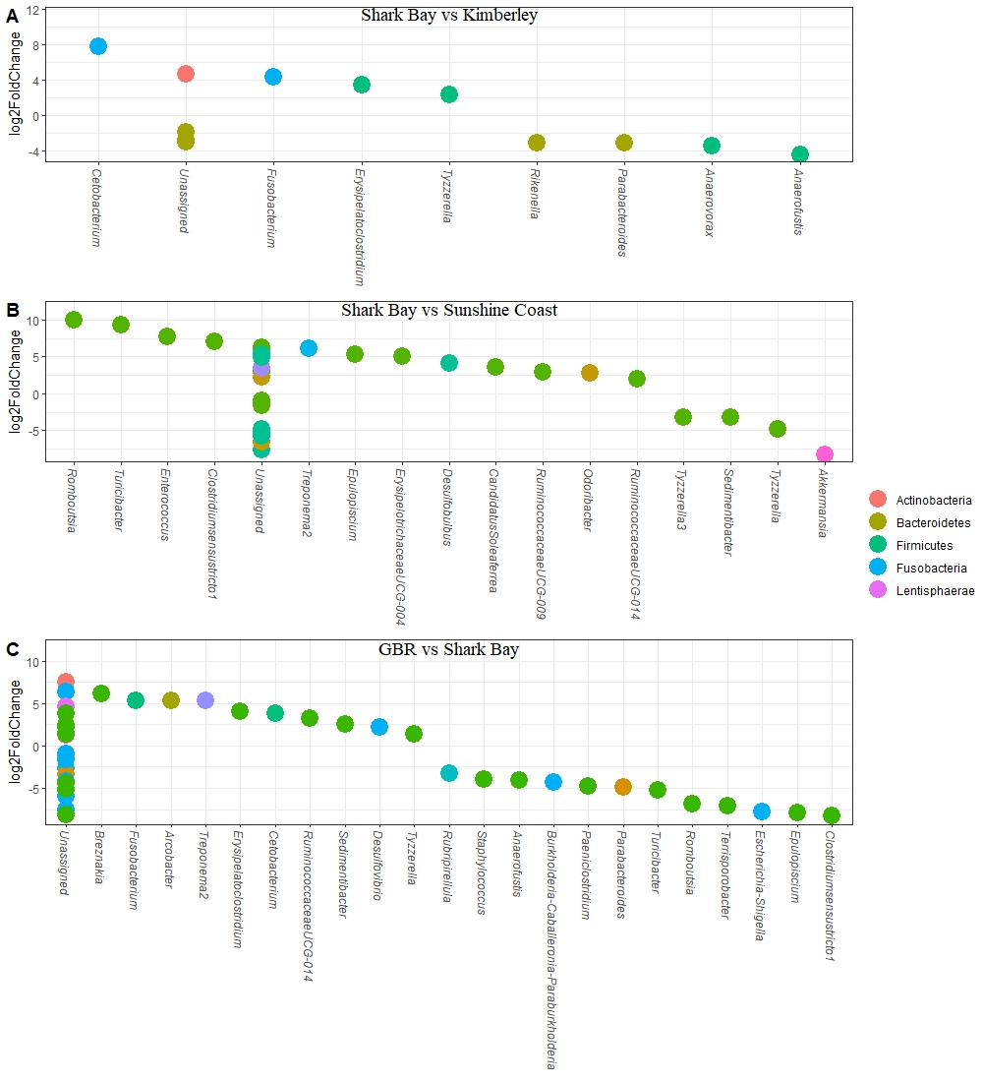
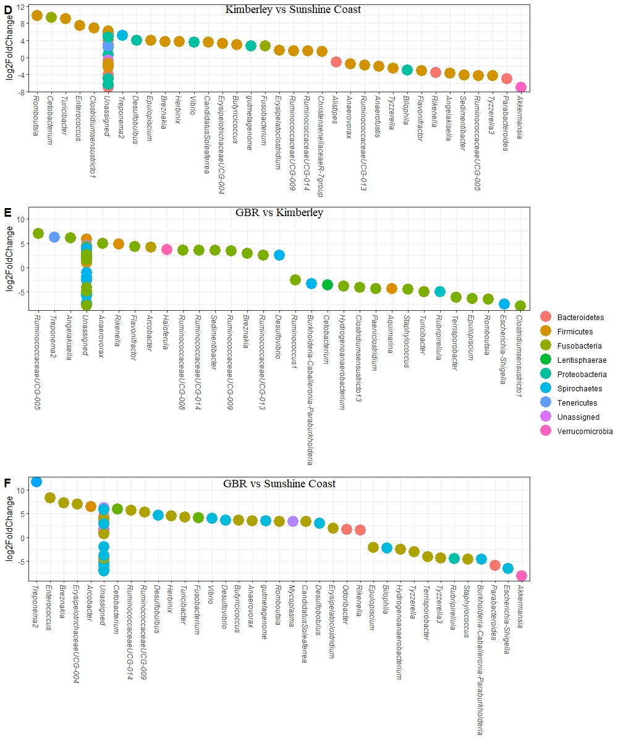
Figure S6 List and fold change of the ASVs that significantly (P < 0.05) differed between the different geographical populations ordered from the least amount of differing ASVs (“A”) to the most differing geographical populations (“F”) with A: 12 ASVs; B: 27 ASVs; C: 39 ASVs; D: 53 ASVs; E: 59 ASVs and F: 65 ASVs.

