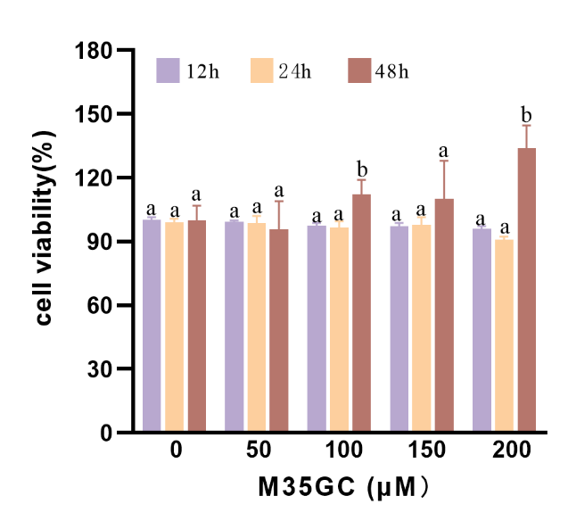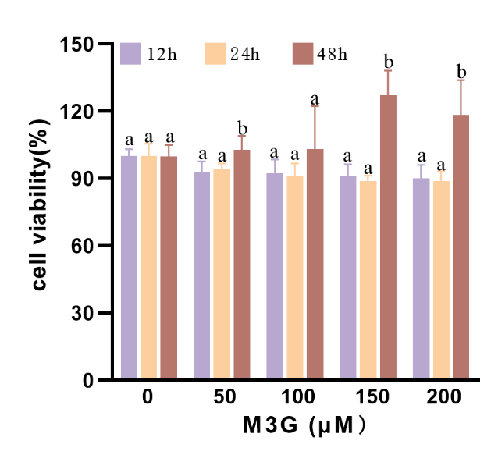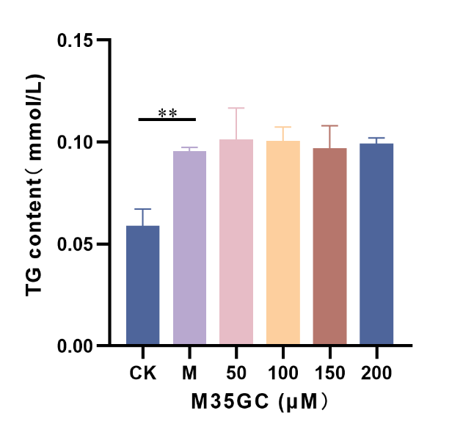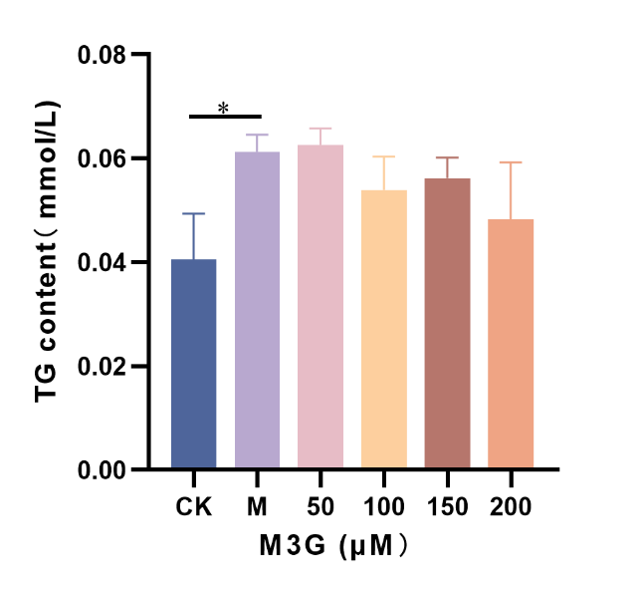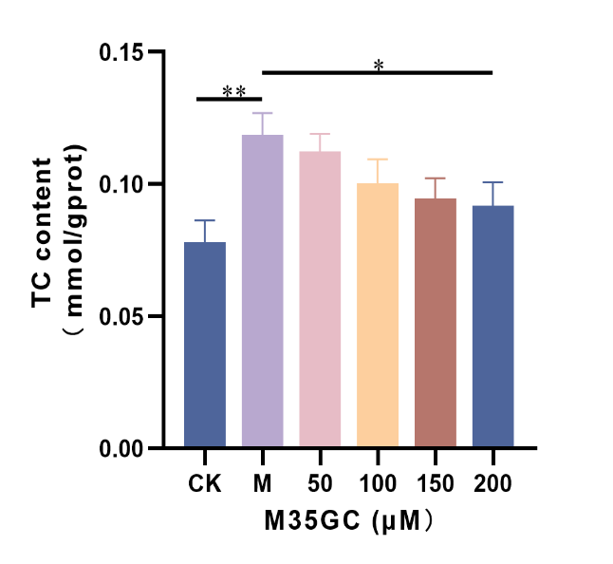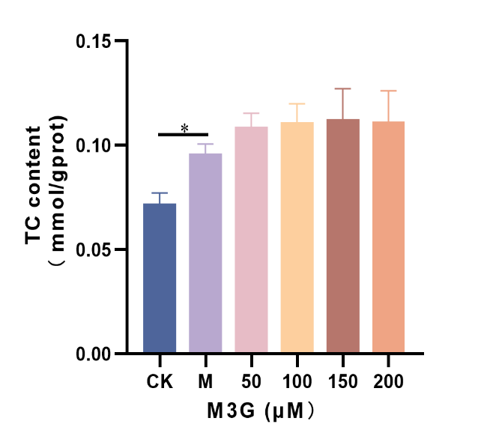Figure S1. The effects of M3G and M35GC on hepatic steatosis caused by fructose in HepG2 cell. (A) Effect of M3G on cell viability in fructose-induced HepG2 cells. (B) Effect of M35GC on cell viability in fructose-induced HepG2 cells. (C) Effect of M3G on TG accumulation in HepG2 cells. (D) Effect of M35GC on TG accumulation in HepG2 cells. (E) Effect of M3G on TC content in HepG2 cells. (F) Effect of M35GC on TC content in HepG2 cells. (* p < 0.05, ** p < 0.01).
A
B
C
D
E
F
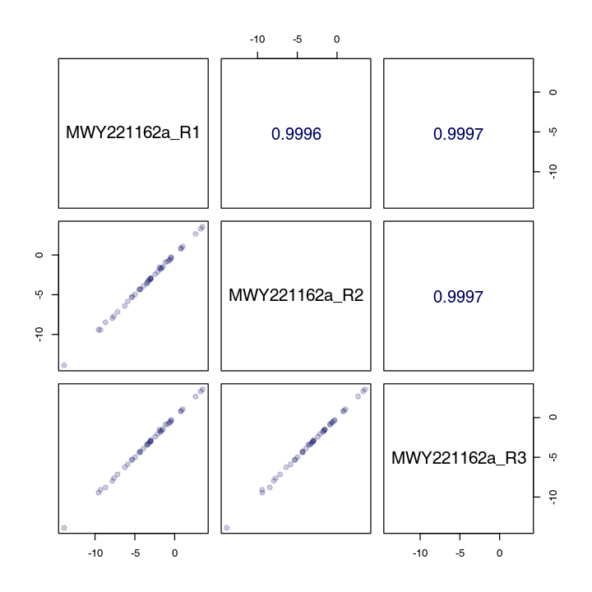
Figure S2. QC sample correlation analysis
Note: The diagonal square represents the name of QC sample; The square in the lower left corner of the diagonal is the correlation scatter plot of the corresponding QC sample, and the horizontal and vertical coordinates are the metabolite content, respectively. Each point in the figure represents a metabolite. The square in the upper right corner of the diagonal is the correlation coefficient of the corresponding QC sample. QC sample correlation is higher (| r | more close to 1) shows the better stability of the whole testing process, data quality is higher.

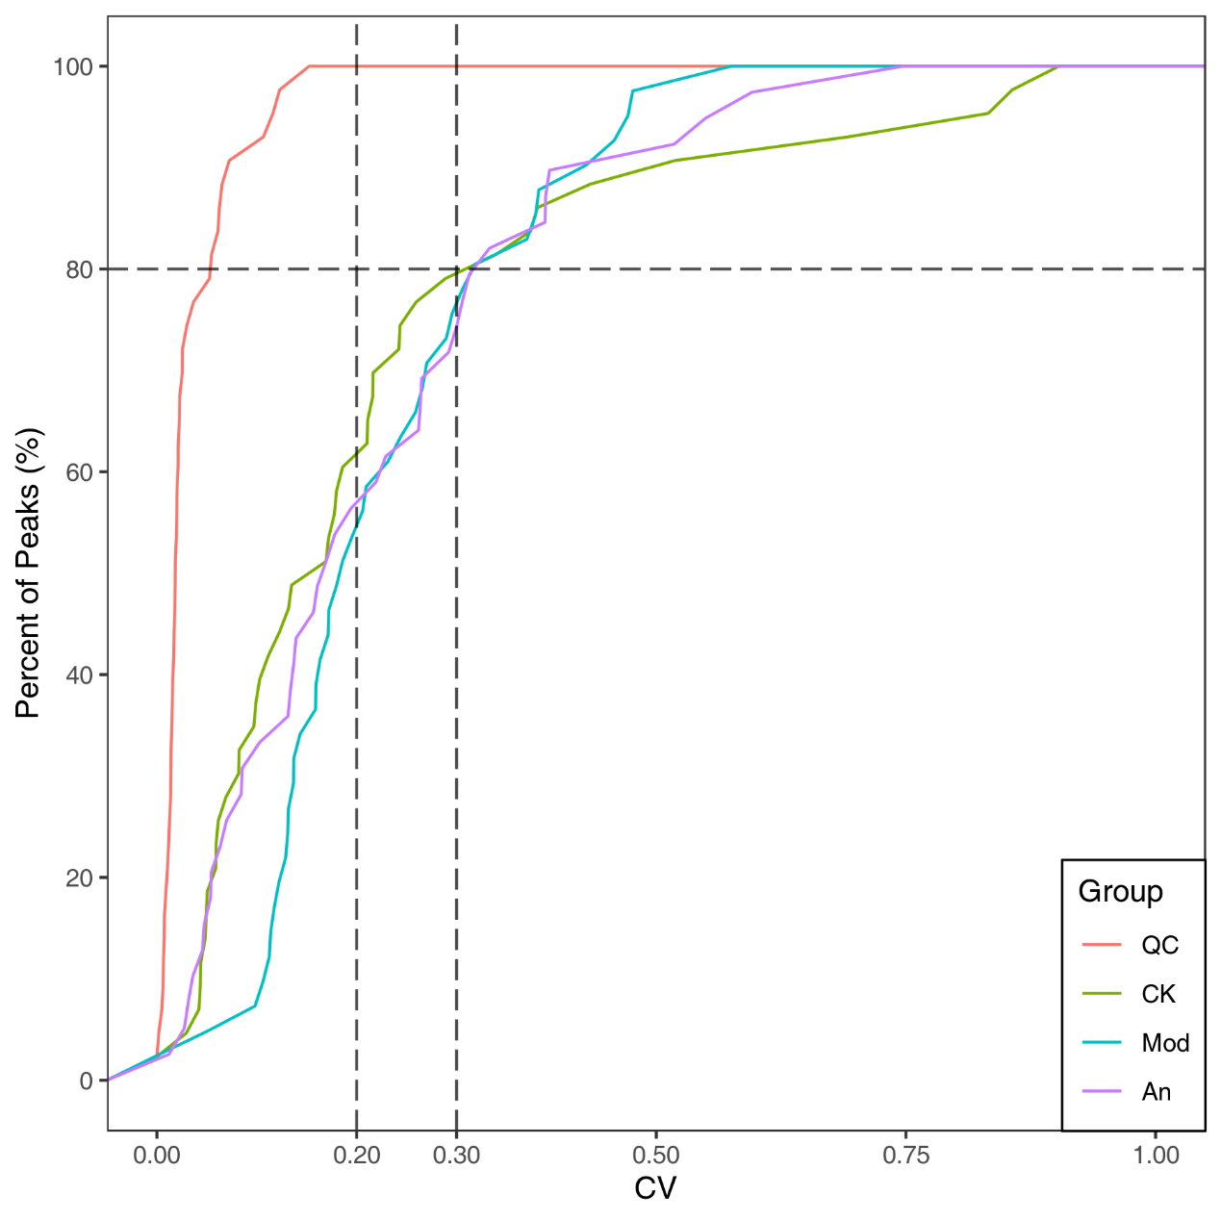
Figure S3 All CV distribution in each group

Note: CV value, namely Coefficient of Variation, is the ratio between the standard deviation of the original data and the average of the original data, which can reflect the degree of data dispersion. The Empirical Cumulative Distribution Function (ECDF) can be used to analyze the frequency of CV of substances less than the reference value. The higher the proportion of substances with lower CV value of QC samples, the more stable the experimental data will be: The proportion of substances with CV value less than 0.3 in QC samples was higher than 80%, indicating that the experimental data was stable. The proportion of substances with CV values less than 0.2 in QC samples was higher than 80%, indicating that the experimental data were very stable.the abscissa represents the CV value, ordinate said a smaller number than the corresponding material of CV value accounted for the proportion of the total number of materials, different colors represent different grouping samples, QC for quality control samples, with two reference of X axis vertical line corresponding to the CV value of 0.2 and 0.3, and X axis parallel to the reference line corresponds to the material number accounts for 80% of the total number of substance
Table S1 Free fatty acid content in different treatment groups
Index | CK (μg/tube) | Mod (μg/tube) | M35G (μg/tube)
C12-0 | 0.04101±0.00497ª | 0.05309±0.00528^{b} | 0.04889±0.00161^{ab}
C22-6n3 | 0.2732±0.03647ª | 0.3232±0.02947ª | 0.26159±0.06666ª
C23-0 | 0.00289±0.00044ª | 0.00562±0.00053^{b} | 0.00452±0.00061^{b}
C24-0 | 0.02101±0.00132ª | 0.04632±0.00455^{c} | 0.0365±0.00346^{b}
C6-0 | 0.00157±0.00063ª | 0.00371±0.00007^{b} | 0.00213±0.00093^{ab}
C9-0 | 0.04742±0.00413ª | 0.07065±0.01184^{b} | 0.04297±0.0048ª
C17-1T | 0.40419±0.04481^{b} | 0.25477±0.03759ª | 0.41786±0.11023^{b}
C18-2n6t | 0.05396±0.00264ª | 0.05203±0.0119ª | 0.03947±0.00596ª
C20-1T | 0.11738±0.00419ª | 0.15144±0.00305^{b} | 0.1462±0.00245^{b}
C20-5n3 | 0.63644±0.10859ª | 0.45841±0.07179ª | 0.60329±0.09384ª
C22-4 | 0.29363±0.0308ª | 0.31032±0.028ª | 0.25508±0.03376ª
C21-0 | 0.00079±0.0001ª | 0.0016±0.00048^{b} | 0.00192±0.00007^{b}
C22-2 | 0.00785±0.00098ª | 0.00607±0.00062ª | 0.00681±0.00071ª
C22-5 | 0.72618±0.06452^{b} | 0.60014±0.12242^{ab} | 0.40493±0.03691ª
C24-1 | 0.09257±0.00523ª | 0.10235±0.01651ª | 0.0816±0.00305ª
C8-0 | 0.01014±0.00084ª | 0.01128±0.0007ª | 0.01552±0.00718ª
C10-0 | 0.00145±0.00042ª | 0.00294±0.00052^{ab} | 0.00365±0.00092^{b}
C22-1T | 0.0169±0.00216ª | 0.02315±0.00223^{b} | 0.03975±0.00293^{c}
C22-1n9 | 0.36548±0.02346ª | 0.33558±0.0201ª | 0.32231±0.05227ª
C22-0 | 0.05296±0.00211ª | 0.0763±0.01062^{b} | 0.07716±0.00513^{b}
C20-4n6 | 1.69735±0.19913^{b} | 1.88139±0.14316^{b} | 1.04792±0.03936ª
C13-0 | 0.01725±0.00564ª | 0.18873±0.20702ª | 0.10254±0.1099ª
C14-0 | 0.55695±0.02641ª | 0.58066±0.03182ª | 0.55667±0.00233ª
C14-1 | 0.01433±0.00289ª | 0.01201±0.00093ª | 0.01465±0.0023ª
C15-0 | 0.11683±0.00394^{b} | 0.09019±0.00795ª | 0.08838±0.00266ª
C15-1 | 0.67958±0.07665^{b} | 0.36506±0.05674ª | 0.67788±0.18873^{b}
C16-0 | 11.67392±0.03696ª | 12.73093±0.77328^{b} | 11.90893±0.28639ª
C16-1 | 0.58516±0.03512ª | 0.66507±0.04991ª | 0.59763±0.01622ª
C17-0 | 0.14204±0.00363^{b} | 0.11781±0.01057^{ab} | 0.10881±0.00193ª
C18-0 | 8.6894±0.12818ª | 9.70442±0.44538^{b} | 10.3008±0.1767^{b}
C18-1n9c | 7.0315±0.41155ª | 6.15853±0.51004ª | 5.8957±0.48149ª
C18-1n9t | 2.04602±0.04058^{b} | 1.58548±0.0473ª | 1.64627±0.04339ª
C18-2n6c | 2.29499±0.17068^{b} | 1.83455±0.23934ª | 2.05671±0.11825^{b}
C18-3n3 | 0.24291±0.01772^{b} | 0.24693±0.01768^{b} | 0.18943±0.02816ª
C18-3n6 | 0.00604±0.00079^{ab} | 0.00509±0.00017ª | 0.00659±0.00052^{b}
C19-0 | 0.01803±0.00046ª | 0.01817±0.00195ª | 0.01658±0.00079ª
C19-1 | 0.07622±0.00342ª | 0.09182±0.00069^{b} | 0.08571±0.00273^{b}
C20-0 | 0.09699±0.00212ª | 0.12±0.00801^{b} | 0.11909±0.00271^{b}
C20-1 | 0.73425±0.00493ª | 0.71147±0.01728ª | 0.70466±0.03251ª
C20-2 | 0.14814±0.00729^{b} | 0.11093±0.0084ª | 0.11405±0.01064ª
C20-3n3 | 0.10346±0.01128ª | 0.23676±0.02704^{b} | 0.09395±0.03343ª
C20-3n6 | 0.33288±0.04204^{ab} | 0.3673±0.02486^{b} | 0.28141±0.01889ª

Note: Values are shown as the mean ± SD (n = 3). Values sharing a common letter (a, b and c) in each row did not show significant differences (P<0.05).

