Appendix
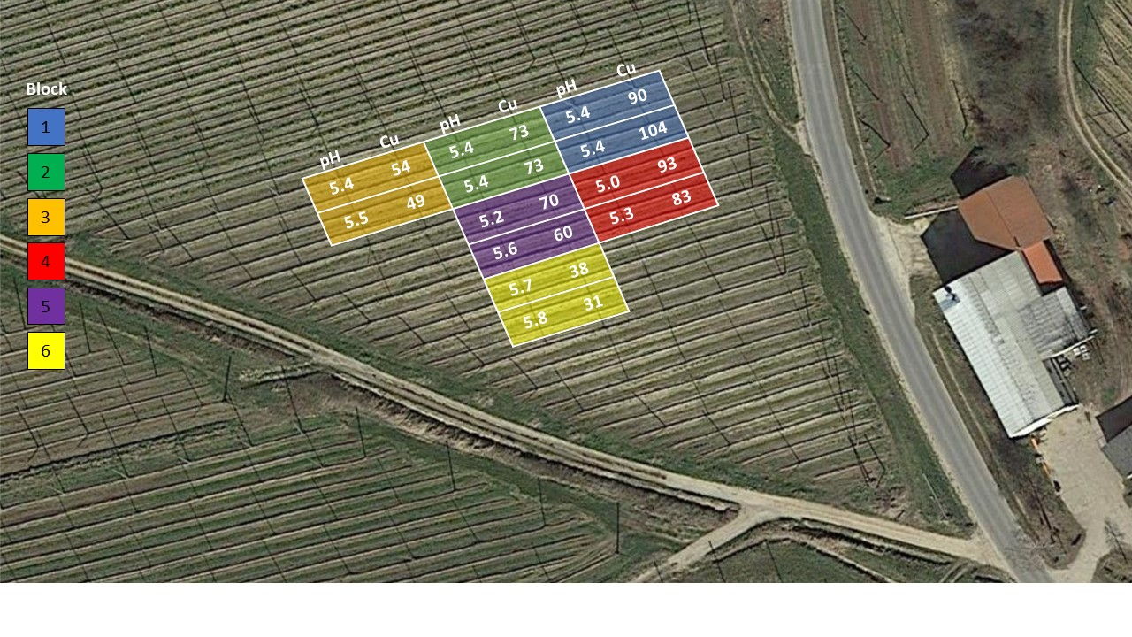
Figure 1. Experimental field with sampling grid, blocks, and corresponding pH values (pH) and CAT-extractable copper concentrations (Cu). Aerial image: Google Maps (Images © 2025 Airbus, GeoBasis-DE/BKG, Maxar Technologies; map data © 2025 GeoBasis-DE/BKG (©2009)).

Table 5. Concentrations of essential macronutrients in leaves and roots during both vegetation periods. Values (% DM) are presented as means ± standard error. Nutrient concentrations well below or above (−30% / +30%) the sufficiency ranges for hop (Bryson and Mills 2014), presented in parentheses next to each nutrient, are highlighted in blue for deficiency and red for excess.
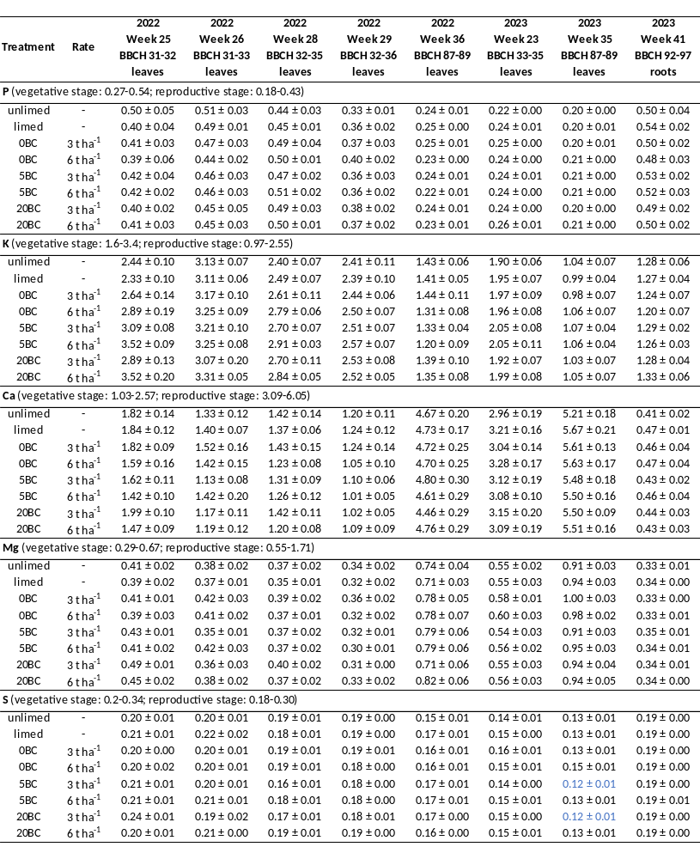

Table 6. Concentrations of essential micronutrients in leaves and roots during both vegetation periods. Values (mg kg⁻¹ DM) are presented as means ± standard error. Nutrient concentrations well below or above (−30% / +30%) the sufficiency ranges for hop (Bryson and Mills 2014), presented in parentheses next to each nutrient, are highlighted in blue for deficiency and red for excess.
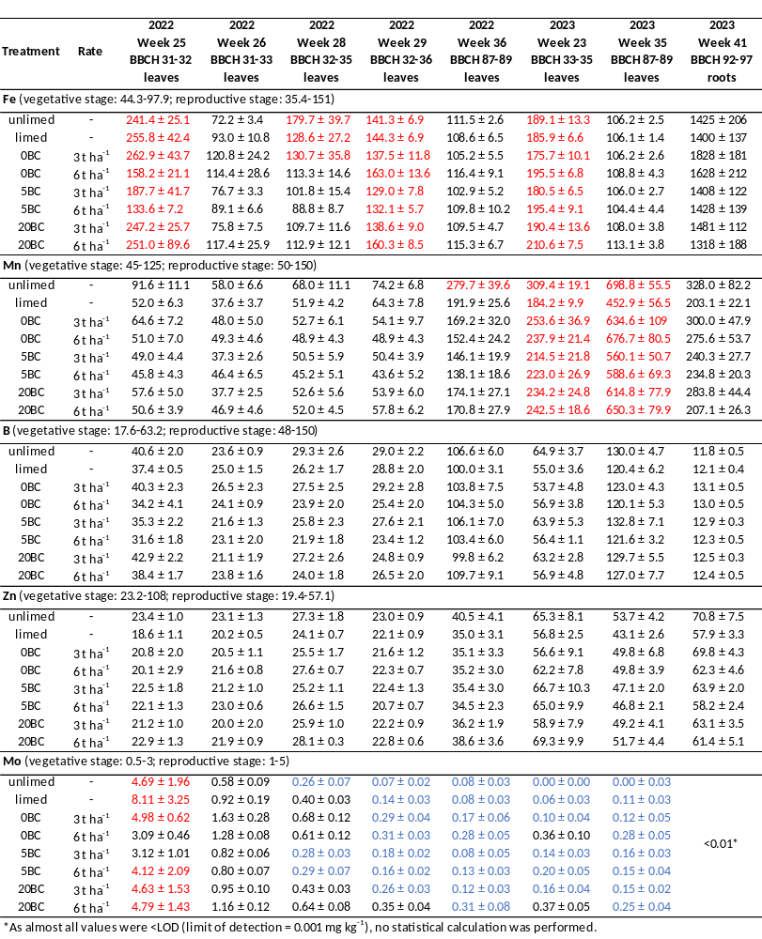

Table 7. Soil pH and CAT-extractable concentrations of essential micronutrients at the end of the first (2022) and second growing season (2023) after planting. Values are presented as means ± standard error.
