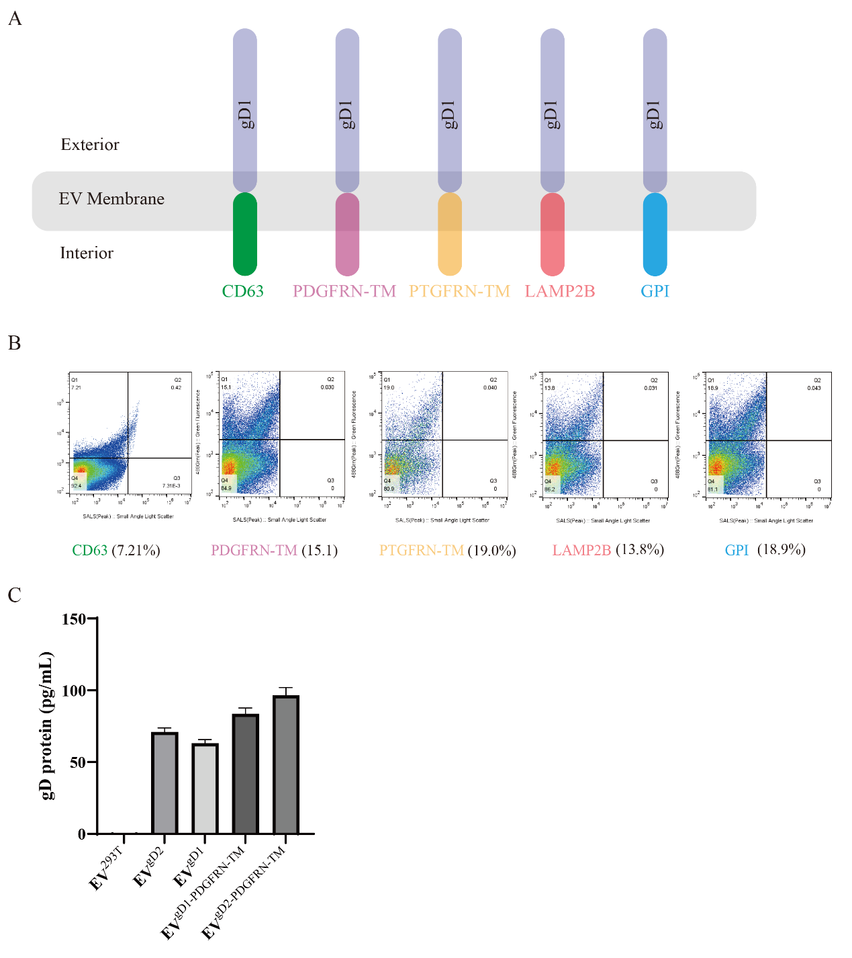
Figure S1: The different diagram of EV vaccine platform
- Schematic diagram of constructing EV-based vaccines. (B) Investigation of gD1 protein content on EVs via nanoscale flow cytometry. (C) Analysis of gD protein content in EV vaccines using ELISA. Data are presented as Mean ± SD (n=3), * P<0.05, ** P<0.01, ***P<0.001
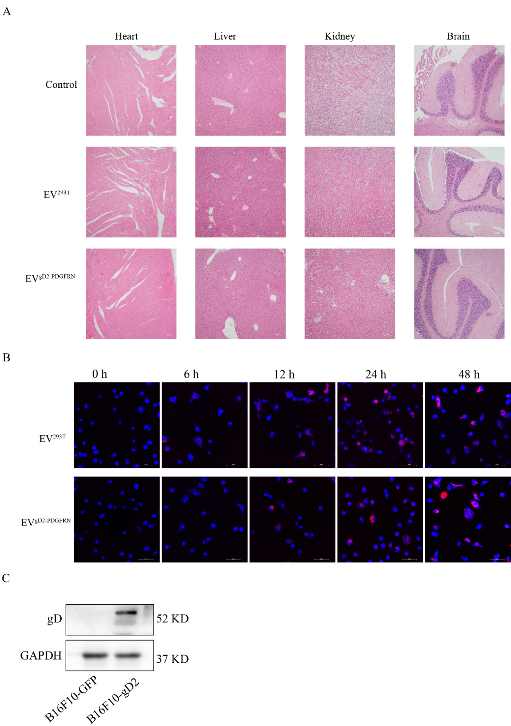
Figure S2: The safety of EV^{gD2-PDGFRN} vaccine
(A) Observation of pathological changes in major tissues (heart, liver, kidney, and brain) after EV administration using HE staining. (B) Extraction of DC cells from mouse BMDC cells, followed by confocal microscopy to observe EVs uptake at different time points, with EVs labeled red using Dil. (C) Detection of gD2 protein content in cells (B16F10-GFP, B16F10-gD2) using the western blot assay.

