Supplementary data: Fluorescent Pseudomonas spp. from Suppressive and Non-Suppressive Soils Share Genomic and Functional Traits Relevant to Fusarium graminearum Disease Suppression

Irena Todorović^{1,2}, Danis Abrouk², Martina Kyselková³, Rubén López-Mondéjar⁴, Vera Raičević⁵, Jelena Jovičić-Petrović⁵, Yvan Moënne-Loccoz^{2,6}, Daniel Muller²

¹Department of Hydroecology and Water Protection, Institute for Biological Research ¨Siniša Stanković¨, National Institute of the Republic of Serbia, University of Belgrade, Bulevar despota Stefana 142, Belgrade 11060, Serbia
²Université Claude Bernard Lyon 1, CNRS, INRAE, VetAgro Sup, UMR5557 Ecologie Microbienne, 43 bd du 11 novembre 1918, F-69622 Villeurbanne, France
³Laboratory of Environmental Microbiology, Institute of Microbiology of the Czech Academy of Sciences, Vídeňská 1083, 14220, Prague 4, Czech Republic
⁴CEBAS-CSIC, Department of Soil and Water Conservation, Campus Universitario de Espinardo, 30100, Murcia, Spain
⁵University of Belgrade, Faculty of Agriculture, Department of Microbial Ecology, Nemanjina 6, 11080 Zemun, Belgrade, Serbia
⁶Institut Universitaire de France (IUF), F-75005 Paris

Supplementary tables

Table S1. Accession numbers of protein sequences corresponding to genes involved in biocontrol and plant-growth promotion, used as a query in genome screening.
Gene | Accession number | Reference species
darA | AAN18031.1 | Pseudomonas chlororaphis subsp. aurantiaca
darB | AAN18032.1 | Pseudomonas chlororaphis subsp. aurantiaca
darC | AAN18033.1 | Pseudomonas chlororaphis subsp. aurantiaca
phzA | AAC18900.1 | Pseudomonas synxantha 2-79
phzB | AAC18901.1 | Pseudomonas synxantha 2-79
phzC | AAC18902.1 | Pseudomonas synxantha 2-79
phzD | AAC18903.1 | Pseudomonas synxantha 2-79
phzE | AAC18904.1 | Pseudomonas synxantha 2-79
phzF | AAC18905.1 | Pseudomonas synxantha 2-79
phzG | AAC18906.1 | Pseudomonas synxantha 2-79
pchA | PFLCHA0_c35300 | Pseudomonas protegens CHA0
pchB | PFLCHA0AM_3611 | Pseudomonas protegens CHA0
pchC | PFLCHA0_c35310 | Pseudomonas protegens CHA0
pchD | PFLCHA0_c35370 | Pseudomonas protegens CHA0
pchE | PFLCHA0_c35340 | Pseudomonas protegens CHA0
pchF | PFLCHA0_c35330 | Pseudomonas protegens CHA0
phlA | PSF113_2462 | Pseudomonas ogarae F113
phlB | PSF113_2460 | Pseudomonas ogarae F113
phlC | PSF113_2461 | Pseudomonas ogarae F113
phlD | PSF113_2459 | Pseudomonas ogarae F113
prnA | PFLCHA0_c36450 | Pseudomonas protegens CHA0
prnB | PFLCHA0_c36460 | Pseudomonas protegens CHA0
prnC | PFLCHA0_c36470 | Pseudomonas protegens CHA0
prnD | PFLCHA0_c36480 | Pseudomonas protegens CHA0
hcnA | PSF113_2367 | Pseudomonas ogarae F113
hcnB | PSF113_2368 | Pseudomonas ogarae F113
hcnC | PSF113_2369 | Pseudomonas ogarae F113
pltA | PFLCHA0_c28450 | Pseudomonas protegens CHA0
pltB | PFLCHA0_c28460 | Pseudomonas protegens CHA0
pltC | PFLCHA0_c28470 | Pseudomonas protegens CHA0
pltD | PFLCHA0_c28480 | Pseudomonas protegens CHA0
pltE | PFLCHA0_c28490 | Pseudomonas protegens CHA0
pltF | PFLCHA0_c28500 | Pseudomonas protegens CHA0
pltG | PFLCHA0_c28510 | Pseudomonas protegens CHA0
pltL | PFLCHA0_c28440 | Pseudomonas protegens CHA0
pltM | VAV69124.1 | Pseudomonas protegens CHA0
pvdL | VAV70531.1 | Pseudomonas protegens CHA0
pmsC | CAA70528.1 | Pseudomonas fluorescens
pmsE | CAA70529.1 | Pseudomonas fluorescens
pmsA | CAA70530.1 | Pseudomonas fluorescens
pmsB | CAA70531.1 | Pseudomonas fluorescens
fitD | AGL84796.1 | Pseudomonas protegens CHA0
acdS | PSF113_3500 | Pseudomonas ogarae F113
iacA | ABY62757.1 | Pseudomonas putida
iacB | ABY62758.1 | Pseudomonas putida
iacC | ABY62759.1 | Pseudomonas putida
iacD | ABY62760.1 | Pseudomonas putida
iacE | ABY62761.1 | Pseudomonas putida
iacF | ABY62762.1 | Pseudomonas putida
iacG | ABY62763.1 | Pseudomonas putida
iacH | ABY62765.1 | Pseudomonas putida
iacI | ABY62766.1 | Pseudomonas putida
acoA | PFLCHA0_c22170 | Pseudomonas protegens CHA0
acoB | PFLCHA0_c22180 | Pseudomonas protegens CHA0
acoC | PFLCHA0_c22190 | Pseudomonas protegens CHA0
acoX | PFLCHA0_c22160 | Pseudomonas protegens CHA0
bdhA | JV497_v1_130113 | Pseudomonas sp. JV497
adh | AAB58982.1 | Pseudomonas putida
budA | AAA25054.1 | Raoultella terrigena
budB | AAA25055.1 | Raoultella terrigena
budC | AAA25056.1 | Raoultella terrigena
alsS | AAA22222.1 | Bacillus subtilis
alsD | AAA22223.1 | Bacillus subtilis
ilvB | AAB81919.1 | Lactococcus lactis subsp. lactis NCDO 2118
ilvN | AAB81920.1 | Lactococcus lactis subsp. lactis NCDO 2118
ydjL | ALH44116.1 | Bacillus subtilis subsp. subtilis
gcd | NP_250980.1 | Pseudomonas aeruginosa PAO1
gad | NP_250955.1 | Pseudomonas aeruginosa PAO1
nifH | AAD03796.1 | Trichodesmium erythraeum IMS101
nifD | AAD03797.1 | Trichodesmium erythraeum IMS101
nifK | AAD03798.1 | Trichodesmium erythraeum IMS101
nirK | PFLCHA0_c54550 | Pseudomonas protegens CHA0
nirS | AAG34381.1 | Pseudomonas fluorescens
aprA | PFLCHA0_c32400 | Pseudomonas protegens CHA0
ipdC | PP_2552 | Pseudomonas alloputida KT2440
ppdC | WP_011158661.1 | Rhodopseudomonas palustris
iaaM | PSF113_5381 | Pseudomonas ogarae F113
iaaH | JV395A_v1_10784 | Pseudomonas sp. JV395A
efe | BBI44544.1 | Pseudomonas syringae pv. actinidiae

Table S2. Most probable numbers (MPN) of putative Pseudomonas from the rhizospheres of wheat grown in MI soils. Data are expressed per root system, showing 95% confidence intervals [34].
Soil | Fg1 inoculation | MPN/root system | Confidence interval (95%)
Soil | Fg1 inoculation | MPN/root system | Lower | Higher
MI2 | Inoculated | 8.0 × 10⁷ | 1.9 × 10⁷ | 2.0 × 10⁸
MI3 | Inoculated | 4.5 × 10⁷ | 1.3 × 10⁷ | 1.1 × 10⁸
MI4 | Inoculated | 4.5 × 10⁸ | 1.3 × 10⁸ | 1.1 × 10⁹
MI5 | Inoculated | 2.7 × 10⁷ | 8.9 × 10⁶ | 7.0 × 10⁷
MI2 | Control | 1.7 × 10⁸ | 5.8 × 10⁷ | 5.0 × 10⁸
MI3 | Control | 8.0 × 10⁹ | 1.9 × 10⁹ | 2.0 × 10¹⁰
MI4 | Control | 4.5 × 10⁸ | 1.3 × 10⁸ | 1.1 × 10⁹
MI5 | Control | 8.0 × 10⁹ | 1.9 × 10⁹ | 2.0 × 10¹⁰

Table S3. Taxonomic overview of the 29 whole-genome sequenced Pseudomonas strains from four Mionica soils. The taxonomic identification was based on digital DNA-DNA hybridization (dDDH) with their closest relative species available at TYGS (Type Strain Genome Server), using genome-to-genome distance calculator website service from DSMZ [49, 50] and the similarity threshold of 70%. dDDH values of the 14 novel genomospecies and their closest described species (i.e., values < 70%) are indicated.
Soil | Species name | P. siliginis SWRI31 ^{T} |  | P. glycinae MS586 ^{T} |  | P. jessenii  DSM 17150 ^{T} |  | P. pisciciola P50 ^{T} |  | P. migulae NBRC 103157 ^{T} |  | P. kielensis MBT-1 ^{T} |  | P. umsongensis DSM 16611 ^{T} |  | P. koreensis LMG 21318 ^{T} |  | P. silesiensis  A3 ^{T} |  | P. arsenicoxydans CECT 7543 ^{T} |  | P. tensinigenes ZA 5.3 ^{T} |  | P. neuropathica P155 ^{T}
MI2 | P. siliginis IT-1P | *
MI2 | Pseudomonas GN-1 IT-2P |  | 58.2
MI2 | Pseudomonas GN-2 IT-4P |  |  |  | 54.6
MI2 | Pseudomonas GN-3 IT-12P |  |  |  |  |  | 28.9
MI2 | P. jessenii IT-43P
MI2 | Pseudomonas GN-4 IT-44P |  |  |  |  |  |  |  | 41.8
MI2 | Pseudomonas GN-5 IT-74P |  |  |  | 52.3
MI3 | Pseudomonas GN-6 IT-100P |  |  |  |  |  |  |  | 50.4
MI3 | Pseudomonas GN-6 IT-171P |  |  |  |  |  |  |  | 50.9
MI3 | Pseudomonas GN-7 IT-176P |  |  |  |  |  |  |  |  |  | 57.4
MI3 | P. serbica IT-194P
MI3 | P. chlororaphis IT-196P
MI3 | P. chlororaphis IT-201P
MI4 | P. serboccidentalis IT-215P
MI4 | Pseudomonas GN-8 IT-218P |  |  |  |  |  |  |  |  |  |  |  | 41.8
MI4 | P. brassicacearum IT-228P
MI4 | Pseudomonas GN-9 IT-253P |  |  |  |  |  |  |  |  |  |  |  |  |  |  |  | 33.2
MI4 | Pseudomonas GN-2 IT-P258 |  |  |  | 53.5
MI4 | Pseudomonas GN-10 IT-260P |  |  |  |  |  |  |  |  |  |  |  |  |  | 43.4
MI4 | P. zeae IT-265P
MI4 | Pseudomonas GN-11 IT-291P |  |  |  | 48.4
MI4 | Pseudomonas GN-12 IT-294P |  |  |  |  |  |  |  |  |  |  |  |  |  |  |  |  |  | 60.9
MI5 | P. chlororaphis IT-324P
MI5 | Pseudomonas GN-13 IT-347P |  |  |  |  |  |  |  |  |  |  |  |  |  |  |  |  |  |  |  | 42.8
MI5 | P. marginalis IT-357P
MI5 | P. serbica IT-P366
MI5 | P. chlororaphis IT-373P
MI5 | P. serboccidentalis IT-P374
MI5 | Pseudomonas GN-14 IT-395P |  |  |  |  |  |  |  |  |  |  |  |  |  |  |  |  |  |  |  |  |  | 47.3
* For P. siliginis IT-1P, dDDH value (GGDC formula 2) with the closest described type strain P. siliginis SWRI31^{T} was 69.3%, but dDDH values for P. siliginis IT-1P and P. siliginis non-type strain OTU6BANIB1 (GenBank BioSample ID: SAMN29009911) was 80.2, showing that IT-1P and P. siliginis OTU6BANIB1 are within the same species.

Table S4. Number of putative biosynthetic gene clusters (BGCs) and number of BGCs with completion 1 or 1*, in the Pseudomonas strains, found using the antiSMASH [71] within the MicroScope platform.
Soil | Species name from TYGS | Bacterial isolate |  | Number of putative BGCs | Number of BGCs with completion 1 or 1*
MI2 | Pseudomonas siliginis | IT-1P |  | 8 | 0
MI2 | Pseudomonas GN-1 | IT-2P |  | 11 | 1
MI2 | Pseudomonas GN-2 | IT-4P |  | 8 | 0
MI2 | Pseudomonas GN-3 | IT-12P |  | 10 | 1
MI2 | P. jessenii | IT-43P |  | 8 | 0
MI2 | Pseudomonas GN-4 | IT-44P |  | 8 | 0
MI2 | Pseudomonas GN-5 | IT-74P |  | 10 | 0
MI3 | Pseudomonas GN-6 | IT-100P |  | 8 | 0
MI3 | Pseudomonas GN-6 | IT-171P |  | 9 | 0
MI3 | Pseudomonas GN-7 | IT-176P |  | 6 | 0
MI3 | P. serbica | IT-194P |  | 12 | 0
MI3 | P. chlororaphis | IT-196P |  | 15 | 3
MI3 | P. chlororaphis | IT-201P |  | 14 | 3
MI4 | P. serboccidentalis | IT-215P |  | 9 | 0
MI4 | Pseudomonas GN-8 | IT-218P |  | 11 | 0
MI4 | P. brassicacearum | IT-228P |  | 13 | 1
MI4 | Pseudomonas GN-9 | IT-253P |  | 7 | 1
MI4 | Pseudomonas GN-2 | IT-P258 |  | 8 | 0
MI4 | Pseudomonas GN-10 | IT-260P |  | 11 | 1
MI4 | P. zeae | IT-265P |  | 11 | 1
MI4 | Pseudomonas GN-11 | IT-291P |  | 9 | 0
MI4 | Pseudomonas GN-12 | IT-294P |  | 10 | 1
MI5 | P. chlororaphis | IT-324P |  | 16 | 2
MI5 | Pseudomonas GN-13 | IT-347P |  | 12 | 1
MI5 | P. marginalis | IT-357P |  | 14 | 2
MI5 | P. serbica | IT-P366 |  | 11 | 0
MI5 | P. chlororaphis | IT-373P |  | 15 | 3
MI5 | P. serboccidentalis | IT-P374 |  | 11 | 0
MI5 | Pseudomonas GN-14 | IT-395P |  | 11 | 1
* When two or more genes in a single MIBiG (The Minimum Information about a Biosynthetic Gene cluster database) curated region were similar, the same gene in MicroScope database can hit on these MIBiG genes. When this happens, the completion can be higher than 1 (represented by 1*).

Supplementary figures

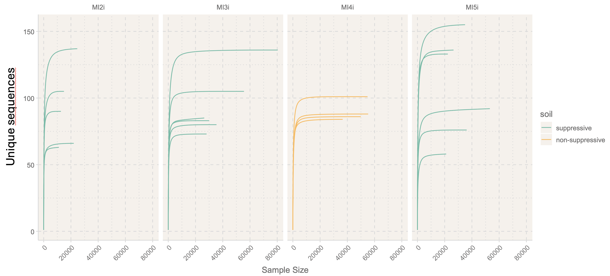

Figure S1. Rarefaction curves with the estimated species richness of each replicate for rpoD metabarcoding of MI2, MI3, MI4 and MI5 soils. One MI2 and two MI4 replicates (with not enough reads) were discarded.

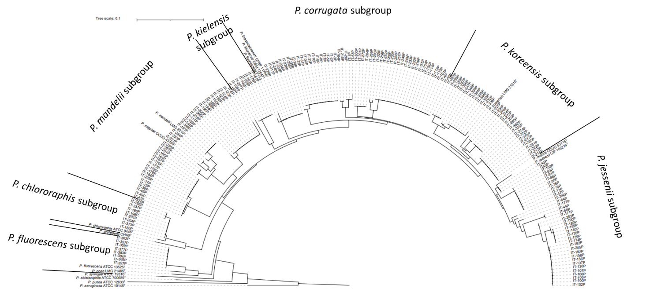
Figure S2. Phylogenetic tree of 185 Pseudomonas isolates characterized based on their rpoD gene sequence, and belonging to the P. fluorescens group. The phylogenetic tree includes 14 Pseudomonas type strains [16] and P. aeruginosa ATCC 10145^{T}, used for tree rooting. Other Pseudomonas groups such as the P. syringae, P. putida and P. lutea groups are also represented. Analysis was done using the SeaView multiplatform [46], the sequences were aligned with Muscle5 v.3.8.31 [42], the phylogenetic tree was constructed with Distance method and 1000 bootstraps and visualized using iTol [47].

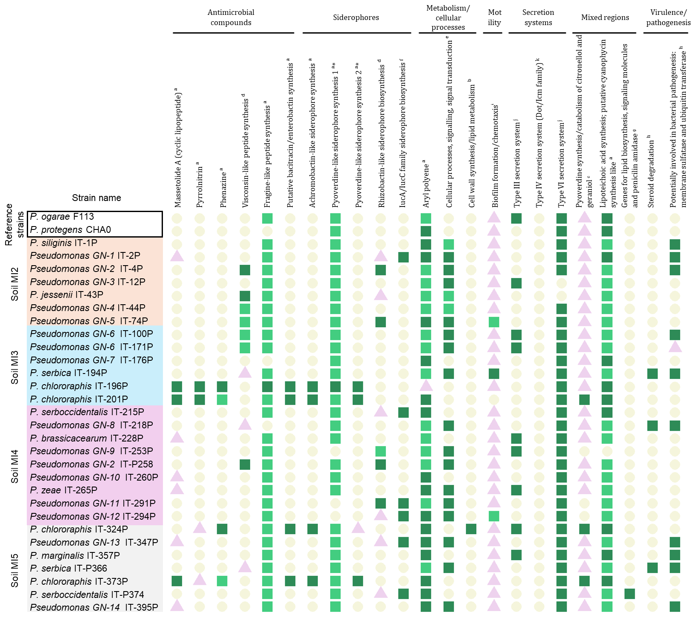
* Pyoverdine-like siderophore synthesis region 1 is present in P. chlororaphis IT-196P from position 4223142 to 4276158 and pyoverdine-like synthesis region 2 from position 6268542 to 6339315.

Figure S3. Putative biosynthetic gene clusters (BGCs) identified using antiSMASH (Blin et al., 2019) and manually curated. Dark green square shows the presence of BGC, pale green square shows the presence of BGC, but with different gene synteny, purple triangle shows the presence of partial BGC and pale circle shows the absence of BGC. ª BGC compared to the one present in IT-196P, ^{b} compared to IT-324P, ^{c} compared to IT-373P, ^{d} compared to IT-P258, ^{e} compared to IT-P4, ^{f} compared to IT-215P, ^{g} compared to IT-P374, ^{h} compared to IT-P366, ^{i} compared to IT-194P, ^{j} compared to P. ogarae F113 and ^{k} as described in Costa et al. (2021). Annotation was completed on April 18th, 2023.

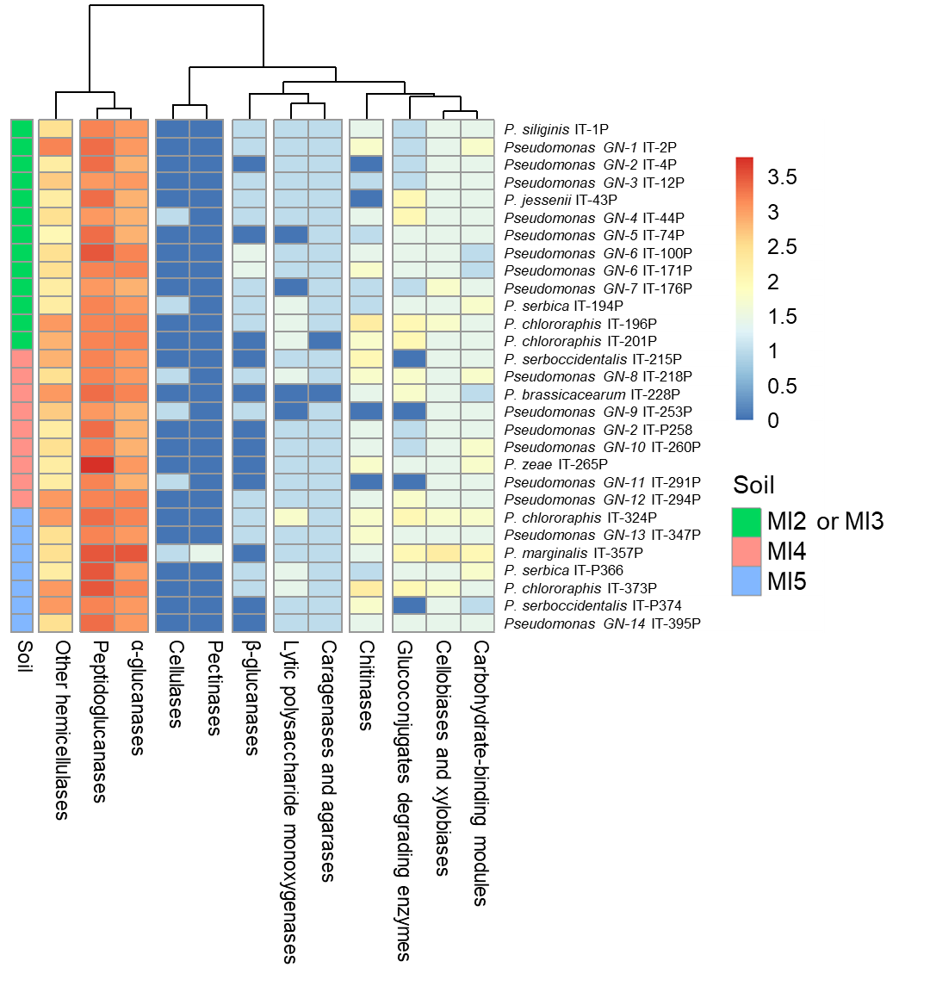

Figure S4. Heatmap showing the abundance of CAZyme genes annotated for each function found in the genomes of Pseudomonas strains. Legend shows transformed counts.

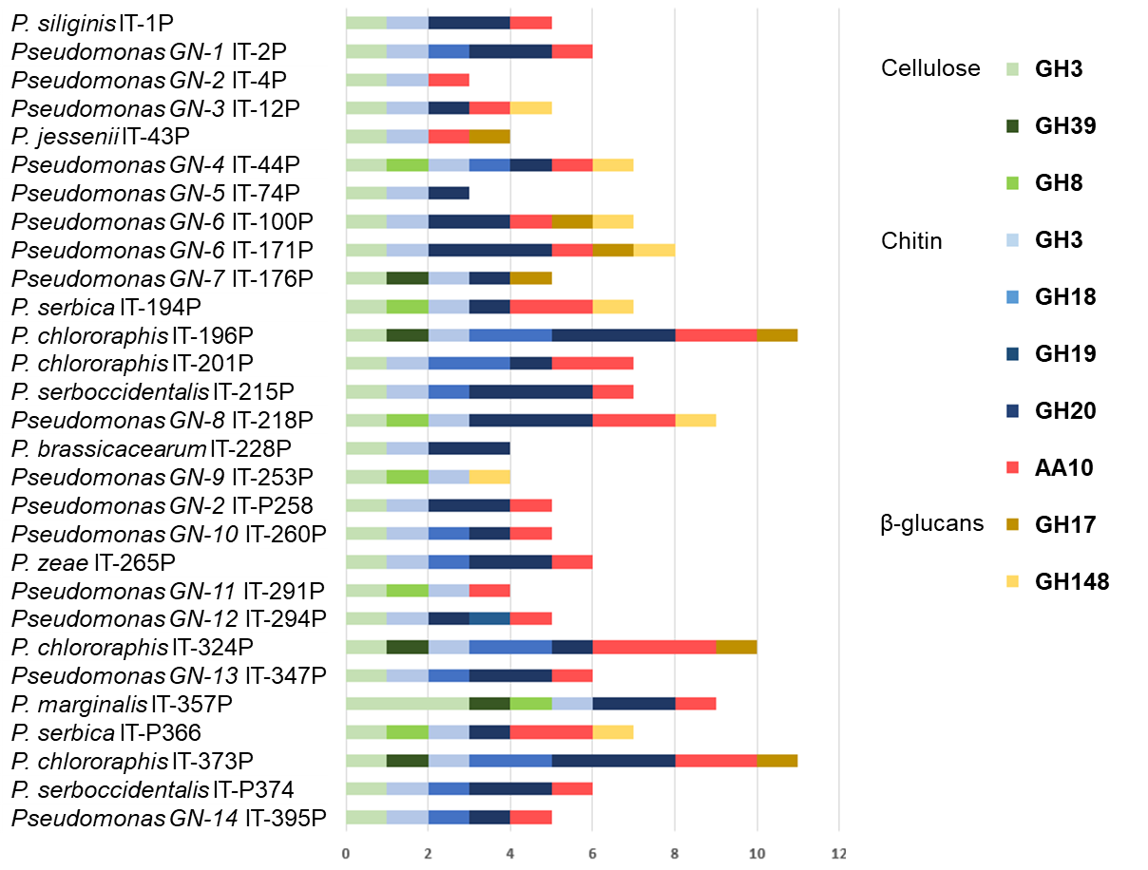
Figure S5. Abundance of Pseudomonas genes corresponding to CAZyme families potentially targeting cell wall components in fungi and oomycetes (cellulose, chitin and β-glucans).

