Supplementary Figures

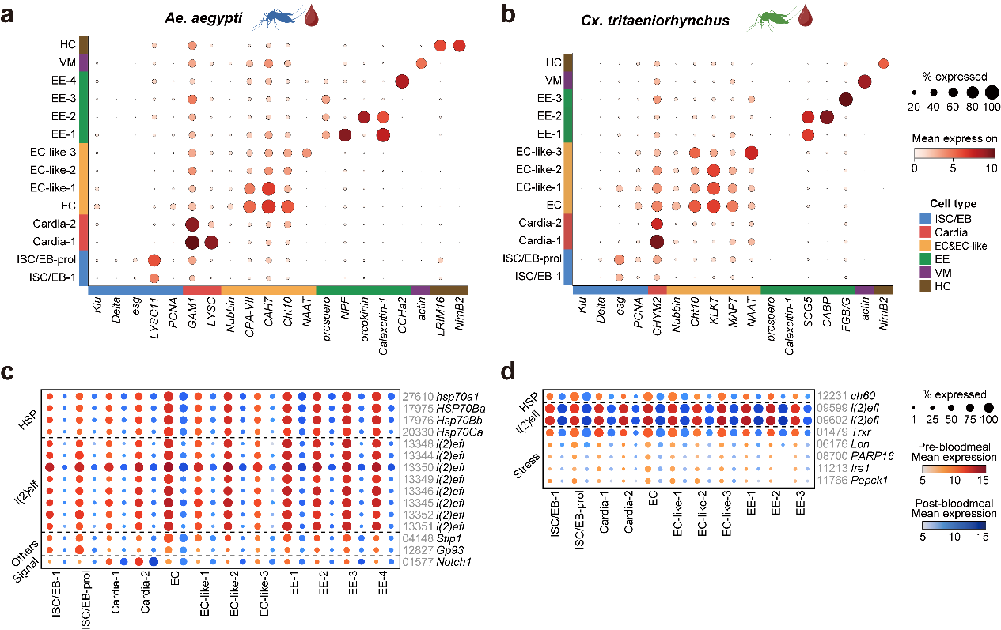
Supplementary Fig. 1 Marker and gene expression of midgut cell populations pre- and post-bloodmeal in Ae. aegypti and Cx. tritaeniorhynchus. a-b, Expression of marker genes in the integrated cell clusters of Ae. aegypti and Cx. tritaeniorhynchus pre- and post-bloodmeal. Dot size represents the percentages of cells expressing each gene and color shows the mean gene expression. The absence of dots means lacking of the corresponding gene in the species. c-d, DEGs in the major midgut cell clusters in Ae. aegypti (c) and Cx. tritaeniorhynchus (d), respectively. Dot size represents the percentages of cells expressing each gene and color shows the relative mean gene expression for pre- (red) and post-bloodmeal (blue).

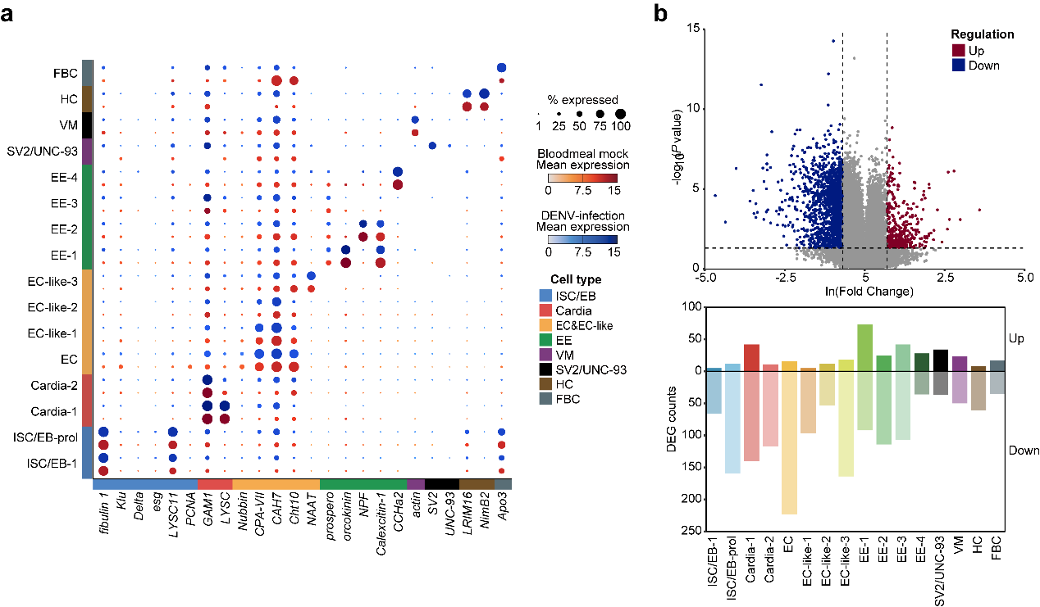
Supplementary Fig. 2 The expression of marker genes and DEG in DENV-2 infected Ae. aegypti. a, Expression of marker genes in each cell clusters in Ae. aegypti between the bloodmeal group versus DENV-infection. Dot size represents the percentages of cells expressing each gene and color shows the relative mean gene expression between the bloodmeal group (red) versus DENV-infection (blue). b, The DEG statistics in between the bloodmeal group versus DENV-infection. The volcano plot shows the DEGs with the thresholds (|ln(FC)| >= 1, p < 0.05) and the bar plot shows the number of DEGs in each cell cluster post-infection. Each dot in the volcano plot represents a gene and color shows the upregulation (red) or downregulation (blue) of the gene post-infection.

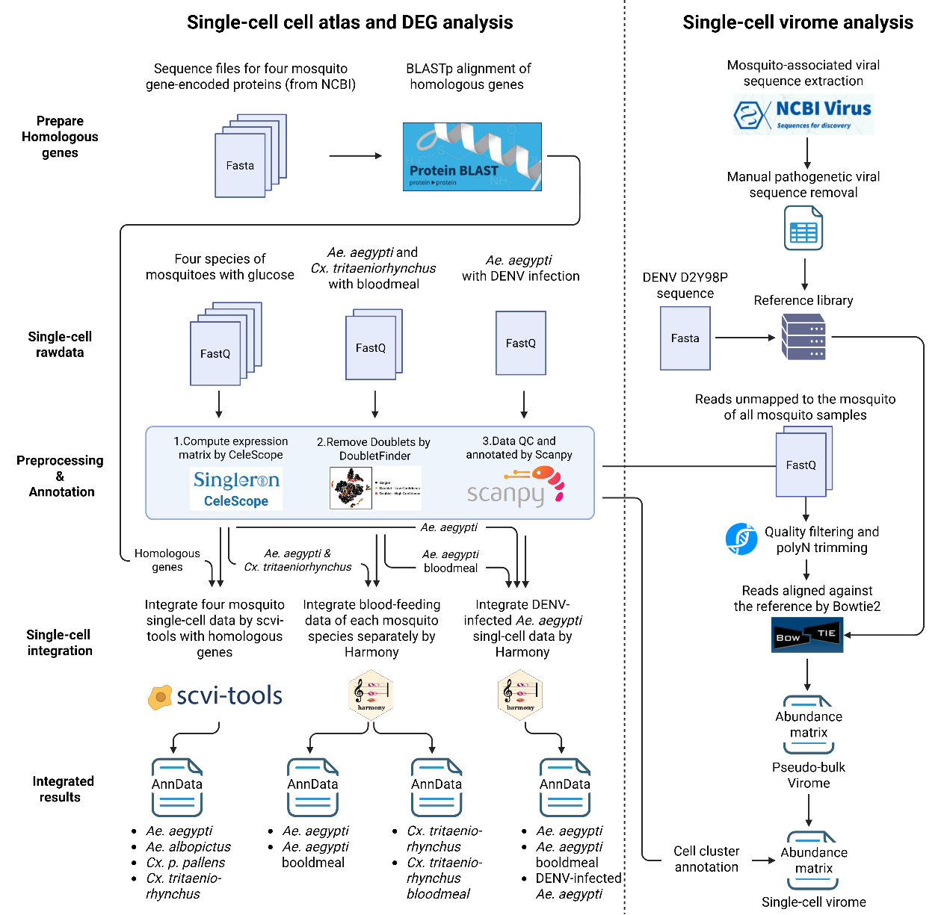

Supplementary Fig. 3 Workflow for data analysis in this study.

