Supplementary materials

Supplementary Tables
Supplementary Table 1. Brown Fat Differentiation Protocol
Induction media was administered for 2 days. Following induction, cells were treated with maintenance medium for 6 to 8 days with medium being replenished every 2 days. Components were added in complete medium that included DMEM/F12, 10%FBS, 1% L-Glutamine and 1% Penicillin-Streptomycin antibiotics.
Compound | Induction Medium | Maintenance Medium
Insulin | 1 µg/ml | 1 µg/ml
3,3′,5-Triiodo-L-thyronine sodium salt (T3) | 1 nM | 1 nM
IBMX | 0.5 mM
Dexamethasone | 250 nM
Indomethacin | 125 µM

Supplementary Table 2. White Fat Differentiation Protocol
Induction medium 1 was administered for 3 to4 days. Following induction medium 1, cells were treated with induction medium 2 for 2 to 3 days and then with maintenance medium for 2 to 3 days. Components were added in complete medium that included DMEM/F12, 10%FBS, 1% L-Glutamine and 1% Penicillin-Streptomycin antibiotics.
Compound | Induction Medium 1 | Induction Medium 2 | Maintenance Medium
Insulin | 5 mg/ml | 5 mg/ml | 5 mg/ml
IBMX | 0.5 mM
Dexamethasone | 250 nM
3,3′,5-Triiodo-L-thyronine sodium salt (T3) | 0.1 nM | 0.1 nM | 0.1 nM
Cortisol | 100 nM
Transferrin | 1 mg/ml | 1 mg/ml | 1 mg/ml
Rosiglitazone | 5 mM | 1 mM
Biotin | 16 mM | 16 mM | 16 mM
Panthothenic acid | 1.8 mM | 1.8 mM | 1.8 mM
Ascorbic acid | 100 mM | 100 mM

Supplementary Table 3. Primer sequences for human genes.
Gene name | Forward primer (5’ to 3’) | Reverse primer (5’ to 3’)
GATA6 | CACACCACAACTACCACCTTAT | TCCTGGTTTGAATTCCCTCTTT
FABP4 | AACTGGTGGTGGAATGCGT | AACTGGTGGTGGAATGCGT
LN19 | GCGGAAGGGTACAGCCAA | GCAGCCGGCGCAAAA
DLK1 | CACGGACTCTGTGGAGAACC | GCAGGCCCGAACATCTCTAT
UCP1 | GTGTGCCCAACTGTGCAATG | CCAGGATCCAAGTCGCAAGA

Supplementary Table 4. Primer sequences for mouse genes.
Gene name | Forward primer (5’ to 3’) | Reverse primer (5’ to 3’)
BMP2 | GAACACAAGTCAGTGGGAGAG | CACCTGGGTTCTCCTCTAAATG
CIDEA | CACGCATTTCATGATCTTGGA | GTTGCTTGCAGACTGGGACAT
DAB2 | GACGCTTTCACTGGCTTAGA | CCTTCCTTGAGGGAACAAGAG
DLK1 | CGGGAAATTCTGCGAAATAG | TGTGCAGGAGCATTCGTACT
FABP4 | ACACCAGATTTCCTTAAACTG | CCATCTAGGGTTATGATGCTCTTCA
GATA4 | GGAAGCCCAAGAACCTGAATA | CTAGTGGCATTGCTGGAGTTA
GATA6 | GCCTTGTCTGCTAAGGAAGAT | GGATGAATGGGTTCTGGGATAA
KLF4 | GTGCCCCGACTAACCGTTG | GTCGTTGAACTCCTCGGTCT
LN19 | GAGCACATCCACAAGCTGAA | TTTCGTGCTTCCTTGGTCTT
NANOG | GCCTCCAGCAGATGCAAG | GGTTTTGAAACCAGGTCTTAACC
OCT4 | CGTGGAGACTTTGCAGCCTG | GCTTGGCAAACTGTTCTAGCTCCT
SOX7 | TCACCTCCCCCATCTACCAG | GGCCAAGGGCTAAAGAACCT
TUB | ACAATGGCGTCAACCCTCAG | CTGGGACGATCACACTCATCTTC
UCP1 | TACCCAAGCGTACCAAGCTG | ACCCGAGTCGCAGAAAAGAA

Supplementary Table 5. Primer sequences for Luciferase and mutagenesis assays.
Gene name | Forward primer (5’ to 3’) | Reverse primer (5’ to 3’)
Gata6 3’UTR | GCTGGTGCTACCAAGAGGC | GGTTGGTCACGTGGTACAGG
Tub 3’UTR | GTTTCTAGAGGGCAGTAGGAC | GCCTGTCCTCACCAAGCTG
Gata6 3’UTR mutagenesis | AGAAAAATATCTTGTTTGCTACCAGATTTACAAATTCCAAGTGACCTCAGATCAGCC | GGCTGATCTGAGGTCACTTGGAATTTGTAAATCTGGTAGCAAACAAGATATTTTTCT
Tub 3’UTR mutagenesis | TAGAGATGACTGCTTAGCTAGGAAGCTCTGCTCTG | CAGAGCAGAGCTTCCTAGCTAAGCAGTCATCTCTA

Supplementary Table 6. CRISPR/Cas9 sgRNA sequences without the NGG end and primers used for HRMA.
Sequence name | Forward sequence (5’ to 3’) | Reverse sequence (5’ to 3’)
miR-10b-5p sgRNA | CCTGTAGAACCGAATTTGTG | CACAAATTCGGTTCTACAGG
Non-Targeted Control sgRNA | GGGTCTTCGAGAAGACCT | AGGTCTTCTCGAAGACCC
HRMA primers | CCGAGGTTGTAACGTTGTC | CCATGTCGGAGATATATGAAG

Supplementary Table 7. Oligonucleotide sequences of miRNA inhibitors and mimics.
name | Catalogue number | Inhibitor sequence
mmu-miR-10b-5p  miRCURY LNA miRNA Inhibitor | YI04100556-DDA | ACAAATTCGGTTCTACAGGGT
miRCURY LNA miRNA Inhibitor Control | YI00199006 | TAACACGTCTATACGCCCA
name | Catalogue number | Mature miRNA sequence​
hsa-miR-10b-5p  miRCURY LNA miRNA Mimic | YM00472145 | UACCCUGUAGAACCGAAUUUGUG
Negative Control  miRCURY LNA miRNA Mimic | YM00479902 | UCACCGGGUGUAAAUCAGCUUG

Supplementary Table 8. On/off target sites of sgRNA miR-10b generated by CCTop - CRISPR/Cas9 target online predictor. (web tool accessed at 17:32pm, 07/12/23)
Coordinates | MM | target_seq | PAM | position | gene name | gene id
chr2:74726077-74726099 | 0 | CCTGTAGA[ACCGAATTTGTG] | TGG | Exonic | Mir10b | ENSMUSG00000065500
chr2:105460157-105460179 | 4 | TATGTGGA[AACGAATTTGTG] | AGG | Intergenic | 4930527A07Rik | ENSMUSG00000086764
chr15:59583720-59583742 | 4 | ATTGGAGA[ACTGAATTTGTG] | TGG | Intronic | Nsmce2 | ENSMUSG00000059586
chr5:109894569-109894591 | 4 | TCTTTAAA[ACGGAATTTGTG] | GGG | Intergenic | Gm26779 | ENSMUSG00000097140
chr9:41431921-41431943 | 4 | GCTGAACA[ACTGAATTTGTG] | GGG | Exonic | 2610203C20Rik | ENSMUSG00000074415
chr1:58718061-58718083 | 4 | GCTGCAGT[ACTGAATTTGTG] | GGG | Intronic | Cflar | ENSMUSG00000026031
chr8:106690664-106690686 | 4 | TCTGGAGC[ACAGAATTTGTG] | TGG | Intronic | Tango6 | ENSMUSG00000041949
chr4:40339598-40339620 | 4 | TCTATAGA[GCTGAATTTGTG] | AGG | Intergenic | 4930509K18Rik | ENSMUSG00000087137
chr15:72912507-72912529 | 4 | AGTGTAGA[AGCTAATTTGTG] | AGG | Intronic | Gm3150 | ENSMUSG00000096173
chr16:84708197-84708219 | 3 | CTTGTAGA[ACTTAATTTGTG] | TGG | Intronic | Mir155hg | ENSMUSG00000097418
chr18:40483559-40483581 | 4 | ACTGTAGT[CCTGAATTTGTG] | GGG | Intronic | Kctd16 | ENSMUSG00000051401
chr5:16220572-16220594 | 4 | CCTTCAGA[AATGAATTTGTG] | TGG | Intronic | Cacna2d1 | ENSMUSG00000040118
chr18:29833061-29833083 | 4 | TCTTTAGA[AACCAATTTGTG] | CGG | Intergenic | NA | NA
chr19:42216214-42216236 | 4 | CCTTTAGT[ATCTAATTTGTG] | TGG | Intergenic | Sfrp5 | ENSMUSG00000018822
chr17:3969757-3969779 | 4 | CATTTACA[ACCGAAATTGTG] | AGG | Intergenic | NA | NA
chr6:36427248-36427270 | 4 | ACAGTAGA[ACAGATTTTGTG] | TGG | Intronic | Mir490 | ENSMUSG00000070075
chr5:124266586-124266608 | 4 | CTTTTAGA[ACCTAGTTTGTG] | TGG | Intronic | Mphosph9 | ENSMUSG00000038126
chr11:107860036-107860058 | 4 | TCTGCAGA[AGCGAATGTGTG] | TGG | Intergenic | Gm27595 | ENSMUSG00000098991
chr12:112107864-112107886 | 3 | CCTGTTGA[ACCTAATTGGTG] | TGG | Intronic | Aspg | ENSMUSG00000037686
chr15:3327419-3327441 | 4 | CCTGAACA[ACAGAATTTCTG] | GGG | Intronic | Ghr | ENSMUSG00000055737

Supplementary Table 9. Study design of the transcriptomic analysis performed on mESCs differentiation to mature adipocytes.
Day 0 |  | Day 12 |  | Day 27
Clone | Number of samples | Clone | Number of samples | Clone | Number of samples
NCT Clone 1 | 3 | NCT Clone 1 | 1 | NCT Clone 1 | 3
NCT Clone 2 | 1 | NCT Clone 2 | 2 | NCT Clone 2
NCT Clone 3 | 1 | NCT Clone 3 | 2 | NCT Clone 3 | 1
1F10 | 3 | 1F10 | 3 | 1F10 | 2
3G6 | 1 | 3G6 | 1 | 3G6
3F2 | 1 | 3F2 |  | 3F2 | 1

Supplementary figures

Figure S1. Assessment of mESC dynamics with/without miR-10b: proliferation, senescence, and alkaline phosphatase activity analysed. A) Cell proliferation assay. Data are representative of three independent experiments and values are expressed in mean ± SEM. B) Alkaline Phosphatase (AP) activity was used to assess the self-renewal capacity of mESCs. Scale bars: 100 μm. C) Cell senescence was analysed in cells with or without depleted miR-10b. miR-10b+/+ and miR-10b-/- stem cells were differentiated to mature adipocytes. At day 27, cells were stained for β-galactosidase and observed at ×20 magnification. For positive control, miR-10b-/- were treated with 500 µM H2O2 for 1 hour. Scale bar represents 100 µM. β-galactosidase-positive cells appear light blue.

Figure S2. Transcriptomic analysis was conducted on mESCs differentiating to mature adipocytes at day 0, 12, and 27. A) PCA plot for stem cells time course. B) Volcano plot illustrating the expression profile of genes in mESCs treated with gRNA targeting miR-10b or NTC vector at Day 0 (log2(FC) > 1 and p adjusted value > 0.05).

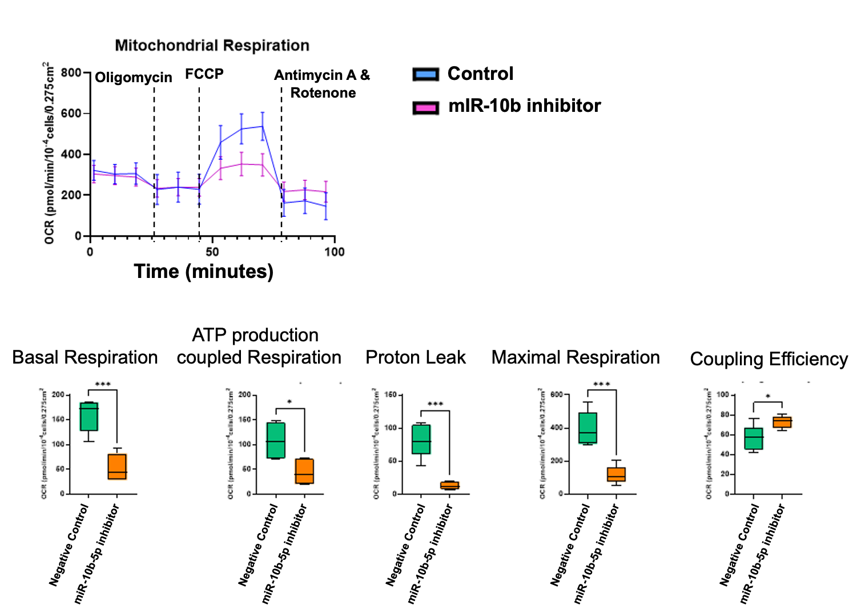
Figure S3. Functional effects of miR-10b Inhibition on Bioenergetics. Brown preadipocytes were differentiated to mature BA for 7 days and then transfected with miR-10b-5p inhibitor or negative control inhibitor. Extracellular acidification rate (ECAR) and oxygen consumption rate (OCR) were assessed 48 hours post-transfection (n ≥ 5). The blue line represents the negative control, while the pink line corresponds to the miR-10b-5p inhibitor. Box and whisker plots illustrate changes in mitochondrial respiration components in differentiated BA, including ATP production-coupled respiration, proton leak, and maximal respiratory capacity.

Figure S4. PCA plot for BAT time course.

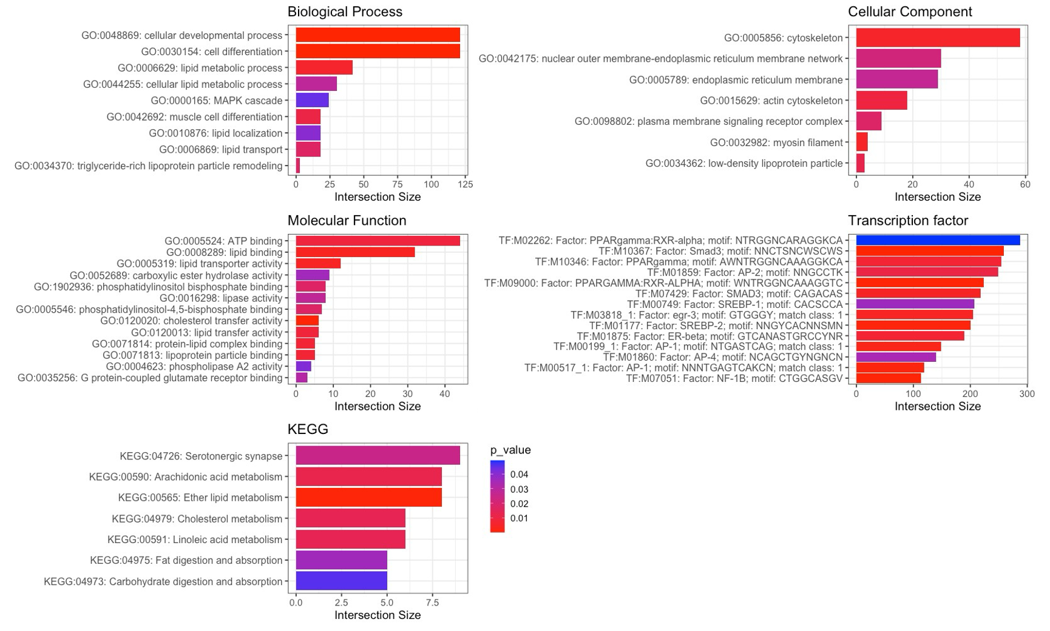
Figure S5. Gene ontology (GO) enrichment analysis of related differentially expressed genes (DEGs) in purple module.

Figure S6. Dot plot of top 12 enriched pathways in DEGs from miR-10b-inhibited brown adipocytes, Day 0. The count represents the number of inputted DEGs as a percentage of the total number of genes. The Benjamini p value for each molecular mechanism is shown.

Figure S7. Dot plot showing top 12 enriched pathways in DEGs from miR-10b-inhibited brown adipocytes, Day 5. Each dot represents the percentage of DEGs within the total number of genes. Additionally, the Benjamini-adjusted p-value for each molecular mechanism is presented.

Figure S8. Dot plot showing top 12 enriched pathways in DEGs from miR-10b-inhibited brown adipocytes, Day 8. The dots represent the percentage of DEGs within each pathway relative to the total number of genes in that category. Additionally, the Benjamini p-value for each pathway is displayed to indicate its statistical significance.

Figure S9. Bright-Field Imaging of Lipid Droplet Formation on Day 6 of Adipocyte Differentiation. Representative 4× magnification images show lipid droplet accumulation as an indicator of differentiation on Day 6. Scale bar: 500 µm (black).
Figure S10. The effects of elevated miR-10b-5p levels on white adipogenesis. A) White preadipocytes were treated with either negative control or miR-10b-5p mimic for 48 hours and differentiated for 8 days, followed by staining of their lipids using a GFP lipid stain and their nucleus with DAPI. Scale bar: 50 B) Lipid droplet quantification.
Figure S11. Tubby immunostaining during WAT differentiation. Scale bar: 50 µm.

Figure S12. Gata6 expression during human and mouse brown adipocyte differentiation and across various adipose tissue depots. A) Gata6 expression during human ESC differentiation to BA. Data (n ≥ 3) are shown as means + SEM (two-way ANOVA test, *p< 0.05, **p < 0.005, ***p < 0.0005, ****p < 0.0001). B) Gata6 expression during mouse BA differentiation. Data (n ≥ 3) are shown as means + SEM (two-way ANOVA test, ****p < 0.0001). C) Tub expression across different adipose tissue depots. D) TPM levels of Gata6 expression during mouse BA differentiation, as measured by RNA sequencing. Data (n ≥ 3) are shown as means + SEM (Kruskal-Wallis test, ns: not significant).

