A PROBIOTIC CONTAINING L. PLANTARUM AND P. ACIDILACTICI STRAINS FOR TREATING UPPER RESPIRATORY INFECTION IN CHILDREN AGED 6 MONTHS TO 5 YEARS: A RANDOMIZED, DOUBLE-BLIND TRIAL

Andrade-Platas D¹, Martinez-Figueroa MG¹, Rodriguez-Palmero M², Espadaler-Mazo J²

¹ Service of Paediatrics, Hospital Medica Sur, Mexico City (Mexico).
² R&D department, AB-Biotics SA (Kaneka Group), Barcelona (Spain).

SUPPLEMENTARY MATERIAL

Supplementary Figure 1. Study outline.
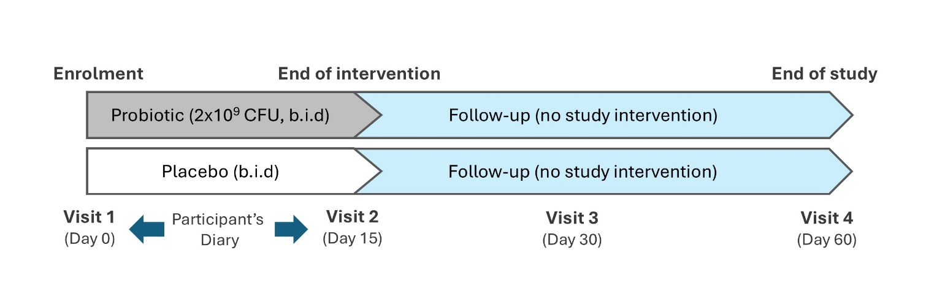

Supplementary Figure 2. Viruses detected in nasopharyngeal swabs of study participants using multiplex PCR, with number of participants positive for each virus and overall prevalence in the study population.

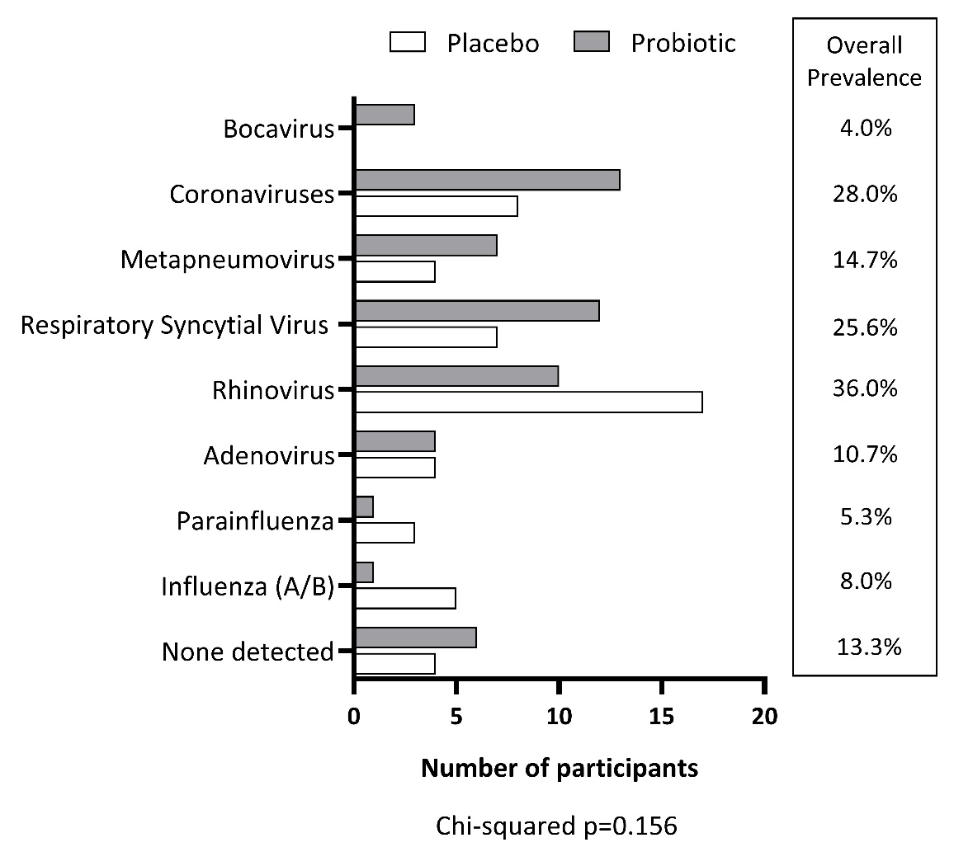
Supplementary Table 1. Sensitivity analyses of the primary outcomes by means of adjusted Generalized Linear Models (GLMs): days if fever (left) and days of pain/discomfort (right). Treatment and baseline factors remain significant (at p<0.01) in all models. Adjustment factors with significant effects are marked in bold.
a) An additional GLM model with a Coronavirus-by-treatment interaction was negative for the interaction (p=0.581).
b) An additional GLM model with a RSV-by-treatment interaction was negative for the interaction (p=0.324).
Days of Fever (Temperature >37.5ºC) |  |  |  |  | Days of Pain/Discomfort (FLACC >3)
 | Type III |  |  |  |  | Type III
 | Wald Chi² | df | P-value |  |  | Wald Chi² | df | P-value
GLM adjusted for detection of Rhinovirus (y/n) |  |  |  |  | GLM adjusted for detection of Rhinovirus (y/n)
(Intercept) | 46.878 | 1 | <0.001 |  | (Intercept) | .083 | 1 | 0.773
Treatment | 11.153 | 1 | 0.001 |  | Treatment | 7.236 | 1 | 0.007
Temp. (ºC) V1 | 50.652 | 1 | <0.001 |  | FLACC V1 | 49.499 | 1 | <0.001
Rhinovirus | .016 | 1 | 0.901 |  | Rhinovirus | .001 | 1 | 0.972
GLM adjusted for detection of Coronaviruses (y/n) |  |  |  |  | GLM adjusted for detection of Coronaviruses (y/n)
(Intercept) | 50.730 | 1 | <0.001 |  | (Intercept) | .140 | 1 | 0.709
Treatment | 14.354 | 1 | <0.001 |  | Treatment | 8.400 | 1 | 0.004
Temp. (ºC) V1 | 54.971 | 1 | <0.001 |  | FLACC V1 | 51.297 | 1 | <0.001
Coronaviruses | 4.192 | 1 | 0.041ª |  | Coronaviruses | 1.393 | 1 | 0.238
GLM adjusted for detection of RSV (y/n) |  |  |  |  | GLM adjusted for detection of RSV (y/n)
(Intercept) | 47.511 | 1 | <0.001 |  | (Intercept) | .123 | 1 | 0.726
Treatment | 11.708 | 1 | 0.001 |  | Treatment | 10.667 | 1 | 0.001
Temp. (ºC) V1 | 51.288 | 1 | <0.001 |  | FLACC V1 | 59.420 | 1 | <0.001
RSV | .080 | 1 | 0.778 |  | RSV | 8.220 | 1 | 0.004^{b}
GLM adjusted for age (up to 12 months vs older) |  |  |  |  | GLM adjusted for age (up to 12 months vs older)
(Intercept) | 39.174 | 1 | <0.001 |  | (Intercept) | .535 | 1 | 0.464
Treatment | 11.680 | 1 | 0.001 |  | Treatment | 7.511 | 1 | 0.006
Temp. (ºC) V1 | 42.443 | 1 | <0.001 |  | FLACC V1 | 43.623 | 1 | <0.001
Age | .000 | 1 | 0.991 |  | Age | 2.492 | 1 | 0.114
GLM adjusted for Sex (male/female) |  |  |  |  | GLM adjusted for Sex (male/female)
(Intercept) | 48.222 | 1 | <0.001 |  | (Intercept) | .304 | 1 | 0.582
Treatment | 10.910 | 1 | 0.001 |  | Treatment | 8.309 | 1 | 0.004
Temp. (ºC) V1 | 51.961 | 1 | <0.001 |  | FLACC V1 | 44.280 | 1 | <0.001
Sex | .621 | 1 | 0.431 |  | Sex | 1.229 | 1 | 0.268
GLM adjusted for number of URIs in past 2 months |  |  |  |  | GLM adjusted for number of URIs in past 2 months
(Intercept) | 44.720 | 1 | <0.001 |  | (Intercept) | .095 | 1 | 0.758
Treatment | 11.010 | 1 | 0.001 |  | Treatment | 6.958 | 1 | 0.008
Temp. (ºC) V1 | 47.372 | 1 | <0.001 |  | FLACC V1 | 46.376 | 1 | <0.001
URI 2 months | .023 | 1 | 0.879 |  | URI 2 months | .012 | 1 | 0.915

Supplementary Table 2. Non-parametric bivariate correlations (Spearman rho).

 |  | Days with  fever | Days with pain  /discomfort | Days with cough | Days with rhinorrhoea | Days with congestion | Days with antipyretic | Days with antihistamine
Days with  fever | Rho |  | 0.78 | -0.14 | -0.05 | -0.17 | 0.56 | 0.01
Days with  fever | P-value |  | <0.001 | 0.221 | 0.641 | 0.144 | <0.001 | 0.909
Days with pain  /discomfort | Rho |  |  | -0.12 | -0.12 | -0.13 | 0.72 | -0.05
Days with pain  /discomfort | P-value |  |  | 0.293 | 0.320 | 0.267 | <0.001 | 0.652
Days with  cough | Rho |  |  |  | 0.19 | 0.11 | -0.14 | 0.12
Days with  cough | P-value |  |  |  | 0.109 | 0.357 | 0.244 | 0.296
Days with  rhinorrhoea | Rho |  |  |  |  | 0.26 | -0.18 | 0.85
Days with  rhinorrhoea | P-value |  |  |  |  | 0.026 | 0.129 | <0.001
Days with  congestion | Rho |  |  |  |  |  | -0.10 | 0.18
Days with  congestion | P-value |  |  |  |  |  | 0.382 | 0.132
Days with  antipyretic | Rho |  |  |  |  |  |  | -0.10
Days with  antipyretic | P-value |  |  |  |  |  |  | 0.414
Days with  antihistamine | Rho
Days with  antihistamine | P-value

Supplementary Table 3. Adverse events (AEs) reported during the study. Digestive AEs reported herein were specifically solicited in the patient diary during the 15-day intervention phase. Other AEs could be reported during study visits 2, 3 and 4, or by phone to the study investigators.

 | Placebo (n=38) | Probiotic (n=37)
Solicited digestive AEs:
- Diarrhoea | 5 | 7
- Constipation | 6 | 2
- Abdominal discomfort or pain | 10 | 7
- Abdominal distension | 7 | 6
Other AEs | 0 | 0
Severe AEs (SAEs) | 0 | 0

