Supplementary Information for

Iron oxyhydroxide as water carrier to the deep mantle
Camarda Carolina^{1,2,3}, Gervasoni Fernanda*^{4,5,2}, Jalowitzki Tiago¹, da Silva M.C. Francisco², Neto P. Antonio², Ferraz Paola², Oliveira F.G. A. João², Miqueles X. Eduardo², Archilha L. Nathaly², Torquato Igor², Almeida M. James⁶, Cedeño G. Daniel^{5,7}, da Silva W. Sebastião⁸, Fuck A. Reinhardt¹, Tolentino C.N. Hélio*².
¹ University of Brasilia, Institute of Geosciences, Graduate Program in Geology; (PPGG/UnB) Brasília, 70910-900, Brazil.
² Brazilian Synchrotron Light Laboratory, Brazilian Center for Research in Energy and Materials (LNLS/CNPEM); Campinas, 13083-100, Brazil.
³ European X-ray free electron laser facility, 22859, Schenefeld, Germany
⁴ Engineers Centre, Federal University of Pelotas (CEng/UFPel); Pelotas, 96010-020, Brazil
⁵ Graduate Program in Geosciences (PPGGEO), Federal University of Rio Grande do Sul (UFRGS); Porto Alegre, 90040-060, Brazil.
⁶ Ilum School of Science, Brazilian Center for Research in Energy and Materials (CNPEM), Campinas, São Paulo, 13087-548, Brazil.
⁷ Tectos Analytical Laboratory and Research Center in Geosciences, Dois Irmãos, 93950-000, Brazil
⁸ Institute of Physics, University of Brasília (IF/UnB), Brasília, 70910-900, Brazil.
*Corresponding author. Email: fernanda.gervasoni@lnls.br; helio.tolentino@lnls.br

The PDF file includes:
Figs. S1 to S14
Tables S1 and S2
References 1-15
Other Supplementary Materials for this manuscript include the following:

Movies S1 to S3

Evidences for the lower mantle origin of the J1 diamond

S1.

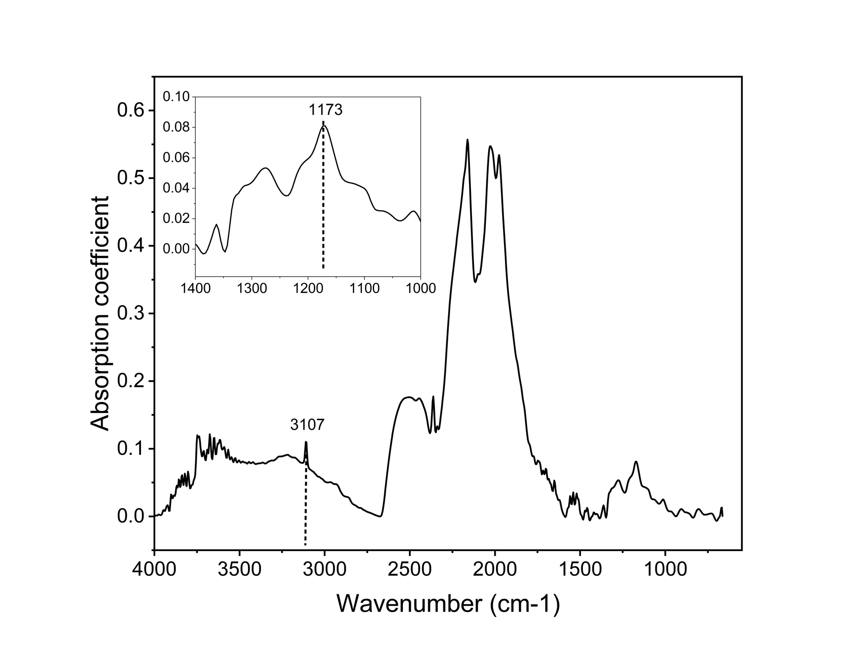

Figure S1. Infrared spectroscopy reveals that the J1 diamond is Type IaB, characterized mostly by nitrogen aggregation into B-centres (peak at 1173 cm⁻¹). Hydrogen related peak at 3107cm⁻¹ could indicate milky type IaB (Ref. ¹ and references therein).

S2.

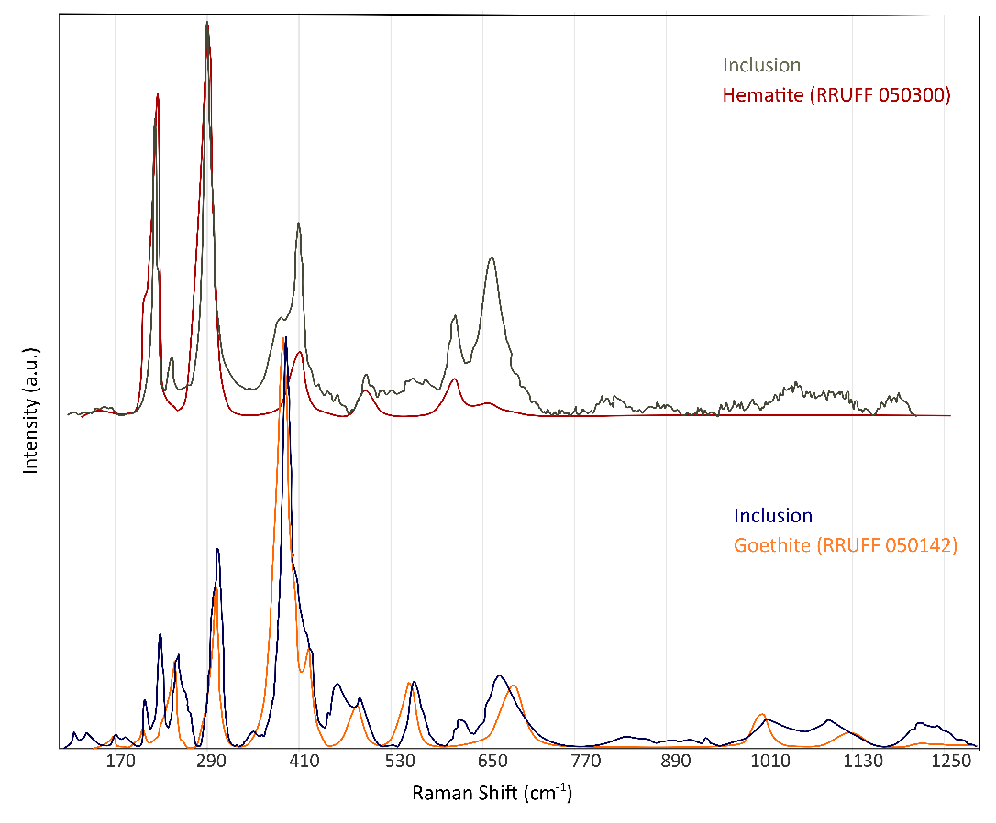

Figure S2. The Raman spectra of the studied inclusion reveal the presence of both goethite and hematite phases at different points within the inclusion. The orange and red reference spectra, corresponding to goethite (R050142) and hematite (R050300), respectively, are from the RRUFF database. The measured spectra are slightly shifted toward higher wavenumbers relative to the RRUFF references. This shift suggests the presence of some residual pressure of the inclusion inside the diamond (Refs. ^{2,3}).

S3.

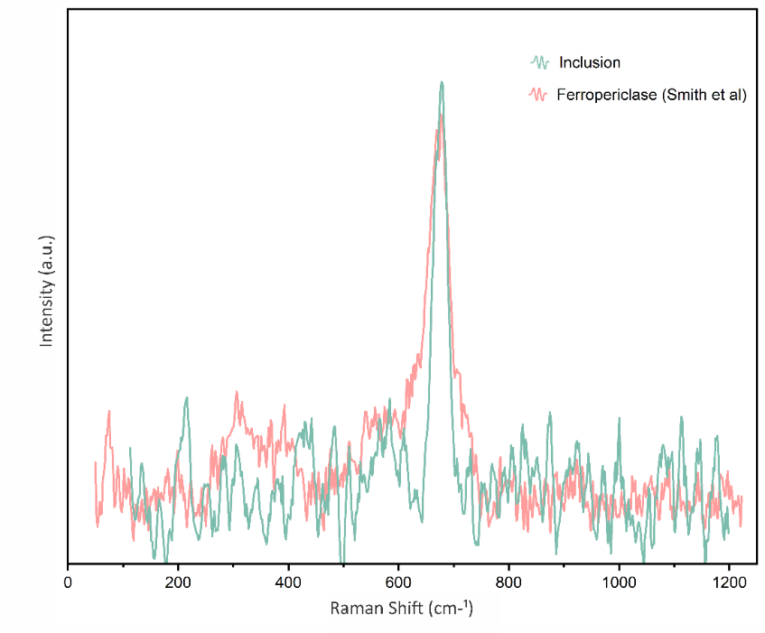

Figure S3. Raman spectrum of the ferropericlase inclusion identified in the J1 diamond sample, compared with reference spectra (Ref.⁴, unpublished sample included in the Supplementary Materials).

S4.
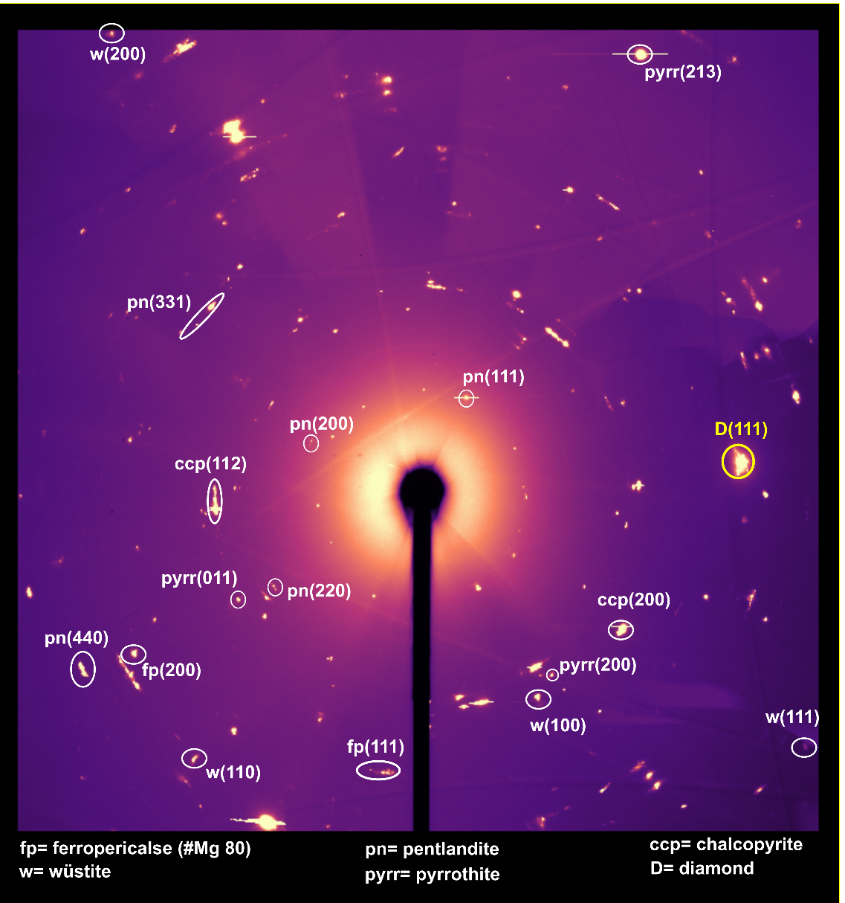

Figure S4. X-ray diffraction pattern measured at the EMA beamline of the ferropericlase + wüstite inclusion found in the J1 diamond sample, associated with sulphide phases.

Additional data concerning the micro mineral inclusion selected in this study

S5.

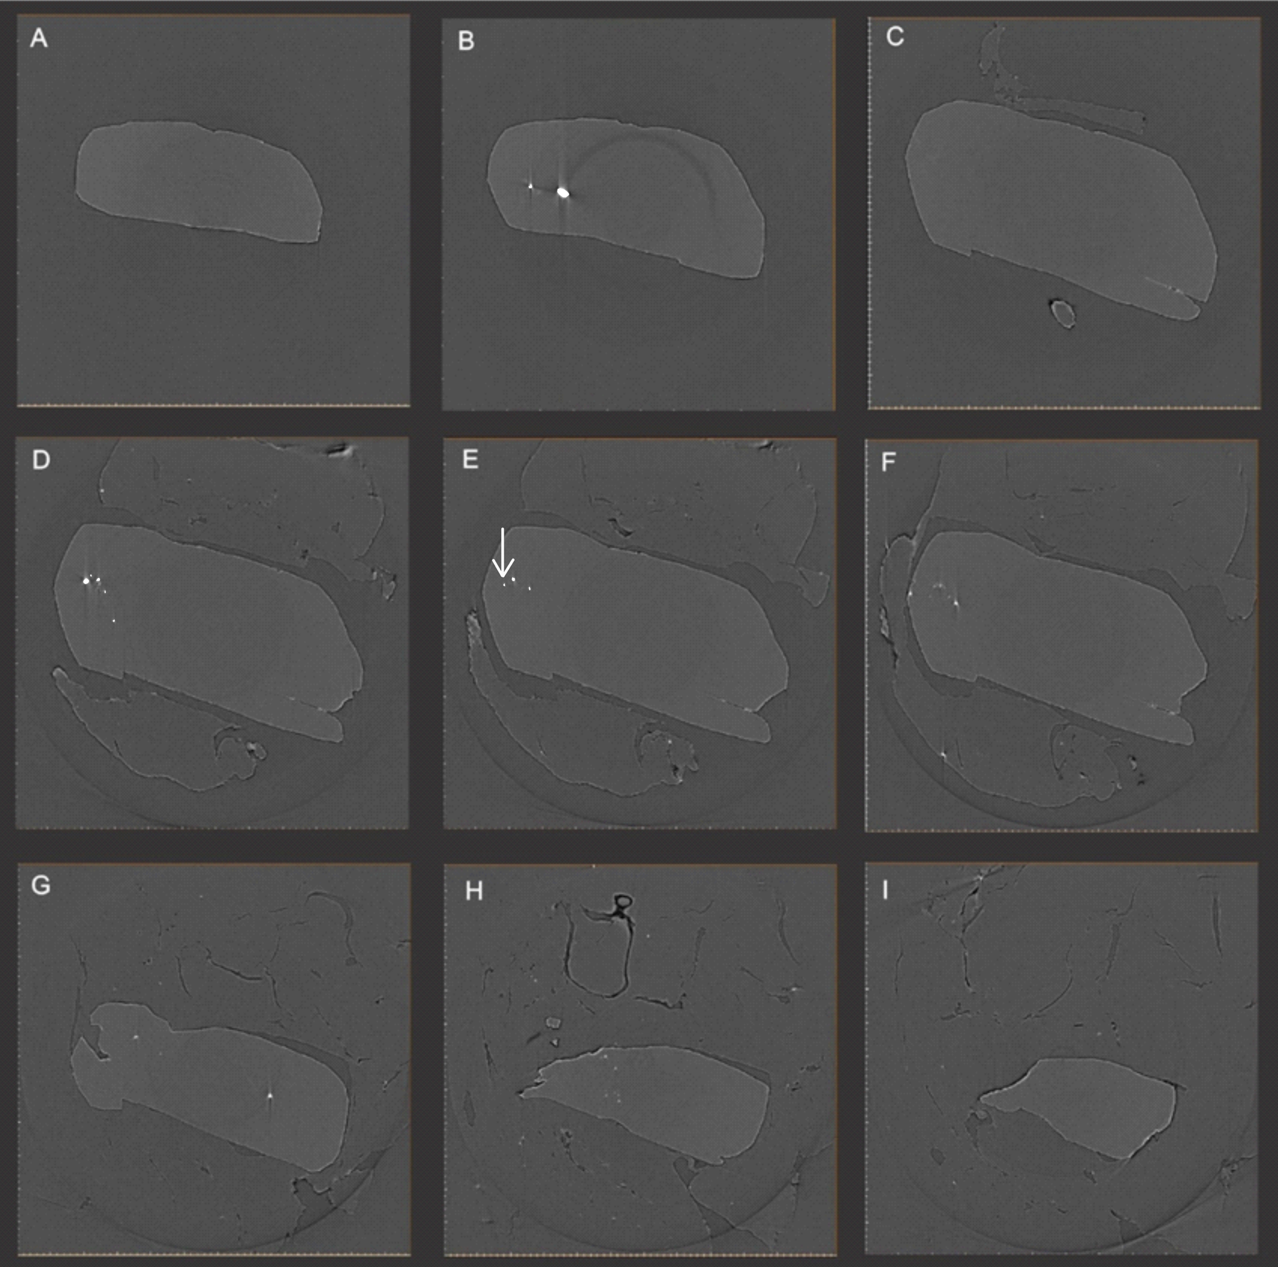
Figure S5. μ-Computed tomography(μ-CT) performed at the MOGNO beamline, showing segmented slices in the inclusion region (D, E, F). The arrow in image E indicates the selected inclusion of Fe oxyhydroxide. The slices show that there is no fracture and the mineral inclusion is completed embedded in the diamond. The only fracture in the diamond is visible in the lower right corner of images C to F.

S6.

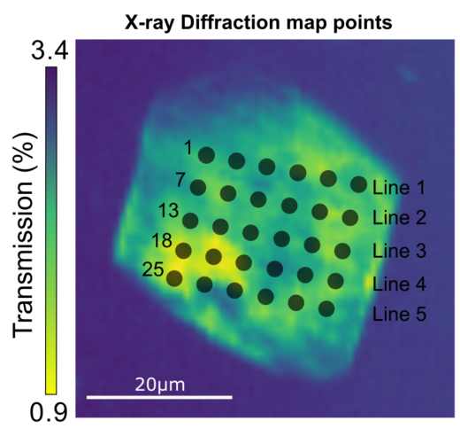

Figure S6. Reference for X-ray diffraction mapped points using the 5 μm-beam at the EMA microdiffraction setup. A 5×6 matrix of points was collected. For unknown reasons (probably data loss during transfer), no data was recorded at point 13.

S7.
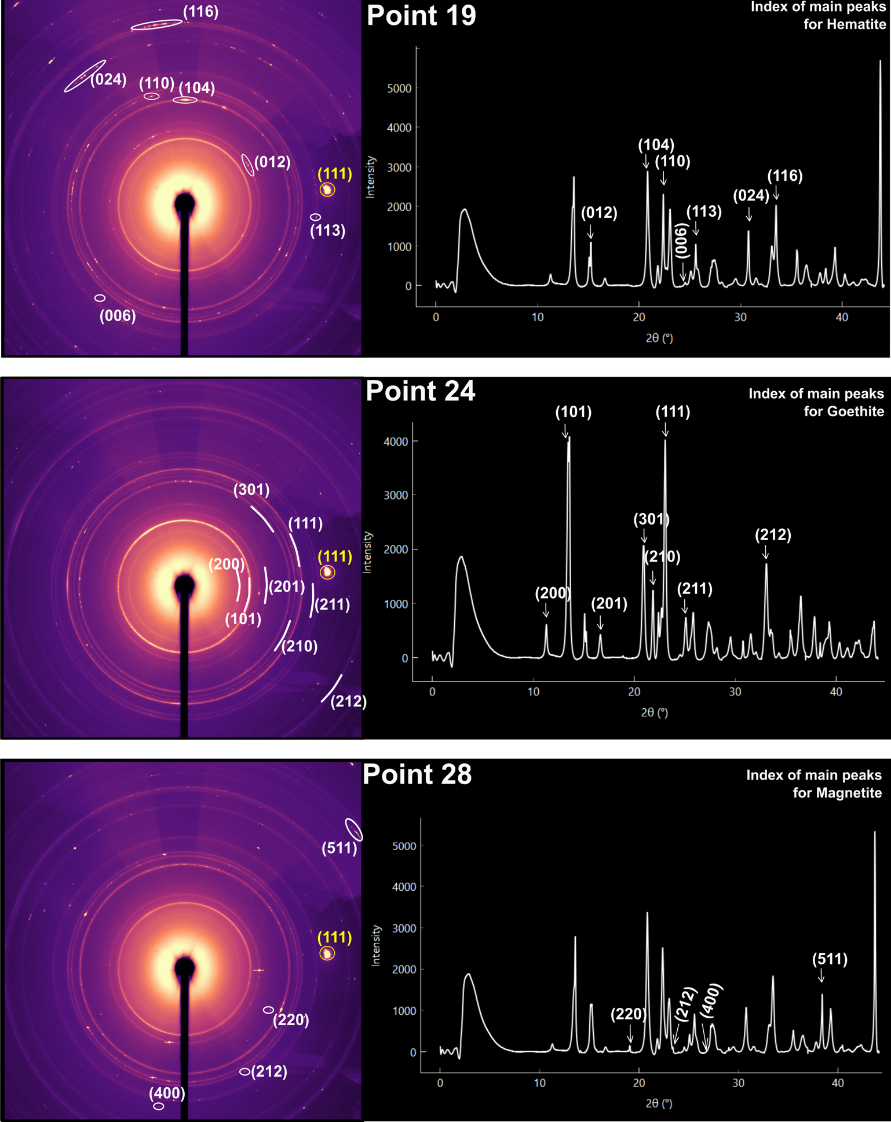

Figure S7. The diffractograms show regions within the inclusion containing distinct proportions of goethite, hematite, and magnetite. Identification of these phases is facilitated by analyzing diffraction patterns collected at different positions. Point 19 (see Fig. S6), located in the denser region of the inclusion, displays light powder rings and bright spots in its diffraction pattern, indicative of a higher concentration of Fe₂O₃ (hematite) with larger crystallite sizes. In contrast, point 24 (see Fig. S6), situated in a less dense area, shows more intense FeOOH (goethite) peaks with a characteristic powder-like pattern and well-defined concentric rings. The contribution from Fe₃O₄ (magnetite) is most pronounced at point 28 (see Fig. S6), which corresponds to a localized region near the central-bottom part of the inclusion. In yellow (111) main peak from diamond. Only the miller indexes of hematite, goethite, and magnetite are indicated in figures A, B, and C, respectively.

S8.

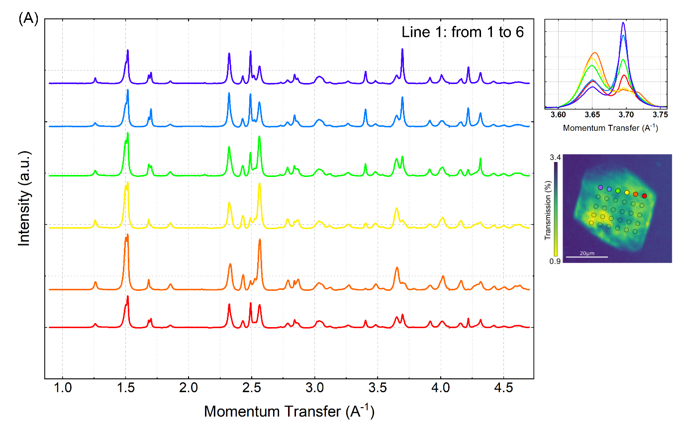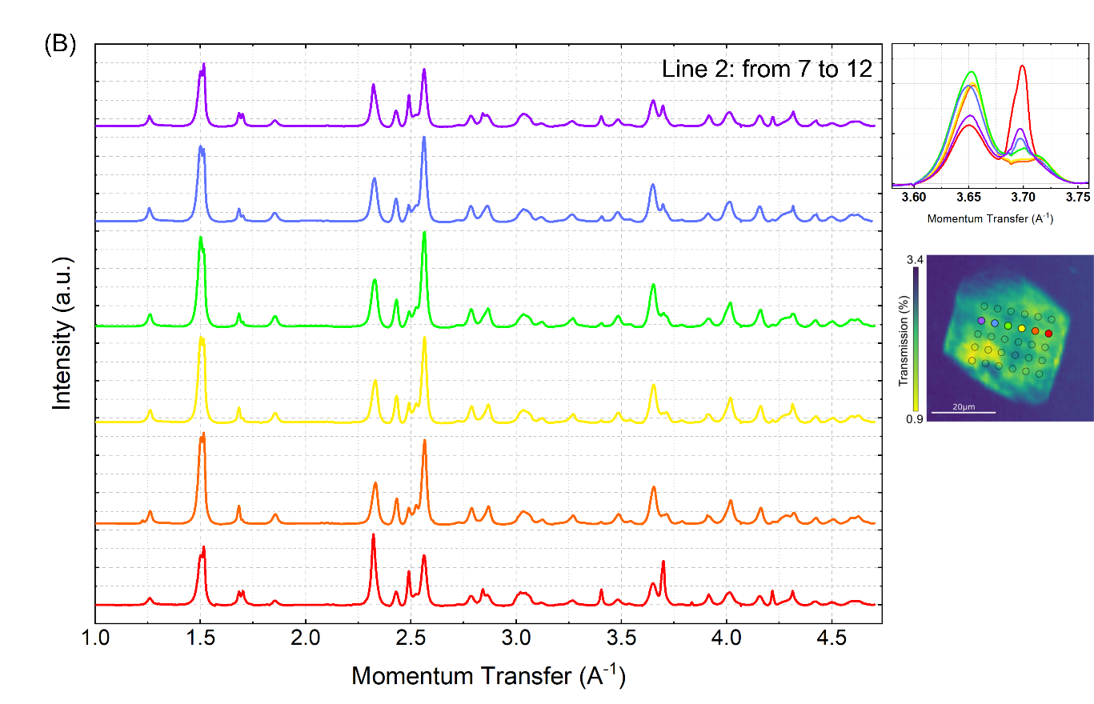

S8.
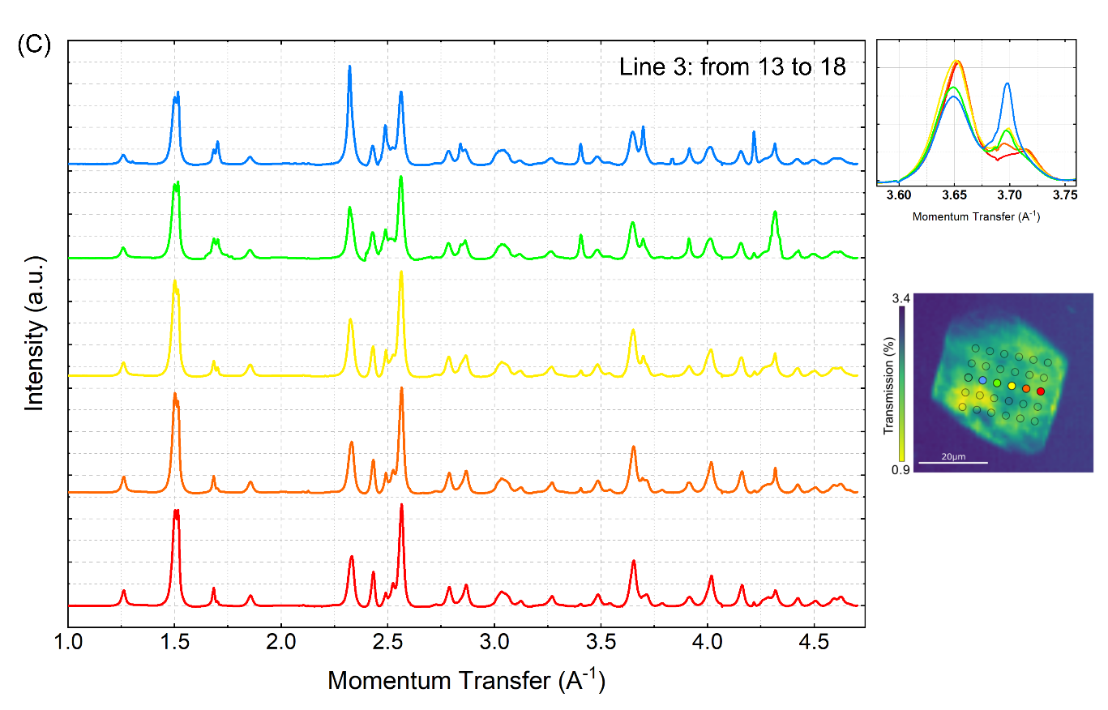
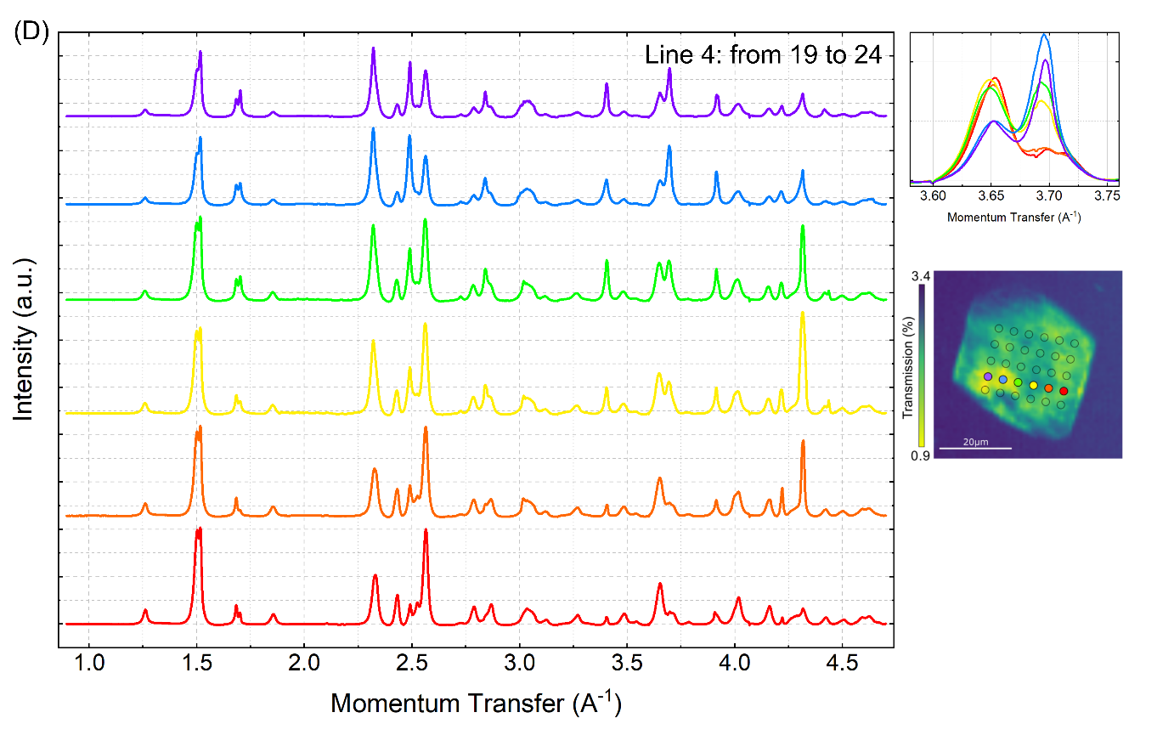

S8.
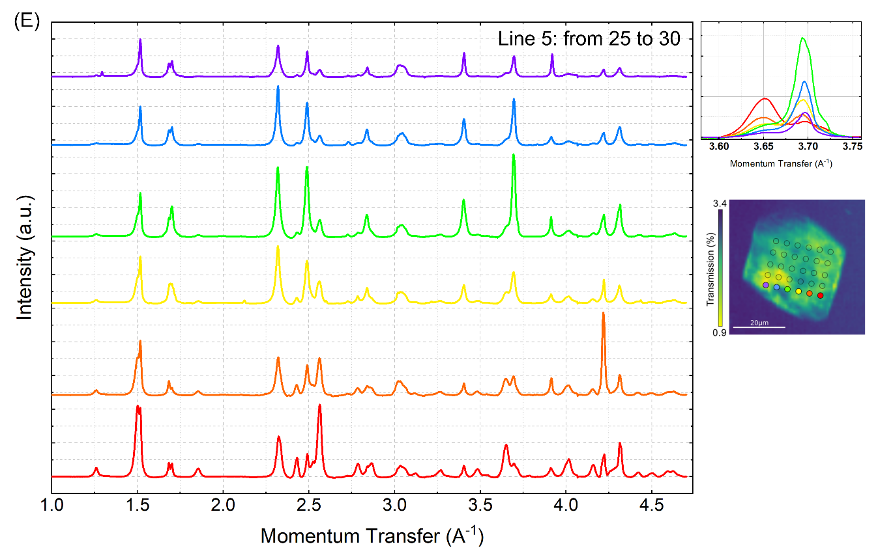
Figure S8. Figures (A) to (E) show all the diffractogram points arranged in a 6×5 matrix, displayed line by line as indicated in each image. Note that in line 3 (Figure C), one point is missing; this data point was not recorded for unknown reasons. These figures highlight the fact that at each point the admixture of mineral phases is different.

S9.
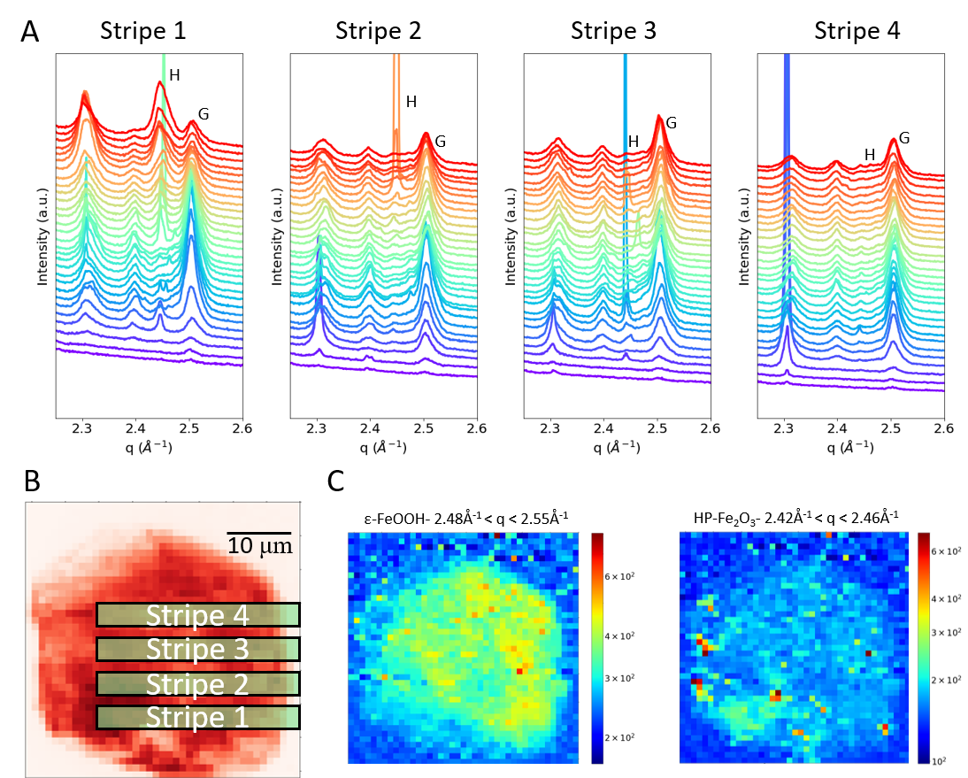

Figure S9. Nano X-ray diffraction map of the inclusion with 40×40 matrix with 400 nm resolution, measured at the X-ray nanoprobe CARNAUBA beamline.Qualitatively, we observed the same phase admixture heterogeneities, with goethite (FeOOH) more evenly distributed and hematite (Fe₂O₃) more concentrated in the denser region and showing a few crystallites with higher intense reflections. However, one can hardly estimate the exact proportion of the phases because of the incomplete powder diffraction rings, random larger crystallite reflections, and limited angular range. Magnetite is very hard to distinguish because the detector has not enough angular range to detect the magnetite main peaks.

S10.

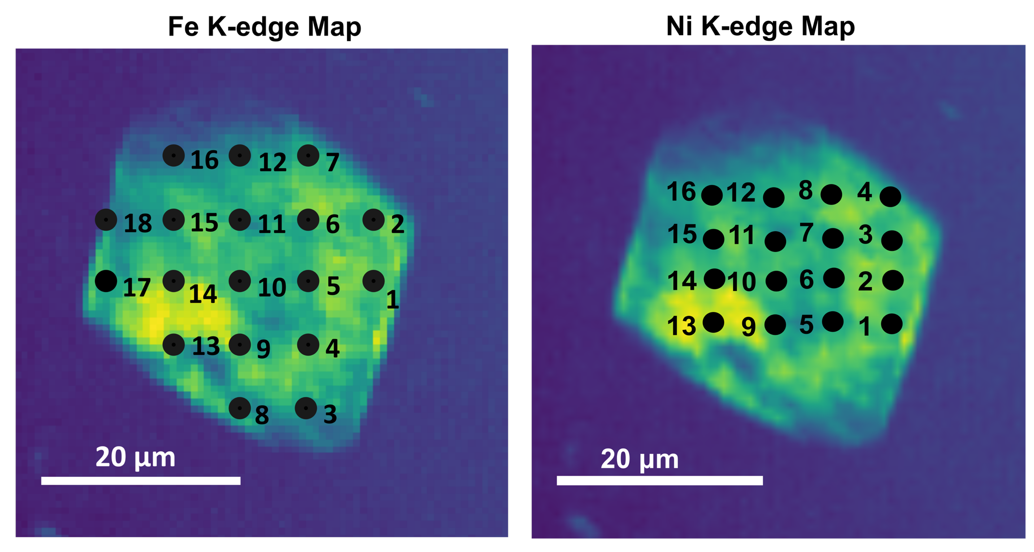

Figure S10. Scanning Transmission X-ray Microscopy (STXM) image with the spatial distribution of the micro-XANES mapped points. Fe-K edge (left) and Ni-K edge (right).

S11.

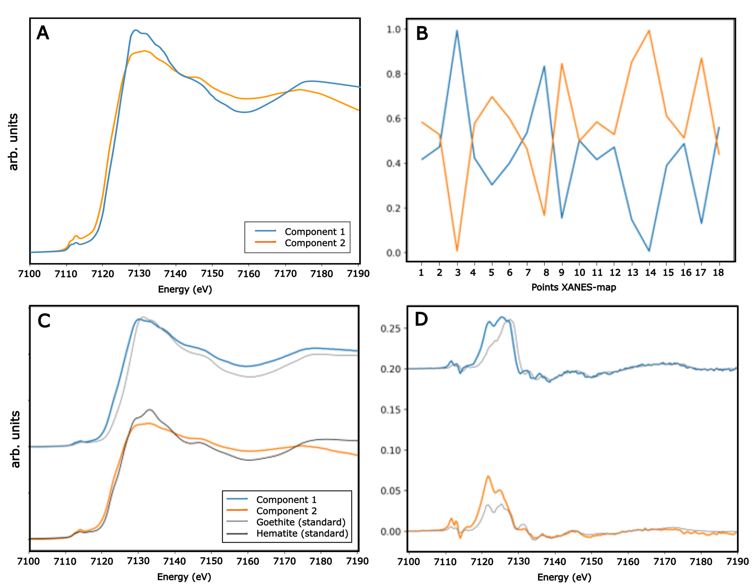

Figure S11. Multivariate Curve Resolution using Alternating Least Squares (MCR-ALS) applied to the sum of the XANES spectra presented in Fig. 4A identifying two principal components (PCA). (A) Component 1 (blue) and Component 2 (orange); (B) Spatial distribution of each component across the XANES map (18 spectra), where point 3 is a pure component 1 and point 14 is pure component 2. One note that point 8, close to point 3, has about 80% of component 1, while points 9, 13 and 17, close to point 14, have about 80% of component 2. This result shows that the denser region around points 9, 13, 14 and 17 is more populated with Component 2. (C) Comparison of the extracted components with reference standards showing that Component 1 closely resembles goethite (FeOOH), but with a shifted edge by about -1.6 eV, while Component 2 exhibits spectral features characteristic of hematite (Fe₂O₃), but with smoothed structures compatible with a disordered system. These maps are consistent with the micro-XRD results where the hematite phase populated the denser region; (D) First derivatives of the components and standards are shown to enhance the assessment of spectral correspondence. The magnetite (Fe₃O₄) component has very low abundance in the inclusion and cannot be distinguished as a component by our XANES data.

S12.
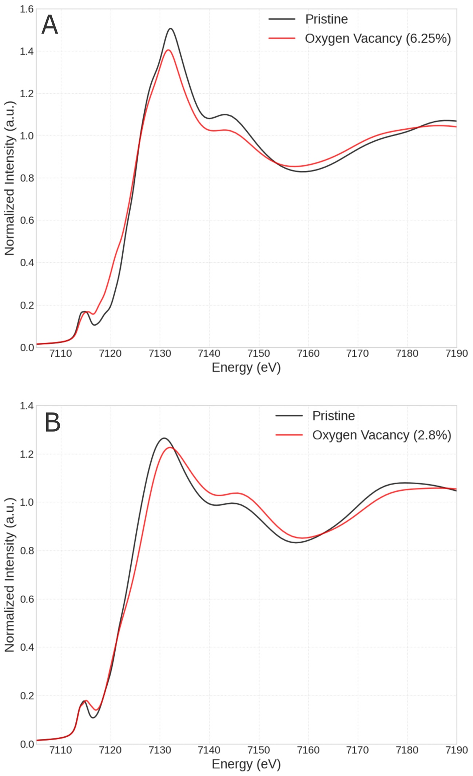
Figure S12. FDMNES XANES spectroscopy simulations showing the effect of introducing oxygen vacancies in the structure: A) Goethite and B) Hematite. The XANES spectroscopy simulations were performed using available CIF files, introducing the defects manually, and applying the Quantum Espresso and FDMNES packages. For more details of these simulations, please see the description at XANES methods. The aim here is to demonstrate that defects like oxygen vacancies tend to modify the XANES spectra, particularly in the rising absorption edge. The effect is clear at the rising absorption edge of goethite where news states become available giving rise to a shift to the lower energies.

S13.

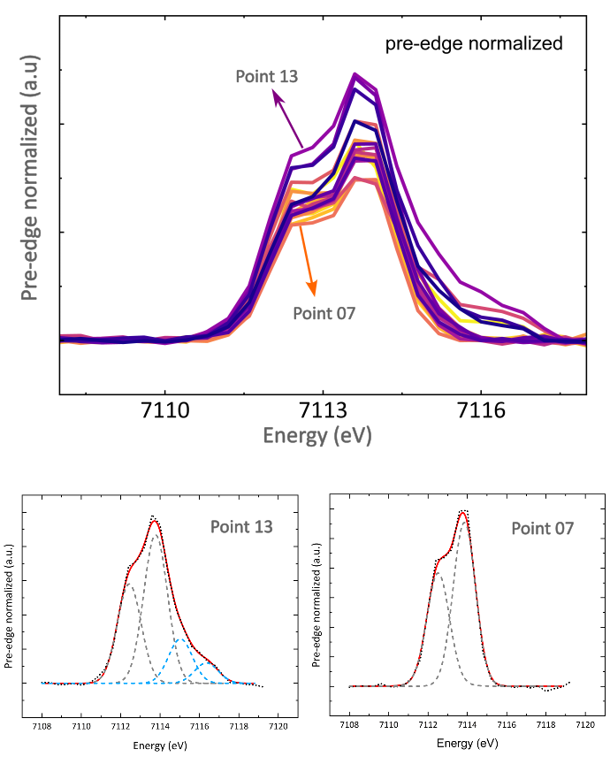

Figure S13. Pre-edge XANES at Fe K-edge measurements showing the highest (point 13) and lowest (point 07) intensities. The gray lines show two contributions relevant to the 1s → 3d/4p transition and blue lines the extra transitions related to some Fe clustering.

Diagram relative to the iron different chemical state and coordination, as known from literature, where the results of our analysis is represented

S14.

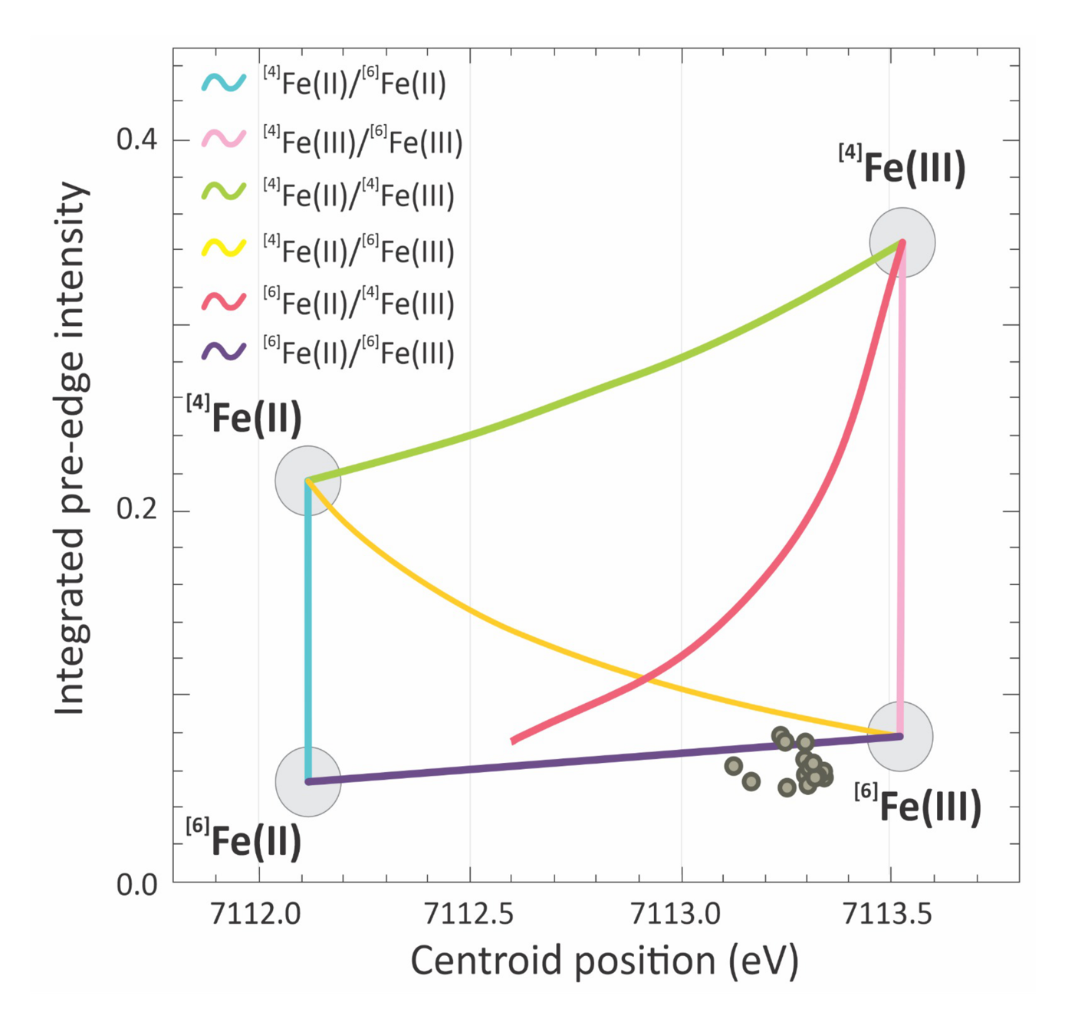

Figure S14. Summary of pre-edge characteristics for the binary mixtures between ^{IV}Fe²⁺, ^{VI}Fe²⁺, ^{IV}Fe³⁺, and ^{VI}Fe³⁺ following the centroid position calculation and diagram (Ref. ⁵). The gray dots represent all 18 XANES (Fe K-edge) curves, while the centroid position of each point is presented at Table S2.

S15.

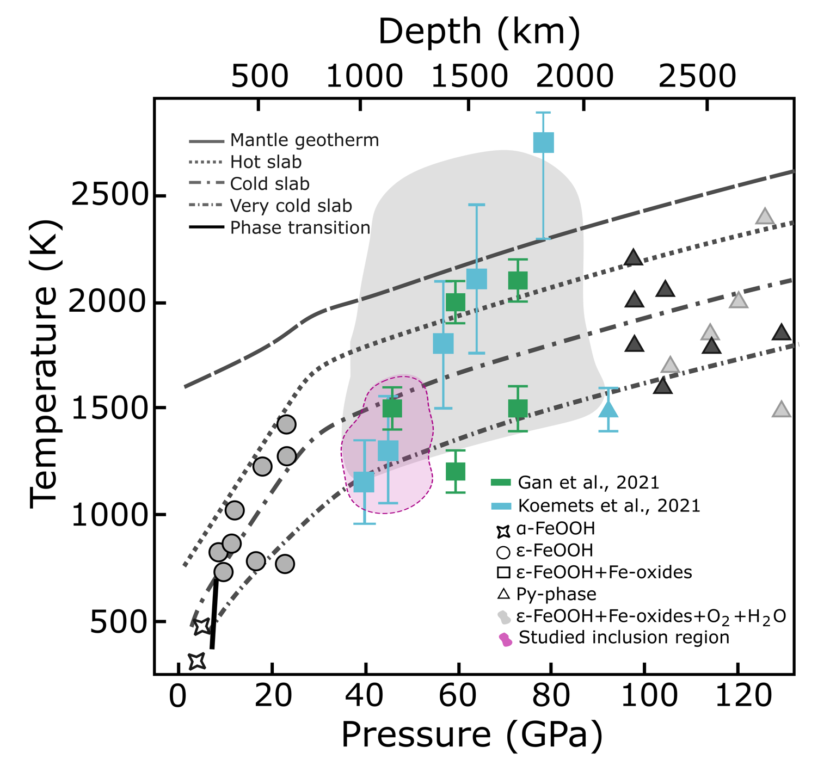

Figure S15. P-T phase diagram modified from Ref. ⁶, presenting the FeOOH thermal stability under Earth’s mantle conditions and hot, cold and very cold subducting slabs conditions. We estimated that our Fe oxyhydroxide inclusion (pink zone) was stable in the lower mantle at ~35-50 GPa at cold subducted slab conditions. Stars are α-FeOOH (Ref. ⁷); gray circles are ε-FeOOH (Ref. ⁸); blues squares (Ref. ⁸) and green squares (Ref. ⁶) indicates that ε-FeOOH partially decomposes into Fe oxides, H₂O, and O₂. Gray triangles represent Py-FeO₂Hx (x = 1) (Refs. ^{10,11}). The solid black line represents the phase boundary between α-FeOOH and ε-FeOOH (Ref. ¹²). The long dashed gray line shows the conditions of the mantle geotherm (Ref. ¹³); and the dotted, dotted dashed, and short dashed-dotted lines represent slab geotherms based on hypothetical models of hot, cold, and very cold slabs (Refs. ^{14,15}), respectively. The light gray shadow exhibits the pressure and temperature conditions of the ε-FeOOH decomposition and formation of Fe-oxides, H₂O and O₂ based on experimental studies cited above.

Table S1. Pre-edge characteristics of each Fe K-edge XANES spectra of our inclusion. The calculation was based on the method applied for the centroid-position diagram (Ref. ⁵).

Movie S1.
This movie shows the X-ray μ-CT results of the diamond sample J1, carried out at MOGNO beamline, with inclusions labeled, enabling to detect ~98 inclusions and the X, Y, Z coordinates of each one.

Movie S2.
This movie shows the X-ray nano-computed tomography (n-CT) transmission of the Fe oxyhydroxide inclusion. The data reveal the overall shape of the inclusion, which exhibits some euhedral faces. However, morphology appears somewhat disturbed, and several voids or ‘holes’ can be observed within the inclusion.

Movie S3.
This movie shows the X-ray n-CT with fluorescence contrast of Fe oxyhydroxide inclusion. The segmentation was divided into 3 labels: High iron intensity, low iron intensity and matrix. Analyzing the tomography of the Fe oxyhydroxide inclusion, in broad terms, it is possible to associate high iron intensity with a greater quantity of hematite crystallites and low intensity with a larger amount of goethite. Additionally, the holes filled with carbon (diamond) indicate that this inclusion went through a highly reactive process, most likely caused by the crystallization of diamond in its surrounding area.

References
- Gu, T., Pamato, M.G., Novella, D., Alvaro, M., Fournelle, J., Brenker, F.E., Wang, W. & Nestola, F. Hydrous peridotitic fragments of Earth's mantle 660 km discontinuity sampled by a diamond. Nature Geoscience 15, 950–954 (2022).
- Nasdala, L., Brenker, F.E., Glinnemann, J., Hofmeister, W., Gasparik, T., Harris, J.W., Stachel, T., Reese, I. Spectroscopic 2D-tomography: Residual pressure and strain around mineral inclusions in diamonds. Eur J Mineral 15, 931–935 (2003).
- Smith, E.M., Krebs, M.Y., Genzel, P.-T. & Brenker, F.E. Raman identification of inclusions in diamond. Rev. Mineral. Geochem. 88, 451–474 (2022).
- Smith, E.M., Shirey, A.B., Richardson, S.H., Nestola, F., Bullock, E.S., Wang, J. & Wang, W. Blue boron-bearing diamonds from Earth’s lower mantle. Nature 560, 84–87 (2018). https://doi.org/10.1038/s41586-018-0334-5
- Wilke, M., Farges, F., Petit, P.E., Brown, G.E. & Martin, F. Oxidation state and coordination of Fe in minerals: An Fe K-XANES spectroscopic study. American Mineralogist 86, 714–730 (2001).
- Gan, B., Zhang, Y., Huang, Y., Li, X. Wang, Q., Li, J., Zhuang, Y., Liu, Y. & Jiang, G. Partial Deoxygenation and Dehydration of Ferric Oxyhydroxide in Earth's Subducting Slabs. Geophysical Research Letters 48 (2021), e2021GL094446. https://doi.org/10.1029/2021GL094446
- Wiethoff, F., Grevel, K.-D., Marler, B., Herrmann, J., Majzlan, J., Kirste, J., & Lathe, C. P-V-T behavior of FeO(OH) and MnO(OH). Physics and Chemistry of Minerals 44(8), 567–576 (2017). https://doi.org/10.1007/s00269-017-0884-3
- Yoshino, T., Baker, E. & Duffey, K. Fate of water in subducted hydrous sediments deduced from stability fields of FeOOH and AlOOH up to 20 GPa. Physics of the Earth and Planetary Interiors 294, (2019).
- Koemets, E., Fedotenko, T., Khandarkhaeva, S., Bykov, M., Bykova, E., Thielmann, M., Chariton, S., Aprilis, G., Koemets, I., Glazyrin, K., Liermann, H. P., Hanfland, M., Ohtani, E., Dubrovinskaia, N., McCammon, C. & Dubrovinsky, L. Chemical Stability of FeOOH at High Pressure and Temperature, and Oxygen Recycling in Early Earth History**. Eur J Inorg Chem 2021, 3048–3053 (2021). https://doi.org/10.1002/ejic.202100274
- Hu, Q., Kim, D. Y., Yang, W., Yang, L., Meng, Y., Zhang, L. & Mao, H. K. FeO2 and FeOOH under deep lower-mantle conditions and Earth's oxygen-hydrogen cycles. Nature 534, 241–244 (2016).
- Hu, Q., Kim, D.Y., Liu, J., Meng, Y., Yang, L., Zhang, D., Mao, W.L. & Mao, H. Dehydrogenation of goethite in Earth’s deep lower mantle. Proc. Natl. Acad. Sci. U.S.A. 114 (7) 1498-1501 (2017). https://doi.org/10.1073/pnas.1620644114
- Voigt, R., & Will, G. The system Fe2O3-H2O under high pressures. Neues Jahrbuch fur Mineralogie 2, 89–96 (1981).
- Katsura, T., Yoneda, A., Yamazaki, D., Yoshino, T. & Ito, E. Adiabatic temperature profile in the mantle. Physics of the Earth and Planetary Interiors 183(1), 212–218 (2010).
- Komabayashi, T., S. Omori, & S. Maruyama. Petrogenetic grid in the system MgO-SiO2-H2O up to 30 GPa, 1600°C: Applications to hydrous peridotite subducting into the Earth’s deep interior. J. Geophys. Res. 109, B03206 (2004). doi:10.1029/2003JB002651.
- Maeda, F., Ohtani, E., Kamada, S., Sakamaki, T., Hirao, N. & Ohishi, Y. Diamond formation in the deep lower mantle: a high-pressure reaction of MgCO3 and SiO2. Sci Rep 7, 40602 (2017). https://doi.org/10.1038/srep40602

