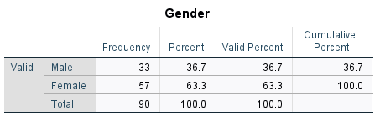
Table 1. Gender Distribution of Study Participants

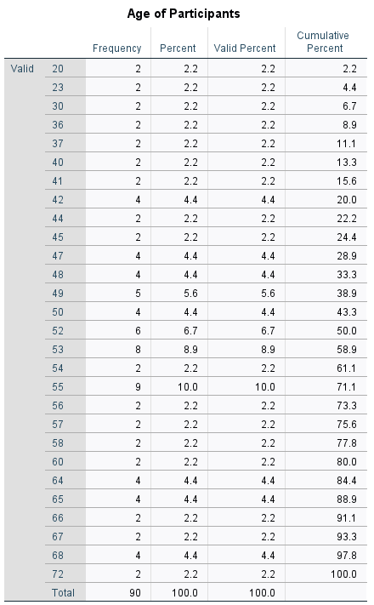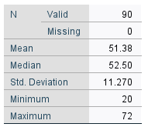
Table 2. Age Distribution of Study Participants
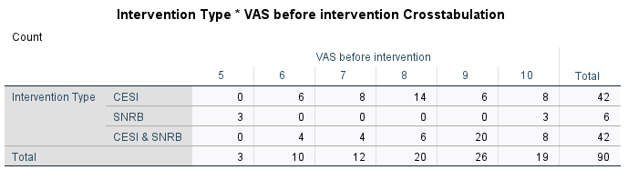
Table 3. Cross-tabulation of Baseline VAS Scores before Intervention Treatment. This table displays the distribution of baseline pain intensity scores (measured by the Visual Analog Scale, VAS) before treatment across the three intervention groups: CESI only, SNRB only, and combined CESI + SNRB. The comparison illustrates the initial pain levels among patients before interventional treatment.

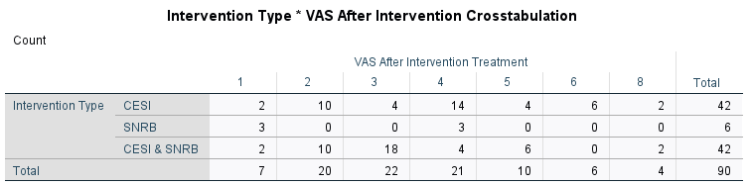
Table 4. Cross-tabulation of Baseline VAS Scores After Intervention Treatment. This table displays the distribution of pain intensity scores (measured by the Visual Analog Scale, VAS) after treatment across the three intervention groups: CESI only, SNRB only, and combined CESI + SNRB. The comparison illustrates the pain levels among patients after interventional treatment.

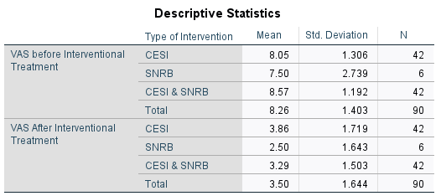
Table 5. Descriptive Statistics Table for VAS before-after Interventional Treatment

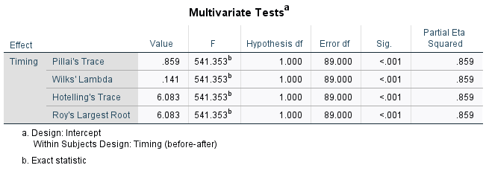
Table 6.Multivariate Analysis Tests to compare VAS before-after Interventional Treatment
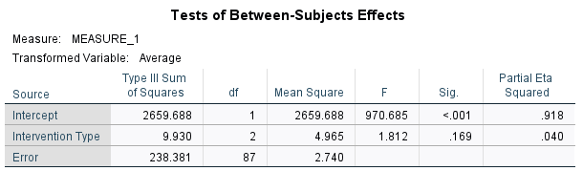
Table 7. Statistical Analysis Tests, to compare the difference in post-treatment VAS scores among the three intervention treatment groups
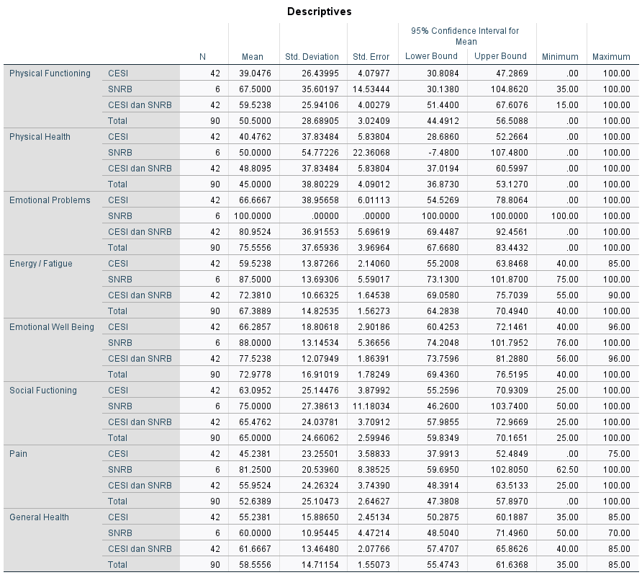
Table 8. Descriptive Statistics Table for the assessment of quality of life and functional outcomes in physical functioning, physical health, role limitations due to emotional problems, energy/fatigue, emotional well-being, social functioning, pain, and general health.
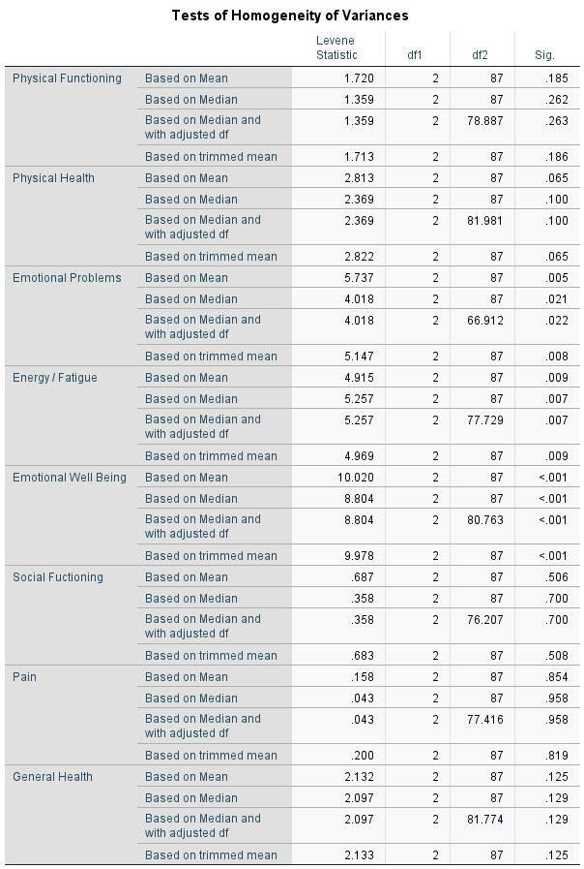
Table 9. Test of Homogeneity of Variances Results for Quality of Life and Functional Outcome Domains Across Intervention Groups

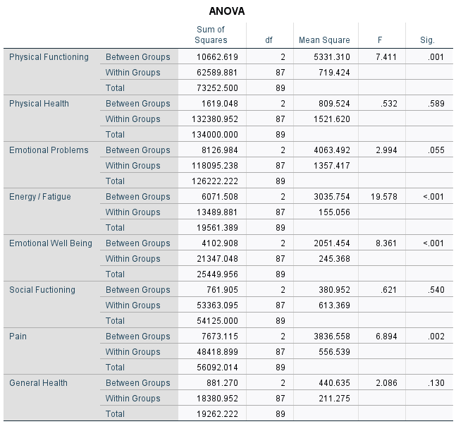
Table 10. ANOVA Results for Quality of Life and Functional Outcome Domains Across Intervention Groups

