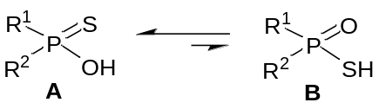
Scheme 1 The thionic acid – thiolic acid tautomeric equilibrium

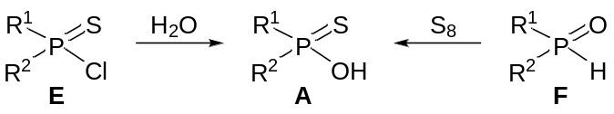
Scheme 2 The synthesis of thionic acids A

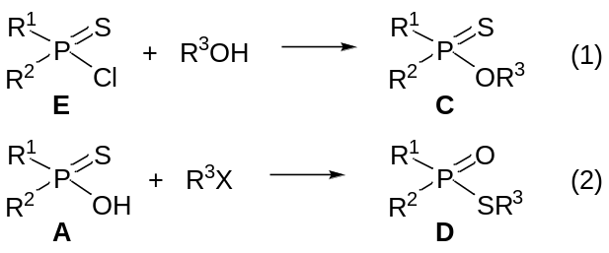
Scheme 3 The preparation of the esters of thionic acids and thiolic acids.

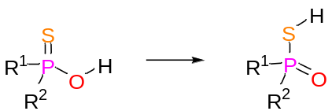
R¹ | R² | DH (kJ mol^{–1}) | DG (kJ mol^{–1}) | DS (J mol^{–1} K^{–1})
Me | Me | 15.0 | 14.6 | 1.2
Me | Ph | 17.5 | 16.9 | 0.9
Ph | Ph | 13.7 | 14.3 | –2.0
Scheme 4. Thermodynamics of the thiophosphinic acid tautomerism
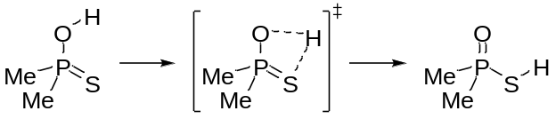
 | DH (kJ mol^{–1}) | DG (kJ mol^{–1}) | DS (J mol^{–1} K^{–1})
difference between the tautomers | 15.0 | 14.6 | 1.2
TS | 114.6 | 117.0 | -8.0
Scheme 5. Kinetics for the monomolecular tautomerism of dimethylthiophosphinic acid
Then, the isomerization was calculated in water.

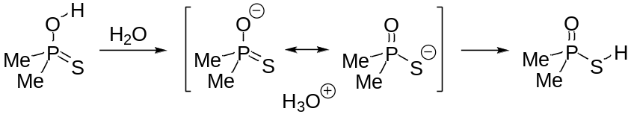
 | DH (kJ mol^{–1}) | DG (kJ mol^{–1}) | DS (J mol^{–1} K^{–1})
difference between the tautomers | 15.0 | 14.6 | 1.2
deprotonation by water | 49.1 | 57.5 | –28.4
Scheme 6. Tautomerism in the presence of water as the base

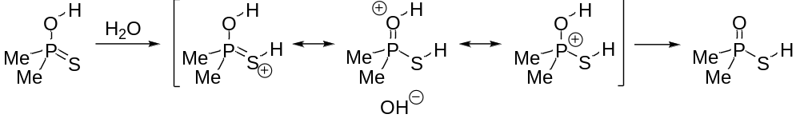
 | DH (kJ mol^{–1}) | DG (kJ mol^{–1}) | DS (J mol^{–1} K^{–1})
difference between the tautomers | 15.0 | 14.6 | 1.2
protonation by water | 134.4 | 139.6 | –17.4
Scheme 7. Tautomerism in the presence of water as the acid

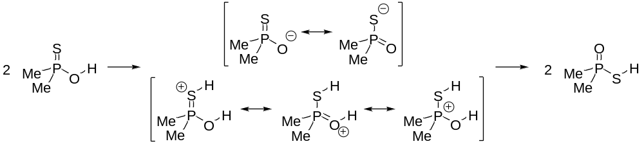
 | DH (kJ mol^{–1}) | DG (kJ mol^{–1}) | DS (J mol^{–1} K^{–1})
deprotonation – protonation | 71.5 | 75.2 | –12.6
Scheme 8. Tautomerism via autoprotolysis

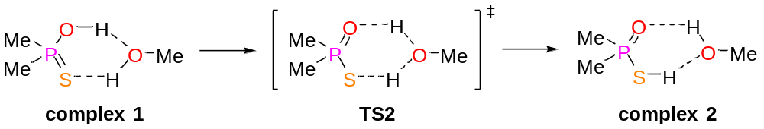
 | DH (kJ mol^{–1}) | DG (kJ mol^{–1}) | DS (J mol^{–1} K^{–1})
difference between the complexes | 25.5 | 22.6 | 10.0
TS2 | 40.2 | 49.3 | –30.5
Scheme 9. Tautomerism with the help of MeOH

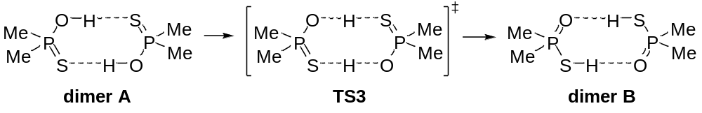
 | DH (kJ mol^{–1}) | DG (kJ mol^{–1}) | DS (J mol^{–1} K^{–1})
difference between the dimers | 46.7 | 44.2 | 8.4
TS3 | 63.2 | 55.0 | –9.6
Scheme 10. Tautomerism via a symmetric dimer

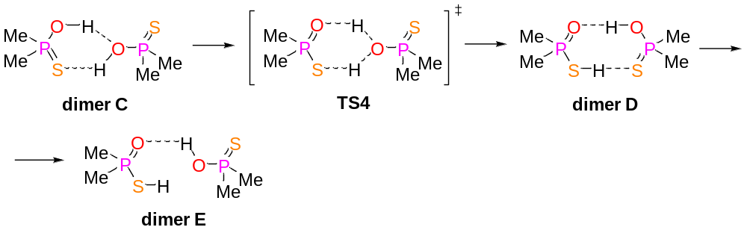
 | DH (kJ mol^{–1}) | DG (kJ mol^{–1}) | DS (J mol^{–1} K^{–1})
TS4 | 37.0 | 49.3 | –41.4
difference between dimers C and D | 1.4 | 5.2 | –12.9
difference between dimers C and E | –3.6 | 3.6 | –24.1
Scheme 11. Tautomerism via an asymmetric dimer

