Supplemental Material for

Chemical Treatment-Induced Indirect-to-Direct Bandgap Transition in MoS₂: Impact on Excitonic Emission

Yusuf Kerem Bostan¹, Elanur Hut¹, Cem Sanga², Nadire Nayir^{2,3}, Ayse Erol¹, Yue Wang⁴ *, and Fahrettin Sarcan^{1,4} *

¹Department of Physics, Faculty of Science, Istanbul University, Vezneciler, Istanbul, 34134, Turkey

²Department of Physics Engineering, Istanbul Technical University, Maslak, Istanbul, 34467, Turkey

³Paul-Drude-Institute for Solid State Electronics, Leibniz Institute within Forschungsverbund Berlin eV., Hausvogteiplatz 5-7, 10117 Berlin, Germany

⁴School of Physics, Engineering and Technology, University of York, York, YO10 5DD, United Kingdom

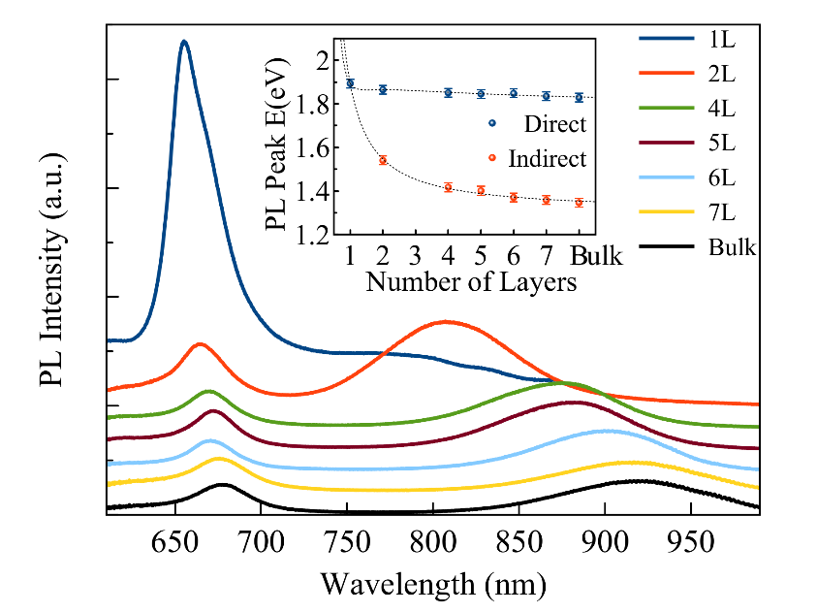
Figure S1. PL spectra of MoS₂ flakes with different numbers of layers, from monolayer to bulk. The inset shows the bandgap energy of each layer extracted from PL peaks.

The output characteristics show that the drain current increased up to 1.5 µA under a 1 V negative drain bias across a 3 µm channel length at 0 V gate voltage (Figure S2b). According to the transfer characteristics of the 3 µm channel device, I_{on}/I_{off} ratio of the pristine FET is 2 orders of magnitude and is improved to 6 orders of magnitude after 12 hours of treatment (Figure S2c). The pristine sample exhibits n-type characteristics, which are enhanced after 12 hours in DCE solution.

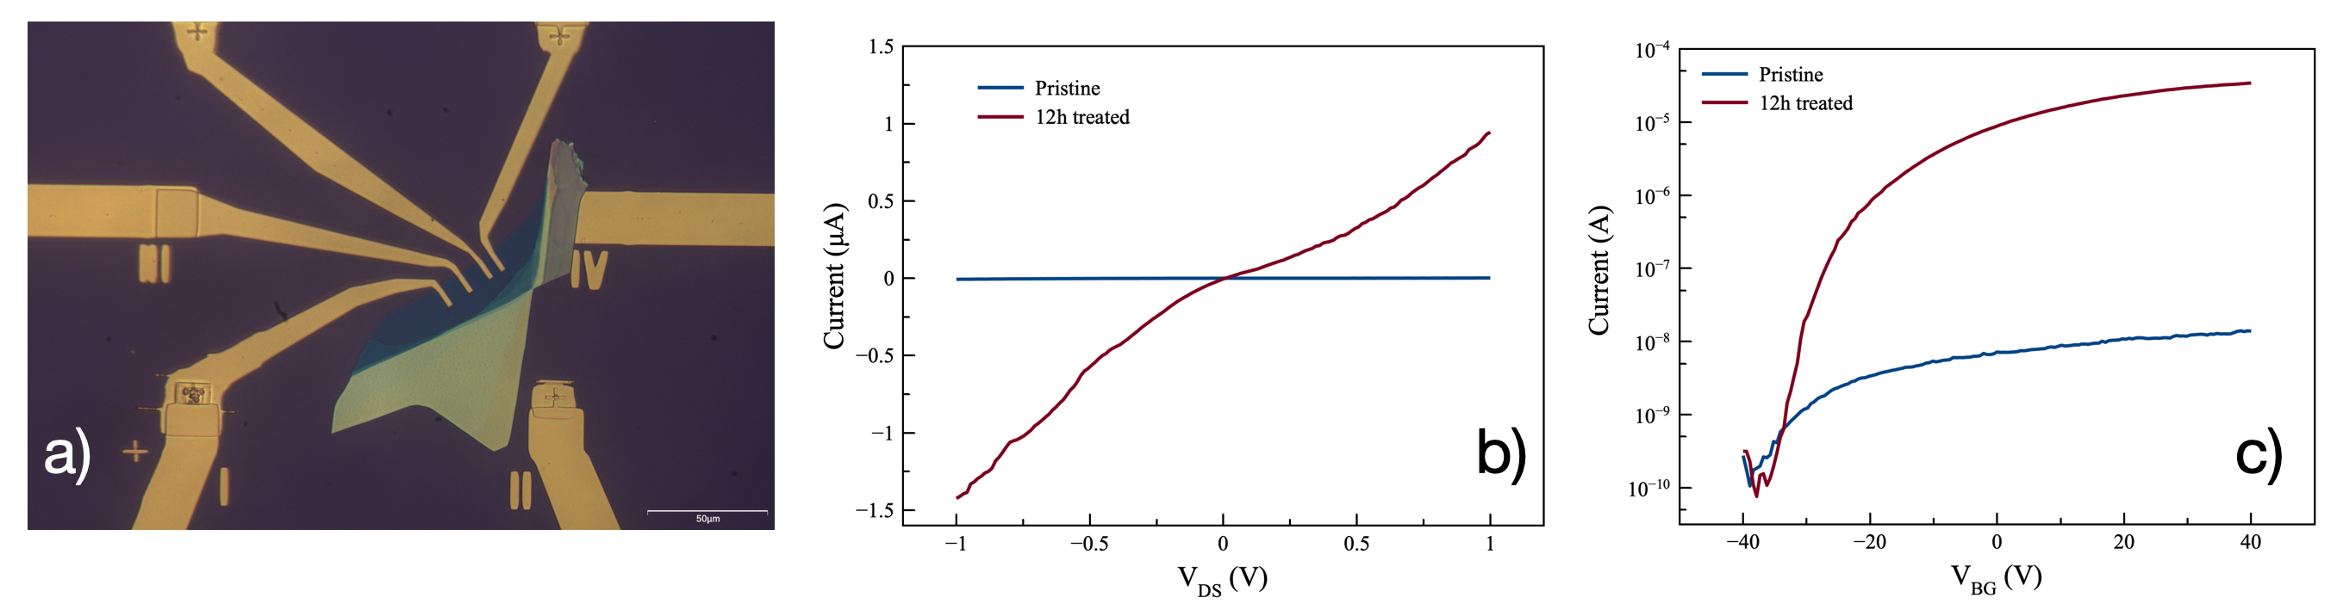
Figure S2. a) Optical microscope images of a few-layer MoS₂ FET device, b) output and c) transfer characteristics of the FET device before and after DCE treatment.

