How do individual behaviors based on visual and auditory cues facilitate spatiotemporal coordination in collective movement of patas monkeys (Erythrocebus patas)?

Supplementary material

Maho Hanzawa^{1,2}, Yoshiki Morimitsu², Erasmus H Owusu³, Richard D Suu-Ire⁴, Naofumi Nakagawa¹

The affiliations of the authors
1 Graduate School of Science, Kyoto University, Kyoto, Japan
2 Institute of Natural and Environmental Sciences, University of Hyogo, and Wildlife Management Research Center, Hyogo, Japan
3 Department of Animal Biology and Conservation Science, University of Ghana, Legon-Accra, Ghana
4 School of Vet. Medicine, University of Ghana, Legon-Accra, Ghana

Authors for correspondence
Maho Hanzawa
Email: m.hanzawa.fmym@gmail.com
The ORCID: 0009-0009-5292-3732 (Maho Hanzawa)

Capturing patas monkeys

We provide additional details on patas monkey capturing. We fitted GPS collars to five adults (sole adult male and four adult females) of the group. We did not fit the device to one of the adult females because she was not fully habituated to the observers. We (veterinarians YM or RS) immobilised individuals with a combination of zoletil (5 mg/kg) and medetomidine (0.1 mg/kg) from a distance of 3–5 m using a blowpipe. After injecting the target, two researchers followed the other members of the group. Once the target was immobilised and the group was out of sight, we fitted the individual with a GPS collar and collected morphometric and other biological data in the shade. In a few cases, subcutaneous fluids were administered to assist with rehydration. We completed all processes within an hour and the veterinarians reversed the medetomidine with atipamezole (0.5 mg/kg). After a full recovery of the individual, we returned it to the group and monitored it until it was ambulatory. After data collection, we dropped the collar with a remote control while observing the individual. Then we continued to observe them for a few days to ensure no problems with their bodies or their behaviour.

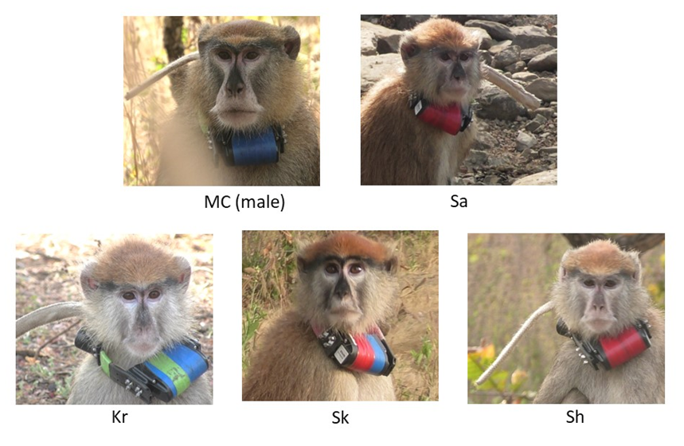
Fig. S1. Individuals fitted with GPS collars in the group

Table S1. Information about sex, number of infants and juvenile offspring, observation time (h) and the number of recorded GPS fixes for each collared individual
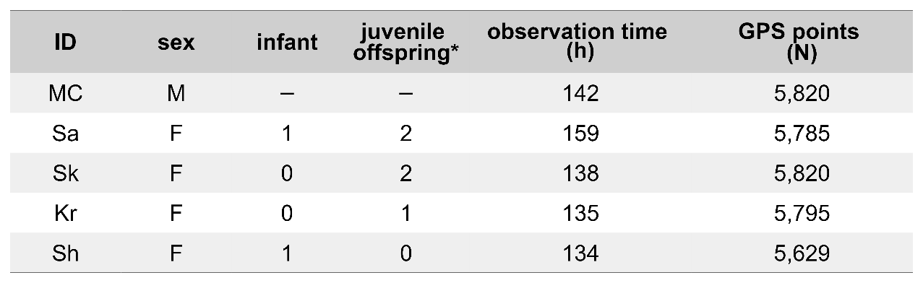
*: the number of juvenile offspring was estimate

