Table 1. Variables affecting the probability of occurrence of female visual monitoring (1a), male visual monitoring (1b), and female contact calls (1c) in Model 1
Nearest IID [ff] / [mf]: Nearest IID between the focal female and other females / between the male and females, Mean IID [notf]: Mean IID of individuals except for the focal animal, IID [mf]: IID between the male and the focal female, Difference velo [fo vs notf]: The difference of travel velocity between focal animal and others (absolute value), SE: standard error, 95% CI: 95% confidence intervals, z: z value, p: p value.
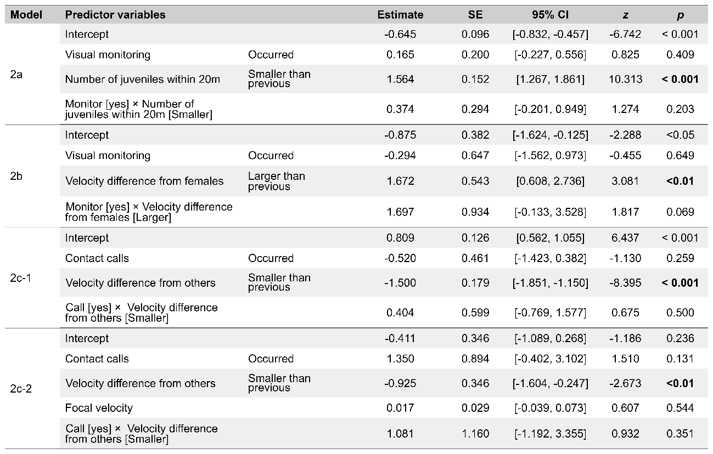
Table 2. Effects of female visual monitoring (2a), male visual monitoring (2b), and female contact calls (2c-1, 2c-2) to variables in Model 2
Response variables: (2a) the change in the number of juveniles within 20 m at the future time compared to the current time, (2b) the change in the velocity difference between the male and the females at the future time period compared to the current time period, (2c-1) the change in the velocity difference between the focal female and others at the future time period compared to the current time period, (2c-2) the change in the mean velocity of others at the future time period compared to the previous time period.

Table 3. Pairwise comparison of the occurrence of female visual monitoring (2a), male visual monitoring (2b), and female contact calls (2c-1, 2c-2) for variables in Model 2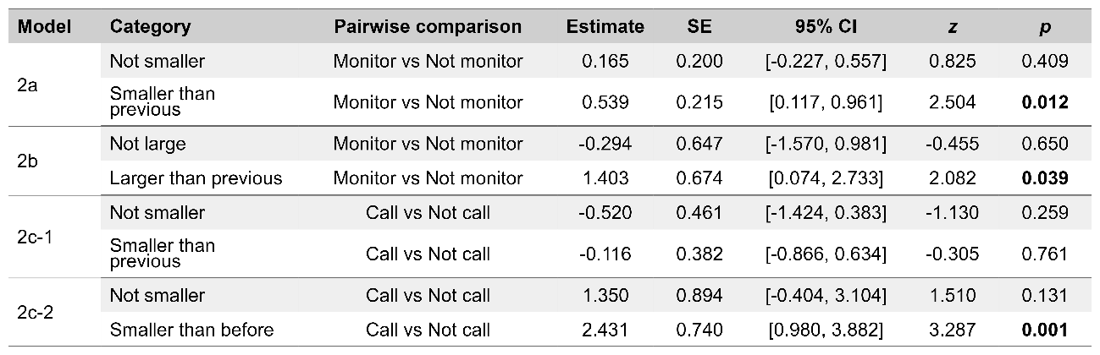
Category: (2a) Whether the number of juveniles within 20 m at the current time was smaller than the previous time or not, (2b-1), (2c-1) and (2c-2) Whether the difference in the velocity between focal animal and others at the current time period was smaller than the previous time period.

