Supplementary information
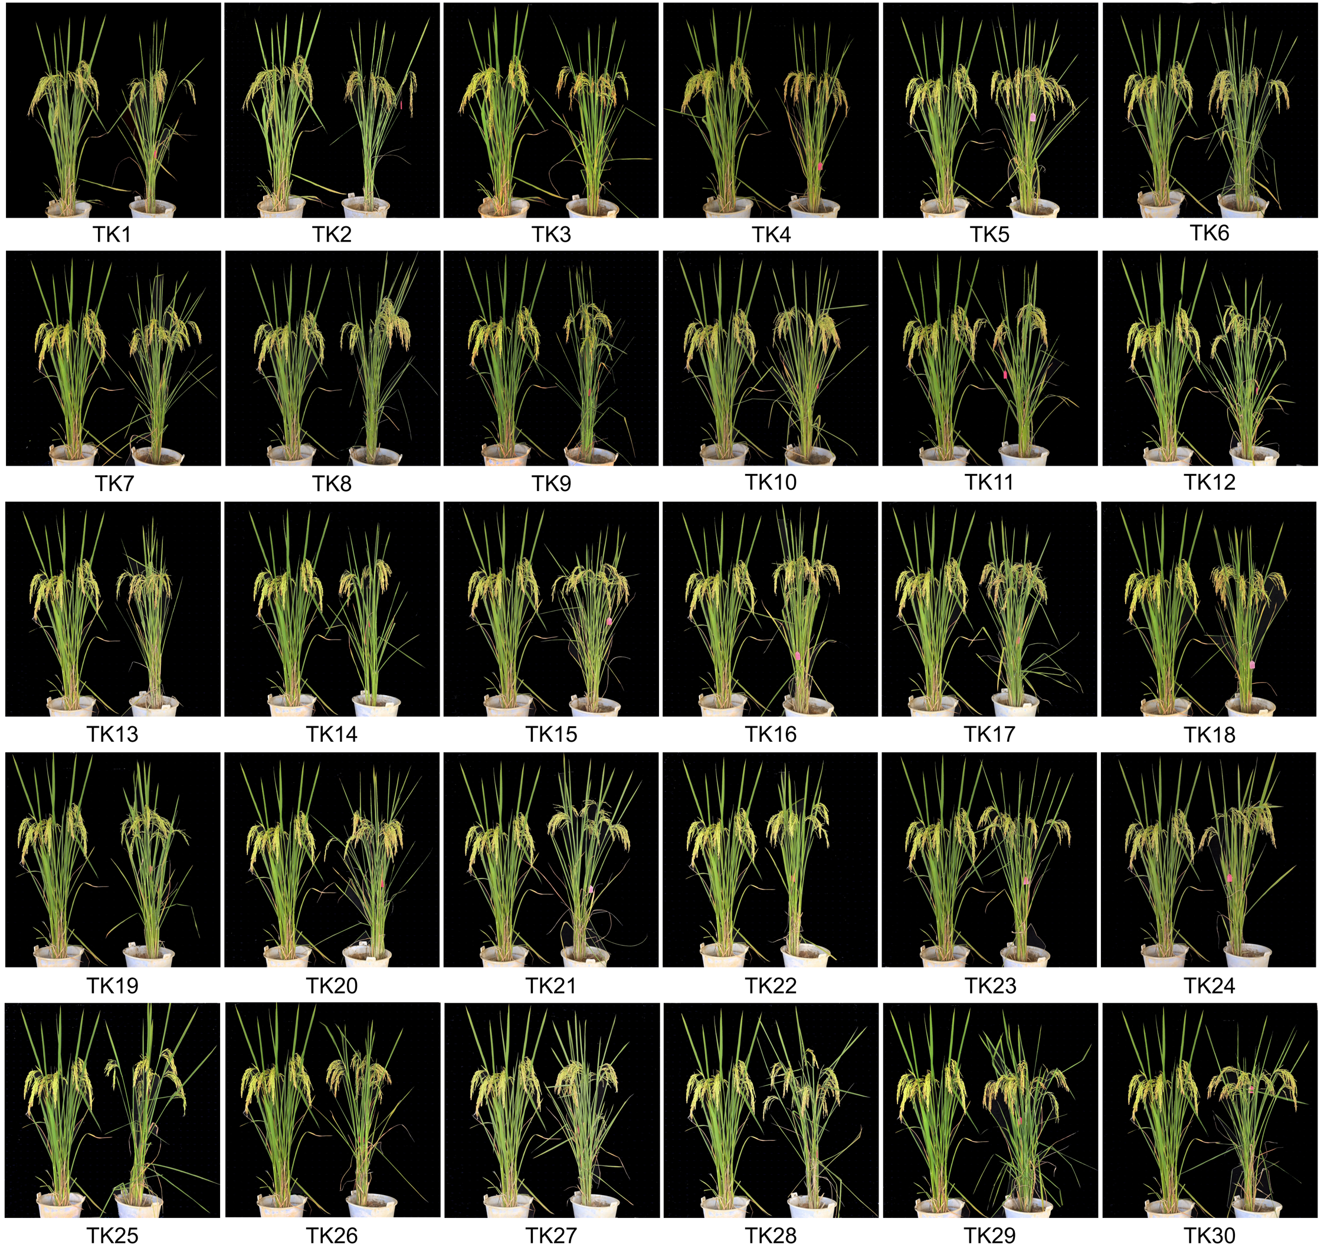
Supplementary Fig. 1 30 TK samples, with the plant on the left of each image as the control.

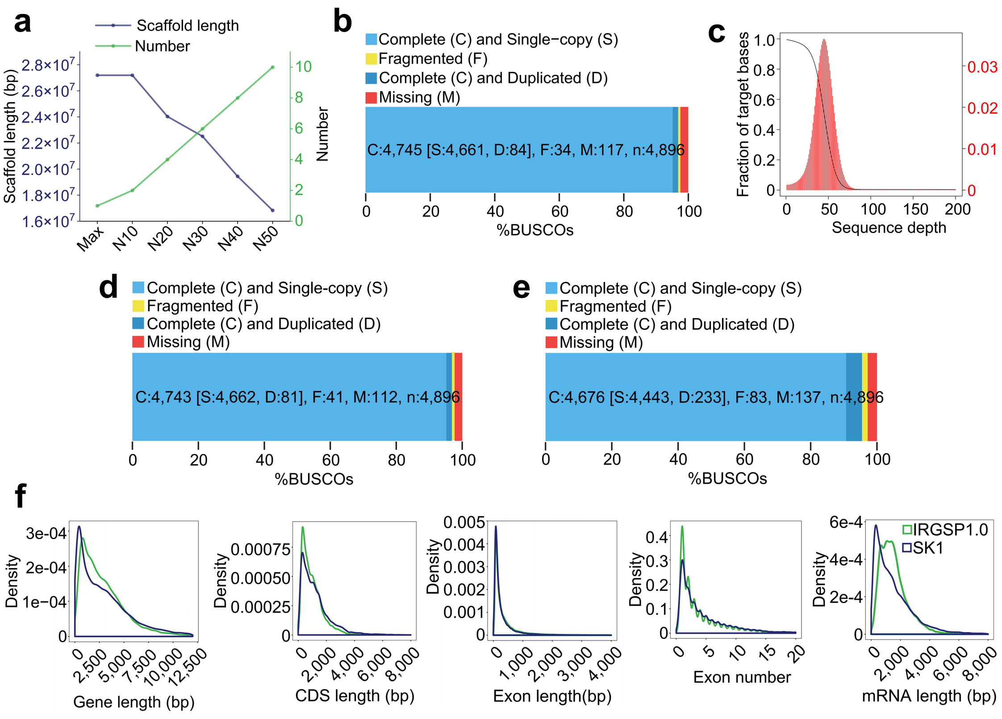
Supplementary Fig. 2 SK1 reference genome assembly. a Scaffold length and corresponding quantity. b Sequence completeness assessed by BUSCO. c Sequencing depth distribution statistics. d BUSCO assessment of genome integrity via Hi-C mapping. e BUSCO assessment of genome annotation completeness. f Comparison of SK1 with IRGSP1.0, showing gene length, CDS length, exon length, exon count, and mRNA length.

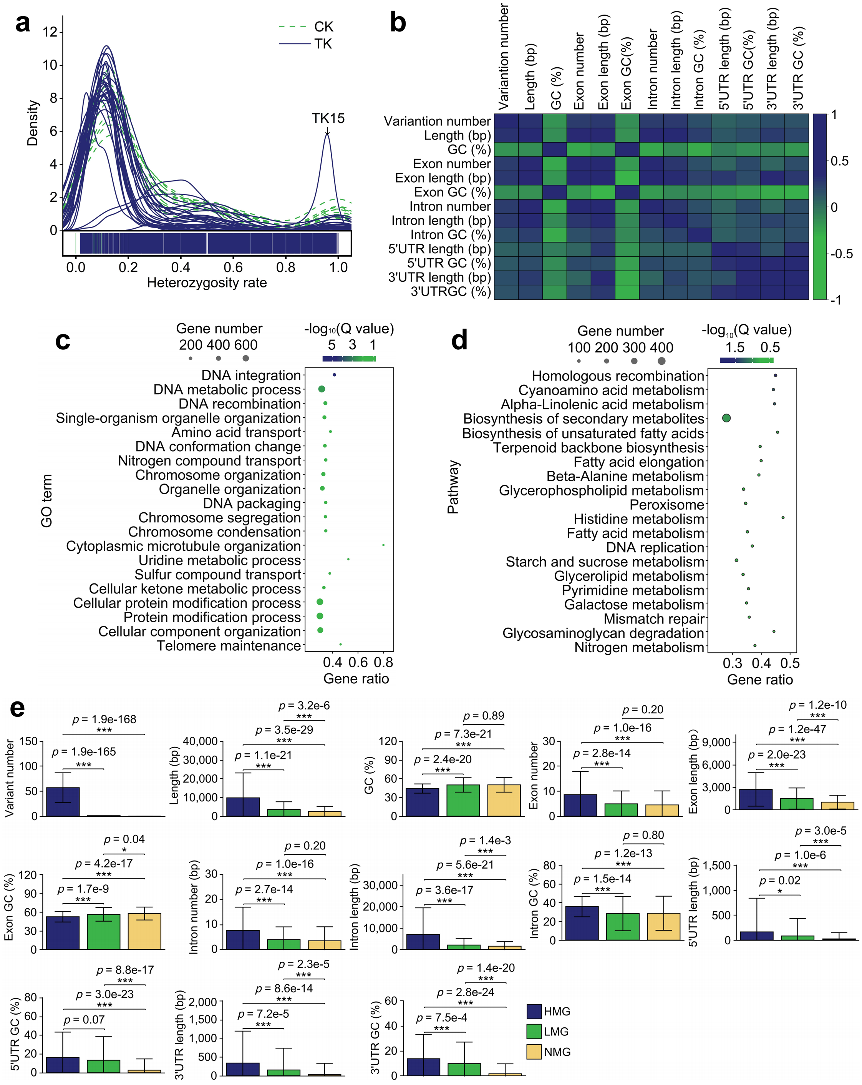
Supplementary Fig. 3 Genomic variation characteristics and preferences. a Heterozygosity frequency of heterozygous mutation sites in CK and TK single samples (heterozygosity frequency = alt reads / all reads). Except for TK15, the heterozygosity frequency of the remaining 39 samples is mostly between 0.1 and 0.2. b Correlation between 13 gene structural features in high-frequency mutated genes (HMG), with color indicating the strength of correlation. c GO enrichment of mutated genes, showing the top 20 biological processes based on -log10(Q value), with circle size indicating the number of genes and color indicating significance. d KEGG enrichment of mutated genes, showing the top 20 pathways based on -log10(Q value), with circle size indicating the number of genes and color indicating significance. e Comparison of 13 gene structural features among HMG, low-frequency mutated genes (LMG), and nonmutated genes (NMG), including mutation count, gene length, GC content, exon count, exon length, exon GC content, intron count, intron length, intron GC content, 3'UTR count, 3'UTR length, 5'UTR count, and 5'UTR length. Data represent means ± SD (n = 500 biological replicates).

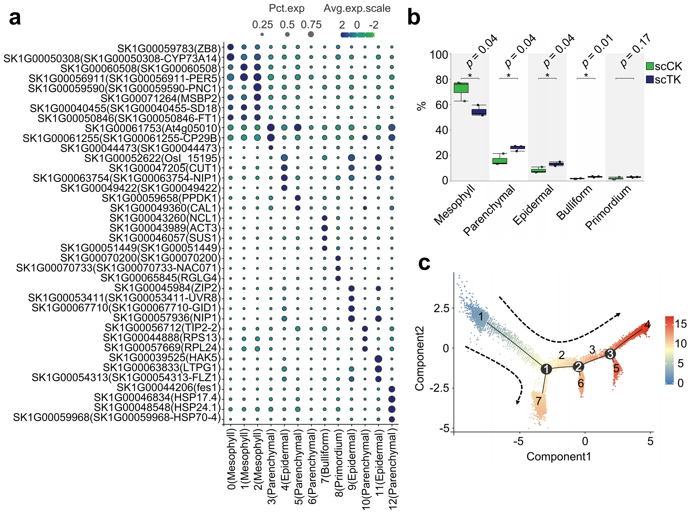
Supplementary Fig. 4 Single-cell expression atlas after deep-space flight. a 13 clusters divided into 5 cell types based on cell marker genes, with circle size indicating the relative percentage of cells expressing marker genes and color indicating relative expression levels. b Differences in the proportions of 5 cell types between scCK and scTK (n = 3 biological replicates). c Pseudotime analysis, with colors indicating the degree of differentiation and arrows indicating the direction of differentiation.
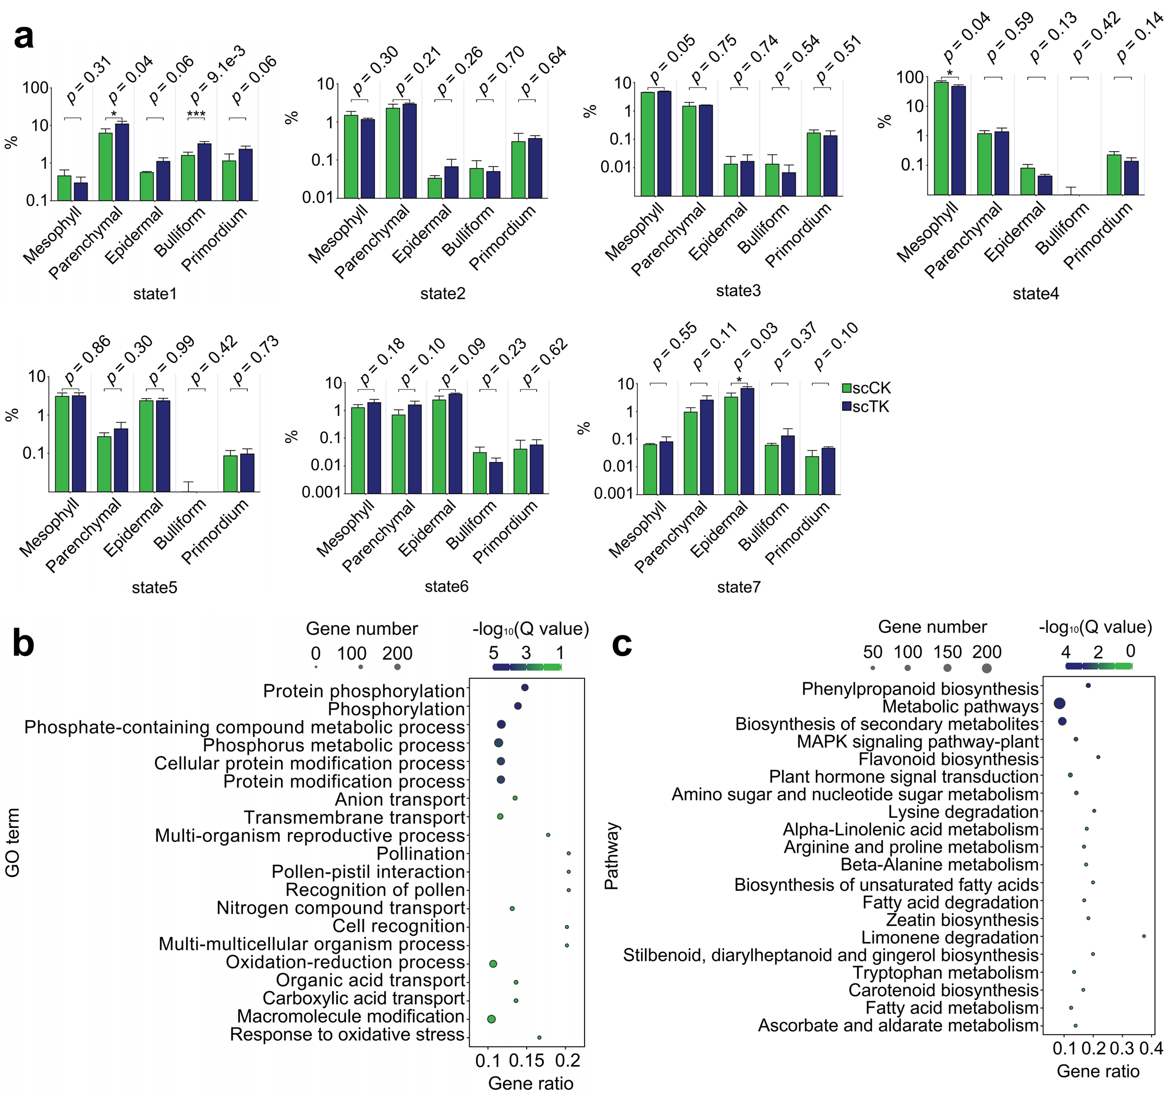
Supplementary Fig. 5 Cell proportion differences of pseudotime analysis, enrichment of RNA-seq DEGs. a Pseudotime analysis showing 7 states, with differences in the proportions of 5 cell types between scCK and scTK in each branch (n = 3 biological replicates). b GO enrichment of RNA-seq DEGs, showing the top 20 biological processes based on -log10(Q value), with circle size indicating the number of genes and color indicating significance. c KEGG enrichment of RNA-seq DEGs, showing the top 20 pathways based on -log10(Q value), with circle size indicating the number of genes and color indicating significance.
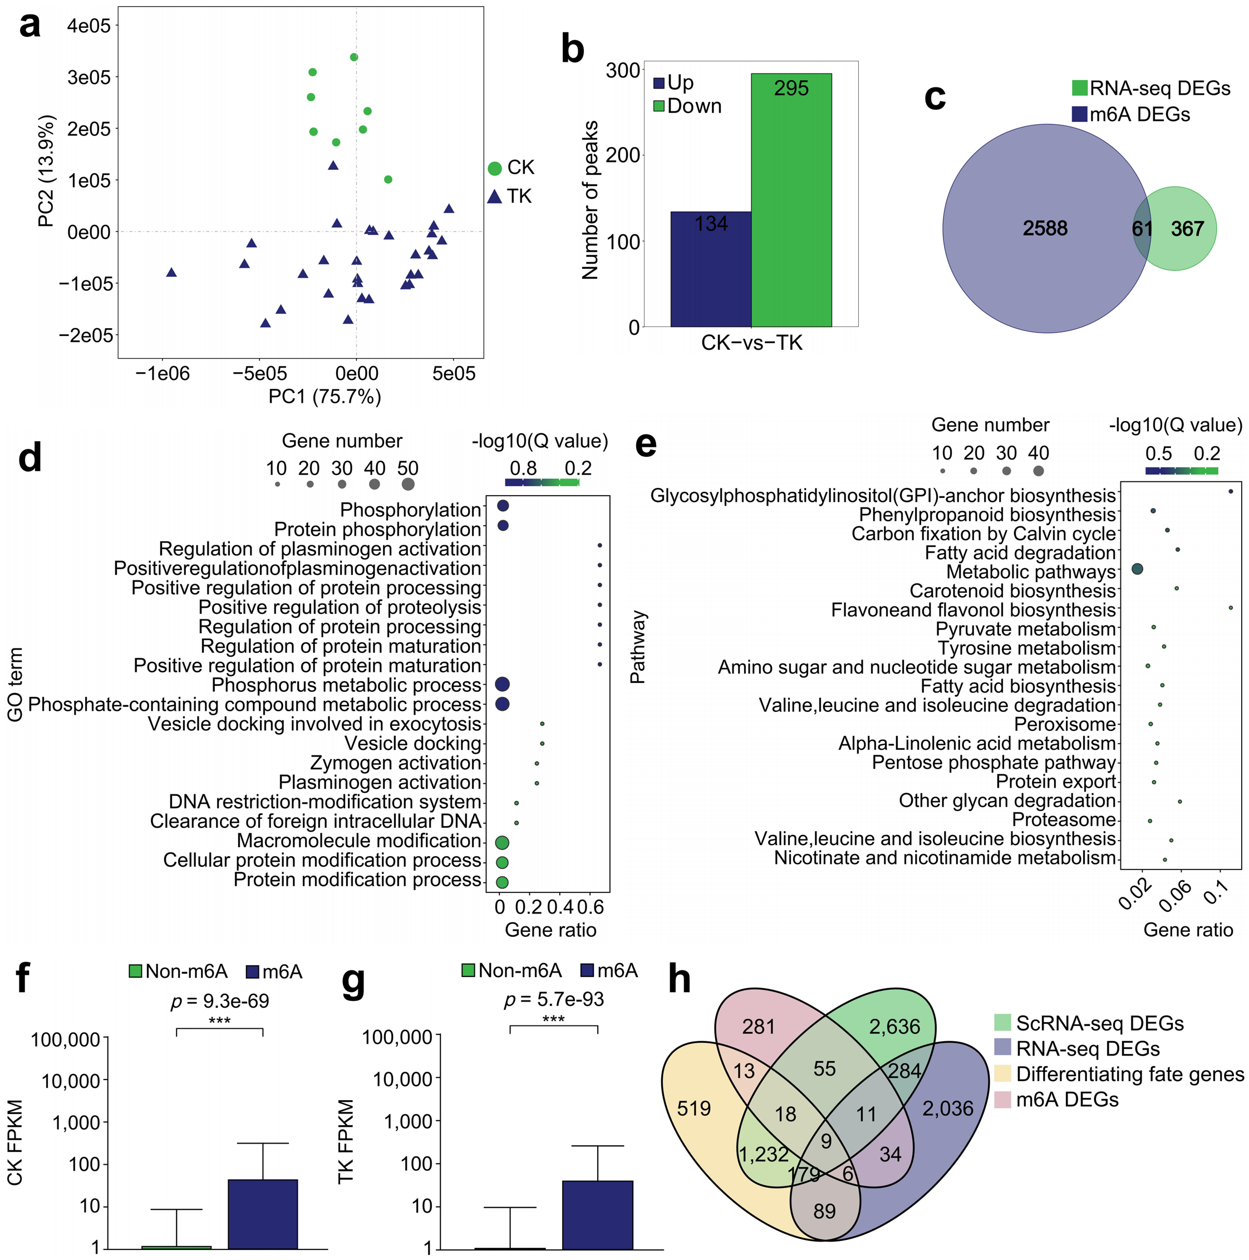
Supplementary Fig. 6 m6A modification after deep-space flight. a PCA analysis plot of CK and TK. b Number of upregulated and downregulated peaks. c Intersection of m6A differential peaks and RNA-seq DEGs. d GO enrichment of differential peak genes, top 20 biological processes based on -log10(Q value), circle size represents the number of genes, color represents significance level. e KEGG enrichment of differential peak genes, top 20 pathways based on -log10(Q value), circle size represents the number of genes, color represents significance level. f Expression level differences of mRNAs with and without m6A modification in CK samples. g Expression level differences of mRNAs with and without m6A modification in TK samples. h Intersection of RNA-seq DEGs, scRNA-seq intergroup differential genes, scRNA-seq genes affecting cell differentiation fate, and m6A differential peak genes.
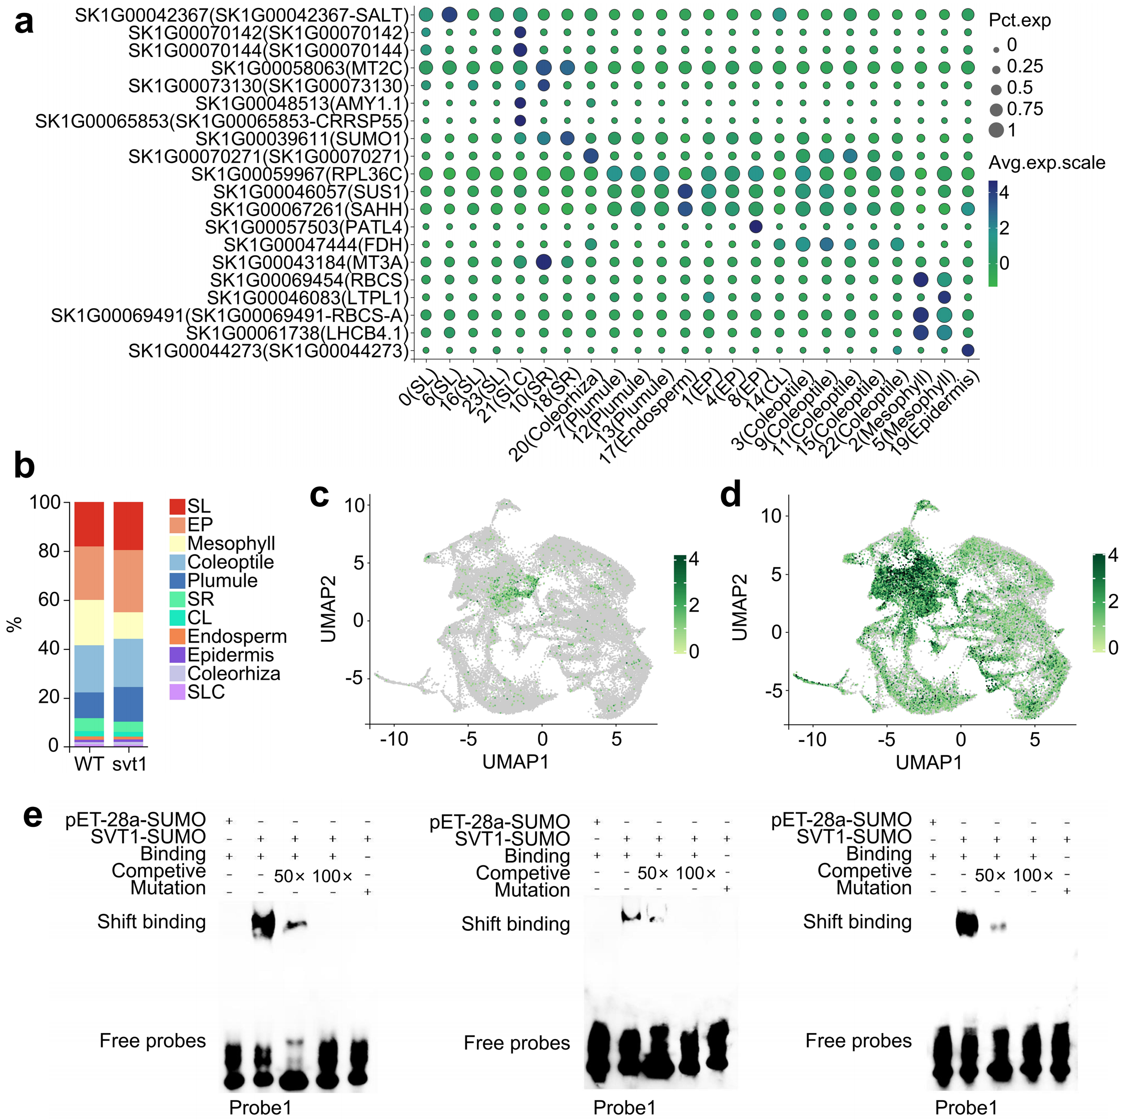
Supplementary Fig. 7 SVT1-mediated MAPK pathway inhibits genomic variation transmission. a Rice seed embryo cell marker, circle size represents the relative percentage of cells expressing the marker gene, and color represents the relative expression level. b Proportions of different cell types and cell regions in WT and svt1. c Expression distribution of SVT1 in different cells, color represents expression level. d Expression distribution of SK1G00063486 in different cells, color represents expression level. e Detection sites probe showed bands for the probe verification group and the competitive binding assay group, and the probe bands in the competitive binding reaction group gradually weakened, while no probe bands were observed in the mutant probe group.

Abnormal function of DNA damage repair genes leads to accumulation of TK15 mutations
Among the 30 TK samples in this study, TK15 exhibited unique variation characteristics at the genomic and transcriptome levels, with a total of 265,320 genomic variations, accounting for 95.82% of the total mutations (Supplementary Fig. 8a). Comparing with a single sample, TK15 had the highest number of DEGs, with 9,821 upregulated DEGs and 6,467 downregulated DEGs (Supplementary Fig. 8b). The number of mutations in the CDS region of TK15 is 55,717, distributed across 8,881 genes. Among them, 11,450 mutation sites cause amino acid changes in 4,268 genes, accounting for 48.05% of the total number of TK15 mutation genes (Supplementary Fig. 8c). KEGG enrichment was performed on the mutated genes, and significant enrichment was observed in DNA damage repair pathways such as homologous recombination (Supplementary Fig. 8d). A total of 44 genes were involved in DNA damage repair related pathways, of which 19 genes encoded altered amino acids. Except for TK15, the 29 samples had 11,578 mutations in the CDS region, located on 1,123 genes. However, only 306 mutation sites caused amino acid changes in 186 genes, accounting for 16.6% of the total number of mutated genes (Supplementary Fig. 8e). Therefore, the genomic variation sites of TK15 cause more changes in the function of DNA damage repair related genes.
In the transcriptome WGCNA results, we observed that the grey60 and yellow modules were specifically expressed in TK15 (Supplementary Fig. 8f), with a total of 758 genes included in both modules. Among the genes identified by transcriptome analysis, a total of 701 genes were annotated with functions related to DNA damage repair. Among them, 232 genes had at least one mutation from TK15 in their ontology, and 109 genes caused amino acid changes. Eight genes were specifically expressed in TK15 (Supplementary Fig. 8g). Comparing the expression levels of non mutated DNA damage repair genes, mutated genes that did not cause amino acid changes, and genes that caused amino acid mutations, it can be seen that the expression level of amino acid mutated genes is relatively lower (Supplementary Fig. 8h, Supplementary Data 10). In summary, the mutations present in TK15 cause abnormal expression of DNA damage repair related genes, and genomic variations cannot be identified and repaired, ultimately leading to the accumulation of TK15 mutations.
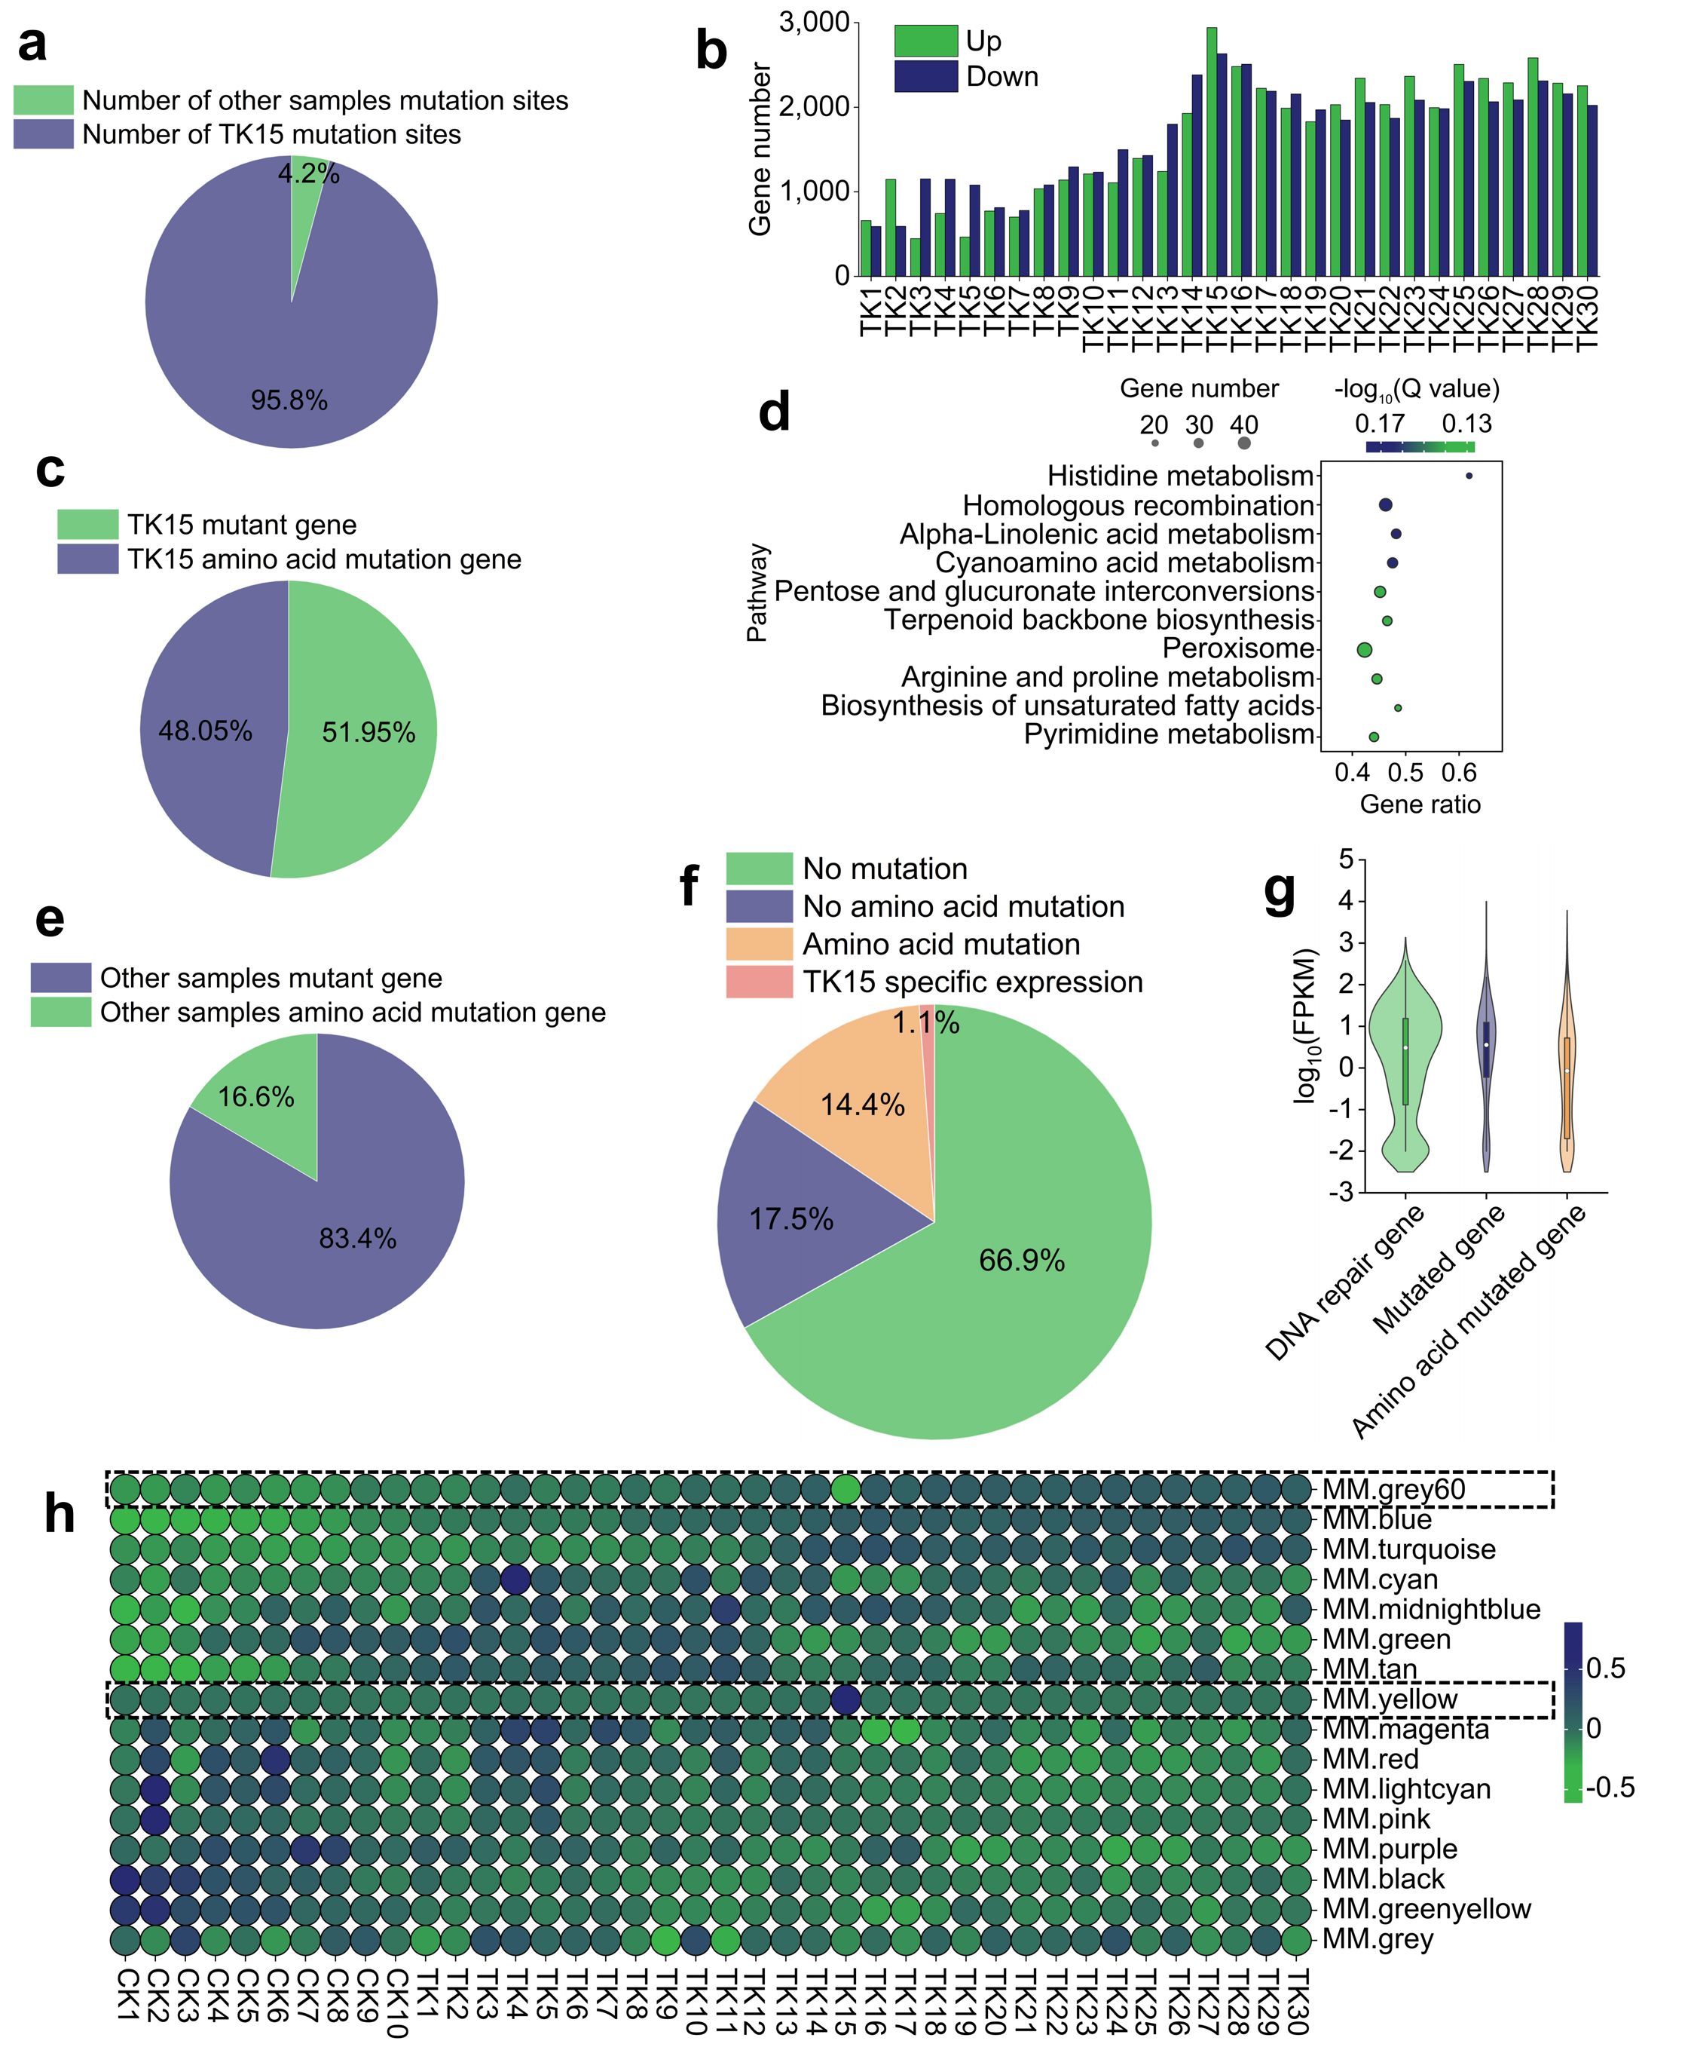
Supplementary Fig. 8 Abnormal function of DNA damage repair genes leads to accumulation of TK15 mutations. a The proportion of TK15 variant sites in the total variation. b The number of DEGs in 30 TK samples. c The proportion of mutation sites causing amino acid changes in TK15 to the total number of mutation sites. d TK15 contains mutation site gene KEGG enrichment, top 10 pathways based on -log10(Q value), circle size represents the number of genes, color represents significance level. e The proportion of the remaining 29 TK mutation sites causing amino acid changes to the total number of mutations. f WGCNA analysis of TK samples, the darker the color, the higher the expression. g The proportion of genes with no mutations in TK15, genes that do not cause amino acid changes, genes that cause amino acid changes, and genes specifically expressed in TK15. h Comparison of expression levels of amino acid mutant genes, non mutant DNA damage repair genes, and mutant genes that do not cause amino acid changes. The dashed box represents the two modules specifically expressed by TK15.

Supplementary Table 1 EMSA probe sequence.
Name | Probe sequence（5´→3´） | Purpose
Probe1 | ataatgaaggCTTAGCAAACACGCAACGAggatgtgct | Marker probe
mProbe1 | ataatgaaggTTTTTTTTTTTTTTTTTTTggatgtgct | Labeled mutation probe
Probe2 | aaagaacacgtCGCATGCATtcatgcatgt | Marker probe
mProbe2 | aaagaacacgtTTTTTTTTTtcatgcatgt | Labeled mutation probe
Probe3 | acctgctggtATGCATGAAttatttaaagt | Marker probe
mProbe3 | acctgctggtTTTTTTTTTttatttaaagt | Labeled mutation probe

