SUPPLEMENTARY MATERIAL

- Identification of cnidarians assemblages for habitats selection

A multivariate analysis was applied to the presence/absence matrix of species or taxa of cnidarians, obtained from beam trawl and rocky dredge samples collected during the INTEMARES research surveys developed in the seamounts of the Mallorca Channel (Balearic Islands, western Mediterranean). These data were complemented by imagery identification obtained through photogrammetric sledge and ROV transects developed during these surveys and also ROV transects made during the LIROBAL_0516 research survey (Guijarro, 2016) and Oceana expeditions (Marín et al., 2011a; Oceana, 2014) in the area.

With the Primer 6 software (Primer, Plymouth, UK), we carried out a cluster analysis and a Similarity Percentage Analysis (SIMPER; Clarke and Warwick, 1994). To do so, the Sørensen-Dice coefficient was used to calculate a between-sample similarity matrix. Then samples were linked into clusters using the Unweighted Pair-Group Method with Arithmetic Mean. These groups detected were considered assemblages. Then, SIMPER analysis was used to identify the most important species contributing to within group similarity.

Five groups were identified at a 20% similarity level (Figure S1). The bathymetric range and the number of samples by group are the following: A) 38 samples between 116 and 433 m; B) 19 samples between 120 and 293 m; C) 60 samples between 104 and 895 m; D) 16 samples between 99 and 649 m; and E) 65 samples between 87 and 693 m. The results of SIMPER analysis applied to these groups are shown in Figure Table S1. Modelling was performed for the Cnidaria A and Cnidaria E groups identified through the cluster analysis, based on data availability.

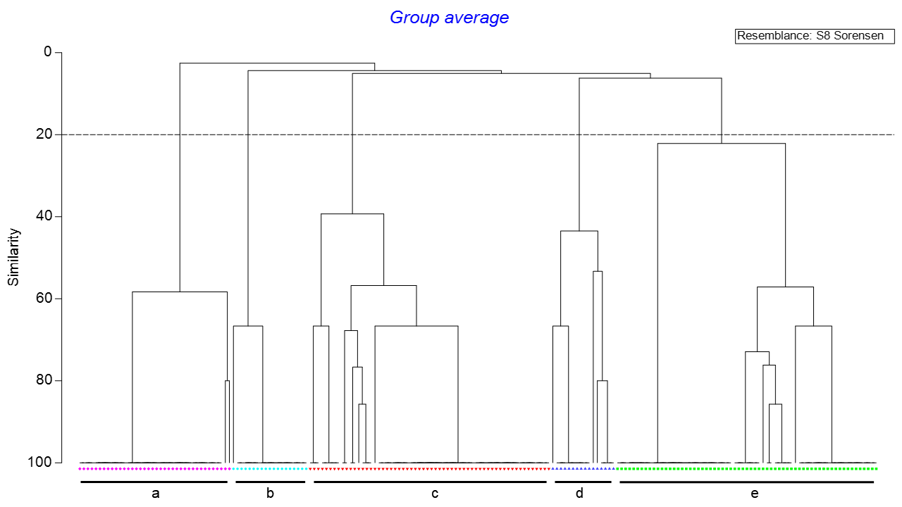
Figure S1.- Cluster analysis of the presence/absence matrix of species or taxa of cnidarians from samples collected with beam trawl and rocky dredge in the seamounts of the Mallorca Channel (Balearic Islands, western Mediterranean).
Table S1.- SIMPER analysis of the five groups identified in the cluster analysis of the presence/absence matrix of species or taxa of cnidarians from samples collected with beam trawl and rocky dredge in the seamounts of the Mallorca Channel (Balearic Islands, western Mediterranean). Sim: average similarity; SD: standard deviation; %Sim: percentage contribution to similarity.

Groups | Species | Sim | Sim/SD | %Sim | Σ%Sim
A (Sim: 95.7%) | Bebryce mollis | 95.65 | 7.31 | 99.94 | 99.94
A (Sim: 95.7%) | Callogorgia verticillata | 0.06 | 0.04 | 0.06 | 100
B (Sim.: 96.5%) | Viminella flagellum | 96.49 | 9.4 | 100 | 100
C (Sim.: 75.7%) | Callogorgia verticillata | 74.07 | 2.32 | 97.85 | 97.85
C (Sim.: 75.7%) | Savalia savaglia | 1.02 | 0.12 | 1.34 | 99.19
C (Sim.: 75.7%) | Acanthogorgia spp. | 0.31 | 0.09 | 0.4 | 99.6
C (Sim.: 75.7%) | Eunicella spp. | 0.31 | 0.09 | 0.4 | 100
D (Sim.: 66.64%) | Dendrophyllia cornigera | 59.75 | 1.85 | 89.66 | 89.66
D (Sim.: 66.64%) | Madrepora oculata | 5.22 | 0.37 | 7.84 | 97.5
D (Sim.: 66.64%) | Acanthogorgia hirsuta | 1.67 | 0.23 | 2.5 | 100
E (Sim.: 53.23%) | Eunicella spp. | 32.34 | 0.8 | 60.76 | 60.76
E (Sim.: 53.23%) | Acanthogorgia hirsuta | 20.41 | 0.61 | 38.34 | 99.09
E (Sim.: 53.23%) | Viminella flagellum | 0.44 | 0.12 | 0.82 | 99.92
E (Sim.: 53.23%) | Bebryce mollis | 0.04 | 0.04 | 0.08 | 100

Table S2.- Potential benthic habitats modeled in the seamounts of the Mallorca Channel (Balearic Islands, western Mediterranean), showing the Habitat-Forming species (HFS) and crosswalks highlighting their possible equivalences to the Habitats Directive (HD), EUNIS, and the Standard List of Marine Habitats in Spain (SLMH; Templado et al., 2012) classifications. A code used by habitat is also shown.

Code | Habitat | HFS | HD | EUNIS | SLMH
H1 | Maërl/rhodolith beds | Maërl/Rhodolith species | 1110 | MC352: Assemblages of Mediterranean coastal detritic bottoms biocenosis with rhodoliths (level 4) | 03040506: Maërl/rhodolith beds  304051601: Infralittoral and circalittoral detritic platforms of seamounts associated with rhodoliths  03040516: Infralittoral and circalittoral detritic platforms of seamounts
H2 | Rocky summits of seamounts in the circalittoral zone with Eunicella spp. | Eunicella spp. | 1170 | MC1519: Facies with Eunicella cavolini (level 5) | 0302022604: Rocky summits of seamounts in the circalittoral zone with Eunicella verrucosa  0302022502: Coralligenous with Eunicella verrucosa  0302022307: Unconsolidated circalittoral rock dominated by invertebrates with Eunicella cavolini
H3 | Infralittoral and circalittoral detritic platforms of seamounts with rhodoliths dominated by sponges | Foraminospongia balearica | 1110 | MC151G: Facies with massive sponges and sparse red algae (level 5)  MD451: Biocenosis of Mediterranean open-sea detritic bottoms on shelf-edge (level 4)  MC45: Mediterranean circalittoral mixed sediment (level 3) | 0304051604: Infralittoral and circalittoral detritic platforms of seamounts associated with rhodoliths dominated by sponges  0302022606: Rocky summits of seamounts in the circalittoral zone with sponge fields
H4 | Rocky summits of seamounts in the circalittoral zone with Viminella flagellum | Viminella flagellum | 1170 | MC1519: Coralligenous biocenosis (level 4) | 0302022601: Rocky summits of seamounts in the circalittoral zone with coralligenous assemblages
H5 | Deep rocky bottoms with aggregations of gorgonians | Cnidaria group E, with Eunicella spp., Acanthogorgia hirsuta, V. flagellum and B. mollis as main species. See Figure S1 and Table S1 | 1170 | MD25: Mediterranean offshore circalittoral biogenic habitat (level 3) | 0302022901: Deep rocky bottoms with aggregations of gorgonians  0302022901: Scarps, walls, and rocky slopes of seamounts and canyons in the circalittoral zone with anthozoans (scleractinians, gorgonians, antipatharians)
H6 | Bathyal rock with octocorals (Bebrice mollis and Callogorgia verticillata) | Cnidaria group A, with Bebryce mollis and Callogorgia verticillata as main species. See Figure S1 and Table S1 | 1170 | MC352: Mediterranean upper bathyal rock (level 3) | 04010201: Bathyal rock covered with sediments and Bebryce mollis  04010104: Clean bathyal rock with Callogorgia verticillata
H7 | Bathyal shelf-edge bottoms with Gryphus vitreus | Gryphus vitreus facies | - | ME551: Biocenosis of Mediterranean upper bathyal detritic sands with Gryphus vitreus (level 4) | 0302022305: Unconsolidated circalittoral rock dominated by invertebrates with sponge dominance
H8 | Cliffs, walls, and rocky slopes of submarine elevations and canyons with sponges | Porifera group sA from Díaz et al., (2024a), with Jaspis, Tretodictyum reiswigi, Heteroxya cf. beauforti, Hamacantha spp., Poecillastra compressa and Phakellia robusta as main species. | 1170 | MD151: Biocenosis of Mediterranean shelf-edge rock (level 5) | 0302022902: Cliffs, walls, and rocky slopes of submarine elevations and canyons in the circalittoral zone with sponges
H9 | Bathyal detritic bottoms with sponges | Porifera group sF from Díaz et al., (2024a), with P. compressa, D. inornata, T. muricata, Hamacantha spp., Dragmatella aberrans and D. annexa as main species. | - | ME451: Assemblages of Mediterranean upper bathyal muds biocenosis characterized by mixed sediment (level 4) | 0402031109: Bathyal detritic bottoms with sponges
H10 | Bathyal muds with Thenea muricata | Porifera group sE from Díaz et al., (2024a), primarily with Thenea muricata, accompanied by Desmacella innornata and Desmacella annexa | - | ME6511: Mediterranean upper bathyal facies of sandy muds with Thenea muricata (level 5) | 0402020401: Bathyal muds with Thenea muricata
H11 | Bathyal muds with Isidella elongata | Isidella elongata | 1170 | ME6515: Mediterranean upper bathyal facies of compact muds with Isidella elongata (level 5) | 04020206: Compact bathyal muds with Isidella elongata  0402030702: Non-muddy bathyal sedimentary bottoms with Isidella elongata
H12 | Pockmark fields | Pockmarks | 1180 | ME6: Upper Bathyal mud (level 2)  ME65: Mediterranean upper bathyal mud (level 3) | 04020101: Pockmarks

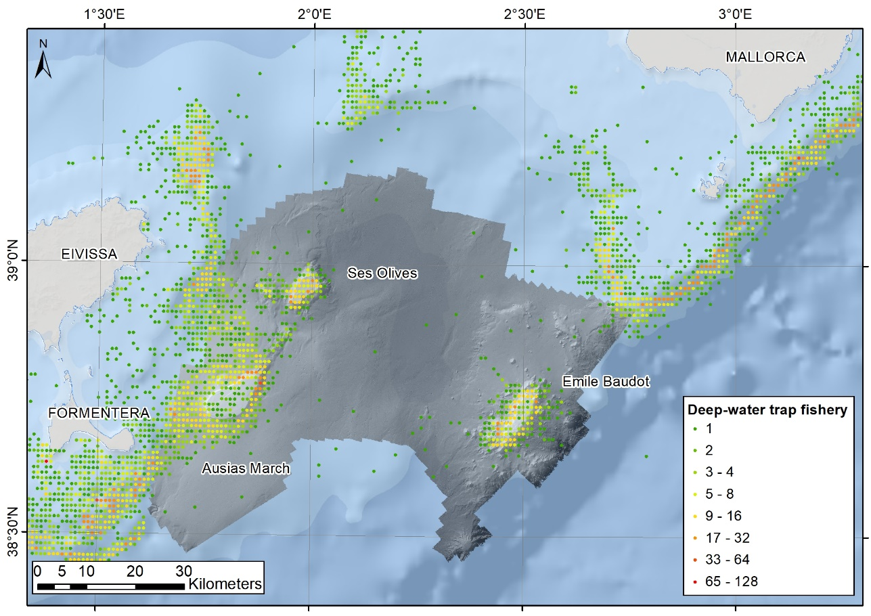
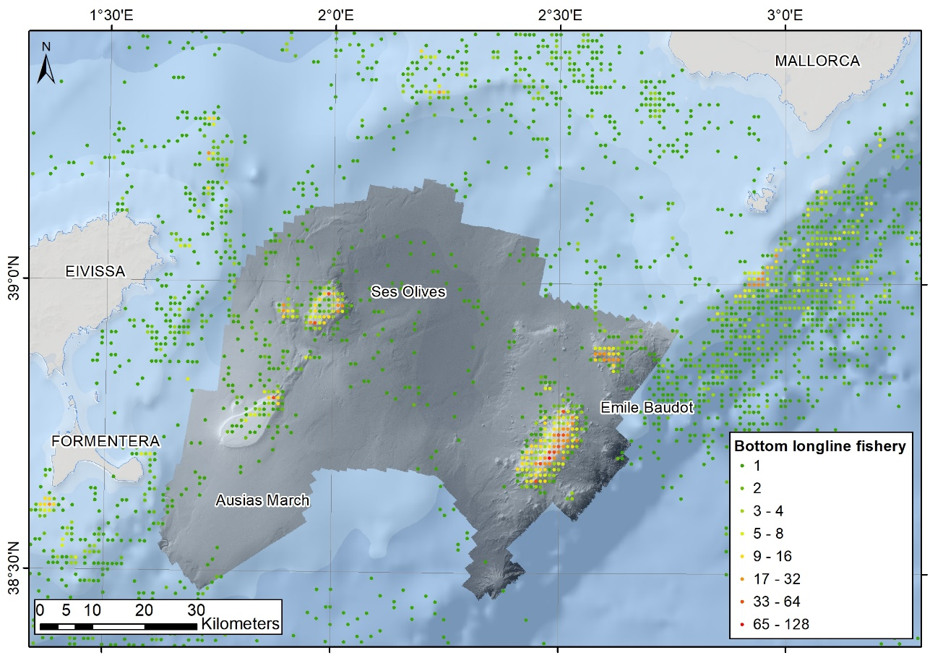

Figure S2.- Fishing footprint of the deep-water trap (above) and the bottom longline (below) fleets in the Mallorca Channel seamounts (Balearic Islands, western Mediterranean). The different colors represent the mean annual VMS (Vessel Monitoring by satellite System) signals per 0.01×0.01° grid cell during the period 2010-2019.
Table S3.- Spearman correlations for collinearity analysis between environmental and fisheries variables in the seamounts of the Mallorca Channel (Balearic Islands, western Mediterranean). Variables with a correlation of ±0.7 or higher are shown in bold. D= depth (m); SLP= slope (º); BKS= backscatter (dB); RUG= rugosity; ASP= aspect; NOR= Northness; EST= Eastness; BPI_{F}= fine BPI; BPI_{B}= broad BPI; OM= organic matter content (%); CN= % carbonates; GRV= % gravel; SAN= % sand; MUD= % mud; D50 = median grain size; SC_{av}= surface current average speed (m/s); SC_{max}= surface current maximum speed (m/s); SC_{v}= surface current variability (standard deviation); SC_{d}= surface current direction (º); BC_{av}= bottom current average speed (m/s); BC_{max}= bottom current maximum speed (m/s); BC_{v}= bottom current variability (SD); BC_{d}= bottom current direction (º); ST_{av}= surface temperature average (ºC); BT_{av}= bottom temperature average (ºC); ST_{v}= surface temperature variability (standard deviation); BT_{v}= bottom temperature variability (standard deviation); BLL= bottom longline fishery (number of VMS signals); DWT= deep-water trap fishery (number of VMS signals); DTFG= distance to the nearest trawling fishing ground (m). VMS: Vessel Monitoring by satellite System.

