We have done preliminary studies to confirm the dose at which memory dysfunction starts while using STZ as toxin.
Following are the results-

Effect of different doses of STZ on blood glucose level in adult zebrafish
Groups (mg/kg) | Blood Glucose Level (mg/dl)
Normal | 69 ± 8.91
STZ (50) | 134 ± 8.63ª
STZ(100) | 145 ± 7.33 ^{a,b}
STZ (200) | 130 ± 16.07 ^{a,c}
STZ (300) | 157 ± 36.08 ^{a, d}
STZ (400) | 210 ± 31.02 ^{a,e}
STZ (500) | 255 ± 52.54 ^{a, f}
STZ (600) | 293 ± 47.54 ^{a,g}

Data were expressed as mean±SD, n=6 zebrafish per group. ªp<0.05 vs normal group; ^{b}p<0.05 vs STZ (50); ^{c}p<0.05 vs STZ (100); ^{d}p<0.05 vs STZ (200); ^{e}p<0.05 vs STZ (300); ^{f}p<0.05 vs STZ (400); ^{g}p<0.05 vs STZ (500). [Abbreviation: STZ-Streptozotocin].

Effect on the memory dysfunction of adult Zebrafish in T-maze apparatus
After intraperitonial STZ administration at different doses (50, 100, 200, 300, 400, 500, 600 mg/kg) there was significant (p<0.0001) memory impairment in adult zebrafish. Results of T-maze indicate the decline in time spent in favorable zone (TSFZ), increase in time spent in unfavorable zone (TSUFZ) and increase in the TL at the dose of STZ (300 mg/kg and above) as compared to the normal group as shown in the figures 4 (a, b and c) which is the indicator of spatial and visual memory loss.

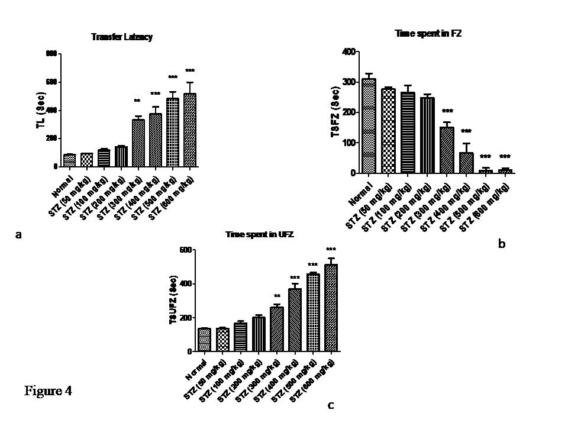
Effect of different doses of STZ on the memory dysfunction of adult Zebrafish in light and dark chamber test
In light-dark chamber test, administration of different doses of STZ produces significant (p<0.05) decline in memory functions in dose dependent manner. The results indicate that the decline in time spent in light chamber and increase in time spent in dark chamber as compared to normal group at the dose of STZ (300 mg/kg and above) as shown in the figures 5 (a and b).
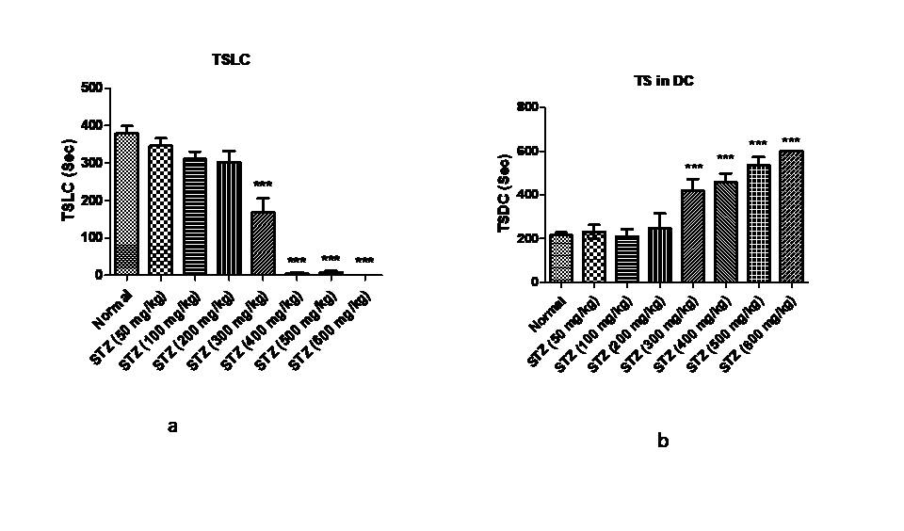

Effect of different doses of STZ on the oxidative stress parameter TBARS or LPO assay in zebrafish model of memory dysfunction
Intraperitonial injection of STZ at the dose of (300, mg/kg and above) start producing the significant (p<0.05) increase in brain LPO level when compared to normal group at the dose of STZ (300 mg/kg and above) as shown in figure 6.
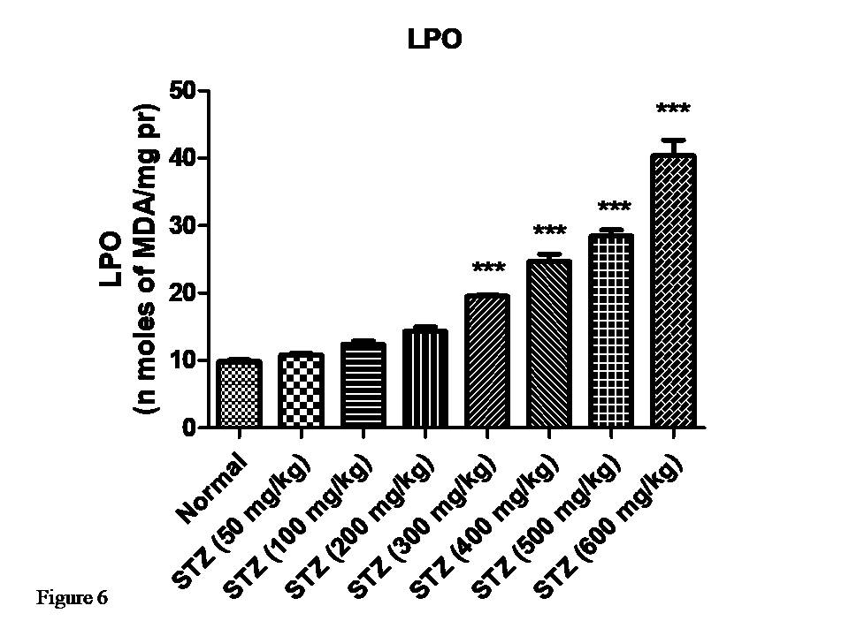

- Effect of different doses of STZ on AChEs level in zebrafish model of memory dysfunction
Hyperglycemia changes the learning and memory parameters in zebrafish. We demonstrated that intraperitoneal administration of STZ (300 mg/kg and above) in adult zebrafish significantly (p<0.05) induced increased level of AChEs activity in the brain as compared to the normal group as shown in figure 7.
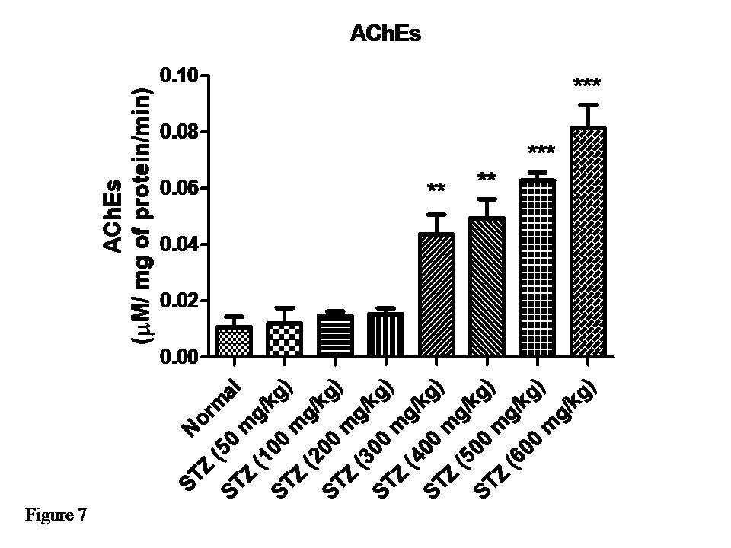

Conclusion: We found that STZ at the dose of 300 mg/kg start producing Cognitive dysfunction in Zebrafish.
So, we have used this dose STZ at the dose of 300 mg/kg to check the protective effect of Quercetin in adult zebrafish.

