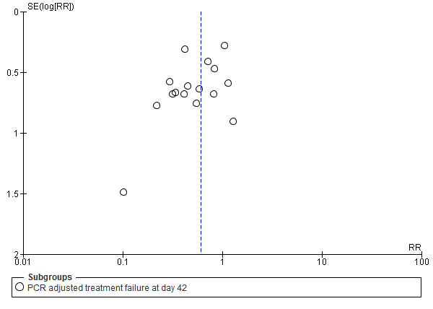
Additional file S9: Funnel plot of comparison: dihydroartemisinin-piperaquine versus artemether-lumefantrine for treatment of uncomplicated plasmodium falciparum malaria among children in Africa, outcome: PCR adjusted treatment failure at day 42.

