Supplementary Material

Content
Figure S1 Histogram of regression standardized residuals for willingness to use medical visit companion services. 2
Figure S2 Normal P-P plot of regression standardized residuals for willingness to use medical visit companion services. 3

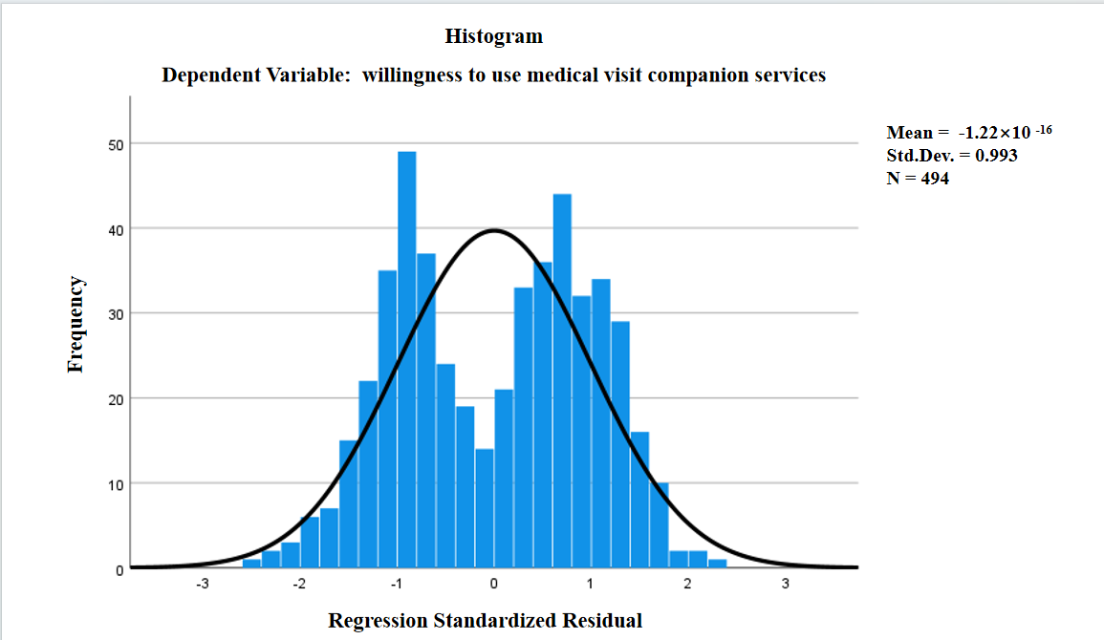

Figure 1 Histogram of regression standardized residuals for willingness to use medical visit companion services.

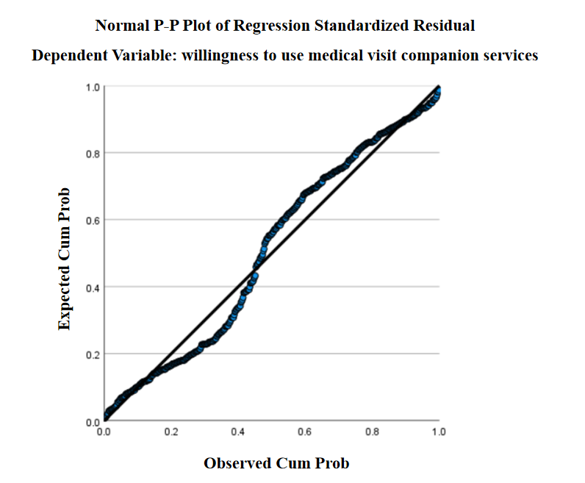
Figure 2 Normal P-P plot of regression standardized residuals for willingness to use medical visit companion services.

