Supporting Information
Crystal structure and biological evolution of 5-bromothiophene based 3,4-dihydropyrimidin-2-(1H)-thi(ones)

Mayank G. Sharma ª, Ruturajsinh M. Vala ª, Dhanji P. Rajani ^{b}, Venkatachalam Ramkumar ^{c}, Sourav Banerjee^{d}, Ramesh L. Gardas ^{c}, and Hitendra M. Patelª*

ª Sardar Patel University, Department of Chemistry, University Campus, Vallabh Vidyanagr- 388 120, Gujarat, India
^{b} Micro care Laboratory, Surat, Gujarat, India
^{c} Department of Chemistry, Indian Institute of Technology, Madras, India.
^{d} Department of Cellular Medicine, School of Medicine, University of Dundee, Dundee DD1 9SY, UK.
*Author for correspondence
Prof. Hitendra M. Patel (Email: hm_patel@spuvvn.edu).
†Present address: Department of Chemistry, Sardar Patel University, University Campus, Vallabh Vidyanagar 388 120, Gujarat, India

Table of Content
Sr. No. | Title | Page No.
1 | Bioavailability Radars of compound 4(a-j) | 02-03
2 | ¹H-NMR spectra | 04-08
3 | Selected ¹³C-APT spectra | 09-12
4 | Selected ATR-FTIR spectra | 13-17
5 | Single Crystal X-ray diffraction | 18-21

- Bioavailability Radars of compound 4(a-j)

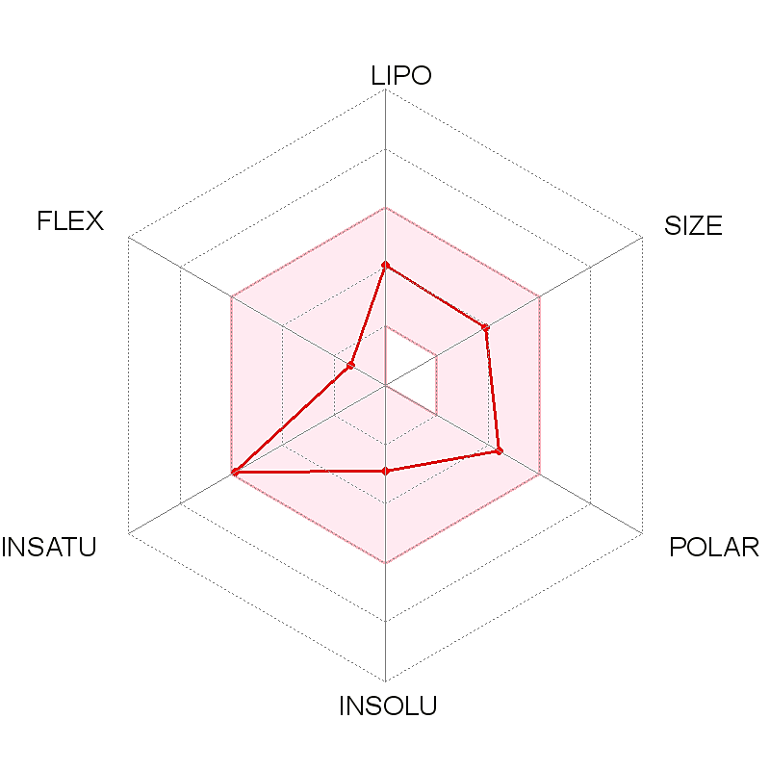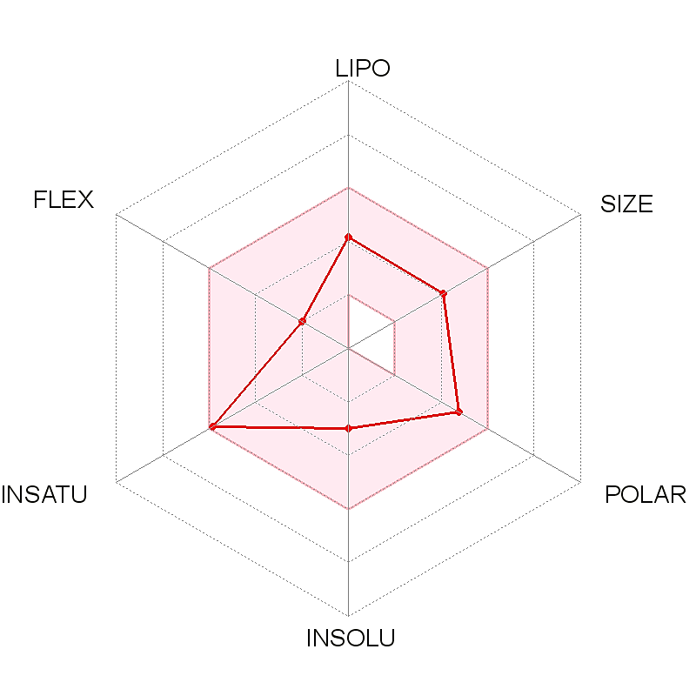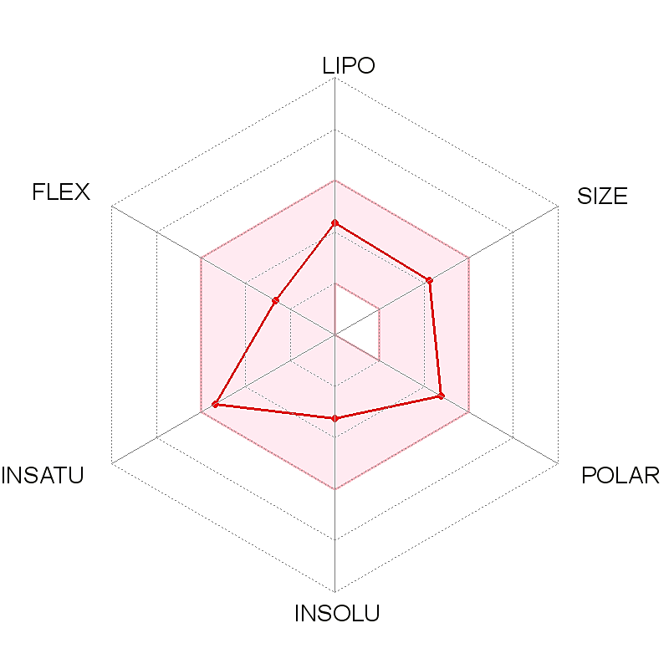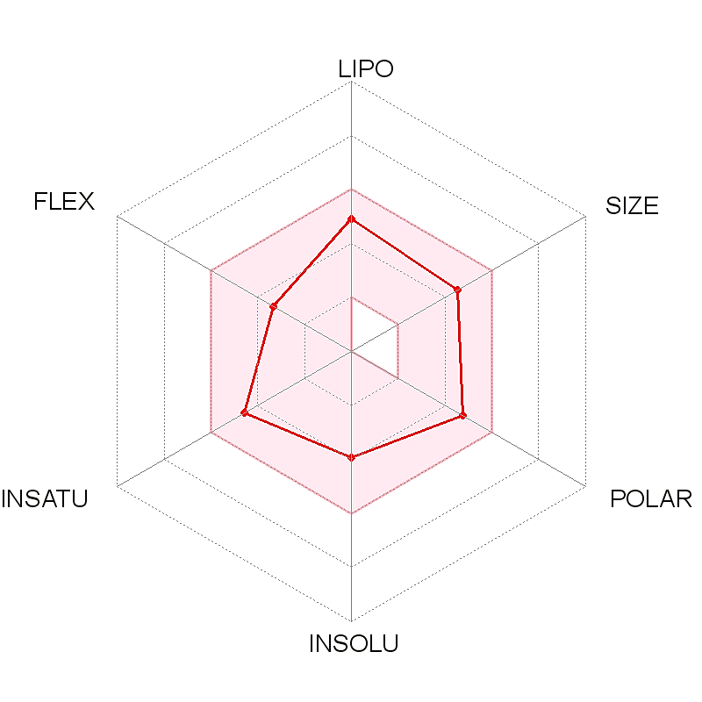
4d
4c
4a
4b
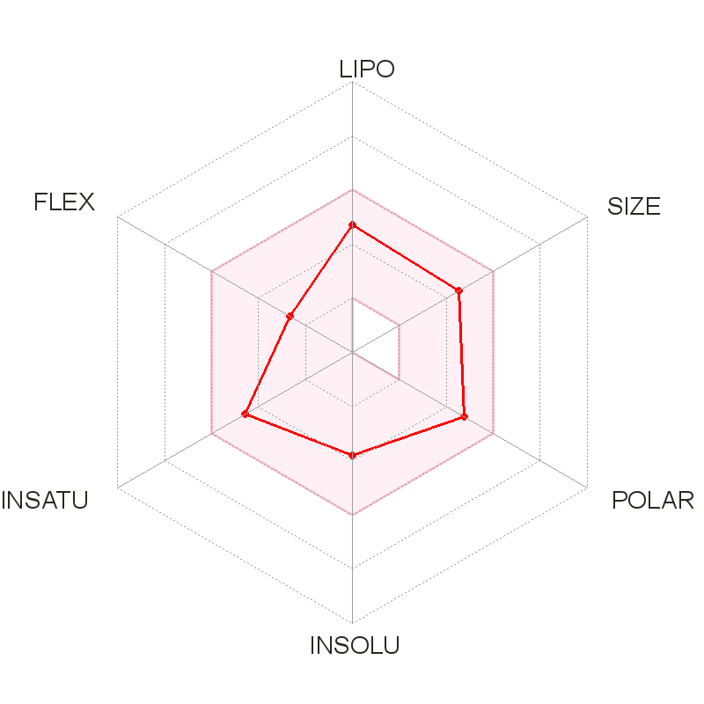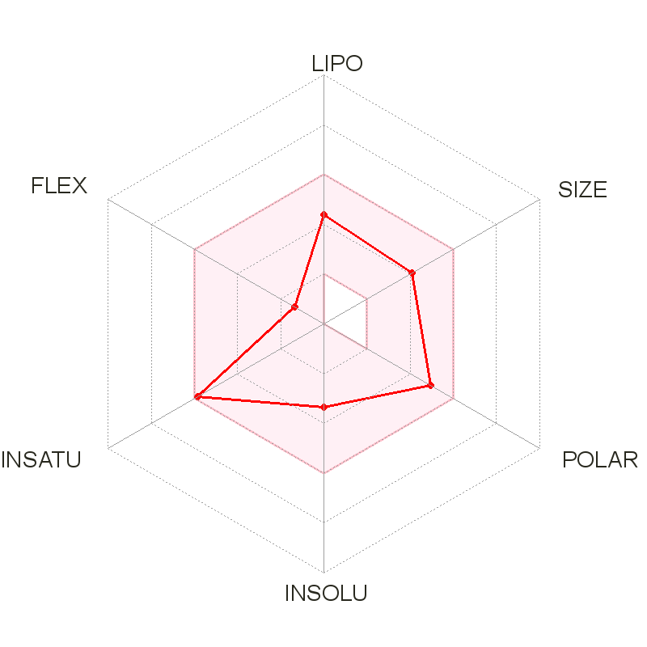
4e
4f
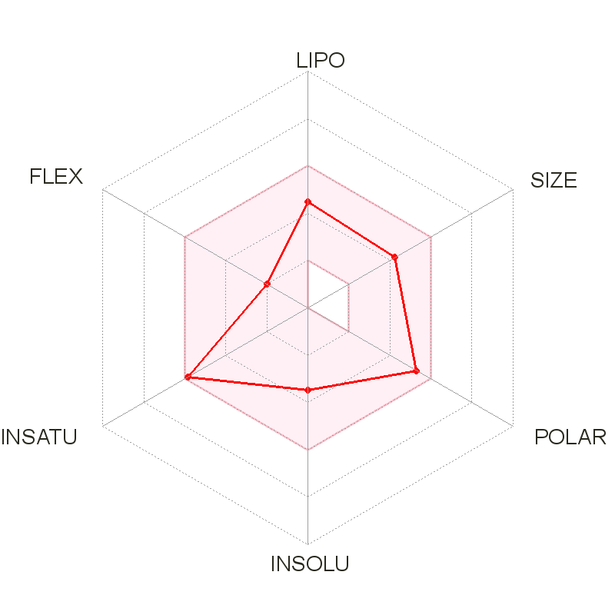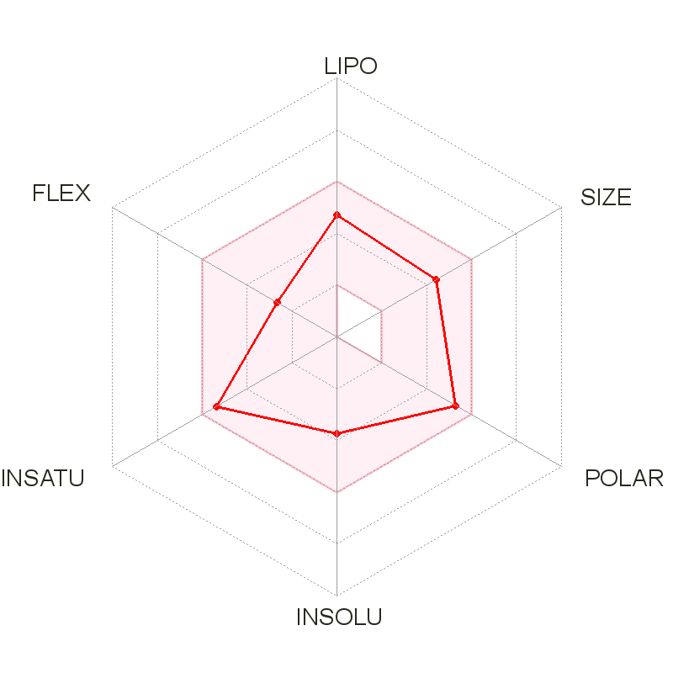
4h
4g
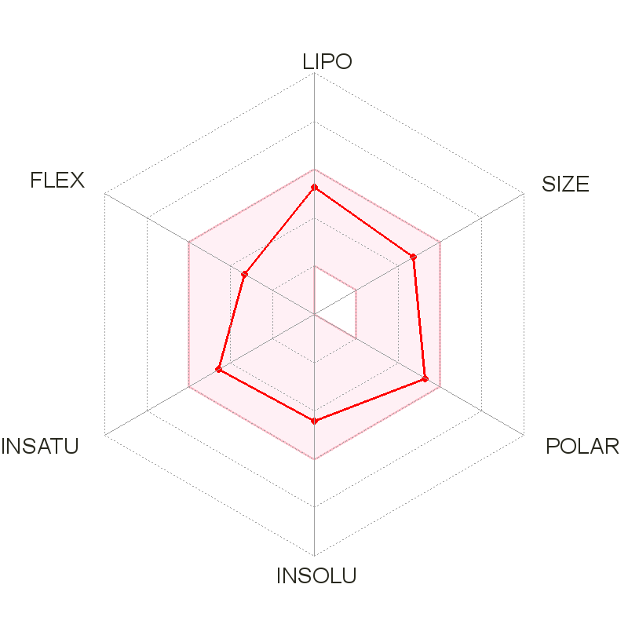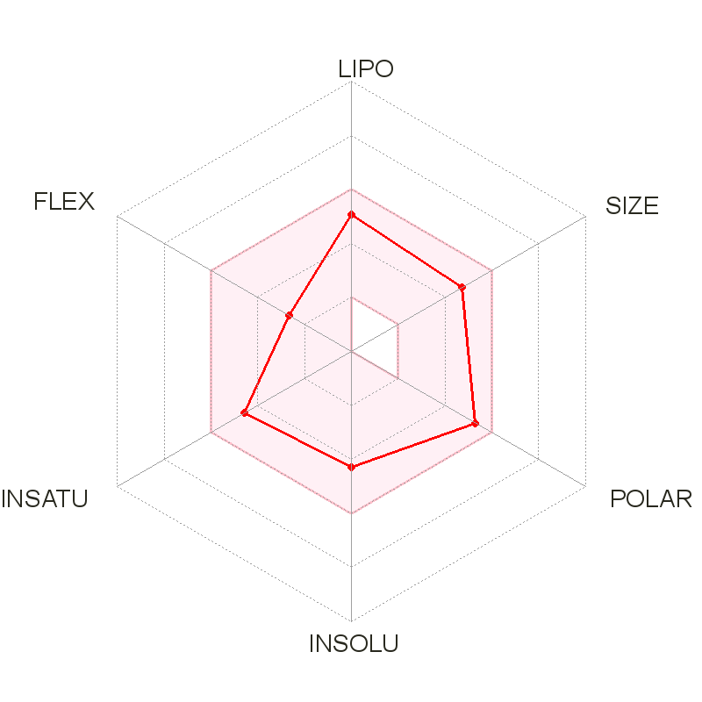
4j
4i
- ¹H-NMR data of compounds 4(a-j)
Compound 4a
Compound 4b
Compound 4c
Compound 4d
Compound 4e
Compound 4f
Compound 4g
Compound 4h
Compound 4i
Compound 4j
- Selected ¹³C-APT data of compounds 4(a-j)
Compound 4a
Compound 4b

Compound 4c
Compound 4d
Compound 4e
Compound 4f
Compound 4g
Compound 4h
- ATR-FTIR spectra of compounds 4(a-j)

Compound 4a
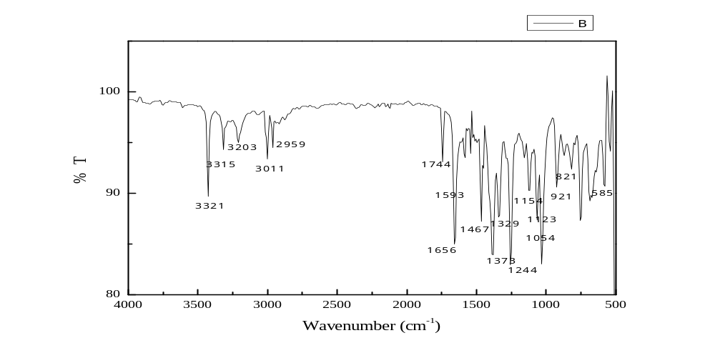

Compound 4b
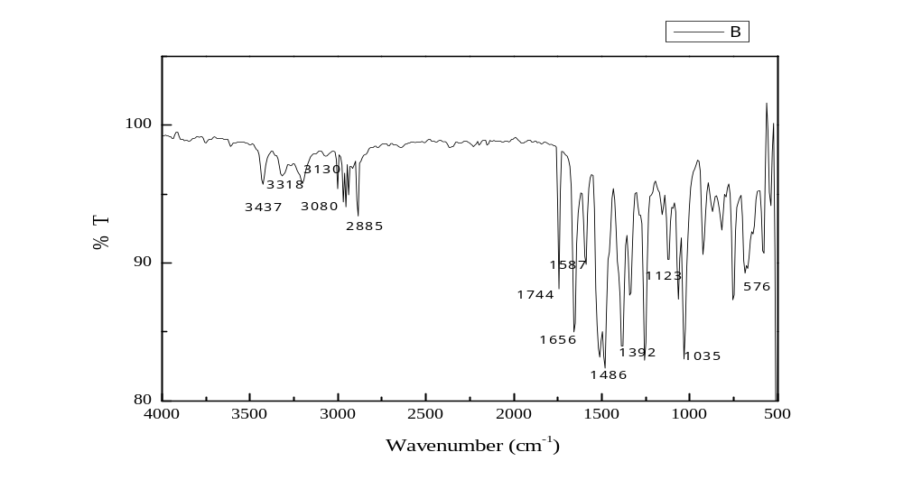

Compound 4c
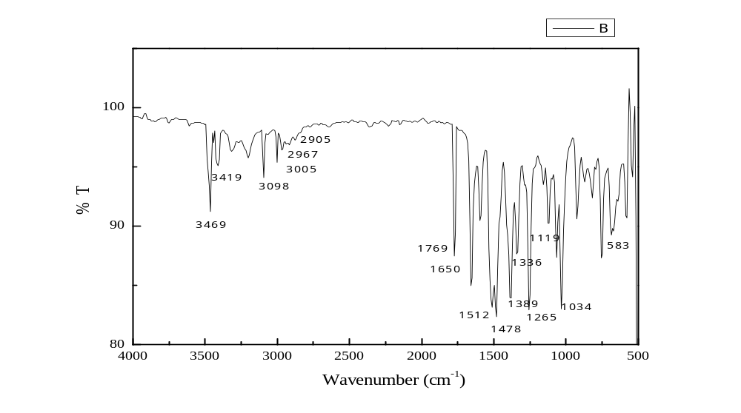

Compound 4d
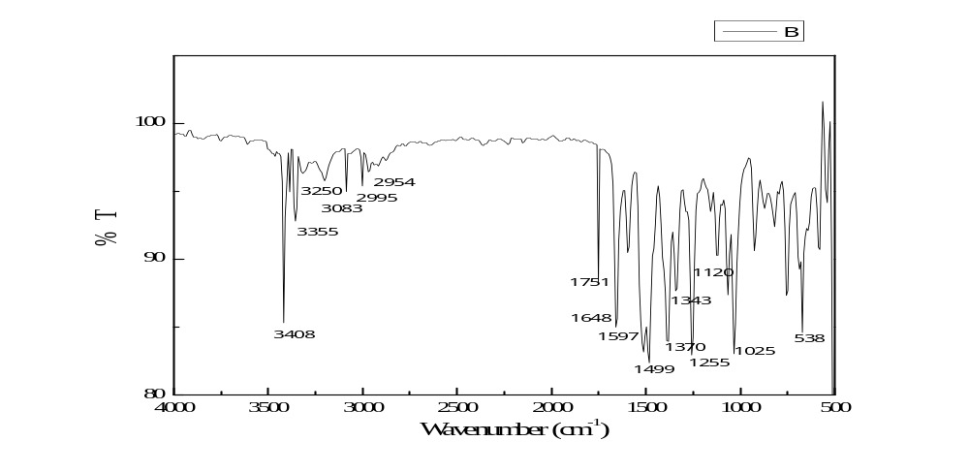

Compound 4e
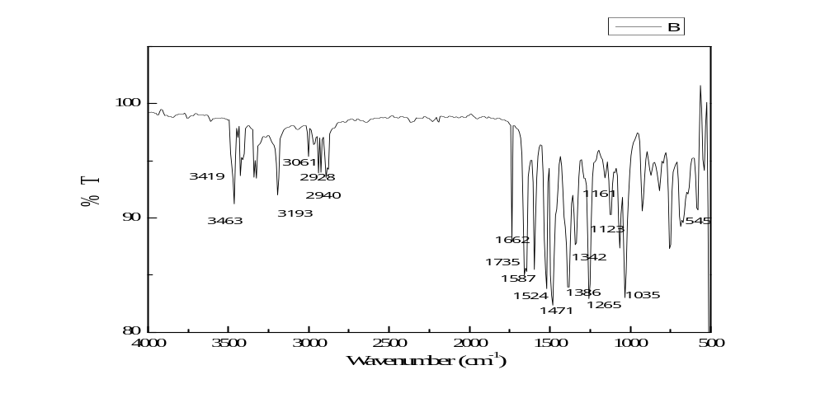

Compound 4f

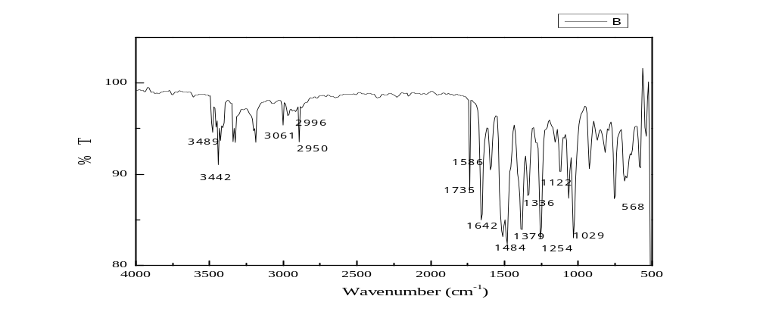

Compound 4g
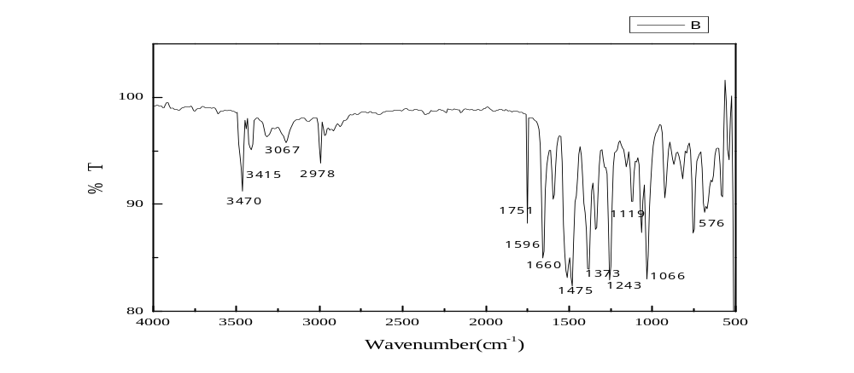

Compound 4h
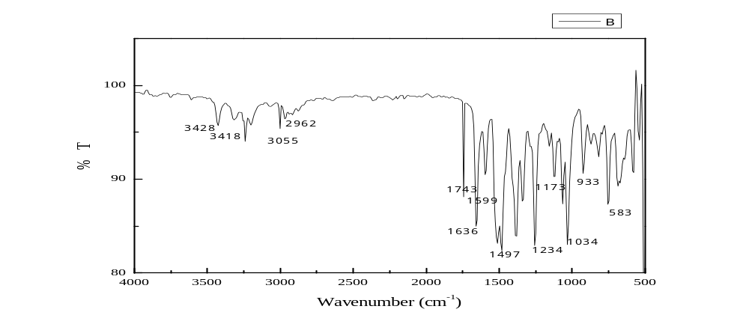

Compound 4i
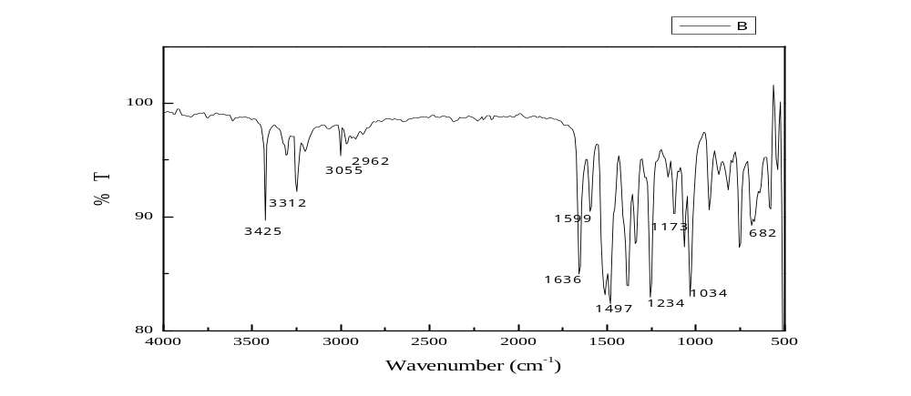

Compound 4j
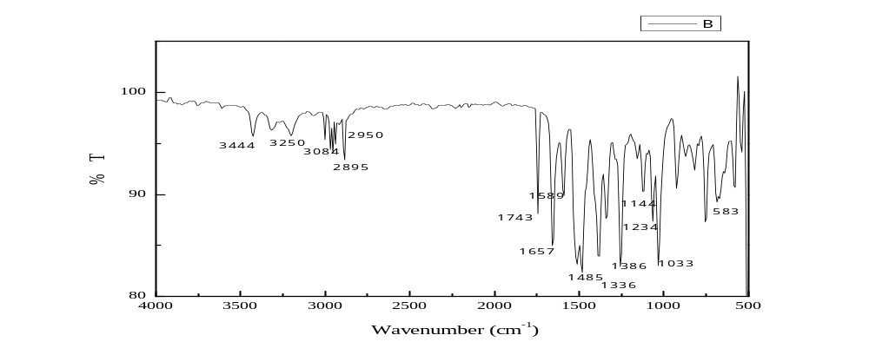

Single crystal X-ray diffraction analysis of compound 4c

checkCIF (basic structural check) running

Checking for embedded fcf data in CIF ...
Found embedded fcf data in CIF. Extracting fcf data from uploaded CIF, please wait . .

checkCIF/PLATON (basic structural check)

Structure factors have been supplied for datablock(s) MB1
THIS REPORT IS FOR GUIDANCE ONLY. IF USED AS PART OF A REVIEW PROCEDURE FOR PUBLICATION, IT SHOULD NOT REPLACE THE EXPERTISE OF AN EXPERIENCED CRYSTALLOGRAPHIC REFEREE.
No syntax errors found. CIF dictionary
Please wait while processing .... Interpreting this report
Structure factor report
Datablock: MB1

Bond precision: | C-C = 0.0123 A | Wavelength=0.71073

Cell: | a=7.3244(3) | b=13.5742(6) | c=14.8486(7)
 | alpha=94.044(2) | beta=103.959(2) | gamma=99.511(2)
Temperature: | 296 K

 | Calculated | Reported
Volume | 1403.57(11) | 1403.57(11)
Space group | P -1 | P -1
Hall group | -P 1 | -P 1
Moiety formula | C12 H13 Br N2 O3 S | C12 H13 Br N2 O3 S
Sum formula | C12 H13 Br N2 O3 S | C12 H13 Br N2 O3 S
Mr | 345.20 | 345.20
Dx,g cm-3 | 1.634 | 1.634
Z | 4 | 4
Mu (mm-1) | 3.082 | 3.082
F000 | 696.0 | 696.0
F000' | 695.63
h,k,lmax | 8,16,17 | 8,16,17
Nref | 4937 | 4920
Tmin,Tmax | 0.467,0.735 | 0.513,0.748
Tmin' | 0.458

Correction method= # Reported T Limits: Tmin=0.513 Tmax=0.748 AbsCorr = MULTI-SCAN

Data completeness= 0.997 | Theta(max)= 24.994

R(reflections)= 0.0802( 2720) | wR2(reflections)= 0.2405( 4920)

S = 1.062 | Npar= 374

The following ALERTS were generated. Each ALERT has the format
test-name_ALERT_alert-type_alert-level.
Click on the hyperlinks for more details of the test.

Alert level B
PLAT234_ALERT_4_B Large Hirshfeld Difference C19 --C20 . 0.26 Ang.
PLAT360_ALERT_2_B Short C(sp3)-C(sp3) Bond C19 - C20 . 1.25 Ang.

Alert level C
PLAT220_ALERT_2_C NonSolvent Resd 1 C Ueq(max) / Ueq(min) Range 5.7 Ratio
PLAT222_ALERT_3_C NonSolvent Resd 1 H Uiso(max)/Uiso(min) Range 8.6 Ratio
PLAT234_ALERT_4_C Large Hirshfeld Difference C23 --C24 . 0.18 Ang.
PLAT241_ALERT_2_C High MainMol Ueq as Compared to Neighbors of C22 Check
And 3 other PLAT241 Alerts
PLAT241_ALERT_2_C High MainMol Ueq as Compared to Neighbors of C23 Check
PLAT241_ALERT_2_C High MainMol Ueq as Compared to Neighbors of C11 Check
PLAT241_ALERT_2_C High MainMol Ueq as Compared to Neighbors of C12 Check
PLAT242_ALERT_2_C Low MainMol Ueq as Compared to Neighbors of C21 Check
And 3 other PLAT242 Alerts
PLAT242_ALERT_2_C Low MainMol Ueq as Compared to Neighbors of C24 Check
PLAT242_ALERT_2_C Low MainMol Ueq as Compared to Neighbors of C9 Check
PLAT242_ALERT_2_C Low MainMol Ueq as Compared to Neighbors of C10 Check
PLAT341_ALERT_3_C Low Bond Precision on C-C Bonds ............... 0.01233 Ang.
PLAT352_ALERT_3_C Short N-H (X0.87,N1.01A) N4 - H4N . 0.74 Ang.
PLAT431_ALERT_2_C Short Inter HL..A Contact Br2 ..S2A . 3.35 Ang.
-x,1-y,1-z = 2_566 Check
PLAT906_ALERT_3_C Large K Value in the Analysis of Variance ...... 3.468 Check
PLAT911_ALERT_3_C Missing FCF Refl Between Thmin & STh/L= 0.595 17 Report
PLAT978_ALERT_2_C Number C-C Bonds with Positive Residual Density. 0 Info

Alert level G
PLAT154_ALERT_1_G The s.u.'s on the Cell Angles are Equal ..(Note) 0.002 Degree
PLAT301_ALERT_3_G Main Residue Disorder ..............(Resd 1 ) 5% Note
PLAT793_ALERT_4_G Model has Chirality at C3 (Centro SPGR) R Verify
PLAT793_ALERT_4_G Model has Chirality at C15 (Centro SPGR) R Verify
PLAT860_ALERT_3_G Number of Least-Squares Restraints ............. 1 Note
PLAT883_ALERT_1_G No Info/Value for _atom_sites_solution_primary . Please Do !
PLAT910_ALERT_3_G Missing # of FCF Reflection(s) Below Theta(Min). 2 Note
PLAT992_ALERT_5_G Repd & Actual _reflns_number_gt Values Differ by 1 Check

0 ALERT level A = Most likely a serious problem - resolve or explain
2 ALERT level B = A potentially serious problem, consider carefully
17 ALERT level C = Check. Ensure it is not caused by an omission or oversight
8 ALERT level G = General information/check it is not something unexpected

2 ALERT type 1 CIF construction/syntax error, inconsistent or missing data
12 ALERT type 2 Indicator that the structure model may be wrong or deficient
8 ALERT type 3 Indicator that the structure quality may be low
4 ALERT type 4 Improvement, methodology, query or suggestion
1 ALERT type 5 Informative message, check

It is advisable to attempt to resolve as many as possible of the alerts in all categories. Often the minor alerts point to easily fixed oversights, errors and omissions in your CIF or refinement strategy, so attention to these fine details can be worthwhile. In order to resolve some of the more serious problems it may be necessary to carry out additional measurements or structure refinements. However, the purpose of your study may justify the reported deviations and the more serious of these should normally be commented upon in the discussion or experimental section of a paper or in the "special_details" fields of the CIF. checkCIF was carefully designed to identify outliers and unusual parameters, but every test has its limitations and alerts that are not important in a particular case may appear. Conversely, the absence of alerts does not guarantee there are no aspects of the results needing attention. It is up to the individual to critically assess their own results and, if necessary, seek expert advice.
Publication of your CIF in IUCr journals
A basic structural check has been run on your CIF. These basic checks will be run on all CIFs submitted for publication in IUCr journals (Acta Crystallographica, Journal of Applied Crystallography, Journal of Synchrotron Radiation); however, if you intend to submit to Acta Crystallographica Section C or E or IUCrData, you should make sure that full publication checks are run on the final version of your CIF prior to submission.
Publication of your CIF in other journals
Please refer to the Notes for Authors of the relevant journal for any special instructions relating to CIF submission.

PLATON version of 22/12/2019; check.def file version of 13/12/2019
Datablock MB1 - ellipsoid plot
