SUPPLEMENTARY
Supplementary Table 1: Demographics
Parameter | FIR n=50 | UIR n=150
Median age, yr (IQR) | 71 (68 - 75) | 74 (71 – 77)
T stage n (%)
T1c | 29 (58) | 38 (25)
T2a | 21 (42) | 38 (25)
T2b |  | 30 (20)
T2c |  | 44 (30)
PSA n (%)
PSA ≥ 10 | 2 (4) | 53 (35)
PSA < 10 | 48 (96) | 97 (65)
Total core involvement n (%)
<50% | 50 (100) | 100 (66)
≥50 % |  | 50 (33)
ISUP n (%)
ISUP 1 | 2 (4)
ISUP 2 | 48 (96) | 62 (41)
ISUP 3 |  | 88 (59)
Median 10-year PCSM risk (IQR) | 0.8 (0.6 – 0.9) | 1.2 (0.9 – 1.6)
Median 10-year DM risk (IQR) | 1.7 (1.4 – 2.0) | 2.6 (2.0 – 3.4)
Predictive Biomarker n (%)
Positive | 7 (14) | 23 (15)
Negative | 43 (86) | 127 (85)

FIR = favourable intermediate-risk; UIR = unfavourable intermediate-risk; IQR = interquartile range; PSA = prostate-specific antigen; ISUP = International Society of Urological Pathology; PCSM = prostate cancer specific mortality; DM = distant metastases

Supplementary Fig. 1 – MMAI Test report examples in four common clinical scenarios. Green box highlighting the 10-year risk of distant metastasis, reported as a continuous variable with low, intermediate, and high-risk categories. Blue box highlighting the 5-year risk of distant metastases and 10-year risk of prostate cancer-specific mortality to help inform decision-making, separate prognostic models are used to calculate these risks. Purple box highlighting the predictive biomarker test result for ADT benefit.
A) Scenario A – initial PSA 9.72, ISUP 3, T1c. Predictive for a Low 2% 10-year risk of distant metastasis with short-term ADT to be of ‘less benefit’. Anticipated very low absolute benefit with the addition of ADT.
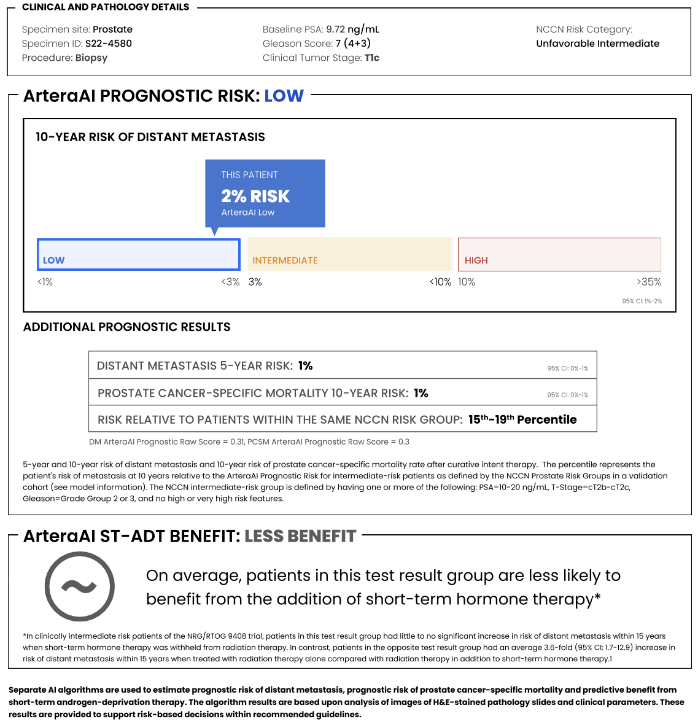

B) Scenario B – initial PSA 12.8, ISUP 2, T2c. Predictive for a High 12% 10-year risk of distant metastasis with short-term ADT to be of ‘more benefit’. Anticipated very high absolute benefit with the addition of ADT.
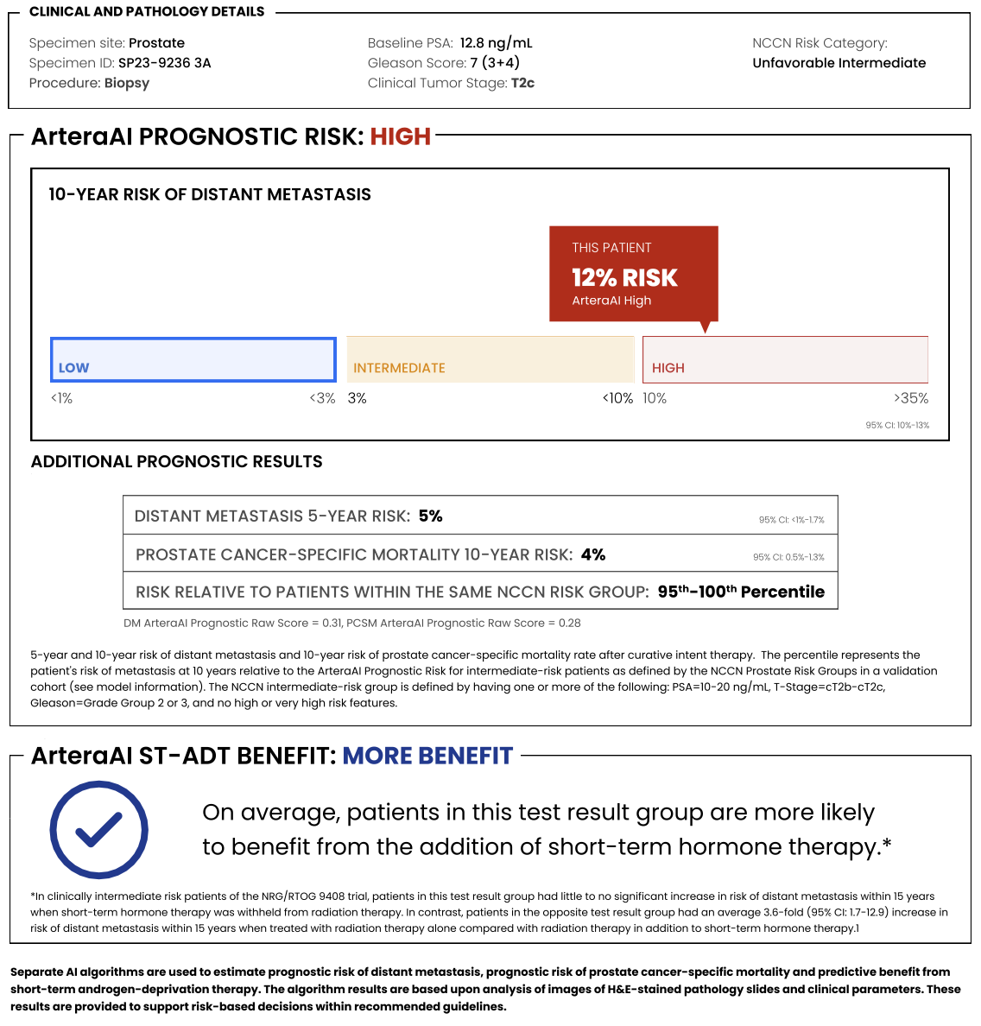

C) Scenario C – initial PSA 11.42, ISUP 3, T2a. Predictive for a Low 2% 10-year risk of distant metastasis with short-term ADT to be of ‘more benefit’. Anticipated low absolute benefit with the addition of ADT.
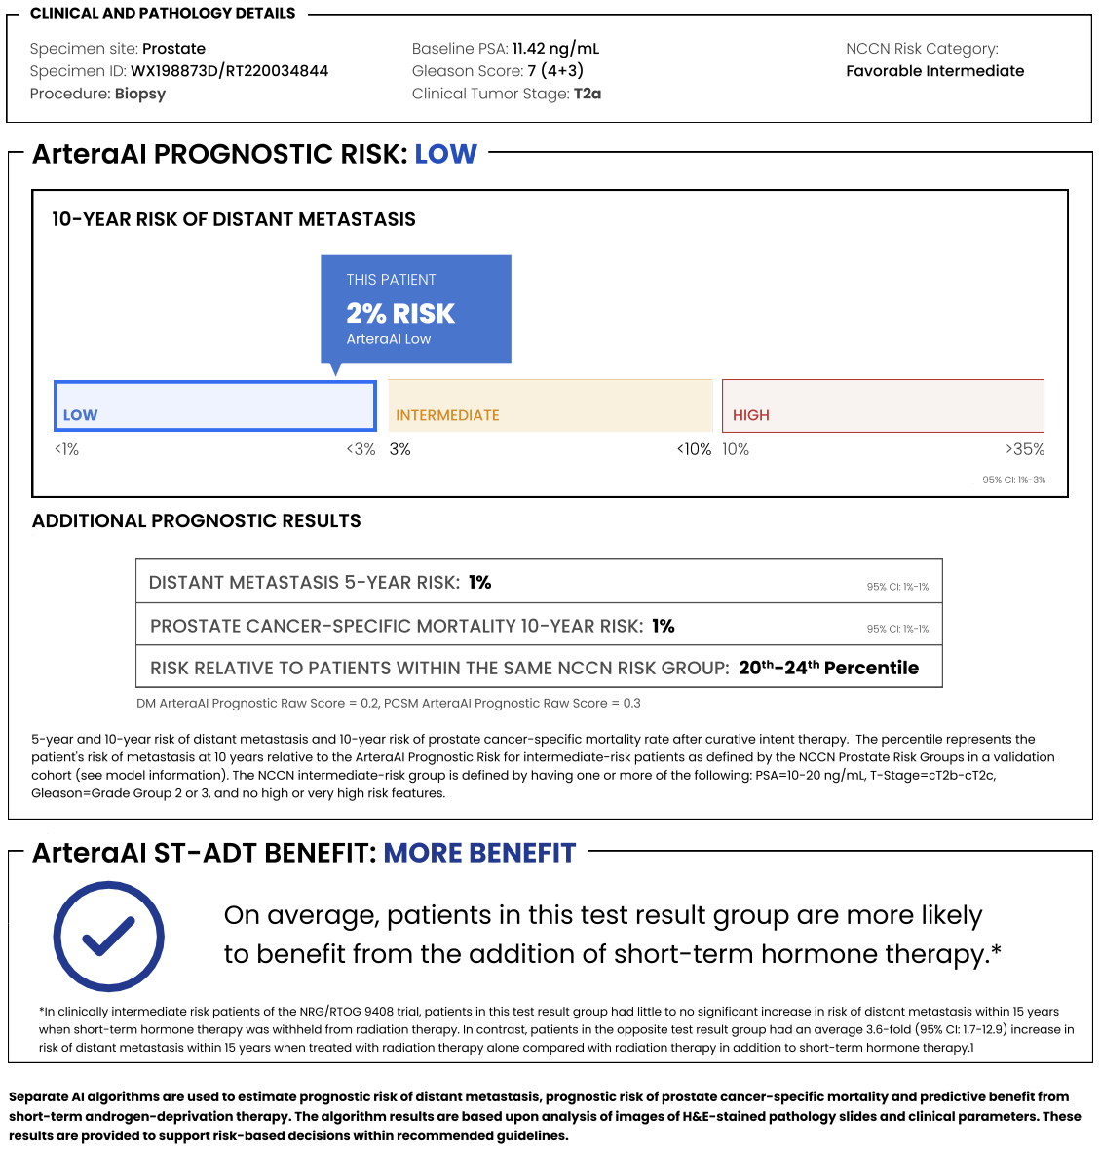

D) Scenario D – initial PSA 6.46, ISUP 2, T2a. Predictive for a High 11% 10-year risk of distant metastasis with short-term ADT to be of ‘less benefit’. Anticipated low absolute benefit with the addition of ADT.
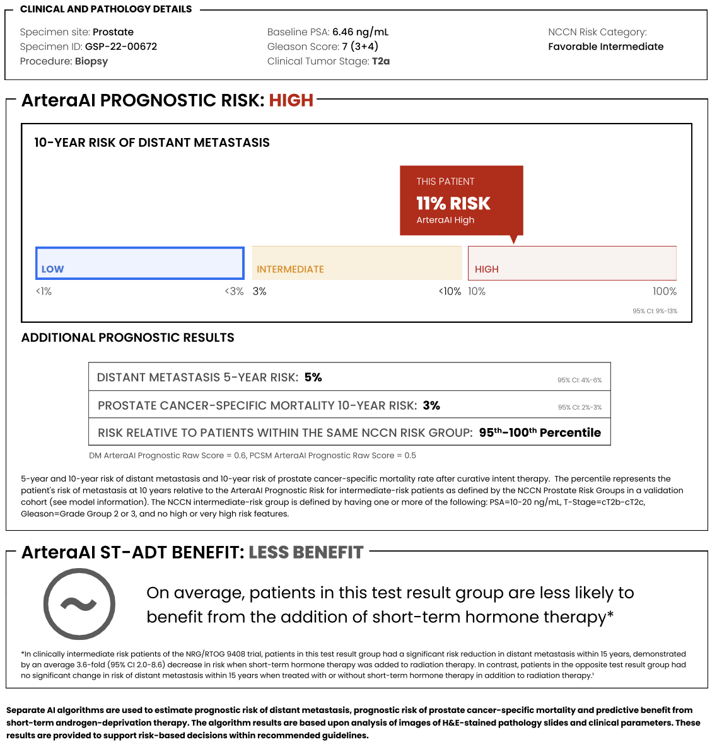

Supplementary Fig. 2 – Prostate cancer-specific mortality ten-year risk in unfavourable and favourable intermediate-risk prostate cancer patients

The prostate cancer-specific mortality ten-year risk was similar to the ten-year distant metastases risk. The median ten-year prostate cancer specific mortality was 1.2% (IQR 0.9 – 1.6) and 0.8% (IQR 0.6 – 0.9) in the UIR and FIR subgroups respectively, which was significantly different (p<0.001).

Supplementary Fig. 3 – Patient and clinician short term-ADT decision choices, pre and post MMAI test results

