Table S1 Ingredients of Panchagavya
Ingredients | Quantity
Fresh cow dung | 5 kg
Cow urine | 5 liters
Cow milk | 1.5 liters
Cow curd | 1.5 liters
Cow ghee | 150 ml
Bananas | 12 numbers
Sugar cane juice | 3 liters
Tender coconut | 3 liters
Toddy | 1.5 liters

Table S2 Chemical properties of Panchagavya
Chemical parameters | Quantity
pH | 6.02
Electrical conductivity | 3.02 Sm⁻¹
Chloride | 248.5 PPM
N | 6650 PPM
TDS | 3.4 PPM
P | 4310 PPM
K | 5200 PPM
Sodium | 1600 PPM
Calcium | 1000 PPM
Boron | 0.422 PPM
Magnesium | 840 PPM
Manganese | 14.8 PPM
Iron | 142.5 PPM
Zinc | 82 PPM
Copper | 58 PPM
Sulphur | 0.56 PPM

Table S3: Chemical properties of chicken waste
Chemical parameters | Quantity
pH | 6.65
EC | 4.25 Sm⁻¹
Chloride | 560 PPM
N | 8400 PPM
TDS | 4.3 PPM
P | 3000 PPM
K | 3000 PPM
Sodium | 1000 PPM
Calcium | 1300 PPM
Boron | 0.18 PPM
Magnesium | 140 PPM
Manganese | 61 PPM
Iron | 260 PPM
Zinc | 19 PPM
Copper | 83 PPM
Sulphur | 0.14 PPM

Table S4: Chemical properties of Gunapaselam
Chemical parameters | Quantity
pH | 4.25
EC | 3.03 Sm⁻¹
Chloride | 420 PPM
N | 7800 PPM
TDS | 2.4 PPM
P | 4200 PPM
K | 2300 PPM
Magnesium | 162 PPM
Manganese | 6.2 PPM
Iron | 240 PPM
Zinc | 1.8 PPM
Copper | 3.5 PPM

Table S5: Ingredients of Azolla
Ingredients | Quantity
Silpaulin sheet | 1
Cow dung | 5kg
Super phosphate | 30-50g
Bore well sand | 40 – 50kg
Azolla culture | 500g

Table S7: Soil testing report of contaminated and uncontaminated soil
Description | Contaminated soil |  | Uncontaminated soil
Parameter | Value | Comments | Value | Comments
Organic Carbon | 4.57 % | High | 0.41 % | Low
pH | 7.75 | Slightly alkaline | 7.87 | Slightly alkaline
EC | 0.13 dS m⁻¹ | Non saline | 0.11 dS m⁻¹ | Non saline
Available N | 202 kg ha⁻¹ | Low | 190 kg ha⁻¹ | Low
Available P (Olsen’s) | 15.0 kg ha⁻¹ | Medium | 15.0 kg ha⁻¹ | Medium
Available K | 420 kg ha⁻¹ | High | 536 kg ha⁻¹ | High
Available Zn | 57.78 ppm | Sufficient | 0.47 ppm | Deficient
Available Cu | 0.82 ppm | Deficient | 0.69 ppm | Deficient
Available Fe | 1.29 ppm | Deficient | 1.11 ppm | Deficient
Available Mn | 4.79 ppm | Sufficient | 1.59 ppm | Deficient

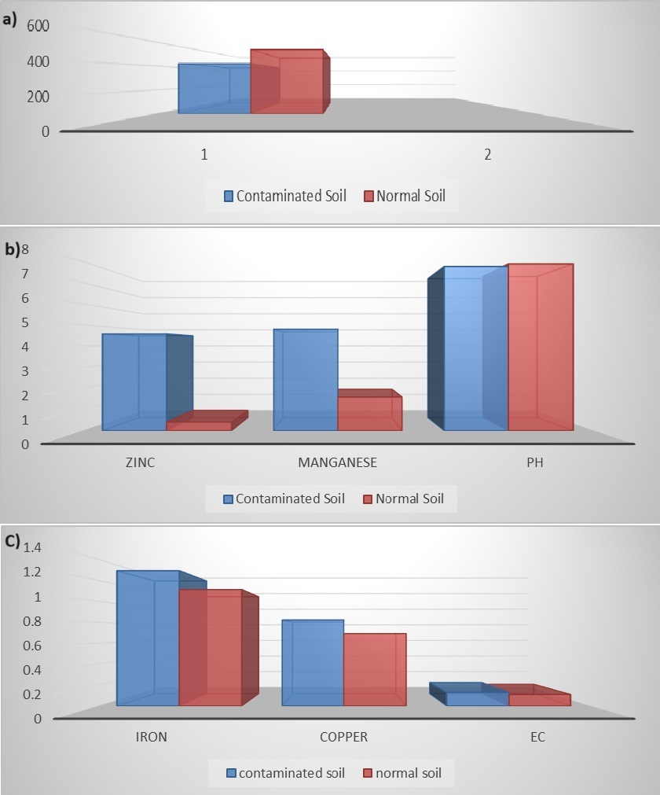
Fig. S1 Different soil nutrients test (a) Potash (b) Zinc, Managnese, pH (c) Iron, Copper, Electrical conductivity

