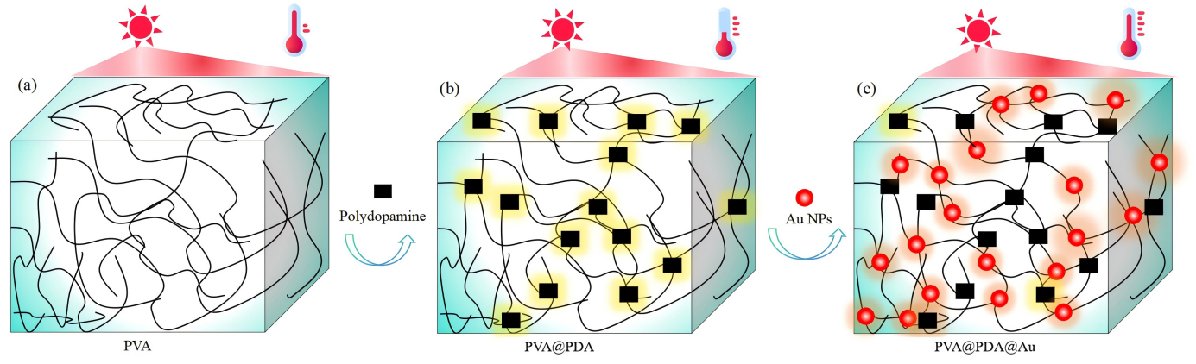
Scheme 1 Illustration of photothermal effect in (a) PVA, (b) PVA@PDA, and (c) PVA@PDA@Au
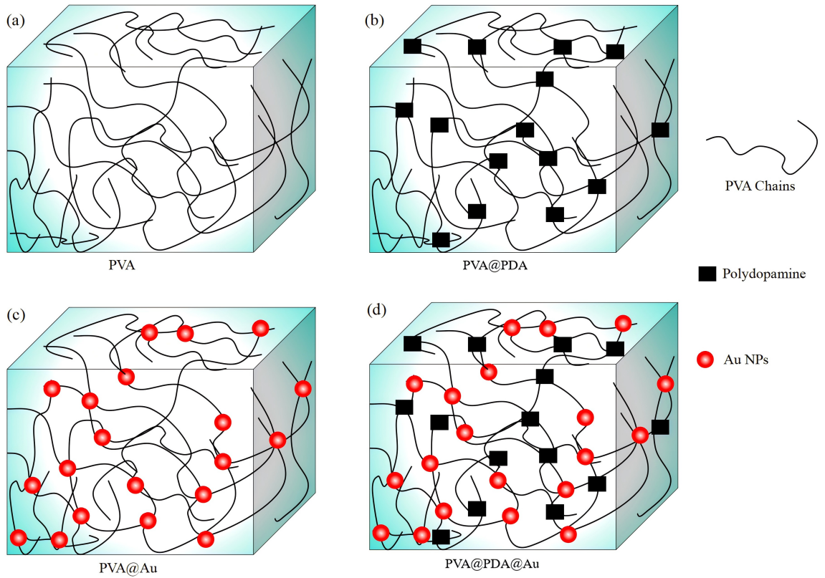
Scheme 2 Structure illustration of PVA-based hydrogels(a) pristine PVA, (b) PVA@PDA,
(c) PVA@Au, and (d) PVA@PDA@Au

