All Solid-state Batteries with Quasi-zero Stack Pressure
Xudong Chen^{1#}, Wuliang Feng^{2#*}, Zhenming Xu³, Peiyao Wang², Yao Liu⁴, Nan Wang¹, Xing Zhou¹, Linghao Deng¹, Jiachen Ying¹, Zhaoqi Wang¹, Le Li¹, Kaixin Ren¹, Sixiao Dong⁵, Wenwen Zhao⁵, Xiaoli Dong¹, Shigang Lu², Yonggang Wang¹, Fei Wang^{1*}, Yongyao Xia^{1*}

1. Department of Chemistry, Department of Materials Science, Shanghai Key Laboratory of Molecular Catalysis and Innovative Materials, Fudan University, Shanghai 200433, China.
2. College of Sciences and Institute for Sustainable Energy, Shanghai University, Shanghai 200444, China
3. Jiangsu Key Laboratory of Electrochemical Energy Storage Technologies, College of Materials Science and Technology, Nanjing University of Aeronautics and Astronautics, Nanjing 210016, China
4. Key Laboratory of Interfacial Physics and Technology, Shanghai Institute of Applied
Physics, Chinese Academy of Sciences, Shanghai 201800, P.R. China
5. Sodium Technology Co., LTD

*Corresponding author
# These authors contributed to the work equally and should be regarded as co-first authors
E-mail: wuliangfeng@shu.edu.cn, feiw@fudan.edu.cn, yyxia@fudan.edu.cn

Experimental Section
1. Preparation of the lithium halide SSEs: LYC solid electrolyte was synthesized by mechano-chemical methods with LiCl and YCl₃ precursors. LiCl and YCl₃ were weighed with a molar ratio 3:1, and went through a high energy ball milling process for 48 h at 500 rmp. The products were calcined at 450°C for 3 h in a muffle furnace. With a natural cooling for approximately 3 h, there obtained crystalline LYC. The amorphous LYC was acquired by quenching the crystalline sample at the temperature of 300 – 500 ℃, and with the high temperature holding-time of 1 - 5 h. Liquid nitrogen acted as the quenching medium. The samples were denoted as LYC-x according to the holding time at high temperature (x represented the holding time). All the above steps were carried out under argon protection. The synthesis of LYB, LIC, LZIC, LEC and their quenched samples were also carried out in the same way.
2. Batteries assembling: Swagelok type all solid-state batteries were assembled in argon glovebox with H₂O < 0.1 ppm and O₂ < 0.1 ppm. The materials systems were Li-In|Li₆PS₅Cl|Li₃YCl₆|LiCoO₂. The mass loading of LiCoO₂ was 8 - 11 mg/cm². A constant stacking pressure ranged from 1.2 to 50 MPa were applied to the Swagelok cells. Galvanostatic charge/discharge tests were conducted with Land battery test system (Wuhan, China) at the voltage range between 2.0 - 3.88 V versus Li⁺/LiIn, corresponding to ~2.6 - 4.5 V versus Li⁺/Li. In regard to the pouch type all solid-state batteries, all preparation procedures were performed at the dry room with a dew point of -50 ℃. The specific cathode loading was 19.4 mg/cm². The membrane of cathodes and solid electrolytes were fabricated by wet coating method, with Li₃YCl₆ and Li₆PS₅Cl acted as buffer layer at cathode and anode sides, respectively.
3. Computational methods: Ab-initio molecular dynamics (AIMD) simulations were performed using the projector augmented wave method within the framework of the density functional theory (DFT), as implemented in the Vienna ab-initio Simulation Package (VASP). The plane-wave energy cutoff was set to 300 eV, and the Γ-centered 1 × 1 × 1 k-point mesh method was employed for the Brillouin zone sampling. All AIMD calculations were performed without spin polarization in an NVT canonical ensemble at elevated temperatures using a Nose−Hoover thermostat. The time step of 2 fs was used, and the total time of each AIMD simulation was 100 ps. The simulation supercell sizes were at least 10 Å along each lattice direction. The Li ion diffusion coefficient of each temperature-dependent AIMD simulation were obtained from a linear fit of the mean square displacement (MSD) of Li ion with respect to time. The Arrhenius plots were constructed from simulations at elevated temperatures to obtain the activation energy and extrapolated room-temperature self-diffusivity and conductivity.
4. Characterizations: X-ray powder diffraction patterns were obtained by Bruker D8 advance diffractometer equipped with Cu Kα radiation (λ = 1.54178). Ultra-thin aluminum foil was integrated to protect the SSEs from being contaminated by the moisture, and also acted as a reference for crystallinity. The EIS profiles were performed (Biologic, VSP-300) with a frequency range from 7 MHz to 1 Hz. The morphology and microstructure were characterized by field emission scanning electron microscope (Hitachi S-4800, Japan) and high-resolution transmission electron microscopy (Tecnai G2 F20 S-Twin, America). Atomic force microscopy (Bruker Dimension Icon) was used to measure the surface roughness and Young's modulus of LYC. Solid-state magic angle spinning nuclear magnetic resonance were conducted by a 600 MHz Bruker Avance III spectrometer. The Y K-edge X-ray Absorption Fine Structure was collected in the transmission mode using in-house laboratory-based X-ray absorption spectrometer (SuperXAFS M9000). The Cl K-edge were measure during fluorescence yield mode at 16 A beamline (1800 − 7500 eV) at the Shanghai Synchrotron Radiation Facility. X-ray computed tomography was carried out by Zeiss Xradia 620 Versa micro-computed tomography. Pair distribution function was acquired using a PANalytical Empyrean instrument equipped with Ag Kα radiation source. The samples were loaded into 0.8 mm inner diameter polyimide capillaries and sealed with epoxy in an Ar-filled glove box. Raman spectroscopy analysis was carried out using a Raman spectrometer system (HORIBA XploRA Plus equipped with a 532nm laser).
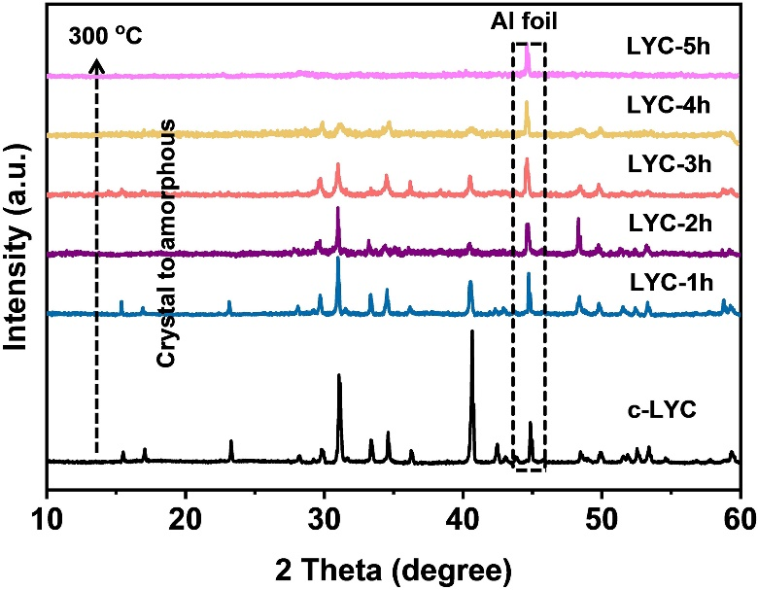
Supplementary Fig. 1 | High temperature XRD patterns of LYC at 300 ℃ with increased annealing time.
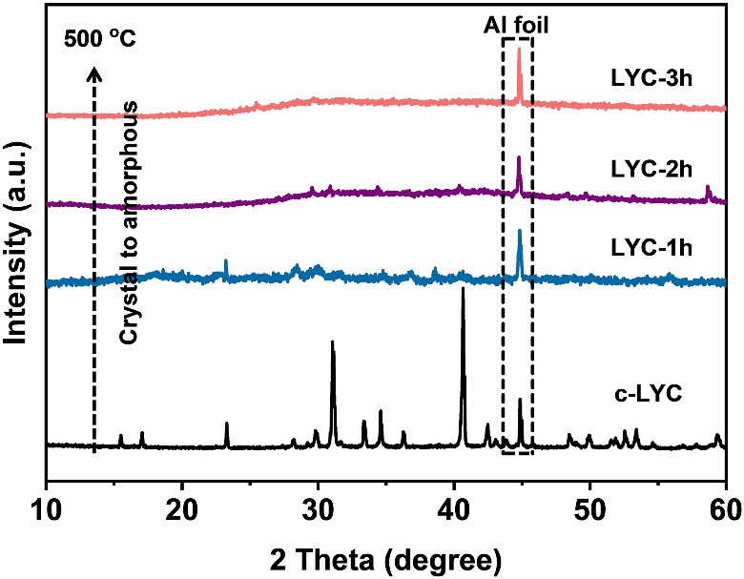
Supplementary Fig. 2 | High temperature XRD patterns of LYC at 500 ℃with increased annealing time.

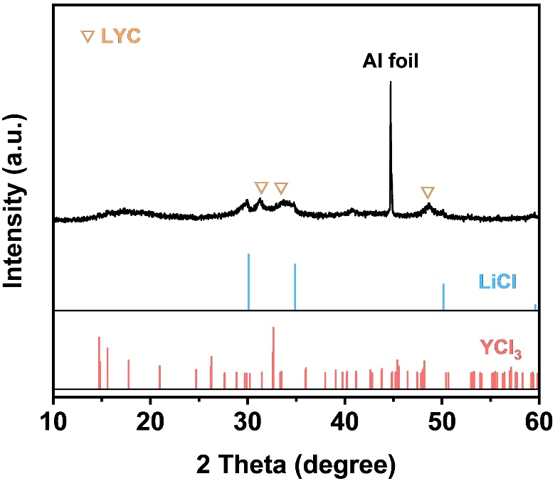
Supplementary Fig. 3 | XRD pattern of the directly quenched sintered-state of the ball milled precursors.

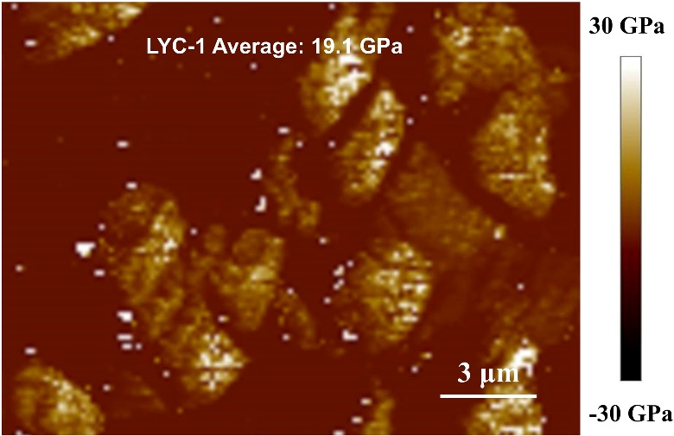
Supplementary Fig. 4 | The Young's modulus of the LYC-1.

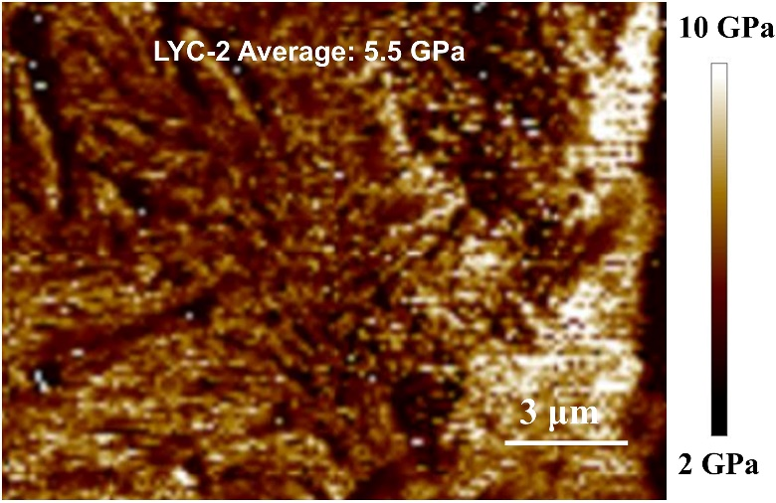
Supplementary Fig. 5 | The Young's modulus of the LYC-2.

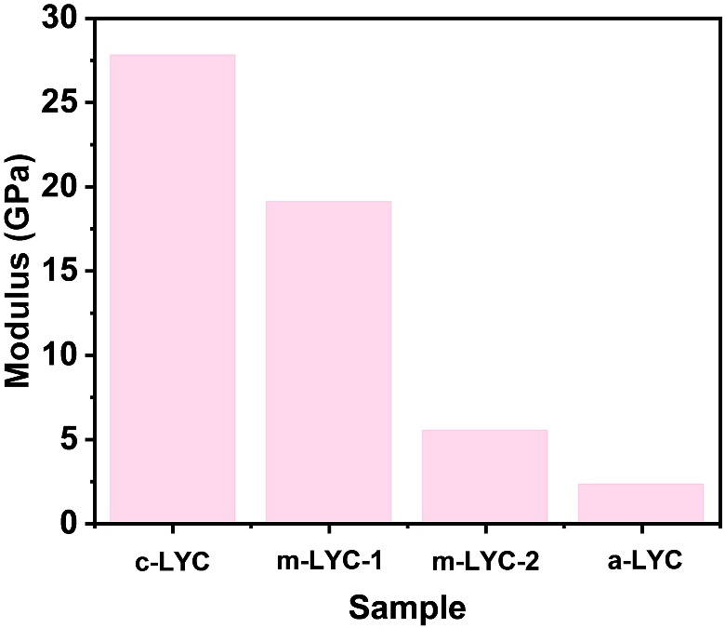
Supplementary Fig. 6 | Comparison of Young's modulus among c-LYC, LYC-1, LYC-2 and a-LYC.

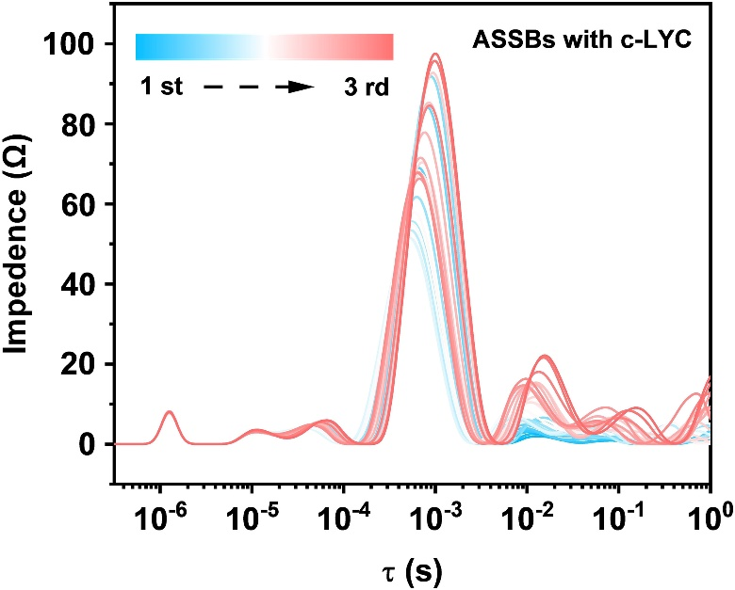
Supplementary Fig. 7 | DRT transformation corresponding to in-situ EIS of ASSBs with c-LYC.

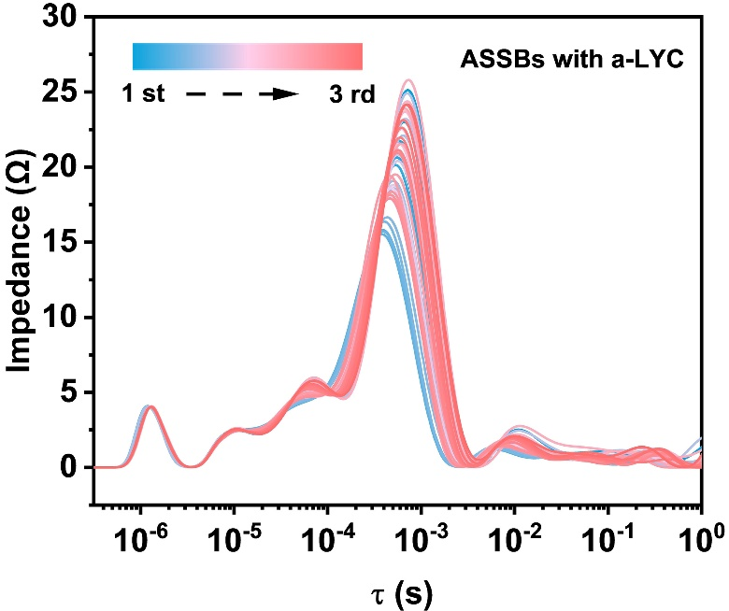
Supplementary Fig. 8 | DRT transformation corresponding to in-situ EIS of ASSBs with a-LYC.
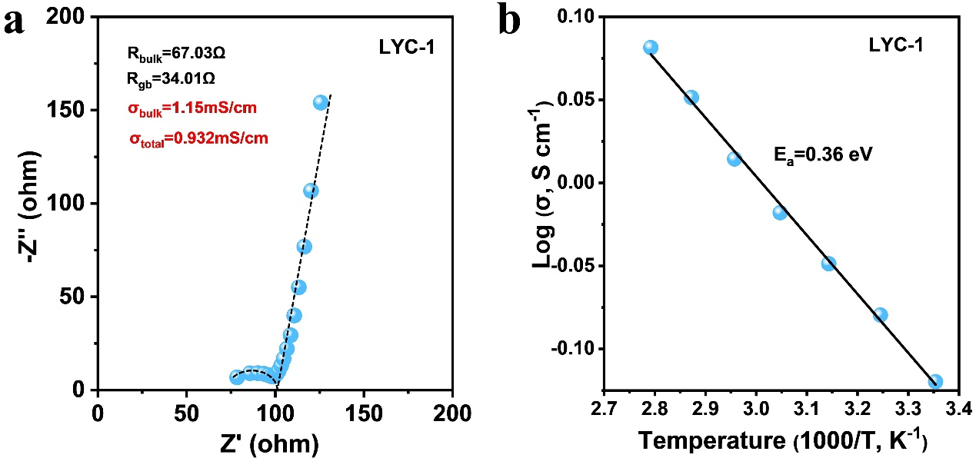
Supplementary Fig. 9 | (a) Nyquist and (b) Arrhenius plots of LYC-1.

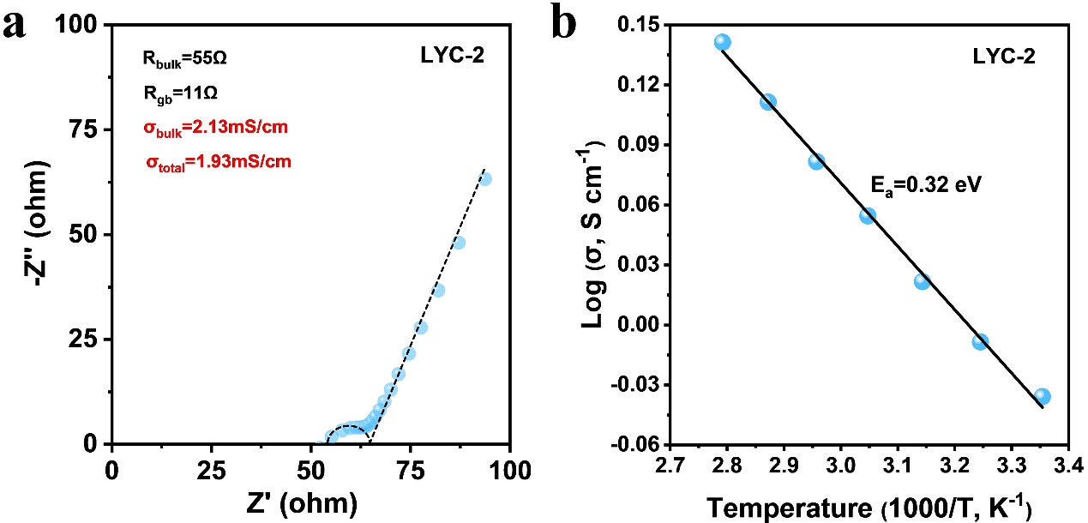
Supplementary Fig. 10 | (a) Nyquist and (b) Arrhenius plots of LYC-2.

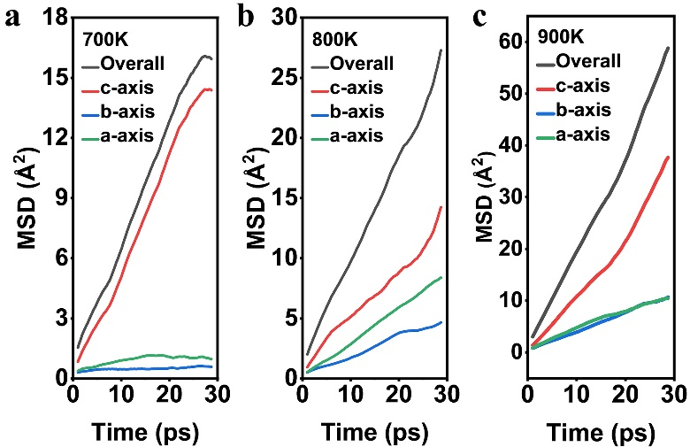
Supplementary Fig. 11 | The ionic transportation MSD along a, b, c-axis at (a) 700 K, (b) 800 K, and (c) 900 K in c-LYC.

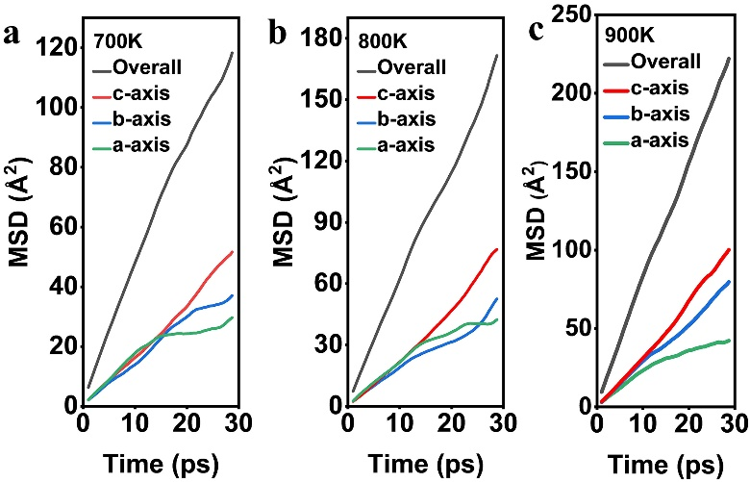
Supplementary Fig. 12 | The ionic transportation MSD along a, b, c-axis at (a) 700 K, (b) 800 K, and (c) 900 K in a-LYC.

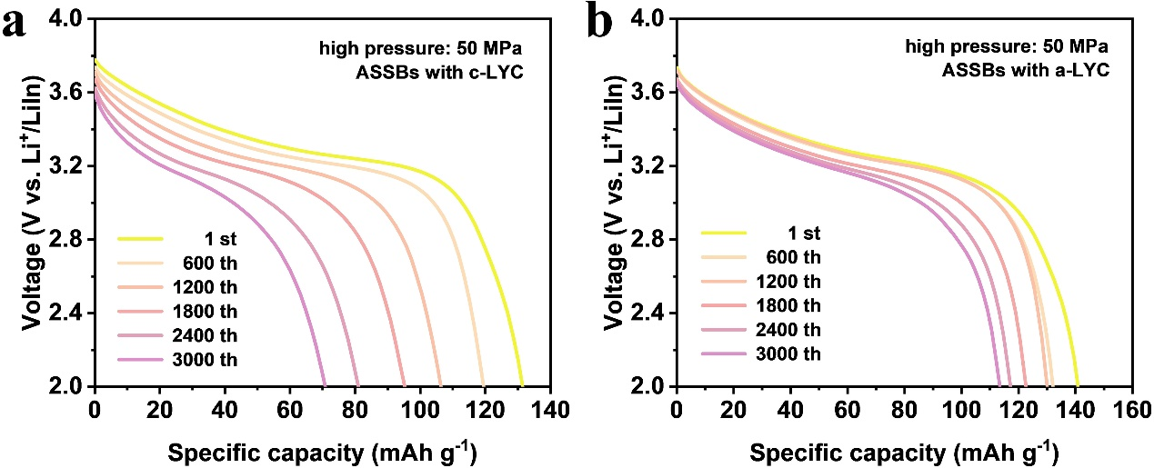
Supplementary Fig. 13 | Galvanostatic discharge of c-LYC and a-LYC under high stacking pressure.

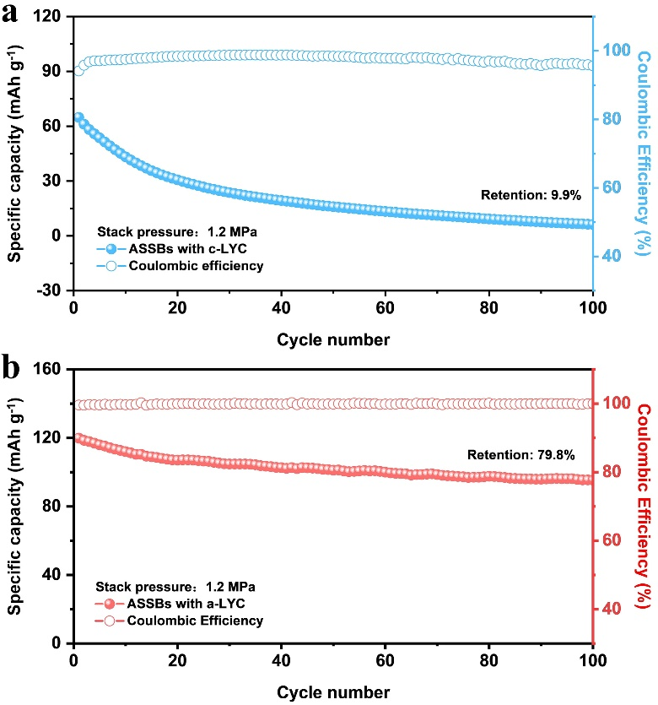
Supplementary Fig. 14 | Cycling performance under the stacking pressure of 1.2 MPa, ASSBs with (a) c-LYC and (b) a-LYC.

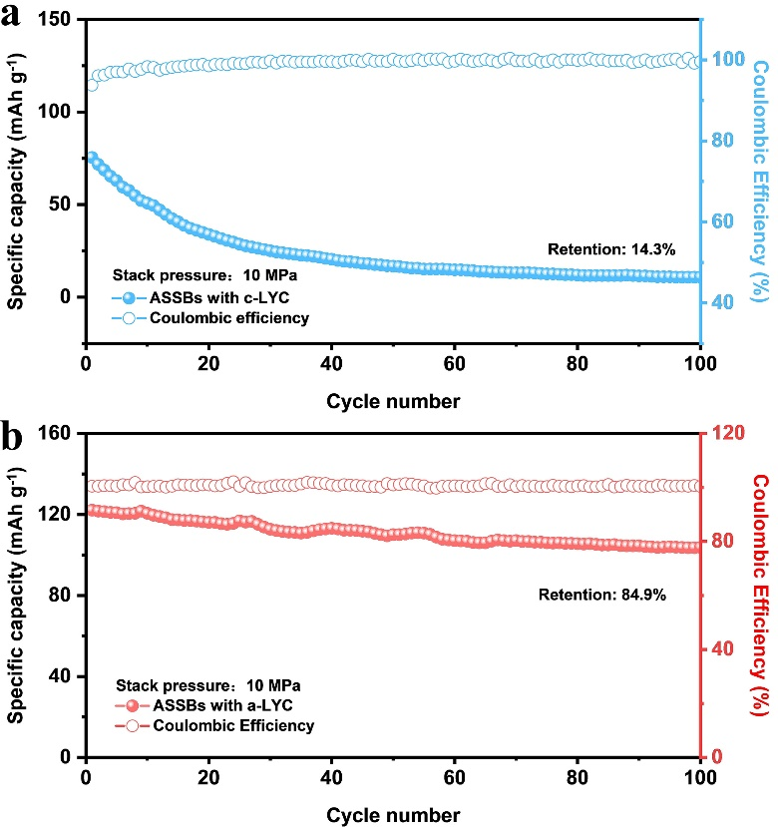
Supplementary Fig. 15 | Cycling performance under the stacking pressure of 10 MPa, ASSBs with (a) c-LYC and (b) a-LYC.

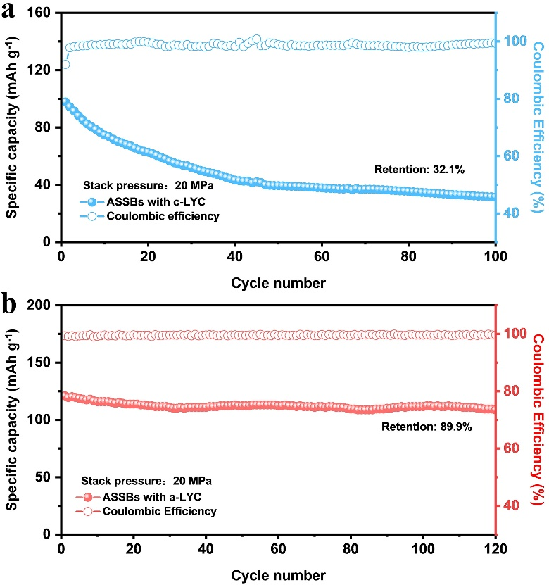
Supplementary Fig. 16 | Cycling performance under the stacking pressure of 20 MPa, ASSBs with (a) c-LYC and (b) a-LYC.

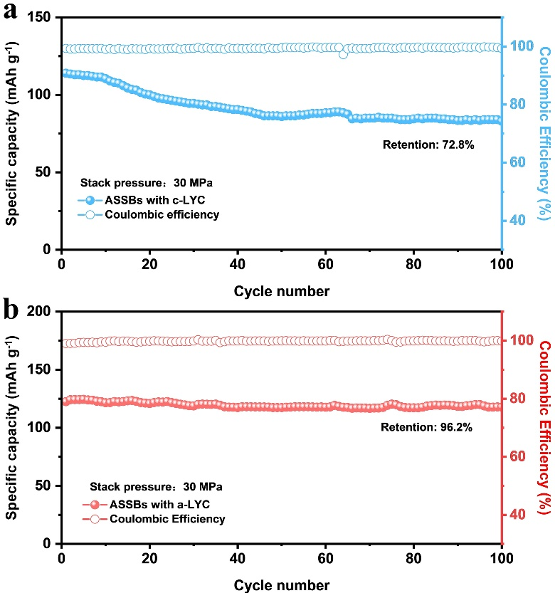
Supplementary Fig. 17 | Cycling performance under the stacking pressure of 30 MPa, ASSBs with (a) c-LYC and (b) a-LYC.

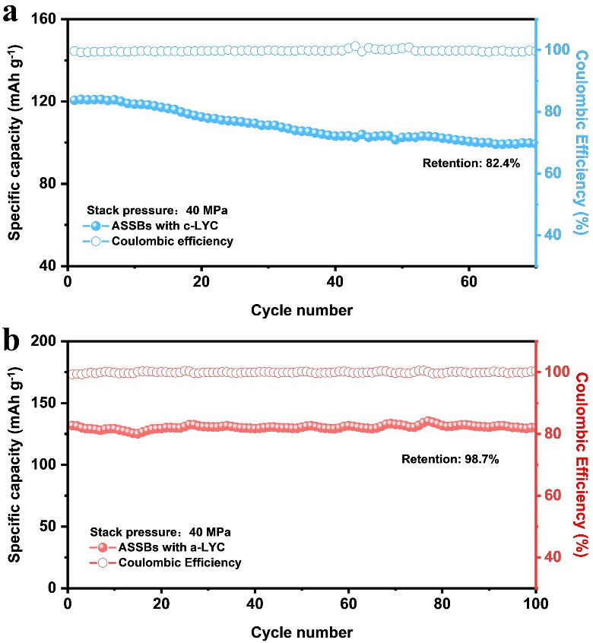
Supplementary Fig. 18 | Cycling performance under the stacking pressure of 40 MPa, ASSBs with (a) c-LYC and (b) a-LYC.

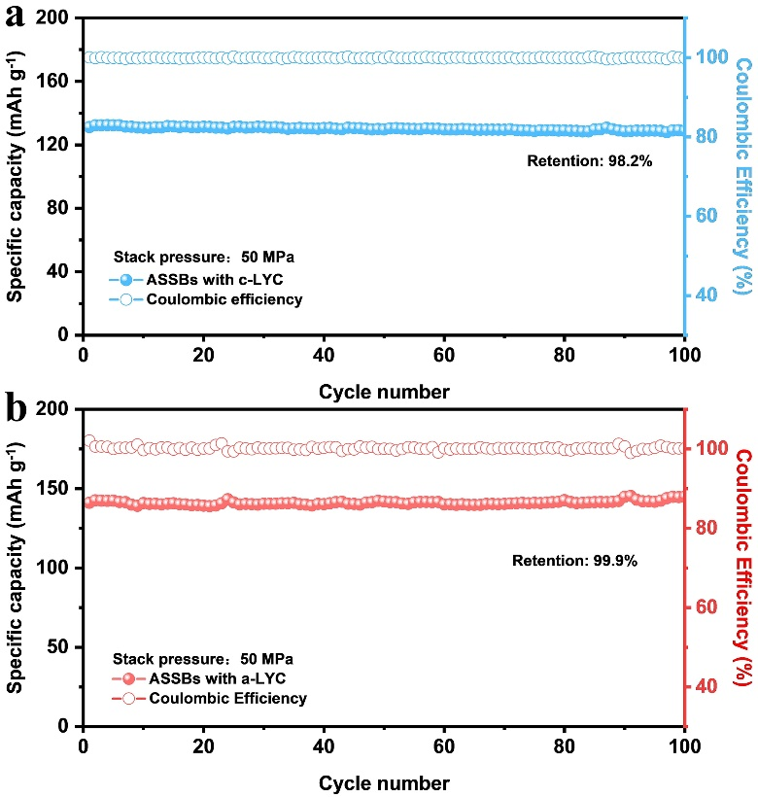
Supplementary Fig. 19 | Cycling performance under the stacking pressure of 50 MPa, ASSBs with (a) c-LYC and (b) a-LYC.

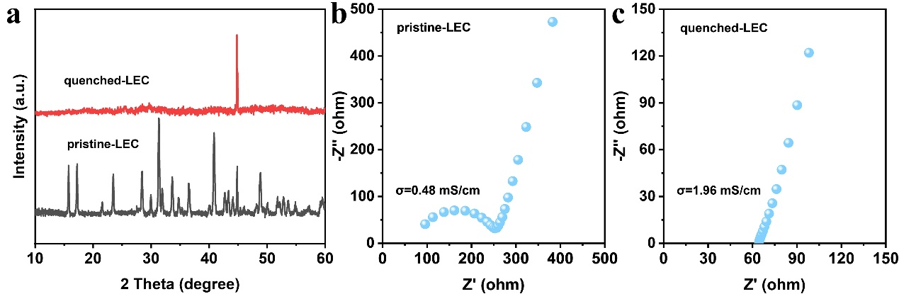
Supplementary Fig. 20 | (a) XRD pattern of pristine-LEC and quenched-LEC; Nyquist plots of (b) pristine-LEC and (c) quenched-LEC.

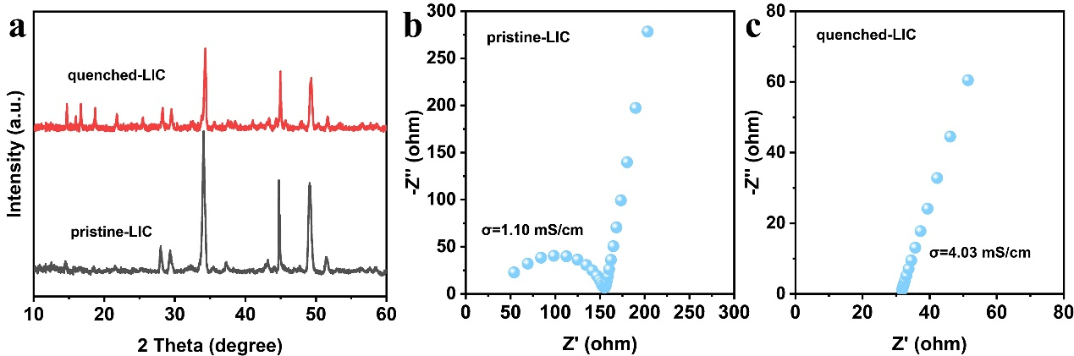
Supplementary Fig. 21 | (a) XRD pattern of pristine-LIC and quenched-LIC; Nyquist plots of (b) pristine-LIC and (c) quenched-LIC.

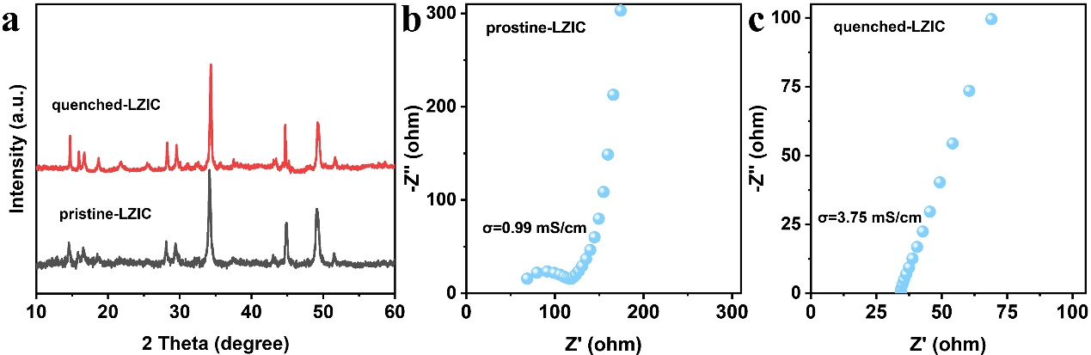
Supplementary Fig. 22 | (a) XRD pattern of pristine-LZIC and quenched-LZIC; Nyquist plots of (b) pristine-LZIC and (c) quenched-LZIC.

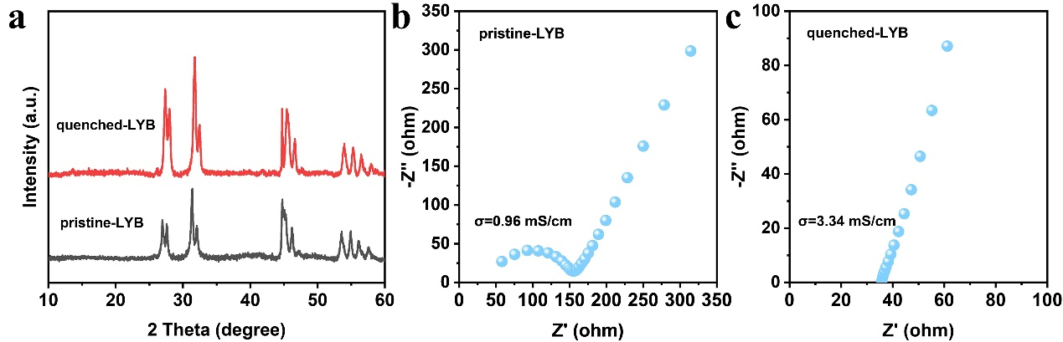
Supplementary Fig. 23 | (a) XRD pattern of pristine-LYB and quenched-LYB; Nyquist plots of (b) pristine-LYB and (c) quenched-LYB.

Supplementary Table 1 Comprehensive comparison of this work with various research.
Cycle number | Pressure | Retention | Ref.
300 | 1.2 MPa | 69.6% | This work
100 | 2MPa | 63.3% | [1]
100 | 10 MPa | 63% | [2]
100 | 5 MPa | 80.9% | [3]
100 | 15 MPa | 64% | [4]
75 | 3 MPa | 64.7% | [5]
50 | 2 MPa | 90% | [6]
40 | 2.5 MPa | 80% | [7]
20 | 2 MPa | 83.3% | [8]

Reference
1. Zhou, K. et al. Tailored Cathode Composite Microstructure Enables Long Cycle Life at Low Pressure for All-Solid-State Batteries. ACS Energy Lett. 10, 966–974 (2025).
2. Qin, X. et al. Self-Pressure Silicon–Carbon Anodes for Low-External-Pressure Solid-State Li-Ion Batteries. ACS Nano 19, 17760–17773 (2025).
3. Doux, J. et al. Stack Pressure Considerations for Room‐Temperature All‐Solid‐State Lithium Metal Batteries. Adv. Energy Mater. 10, 1903253 (2020).
4. Jun, S. et al. Interlayer Engineering and Prelithiation: Empowering Si Anodes for Low‐Pressure‐Operating All‐Solid‐State Batteries. Small 20, 2309437 (2024).
5. Oh, J. et al. All‐Solid‐State Batteries with Extremely Low N/P Ratio Operating at Low Stack Pressure. Adv. Energy Mater. 15, 2404817 (2025).
6. Xu, F. et al. Low‐Pressure Sulfide All‐Solid‐State Lithium‐Metal Pouch Cell by Self‐Limiting Electrolyte Design. Adv. Energy Mater. 15, 2405369 (2025).
7. Wan, H., Wang, Z., Zhang, W., He, X. & Wang, C. Interface design for all-solid-state lithium batteries. Nature 623, 739–744 (2023).
8. Zhao, W. et al. Maintaining Interfacial Transports for Sulfide-Based All-Solid-State Batteries Operating at Low External Pressure. ACS Energy Lett. 8, 5050–5060 (2023).

