Additional File 1: Supplementary Figures & Tables
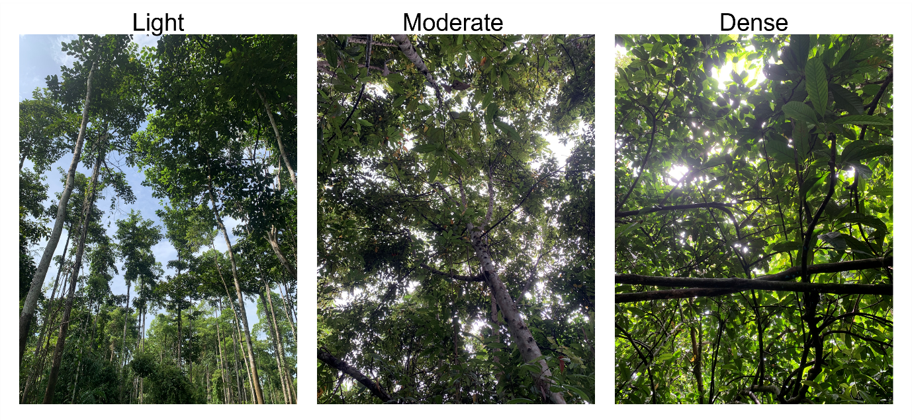
Figure A1. Varying canopy cover at test site in Sabah, Malaysia.

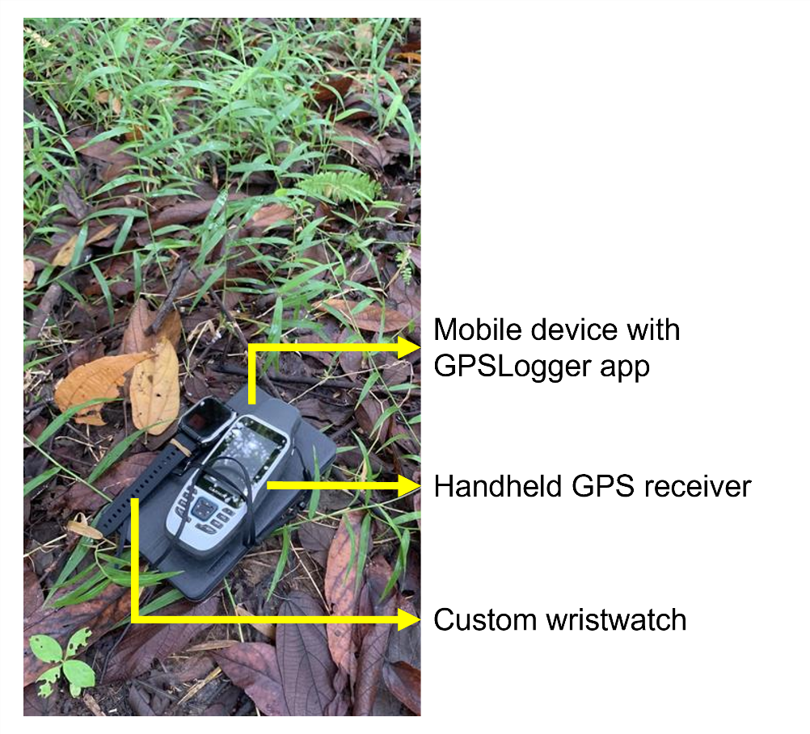
Figure A2. Experimental setup of three location tracking devices.
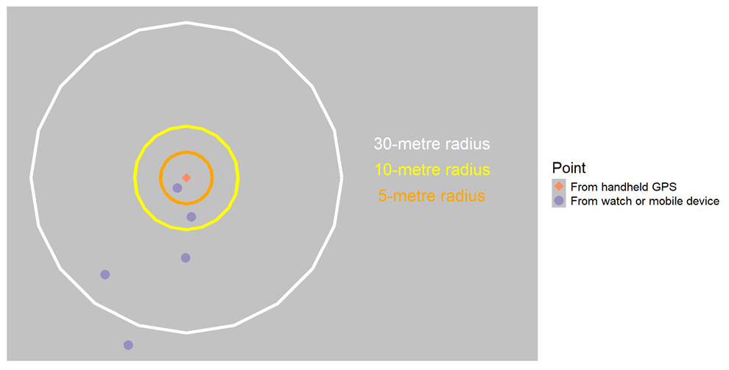
Figure A3. Points within a distance to reference. 5 metres: 1/5. 10 metres: 2/5. 30 metres: 4/5.

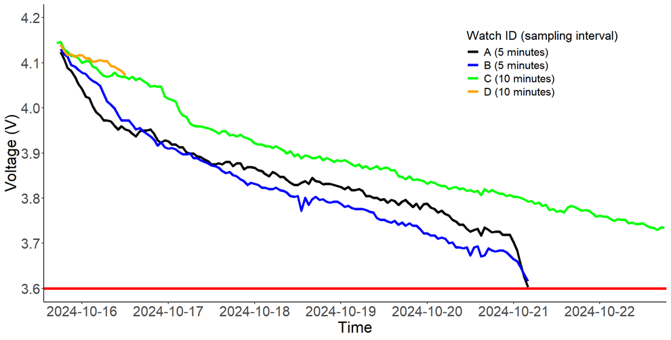
Figure A4. Battery voltage over time during pilot study in Guinea. Red line is 3.6-Volts threshold.
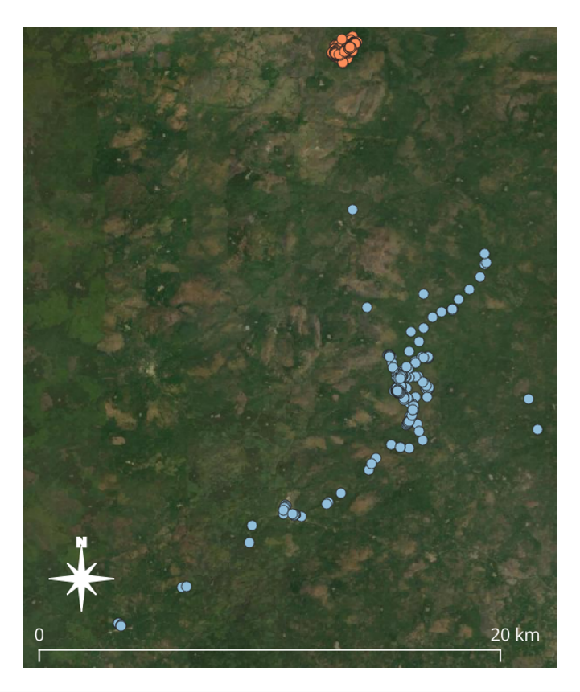
Figure A5. Tracks of a participant with low (red) and high (blue) activity, collected from mobile devices.

Table A1. Proportion of sampled watch and mobile device points within a distance to reference point.
 | Type of Canopy Cover | Within 5 metres  (%) | Within 10 metres (%) | Within 30 metres (%)
Watch | Light | 8.3 | 58.3 | 100.0
Watch | Moderate | 6.7 | 40.0 | 80.0
Watch | Dense | 13.6 | 31.8 | 86.4
Watch | Overall | 10.2 | 40.1 | 87.8
Mobile device | Light | 22.0 | 76.0 | 98.0
Mobile device | Moderate | 1.8 | 12.7 | 41.8
Mobile device | Dense | 5.1 | 11.5 | 42.3
Mobile device | Overall | 8.7 | 29.5 | 57.4

