Additional File 2 – Sample Watch Protocol
LOCATION TRACKING WATCHES – SAMPLE PROTOCOL
Version number: | Version date: | Site:
1.0 | October 2024 | Macenta Prefecture, Republic of Guinea

1. ABBREVIATIONS AND DEFINITIONS
Watch – refers to custom devices in wristwatch form, developed by Druid Technology (Shenzhen, China) and equipped with GNSS technology for tracking the location of wearers
Ecotopia – the application installed on a mobile device that is wirelessly paired with the custom watches, used to deliver settings and sync collected data to a server for remote access and cloud storage
GNSS – Global Navigation Satellite System; a collection of satellite-based systems that provide geolocation services, including GPS (USA), Galileo (European Union), and GLONASS (Russia)
Geofence – a virtual area of interest defined in the software for the custom watches, enabling entry/exit of the area to be detected to trigger changes in sampling parameters
ODBA – Overall Dynamic Body Acceleration; an acceleration index for measuring motion and used by the custom watches to detect rest periods, during which location data collection can be suspended to preserve battery power
2. OBJECTIVE
To define preparation, deployment, and retrieval procedures for location tracking watches.
The human movement data collect by these watches will be integrated with other data sources to understand human-wildlife contact and disease spillover risk among study participants from sampled villages in Macenta Prefecture, Guinea.
3. INTENDED USERS
The intended users of this SOP are the field and data analysis teams.
4. MATERIALS AND EQUIPMENT
- Device with Internet browser for accessing Ecotopia Data Center (e.g., laptop or smartphone)
- Smartphone(s) or study tablet(s) with Ecotopia app installed
- Location tracking watches
5. PREPARATION
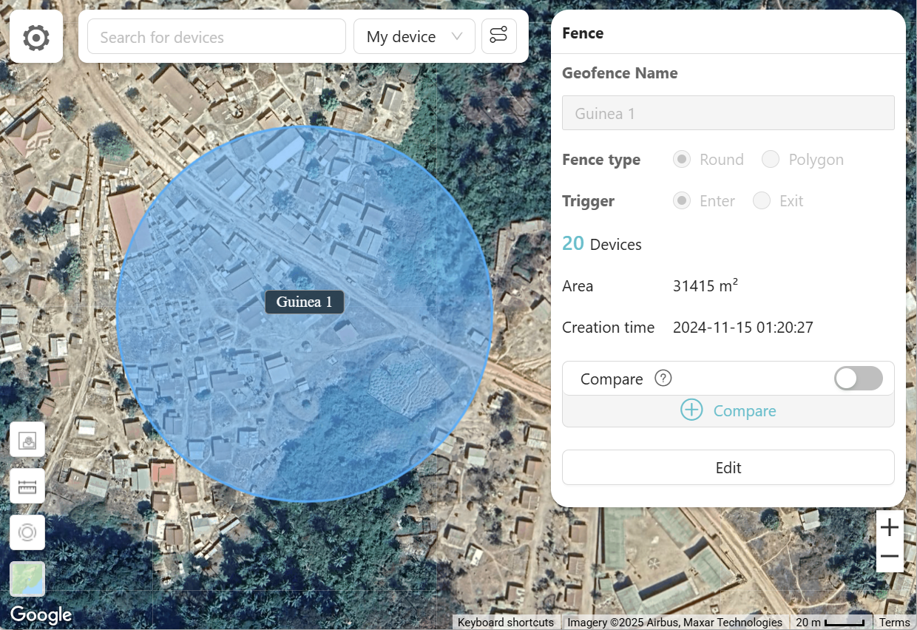
- Define up to 20 geofences at a 100-metre radius from locations of known bat roosts through the Ecotopia Data Center.

- Define the settings as follows for each watch through the Ecotopia Data Center.
  - Basic Setting: (collect location coordinates every 10 minutes)
    - Mode: Customization
    - GNNS: Interval, 10 minutes
    - Environment: Interval, 1 hour
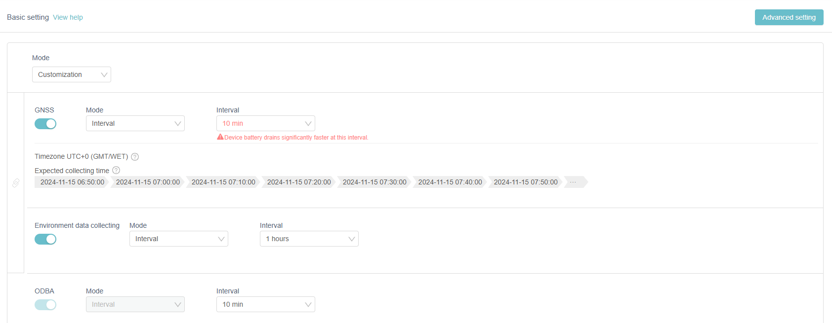
    - ODBA: Interval, 10 minutes

  - Advanced Setting: (1st rule, for controlling rest mode)
    - Rule name: Rest
    - Variable: Activity, Lower than, 800
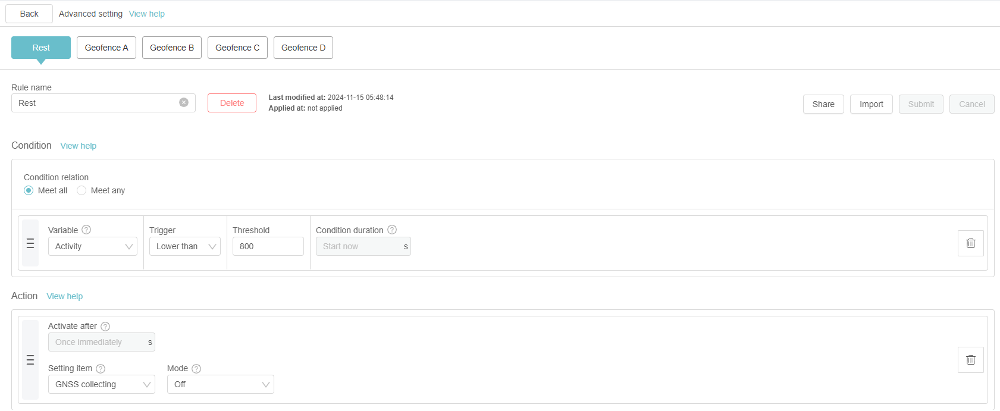
    - Action: GNNS collecting, Off

  - Advanced Setting: (2nd rule, for decreasing location sampling intervals to 5 minutes near bat roosts)
    - Rule name: Geofence A
    - Variables: Geofence, Enter, Guinea 1
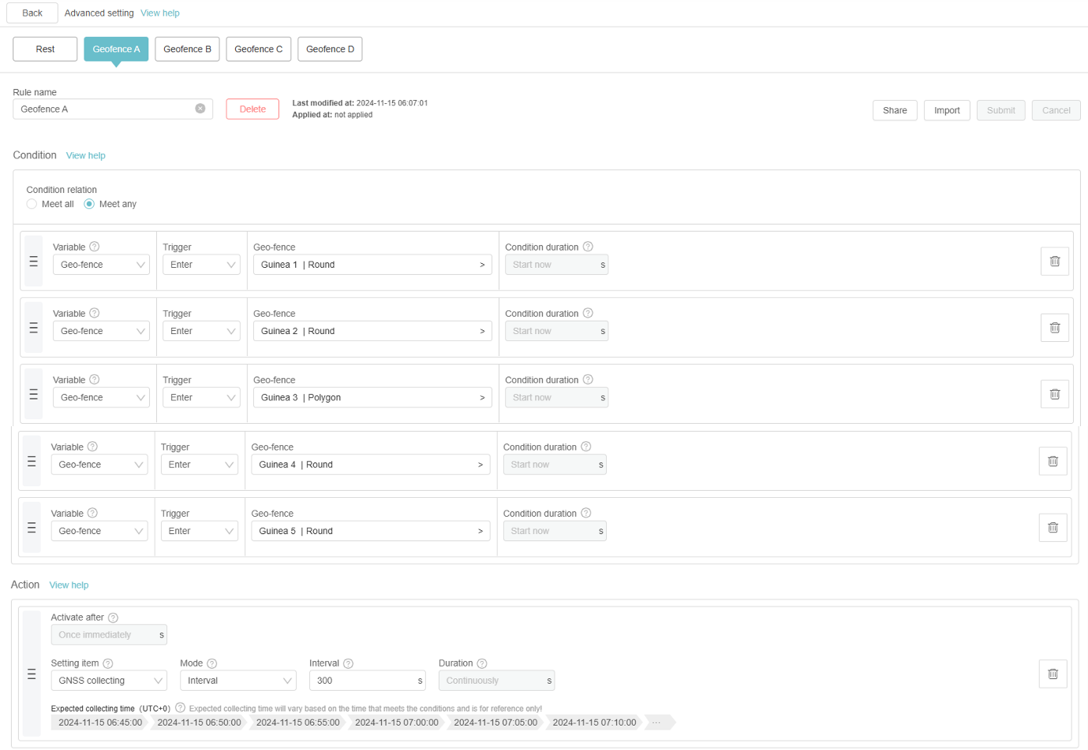
    - Action: GNSS collecting, Interval, 300 seconds
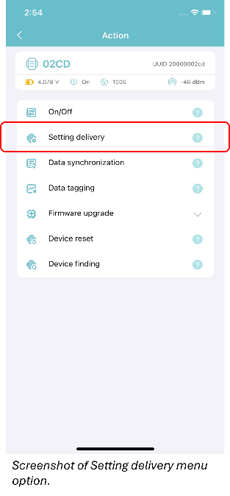
- Add all watches to Geofence A.
- Using the Ecotopia app, deliver the settings to all watches.
- Charge all watches to maximum charge (at least 5 hours of charging).
6. DEPLOYMENT
- Recruit participants for enrolment in the study, as per applicable SOPs.
  - Obtain informed consent from participants.
- Deliver a charged watch to each participant, ensuring that the watch is powered on.
- Record the watch ID and date/time of deployment.
- Provide the following instructions to the participant: Please wear the watch as much as possible, including while in the home, village, and forest. Please refrain from pressing the buttons or otherwise damaging the watch. Please do not give the watch to anyone else.
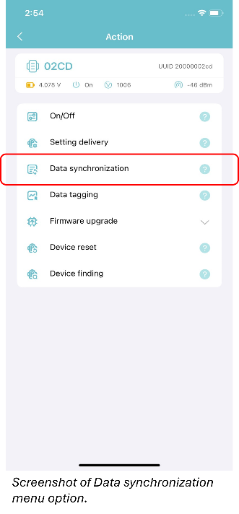
- Arrange with the participant to collect the watch back at the end of the study period (in 14 days).
7. RETRIEVAL & REDEPLOYMENT
- Record the following at retrieval:
  - Date & time of watch retrieval
  - How often did you wear the watch? (1 = never, 2 = rarely, 3 = sometimes, 4 = most of the time, 5 = always)
  - If you did not wear the watch continuously, when and why did you take the watch off?
- While the phone is connected to WiFi and near the watches, perform data synchronization on the Ecotopia app to back up the data to the server.
- Recharge the watches (at least 5 hours each).
- Redeploy the watches to the next group of participants.

