Supplementary Figures

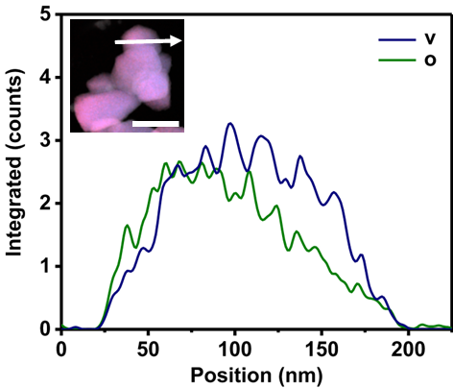
Figure S1. Location of EDS line sweeps. Scale bar, 400 nm.

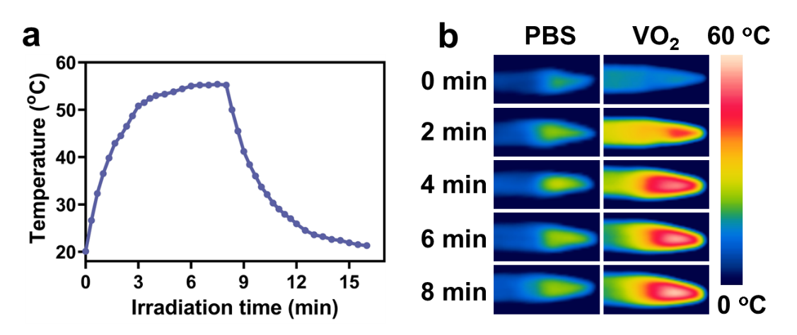
Figure S2. (a) The temperature change curve of VO₂ during a single hot and cold cycle. (b) Infrared thermal image of VO₂ under NIR irradiation.

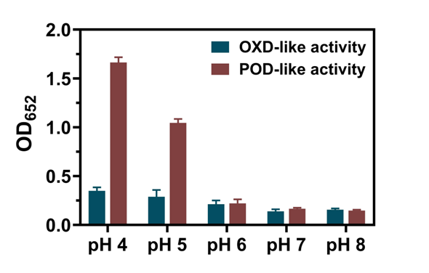
Figure S3. Oxidase activity and peroxidase activity of VO₂ under different pH conditions.

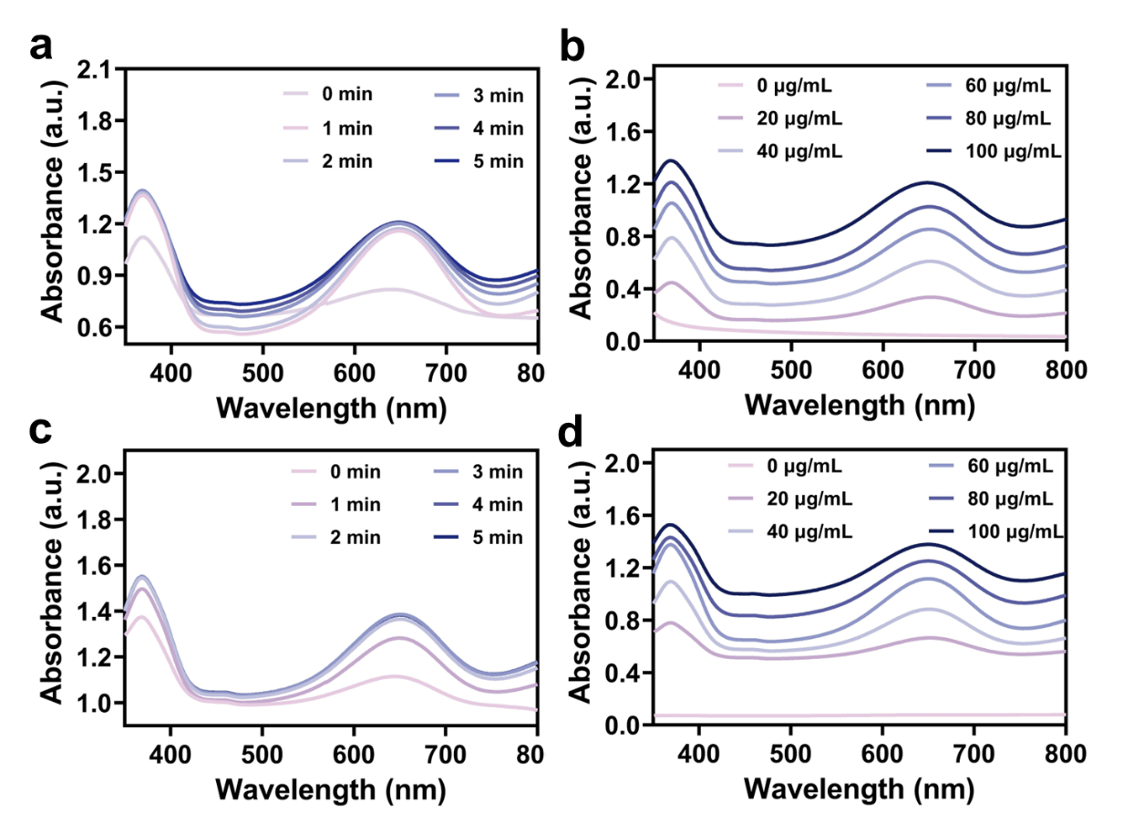
Figure S4. (a, b) Oxidase-like activity of VO₂ nanoparticles at different times and concentrations using TMB as substrate. (c, d) Peroxidase-like activity of VO₂ nanoparticles at different times and concentrations using TMB as substrate.

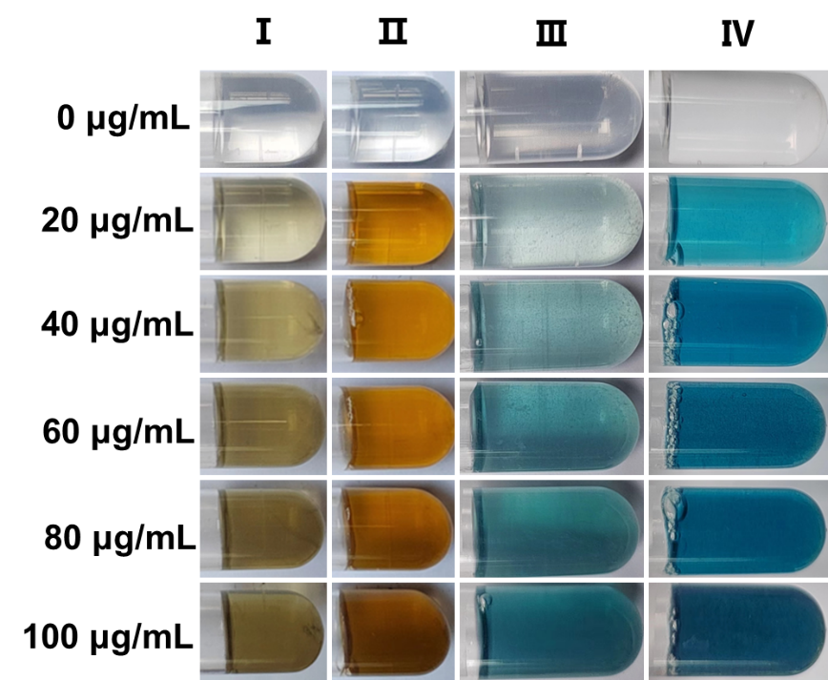
Figure S5. Color changes of VO₂ oxidase-like and peroxidase-like enzymes at different concentrations using TMB/OPD as substrates. Ⅰ: VO₂ + OPD; Ⅱ: VO₂ + H₂O₂ + OPD; Ⅲ: VO₂ + TMB; Ⅳ: VO₂ + H₂O₂ + TMB.

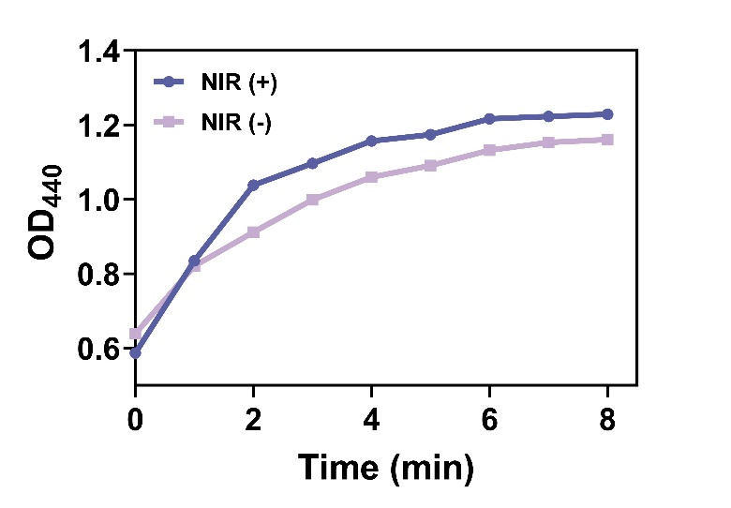
Figure S6. Oxidase activity of VO₂ with and without NIR irradiation using OPD as substrate.

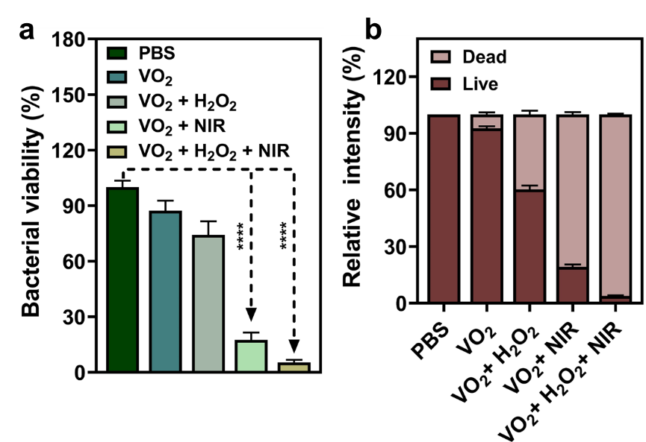
Figure S7. (a) Statistical analysis of data derived from Figure 3a. (b) Fluorescence quantification analysis derived from Figure 3c. Data are presented as mean ± SD (n=3), *p < 0.05, **p < 0.01, ***p < 0.001, ****p < 0.0001.

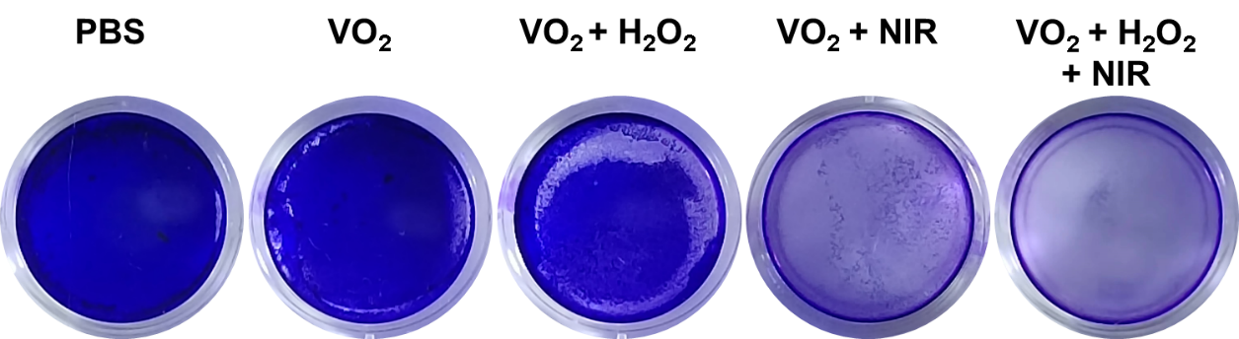
Figure S8. Typical images of crystal violet staining are presented for each group following eradication treatment.

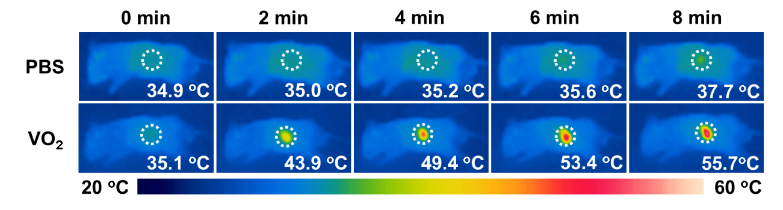
Figure S9. Representative infrared thermal images of differently treated mice irradiated at NIR for 8 min.

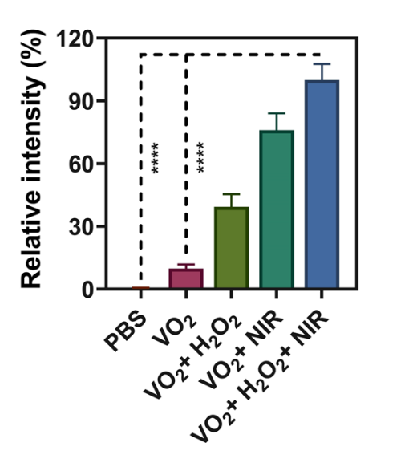
Figure S10. Derived from quantitative immunofluorescence analysis of Figure 6c. Data are presented as mean ± SD (n=3), *p < 0.05, **p < 0.01, ***p < 0.001, ****p < 0.0001.

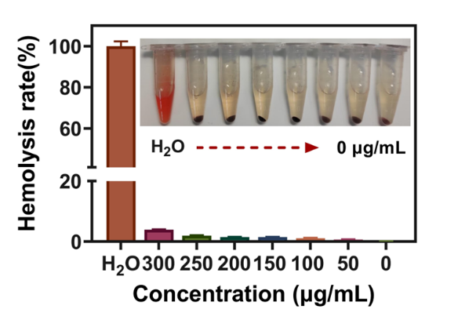
Figure S11. Representative photographs and quantitative analysis of hemolysis activity of VO₂ with different concentrations. Data are presented as mean ± SD (n=3).

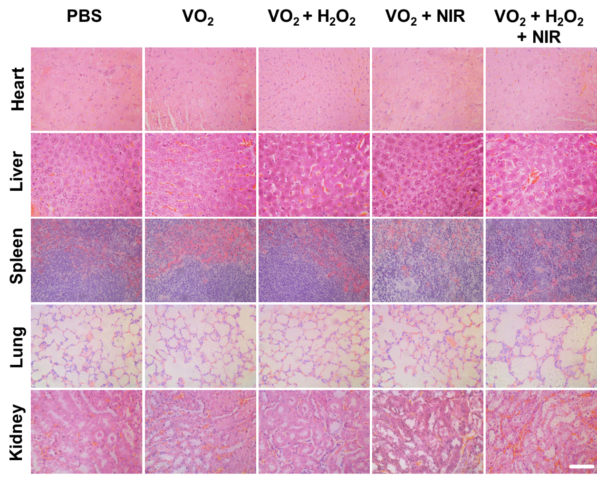
Figure S12. H&E staining results of major tissues of mice after different treatments. Scale bar, 60 μm.

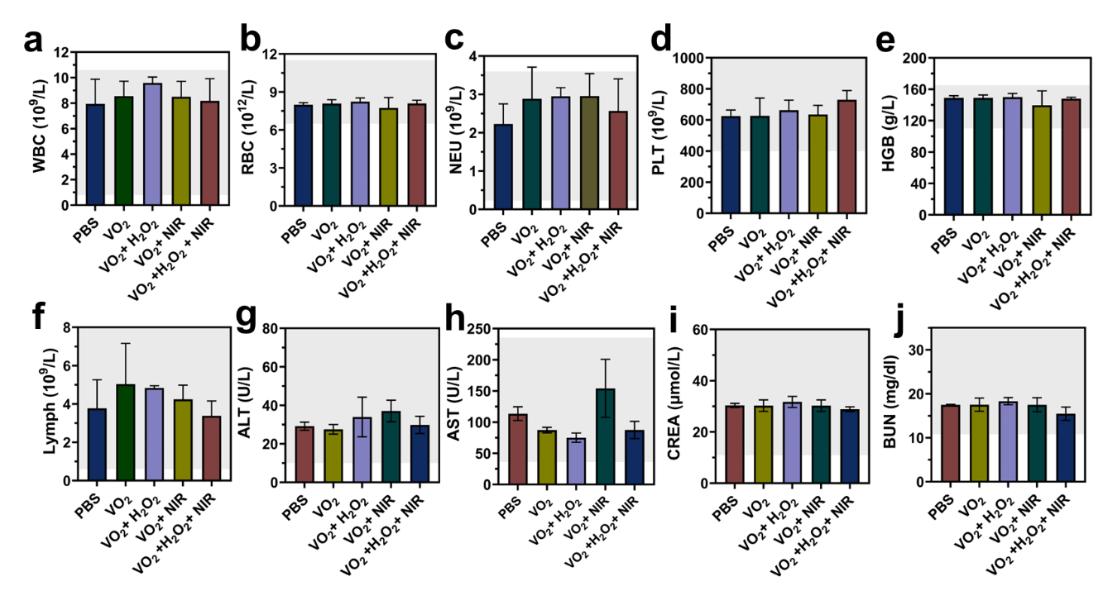
Figure S13. Biosafety evaluations of VO₂ in vivo. Blood routine examination including (a) white blood cell (WBC), (b) red blood cell (RBC), (c) neutrophil (NEU), (d) platelet (PLT), (e) hemoglobin (HGB), (f) lymphocyte (Lymph). Blood biochemistry examination, including (g) alanine aminotransferase (ALT), (h) aspartate aminotransferase (AST), (i) creatinine (CREA), (j) blood urea nitrogen (BUN). Healthy mice were treated differently and blood was taken from their eyes 24 h later for testing. Data are presented as mean ± SD (n=3).

