Supplementary Material
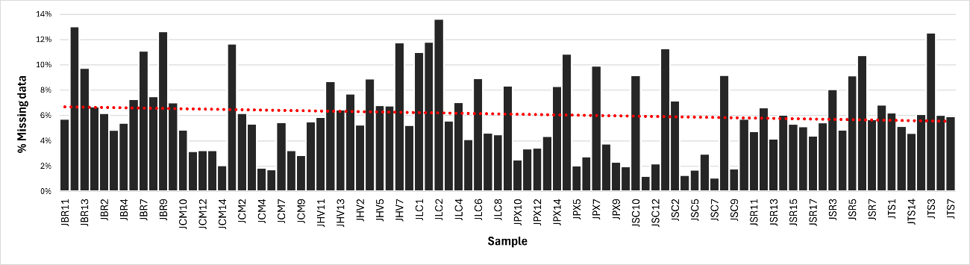
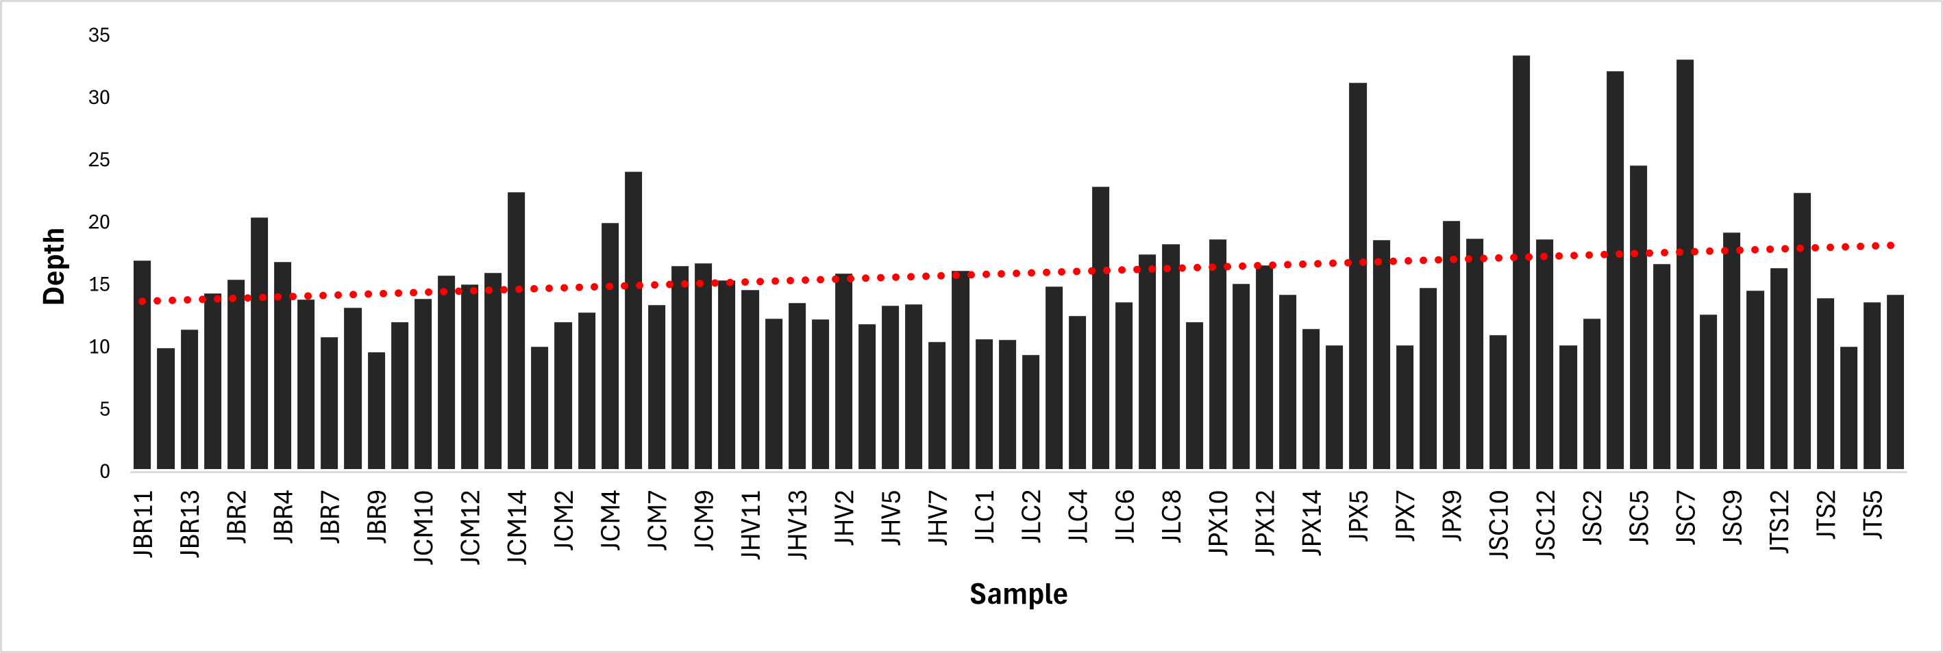
Figure 1. Sequencing quality and filtering of 91 individuals to obtain 24,859 SNPs.
(A) Percentage of missing data per individual. (B) Sequencing depth per individual.
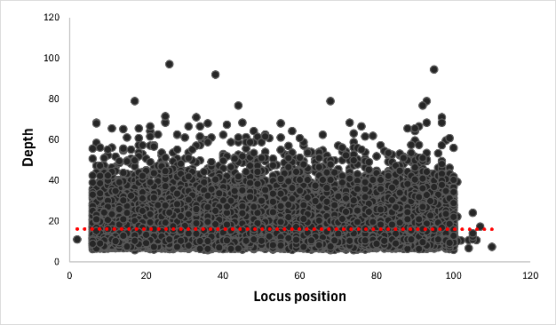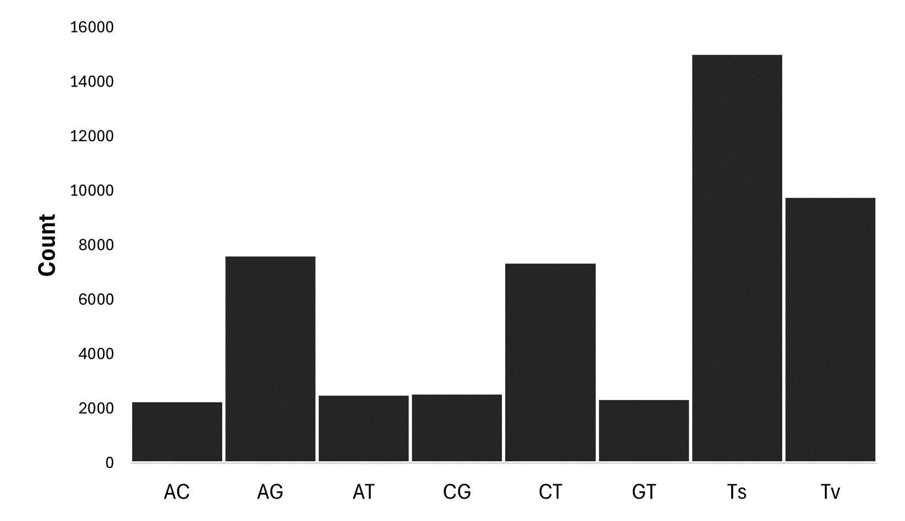
Figure 2. Sequencing quality and filtering of 91 individuals to obtain 24,859 SNPs.
(A) Sequencing depth per locus. (B) Observed transitions and transversions among the obtained SNPs.

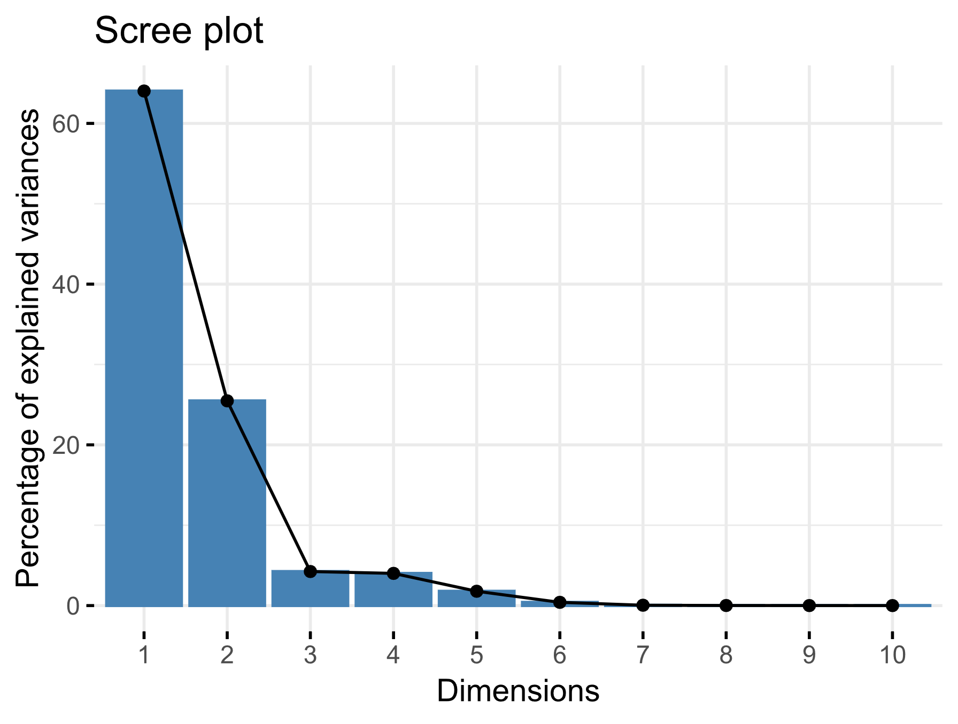
Figure 3. Scree plot of the Principal Component Analysis (PCA) with the 19 bioclimatic variables from WorldClim. The first two principal components together explain approximately 85% of the total variance, justifying the selection of the variables bio06 (minimum temperature of the coldest month) and bio19 (precipitation of the coldest quarter) as environmental predictors in the genomic association analyses.

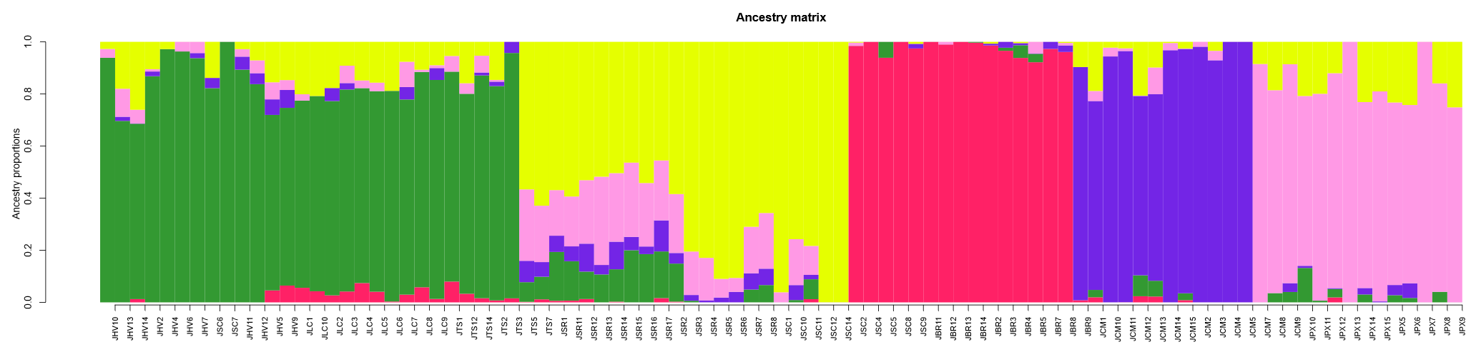
Figure 4. Genetic structure inferred by sNMF using all SNPs (neutral and adaptive) for 91 individuals of Syagrus romanzoffiana. The model with K = 5 was the most suitable based on the cross-entropy criterion. Each bar represents an individual, and the colors indicate ancestry proportions in different genetic groups. Populations are grouped according to sampling sites in southern Brazil and Paraguay.

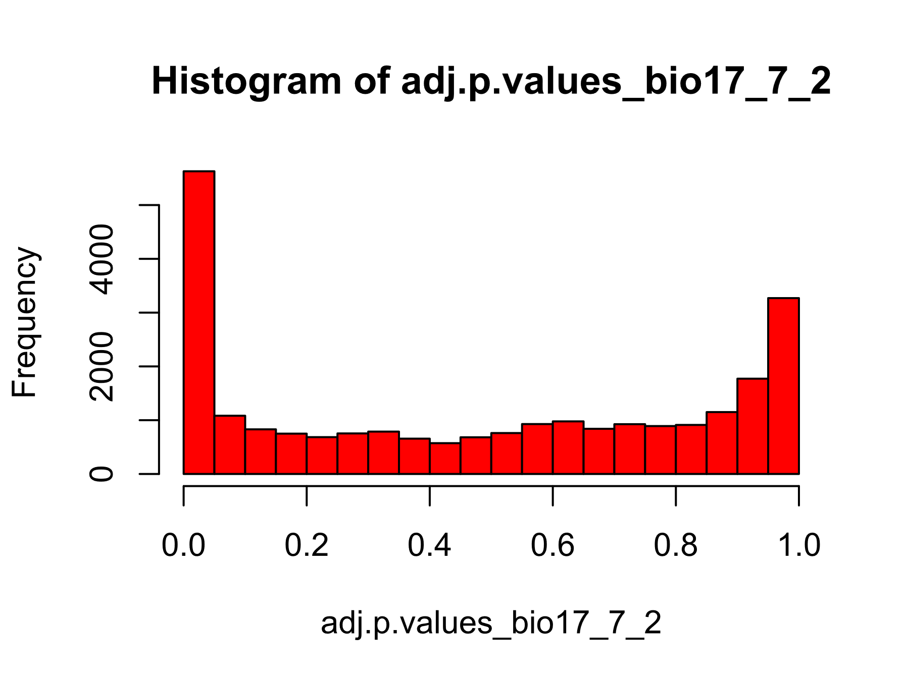
Figure 5. Histogram of adjusted p-values obtained from the LFMM model for the bioclimatic variable bio19 (precipitation of the coldest quarter). The distribution of values indicates a considerable proportion of SNPs with low p-values, suggesting strong genotype–environment association and the presence of candidate loci under local selection.

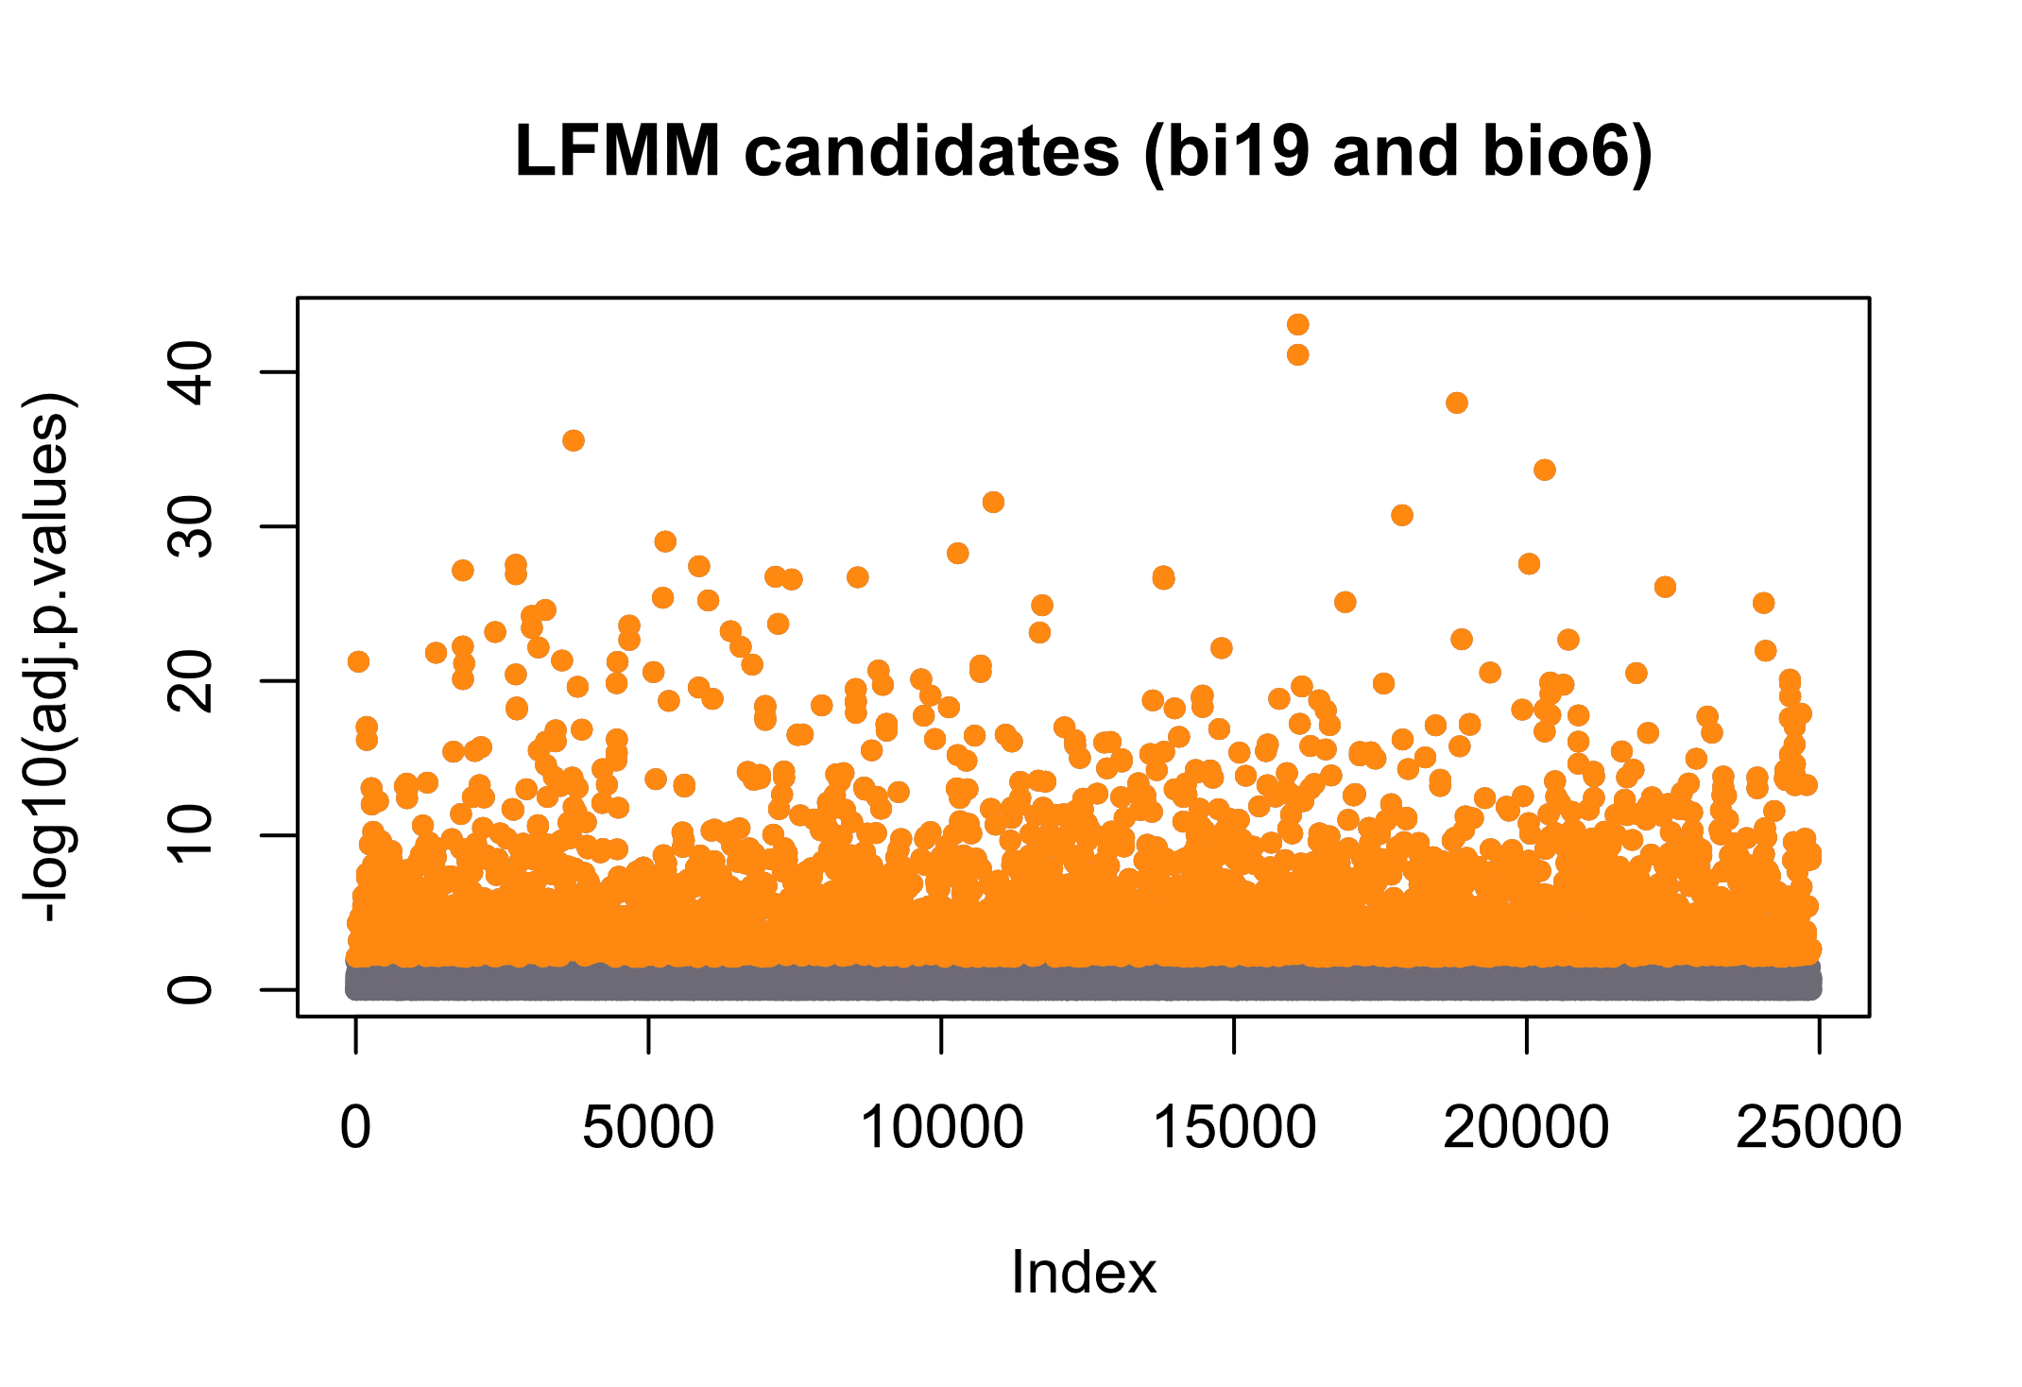
Figure 6. Distribution of adjusted –log₁₀(p) values for the candidate SNPs under selection identified by the LFMM model, associated with the bioclimatic variables bio06 (minimum temperature of the coldest month) and bio19 (precipitation of the coldest quarter). Orange dots represent loci with significant association (q < 0.05), indicating possible regions under adaptive selection.

