Graphical abstract

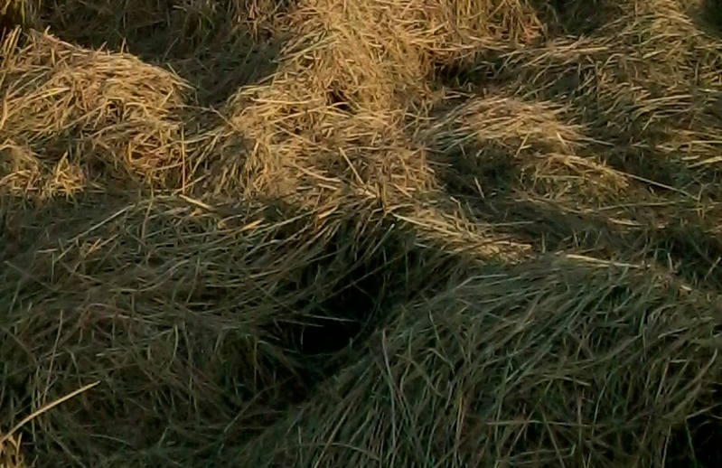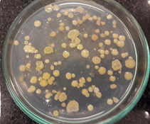

Rice straw as source for PHA-accumulating bacteria and as carbon source for PHA production

