Carbon encapsulation of silicon via lignosulfonate/chitosan electrostatic assembly and glucose-coating for enhanced lithium-ion battery anodes

Ling Wu¹, Yang Liu¹, Tingwei Zhang^{1,2,}*, Yongcan Jin^{1,2,}*, Huining Xiao³

¹ Jiangsu Co-Innovation Center of Efficient Processing and Utilization of Forest Resources, College of Light Industry and Food Engineering, Nanjing Forestry University, Nanjing 210037, China;
² International Innovation Center for Forest Chemicals and Materials, Nanjing Forestry University, Nanjing 210037, China;
³ Department of Chemical Engineering, University of New Brunswick, Fredericton, NB, E3B 5A3, Canada.

Corresponding authors: jinyongcan@njfu.edu.cn (Y.C. Jin); ztwei@njfu.edu.cn (T.W. Zhang)

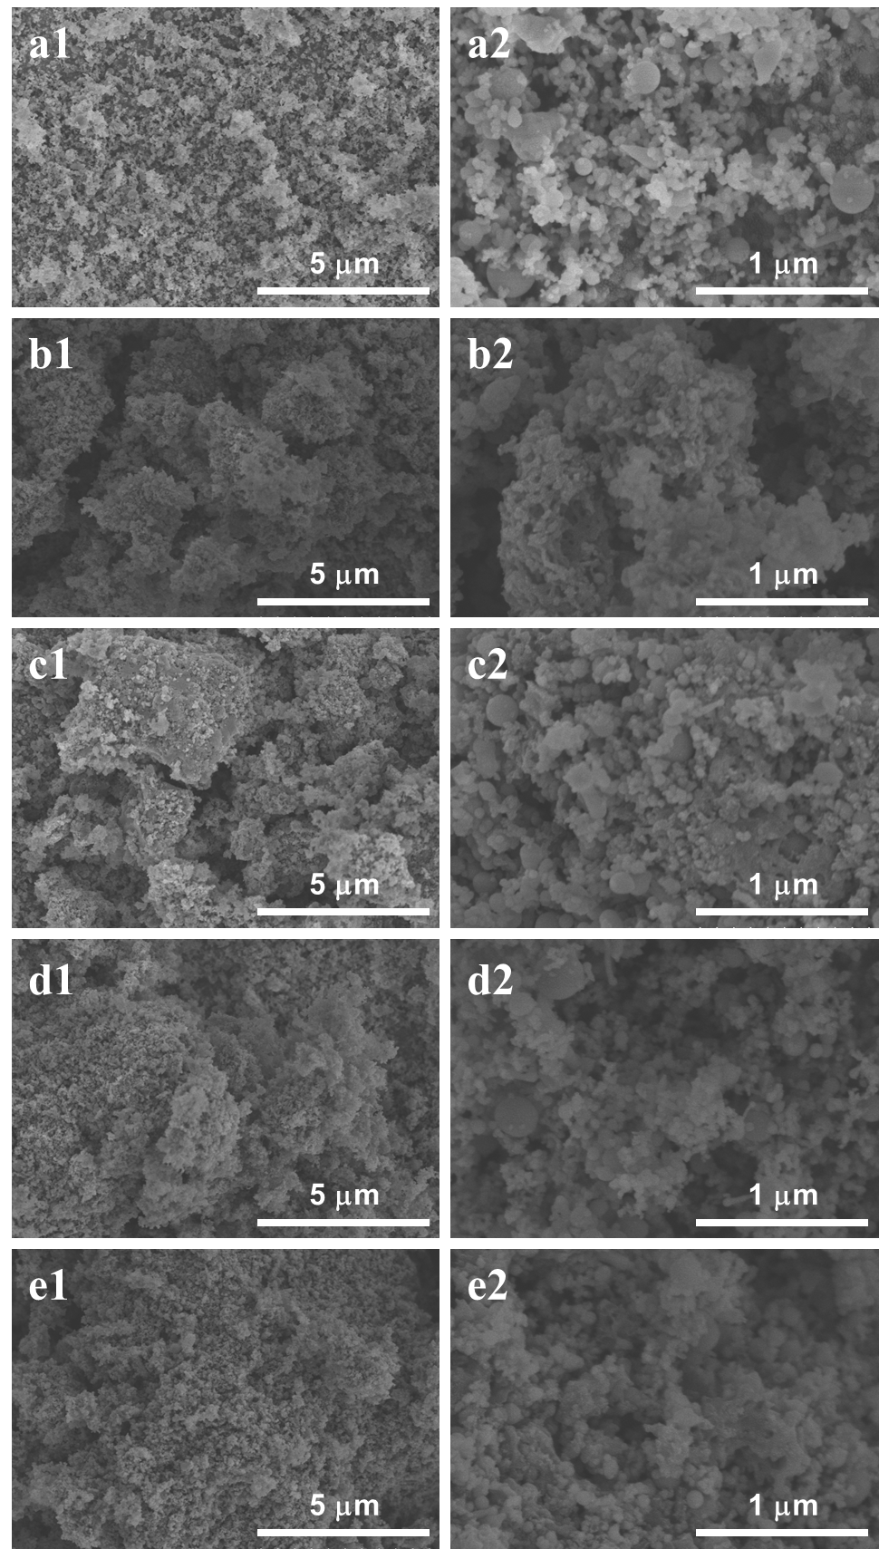
Fig. S1. SEM images of Si (a1-a2), 650-4 (b1-b2), 650-4-glu (c1-c2), 650-8 (d1-d2) and 650-8-glu (e1-e2).
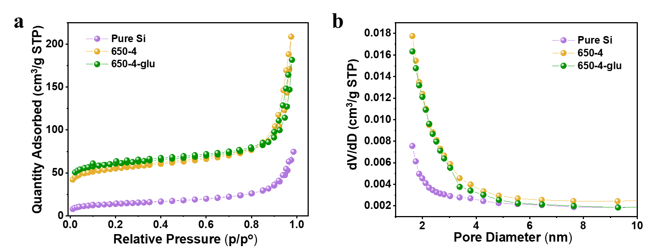
Fig. S2. (a) N₂ adsorption-desorption isotherms and (b) pore size distribution plots of the samples.

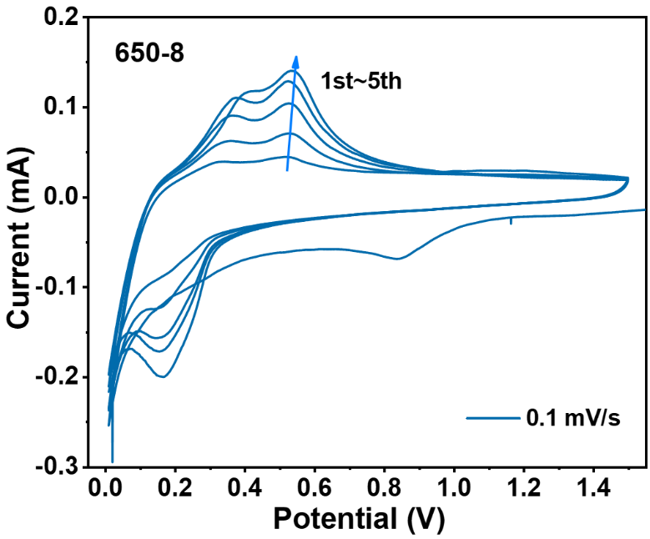
Fig. S3. CV curves of 650-8.

Fig. S4. The charge-discharge curves of different cycles of 650-8.

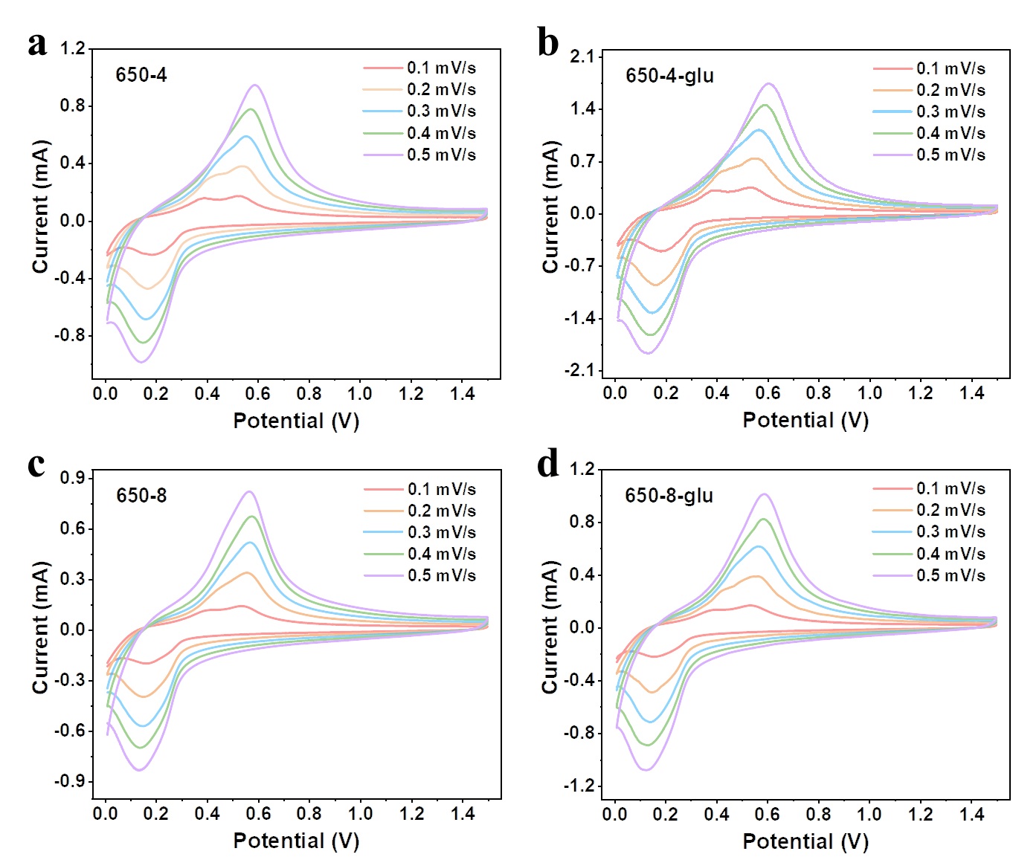
Fig. S5. CV curves of the samples at different scan rates.

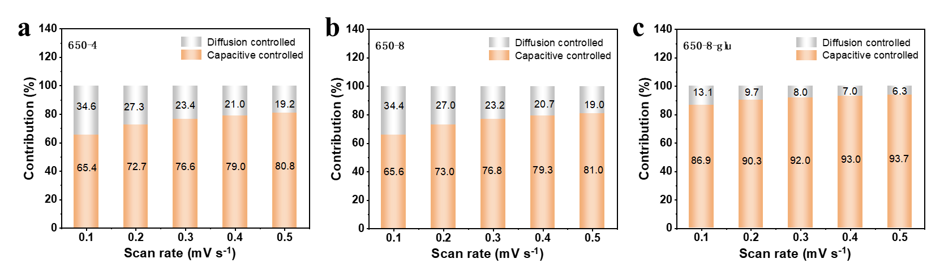
Fig. S6. The proportion of diffusion-controlled capacity and capacity-controlled capacity of 650-4 (a), 650-4-glu (b) and 650-8-glu (c) at various scan rates.

Fig. S7. EIS plots of the newly prepared electrodes.

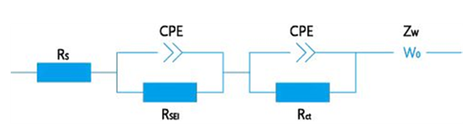
Fig. S8. The equivalent circuit of samples.

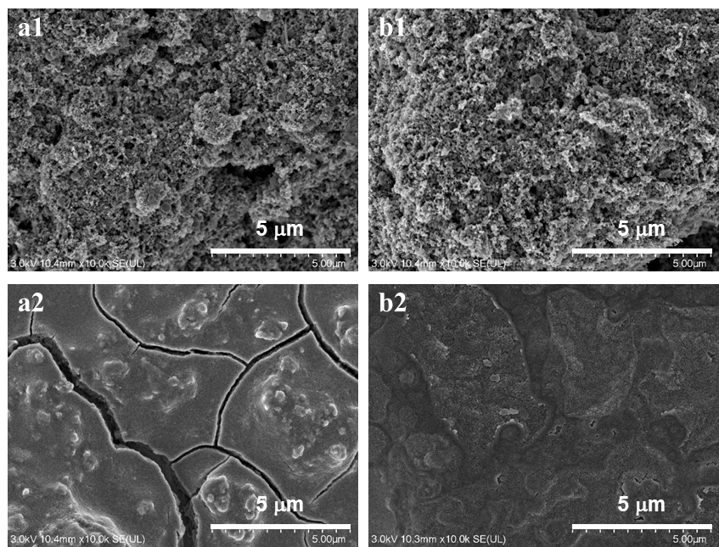
Fig. S9. (a1, b1) Top-view SEM images of newly fabricated 650-4 and 650-4-glu electrode materials; (a2, b2) top-view SEM images of post-cycled 650-4 and 650-4-glu electrode materials after 1000 cycles at 1.0 A/g.
Table S1. Textural parameters of Si, 650-4 and 650-4-glu determined by N₂ adsorption/desorption measurements.
Samples | Type of isotherm | S_{BET} (m²/g) | S_{micro} (m²/g) | Total pore volume (cm³/g) | t-Plot micropore volume (cm³/g) | R_{micro} (%)
Si | II | 50.5 | 20.7 | 0.12 | 0.0086 | 7.2
650-4 | IV | 207.0 | 153.5 | 0.32 | 0.063 | 19.7
650-4-glu | IV | 233.1 | 189.2 | 0.28 | 0.076 | 27.1

Table S2 The R_{ct} values of newly prepared and 200r-cycled electrodes.
Samples | 650-4 | 650-4-glu | 650-8 | 650-8-glu
New | 137.9 | 160.0 | 179.5 | 168.3
200R | 76.7 | 72.5 | 90.6 | 87.0

