m-WeTex: A Scalable, Superhydrophilic, Multifunctional Wearable Textile Platform
Sutirtha Roy^{*1}, Krishna Prasad Aryal^{*2}, Moshfiq-Us-Saleheen Chowdhury¹, Eliot Felix², Aditya Shekhar Nittala^{¥,3}, Richa Pandey^{¥,2,4}
1.Department of Electrical and Software Engineering, University of Calgary
2.Department of Biomedical Engineering, University of Calgary
3.Department of Computer Science, University of Calgary
4.Hotchkiss Brain Institute, University of Calgary

*Indicated for the equal contribution to this work.
¥Corresponding author’s emails: anittala@ucalgary.ca, richa.pandey@ucalgary.ca.

Tables

Table S1: Overview of textile-based composites and their applications in wettability control and sensing functions, highlighting the multifunctionality achieved in this work.

Material | Application | Wettability test | Touch sensing | Deformation sensing | Biochemical Sensing
⁴⁸Plasma treated Polyester | O₂ plasma treatment for oil-water separation | ✓ | ✗ | ✗ | ✗
⁴⁹Plasma treated Polyester | Atmospheric Plasma Treatment for enhancing the breathability of fabrics | ✓ | ✗ | ✗ | ✗
¹⁹Polypyrrole-polyester nonwoven fabric | Wearable smart device | ✗ | ✗ | ✗ | ✗
²⁰Graphene-Nonwoven fabric | Sensing for Multifunctional application | ✗ | ✗ | ✓ | ✗
¹⁷rGO-polyester composite | Multifunctional wearable smart device | ✗ | ✗ | ✓ | ✗
¹⁸PANI/rGO/PDA/LC | Modified Lycra cotton for wearable sensor | ✗ | ✗ | ✓ | ✗
²¹GO/PU-Nylon polyurethane | Flexible wearable sensor | ✗ | ✗ | ✓ | ✗
²²rGO-PYs | Yarn based wearable integrated sensor | ✗ | ✗ | ✓ | ✗
²³rGO coated elastic fibers | Human motion detection | ✗ | ✗ | ✓ | ✗
²⁴rGO-coated cotton/PDMS | Strain sensing device | ✗ | ✗ | ✓ | ✗
²⁵Cotton/rGO/CNT | Multifunctional flexible sensor | ✗ | ✗ | ✓ | ✗
²⁶Graphene coated textiles | Human health monitoring | ✗ | ✗ | ✓ | ✗
²⁷Graphene Non-Woven Fabric | Textile compatible strain and pressure sensors | ✓ | ✗ | ✓ | ✗
²⁸rGO/Fluoropolymer-coated Polyester Fabric | Multifunctional smart textile | ✓ | ✗ | ✓ | ✗
rGO-polyester nonwoven fabric (This work) | Flexible multifunctional wearable sensing | ✓ | ✓ | ✓ | ✓
PET-polyester, PDMS-polydimethylsiloxane, PANI-polyaniline, PDA-polydopamine, LC-lycra cotton, PU-polyurethane, PY-polyimide yarns.

1. Supplementary Methods

Materials
Nonwoven polyester fabric is sourced from Amazon (LdevotionR). Other chemicals, such as graphene oxide and ascorbic acid, are obtained from Sigma–Aldrich. Denoised water (DI) is used as a solvent throughout the experiment. All the chemicals are used without further purification. We purchased kinesiology tape from Amazon (CKeep Kinesiology Tape) for one of our applications.

Sensor Characterization
TGA is performed to confirm functionalization of rGO onto nonwoven fabric surface. From the data Initial loss of weight, i.e. 2.9%, is observed due to loss of moisture from the fabric surface until 200 °C. Two major weight loss regions are observed, firstly from 270 °C up to 400 °C, i.e. 21.4%, and secondly, 60.2% weight loss after 400 °C. The first region corresponds to the decomposition of polyester materials in nonwoven polyester fabric [1-2], while the second weight loss region represents the decomposition of a few oxygen functionalities present in the modified fabric surface [3].
Raman spectroscopy and XPS analysis are utilized to confirm the reduction of graphene oxide (GO) into reduced graphene oxide (rGO). Raman spectra of both GO and rGO displayed the D bands at 1355 cm⁻¹ and 1349.2 cm⁻¹, respectively, as shown in Fig. S2. Formation of defects after reduction of GO is also confirmed with lower intensity of D-band in rGO surface [4]. Furthermore, the intensity ratio of D-band to G-band (I_{D}/I_{G}) is reduced from 0.94 to 0.85 after the chemical reduction of GO. This confirms the reinstatement of Sp² graphene structure, confirming the reduction [5-6].
The reduction of the oxygenated functional group is also confirmed with XPS measurement of O 1s spectra in both GO and rGO samples, as shown in Fig. S3. Two major O1s peaks are observed at the binding energies of 530.3 eV and 530.8 eV [7-8] indicating the presence of lattice oxygen and carbonyl groups, respectively. Additionally, the appearance of a prominent peak at 532.4 eV indicated the presence of oxygen atoms in the hydroxyl group (-OH) in both the GO and rGO spectra [9]. However, after the chemical reduction of GO, it is found to be less prominent in rGO. It also confirmed the presence of residual oxygen-containing functional groups in rGO, even after the reduction.

2. Supplementary Results and Discussions

Scanning electron microscopy (SEM) study of unmodified and modified fabrics
SEM images of unmodified nonwoven polyester fabric (a and b), and modified fabric rGO-F2 (c and d) are shown in Fig S4. In two different magnifications, 30 µm and 100 µm, nonwoven fabric exhibited the rigid and compact surface while the modified fabric surface displayed the rough, loosely held surface. In the meantime, we also observed the images of rGO-F1 and rGO-F3, presented in Fig. S5. A bit denser and more agglomerated surface of rGO is seen in case of rGO-F1 (a, b and c), in contrast to crosslinked morphology of rGO-F2, as depicted in Fig. S4. On the other hand, the rGO-F3 surface consisted of less rGO surface, which is incorporated with the nonwoven surface, as shown in Fig S5 (d, e and f). Overall morphology suggested the alteration of nonwoven fabric morphology after introducing conductive material, rGO.

Electron dispersion spectroscopy (EDS) study of unmodified and modified fabrics
EDS measurement was performed for both of the fabrics, modified and unmodified. From the obtained data, a nonwoven fabric (Fig. S6a) comprised of 69.6 at. % of C and 30.4 at. % of O (Fig. S6b and S6c, respectively). On the other hand, rGO-F2 (Fig. S6d) possessed 76.9 at. % of C and 23.1 at. % of O (Fig. S6e and S6f, respectively). It confirmed the increase, at. 7.3 %, of C after adding rGO onto nonwoven fabric, further confirming the incorporation of rGO onto nonwoven fabric surface.

Tensile strength and Sheet resistance
From the measurement, rGO-F1 and rGO-F3 have shown a breaking point of 4.8 N and 3.9 N with displacements of 7.1 mm and 3.1 mm, respectively. Similarly, rGO-F1 and rGO-F3 fabric possessed a sheet resistance of 2.2×10⁴ (±21.42) Ω/sq. and 3.4×10⁴ (54.97) Ω/sq., respectively. The observed variation of sheet resistance among the samples indicated the differences in the conductive pathways formed with rGO. Enhancement of conductivity, particularly in rGO-F2, can be attributed to the porous and expanded morphology of nonwoven fabric, which likely facilitates the electron transfer pathways after the introduction of rGO in comparison to other fabric surfaces.

3. Supplementary Figures

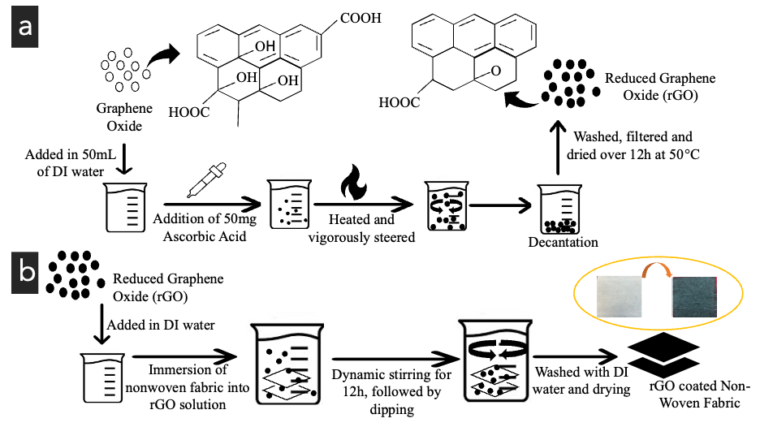

Figure S1. Schematic representation of (A) the synthesis of reduced graphene oxide (rGO) and (B) the fabrication process of rGO-coated non-woven polyester fabric using the KIC (Kinetic-Immersion-Coating) method.

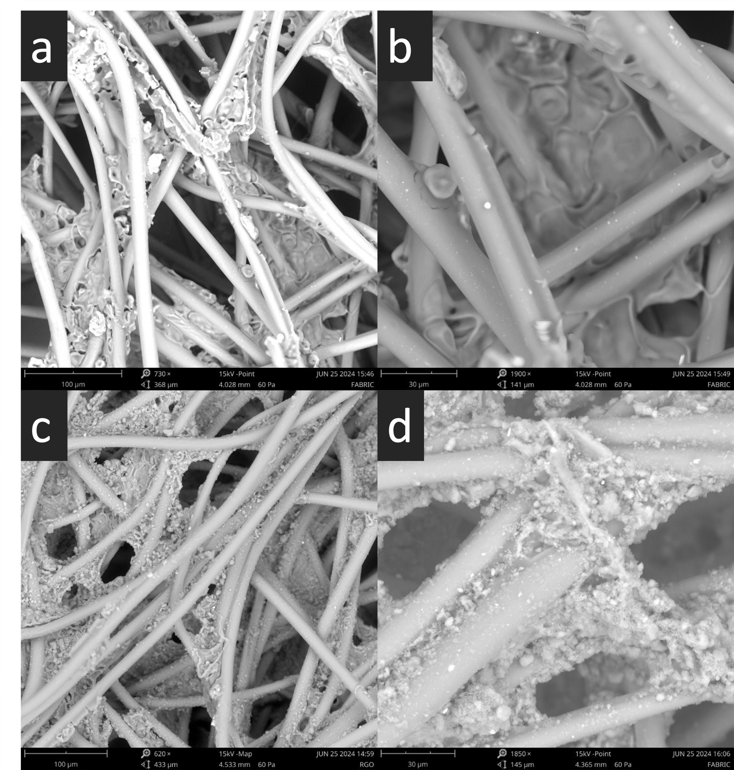

Figure S2. Scanning electron microscopy (SEM) images of the rGO-F2-coated non-woven polyester textile at various magnifications, showing uniform coating and surface morphology of the graphene oxide layer across the fabric fibers.

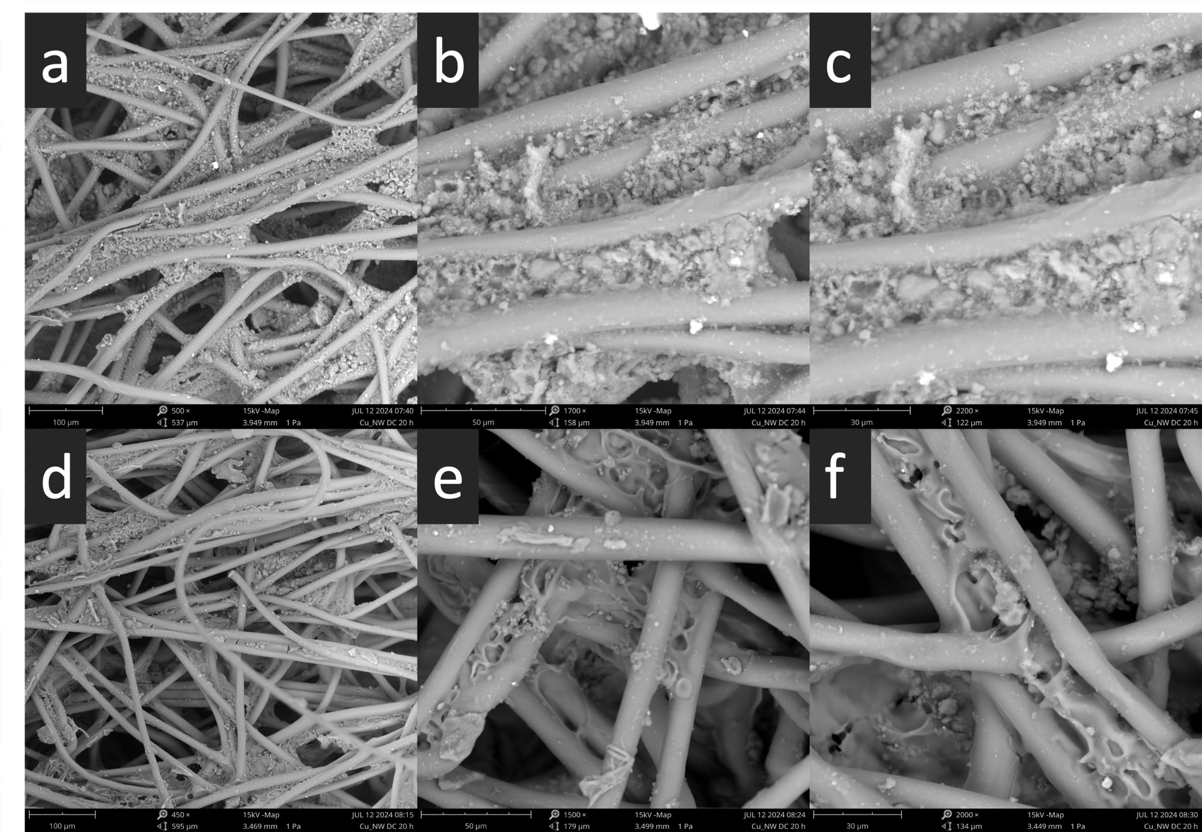

Figure S3. Scanning electron microscopy (SEM) images of rGO-F1-coated (a–c) and rGO-F3-coated (d–f) non-woven polyester textiles at different magnifications, highlighting differences in surface morphology and distribution of the rGO coating on the fiber networks of the non-woven polyester fabric.

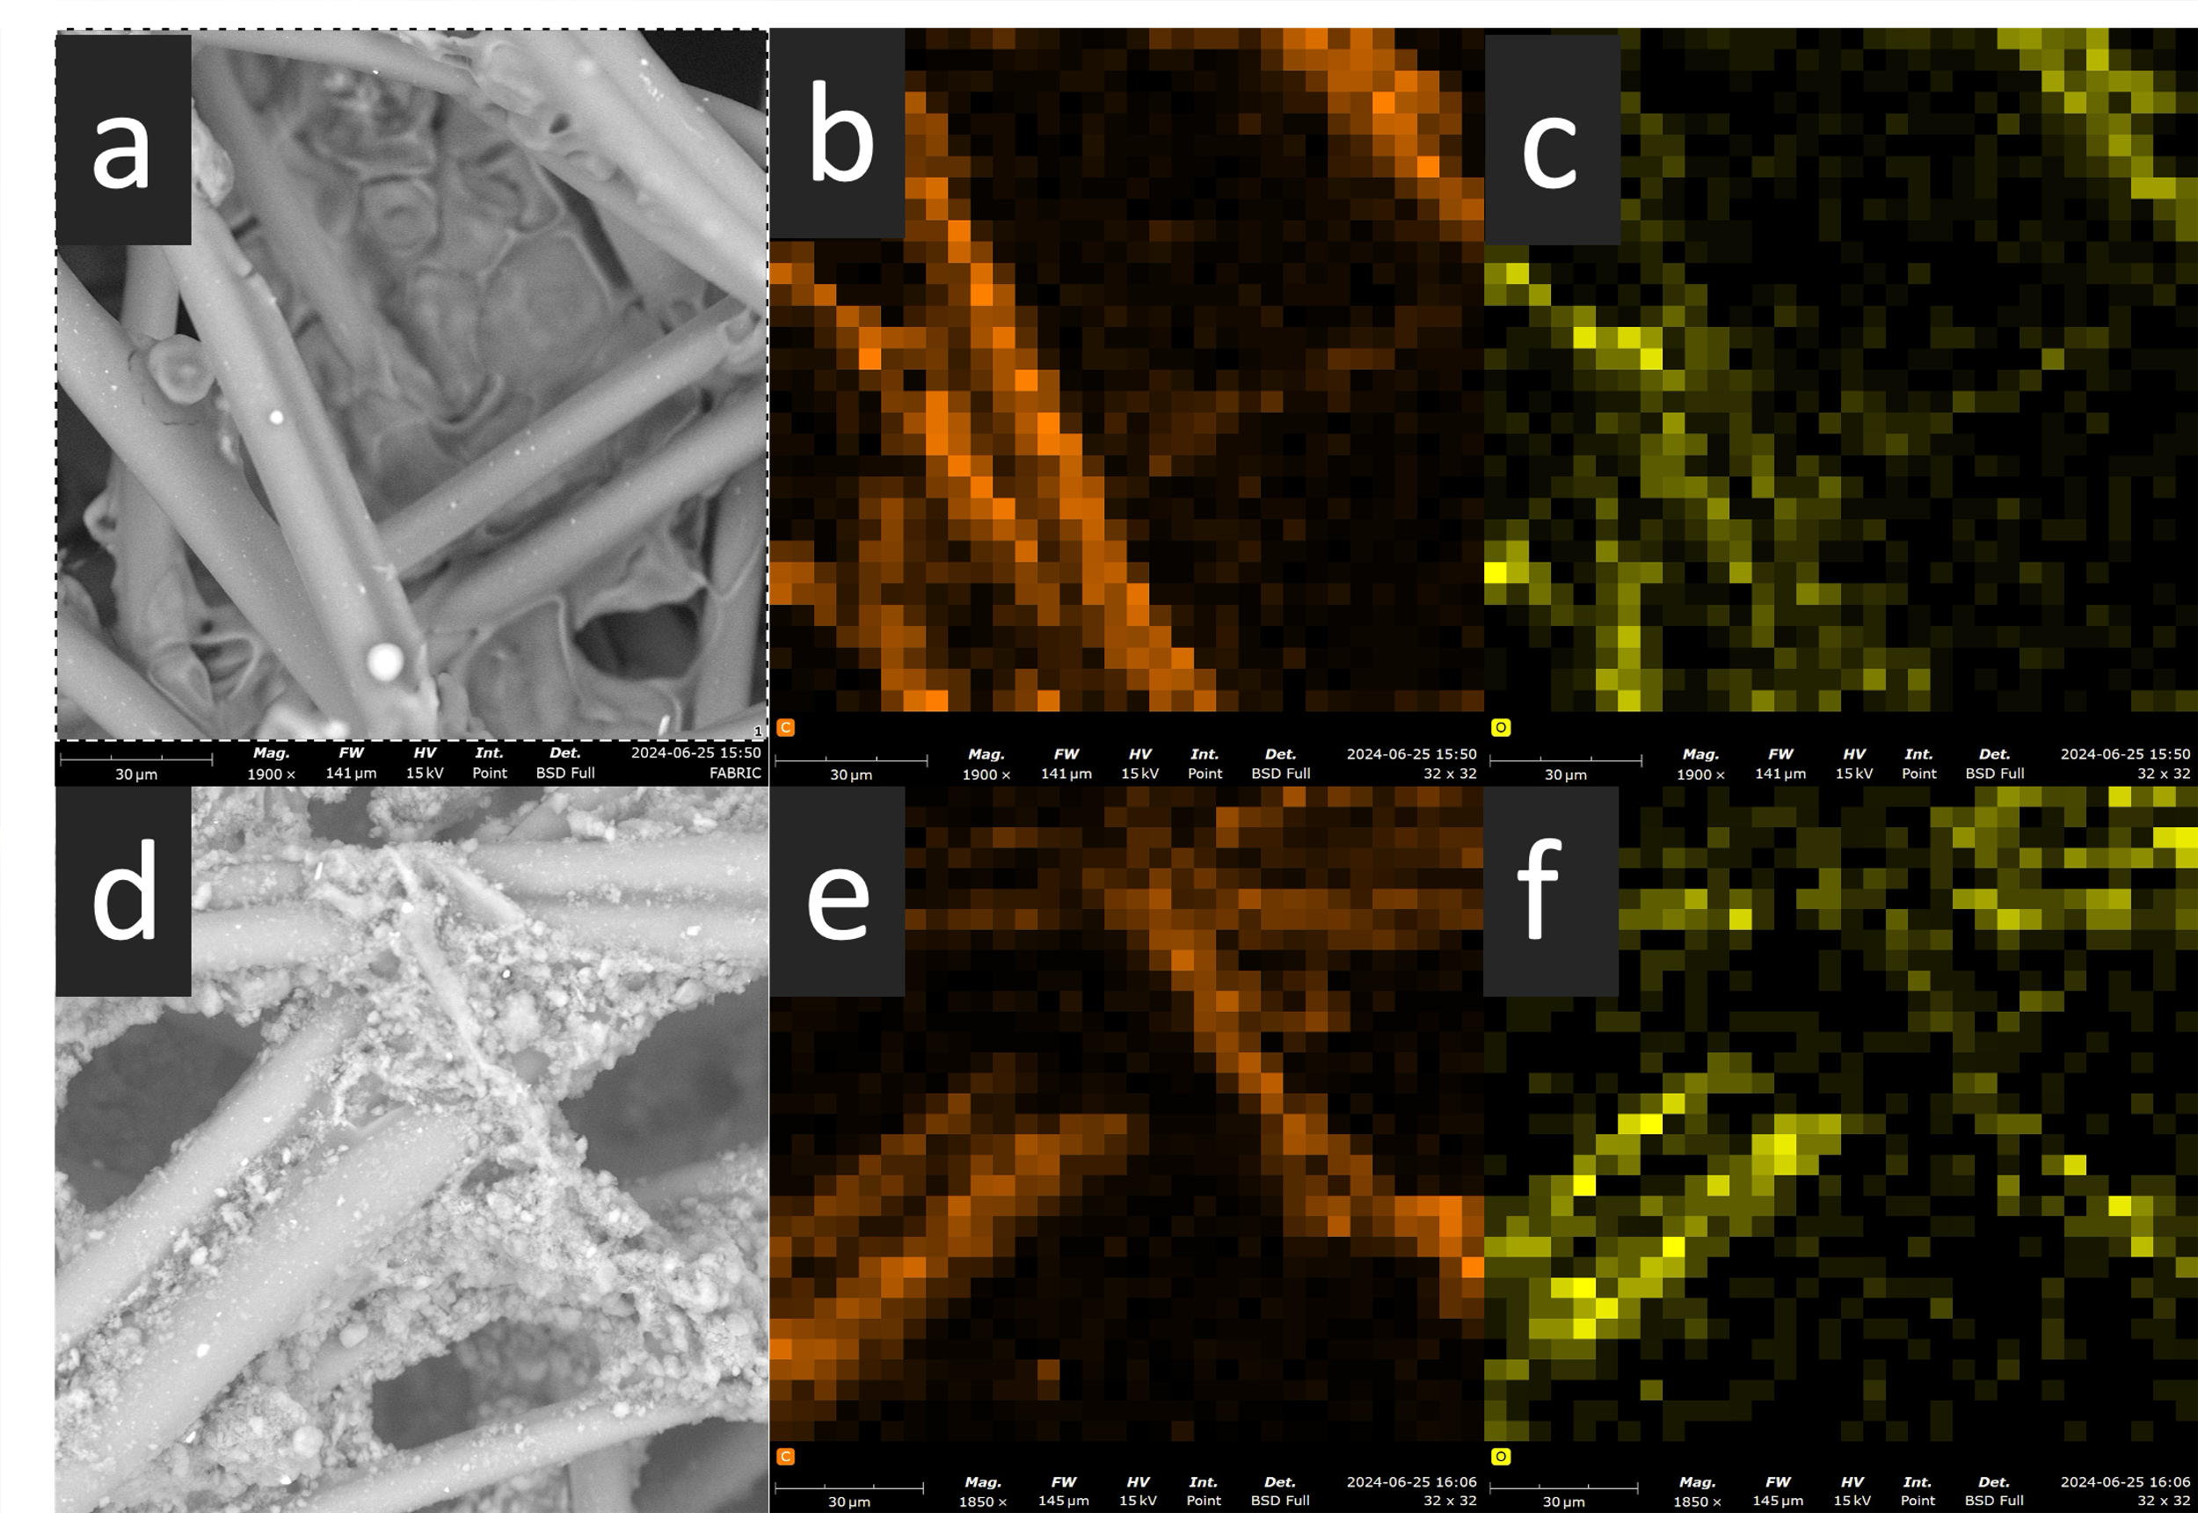

Figure S4. Scanning electron microscopy (SEM) and energy-dispersive X-ray spectroscopy (EDS) mapping images of (a–c) pristine non-woven polyester fabric and (d–f) rGO-F2-coated non-woven polyester fabric. Panels (b, e) and (c, f) show elemental distributions corresponding to characteristic elements of the textile and rGO coating, respectively, confirming the successful deposition of rGO on the textile fibers.

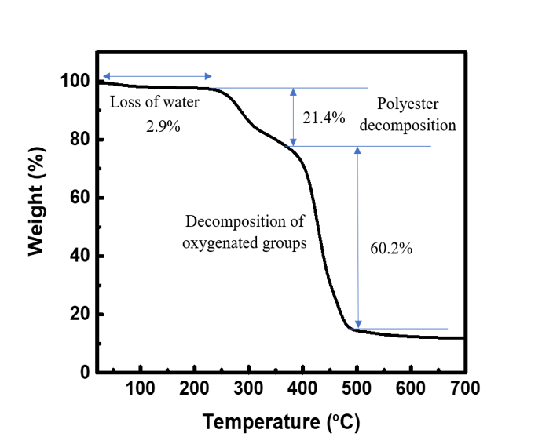

Figure S5. Thermogravimetric analysis (TGA) curve of the rGO-F2-coated non-woven polyester textile, showing weight loss behavior as a function of temperature, indicative of thermal stability and decomposition characteristics of the rGO-modified fabric.

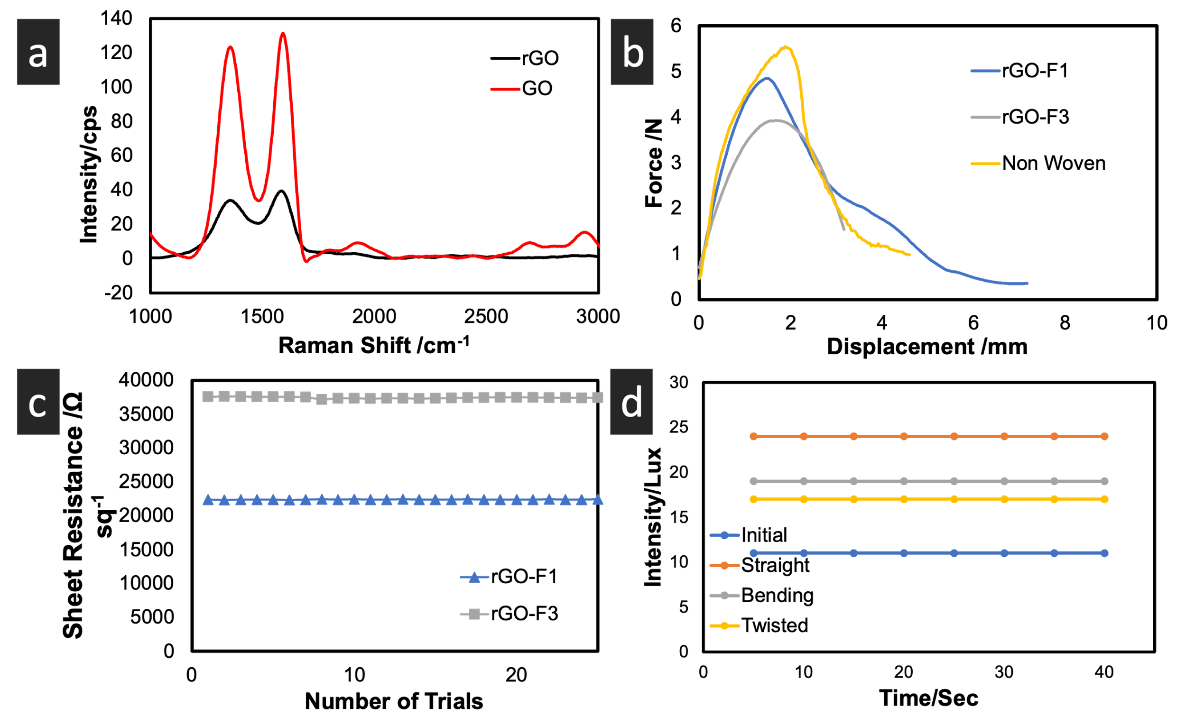

Figure S6. Characterization of rGO-coated non-woven polyester textiles. (a) Raman spectra of graphene oxide (GO) and reduced graphene oxide (rGO) before and after chemical reduction, confirming structural changes associated with reduction. (b) Tensile strength curves comparing mechanical properties of rGO-F1, rGO-F3, and pristine non-woven fabric. (c) Sheet resistance measurements of rGO-coated fabrics demonstrating electrical conductivity. (d) Light intensity output of an LED integrated with the fabric under different deformation states (straight, bending, twisting), as measured by a light-dependent resistor (LDR), indicating stable optical performance during mechanical deformation.

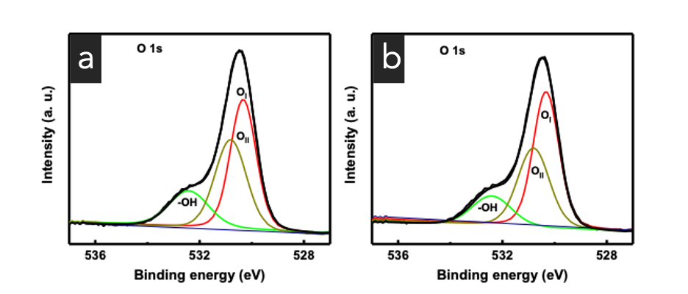

Figure S7. X-ray photoelectron spectroscopy (XPS) O 1s spectra of (a) graphene oxide (GO) and (b) reduced graphene oxide (rGO), showing changes in oxygen-containing functional groups before and after chemical reduction.

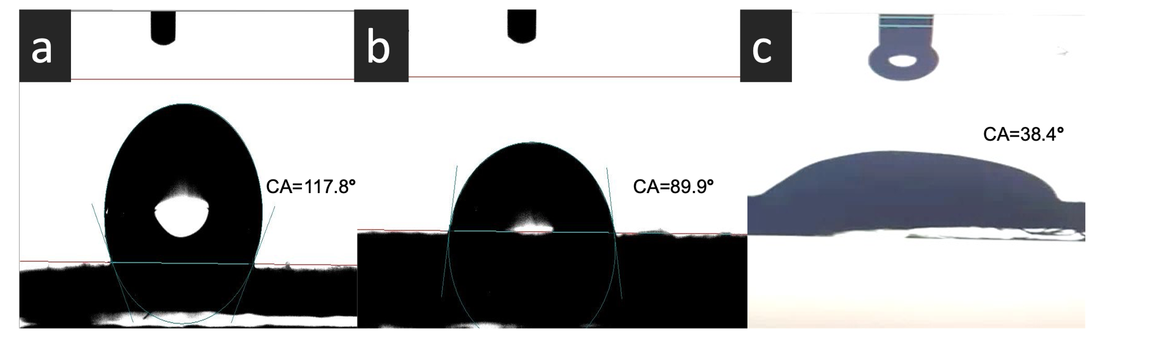

Figure S8. Water contact angle measurements on different textile samples: (a) pristine non-woven polyester fabric exhibiting a contact angle of 117.8°, indicating hydrophobic behavior; (b) rGO-F3-coated fabric with a contact angle of 89.9°, showing moderate hydrophilicity; and (c) rGO-F1-coated fabric displaying a contact angle of 38.4°, demonstrating increased hydrophilicity after rGO coating.

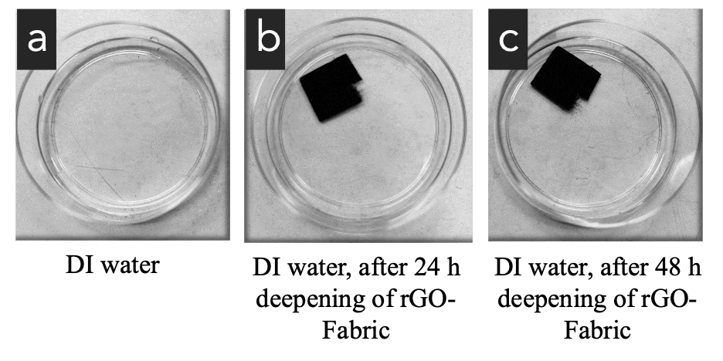

Figure S9. Observation of particle stability and wettability behavior of modified non-woven polyester fabrics in water. (a) Control sample without fabric. (b, c) rGO-coated non-woven polyester fabric samples showing stable floating behavior and minimal particle dispersion, indicating improved hydrophobicity and surface integrity after modification.

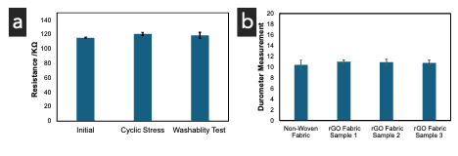

Figure S10. Durability tests of the rGO-coated non-woven fabrics. (a) Durability assessment of rGO-F2 textile through cyclic stress and washability tests, showing initial and final resistance values. (b) Durometer test results measuring material hardness before and after rGO coating, demonstrating the effect of the coating on the textile’s mechanical softness.

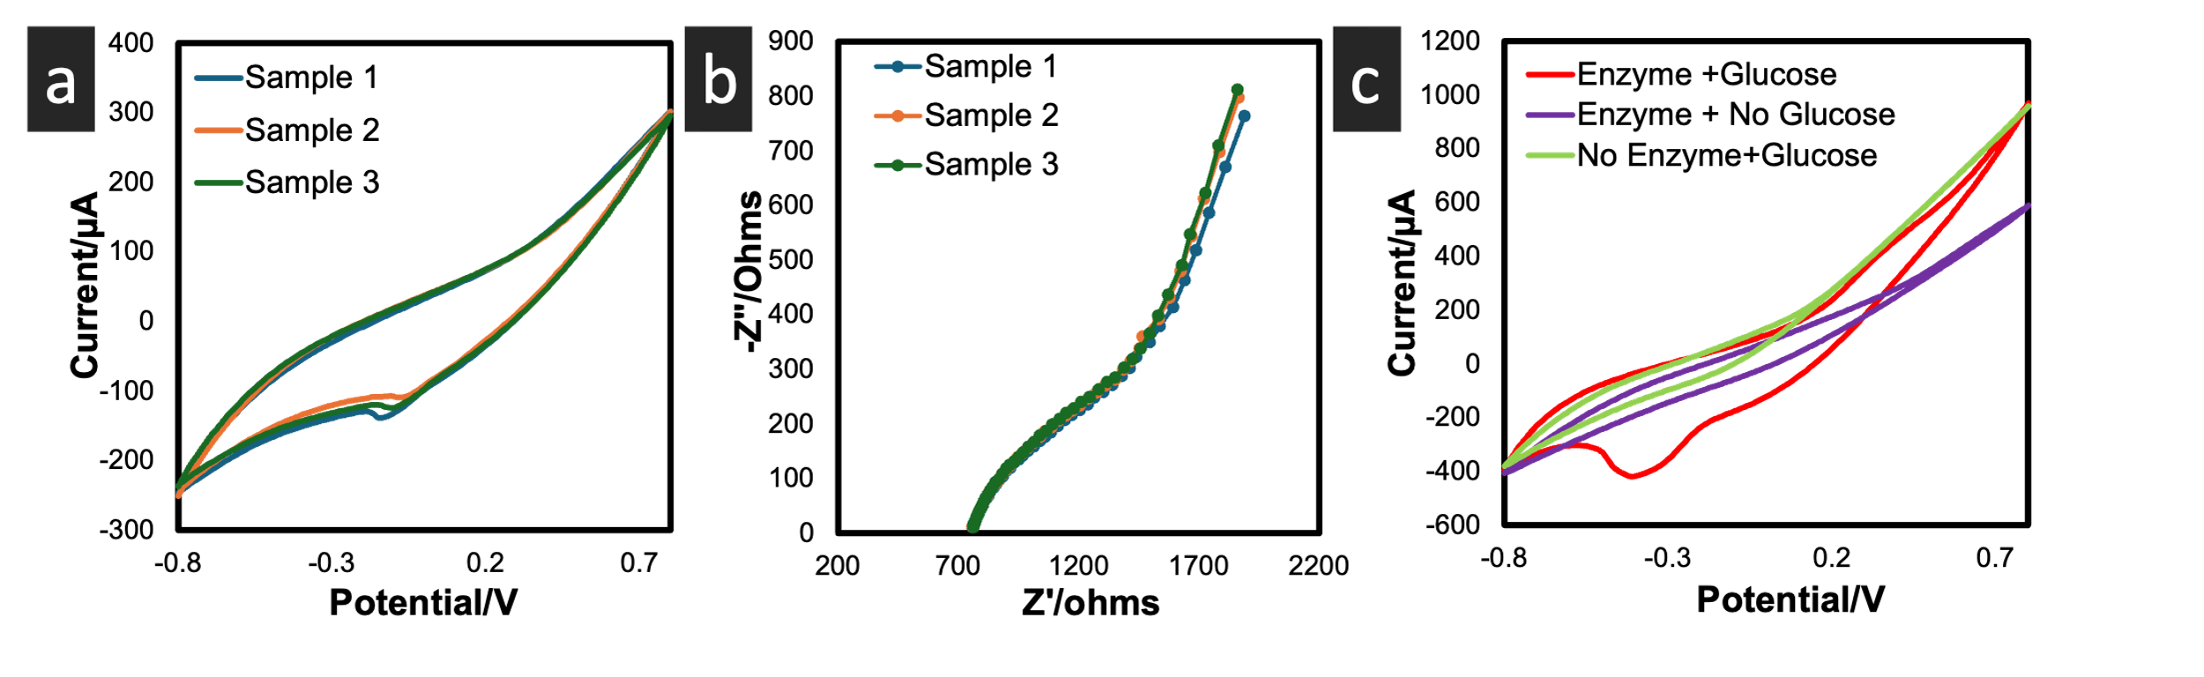

Figure S11. Electrochemical characterization of rGO-F2-coated non-woven polyester textile. (a) Cyclic voltammetry (CV) curves of rGO-F2 electrodes measured in 2 mM potassium hexacyanoferrate(II) solution, demonstrating reproducible electrochemical behavior across samples. (b) Electrochemical impedance spectroscopy (EIS) Nyquist plots for three rGO-F2 samples in the same electrolyte, showing consistent charge transfer resistance and impedance characteristics. (c) CV curves comparing electrochemical responses under three different test conditions, highlighting differences in redox behavior among the cases studied.

References
[1]. V. G. Gorade, B. U. Chaudhary, R. D. Kale, Moisture management of polypropylene non-woven fabric using microcrystalline cellulose through surface modification, Applied Surface Science Advances 6 (2021) 100151.
[2]. J. Drelich, E. Chibowski, Superhydrophilic and Superwetting Surfaces: Definition and Mechanisms of Control, Langmuir 26(24) (2010) 18621-18623.
[3]. P. L. Teh, H. T. Ng, C. K. Yeoh, Recycled Copper as the Conductive Filler in Polyester Composites, Malaysian Polymer Journal 6 (2011) 98-108.
[4] Zhang, H. Yang, G. Shen, P. Cheng, J. Zhang, S. Guo, Reduction of graphene oxide via L-ascorbic acid, Chem. Commun. 46 (2010) 1112-1114.
[5] K. K. H. De Silva, H.-H. Huang, M. Yoshimura, Progress of reduction of graphene oxide by ascorbic acid, Applied Surface Science 447 (2018) 338-346.
[6] J. A. Q. Renteria, C. R. Garcia, T. Sauvage, L. F. Chazaro-Ruiz, J. R. Rangel-Mendez, C. O. Ania, Photochemical and electrochemical reduction of graphene oxide thin films: tuning the nature of surface defects, Phys. Chem. Chem. Phys. 22 (2020) 20732.
[7] M. Karakoti, R. Jangra, S. Pandey, P. S. Dhapola, S. Dhali, S. Mahendia, P. K. Singh, N. G. Sahoo, Binder-free reduced graphene oxide as electrode material for efficient supercapacitor with aqueous and polymer electrolytes, High Performance Polymers 32(2) (2020) 175-182.
[8] M. H. Tran, H. K. Jeong, Improved dispersion of graphite derivatives by solution plasma, J. Mater. Sci. 53 (2017) 3388-3397.
[9] R. Al-Gaashania, A. Najjarc, Y. Zakariaa, S. Mansoura, M. A. Atieh, XPS and structural studies of high-quality graphene oxide and reduced graphene oxide prepared by different chemical oxidation methods, Ceramics International 45 (2019) 14439-14448.

