SUPPLEMENTARY MATERIAL

Integrating Brain Imaging Volumetrics and Quantitative Pupillometry for Predicting Neurologic Deterioration after Large Hemispheric Stroke

Yili Du, MS, Leigh Ann Mallinger, BA, Allyson L. Reinert, BS, Stefanos Chatzidakis, MD, Nawal J. Ibrahim, BS, Gabriella Wirth, Atul Kumar, MBBS, DRE, Amrit Avula, MS, Huimin Cheng, PhD, David M. Greer, MD, MA, Rajat Dhar, MD and Charlene J. Ong, MD, MPHS

Table of Contents
Supplementary Methods 3
Data Collection and Ascertainment 3
Image Processing and Analysis Pipeline 6
Supplementary Figures 8
Supplementary Figure 1. Density Plots of Volumetric Data by Observation Time 8
Supplementary Figure 2. Temporal Trends in Brain Volume Ratio and Net Water Uptake Volume 9
Supplementary Figure 3. Distribution Histograms of Delta Volumetric Data 10
Supplementary Figure 4. Spaghetti Plots Depicting Patient-Level CSF Volumetric Data over 72 Hours 11
Supplementary Figure 5. Spearman Correlations between Standardized Brain Volume and Pupillometry at Baseline 12
Supplemental Figure 6. Time-dependent Receiver Operating Characteristic Curve for Cox models of Neurological Deterioration in Each 12-hour Interval under Leave-One-Out Cross Validation 13
Supplemental Figure 7. Exploratory time-dependent ROCs of Cox Models including CSF Volumetric Data 15
Supplemental Figure 8. Model Comparisons among Cox Models using AIC and BIC 16
Supplementary Table 17
Supplemental Table 1. Correlation Between CSF Volume Ratio and Quantitative Pupillometry Around Imaging 17
Reference 18

Supplementary Methods

Data Collection and Ascertainment
Demographics, clinical variables including past medical history, stroke assessment, procedures and treatment, and outcomes were extracted from the electronic medical record at Boston Medical Center. We included the following ascertainment rules that pertain to relevant variables.

Middle Cerebral Artery (MCA) involvement criteria were adjudicated by the principal investigator (CJO) and co-author (DMD). Involvement was defined as ≥1/2 MCA territory on admission CT or MRI scan by visualization of either full involvement of the superior or inferior division, or sufficient hypodensity/diffusion restriction of both superior and inferior divisions equating to ≥1/2 of the full MCA territory on patients who had available volumetric imaging on CT within 10 days of last seen well (N=71).

Last seen well date times were identified via clinical notes. Last seen well was considered the last time before a patient had a significant deficit, as inferred by National Institutes of Health Stroke Score (NIHSS) (times in which symptoms of numbness, tingling, or other symptoms that would result in NIHSS<3 were not observed at the time of last seen well). Last seen well without exact times or only reference to time were labeled as “inferred” (N=1). If last seen well referred to “last night before bed” with no exact time, then last seen well was assumed to be 10:00 PM. All last seen well data underwent PI review (CJO).

Longitudinal quantitative pupillometry data were stored on single-patent-use SmartGuard memory cards, along with their measurement time. We collected the SmartGuard cards for each patient and used a SmartGuard reader to retrieve and upload these data into Excel sheets. Each SmartGuard card was labeled with patient identifiers and admission timestamps. For a subset of our patients who otherwise met inclusion criteria but in whom SmartGuards were unavailable, we obtained the Neurologic Pupil Index (NPi) and pupil size data from the electronic medical record. These patients were excluded from analyses of additional pupillometry characteristics. Missing pupil measurement data due to an NPi value of 0 were imputed as follows: dilation velocity was set to 0. We included the following definition and nomenclature rules for each pupillometric variable:
- The Neurological Pupil Index (NPi) was automatically computed by the NeurOptics NPi-300 pupillometer using an algorithm using the resting and constriction pupil size, percentage constriction change, constriction velocity, dilation velocity and latency. he NPi is a scaled value that is based on a model of normal pupillometer values. Numeric NPi scale ranges from 0 to 5, in which a decreasing NPi <3 is considered abnormal by the manufacturer. An NPi of 0 indicates non-reactive pupil. We used the minimum NPi between two eyes (NPi) and ipsilateral NPi (the NPi value in the eye of the stroke affected side).
  - In correlation analysis and adjusted mixed-effects linear models, we further derived summary variables for observations measured within ±1 hour of the imaging time including: 1) minimum value of NPi (Minimum NPi), 2) the closest NPi measurement to each image (Closest NPi), 3) the average value (Average NPi), 4) minimum value of ipsilateral NPi (Minimum ipsilateral NPi). And we further consolidated 5) the average value over 24 hours post-imaging (NPi_{24post}).
  - In our Cox Proportional Hazard Models with time-dependent covariates, we used the minimum NPi between right and left eye of each patient at time t as the primary exposure (NPi_{t}).
- Dilation velocity is the amount of pupil size in millimeters of recovery after constriction divided by the duration in seconds of the recovery, which is a result of mean pupil velocity when, after having reached the constriction peak, the pupil recovers and dilates to reach the size of early rest. We used the minimum dilation velocity between two eyes at time t as an exploratory pupil feature. We had 55 patients with available data in these analyses.
  - In correlation analysis and adjusted mixed-effects linear models, we used derived summary variable including minimum value within ±1 hour of the imaging time (Minimum Dilation Velocity).
  - In our Cox Proportional Hazard Models with time-dependent covariates, we used the minimum DV between right and left eye of each patient at time t as the primary exposure (DV_{t}).

- The difference in NPi (NPi Diff) between two eyes at time t was examined as an additional pupil feature (NPi Diff_{t}), with an NPi Diff $≥$0.7 considered abnormal by manufacturer.
  - In correlation analysis and adjusted mixed-effects linear models, we used derived summary variable including maximum value within ±1 hour of the imaging time (Maximum NPi Difference).
- Resting pupil size (Size) is defined as the initial resting pupil size in millimeters, which is the mean pupil size during the latent period. We used the difference in resting pupil size (Size Diff, mm) between two eyes at time t as one of the exploratory pupil features (Size Diff_{t}), in which Size Diff >1mm is considered abnormal⁶.
  - In correlation analysis and adjusted mixed-effects linear models, we used derived summary variable including maximum value within ±1 hour of the imaging time (Maximum Pupil Size Difference).

CSF volumetrics were derived from each CT scan using the deep learning pipeline detailed below. Additional variables including midline shift, and hemorrhagic transformation were calculated using previously described methods^{25,26}. In brief, hemorrhagic transformation, midline shift at the septum pellucidum was determined by trained team members after establishing satisfactory inter-rater reliability defined as >80% of 10-15% of the data²⁶. Instances in which there was a discrepancy regarding radiographic features underwent a third review (CJO) and were discussed to reach consensus. Hemorrhage transformation was recorded by manual inspection according to European Cooperative Acute Stroke Study (ECASS) II criteria.²⁶ Percent agreement between trained team members (SC, CJO) on a 14% sample was 80%. Midline shift was measured at the level of the septum pellucidum by a trained member of the team using imaging viewer software Centricity™ Enterprise Web v.3.0 (GE healthcare, US) by navigating to the level of the septum pellucidum at the slice of maximum midline shift. The reviewer created a line connecting the attachment of falx cerebri anteriorly (the most frontal notch visible on the scan) and the occipital protuberance (the most posterior notch seen on the skull image). Windows were set at W:30 L:30. The distance between the midline and the septum pellucidum at both the most lateral and medial boundaries was measured by adding a line perpendicular to the midline. The average of the lateral and medial boundary was used for the final midline shift used in analysis. The results were recorded in a csv file and the difference between the manually recorded midline shift and the midline shift extracted from the radiology reports were calculated. A blinded assessment of >10% of the data found the mean error was 1.19 mm between the midline shift reported in the radiographic reports and our measurements.

Image Processing and Analysis Pipeline
- Preprocessing and Skull-Stripping
Non-contrast head CT scans were converted to NIfTI format and preprocessed to isolate intracranial brain tissue. Skull-stripping was performed in two stages: an initial head extraction using level-set segmentation via the Computational Morphometry Toolkit (CMTK), followed by automated brain extraction using the FSL Brain Extraction Tool (BET). Intensity normalization was achieved by subtracting the mean brain intensity and dividing by twice the standard deviation.

- Midline Estimation and Registration
A CT template with pre-annotated midline landmarks was resampled and registered to each subject scan using affine transformation via FSL’s FLIRT tool (12 degrees of freedom, correlation ratio as the cost function). The resulting transformation matrix was applied to the midline mask to align it with the subject space. For increased robustness, the midline coordinates were smoothed across slices using RANSAC-based linear regression.

- Infarct Segmentation (Follow-up and Visible Baseline CTs)
Regions of infarction were segmented using a deep learning model based on the U-Net architecture, trained to detect hypodense infarct regions on non-contrast CT images. The model produced a probabilistic infarct mask, which was thresholded to yield a binary segmentation. To ensure anatomical validity, the mask was post-processed using 3D region-growing, retaining only the largest connected component for subsequent analysis.

- Cerebrospinal Fluid (CSF) Segmentation
CSF regions were segmented using a previously validated U-Net–based deep learning model trained specifically for stroke-related CT scans. The resulting CSF mask was employed to exclude non-parenchymal voxels from normalized water uptake (NWU) calculations.

- Hemispheric Division and Mask Mirroring
The transformed midline was used to bisect the brain into left and right hemispheres. Infarct masks were mirrored to the contralateral hemisphere using a series of geometric transformations—translation, rotation, reflection, and inverse affine registration—implemented via OpenCV. Voxels corresponding to CSF or falling outside predefined Hounsfield Unit (HU) thresholds (0–40 HU for infarct, 20–80 HU for normal brain tissue) were excluded prior to density analysis.

Supplementary Figures

Supplementary Figure 1. Density Plots of Volumetric Data by Observation Time
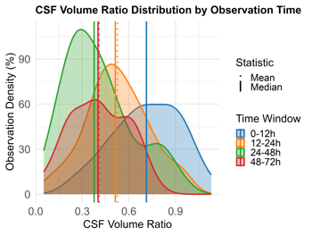 |  | 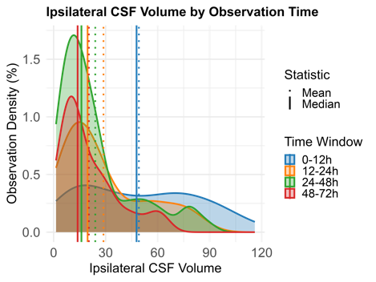 |  | 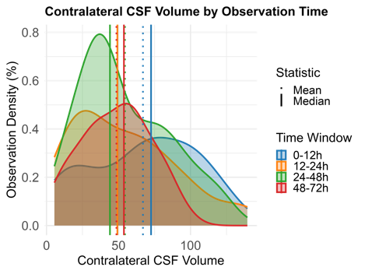
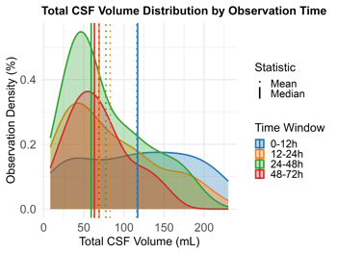 | 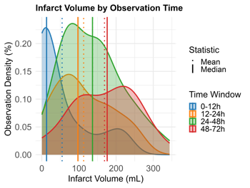 |  | 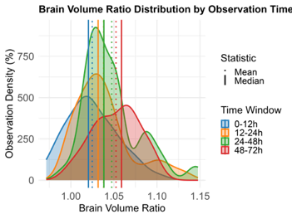 |  | 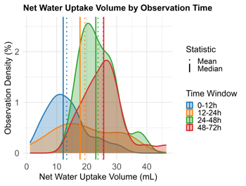
The CSF volume ratio shifts downward within 48 hours of observation, suggesting a greater reduction in CSF volume on the ipsilateral side. Total CSF volume, particularly on the ipsilateral side, progressively decreases over 72 hours. Infarct volume, brain volume ratio and net water uptake volume show an overall increase within the first 72 hours post-observation.

Supplementary Figure 2. Temporal Trends in Brain Volume Ratio and Net Water Uptake Volume
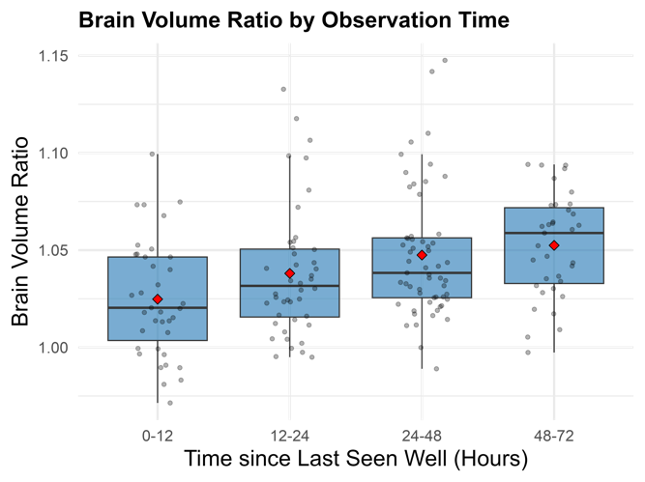 | 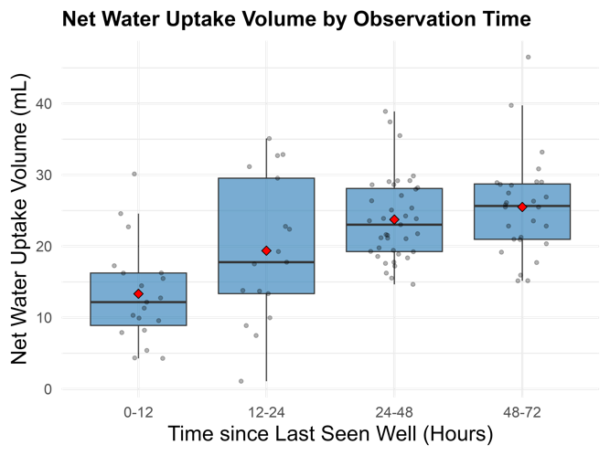
Box plots demostrate a clear linear increase in brain volume ratio from 0 to 48 hours post presentation. Similaraly, NWU volume increases across the initial 72 hour window post presentation. This suggests a progressive expansion of brain volume, and accumulaiton of net water uptake following presentation, potentially refelcting evolving cerebral edema.

Supplementary Figure 3. Distribution Histograms of Delta Volumetric Data
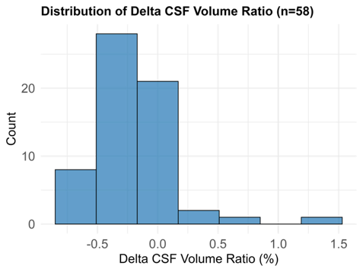 | 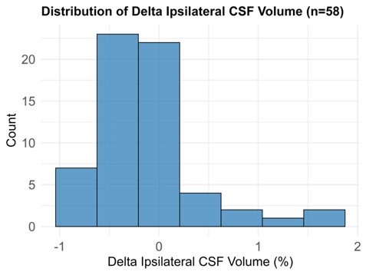 |  | 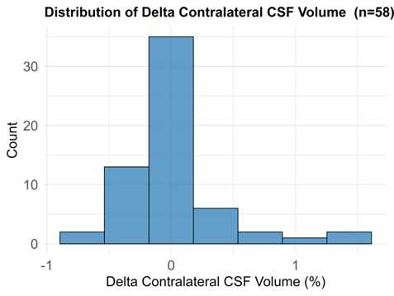
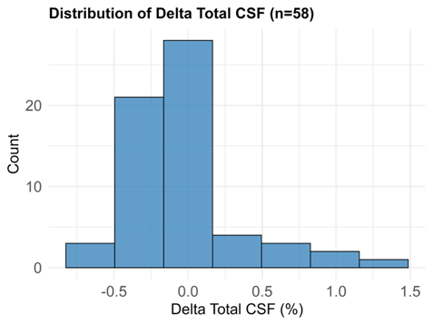 |  | 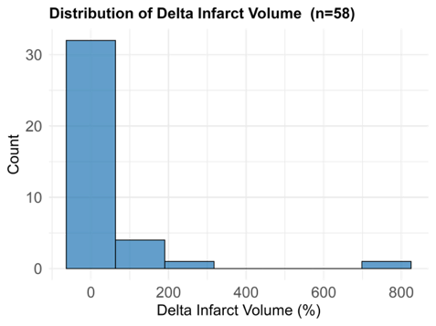
Most patients exhibited a decrease in CSF volume ratio, reflecting a greater reduction in CSF volume on the ipsilateral side compared to the contralateral side at follow-up. The delta CSF volume ratio was –0.21 ± 0.31 (median –0.22 [–0.37 to –0.10]). Ipsilateral CSF volume decreased (Δ=–0.16 ± 0.51; median –0.20 [–0.45 to –0.06]), while contralateral CSF volume showed minimal change (Δ=0.04 ± 0.39; median –0.02 [–0.16 to 0.11]). Total CSF volume decreased slightly overall (Δ=–0.04 ± 0.39; median –0.05 [–0.27 to 0.04]). In contrast, infarct volume increased between scans (Δ=38.69 ± 128 cm³; median 1.52 [0.42–8.89]).

Supplementary Figure 4. Spaghetti Plots Depicting Patient-Level CSF Volumetric Data over 72 Hours
In 67 patients with imaging in the first 72 hours of hospitalization, most patients have a decreasing trend in CSF volume ratio, a relatively flat trend in total CSF and an increasing trend in infarct volume. The median image count per patient: 2 [3-6].

Supplementary Figure 5. Spearman Correlations between Standardized Brain Volume and Pupillometry at Baseline
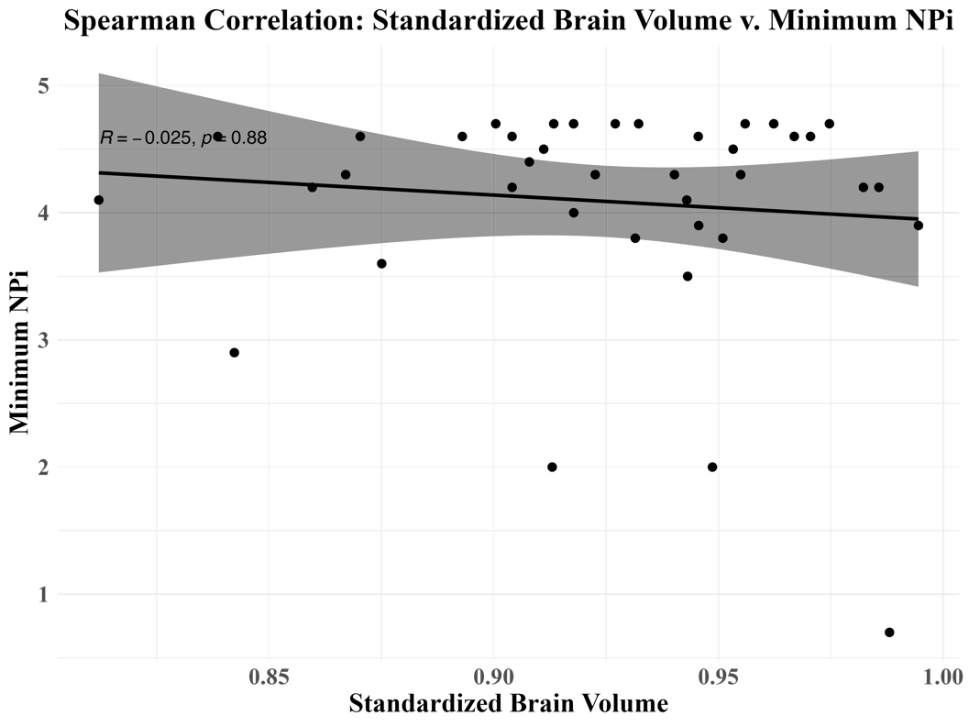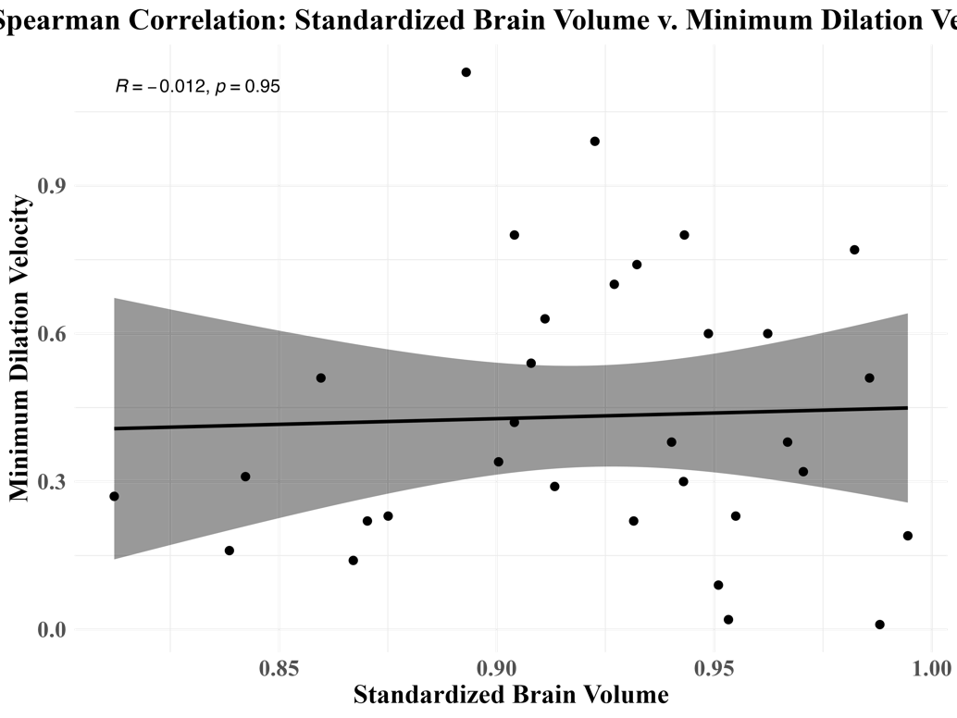
No significant correlation was observed between standardized brain volume and reactive pupillometry: minimum NPi (r=-0.025, p=0.88) or minimum dilation velocity (r=-0.012, p=0.95).

Supplemental Figure 6. Time-dependent Receiver Operating Characteristic Curve for Cox models of Neurological Deterioration in Each 12-hour Interval under Leave-One-Out Cross Validation
- Time-dependent ROCs of Cox Modeling Including EDEMA Score only, average AUC=58.9
ROC at t=24, AUC 54.2 | ROC at t=36, AUC 59.4 | ROC at t=48, AUC 60.5 | ROC at t=60, AUC 57.8
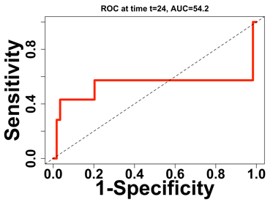 | 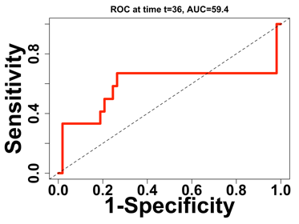 | 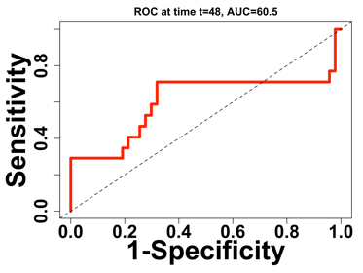 | 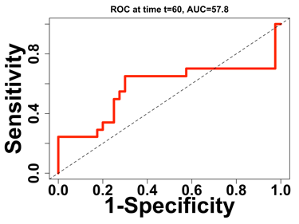
ROC at 72, AUC 56.1 | ROC at 84, AUC 62.4 | ROC at t=96, AUC 62.0
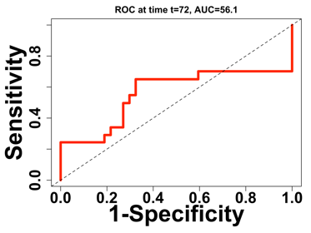 | 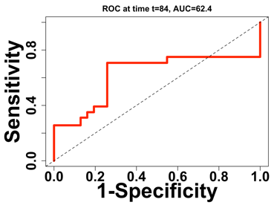 | 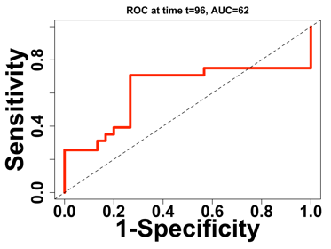
- Time-dependent ROCs of Cox Models including EDEMA and Pupillometry, average AUC=79.2
ROC at t=24, AUC 80.3 | ROC at t=36, AUC 79.1 | ROC at t=48, AUC 77.0 | ROC at t=60, AUC 76.4
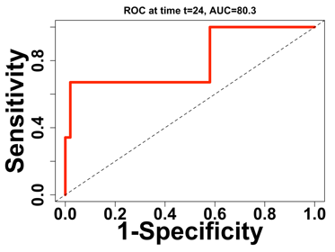 | 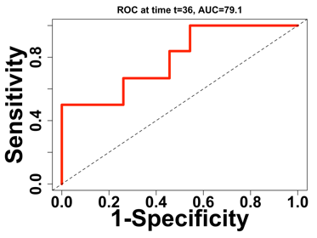 | 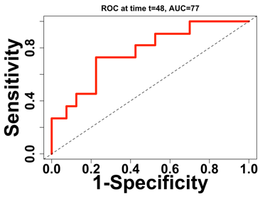 | 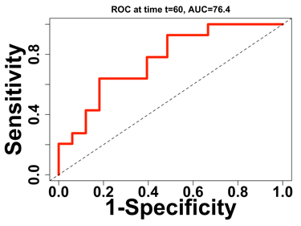
ROC at 72, AUC 75.2 | ROC at 84, AUC 83.8 | ROC at t=96, AUC 83.1
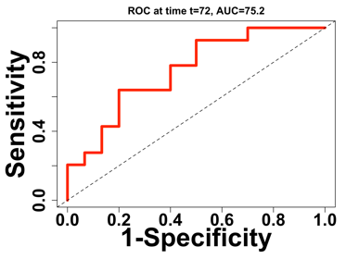 | 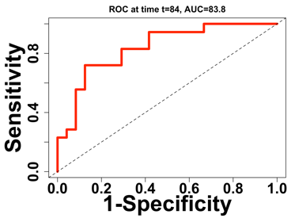 | 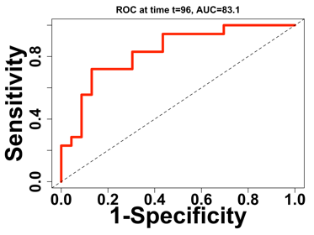
- Time-dependent ROCs of Cox Models including EDEMA, Pupillometry, and CSF Volume Ratio, average AUC=80.4
ROC at t=24, AUC 80.3 | ROC at t=36, AUC 79.4 | ROC at t=48, AUC 77.0 | ROC at t=60, AUC 80.5
 | 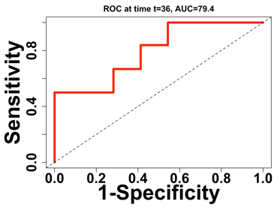 | 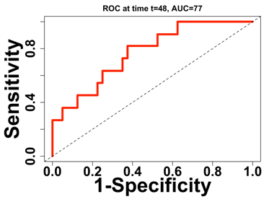 | 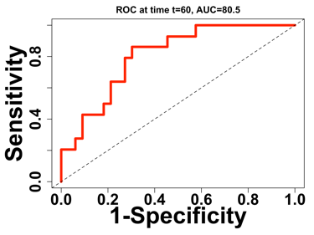
ROC at 72, AUC 78.8 | ROC at 84, AUC 83.7 | ROC at t=96, AUC 83.0
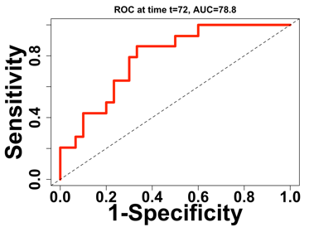 | 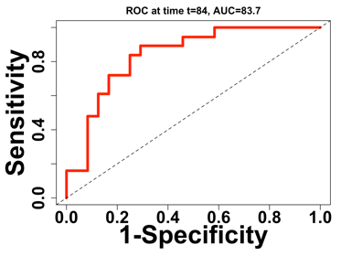 | 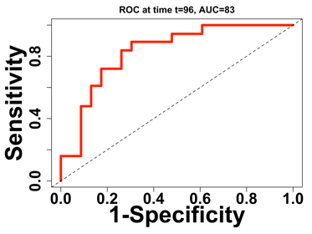
- Time-dependent ROCs of Cox Models including EDEMA, Pupillometry, and Total CSF Volume, average AUC=81.2
ROC at t=24, AUC 86.8 | ROC at t=36, AUC 81.5 | ROC at t=48, AUC 77.8 | ROC at t=60, AUC 79.3
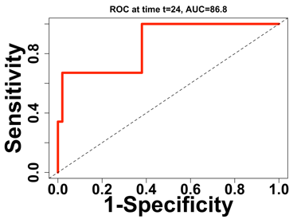 | 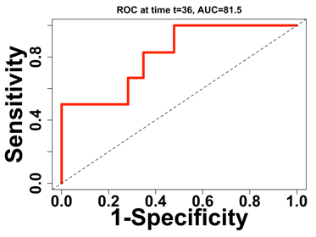 | 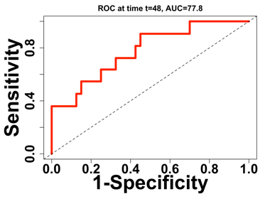 | 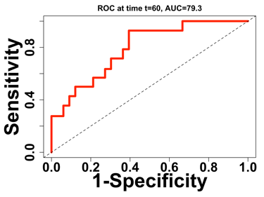
ROC at 72, AUC 77.5 | ROC at 84, AUC 83.0 | ROC at t=96, AUC 82.3
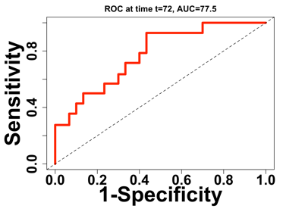 | 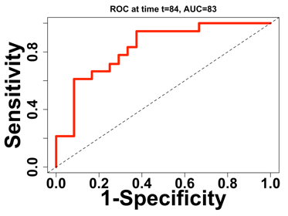 | 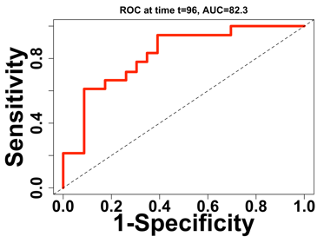
Time-dependent ROC curves for Cox models predicting time-to-neurologic deterioration, adjusted by EDEMA score (fixed variable), pupillometry (NPi and dilation velocity) and CSF volumetric data (time-dependent covariates) in each 12-hour interval under leave-one-out cross-validation. Panel A: EDEMA; Panel B: EDEMA and pupillometry; Panel C: EDEMA, pupillometry, and CSF volume ratio; Panel D: EDEMA, pupillometry, and total CSF volume. Overall average AUCs of models displayed in panels C and D (including CSF volumetric data) were higher compared to models in panels A and B (not including CSF volumetric data). Abb.: AUC=Area Under Curve; CSF=Cerebrospinal Fluid; EDEMA=Enhanced Detection of Edema in Malignant Anterior Circulation Stroke; NPi=Neurological Pupil Index; ROC=Receiver Operating Characteristic.

Supplemental Figure 7. Exploratory time-dependent ROCs of Cox Models including CSF Volumetric Data

- Exploratory time-dependent ROCs of Cox Models including CSF Volume Ratio, average AUC=81.0
ROC at t=24, AUC 86.6 | ROC at t=36, AUC 70.7 | ROC at t=48, AUC 72.9 | ROC at t=60, AUC 81.2
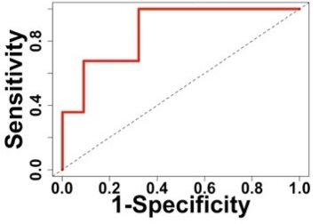 | 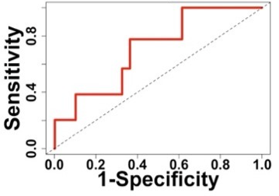 | 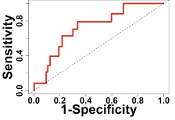 | 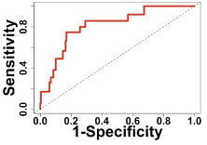
ROC at t=72, AUC 81.6 | ROC at t=84, AUC 86.7 | ROC at t=96, AUC 87.6
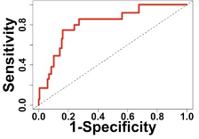 | 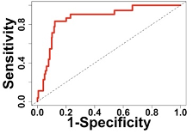 | 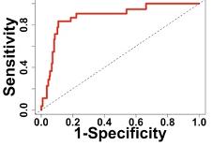
- Exploratory time-dependent ROCs of Cox Models including Total CSF Volume, average AUC=82.1
ROC at t=24, AUC 87.4 | ROC at t=36, AUC 75.7 | ROC at t=48, AUC 73.7 | ROC at t=60, AUC 79.8
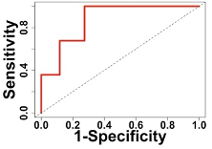 | 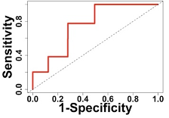 | 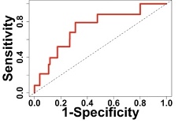 | 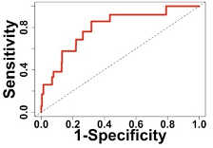
ROC at t=72, AUC 80.9 | ROC at t=84, AUC 88.2 | ROC at t=96, AUC 89.1
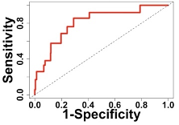 | 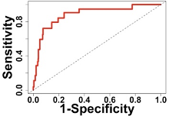 | 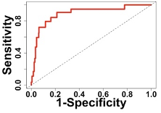
Time-dependent ROC curves for Cox models predicting time-to-neurologic deterioration, adjusted by baseline glucose, baseline standardized brain volume, treating pupillometry (NPi and dilation velocity) and CSF volumetric data (Panel A: CSF volume ratio; Panel B: total CSF volume) as time-dependent covariates in each 12-hour interval. Overall average AUCs of models with CSF volume ratio were 81.0% compared to 82.1% with total CSF volume. Abbr.: AUC=area under ROC curve; CSF=Cerebrospinal Fluid; NPi=Neurological Pupil Index; ROC=Receiver Operating Characteristic.

Supplemental Figure 8. Model Comparisons among Cox Models using AIC and BIC
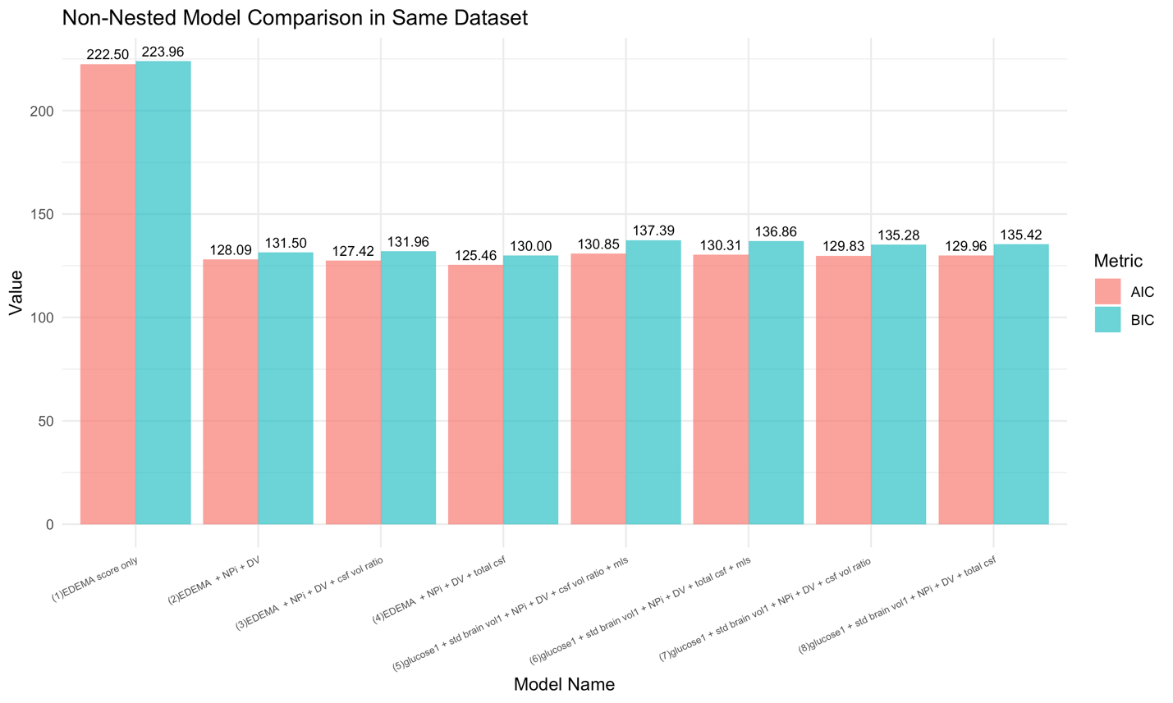
Model 5 and Model 6 had relatively higher AIC and BIC values compared to Models 2–4, though still lower than the static Model 1. Abb.: AIC= Akaike Information Criterion; BIC= Bayesian Information Criterion; CSF=cerebrospinal fluid; DV=Dilation Velocity; EDEMA=Enhanced Detection of Edema in Malignant Anterior Circulation Stroke (EDEMA) Score; NPi=Neurological Pupil Index.

Supplementary Table

Supplemental Table 1. Correlation Between CSF Volume Ratio and Quantitative Pupillometry Around Imaging

Pupillometry Variables | r_{s}* | p
Closest NPi | -0.07 | 0.35
Average NPi | -0.05 | 0.52
Minimum Ipsilateral NPi | -0.06 | 0.39
Minimum Dilation Velocity | 0.05 | 0.56
Average Dilation Velocity | 0.08 | 0.33
Maximum NPi Difference | 0.15 | 0.05
Size Difference >1mm** | 0.10 | 0.18
Maximum Size Difference | 0.12 | 0.11
NPi_{24post} | 0.02 | 0.77
NPi <3** | 0.03 | 0.63
All summary variables are evaluated in ±1 hour of imaging, except NPi_{24post} (evaluated in 24 hours post imaging). Using all available pupillometric and CSF variable pairs, we did not observe significant correlations between any pupillometric variables and CSF volume ratio. *Data are presented as Spearman's rank correlation coefficient[r_{s}] and p value. We use significance level of two-sided alpha of 0.05. **Point-biserial method was used for the binary variable.

Reference

25. Ong CJ HQ, Kim ISY, et al. Association of dynamic trajectories of time-series data and life-threatening mass effect in large middle cerebral artery stroke. Neurocrit Care 2025;42:77–89.
26. Pohlmann JE, Kim ISY, Brush B, et al. Association of large core middle cerebral artery stroke and hemorrhagic transformation with hospitalization outcomes. Sci Rep 2024;14(1):10008. DOI: 10.1038/s41598-024-60635-0.

