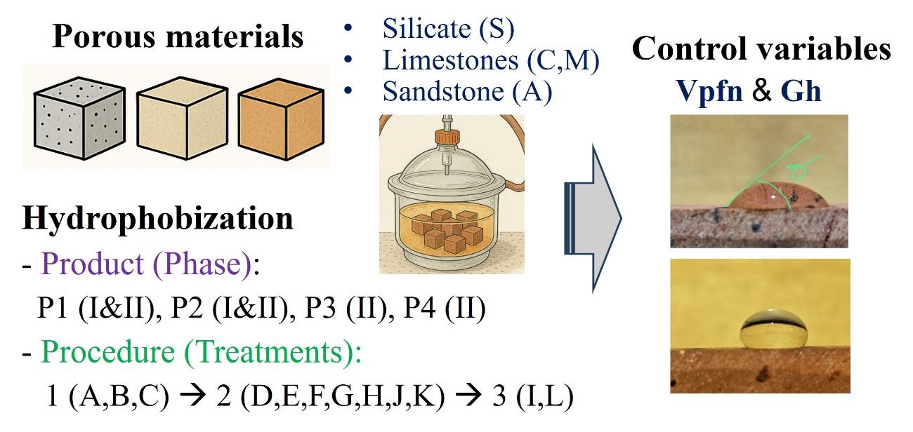
Eco-friendly hydrophobic treatments reduce water absorption and protect porous materials without altering pore structure or transport properties

