Supplementary Materials for:

Unleashing Continuous Polarization–Wavelength Control with Nonlocal Metasurfaces
Jiuxu Wang^{1,2#}, Jie Wang^{1#}, Feilong Yu^{1#}, Jin Chen¹, Rongsheng Chen¹, Tianxiong Geng¹, Rong Jin^{1,2}, Yiran Zhou¹, Tongwen Zheng¹, Guanhai Li^{1,2,3,4}*, Xiaoshuang Chen^{1,2,3,4*}, and Wei Lu^{1,2,3,4*}
¹State Key Laboratory of Infrared Physics, Shanghai Institute of Technical Physics, Chinese Academy of Sciences, 500 Yu-Tian Road, Shanghai, 200083, China
²University of Chinese Academy of Sciences, No.19 Yuquan Road, Beijing 100049, China
³Hangzhou Institute for Advanced Study, University of Chinese Academy of Sciences, No.1 SubLane Xiangshan, Hangzhou, 310024, China
⁴Shanghai Research Center for Quantum Sciences, 99 Xiupu Road, Shanghai, 201315, China
* ghli0120@mail.sitp.ac.cn; xschen@mail.sitp.ac.cn; luwei@mail.sitp.ac.cn

Note 1. Decouple the continuously conjugated polarization channels from spectral dispersion
For the fast and slow axis-symmetric linearly birefringent elements, the precession axis of polarization states conversion is located at the equator of the Poincaré sphere and determined by the angular orientation of elements. Only the input and output polarization states are mirrored about the equator or conjugate, the rotation angle DoF of elements can be harnessed for precise phase control. Therefore, the conjugate channel flipped handedness between the input and output polarization is essential for continuous-domain photonic multiplexing. Unlike traditional broadband achromatic designs that are limited to circular polarization channels, the proposed continuous information-domain reconstruction framework is broadly applicable to arbitrary conjugate elliptical polarization channels. The comparison of the polarization evolutions between circular and general elliptical polarization is shown on the Poincaré sphere in Figure S1, where the shaded regions indicate the variation in the rotation angle of meta-atom elements.
For traditional polarization-wavelength-degenerate elements structure, where the phase retardation $φ_{β}$- $φ_{α}$ of Y polarization and the X polarization component is independent of wavelength as the inset shows, the conjugate modulation phase (CMP, red line) varies linearly with the rotation angle θ as shown in the left panel of Figure S1. The birefringence phase retardation (BPR, blue line) always remains π, consistent with a half-wave plate. In contrast, for birefringent dispersion elements, CMP exhibits a nonlinear dependence on θ and the corresponding BPR requirement for each θ is no longer fixed as shown in the right panel of Figure S1. Due to θ being invariant across the metasurfaces array, the function relationship between BPR and θ varies with different elliptical polarization conjugated channels. This implies that an additional DoF, i.e., wavelength, is necessary to decouple the continuous polarization evolution. Moreover, θ can be treated as a perturbation parameter to optimize the far-field information within the continuous polarization-wavelength domain. Within our design framework, the initial step involves defining the range of rotational angle perturbations and establishing the initial iteration value. This process is guided by the projection of the continuous polarization channel, in conjunction with a third-order or higher-order nonlinear approximation of the unit dispersion response. Subsequently, a hierarchical, dimension-interlaced vectorial diffraction neural network is employed to further refine the solution, with the goal of achieving a global optimum via nonlocal Pancharatnam–Berry phase evolution, as elaborated in the main manuscript.
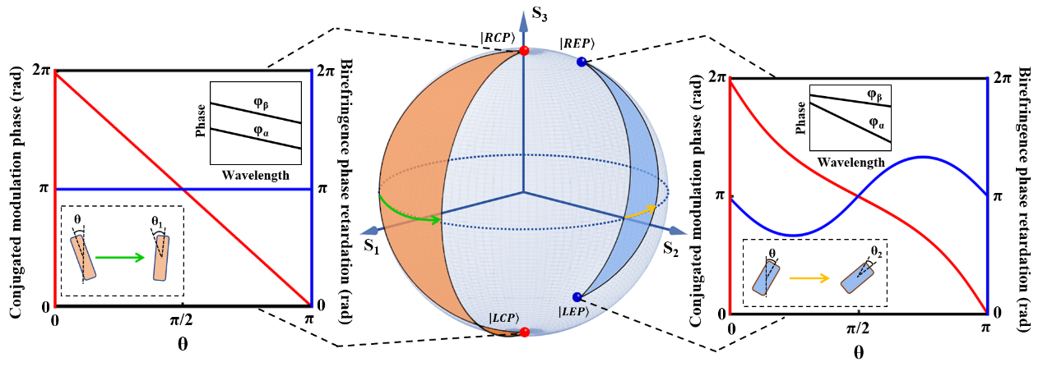
Supplementary Fig. 1. Comparison between arbitrary elliptical polarization modulation (right) and conventional broadband circular polarization modulation (left). Left: For circular polarization state, polarization–wavelength-degenerate elements exhibit a constant birefringent phase retardation of π (blue line), while the conjugate modulation phase (red line) varies linearly with twice the element rotation angle θ. Right: For arbitrary elliptical polarization state, the conjugate modulation phase exhibits a nonlinear dependence on the element rotation angle, and the birefringent retardation varies with the rotation angle, rather than remaining fixed. This general case necessitates the introduction of a dispersion-compensating element (inset). Center: Polarization evolution on the Poincaré sphere, where the shaded regions indicate the variation in the polarization precession axis associated with different element rotation angles.

Note 2. The forward analytical model for continuous polarization-wavelength path
The interaction between light and optical structures can be described using a 2×2 Jones matrix J (x, y) and corresponding Jones vectors. The matrix J (x, y) characterizes the optical response of individual metaatoms at each spatial coordinate (x, y), comprising four complex elements—equivalently, eight independent parameters, including both amplitude and phase. Consequently, these eight DoFs can, in principle, be fully controlled to realize completely independent optical functions without relying on additional physical dimensions. In the case of C₂-symmetrical metaatoms:
$\begin{aligned}J \left(x,y\right)=R\left(-θ\left(λ\right)\right)·\left(\begin{matrix}t_{xx} & 0 \\ 0 & t_{yy}\end{matrix}\right)·R\left(θ\left(λ\right)\right)\#\left(S1\right)\end{aligned}$ where $R\left(θ\right)=\left[\begin{matrix}cosθ & sinθ \\ -sinθ & cosθ\end{matrix}\right]$ is the rotation matrix of the metaatoms; t_{xx} and t_{yy} are complex transmittance coefficients. The input polarization state can also be described with a rotation matrix and ellipticity angle $P_{1}(λ)$, $\tilde{P}=R\left(-P_{2}(λ)\right)∙\left(\begin{matrix}cosP_{1}(λ) \\ i∙sinP_{1}(λ)\end{matrix}\right)$. To distinguish it from the rotation angle θ of the metaatoms, we denote the counterclockwise rotation angle of the input polarization as $P_{2}(λ)$. With phase modulation provided by the metaatoms—while maintaining approximately equal amplitude transmission coefficients |$t_{xx}$|=|$t_{yy}$|—the resulting output polarization state can be expressed as:
$$\begin{aligned}\tilde{P^{-}}=J \left(x,y\right)∙R\left(-P_{2}\left(λ\right)\right)∙\left(\begin{matrix}cosP_{1}(λ) \\ i∙sinP_{1}(λ)\end{matrix}\right) \\ =R\left(-θ\left(λ\right)\right)∙\left(\begin{matrix}e^{iφ_{α}\left(λ\right)} & 0 \\ 0 & e^{iφ_{β}\left(λ\right)}\end{matrix}\right)·R\left(θ\left(λ\right)\right)∙R\left(-P_{2}\left(λ\right)\right)∙\left(\begin{matrix}cosP_{1}(λ) \\ i∙sinP_{1}(λ)\end{matrix}\right)\#\left(S2\right)\end{aligned}$$
By incorporating the rotation matrix, the output polarization state can be expressed as:
$$\begin{aligned}\tilde{P^{-}}=\left(\begin{matrix}e^{iφ_{α}\left(λ\right)} & 0 \\ 0 & e^{iφ_{β}\left(λ\right)}\end{matrix}\right)∙R\left(-P_{1}\left(λ\right)-θ\left(λ\right)\right)∙\left(\begin{matrix}cosP_{1}(λ) \\ i∙sinP_{1}(λ)\end{matrix}\right)\#\left(S3\right)\end{aligned}$$
This implies that the eigenvector transformation of a birefringent metaatom has its eigen-polarization precession axis fixed on the equator of the Poincaré sphere, determined solely by the metaatom’s rotation angle θ. To enable the engineering of continuous polarization states, additional DoFs must be introduced to decouple the continuous polarization channels, such as the wavelength dimension. Thus, the dispersive Jones matrix can be written as
$\begin{aligned}J \left(x,y,λ\right)=R\left(-θ\left(λ\right)\right)·\left(\begin{matrix}e^{iφ_{α}\left(λ\right)} & 0 \\ 0 & e^{iφ_{β}\left(λ\right)}\end{matrix}\right)·R\left(θ\left(λ\right)\right)\#\left(S4\right)\end{aligned}$Here, the continuous polarization channels vary with the continuous wavelengths. The input polarization states are represented in the form:
$\begin{aligned}\tilde{P^{+}}=R\left(-P_{2}\left(λ\right)\right)∙\left(\begin{matrix}cosP_{1}(λ) \\ i∙sinP_{1}(λ)\end{matrix}\right)\#\left(S5\right)\end{aligned}$
And output polarization states can be written as:
$\tilde{P^{-}}=\left(\begin{matrix}e^{iφ_{α}\left(λ\right)} & 0 \\ 0 & e^{iφ_{β}\left(λ\right)}\end{matrix}\right)∙R\left(-P_{2}(λ)-θ(λ)\right)∙\left(\begin{matrix}cosP_{1}(λ) \\ i∙sinP_{1}(λ)\end{matrix}\right)$
$\begin{aligned}=\left(\begin{matrix}e^{iφ_{α}\left(λ\right)} & 0 \\ 0 & e^{iφ_{β}\left(λ\right)}\end{matrix}\right)∙ \left(\begin{aligned}cosα_{λ} \\ sinα_{λ}⋅e^{iβ_{λ}}\end{aligned}\right)\#\left(S6\right)\end{aligned}$
For conjugate polarization conversion, $\tilde{P^{-}}=\left(\begin{aligned}cosα_{λ} \\ sinα_{λ}⋅e^{-iβ_{λ}}\end{aligned}\right)$, where $β_{λ}=-[φ_{β}\left(λ\right)-φ_{α}\left(λ\right)]/2$represents conjugate evolutionary phase. Thus, the relationship between continuous conjugate polarization conversions and the continuous optical responses of meta-atoms can be established:
$\left(\begin{aligned}cosα_{λ} \\ sinα_{λ}⋅e^{iβ_{λ}}\end{aligned}\right)=R\left(-P_{2}(λ)-θ(λ)\right)∙\left(\begin{matrix}cosP_{1}(λ) \\ i∙sinP_{1}(λ)\end{matrix}\right)$
$$\begin{aligned}=\left(\begin{matrix}\cos{(P_{2}(λ)}+θ(λ))\cos{P_{1}\left(λ\right)}-i⋅sin\left(P_{2}\left(λ\right)+θ\left(λ\right)\right)\sin{P_{1}\left(λ\right)} \\ \sin\left(P_{2}\left(λ\right)+θ\left(λ\right)\right)\cos{P_{1}\left(λ\right)}+i⋅cos⁡({P_{2}\left(λ\right)}+θ(λ))\sin{P_{1}\left(λ\right)}\end{matrix}\right)\#\left(S7\right)\end{aligned}$$
Thus,
$$\frac{sinα_{λ}}{cosα_{λ}}⋅e^{iβ_{λ}}=\frac{\sin\left(P_{2}(λ)+θ(λ)\right)\cos{P_{1}(λ)}+i⋅cos⁡({P_{2}(λ)}+θ(λ))\sin{P_{1}(λ)}}{\cos{(P_{2}(λ)}+θ(λ))\cos{P_{1}(λ)}-i⋅sin\left(P_{2}(λ)+θ(λ)\right)\sin{P_{1}(λ)}}$$
$$\begin{aligned}=\frac{\sin\left(2P_{2}\left(λ\right)+2θ\left(λ\right)\right)\cos\left({2P}_{1}\left(λ\right)\right)+i∙\sin\left(2P_{1}\left(λ\right)\right)}{1+cos\left(2P_{2}\left(λ\right)+2θ\left(λ\right)\right)cos⁡(2P_{1}(λ))}\#\left(S8\right)\end{aligned}$$
By equating the real and imaginary parts on both sides, we obtain:
$$\begin{aligned}\tan\left(-\frac{∆φ(λ)}{2}\right)=\frac{tan\left(2P_{1}(λ)\right)}{sin2(P_{2}(λ)+θ\left(λ\right))}\#\left(S9\right)\end{aligned}$$
It relates the metaatoms response to continuous conjugate polarization-wavelength channels conversion. Finally, we can obtain the corresponding conjugate modulation by inversely rotating the output polarization states, $\left(\begin{matrix}\cos{θ(λ)} & \sin{θ(λ)} \\ -\sin{θ(λ)} & \cos{θ(λ)}\end{matrix}\right)⋅\left(\begin{aligned}cosα_{λ} \\ sinα_{λ}⋅e^{-iβ_{λ}}\end{aligned}\right)$.

Note 3. A dimension-interlaced vectorial diffraction neural network for data space compression and nonlocal continuous-domain information reconstruction
As shown in Figure 2(a) in the manuscript, the diffraction neural network consists of an input layer, a hidden layer, and an output layer. The input layer contains the initial complex field distribution, represented as $A_{0}exp⁡(iφ_{0})$ , along with continuous inputs corresponding to different wavelengths and polarization states, denoted as $P_{n}$. The meta-holography, serving as the hidden layer, is trained to generate multi-channel holographic patterns. The output layer corresponds to the intensity and polarization distribution $A^{՛}exp⁡(iφ^{՛}{P_{n}}^{՛})$ on the image plane. According to the Huygens-Fresnel principle, every point on a wavefront can be treated as a secondary source emitting spherical wavelets, and the resulting field at an observation point is given by the superposition of these wavelets. In this context, each neuron located at a spatial coordinate ($x_{h},{ y}_{h}, z_{h}$) in the hidden layer can be interpreted as a secondary spherical wavelet source. The modulated output field from each neuron is described as $E_{out}=J \left(x, y,λ\right)E_{in}$, where J represents the modulation function of the meta-hologram. The propagation of the modulated field from the hidden layer to the output layer is modeled using Rayleigh–Sommerfeld diffraction theory:
$$\begin{aligned}t_{h}^{o}=\frac{d}{r^{2}}\left(\frac{1}{2πr}+\frac{1}{iλ}\right)\exp\left(\frac{i2πr}{λ}\right)\#\left(S10\right)\end{aligned}$$
where λ is the incident wavelength in a vacuum, d is the distance from the hidden layer to the output layer, and $r=\sqrt{{(x_{o}-x_{h})}^{2}+{(y_{o}-y_{h})}^{2}+{(z_{o}-z_{h})}^{2}}$ represents the diffraction distance from each neuron to a sampling point ($x_{0},{ y}_{0}, z_{0}$) on the output layer. The distribution of output layer $U=\sum_{n}{\sum_{o}{t_{h}^{o}}}E_{out}$ represents the energy superposition from each neuron in the hidden layer to each sampling point in the output layer. The loss function is defined as the sum of squared errors between the generated holograms and the target holograms SSE = $\sum_{1}^{n}{{(\sqrt{\text{I}\text{n}}-\text{A}\text{ '})}^{2}/\sum_{1}^{n}{\text{I}\text{n}}}$. Finally, we employ a gradient descent algorithm to iteratively optimize the phase gradients of the preprocessed meta-atom library until convergence to a predefined threshold ε, thereby obtaining the optimal geometric parameters and rotation angles of the meta-atoms at each pixel position.
Traditional diffractive neural networks face challenges in handling continuous data spaces involving polarization and wavelength. To realize the functionality proposed in this manuscript, conventional methods must satisfy the requirement of conjugate polarization conversion at the level of local Jones matrix elements.
$$\begin{aligned}{\tilde{J}}^{'}(λ)=E\left(λ\right)∙\left.\left|{P\left(λ\right)}^{*}\right.\right\rangle \left\langle \left.P\left(λ\right)\right|\right.+E_{⊥}\left(λ\right)∙\left.\left|{P_{⊥}\left(λ\right)}^{*}\right.\right\rangle \left\langle \left.P\left(λ\right)\right|\right. \\ +∼∙\left.\left|{P_{⊥}\left(λ\right)}^{*}\right.\right\rangle \left\langle \left.P_{⊥}\left(λ\right)\right|\right.+∼∙\left.\left|{P_{⊥}\left(λ\right)}^{*}\right.\right\rangle \left\langle \left.P_{⊥}\left(λ\right)\right|\right.\#\left(S11\right)\end{aligned}$$
This equation requires that the conjugate channel equals 1, while the orthogonal conjugate channel equals 0. For axis-symmetric linearly birefringent elements with fast and slow axes, the local Jones matrix takes the form: $\left[\begin{matrix}A & B \\ B & D\end{matrix}\right]$. Each meta-atom possesses two DoFs, namely amplitude and phase. Additionally, to enable control across multiple wavelength channels (λ), it is necessary to separately determine the equivalent rotation angle θ for each λ. This results in a data space of dimensionality 4×θ×λ×n, where n is the number of elements in the metaatom library, and the factor of 4 accounts for the complex amplitude responses along two eigenpolarization directions, each described by two effective parameters. If the wavelength dimension is directly incorporated into the optimization design, the high-dimensional nature of the resulting database poses a significant computational challenge. This becomes a bottleneck in practical implementations. Finding the suitable metaatoms may be less practical or even unfestible as the number of channels increases. Therefore, dimensionality compression of the database becomes essential. A common strategy is to reduce the dimensionality along the wavelength axis. In this work, a third-order approximation is employed to compress the data space to 8n² by performing a nonlocally continuous reconstruction of the Jones matrix and using the unit rotation angle as a bridge to link continuous polarization and wavelength channels. For two conjugate and orthogonal polarization channels, the unit Jones matrix is expressed as a third-order curve associated with a global equivalent rotation angle $θ_{λ}$, resulting in a reduced data space of 8×$θ_{λ}$×n. The reconstructed continuous Jones matrix is given in Eq. (7) of the manuscript. Moreover, this method only partially compresses the wavelength dimension and has limited impact on improving computational efficiency. To further enhance performance, we integrate the equivalent rotation angle as a perturbation parameter into the neural network framework. By employing a forward analytical model to determine the optimal efficiency weights corresponding to the rotation angle of each structure, and subsequently applying a perturbation layer for refinement, the data space can be further compressed. As a result, the dimensionality is reduced to 8×n, effectively eliminating the rotation angle dimension. With this proposed design strategy, we successfully realize arbitrary and continuous control over dispersion-resolved polarization channels.

Note 4. The detailed process of the forward analytical model
According to the flowchart of the continuous information-domain reconstruction framework shown in Figure 2(a) of the manuscript, the detailed process of constructing the metaatom library is shown in Figure S2. The simulation phase data of X-polarization $φ_{α}$ and Y-polarization $φ_{β}$ were obtained by sweeping the length and width of the metaatoms from 0.1 to 1.6 μm with a period of 1.7 μm. Then, $φ_{α}$ and $φ_{β}$ were fitted as functions of wavelength, and their birefringent phase retardation ranges are shown in Figure S2 (a-b). The birefringent retardation $φ_{β}-φ_{α}$ representing the continuous dispersion response of the metaatoms (Figure S2 (c)), is employed to fulfill the birefringent phase retardation requirements for continuous polarization states. These requirements are derived through the forward analytical model, expressed as functions of the polarization ellipticity angle and the rotation angle of the metaatoms, $\tan\left(β_{λ}\right)$= tan (2$P_{1}(λ)$) /sin [2($P_{2}(λ)+θ(λ))]$ (mentioned in the manuscript) shown in Figure S2 (d).
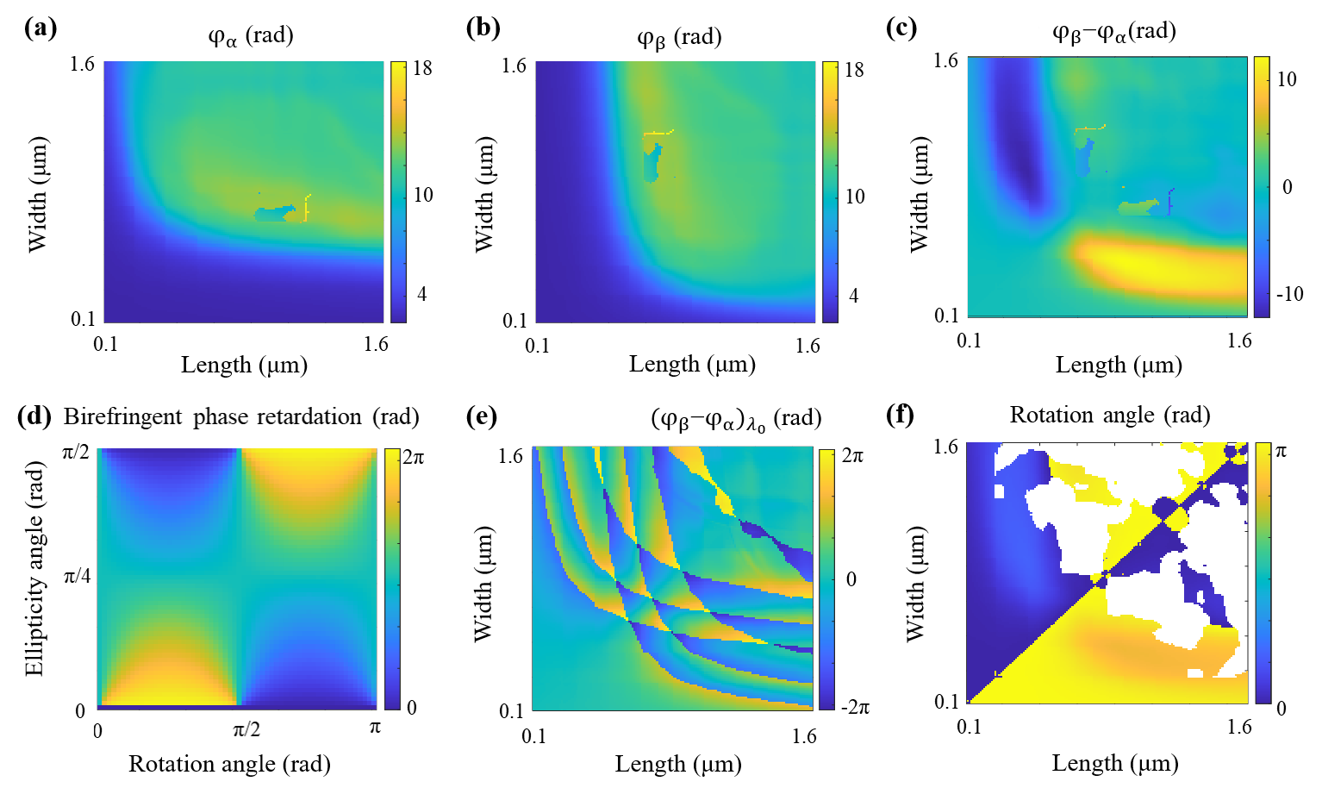
Supplementary Fig. 2. The building process of the metaatoms library according to the forward analytical model. The dispersion libraries of X-polarization and Y-polarization are represented in (a) and (b), respectively. (c) The birefringent phase retardation range of metaatoms’ dispersion response. (d) The required birefringent phase retardation is a function of the continuous ellipticity angle and metaatom’s rotation angle. (e) presents the birefringent phase retardation at the central wavelength for all metaatoms in the library. (f) The final metaatoms library with a perturbative factor θ(λ).
Next, it is necessary to optimize the global matching between dispersion and polarization in order to decouple the continuously reconstructed functionalities. During this process, we evaluate the candidate metaatoms based on their phase and dispersion coverage to identify the optimal matching configuration. The birefringent phase retardation at the central wavelength is employed to tune the global birefringent response, as illustrated in Figure S2(e). This response serves as an intermediate bridge, enabling alignment between the continuous polarization and dispersion characteristics. Once the matching is finalized, the rotation angles of the metaatoms are employed as a perturbation parameter for further optimization. The initial perturbation is shown in Figure S2(f). Metaatoms exhibiting transmittance deviations greater than 18% between the X- and Y-polarization channels are excluded. The resulting metaatom library thus consists of elements with perturbative rotation angle and well-matched optical responses.

Note 5. Expansion of non-degenerate multicolor holography
Here, we present simulation results of non-degenerate continuous-polarization-wavelength multiplexed achromatic and vector holograms with seven independent channel combinations, as shown in Figures S3 and S4. In these designs, the input and output polarization channels are conjugate and vary continuously with the wavelength. It is important to note that achieving seven independent holographic images across seven distinct wavelengths and polarization channels does not represent the upper limit of our approach. To ensure sufficient channel isolation, we demonstrate only seven multiplexed holograms in this work. We emphasize that the information capacity of metasurface holography can be further extended by increasing the structure height, optimizing the modal topology of the meta-atoms, or enlarging the metasurface area.
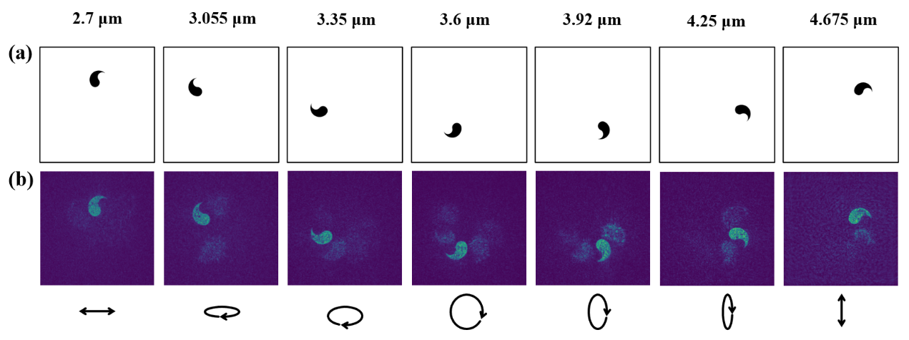
Supplementary Fig. 3. (a) Target and (b) simulation images of the non-degenerate continuous-polarization-wavelength multiplexed achromatic hologram with 7 continuous polarization and wavelength channels.
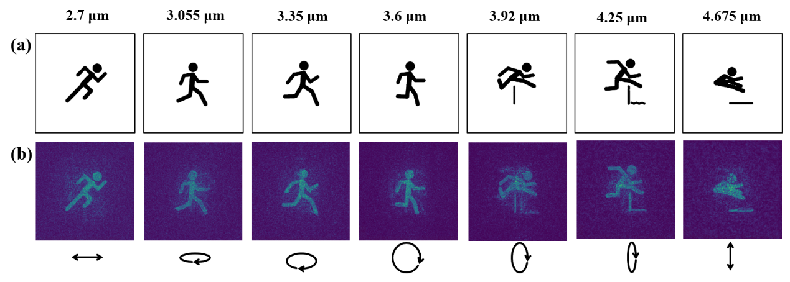
Supplementary Fig. 4. (a) Target and (b) simulation images of the non-degenerate continuous-polarization-wavelength multiplexed vector hologram with 7 continuous polarization and wavelength channels.

