Supplementary Material

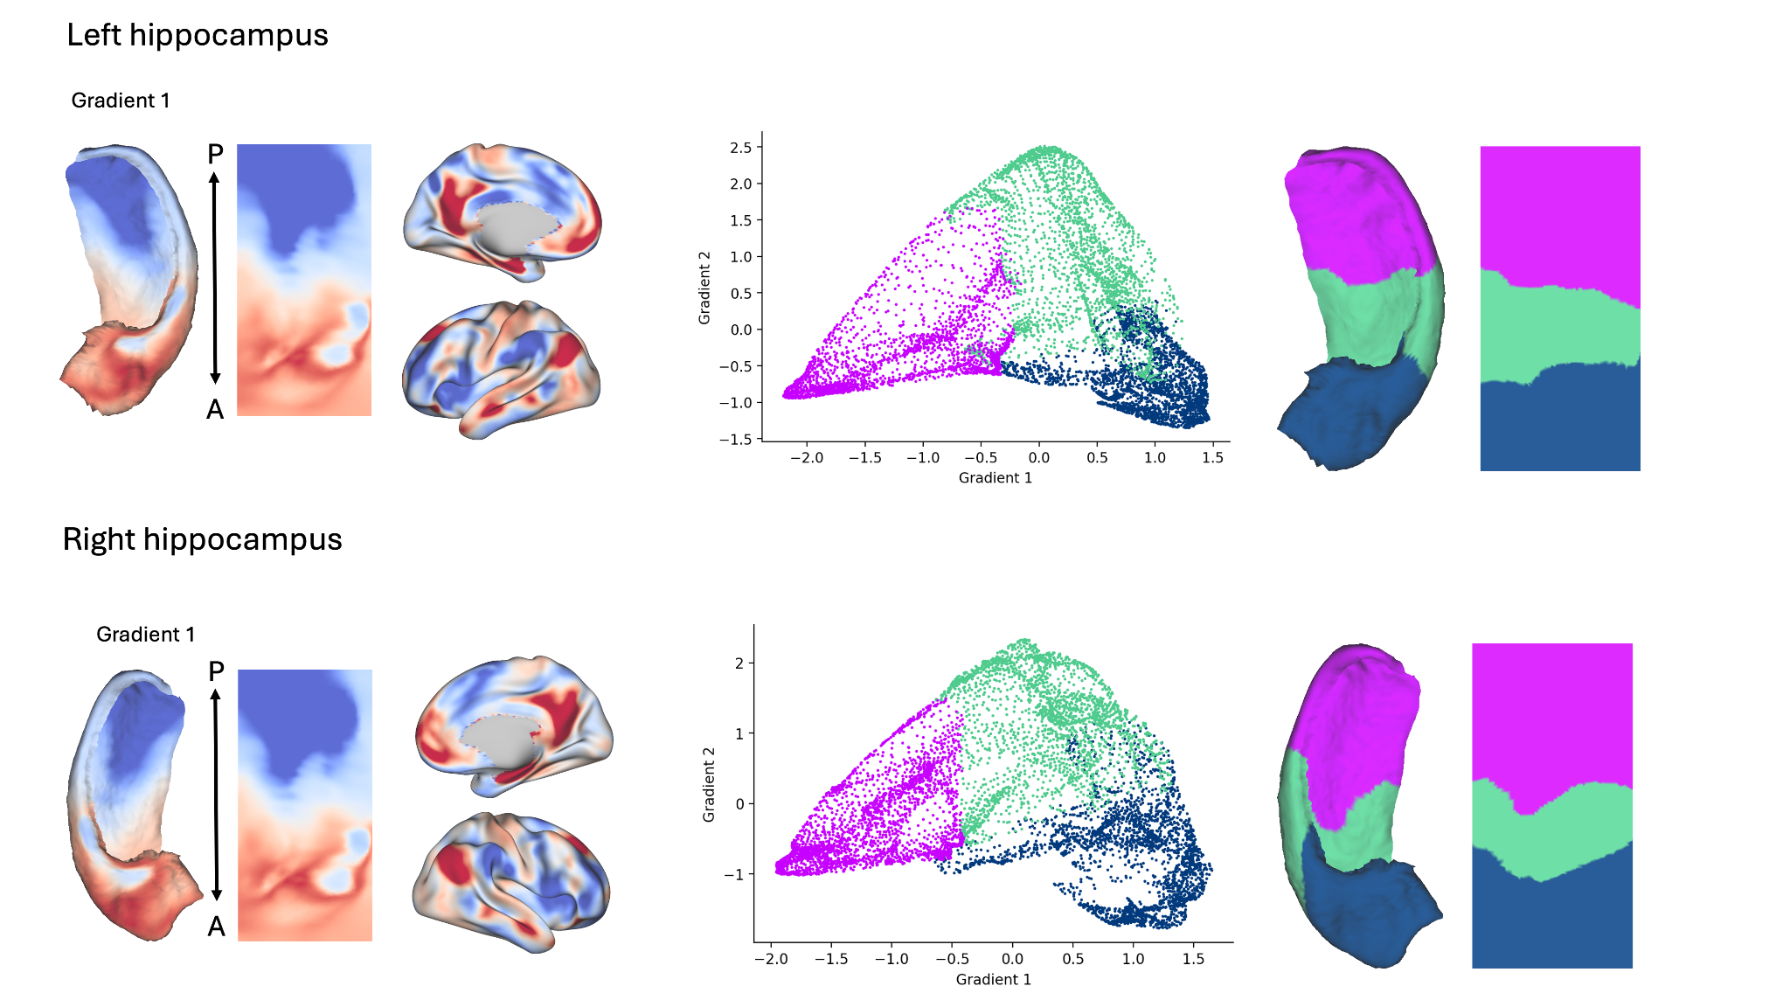

Fig 1 Comparison of right and left hippocampal gradients and systems.

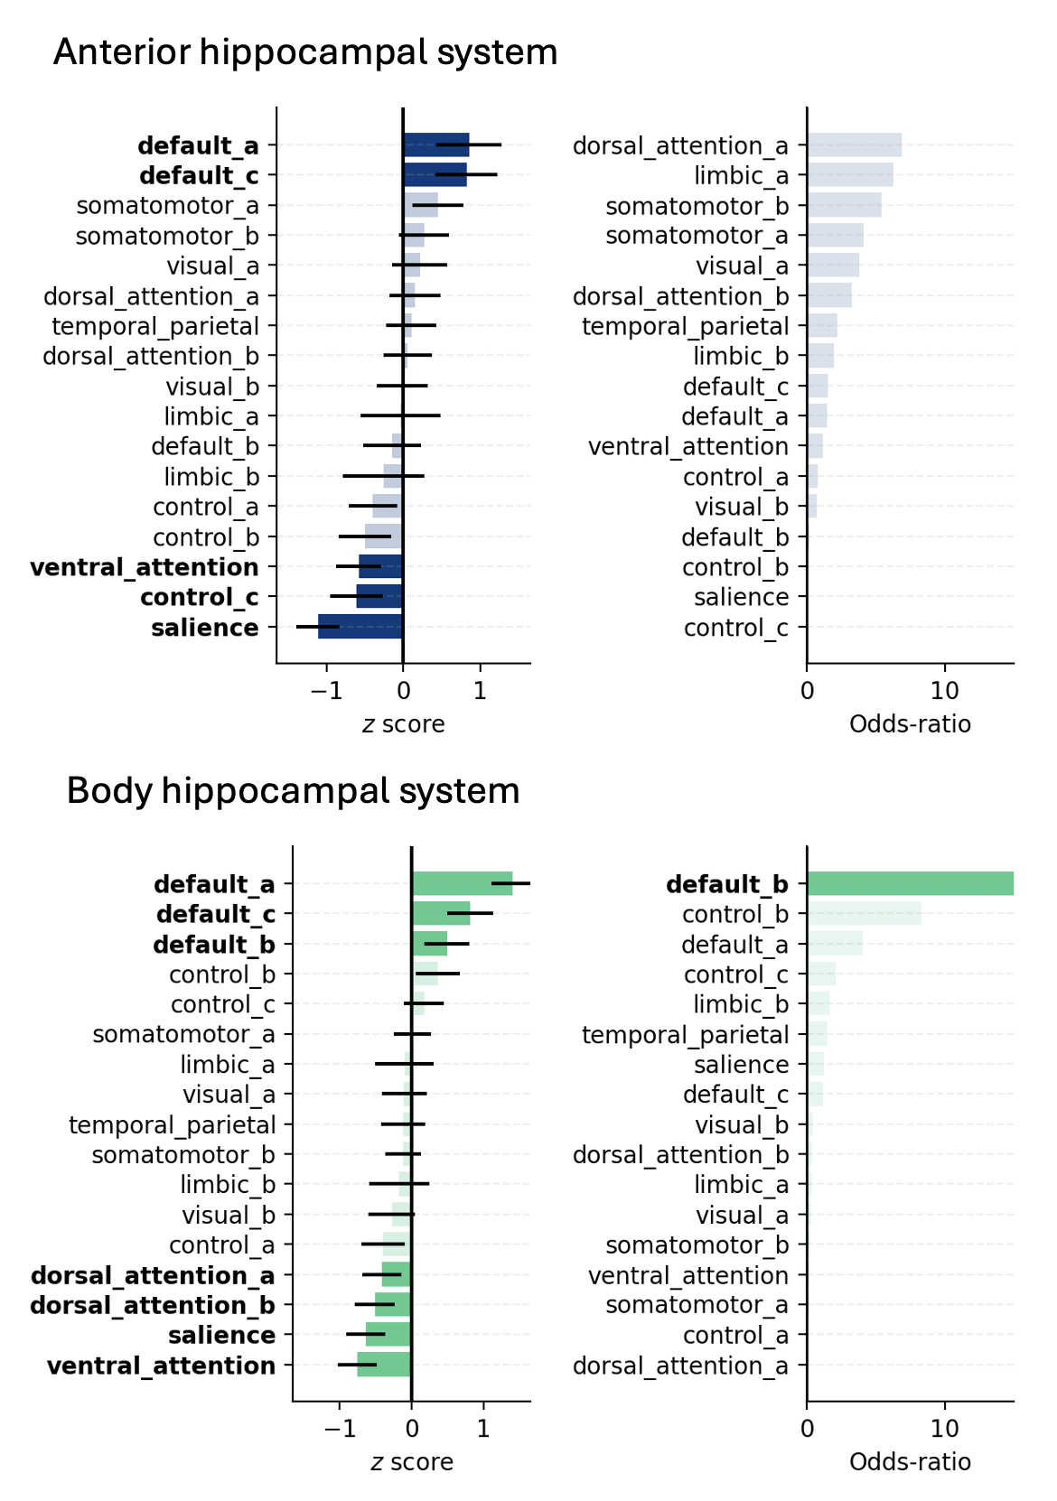

Fig 2 Mean neocortical-connectivity (±SD) across subjects for each hippocampal system, along with odds-ratios from the one-versus-rest logistic regression models trained to classify each hippocampal system from all others.

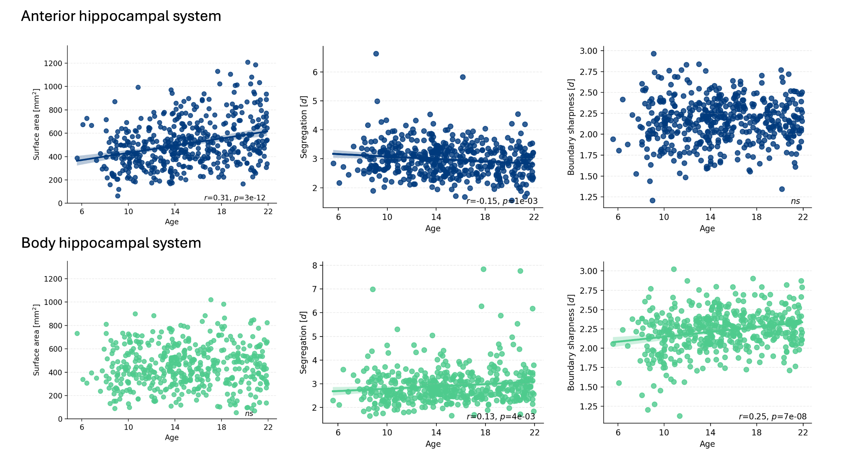
Fig 3 Correlations between age and: surface-area, segregation, and boundary-sharpness for the anterior and body hippocampal systems.

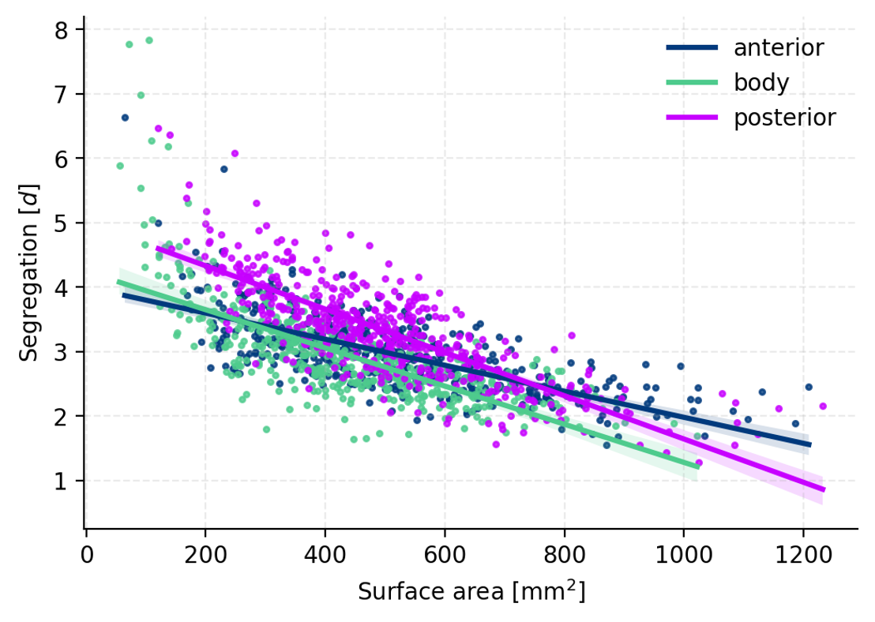
Fig 4 Scatterplot illustrating the correlation between segregation and surface-area. Larger networks show lower segregation.
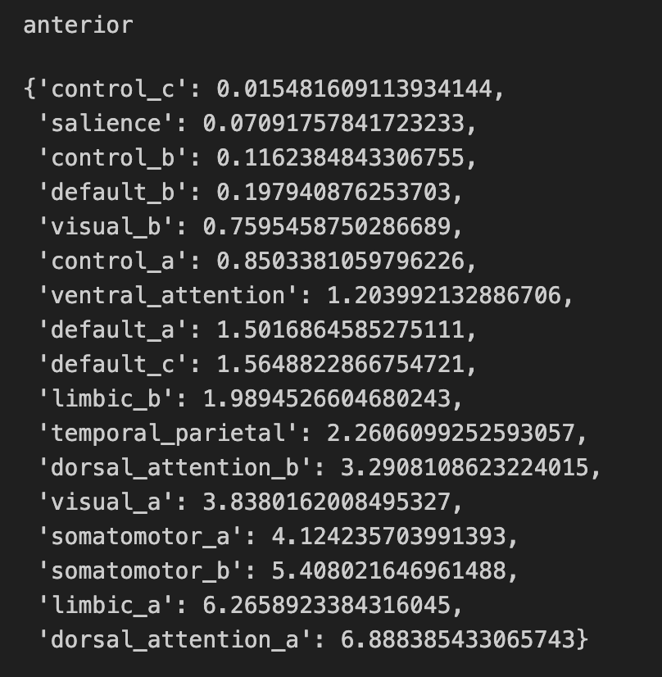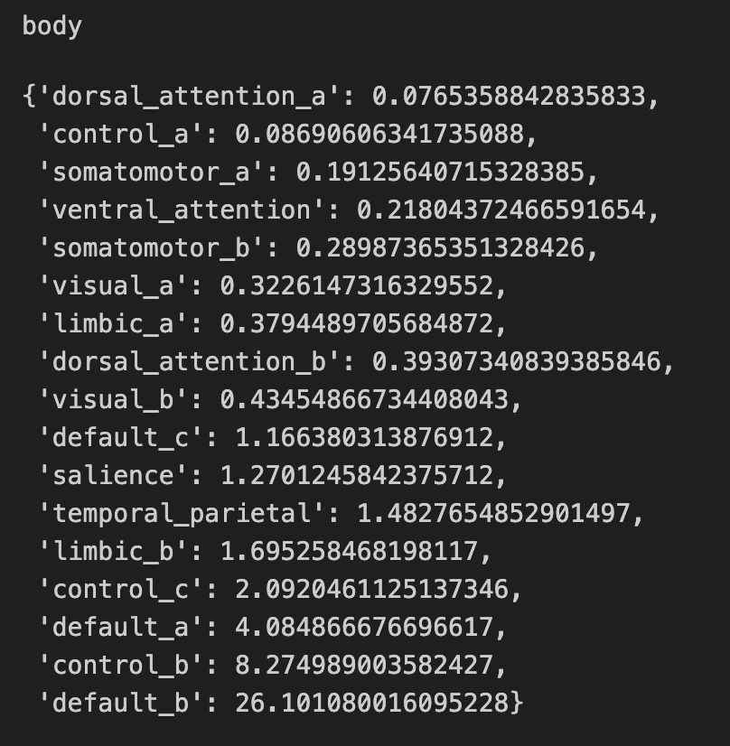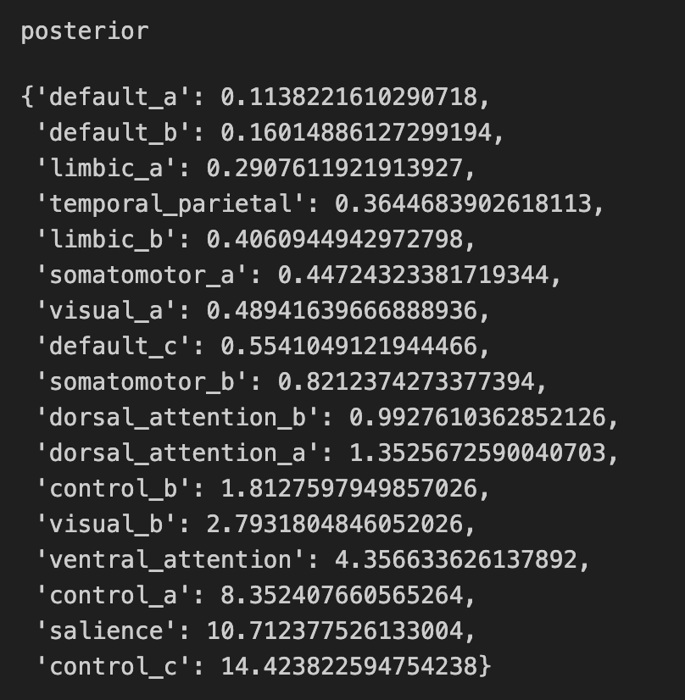

Fig 5 Exact odds-ratios from the one-versus-rest logistic regression models trained to classify each hippocampal system from all others.

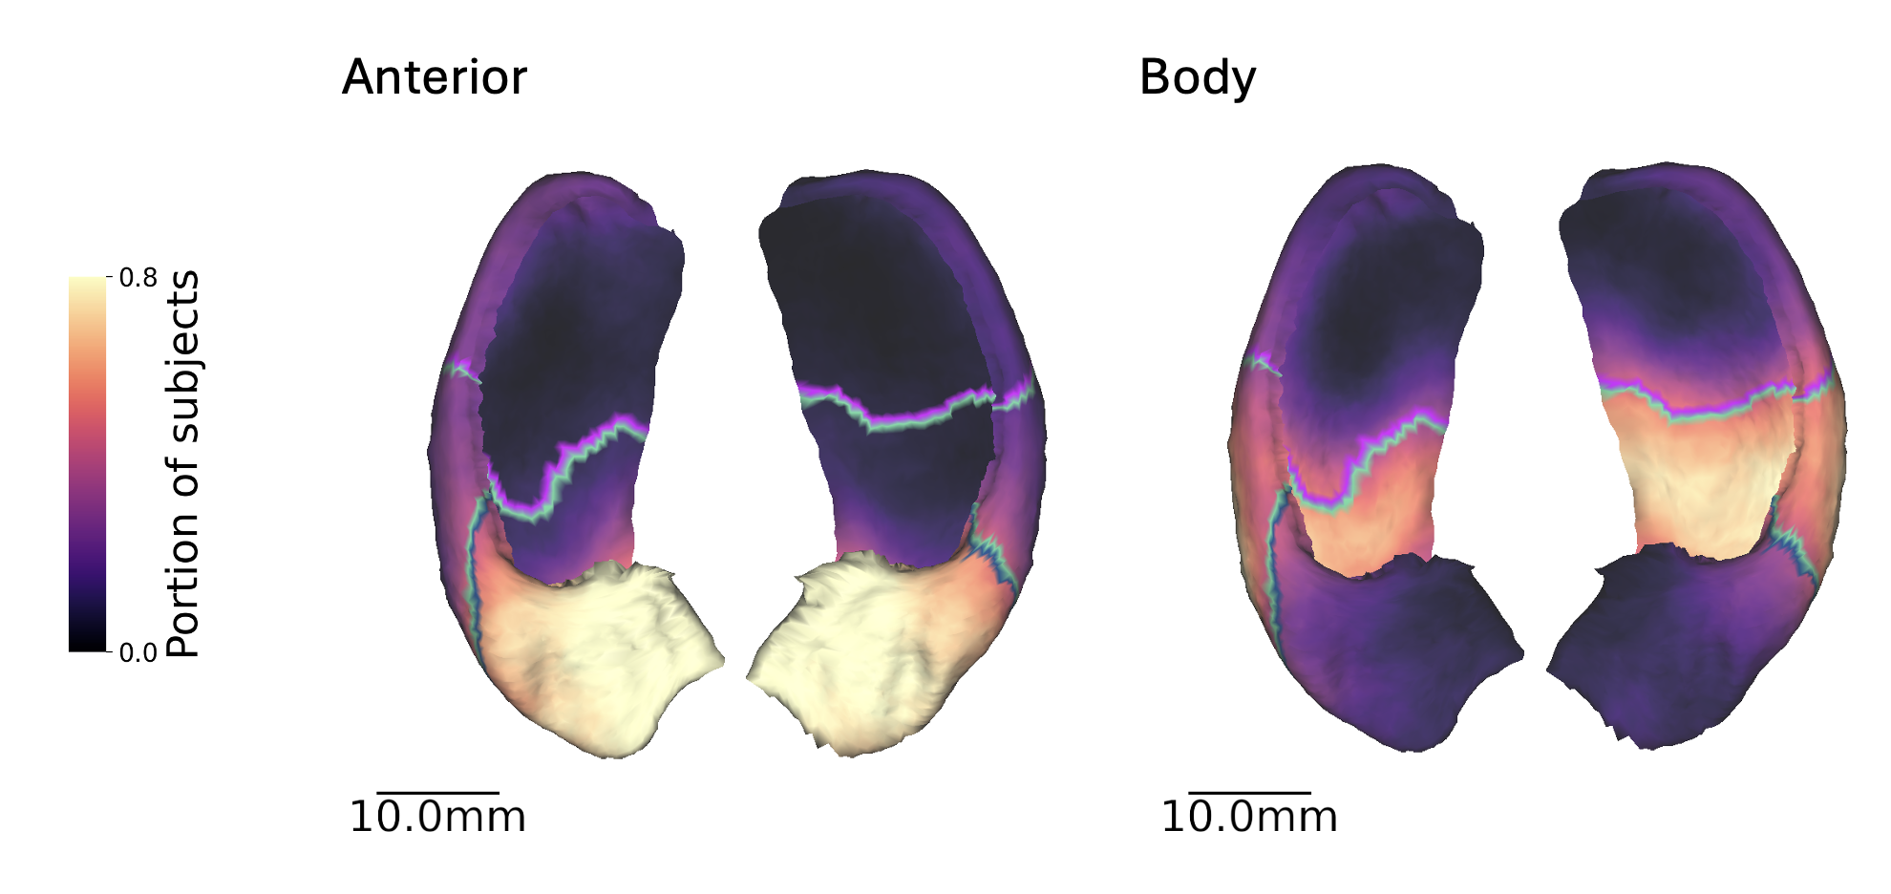

Fig 6 Portion of subjects in which each vertex on the hippocampal surface was assigned to the anterior system (left) and body system (right) following precision mapping, overlaid as a heatmap on the right and left template hippocampi. Each hippocampal system (posterior, body. anterior) is shown as an outline on the group-average heatmap.

