Environmental Science and Pollution Research
RESEARCH ARTICLE
Heavy Metal Bioaccumulation, Systemic and Gastric Toxicopathology in Rattus norvegicus Exposed In situ to Municipal Solid Waste Landfill-Derived Contaminants
Adeyinka Michael Gbadebo^{1,2,*}. Omolola Adebimpe-John³. Okunola Adenrele Alabi⁴. Chibuisi Gideon Alimba⁵. Samuel Adetunji Onasanwo⁶. Adekunle Akeem Bakare⁷
¹Ecology and Environmental Biology Unit, Department of Zoology, University of Ibadan, Ibadan, Oyo State 200005, Nigeria.
²Department of Molecular Biology and Biotechnology, Chrisland University, Owode, Abeokuta, Ogun State 23409, Nigeria.
³Department of Physiology, University of Ilorin, Ilorin, Kwara State 1515, Nigeria.
⁴Department of Biology, Federal University of Technology, Akure, Ondo State 340001, Nigeria.
⁵Leibniz Research Centre for Working Environment and Human Factors (IfADo), Technical University of Dortmund, 44139, Dortmund, Germany.
⁶Department of Physiology, Faculty of Basic Medical Sciences, College of Medicine, University of Ibadan, Ibadan, Oyo Sate 200005, Nigeria.
⁷Cell Biology and Genetics Unit, Department of Zoology, University of Ibadan, Ibadan, Oyo State 200005, Nigeria.
*Corresponding author: Adeyinka Michael Gbadebo
Email Addresses: adeyinka.gbadebo@yahoo.com; adeyinka.gbadebo@chrislanduniversity.edu.ng; Tel: +234 8138151100

Online Resource
Appendix A. Supplementary data
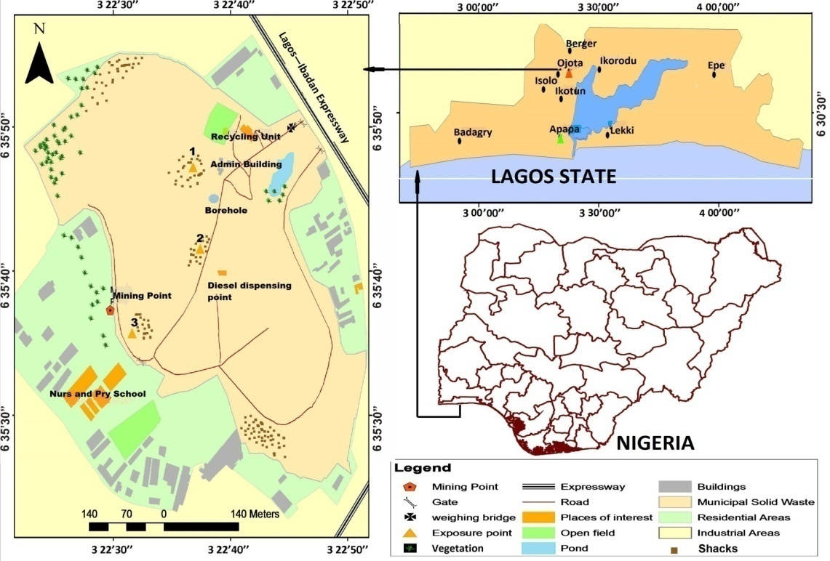
Supplementary Fig. 1 Olusosun landfill site showing exposure points (marked as 1, 2 and 3) and map of Lagos State showing the relative position of the landfill at Ojota (orange triangle) and the control site (green triangle) (Gbadebo et al., 2022)

. 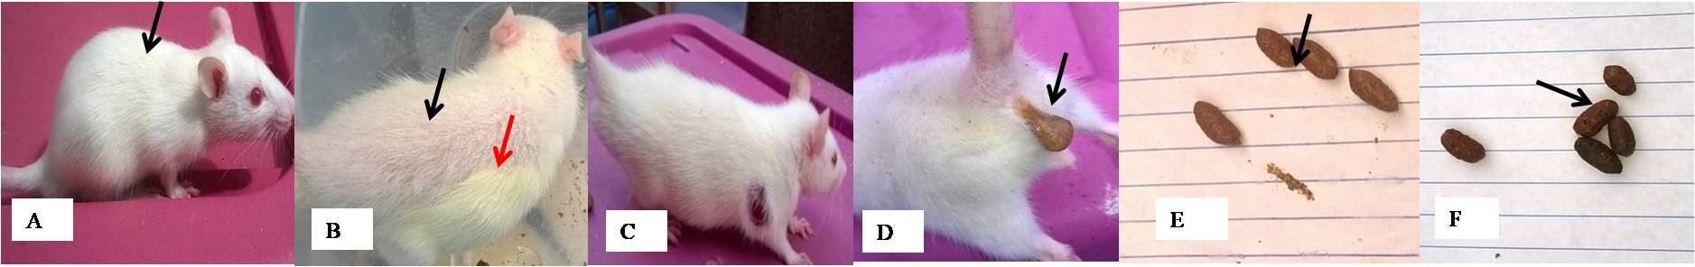
Supplementary Fig. 2 Clinical observations in rats exposed in situ to underground water and ambient air emissions at Olusosun landfill and control site (Mag.: X0.5). (A) Well-groomed rat from control site, (B) Poorly groomed (black arrow) with yellow colouration (red arrow) on rat’s fur from Olusosun landfill, (C) Abscess on rat body, (D) Watery and mucous feace (diarrhoea) observed in rats during the first 4 weeks of exposure, (E) Yellow to light-brown feaces observed in control groups, and (F) black to black-brown pigmented feaces observed in exposed groups

Supplementary Table 1 Liver and kidney absolute and relative weights in rats exposed at the landfill
Organ weight (g) | Exposure period (week) | Mean±SEM
Organ weight (g) | Exposure period (week) | Control | Landfill
Organ weight (g) | Exposure period (week) |  | Point 1 | Point 2 | Point 3 | Mean
ALW | 4 | 1.77±0.13 | 3.79±0.19* | 3.40±0.47 | 3.46±0.37* | 3.56±0.19*
 | 8 | 2.90±0.25 | 4.72±0.41 | 5.86±0.31* | 6.21±0.31* | 5.59±0.25*
 | 12 | 3.14±0.30 | 5.73±0.43* | 5.31±0.16* | 5.89±0.82* | 5.65±0.29*
 | 16 | 3.34±0.35 | 6.86±0.33* | 5.40±0.64 | 5.83±0.07 | 6.04±0.30*
 | 20 | 4.00±0.23 | 7.03±0.37* | 6.23±0.53* | 5.86±0.40 | 6.38±0.27*
 | 24 | 4.66±0.20 | 7.62±0.40* | 6.36±0.50 | 5.94±0.38 | 6.71±0.31*
RLW | 4 | 2.39±0.20 | 4.88±0.23* | 3.99±0.38 | 5.26±0.67* | 4.76±0.29*
 | 8 | 3.21±0.26 | 4.07±0.17* | 4.08±0.07* | 4.68±0.23* | 4.28±0.12*
 | 12 | 3.25±0.22 | 3.74±0.12 | 4.25±0.25* | 4.23±0.37* | 4.07±0.16*
 | 16 | 3.13±0.18 | 3.78±0.06* | 3.84±0.05* | 3.77±0.10* | 3.80±0.04*
 | 20 | 2.99±0.09 | 3.56±0.04* | 3.80±0.12* | 3.46±0.21* | 3.59±0.08*
 | 24 | 2.86±0.12 | 3.47±0.09* | 3.23±0.16 | 3.27±0.15 | 3.33±0.08*
AKW | 4 | 0.51±0.04 | 1.47±0.23* | 0.79±0.07 | 1.02±0.37 | 1.12±0.17*
 | 8 | 0.78±0.05 | 1.06±0.07* | 1.13±0.08* | 1.00±0.05 | 1.06±0.04*
 | 12 | 0.75±0.04 | 1.11±0.19 | 0.88±0.08 | 1.05±0.18 | 1.01±0.09
 | 16 | 0.71±0.05 | 1.51±0.08* | 1.17±0.11* | 1.09±0.08 | 1.27±0.07*
 | 20 | 0.80±0.08 | 1.59±0.11* | 1.32±0.09 | 1.32±0.07* | 1.42±0.06*
 | 24 | 0.96±0.05 | 1.55±0.04* | 1.40±0.04* | 1.30±0.03 | 1.43±0.04*
RKW | 4 | 0.70±0.08 | 1.87±0.23* | 0.96±0.11 | 1.47±0.46 | 1.47±0.20*
 | 8 | 0.86±0.04 | 0.92±0.04 | 0.79±0.05 | 0.76±0.04 | 0.82±0.03
 | 12 | 0.78±0.02 | 0.71±0.09 | 0.69±0.04 | 0.75±0.09 | 0.72±0.04
 | 16 | 0.68±0.04 | 0.83±0.03* | 0.84±0.04* | 0.70±0.04 | 0.80±0.03*
 | 20 | 0.60±0.06 | 0.80±0.02* | 0.81±0.05* | 0.78±0.03* | 0.80±0.02*
 | 24 | 0.60±0.05 | 0.71±0.03 | 0.72±0.04 | 0.72±0.02 | 0.72±0.02*
Signifcant at *p<0.05 compared with the corresponding control using Dunn’s multiple post hoc test.
ALW- Absolute liver weight (g); RLW- Relative liver weight (g); AKW - Absolute kidney weight (g); RKW- Relative kidney weight (g).

Supplementary Table 2 Lungs and spleen absolute and relative weights in rats exposed to the landfill
Organ weight (g) | Exposure period (week) | Mean±SEM
Organ weight (g) | Exposure period (week) | Control | Landfill
 |  |  | Point 1 | Point 2 | Point 3 | Mean
ALgW | 4 | 0.37±0.02 | 0.65±0.13* | 0.70±0.17* | 0.48±0.02 | 0.61±0.07*
 | 8 | 0.79±0.09 | 0.90±0.17 | 1.02±0.07 | 1.16±0.15 | 1.03±0.08
 | 12 | 0.79±0.05 | 0.99±0.19 | 1.08±0.07* | 1.30±0.33 | 1.13±0.12*
 | 16 | 0.93±0.15 | 1.00±0.01 | 0.95±0.03 | 0.84±0.06 | 0.93±0.03
 | 20 | 0.93±0.08 | 1.18±0.10 | 1.03±0.13 | 1.09±0.11 | 1.10±0.06
 | 24 | 1.60±0.23 | 1.30±0.15 | 1.17±0.11 | 1.58±0.37 | 1.35±0.13
RLgW | 4 | 0.51±0.05 | 0.82±0.13 | 0.82±0.15 | 0.73±0.06 | 0.79±0.06*
 | 8 | 0.86±0.07 | 0.81±0.16 | 0.71±0.02 | 0.85±0.06 | 0.79±0.06
 | 12 | 0.83±0.06 | 0.63±0.08 | 0.87±0.08 | 0.93±0.21 | 0.81±0.08
 | 16 | 0.98±0.23 | 0.57±0.02 | 0.71±0.07 | 0.54±0.03 | 0.62±0.04
 | 20 | 0.70±0.07 | 0.60±0.05 | 0.62±0.05 | 0.65±0.07 | 0.62±0.03
 | 24 | 1.02±0.18 | 0.59±0.05 | 0.60±0.06 | 0.87±0.19 | 0.68±0.07
ASW | 4 | 0.30±0.06 | 0.47±0.03 | 0.40±0.06 | 0.64±0.34 | 0.50±0.11
 | 8 | 0.47±0.01 | 0.55±0.07 | 0.66±0.03 | 0.58±0.08 | 0.60±0.04
 | 12 | 0.42±0.05 | 0.62±0.13 | 0.48±0.07 | 0.69±0.10 | 0.60±0.06
 | 16 | 0.44±0.07 | 0.71±0.06 | 0.52±0.04 | 0.52±0.12 | 0.59±0.05
 | 20 | 0.43±0.03 | 0.72±0.10* | 0.64±0.12 | 0.63±0.01 | 0.67±0.04*
 | 24 | 0.64±0.06 | 0.70±0.01 | 0.75±0.10 | 0.83±0.14 | 0.75±0.04
RSW | 4 | 0.43±0.06 | 0.61±0.03 | 0.43±0.07 | 0.85±0.44 | 0.66±0.16
 | 8 | 0.47±0.01 | 0.44±0.03 | 0.47±0.04 | 0.40±0.07 | 0.44±0.03
 | 12 | 0.38±0.03 | 0.37±0.06 | 0.38±0.08 | 0.46±0.05 | 0.40±0.04
 | 16 | 0.43±0.04 | 0.40±0.03 | 0.36±0.04 | 0.32±0.09 | 0.37±0.03
 | 20 | 0.34±0.04 | 0.36±0.04 | 0.40±0.08 | 0.37±0.02 | 0.38±0.02
 | 24 | 0.40±0.05 | 0.33±0.02 | 0.40±0.03 | 0.46±0.04 | 0.39±0.03
Signifcant at *p<0.05 compared with the corresponding control using Dunn’s multiple post hoc test.
ALgW- Absolute lung weight (g); RLgW- Relative lung weight (g); ASW - Absolute spleen weight (g); RSW- Relative spleen weight (g).

Supplementary Table 3 Stomach absolute and relative weights in rats exposed to the landfill
Organ weight (g) | Exposure period (week) | Mean±SEM
Organ weight (g) | Exposure period (week) | Control | Landfill
 |  |  | Point 1 | Point 2 | Point 3 | Mean
ASmW | 4 | 1.77±0.27 | 1.22±0.13 | 1.50±0.10 | 1.31±0.12 | 1.34±0.07
 | 8 | 1.27±0.14 | 1.83±0.38 | 2.14±0.31 | 1.98±0.22 | 1.98±0.16*
 | 12 | 1.28±0.01 | 1.66±0.08* | 1.53±0.06 | 1.55±0.01 | 1.58±0.04*
 | 16 | 1.41±0.03 | 1.56±0.03 | 1.74±0.16 | 1.64±0.07 | 1.66±0.07*
 | 20 | 1.80±0.17 | 2.12±0.06 | 1.57±0.09 | 1.63±0.11 | 1.77±0.10
 | 24 | 1.60±0.01 | 1.89±0.12 | 1.97±0.08 | 1.56±0.04 | 1.81±0.08
RSmW | 4 | 2.11±0.28 | 1.59±0.12 | 1.78±0.15 | 2.10±0.05 | 1.82±0.09
 | 8 | 1.47±0.04 | 1.70±0.20 | 1.54±0.23 | 1.51±0.11 | 1.58±0.10
 | 12 | 1.53±0.06 | 1.14±0.01 | 1.28±0.14 | 1.16±0.08 | 1.19±0.05*
 | 16 | 1.36±0.12 | 0.86±0.04* | 1.27±0.10 | 1.06±0.06 | 1.10±0.07
 | 20 | 1.31±0.05 | 1.12±0.07 | 0.97±0.04 | 0.97±0.05* | 1.02±0.04*
 | 24 | 0.97±0.11 | 0.82±0.04 | 1.02±0.09 | 0.84±0.02 | 0.89±0.04
Signifcant at *p<0.05 compared with the corresponding control using Dunn’s multiple post hoc test.
ASmW- Absolute stomach weight (g); RSmW- Relative stomach weight (g).

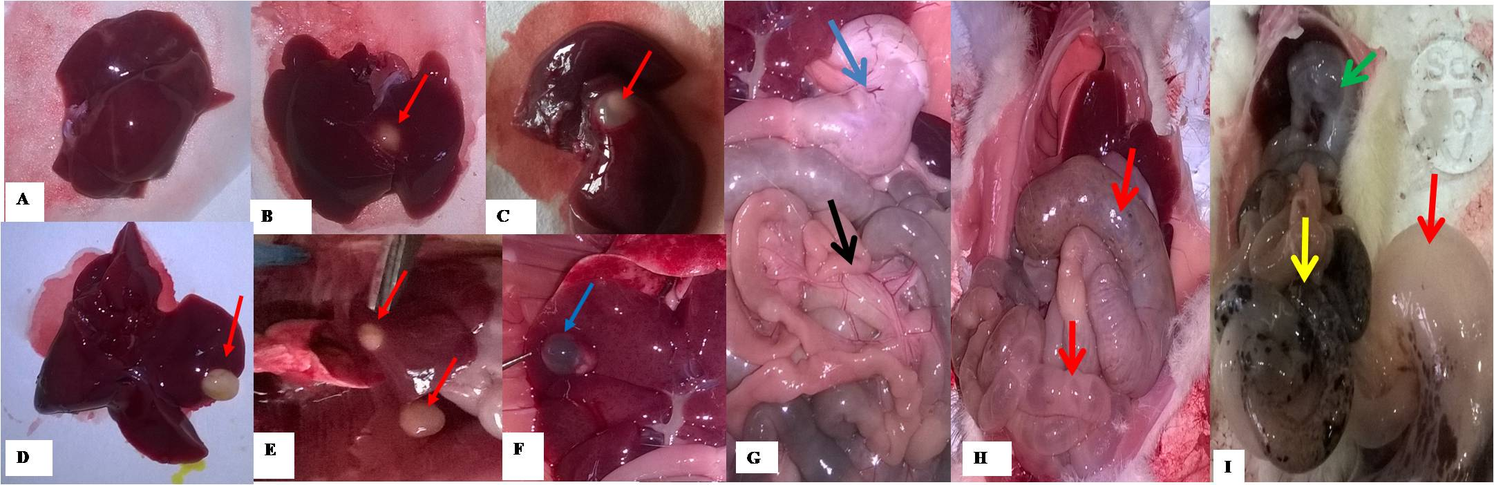
Supplementary Fig 3 Gross anatomy of liver and gastrointestinal tract in landfill exposed rats and control (Mag.: X0.5). (A) Healthy liver from control rat with no out growth, (B) to (E) Progressive increase in size and number of liver cyst (red arrows) in rats exposed to Olusosun landfill, (F) Liver cyst has turned black (necrotic - blue arrow) in a rat exposed for 24 weeks, (G) Normal anatomy of the stomach (blue arrow) and intestine (black arrow), (H) Moderate bloating (air filled space) of the small intestine and colon (red arrows) observed in a rat exposed for 12 weeks (Pt1), and (I) Severe bloating of the stomach (green arrow), small intestine (yellow arrow) and colon (red arrow) observed in a rat exposed for 20 weeks (Pt3)

Supplementary Table 4 Frequency of histological alterations in tissues of rats exposed to underground water and ambient air at Olusosun landfill
Organs | Landfill (N = 36)
Organs | Duration of exposure (weeks) |  |  |  |  |  | Total cases | Freq-uency (%)
Organs | 4 | 8 | 12 | 16 | 20 | 24 | Total cases | Freq-uency (%)
Organs | Number of cases |  |  |  |  |  | Total cases | Freq-uency (%)
Liver
Necrosis | - | - | - | - | 2 | 3 | 5 | 13.9
Sinusoid dilation & congestion | 1 | - | - | - | 1 | 3 | 5 | 13.9
Steatosis | - | 1 | 1 | 2 | - | - | 4 | 11.1
Periportal inflammation | 1 | 1 | 1 | - | 2 | 2 | 7 | 19.4
Congestion of portal vein | - | - | - | 1 | 1 | - | 2 | 5.6
Kidneys
Fibrosis | - | 1 | 2 | - | 5 | - | 8 | 22.2
Degeneration of glomeruli | - | 1 | 1 | 1 | 2 | 2 | 7 | 19.4
Renal tissue inflammations | - | 3 | - | - | - | - | 3 | 8.3
Tubules with vesicular nuclei | - | 2 | - | - | - | - | 2 | 5.6
Congestion of blood vessels | - | - | - | 1 | - | 3 | 4 | 11.1
Lungs
Moderate oedema | 1 | 2 | 1 | 2 | 3 | - | 9 | 25.0
Alveolar cells hyperplasia | 1 | 1 | 1 | 1 | 2 | 2 | 8 | 22.2
Thickening of alveolar septa | - | 1 | 1 | 2 | 2 | 2 | 8 | 22.2
Air space enlargement | - | - | 1 | 1 | 2 | 4 | 8 | 22.2
Perivascular inflammation | 1 | 1 | 1 | 2 | 1 | 1 | 7 | 19.4
Thickened arteries | - | - | - | 2 | - | 1 | 3 | 8.3
Adipocytes infiltration | - | - | 1 | - | 1 | - | 2 | 5.6
Spleen
Fusion of white pulps | 1 | 1 | - | 1 | 1 | 2 | 6 | 16.7
Adipocyte infiltration of red pulp | - | 1 | 2 | - | - | - | 3 | 8.3
Fibrosis | - | 1 | 2 | - | - | - | 3 | 8.3
Haemorrhagic lesion in red pulp | 1 | 1 | 1 | - | - | 2 | 5 | 13.9
Heamosiderin depositions | 1 | 1 | 1 | - | - | 2 | 5 | 13.9
Splenic vessels congestion | 1 | 1 | 1 | 1 | - | 3 | 7 | 19.4
Thickened/irregular trabeculae | 1 | 1 | 1 | 1 | - | 3 | 7 | 19.4
Stomach
Inflammatory cells within the mucosa | - | 1 | 1 | 3 | 6 | - | 11 | 30.6
Mucous glands with no mucin production | - | 1 | 1 | 1 | 7 | - | 11 | 30.6
Severe inflammation of the mucosa glands | - | 2 | 3 | 6 | - | - | 11 | 30.6
Congestion of mucosa and submucosa | 1 | - | - | - | 2 | 5 | 8 | 22.2
Mucous glands with vesicular nuclei | - | 1 | - | 1 | - | 2 | 4 | 11.1
Ulceration of the surface mucosa | - | - | - | - | - | 3 | 3 | 8.3

