Supporting Information

This PDF file includes:
Supplemental behavioural results
Figures S1 to S5
Tables S1 to S5

Supplemental behavioural results

Social cognition: visual perspective-taking task

We used a visual perspective-taking task (VPT) (see Fig. 2A) to investigate whether the dysbiotic subgroup displayed lesser natural tendency to consider spontaneously the perspective of others, as compared to the non-dysbiotic group. A 2 (Congruency: Congruent vs. incongruent perspectives) x 2 (Perspective: Self- vs. other-perspective) x 2 (Group: Dysbiotic vs. Non-Dysbiotic) ANOVA was conducted on the mean reaction times (RT, speed) and on accuracy rates. One patient was excluded from the analyses for outlying performance (accuracy at chance level). The ANOVA revealed a significant main effect of Congruency, F(1, 43) = 19.16, p < 0.001, with a slower RT in the incongruent condition (mean = 1.47s) than in the congruent condition (mean = 1.27s). The analyses showed no significant main effect of Perspective, F(1, 43) < 1, p = 0.82 and a significant Congruency x Perspective interaction, F(1, 43) = 8.89, p=0.005.

Fig. S1.

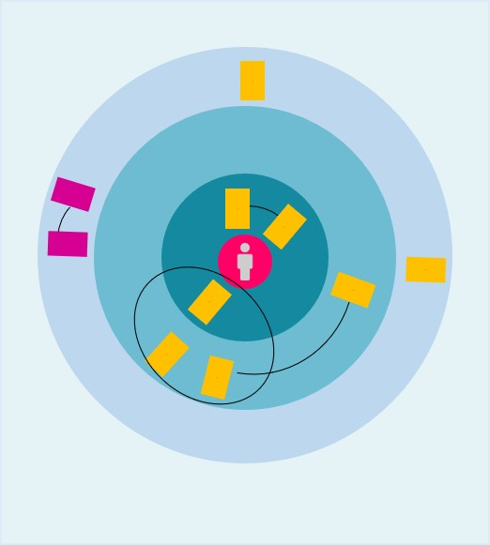

Illustration of the sociogram.

The pink circle in the center represents the patient. The different concentric circles represent the different levels of support (from most important [closest to the patient] to least important).

Fig. S2.

Social network composition of Dysbiotic and Non-dysbiotic sAUD patients.

Fig. S3.

Fecal short chain fatty acid level according to Dysbiotic and Non-dysbiotic group. P-values were obtained using Mann-Whitney-Wilcoxon test. Data are expressed as mean ± SEM.

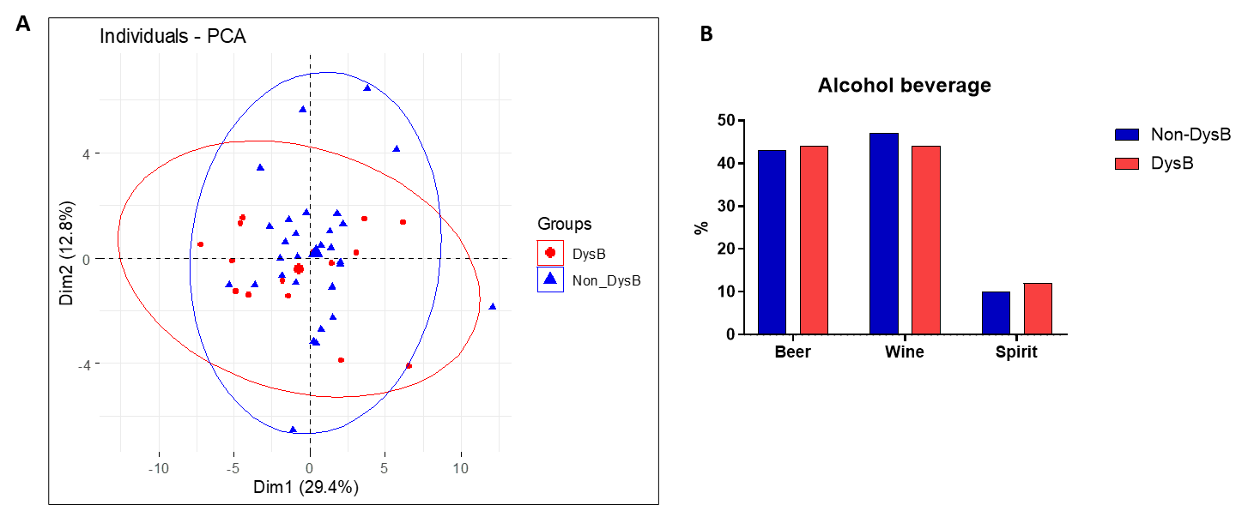
Fig. S4.

Nutritional habits of dysbiotic and non-dysbiotic sAUD patients. (A) Principal component analysis (PCA) of macronutrient intake. N=46. Individuals are plotted along with confidence ellipses. (B) Comparison of the principal types of alcohol beverage consumed according to gut dysbiosis. Alcohol consumption for the week prior to hospitalization was calculated using the time-line follow-back approach.

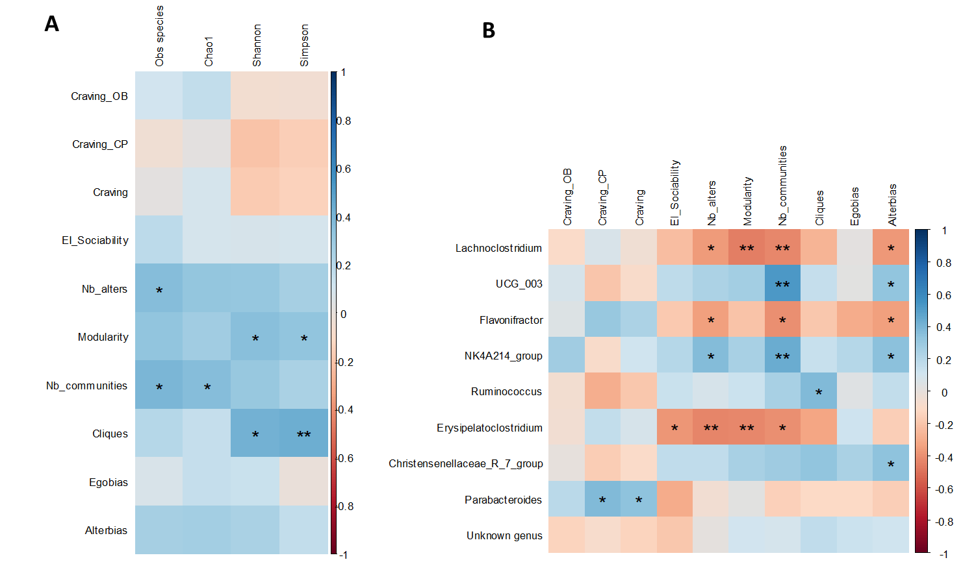
Fig. S5.

Partial correlations between sociability indexes and microbial data. Spearman partial correlations between the sociability indexes and A. α diversity and B. microbial genera which differed between dysbiotic and non dysbiotic AUD subjects. Correlations were adjusted for age, gender, and body mass index. *p<0.05, **p<0.01,***p<0.001. EI, emotional intelligence.

Table S1. Definition of the main measures used to describe the social networks
 | Definition
Density (%) | Proportion of effective ties among all possible ties between alters
Network size | Number of alters (network members) supporting ego (the focal service user)
Number of dyads | Number of dyads in ego’s network
Number of triads | Number of triads in ego’s network
Degree | Average number of other alters with which all ego’s alters are in contact
Betweenness | Frequency where an alter is a crossing point along the shortest path between two other alters
Closeness | Ratio between (n-1) and the distance between pairs of nodes
Modularity | Tendency of nodes to cluster
Number of communities | Number of communities (linked alters) in the network
Diameter | Maximum distance in the graph
Transitivity | Percentage of triples that are triads.
Professional proportion | Proportion of professional (psychiatrist, nurse, social worker, etc.) among the alters supporting ego
Gender homophily | Proportion of gender homophily in the network (link between alters of the same gender)
Ring homophily | Circle homophily on the target, i.e. the fact that alters preferentially have links with other alters in the same circle.
Isolated | Alter which is not in contact with any other alter in ego’s network
Isolated dyads | Number of dyads of two isolated alters (without link to another alter) in the network
Number of community with more than 3 alters | Number of communities with more than 3 alters
Cliques | Subset of alters that are all connected to each other (maximum density subnetwork)

Table S2. Biological parameters of sAUD patients according to gut dysbiosis
 | Dysbiotic |  | Non Dysbiotic |  | Model 1^{b} |  |  | Model 2^{c}
 | n=16 |  | n=30
 | Mean± SD |  | Mean± SD | p ª | OR | p |  | OR | p
Liver parameters
AST | 48.6 ± 32.0 |  | 43.1 ± 27.9 | 0.63 | 0.99  [0.99 ; 1.01] | 0.75 |  | 0.99  [0.98 ; 1.001] | 0.96
ALT | 42.3 ± 33.3 |  | 42.0 ± 31.2 | 0.70 | 1.00  [0.99 ; 1.01] | 0.69 |  | 1.00  [0.99 ; 1.01] | 0.92
CK18-M65 | 285.5 ± 172.3 |  | 304.8 ± 193.0 | 0.73 | 1.00  [0.99 ; 1.01] | 0.92 |  | 1.00  [0.99 ; 1.01] | 0.91
FGF-21 | 4284.5 ± 3312.8 |  | 2766.1 ± 2048.3 | 0.11 | 1.00  [0.99 ; 1.01] | 0.1 |  | 1.00  [0.99 ; 1.01] | 0.13
CAP | 262.9 ± 62.9 |  | 278.2 ± 60.3 | 0.43 | 1.00  [0.99 ; 1.02] | 0.64 |  | 1.00  [0.99 ; 1.02] | 0.58
Inflammation
TNFα (ng/ml) | 2.8 ± 1.4 |  | 3.5 ± 2.1 | 0.25 | 0.93 | 0.74 |  | 1.02 | 0.92
 |  |  |  |  | [0.61 ; 1.41] | 0.74 |  | [0.67 ; 1.56] | 0.92
IL-6 (ng/ml) | 3.8 ± 2.2 |  | 5.0 ± 3.3 | 0.22 | 0.94 | 0.70 |  | 0.99 | 0.94
 |  |  |  |  | [0.68 ; 1.29] | 0.70 |  | [0.70 ; 1.39] | 0.94
IL-18 (ng/ml) | 547.0 ± 289.0 |  | 543.1 ± 230.4 | 0.73 | 1.00 | 0.64 |  | 1.00 | 0.69
 |  |  |  |  | [0.99 ; 1.00] | 0.64 |  | [0.99 ; 1.00] | 0.69
IFNy (ng/ml) | 123.4 ± 121.2 |  | 172.4 ± 152.5 | 0.14 | 1.00 | 0.55 |  | 1.00 | 0.98
 |  |  |  |  | [0.99 ; 1.00] | 0.55 |  | [0.99 ; 1.01] | 0.98
IL-8 (ng/ml) | 8.0 ± 5.0 |  | 6.3 ± 3.4 | 0.41 | 1.21 | 0.048 |  | 1.20 | 0.06
 |  |  |  |  | [1.01 ; 1.46] | 0.048 |  | [0.99 ; 1.46] | 0.06
MCP-1 (ng/ml) | 231.9 ± 70.3 |  | 277.2 ± 90.5 | 0.07 | 0.99 | 0.39 |  | 1.00 | 0.57
 |  |  |  |  | [0.98 ; 1.01] | 0.39 |  | [0.98 ; 1.01] | 0.57
IL-10 (ng/ml) | 1.8 ± 1.3 |  | 2.0 ± 1.3 | 0.62 | 1.06 | 0.85 |  | 1.41 | 0.36
 |  |  |  |  | [0.56 ; 2.01] | 0.85 |  | [0.67 ; 2.98] | 0.36
Growth factor
BDNF (ng/ml) | 38.7 ± 16.1 |  | 43.7 ± 25.4 | 0.84 | 0.98 | 0.40 |  | 0.98 | 0.42
 |  |  |  |  | [0.95 ; 1.02] | 0.40 |  | [0.95 ; 1.02] | 0.42
ª p values were calculated using a T-test or Mann Whitney Wilcoxon's test.
^{b} Logistic regression adjusted for age, gender and body mass index
^{c} Logistic regression adjusted for age, gender, body mass index and nutritional intakes

Table S3. Energy and nutritional intake and circulating nutrients of sAUD patients according to gut dysbiosis
 | Dysbiotic patients n=16 |  | Non Dysbiotic patients n=30 | pª | Model 1^{b} |  | Model 2^{c}
 | Mean± SD |  | Mean± SD | pª | OR | P | OR | P
Energy intake (Kcal/d) | 2396.6 ± 989.6 |  | 2343.0 ± 623.2 | 0.50 | 1.00 | 0.29 | - | -
 |  |  |  |  | [0.99 ; 1.01] | 0.29 |  | -
Macronutrients (g/d)
Alcohol | 133.6 ± 78.6 |  | 124 ± 51.3 | 0.78 | 1.01 | 0.11 | 1.01 | 0.21
 |  |  |  |  | [0.99 ; 1.03] | 0.11 | [0.99 ; 1.04] | 0.21
Protein | 57.6 ± 20.2 |  | 67.5 ± 19.8 | 0.11 | 0.96 | 0.09 | 0.93 | 0.03
 |  |  |  |  | [0.91 ; 1.01] | 0.09 | [0.89 ; 1.01] | 0.03
Carbohydrates | 201 ± 113.9 |  | 188.9 ± 98.2 | 0.62 | 1.00 | 0.69 | 1.00 | 0.59
 |  |  |  |  | [0.99 ; 1.01] | 0.69 | [0.99 ; 1.01] | 0.59
Added suggar | 114.1 ± 87.9 |  | 103.4 ± 82.7 | 0.83 | 1.00 | 0.78 | 1.00 | 0.67
 |  |  |  |  | [0.99 ; 1.01] | 0.78 | [0.98 ; 1.01] | 0.67
Fats | 47.5 ± 31.1 |  | 49.9 ± 20.5 | 0.50 | 0.99 | 0.68 | 0.98 | 0.41
 |  |  |  |  | [0.96 ; 1.02] | 0.68 | [0.95 ; 1.02] | 0.41
Cholesterol | 135.4 ± 76.4 |  | 189.0 ± 103.0 | 0.07 | 0.99 | 0.07 | 0.99 | 0.06
 |  |  |  |  | [0.98 ; 1.01] | 0.07 | [0.98 ; 1.00] | 0.06
Ratio n6/n3 | 7.7 ± 5.6 |  | 6.1 ± 4 | 0.30 | 1.06 | 0.47 | 1.07 | 0.41
 |  |  |  |  | [0.90 ; 1.24] | 0.47 | [0.91 ; 1.27] | 0.41
Fiber intake
Total DF (g/d) | 10.8 ± 8.3 |  | 14.2 ± 7.8 | 0.11 | 0.92 | 0.16 | 0.84 | 0.05
 |  |  |  |  | [0.82 ; 1.03] | 0.16 | [0.69 ; 0.98] | 0.05
Insoluble DF (g/d) | 5.5 ± 4 |  | 7.3 ± 4.8 | 0.13 | 0.86 | 0.16 | 0.76 | 0.06
 |  |  |  |  | [0.70 ; 1.06] | 0.16 | [0.53 ; 1.01] | 0.06
Soluble DF (g/d) | 3.2 ± 2.1 |  | 4.1 ± 2.4 | 0.33 | 0.75 | 0.16 | 0.57 | 0.07
 |  |  |  |  | [0.50 ; 1.12] | 0.16 | [0.24 ; 0.98] | 0.07
FOS (g/d) | 0.97 ± 1.03 |  | 0.92 ± 0.97 | 0.92 | 1.24 | 0.60 | 1.04 | 0.92
 |  |  |  |  | [0.55; 2.78] | 0.60 | [0.40; 2,56] | 0.92
GOS (g/d) | 0.24 ± 0.49 |  | 0.21 ± 0.29 | 0.40 | 2.82 | 0.35 | 2.05 | 0.57
 |  |  |  |  | [0.92; 1.06] | 0.35 | [0.19; 31,51] | 0.57
Transformed food
NOVA score | 2.3 ± 0.8 |  | 2 ± 0.7 | 0.25 | 1.43 | 0.53 | 1.54 | 0.46
 |  |  |  |  | [0.47; 4.39] | 0.53 | [0.49; 5,09] | 0.46
TF | 14.3 ± 12.9 |  | 14.5 ± 11.2 | 0.75 | 0.99 | 0.5 | 0.99 | 0.29
 |  |  |  |  | [0.99; 1.00] | 0.5 | [0.99; 1.00] | 0.29
UTF | 33.9 ± 24.5 |  | 24.2 ± 21.1 | 0.17 | 0.99 | 0.29 | 1.01 | 0.78
 |  |  |  |  | [0.98; 1.05] | 0.29 | [0.96; 1.06] | 0.78
Micronutrients
Sodium (g/d) | 1968 ± 1105 |  | 2097 ± 760 | 0.52 | 0.99  [0.99 ; 1.00] | 0.3 | 0.99  [0.99 ; 1.00] | 0.12
Potassium (g/d) | 2739 ± 1410 |  | 2969 ± 968 | 0.49 | 0.99  [0.99 ; 1.00] | 0.93 | 0.99  [0.99 ; 1.00] | 0.54
Calcium (mg/d) | 760 ± 468 |  | 715. ± 439 | 0.64 | 1.00  [0.99 ; 1.00] | 0.82 | 1.00  [0.99 ; 1.00] | 0.76
Phosphorus (g/d) | 1177 ± 625 |  | 1163 ± 44 | 0.70 | 1.00  [0.99 ; 1.00] | 0.85 | 1.00  [0.99 ; 1.01] | 0.6
Magnesium (mg/d) | 300 ± 130 |  | 309 ± 105 | 0.94 | 1.00  [0.99 ; 1.01] | 0.78 | 1.00  [0.98 ; 1.01] | 0.59
Iron (mg/d) | 9.40 ± 5.10 |  | 13.44 ± 7.12 | 0.04 | 0.91  [0.78 ; 1.05] | 0.23 | 0.89  [0.75 ; 1.03] | 0.15
Copper (mg/d) | 0.63 ± 0.41 |  | 1.00 ± 0.71 | 0.09 | 0.20  [0.01 ; 1.31] | 0.15 | 0.08  [0.002 ; 0.75] | 0.07
Zinc (mg/d) | 9.37 ± 4.05 |  | 8.94 ± 3.69 | 0.98 | 1.05  [0.86 ; 1.31] | 0.63 | 1.02  [0.82 ; 1.28] | 0.87
Selenium (µg/d) | 66.94 ± 47.53 |  | 61.39 ± 33.68 | 0.98 | 0.99  [0.97 ; 1.02] | 0.78 | 0.99  [0.97 ; 1.01] | 0.54
Vit. B1 (mg/d) | 1.19 ± 1.03 |  | 1.12 ± 0.65 | 0.61 | 0.94  [0.36 ; 2.48] | 0.89 | 0.79  [0.28 ; 2.17] | 0.63
Vit. B2 (mg/d) | 1.27 ± 0.81 |  | 1.83 ± 2.24 | 0.39 | 0.53  [0.16 ; 1.20] | 0.2 | 0.36  [0.06 ; 1.04] | 0.15
Vit. B12 (µg/d) | 2.57 ± 1.35 |  | 3.70 ± 2.49 | 0.12 | 0.58  [0.33 ; 0.92] | 0.03 | 0.55  [0.31 ; 0.87] | 0.02
Folates (µg/d) | 216 ± 177 |  | 223 ± 119 | 0.46 | 0.99  [0.99 ; 1.01] | 0.89 | 0.99  [0.98 ; 1.01] | 0.43
Vit. C (mg/d) | 61.9 ± 71.3 |  | 90.3 ± 93.9 | 0.31 | 0.98  [0.97 ; 1.00] | 0.06 | 0.98  [0.97 ; 1.00] | 0.06
Vit. D (µg/d) | 1.67 ± 1.41 |  | 3.37 ± 4.72 | 0.38 | 0.71  [0.39 ; 0.96] | 0.17 | 0.71  [0.39 ; 0.96] | 0.17
Vit. E (mg/d) | 6.21 ± 9.43 |  | 7.67 ± 5.93 | 0.09 | 0.97  [0.85 ; 1.08] | 0.64 | 0.97  [0.84 ; 1.07] | 0.56
Serum nutrients
β carotene | 74.3 ± 22.0 |  | 108.4 ± 48.4 | 0.03 | 0.95  [0.89 ; 0.98] | 0.02 | 0.94  [0.87 ; 0.98] | 0.03
Folates | 5.9 ± 4.8 |  | 9.4 ± 8.1 | 0.02 | 0.81  [0.65 ; 0.95] | 0.02 | 0.80  [0.64 ; 0.95] | 0.02
B12 vitamin | 586.6 ± 265.6 |  | 513.8 ± 215.1 | 0.35 | 1.00  [0.99 ; 1.01] | 0.76 | 1.00  [0.99 ; 1.01] | 0.75
Phosphorus | 1.03 ± 0.9 |  | 1.02 ± 0.3 | 0.4 | 0.89  [0.02 ; 34.95] | 0.95 | 1.48  [0.03 ; 80.05] | 0.83
Zinc | 78.7 ± 13.31 |  | 76.2 ± 15.3 | 0.72 | 1.00  [0.95 ; 1.06] | 0.87 | 1.00  [0.95 ; 1.06] | 0.9
Sodium | 140.8 ± 2.8 |  | 140.3 ± 2.3 | 0.69 | 1.03  [0.77 ; 1.40] | 0.83 | 1.10  [0.80 ; 1.55] | 0.57
Potassium | 3.9 ± 0.3 |  | 4.0 ± 0.2 | 0.72 | 0.72  [0.04 ; 12.44] | 0.82 | 0.45  [0.02 ; 8.98] | 0.61
Albumin | 46.0 ± 2.4 |  | 47.0 ± 3.0 | 0.35 | 0.85  [0.62 ; 1.13] | 0.3 | 0.82  [0.57 ; 1.11] | 0.22

ª p values were calculated using a T-test or Mann Whitney Wilcoxon's

^{b} Logistic regression adjusted for age, gender and BMI

^{c} Logistic regression adjusted for age, gender, BMI and energy intake.

sAUD: alcohol use disorder; DF: dietary fiber; FOS: fructo-oligosaccharide; GOS: galacto-oligosaccharide; TF: transformed food; UTF: ultra-transformed food

Table S4. Description of medication use according to gut dysbiosis

 | Dysbiotic n=16 |  | Non Dysbiotic n=30
 | n (%) |  | n (%) | p
Anxiolytics | 5 (31.3) |  | 7 (23.3) | 0.73
Antidepressants | 4 (25.0) |  | 12 (40.0) | 0.31
Neuroleptics | 0 (0.0) |  | 6 (20.0) | 0.08
Hypnotics | 2 (12.5) |  | 2 (6.7) | 0.60
Antihypertensives drugs | 1 (6.3) |  | 6 (20.0) | 0.39
Beta-blockers | 1 (6.3) |  | 0 (0.0) | 0.35
Hypolipidemic drugs | 0 (0.0) |  | 4 (13.3) | 0.28
Myorelaxants | 1 (6.3) |  | 2 (6.7) | 1.00
Proton pump inhibitors | 2 (12.5) |  | 7 (23.3) | 0.46
Alcohol withdrawal | 1 (6.3) |  | 3 (10.0) | 1.00

p values were calculated using Fisher's test

Table S5. Partial correlations between faecal and plasma metabolome and sociability indices

 | EI_Sociability |  | Nb_alters |  | modularity |  | nb_communities |  | cliques |  | Alterbias_index
Feacal Metabolites | r | p | r | p | r | p | r | p | r | p | r | p
CDCA | -0.166 | 0.342 | -0.111 | 0.524 | -0.152 | 0.383 | -0.160 | 0.358 | -0.246 | 0.155 | -0.409 | 0.01
4-Trimethylammoniobutanoic acid | -0.153 | 0.381 | -0.028 | 0.873 | 0.129 | 0.461 | -0.081 | 0.645 | 0.186 | 0.284 | -0.059 | 0.738
N8-Acetylspermidine | -0.057 | 0.744 | 0.262 | 0.128 | 0.078 | 0.654 | 0.049 | 0.781 | -0.078 | 0.658 | -0.098 | 0.574
HKDCA | -0.233 | 0.177 | 0.182 | 0.295 | 0.148 | 0.396 | 0.259 | 0.133 | 0.223 | 0.197 | -0.072 | 0.682
L-Carnitine | -0.236 | 0.172 | 0.001 | 0.997 | 0.127 | 0.468 | -0.065 | 0.712 | 0.281 | 0.102 | -0.083 | 0.635
Leucine-Proline | -0.281 | 0.102 | -0.424 | 0.011 | -0.200 | 0.250 | -0.345 | 0.043 | -0.132 | 0.449 | -0.013 | 0.939
Cholic acid | -0.352 | 0.038 | 0.039 | 0.826 | 0.070 | 0.690 | -0.057 | 0.743 | 0.132 | 0.448 | -0.126 | 0.472
LPC 16:0 | -0.034 | 0.844 | -0.084 | 0.630 | -0.241 | 0.163 | -0.053 | 0.762 | -0.406 | 0.016 | -0.378 | 0.025
Stercobilin | -0.021 | 0.904 | 0.269 | 0.118 | 0.290 | 0.091 | 0.282 | 0.101 | 0.304 | 0.076 | 0.116 | 0.509
Choline | -0.126 | 0.471 | 0.042 | 0.809 | -0.134 | 0.443 | -0.046 | 0.794 | -0.160 | 0.357 | -0.276 | 0.109
Urobilin | 0.093 | 0.595 | -0.058 | 0.740 | -0.186 | 0.286 | -0.139 | 0.425 | -0.311 | 0.069 | -0.154 | 0.376
N-Methyl-2-pyrrolidone | -0.561 | 0.0004 | -0.087 | 0.620 | -0.011 | 0.948 | -0.255 | 0.140 | -0.014 | 0.938 | -0.056 | 0.748
Methylimidazoleacetic acid | 0.003 | 0.987 | 0.258 | 0.135 | 0.176 | 0.313 | 0.315 | 0.066 | 0.129 | 0.461 | 0.131 | 0.455
Tryptophan | -0.017 | 0.924 | 0.042 | 0.810 | -0.100 | 0.569 | -0.078 | 0.656 | -0.177 | 0.310 | -0.565 | 0.0004
C6H11NO | -0.059 | 0.737 | 0.180 | 0.302 | 0.042 | 0.813 | 0.084 | 0.633 | -0.108 | 0.537 | -0.264 | 0.126
Blood metabolites | r | p | r | p | r | p | r | p | r | p | r | p
Venlafaxine | 0.128 | 0.464 | -0.042 | 0.809 | 0.062 | 0.724 | -0.208 | 0.230 | 0.211 | 0.225 | -0.214 | 0.216
C29H50O4 | 0.199 | 0.252 | 0.159 | 0.361 | 0.220 | 0.204 | 0.207 | 0.234 | 0.332 | 0.052 | 0.135 | 0.438
Creatinine | 0.047 | 0.789 | -0.083 | 0.637 | -0.184 | 0.290 | 0.007 | 0.967 | -0.021 | 0.905 | 0.094 | 0.591
GCDCA | 0.055 | 0.755 | 0.097 | 0.580 | -0.072 | 0.679 | -0.001 | 0.998 | 0.111 | 0.524 | -0.249 | 0.149
GCA | 0.084 | 0.631 | 0.051 | 0.769 | -0.143 | 0.413 | 0.006 | 0.974 | 0.055 | 0.755 | -0.214 | 0.217
Paraxanthine | -0.280 | 0.103 | -0.198 | 0.255 | -0.220 | 0.205 | -0.101 | 0.564 | -0.163 | 0.348 | 0.304 | 0.076
GHDCA | -0.096 | 0.584 | -0.145 | 0.407 | -0.260 | 0.131 | -0.167 | 0.336 | -0.064 | 0.714 | -0.216 | 0.212
PC 36:5 | 0.218 | 0.208 | 0.324 | 0.058 | 0.317 | 0.064 | 0.350 | 0.039 | 0.251 | 0.146 | -0.173 | 0.321
PC 34:1 | 0.142 | 0.416 | 0.169 | 0.331 | 0.013 | 0.942 | 0.066 | 0.707 | 0.053 | 0.762 | -0.434 | 0.009
LPC 16:1 | -0.112 | 0.523 | 0.064 | 0.717 | 0.005 | 0.980 | 0.132 | 0.450 | 0.126 | 0.471 | -0.549 | 0.001
PAG | -0.119 | 0.495 | 0.102 | 0.561 | 0.073 | 0.675 | 0.104 | 0.551 | 0.098 | 0.576 | 0.238 | 0.169
p-Cresol sulfate | -0.153 | 0.381 | 0.072 | 0.682 | 0.050 | 0.774 | 0.134 | 0.442 | 0.152 | 0.385 | 0.297 | 0.083
PC 38:6 | 0.102 | 0.559 | 0.414 | 0.013 | 0.259 | 0.133 | 0.433 | 0.009 | -0.017 | 0.925 | -0.003 | 0.988
CMPF | 0.090 | 0.606 | 0.404 | 0.016 | 0.231 | 0.183 | 0.548 | 0.001 | 0.030 | 0.862 | -0.022 | 0.901
3-CMPFP | 0.092 | 0.599 | 0.178 | 0.307 | 0.169 | 0.333 | 0.404 | 0.016 | 0.014 | 0.938 | 0.033 | 0.852
LPC 18:1 | -0.161 | 0.355 | 0.003 | 0.987 | -0.153 | 0.379 | 0.035 | 0.840 | -0.101 | 0.565 | -0.116 | 0.507
PC 38:4 | -0.050 | 0.775 | -0.141 | 0.418 | -0.063 | 0.717 | -0.126 | 0.470 | 0.033 | 0.851 | -0.140 | 0.423
PC 36:3 | 0.043 | 0.808 | -0.005 | 0.979 | 0.099 | 0.571 | 0.021 | 0.906 | 0.064 | 0.716 | -0.148 | 0.396
PC 34:3 | 0.019 | 0.914 | 0.275 | 0.110 | 0.266 | 0.123 | 0.128 | 0.465 | 0.313 | 0.067 | -0.270 | 0.116
PC 38:5 | 0.059 | 0.736 | -0.192 | 0.269 | -0.004 | 0.982 | -0.181 | 0.298 | -0.074 | 0.672 | -0.137 | 0.433
Proline betaine | 0.042 | 0.809 | 0.182 | 0.295 | 0.232 | 0.179 | -0.027 | 0.879 | 0.355 | 0.036 | 0.148 | 0.396
Androsterone sulfate | 0.463 | 0.005 | 0.069 | 0.695 | 0.063 | 0.718 | 0.154 | 0.378 | -0.083 | 0.634 | 0.157 | 0.367
LPC 18:2 | 0.125 | 0.473 | 0.133 | 0.447 | 0.156 | 0.369 | 0.239 | 0.166 | 0.099 | 0.572 | 0.086 | 0.622
LPE 20:4 | 0.037 | 0.834 | 0.169 | 0.332 | -0.022 | 0.900 | 0.111 | 0.525 | 0.052 | 0.767 | -0.220 | 0.205
Kynurenine | 0.176 | 0.311 | -0.076 | 0.663 | -0.097 | 0.579 | 0.149 | 0.394 | -0.010 | 0.956 | -0.009 | 0.959
LPE 18:2 | 0.000 | 0.998 | 0.155 | 0.374 | 0.006 | 0.971 | 0.223 | 0.198 | 0.052 | 0.766 | -0.170 | 0.329
Pantoprazole | 0.113 | 0.519 | -0.162 | 0.352 | -0.233 | 0.179 | -0.217 | 0.211 | -0.058 | 0.743 | -0.242 | 0.161
p-Acetamidophenyl glucuronide | 0.073 | 0.676 | -0.036 | 0.836 | 0.010 | 0.956 | -0.012 | 0.944 | 0.151 | 0.386 | -0.172 | 0.322
FA 18:1 | -0.209 | 0.228 | -0.007 | 0.970 | -0.111 | 0.525 | -0.133 | 0.445 | -0.097 | 0.578 | -0.090 | 0.608
LPE 22:5 | 0.052 | 0.767 | 0.269 | 0.119 | 0.173 | 0.321 | 0.191 | 0.273 | 0.214 | 0.218 | -0.528 | 0.001
FA 20:3 | -0.174 | 0.318 | 0.007 | 0.967 | -0.067 | 0.702 | -0.079 | 0.653 | -0.048 | 0.783 | -0.132 | 0.449
FA 16:0 | 0.125 | 0.473 | 0.099 | 0.572 | 0.052 | 0.767 | -0.111 | 0.526 | -0.096 | 0.585 | -0.034 | 0.848
C27H50O2 | 0.061 | 0.727 | -0.091 | 0.604 | 0.017 | 0.922 | 0.117 | 0.502 | -0.013 | 0.941 | 0.058 | 0.740
b-Hydroxycaprylic acid | -0.178 | 0.306 | -0.018 | 0.917 | -0.190 | 0.274 | -0.026 | 0.881 | 0.133 | 0.446 | 0.073 | 0.677
LPC 22:4 | -0.006 | 0.974 | 0.103 | 0.556 | 0.081 | 0.643 | 0.066 | 0.707 | 0.068 | 0.700 | 0.106 | 0.546
FA 16:1 | 0.194 | 0.265 | 0.236 | 0.172 | 0.141 | 0.420 | 0.080 | 0.647 | 0.189 | 0.276 | -0.024 | 0.889
C26H43NO8S | 0.014 | 0.938 | 0.010 | 0.953 | -0.187 | 0.283 | 0.001 | 0.994 | 0.027 | 0.877 | -0.287 | 0.095
LPE 20:3 | -0.111 | 0.527 | 0.038 | 0.828 | -0.014 | 0.937 | 0.137 | 0.431 | 0.049 | 0.780 | -0.215 | 0.215
TUDCA | 0.105 | 0.548 | -0.077 | 0.659 | -0.141 | 0.420 | -0.080 | 0.647 | -0.006 | 0.974 | -0.124 | 0.477
C12H16O6 | 0.092 | 0.601 | 0.152 | 0.383 | 0.076 | 0.663 | 0.289 | 0.092 | -0.151 | 0.386 | 0.073 | 0.678
PC 38:7 | 0.208 | 0.231 | 0.341 | 0.045 | 0.258 | 0.134 | 0.258 | 0.134 | -0.043 | 0.808 | 0.092 | 0.598
UDCA | -0.313 | 0.067 | -0.084 | 0.631 | -0.068 | 0.697 | -0.093 | 0.593 | -0.001 | 0.997 | 0.058 | 0.742
C8H15NO2 | -0.172 | 0.323 | 0.146 | 0.401 | 0.056 | 0.748 | 0.234 | 0.177 | 0.121 | 0.488 | 0.162 | 0.353
LPE 18:1 | -0.182 | 0.295 | 0.000 | 0.998 | -0.145 | 0.405 | -0.008 | 0.965 | -0.110 | 0.528 | -0.129 | 0.461
3-dimethoxyphenylpropanoic acid | -0.032 | 0.855 | -0.016 | 0.925 | 0.022 | 0.898 | -0.078 | 0.656 | 0.028 | 0.875 | -0.025 | 0.886

Spearman partial correlations between the sociability indexes and selected metabolites which were different between dysbiotic and non dysbiotic sAUD subjects. Correlations were adjusted for age, gender and body mass index. p<0.01 indicates a significant correlation. EI, emotional intelligence.

