Supplemental Material
Pediatric Cardiology
Optimal strategy for thromboprophylaxis in Fontan circulation: A systematic review and meta-analysis with a focus on ethnic differences

Kyung-Jin Oh, Jue Seong Lee, Jae Hee Seol, Hee Joung Choi, Min Jung Cho, Miyoung Choi, Jin Young Song, Jo Won Jung, Jae Yoon Na, and Jin Ah Kim, Soo-Jin Kim

Soo-Jin Kim, MD
Department of Pediatrics, Sejong General Hospital
28, Hohyeon-ro 489beon-gil, Sosa-gu, Bucheon 14754, Republic of Korea
Tel.: +82-32-340-1121
E-mail: ksoojn@naver.com

Table of Contents
Online Resource 1. Literature review search strategy

Online Resource 2. Risk of bias assessment for the outcomes of events among the included studies
(A) Risk of bias assessment tool for nonrandomized studies (RoBANS) assessment of the quality of the included observational studies. (B) Risk of bias assessment tool for randomized studies (ROB) assessment of the quality of the included randomized controlled trial studies.

Online Resource 3. Prophylactic effect of aspirin versus warfarin on thromboembolic events in patients with Fontan circulation: a meta-analysis of randomized controlled trials (RCTs)

Online Resource 4. Prophylactic effect of aspirin versus direct oral anticoagulants on thromboembolic events in patients with Fontan circulation: a meta-analysis including the overall and non-East Asian subgroups

Online Resource 5. Prophylactic effect of warfarin versus direct oral anticoagulants on thromboembolic events in patients with Fontan circulation: a meta-analysis including the overall and non-East Asian subgroups

Online Resource 6. Prophylactic effect of direct oral anticoagulants versus no prophylaxis on thromboembolic events in patients with Fontan circulation: a meta-analysis of the East Asian subgroup

Online Resource 7. Prophylactic effect of aspirin versus combination therapy on thromboembolic events in patients with Fontan circulation: a meta-analysis including the overall, East Asian, and non-East Asian subgroups

Online Resource 8. Prophylactic effect of warfarin versus combination therapy on thromboembolic events in patients with Fontan circulation: a meta-analysis including the overall, East Asian, and non-East Asian subgroups

Online Resource 9. No prophylaxis versus the prophylactic effect of combination therapy on thromboembolic events in patients with Fontan circulation: a meta-analysis including the overall and East Asian subgroups

Online Resource 10. Prophylactic effect of aspirin versus warfarin on bleeding events in patients with Fontan circulation: a meta-analysis including the overall and non-East Asian subgroups

Online Resource 11. Prophylactic effect of aspirin versus no prophylaxis on bleeding events in patients with Fontan circulation: a meta-analysis including overall and non-East Asian subgroups

Online Resource 12. Prophylactic effect of warfarin versus no prophylaxis on bleeding events in patients with Fontan circulation: a meta-analysis including overall and non-East Asian subgroup

Online Resource 13. Prophylactic effect of aspirin versus combination therapy on bleeding events in patients with Fontan circulation: a meta-analysis of the East Asian subgroup

Online Resource 14. Prophylactic effect of warfarin versus combination therapy on bleeding events in patients with Fontan circulation: a meta-analysis of the East Asian subgroup

Online Resource 1. Literature review search strategy
Database: PubMed (on December 11, 2023)
#1 | Fontan Procedure [mh] OR Fontan [tw]
#2 | Univentricular Heart/surgery [mh] OR univentricular heart*[tw] OR single ventric*[tw] OR hypoplastic left heart syndrome*[tw] OR left heart hypoplasia syndrome*[tw]
#3 | #1 OR #2
#4 | Anticoagulants [mh] OR anti-coagulant*[tw] OR anticoagulant*[tw] OR anti-coagulat*[tw] OR anticoagulat*[tw] OR antithrombotic*[tw] OR anti-thrombotic*[tw] OR antithrombin*[tw] OR anti-thrombin*[tw] OR thrombin inhibitor*[tw] OR factor Xa inhibitor*[tw] OR factor 10a inhibitor*[tw] OR vitamin K antagonist*[tw] OR antivitamin K [tw] OR anti-vitamin K [tw] OR antivitamins K [tw] OR NOAC [tw] OR NOACs [tw] OR DOAC [tw] OR DOACs [tw] OR nonvitamin K antagonist*[tw]
#5 | Warfarin [mh] OR warfarin*[tw] OR adoisine[tw] OR aldocumar [tw] OR antrombin [tw] OR athrombin*[tw] OR carfin [tw] OR coumadin*[tw] OR coumafene [tw] OR coumaphene [tw] OR jantoven [tw] OR kumatox [tw] OR lawarin [tw] OR marevan[tw] OR panwarfarin [tw] OR panwarfin [tw] OR prothromadin [tw] OR sofarin [tw] OR tedicumar [tw] OR tintorane [tw] OR waran [tw] OR warfant [tw] OR warfilone [tw] OR warnerin[tw]
#6 | Rivaroxaban [mh] OR rivaroxaban [tw] OR xarelto [tw] OR BAY-59-7939 [tw] OR BAY-597939 [tw] OR BAY59-7939 [tw] OR BAY597939 [tw]
#7 | Dabigatran [mh] OR dabigatran [tw] OR pradaxa [tw] OR BIBR-1048 [tw] OR BIBR1048 [tw] OR BIBR-953 [tw] OR BIBR953 [tw]
#8 | apixaban [nm] OR apixaban [tw] OR BMS-562247 [tw] OR BMS562247 [tw] OR eliques [tw] OR eliquis [tw]
#9 | edoxaban [nm] OR edoxaban [tw] OR DU-176 [tw] OR DU176 [tw] OR lixiana[tw] OR roteas[tw] OR savaysa [tw]
#10 | Heparin, Low-Molecular-Weight[mh] OR low molecular weight heparin [tw] OR LMWH [tw] OR dalteparin [tw] OR enoxaparin [tw] OR nadroparin [tw] OR tinzaparin [tw]
#11 | Platelet Aggregation Inhibitors[mh] OR antiplatelet*[tw] OR platelet aggregation inhibitor*[tw] OR platelet inhibitor*[tw] OR thrombocyte aggregation inhib*[tw] OR antithrombocytic agent*[tw]
#12 | Aspirin [mh:noexp] OR aspirin [tw] OR acetylsalicylic acid [tw] OR acylpyrin [tw] OR aloxiprimum [tw] OR colfarit [tw] OR dispril [tw] OR easprin [tw] OR ecotrin [tw] OR endosprin [tw] OR magnecyl [tw] OR micristin [tw] OR polopirin [tw] OR polopiryna [tw] OR solprin [tw] OR solupsan [tw] OR zorprin [tw] OR acetysal [tw]
#13 | Ticlopidine [mh:noexp] OR ticlopidine [tw] OR ticlodix [tw] OR ticlodone [tw] OR 53-32C [tw] OR 5332C [tw] OR ticlid [tw]
#14 | Clopidogrel [mh] OR clopidogrel [tw] OR SC-25989C [tw] OR SC-25990C [tw] OR SR-25989 [tw] OR iscover [tw] OR PCR-4099 [tw] OR plavix [tw]
#15 | Thrombosis/prevention and control [mh:noexp] OR Thromboembolism/prevention and control [mh:noexp] OR thromboprophylaxis [tw] OR thrombo-prophylaxis [tw] OR thrombosis prophylaxis [tw] OR thrombosis prevent*[tw] OR thromboembolism prevent*[tw]
#16 | #4 OR #5 OR #6 OR #7 OR #8 OR #9 OR #10 OR #11 OR #12 OR #13 OR #14 OR #15
#17 | #3 AND #16
#18 | (Animals [mh] NOT Humans [mh]) OR Models, Animal [mh:noexp] OR Disease Models, Animal [mh] OR Animal Experimentation [mh]
#19 | English [la]
#20 | #17 NOT #18 AND #19

Database: Embase (on December 11, 2023)
#1 | ('Fontan procedure'/de OR Fontan:ti,ab,kw)
#2 | ('heart single ventricle'/de/dm_su OR ('univentricular heart*' OR 'single ventric*' OR 'hypoplastic left heart syndrome*' OR 'left heart hypoplasia syndrome*'):ti,ab,kw)
#3 | #1 OR #2
#4 | ('anticoagulant agent'/exp OR (anti-coagulant* OR anticoagulant* OR anti-coagulat* OR anticoagulat* OR antithrombotic* OR anti-thrombotic* OR antithrombin* OR anti-thrombin* OR 'antivitamin* K' OR 'anti-vitamin K' OR NOAC OR NOACs OR DOAC OR DOACs):ti,ab,kw OR ((thrombin OR 'factor Xa' OR 'factor 10a') NEXT/1 inhibit*):ti,ab,kw OR (('vitamin K' OR 'nonvitamin K') NEXT/1 antagonist*):ti,ab,kw)
#5 | warfarin/de OR (warfarin* OR adoisine OR aldocumar OR antrombin OR athrombin* OR carfin OR coumadin* OR coumafene OR coumaphene OR jantoven OR kumatox OR lawarin OR marevan OR panwarfarin OR panwarfin OR prothromadin OR sofarin OR tedicumar OR tintorane OR waran OR warfant OR warfilone OR warnerin):ti,ab,kw
#6 | rivaroxaban/de OR (rivaroxaban OR xarelto OR BAY-59-7939 OR BAY-597939 OR BAY59-7939 OR BAY597939):ti,ab,kw
#7 | dabigatran/de OR (dabigatran OR pradaxa OR BIBR-1048 OR BIBR1048 OR BIBR-953 OR BIBR953):ti,ab,kw
#8 | apixaban/de OR (apixaban OR BMS-562247 OR BMS562247 OR eliques OR eliquis):ti,ab,kw
#9 | edoxaban/de OR (edoxaban OR DU-176 OR DU176 OR lixiana OR roteas OR savaysa):ti,ab,kw
#10 | ('low molecular weight heparin'/exp OR ('low molecular weight heparin' OR LMWH OR dalteparin OR enoxaparin OR nadroparin OR tinzaparin):ti,ab,kw)
#11 | ('antithrombocytic agent'/exp OR antiplatelet*:ti,ab,kw OR ((platelet OR thrombocyte) NEXT/2 inhibitor*):ti,ab,kw OR 'antithrombocytic agent*':ti,ab,kw)
#12 | ('acetylsalicylic acid'/de OR (aspirin OR 'acetylsalicylic acid' OR acylpyrin OR aloxiprimum OR colfarit OR dispril OR easprin OR ecotrin OR endosprin OR magnecyl OR micristin OR polopirin OR polopiryna OR solprin OR solupsan OR zorprin OR acetysal):ti,ab,kw)
#13 | ticlopidine/de OR (ticlopidine OR ticlodix OR ticlodone OR 53-32C OR 5332C OR ticlid):ti,ab,kw
#14 | clopidogrel/de OR (clopidogrel OR SC-25989C OR SC-25990C OR SR-25989 OR iscover OR PCR-4099 OR plavix):ti,ab,kw
#15 | thrombosis/de/dm_pc OR thromboembolism/de/dm_pc OR (thromboprophylaxis OR thrombo-prophylaxis OR 'thrombosis prophylaxis'):ti,ab,kw OR ((thrombosis OR thromboembolism) NEAR/2 prevent*):ti,ab,kw
#16 | #4 OR #5 OR #6 OR #7 OR #8 OR #9 OR #10 OR #11 OR #12 OR #13 OR #14 OR #15
#17 | #3 AND #16
#18 | (animal/exp NOT human/exp) OR 'animal model'/exp OR 'animal experiment'/exp OR [animal cell]/lim OR [animal experiment]/lim OR [animal model]/lim OR [animal tissue]/lim
#19 | [english]/lim
#20 | #17 NOT #18 AND #19
#21 | #20 AND ('conference abstract'/it OR 'conference paper'/it OR 'conference review'/it)
#22 | #20 NOT #21

Database: Cochrane (on December 11, 2023)
#1 | [mh "Fontan Procedure"] OR Fontan:ti,ab,kw
#2 | [mh "Univentricular Heart"] OR (univentricular NEXT heart*):ti,ab,kw OR (single NEXT ventric*):ti,ab,kw OR ("hypoplastic left heart" NEXT syndrome*):ti,ab,kw OR ("left heart hypoplasia" NEXT syndrome*):ti,ab,kw
#3 | #1 OR #2
#4 | [mh Anticoagulants] OR (anti-coagulant* OR anticoagulant* OR anti-coagulat* OR anticoagulat* OR antithrombotic* OR anti-thrombotic* OR antithrombin* OR anti-thrombin* OR "antivitamin K" OR "anti-vitamin K" OR "antivitamins K" OR NOAC OR NOACs OR DOAC OR DOACs):ti,ab,kw OR ((thrombin OR "factor Xa" OR "factor 10a") NEXT inhibit*):ti,ab,kw OR (("vitamin K" OR "nonvitamin K") NEXT antagonist*):ti,ab,kw
#5 | [mh Warfarin] OR (warfarin* OR adoisine OR aldocumar OR antrombin OR athrombin* OR carfin OR coumadin* OR coumafene OR coumaphene OR jantoven OR kumatox OR lawarin OR marevan OR panwarfarin OR panwarfin OR prothromadin OR sofarin OR tedicumar OR tintorane OR waran OR warfant OR warfilone OR warnerin):ti,ab,kw
#6 | [mh Rivaroxaban] OR (rivaroxaban OR xarelto OR BAY-59-7939 OR BAY-597939 OR BAY59-7939 OR BAY597939):ti,ab,kw
#7 | [mh Dabigatran] OR (dabigatran OR pradaxa OR BIBR-1048 OR BIBR1048 OR BIBR-953 OR BIBR953):ti,ab,kw
#8 | (apixaban OR BMS-562247 OR BMS562247 OR eliques OR eliquis):ti,ab,kw
#9 | (edoxaban OR DU-176 OR DU176 OR lixiana OR roteas OR savaysa):ti,ab,kw
#10 | [mh "Heparin, Low-Molecular-Weight"] OR ("low molecular weight heparin" OR LMWH OR dalteparin OR enoxaparin OR nadroparin OR tinzaparin):ti,ab,kw
#11 | [mh "Platelet Aggregation Inhibitors"] OR antiplatelet*:ti,ab,kw OR ((platelet OR thrombocyte) NEXT/2 inhibitor*):ti,ab,kw OR (antithrombocytic NEXT agent*):ti,ab,kw
#12 | [mh ^Aspirin] OR (aspirin OR "acetylsalicylic acid" OR acylpyrin OR aloxiprimum OR colfarit OR dispril OR easprin OR ecotrin OR endosprin OR magnecyl OR micristin OR polopirin OR polopiryna OR solprin OR solupsan OR zorprin OR acetysal):ti,ab,kw
#13 | [mh ^Ticlopidine] OR (ticlopidine OR ticlodix OR ticlodone OR 53-32C OR 5332C OR ticlid):ti,ab,kw
#14 | [mh Clopidogrel] OR (clopidogrel OR SC-25989C OR SC-25990C OR SR-25989 OR iscover OR PCR-4099 OR plavix):ti,ab,kw
#15 | [mh ^Thrombosis/PC] OR [mh ^Thromboembolism/PC] OR (thromboprophylaxis OR thrombo-prophylaxis OR "thrombosis prophylaxis"):ti,ab,kw OR ((thrombosis OR thromboembolism) NEAR/2 prevent*):ti,ab,kw
#16 | {OR #4-#15}
#17 | #3 AND #16
 | limits for language (English)

Database: Scopus (on December 11, 2023)
#1 | TITLE-ABS-KEY(Fontan)
#2 | TITLE-ABS-KEY("univentricular heart*" OR "single ventric*" OR "hypoplastic left heart syndrome*" OR "left heart hypoplasia syndrome*")
#3 | #1 OR #2
#4 | TITLE-ABS-KEY(anti-coagulant* OR anticoagulant* OR anti-coagulat* OR anticoagulat* OR antithrombotic* OR anti-thrombotic* OR antithrombin* OR anti-thrombin* OR "antivitamin K" OR "anti-vitamin K" OR "antivitamins K" OR NOAC OR NOACs OR DOAC OR DOACs) OR TITLE-ABS-KEY((thrombin OR "factor Xa" OR "factor 10a") PRE/0 inhibit*) OR TITLE-ABS-KEY(("vitamin K" OR "nonvitamin K") PRE/0 antagonist*)
#5 | TITLE-ABS-KEY(warfarin* OR adoisine OR aldocumar OR antrombin OR athrombin* OR carfin OR coumadin* OR coumafene OR coumaphene OR jantoven OR kumatox OR lawarin OR marevan OR panwarfarin OR panwarfin OR prothromadin OR sofarin OR tedicumar OR tintorane OR waran OR warfant OR warfilone OR warnerin)
#6 | TITLE-ABS-KEY(rivaroxaban OR xarelto OR BAY-59-7939 OR BAY-597939 OR BAY59-7939 OR BAY597939)
#7 | TITLE-ABS-KEY(dabigatran OR pradaxa OR BIBR-1048 OR BIBR1048 OR BIBR-953 OR BIBR953)
#8 | TITLE-ABS-KEY(apixaban OR BMS-562247 OR BMS562247 OR eliques OR eliquis)
#9 | TITLE-ABS-KEY(edoxaban OR DU-176 OR DU176 OR lixiana OR roteas OR savaysa)
#10 | TITLE-ABS-KEY("low molecular weight heparin" OR LMWH OR dalteparin OR enoxaparin OR nadroparin OR tinzaparin)
#11 | TITLE-ABS-KEY(antiplatelet*) OR TITLE-ABS-KEY((platelet OR thrombocyte) PRE/1 inhibitor*) OR TITLE-ABS-KEY("antithrombocytic agent*")
#12 | TITLE-ABS-KEY(aspirin OR "acetylsalicylic acid" OR acylpyrin OR aloxiprimum OR colfarit OR dispril OR easprin OR ecotrin OR endosprin OR magnecyl OR micristin OR polopirin OR polopiryna OR solprin OR solupsan OR zorprin OR acetysal)
#13 | TITLE-ABS-KEY(ticlopidine OR ticlodix OR ticlodone OR 53-32C OR 5332C OR ticlid)
#14 | TITLE-ABS-KEY(clopidogrel OR SC-25989C OR SC-25990C OR SR-25989 OR iscover OR PCR-4099 OR plavix)
#15 | TITLE-ABS-KEY(thromboprophylaxis OR thrombo-prophylaxis OR "thrombosis prophylaxis") OR TITLE-ABS-KEY((thrombosis OR thromboembolism) W/1 prevent*)
#16 | #4 OR #5 OR #6 OR #7 OR #8 OR #9 OR #10 OR #11 OR #12 OR #13 OR #14 OR #15
#17 | #3 AND #16
 | limits for language (English)

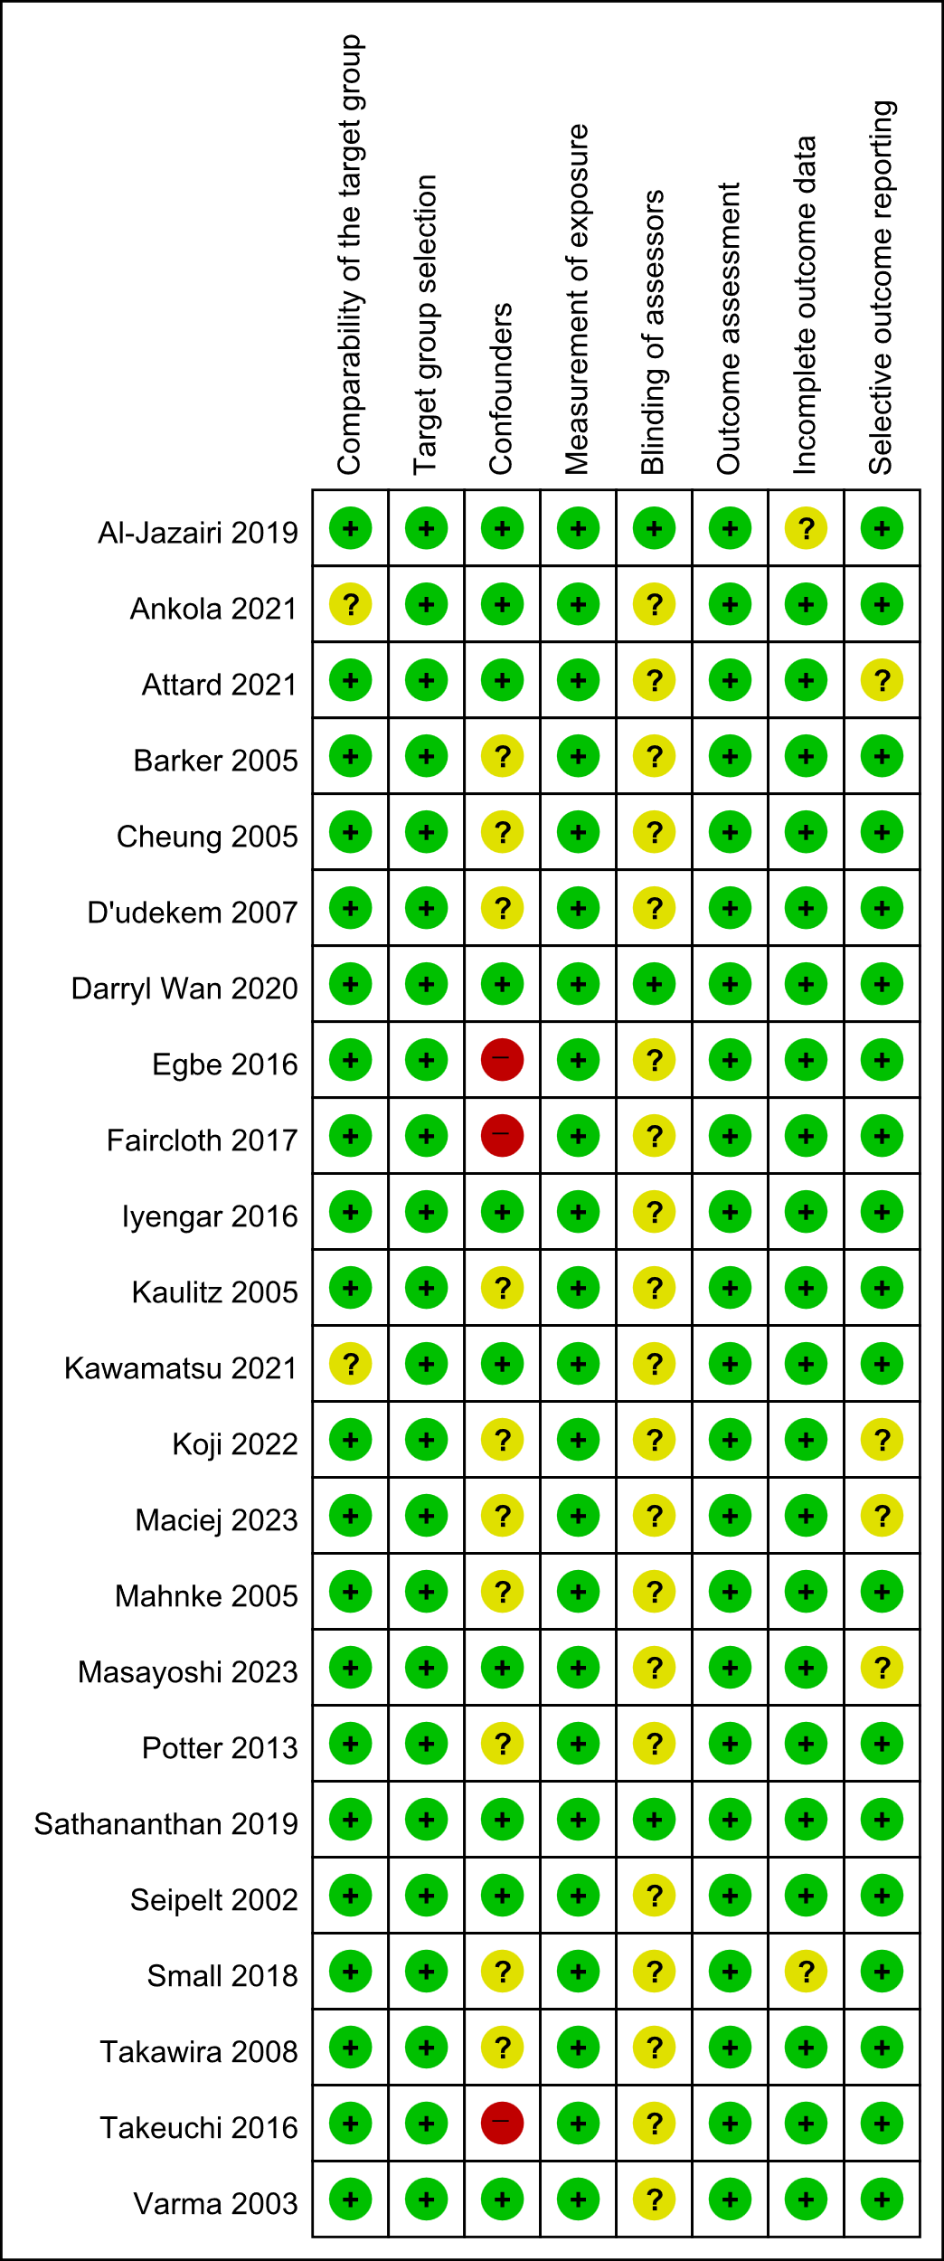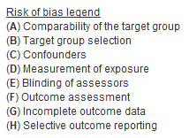
(A)

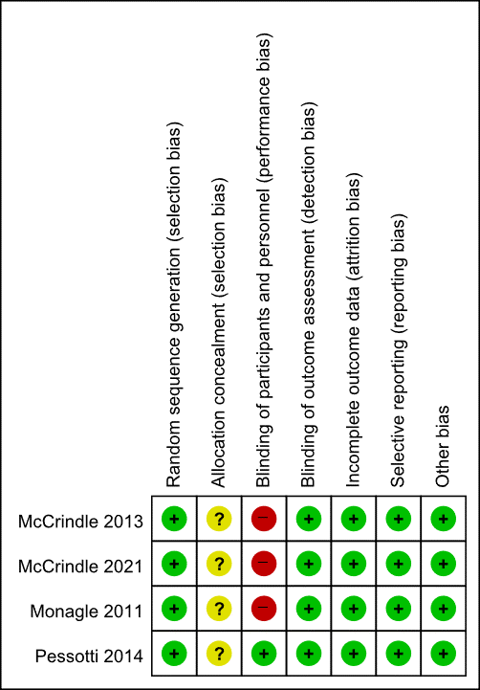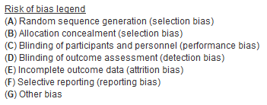
(B)
Online Resource 2 Risk of bias assessment for the outcomes of events among the included studies
(A) Risk of bias assessment tool for nonrandomized studies (RoBANS) assessment of the quality of the included observational studies. (B) Risk of bias assessment tool for randomized studies (ROB) assessment of the quality of the included randomized controlled trial studies.

Online Resource 3. Prophylactic effect of aspirin versus warfarin on thromboembolic events in patients with Fontan circulation: a meta-analysis of randomized controlled trials.
CI, confidence interval; DOAC, direct oral anticoagulant; RCT, randomized controlled trial

Online Resource 4. Prophylactic effect of aspirin versus direct oral anticoagulants on thromboembolic events in patients with Fontan circulation: a meta-analysis including the overall and non-East Asian subgroups.
CI, confidence interval; DOAC, direct oral anticoagulant; RCT, randomized controlled trial

Online Resource 5. Prophylactic effect of warfarin versus direct oral anticoagulants on thromboembolic events in patients with Fontan circulation: a meta-analysis including the overall and non-East Asian subgroups.
CI, confidence interval; DOAC, direct oral anticoagulant; RCT, randomized controlled trial

Online Resource 6. Prophylactic effect of direct oral anticoagulants versus no prophylaxis on thromboembolic events in patients with Fontan circulation: a meta-analysis of the East Asian subgroup.
CI, confidence interval; DOAC, direct oral anticoagulant; RCT, randomized controlled trial

Online Resource 7. Prophylactic effect of aspirin versus combination therapy on thromboembolic events in patients with Fontan circulation: a meta-analysis including the overall, East Asian, and non-East Asian subgroups.
CI, confidence interval; DOAC, direct oral anticoagulant; RCT, randomized controlled trial

Online Resource 8. Prophylactic effect of warfarin versus combination therapy on thromboembolic events in patients with Fontan circulation: a meta-analysis including the overall, East Asian, and non-East Asian subgroups.
CI, confidence interval; DOAC, direct oral anticoagulant; RCT, randomized controlled trial

Online Resource 9. No prophylaxis versus the prophylactic effect of combination therapy on thromboembolic events in patients with Fontan circulation: a meta-analysis including the overall and East Asian subgroups.
CI, confidence interval; DOAC, direct oral anticoagulant; RCT, randomized controlled trial

Online Resource 10. Prophylactic effect of aspirin versus warfarin on bleeding events in patients with Fontan circulation: a meta-analysis including the overall and non-East Asian subgroups.
CI, confidence interval; DOAC, direct oral anticoagulant; RCT, randomized controlled trial

Online Resource 11. Prophylactic effect of aspirin versus no prophylaxis on bleeding events in patients with Fontan circulation: a meta-analysis including overall and non-East Asian subgroups.
CI, confidence interval; DOAC, direct oral anticoagulant; RCT, randomized controlled trial

Online Resource 12. Prophylactic effect of warfarin versus no prophylaxis on bleeding events in patients with Fontan circulation: a meta-analysis including overall and non-East Asian subgroup.
CI, confidence interval; DOAC, direct oral anticoagulant; RCT, randomized controlled trial

Online Resource 13. Prophylactic effect of aspirin versus combination therapy on bleeding events in patients with Fontan circulation: a meta-analysis of the East Asian subgroup.
CI, confidence interval; DOAC, direct oral anticoagulant; RCT, randomized controlled trial

Online Resource 14. Prophylactic effect of warfarin versus combination therapy on bleeding events in patients with Fontan circulation: a meta-analysis of the East Asian subgroup.
CI, confidence interval; DOAC, direct oral anticoagulant; RCT, randomized controlled trial

