Appendix

Appendix I
Placebo test results are shown in Figures A-F.
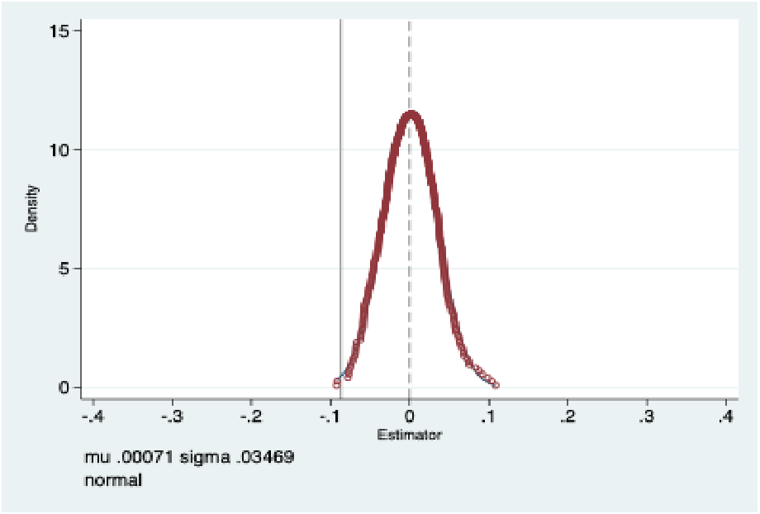
Fig. A Placebo test-kernel density estimates of coefficients (carbon emissions)
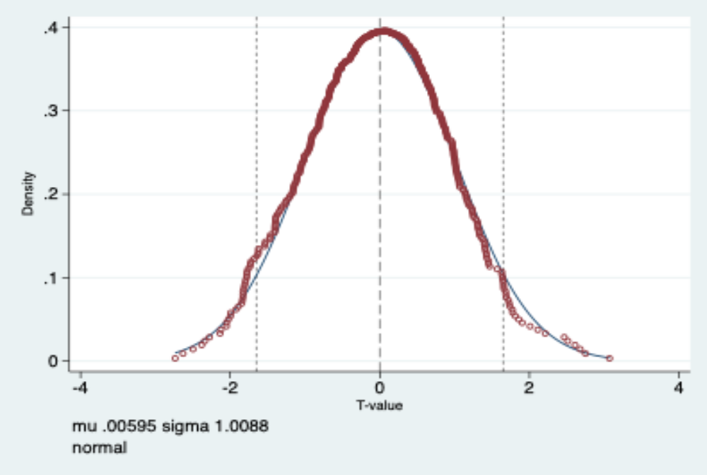
Fig. B Placebo test-kernel density estimates for t values (carbon emissions)
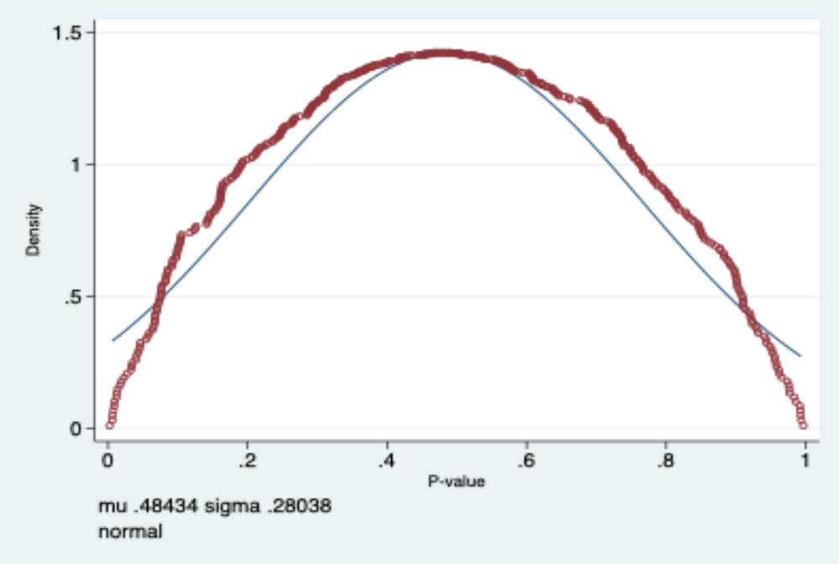
Fig. C Placebo test-kernel density estimation plot for P values (carbon emissions)
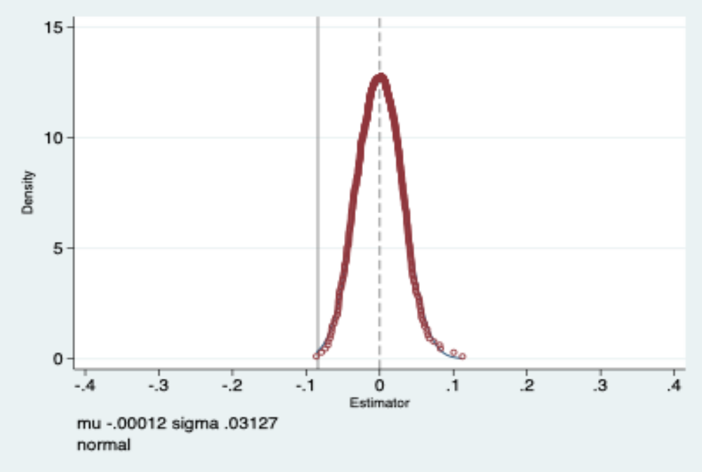
Fig. D Placebo test-kernel density estimates of coefficients (carbon intensity)
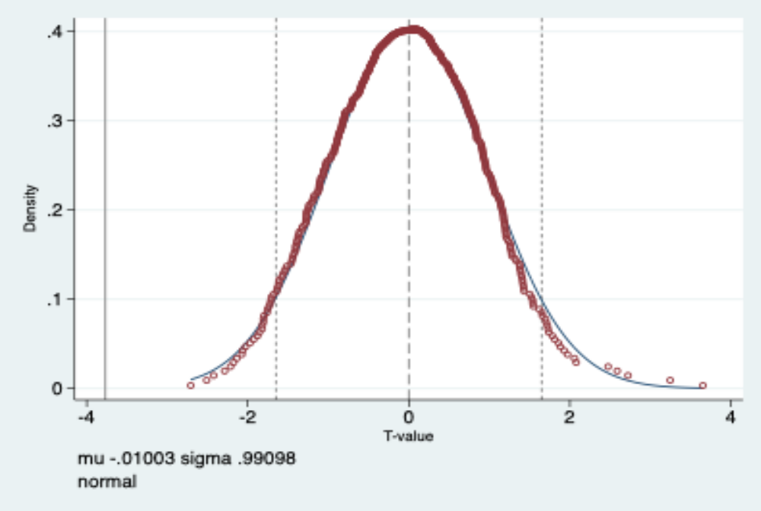
Fig. E Placebo test-kernel density estimates for t values (carbon intensity)
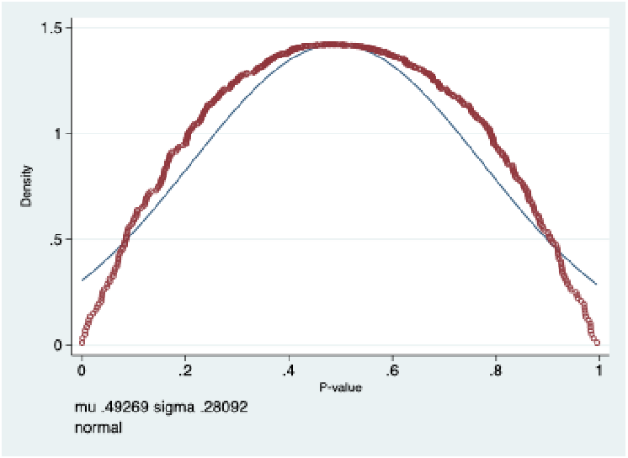
Fig. F Placebo test-kernel density estimation plot for P values (carbon intensity)

