Supporting Figure S1 (a) Effect of linear CYGSR on viability of RAW 264 (b) Antioxidant effect of linear CYGSR by DPPH method (IC₅₀ of 394.1 μg/mL) (c) Tyrosinase inhibitory activity of linear CYGSR (IC₅₀ of 687.2 μg/mL)

Supporting Figure S2 (a) Antioxidant effect by DPPH method of control ascorbic acid of CR5 (IC₅₀ of 1.99 μg/mL) (b) Tyrosinase inhibitory activity of control β-arbutin of CR5 (IC₅₀ of 160.12 μg/mL)
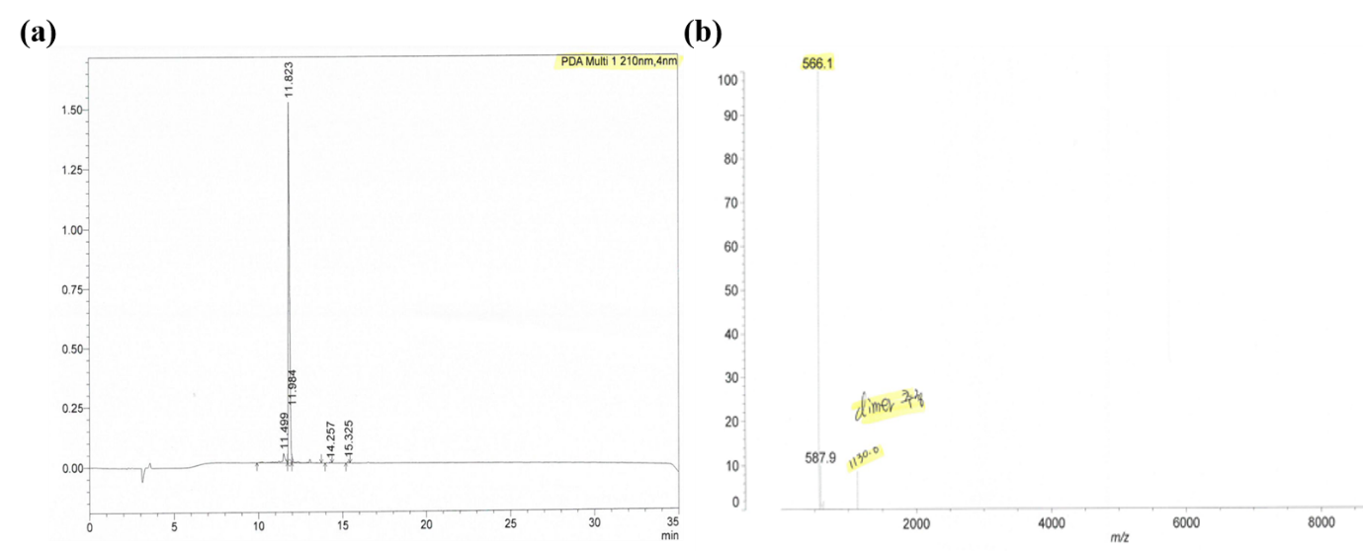
Supporting Figure S3 (a) HPLC chromatogram of the synthesized CR5, monitored at 210 nm (b) LC-MS spectrum of the synthesized CR5 (m/z 566.1)

