Supplementary Data: Figures 1 and 2
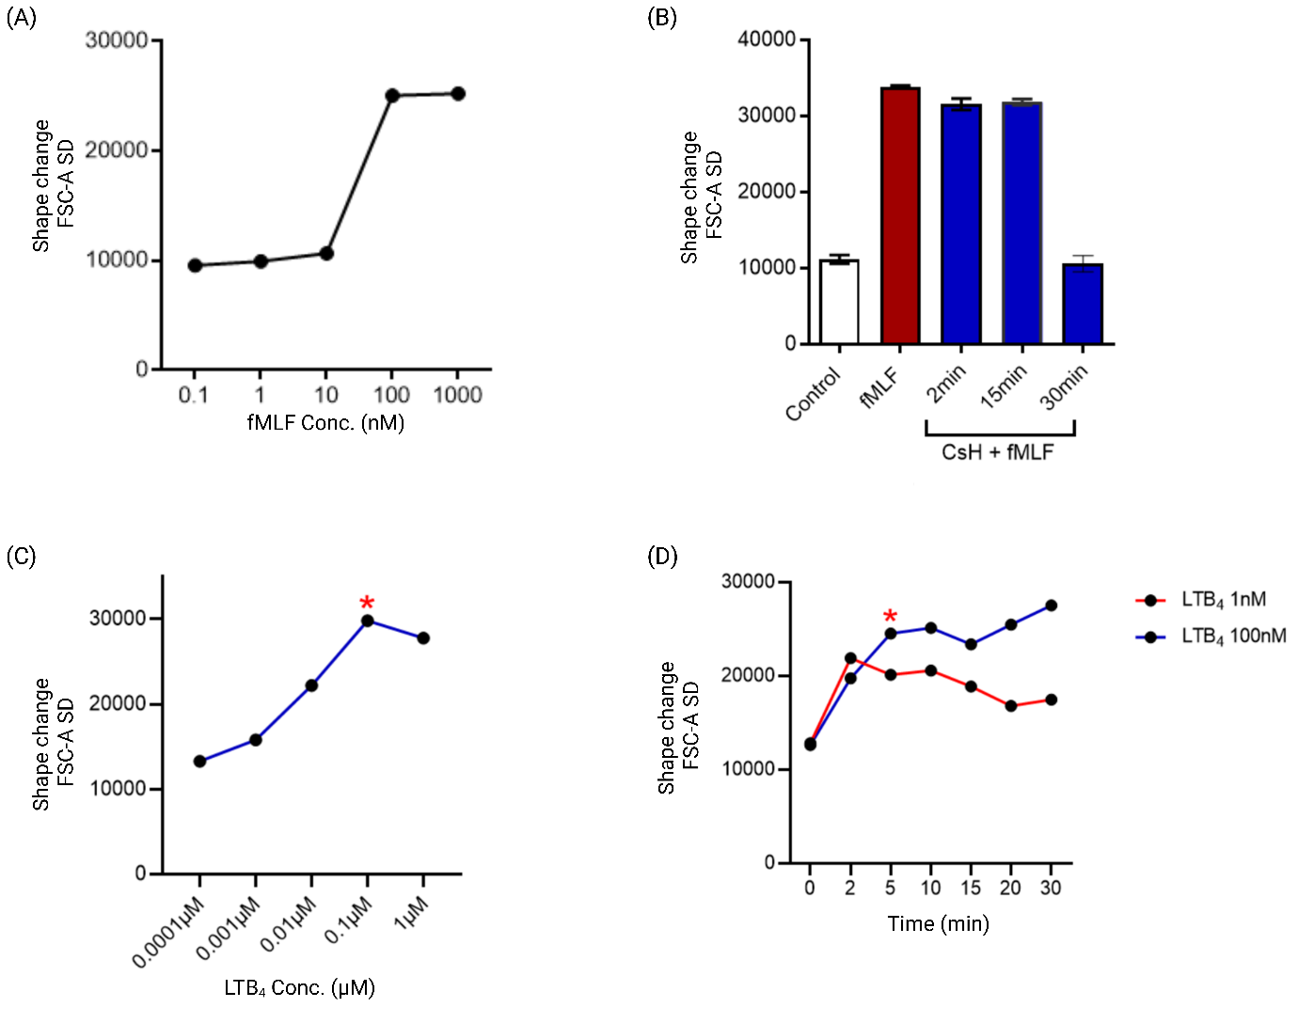

Supplementary Figure 1: Concentration- and time-dependent effects of GPCR modulators on human neutrophil shape change. (A) An initial concentration-response curve for fMLF (an FPR1 agonist) on human neutrophils from one donor, identifying 100nM as an appropriate test concentration for subsequent experiments. (B) Time-course analysis indicating that a 30min pre-incubation with 10µM CsH is sufficient to inhibit the fMLF-induced shape change response (n=2). (C) Concentration-response and (C) time-course analyses were performed using LTB₄ (1nM and 100nM) to identify the optimal concentration and incubation period for BLT1 activation. The conditions selected for subsequent experiments is indicated with a red asterix (*).

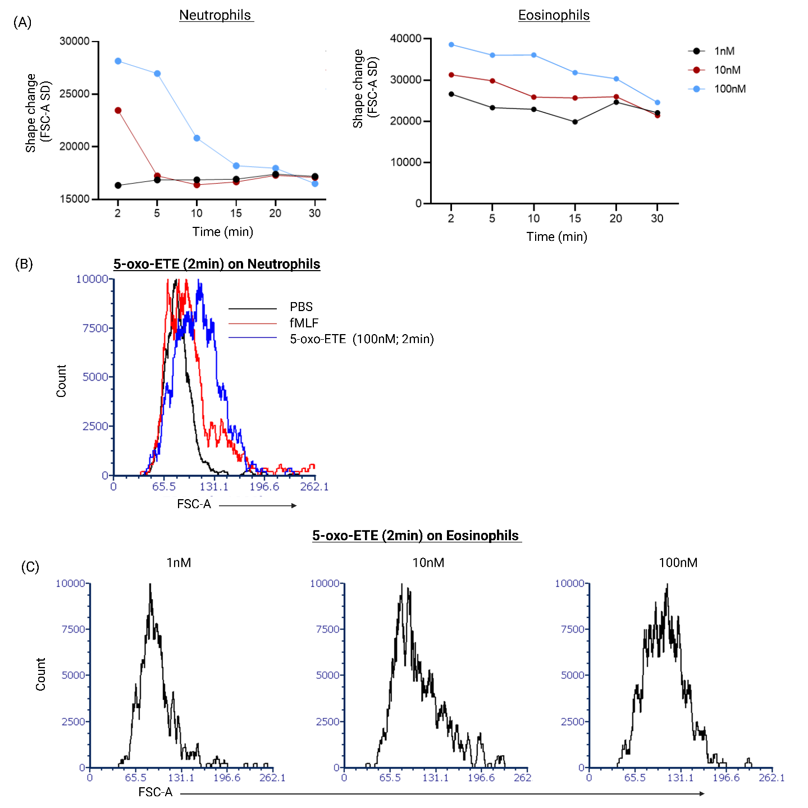
Supplementary Figure 2: 5-oxo-ETE triggers rapid, concentration-dependent activation of both human neutrophils and eosinophils. (A) Time-course data of neutrophil (left) and eosinophil (right) shape change following stimulation with 5-oxo-ETE at 1nM, 10nM and 100nM doses, quantified using the FSC-A SD with measurements taken from 2 to 30 minutes post-stimulation. A rapid, concentration-dependent increase in shape change was observed in both cell types at early time points. (B) Representative flow cytometry histograms showing FSC-A shifts in human eosinophils stimulated for 2min with PBS (black), 100nM fMLF (red), or 100nM 5-oxo-ETE (blue) indicating a clear increase in shape change with 5-oxo-ETE stimulation. (C) FSC-A histogram plots of eosinophils following 2 minutes stimulation with 1nM, 10nM, and 100nM 5-oxo-ETE, depicting a concentration-dependent shift in FSC-A consistent with shape change.

