Combined lymphocyte/monocyte count, D-dimer and iron status predict COVID-19 course and outcome in a long-term care facility
Flavia Biamonte^{1,#,} Cirino Botta^{2,#}, Maria Mazzitelli³, Salvatore Rotundo¹, Enrico Maria Trecarichi³, Daniela Foti⁴, Carlo Torti³, Giuseppe Viglietto¹, Daniele Torella¹, Francesco Costanzo⁵

SUPPLEMENTARY MATERIAL

Supplementary Figure S1
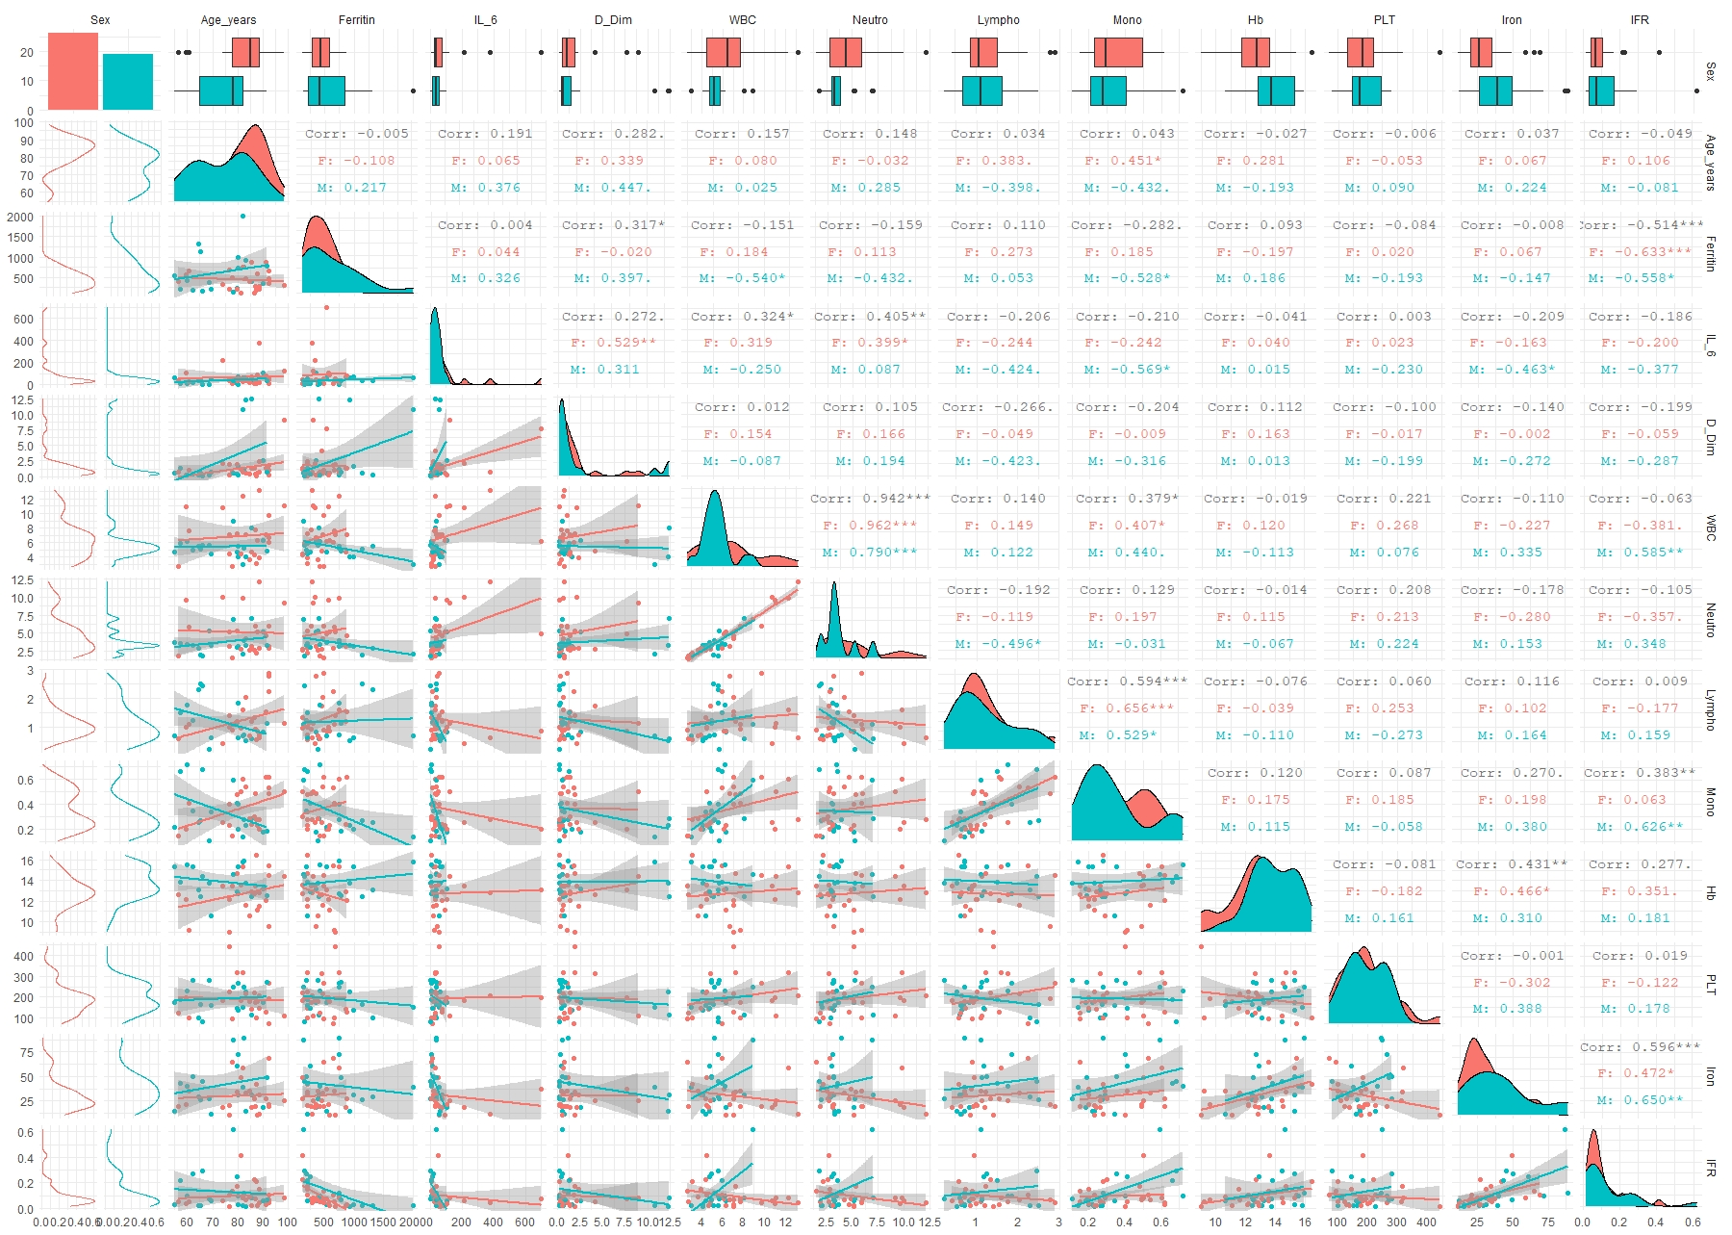

Fig. S1: Boxplot, correlation plots, density plots and histograms reporting the association between each laboratory variable and Sex. The p values for overall and group based correlation is reported in the top-right part of each image.

Supplementary Figure S2
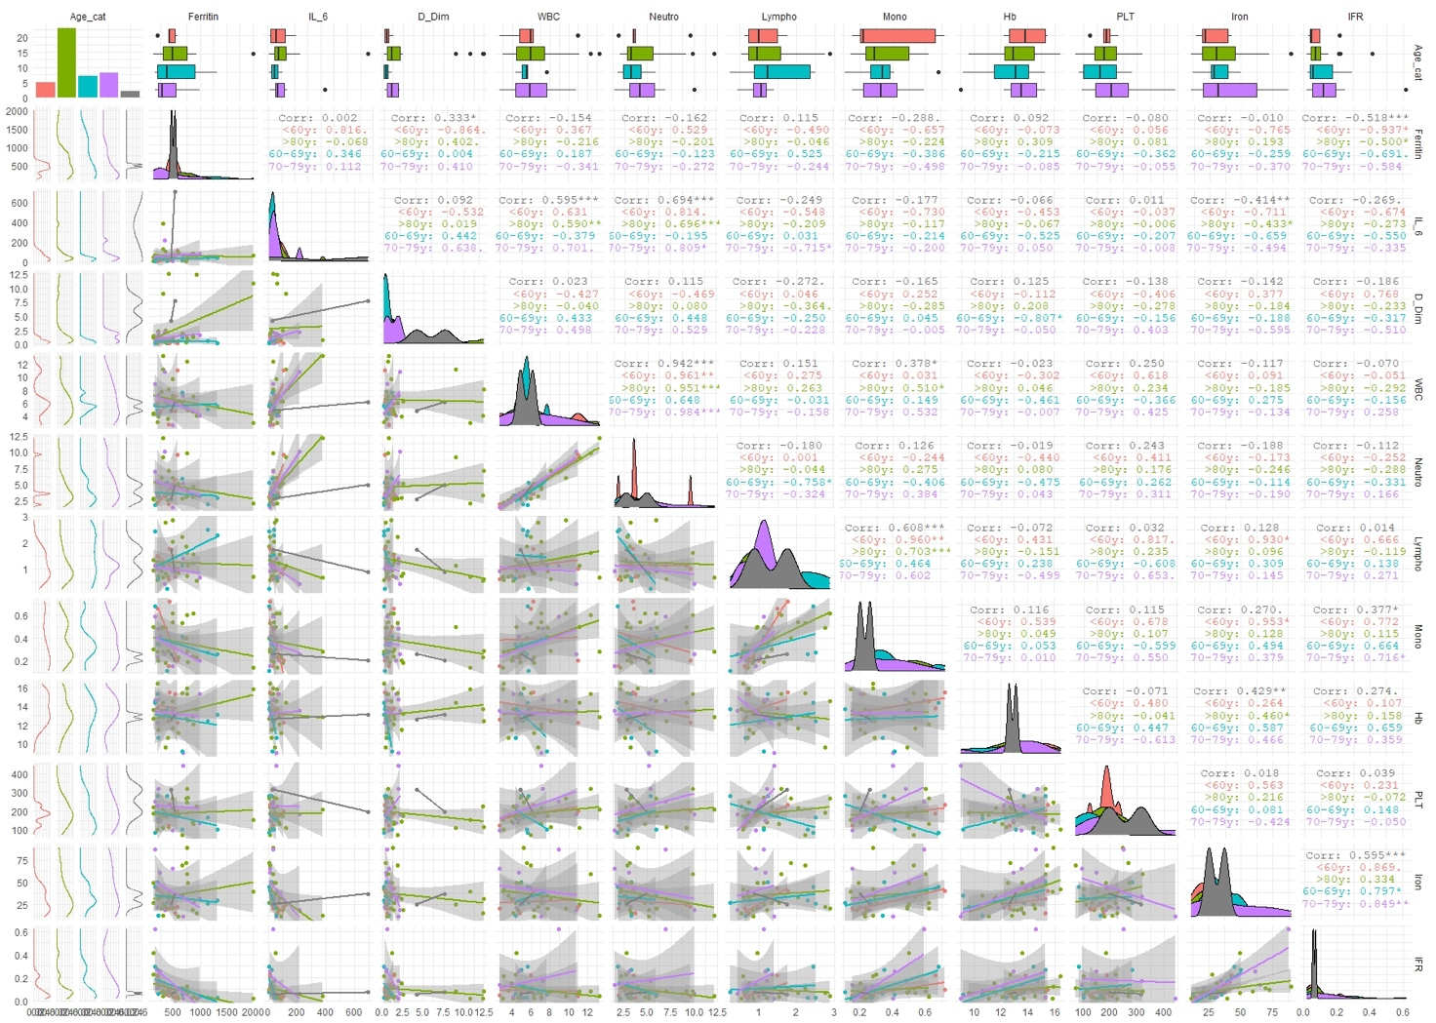

Fig. S2: Boxplot, correlation plots, density plots and histograms reporting the association between each laboratory variable and Age, respectively. The p values for overall and group based correlation is reported in the top-right part of each image.

Supplementary Figure S3

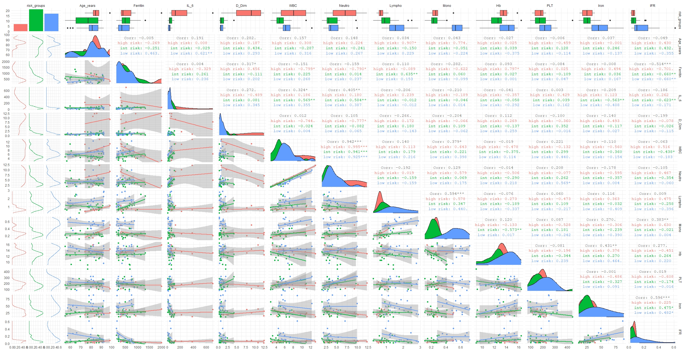
Fig. S3: Boxplot, correlation plots, density plots and histograms reporting the association between each laboratory variable and risk group, respectively. The p values for overall and group based correlation is reported in the top-right part of each image.

Supplementary Figure S4
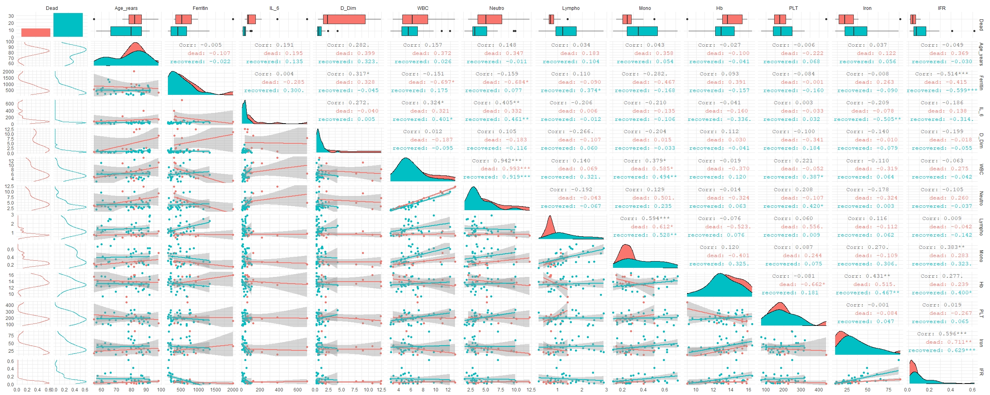

Fig. S4: Boxplot, correlation plots, density plots and histograms reporting the association between each laboratory variable and survival, respectively. The p values for overall and group based correlation is reported in the top-right part of each image.

