Supplementary Information for: Disarming Streptococcus mutans in real time: live-cell DARTS uncovers ABC transporter targeting by manool
Authors: Raffaella Nocera^{1,2}; Emanuele Rosa¹; Valentina Parisi^{1,3}; Tiziano Tuccinardi⁴, Miriana Di Stefano⁴, Giuliana Donadio¹*, Fabrizio Dal Piaz⁵*; Nunziatina De Tommasi^{1,3}

¹ Department of Pharmacy, University of Salerno, Via Giovanni Paolo II, 84084, Fisciano (SA),Italy
² Ph.D. Program in Drug Discovery and Development, University of Salerno, Via Giovanni Paolo II, 84084, Fisciano (SA), Italy
³National Biodiversity Future Center (NBFC), Palermo,Italy
⁴ Department of Pharmacy, University of Pisa, Via Bonanno 6, 56126, Pisa, Italy
⁵ Department of Medicine and Surgery, University of Salerno, Via S. Allende, 84081, Baronissi (SA), Italy

*Corresponding authors: Giuliana Donadio and Fabrizio Dal Piaz.
Email: gdonadio@unisa.it; fdalpiaz@unisa.it
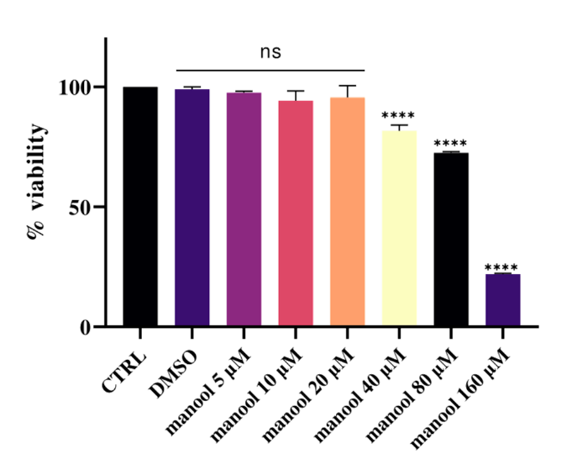

Figure S1. MTT cell viability of manool on “HaCaT” cell line, immortalized human keratinocytes. Concentrations starting from 5 µM to 160 µM. Data calculated from the average of three independent experiments with error bars representing SD. (ns, not significan; ****p-value< 0,0001).

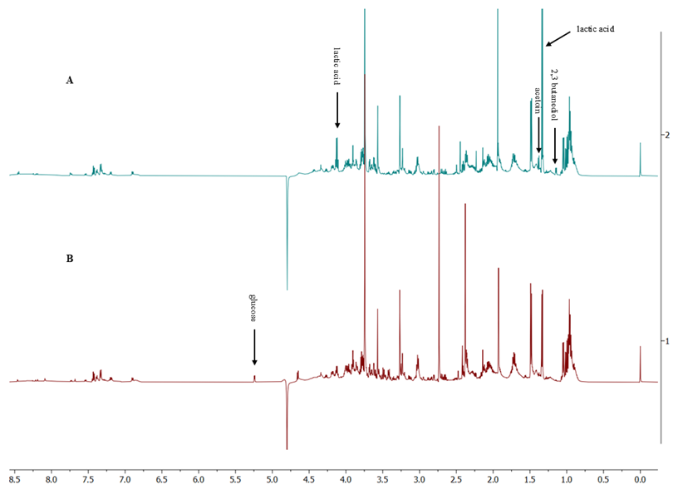

Figure S2 Representative NMR spectra of control group (A) and treatment with 10 µM of manool (B) growth media at 660 minutes.
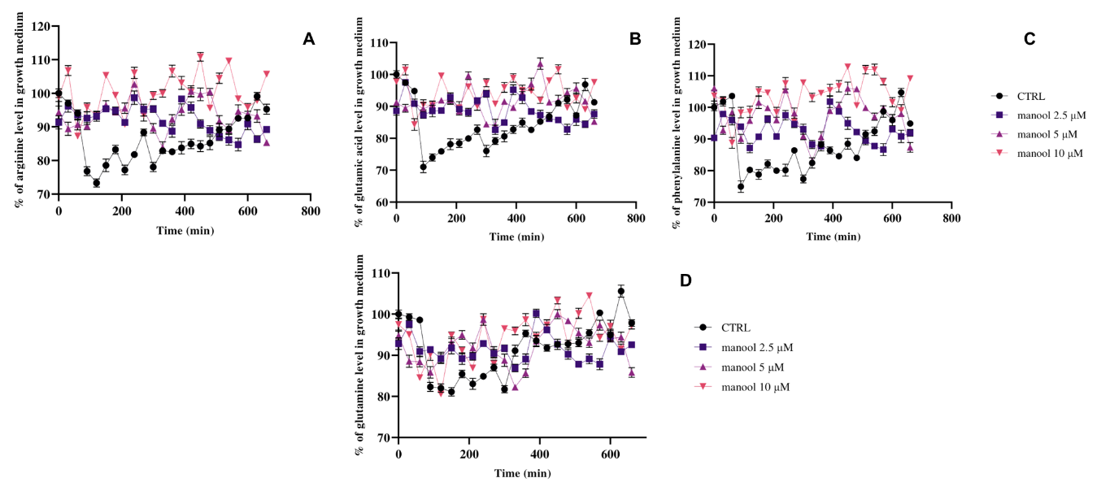

Figure S3. Levels of amio acid in the growth medium for the control group and the treatment groups with manool at 2.5, 5 and 10 µM. Ariginine (A), Glutamic acid (B), Phenylalanine (C) and Glutamine (D) levels in the growth medium for the control and the treatments with manool at 2.5,5 and 10 µM.

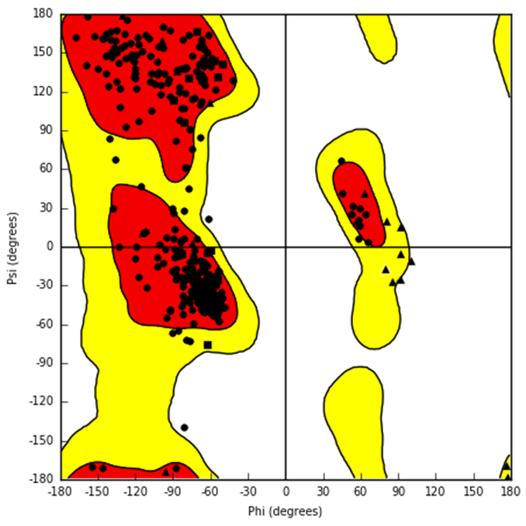
Figure S4. Ramachandran plot of the minimized model of the multiple sugar-binding protein obtained from Modeller.
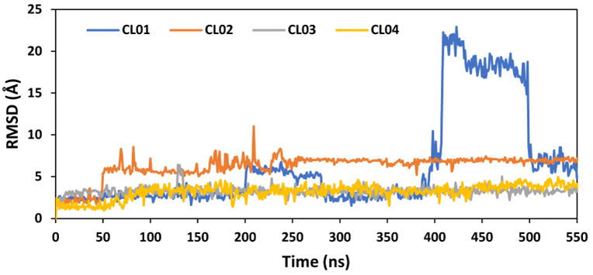
Figure S5. Analysis of the MD simulations of the different protein-cpd01 complexes.

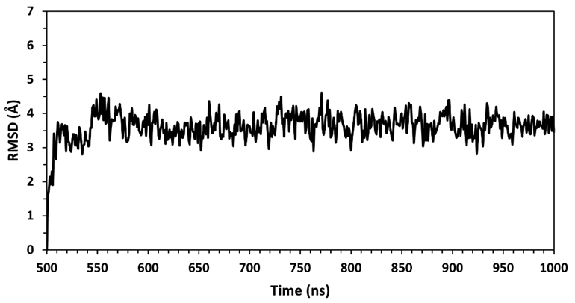
Figure S6. Distribution of cpd01 docking poses across different clusters. The x-axis represents the number of poses within each cluster, while the y-axis indicates the identified docking pose clusters. Clusters are sorted based on the similarity of the docking configurations, highlighting the most populated binding modes. The red dashed line indicates the number of poses threshold used for selecting the most representative clusters.
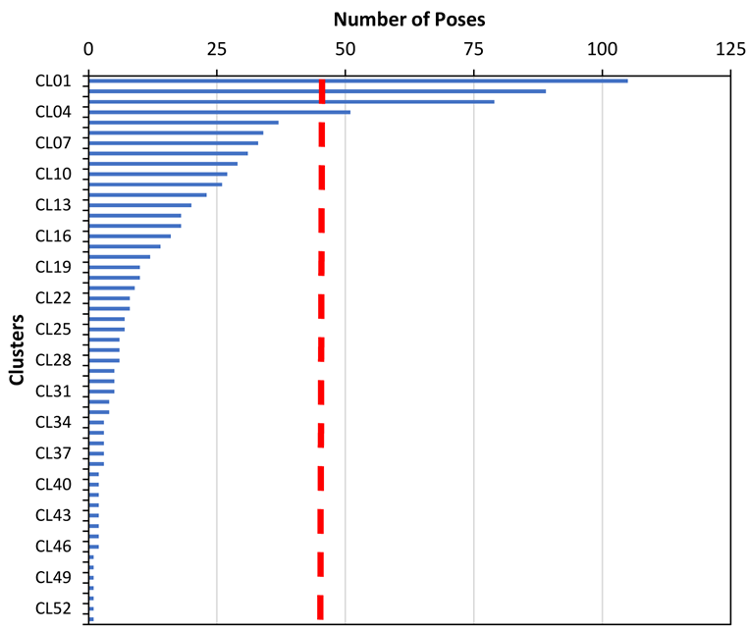

Figure S7. Analysis of the MD simulation of multiple sugar-binding protein. The plot shows the RMSD of all the α carbon atoms from the starting model structure during the last 500 ns of simulation.
Table S1 Fractional Inhibitory Concentration Index (FICI) of manool in combination with kanamycin.
Molecules | MIC₁₀₀ (alone) µg/mL | MIC₁₀₀ (combination) µg/mL | FICI value
Kanamycin | 110 | 13.25 | 0.62
Manool | 6 | 3 | 0.62

Table S2. MM-PBSA results for the analyzed protein-manool complexes. ΔPBSA is the sum of the van der Waals (VDW), electrostatic (ELE), as well as polar (EPB) and non-polar (ENPOLAR) solvation free energy. Data are expressed as kcal·mol⁻¹.

Cpd01 | VDW | ELE | EPB | ENPOLAR | EDISPER | ΔPBSA
CL01 | -39.05 | -1.54 | 8.14 | -31.07 | 53.94 | -10.42
CL02 | -38.34 | -3.02 | 10.37 | -30.81 | 53.12 | -9.11
CL03 | -42.55 | -4.17 | 7.59 | -31.12 | 53.62 | -17.02
CL04 | -35.01 | -3.86 | 8.27 | -30.11 | 52.91 | -7.91

