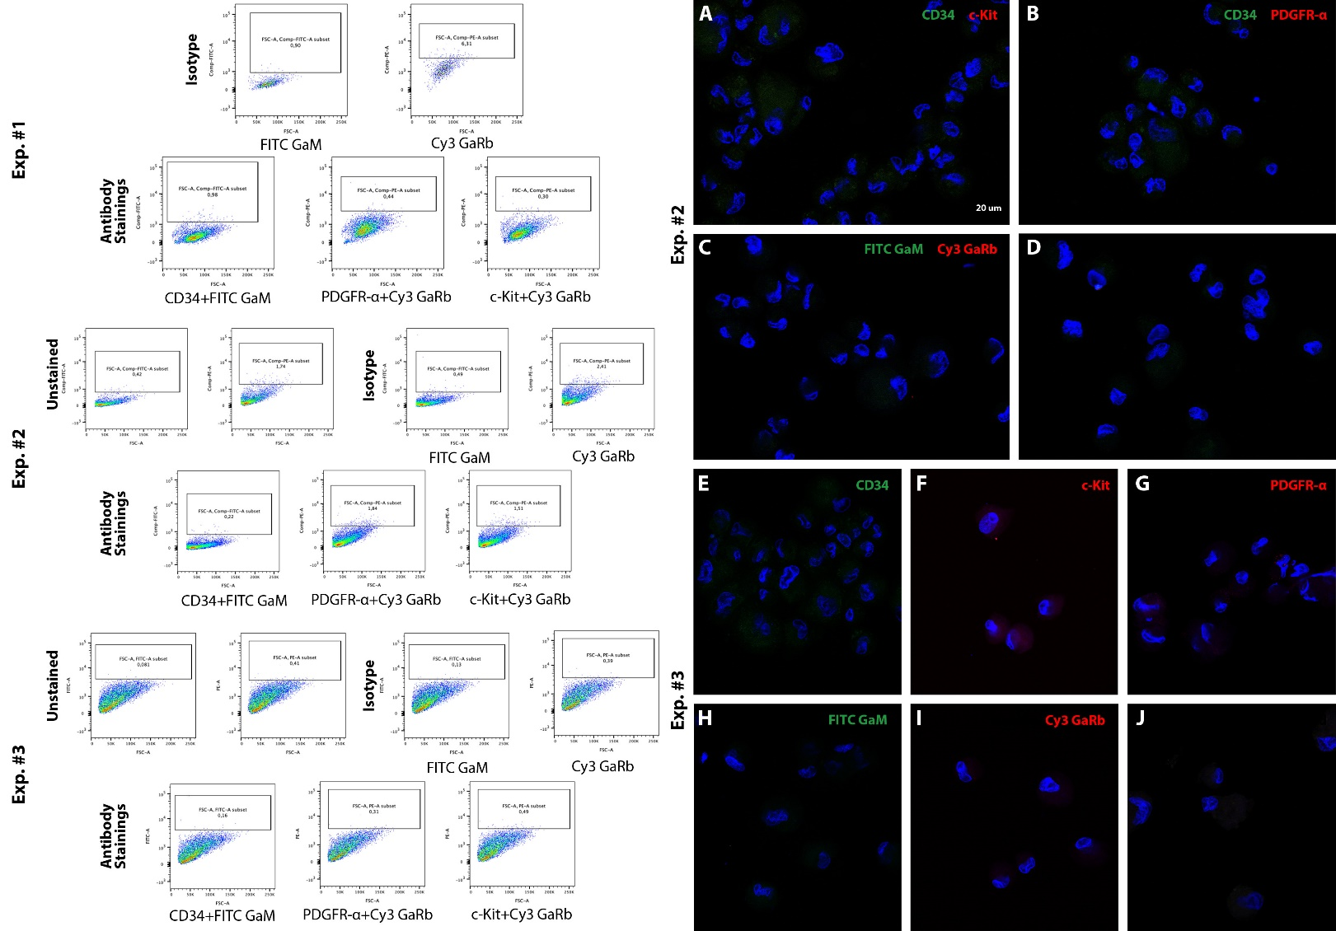
Supplementary Fig. 2.
Flow cytometry and SR-CM analysis of UC stromal cell populations using known telocyte markers. Flow cytometry did not reveal any distinct cell populations based on known telocyte markers (i.e., CD34, PDGFR-α, and c-Kit) in isolated, cultured, live UC stromal cells. Three sets of experiments were conducted using single and double marker combinations, with variations in antibody concentration and incubation time. (A–J) To verify the negative results, the same cell populations were examined using SR-CM. No specific fluorescence signal was detected in either single- or double-labeled specimens. Scale bars: 20 µm.

