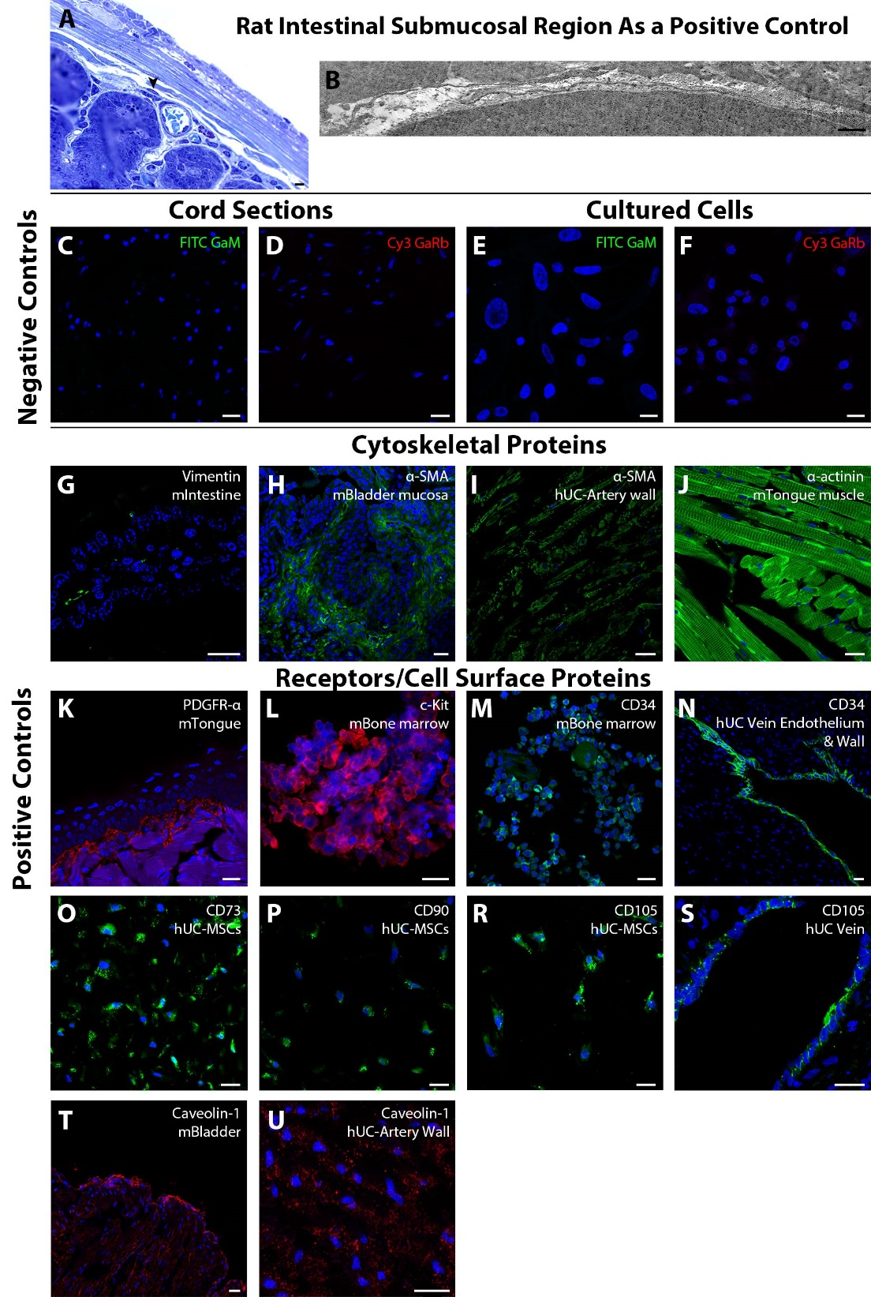
Supplementary Fig. 1.
(A and B) Rat intestinal submucosa for verifying the existence and phenotype of telocytes. (C–F) Antibody omission results (negative controls) for secondary antibodies used. (G–U). Various tissue sections used for positive controls. m: Mouse; h: Human. Scale bars: 10 µm (A); 1 µm (B); 20 µm (C–U).

