Supplementary Information

Breaking of C–N bonds in epoxy resins via an oxidation–Cope elimination pathway

Beitao Liu¹, Runyue Mao², Xiaotong Pan¹, Cijian Zhang¹, Leiming Sun¹, Yan Kou³, Fangyuan Hu², Jinyan Wang¹, Shouhai Zhang¹, Francisco Zaera⁴*, Xigao Jian¹, Zhihuan Weng¹*
¹ State Key Laboratory of Fine Chemicals, Frontiers Science Center for Smart Materials, Liaoning Technology Innovation Center of High Performance Resin Materials, Department of Polymer Science & Engineering, Dalian University of Technology, Dalian 116024, China.
² School of Materials Science and Engineering, Liaoning Technology Innovation Center of High Performance Resin Materials, Dalian University of Technology, Dalian 116024, China.
³ Thermochemistry Laboratory, Liaoning Province Key Laboratory of Thermochemistry for Energy and Materials, Dalian National Laboratory for Clean Energy, Dalian Institute of Chemical Physics, Chinese Academy of Sciences, Dalian, 116023, PR China.
⁴ Department of Chemistry and UCR Center for Catalysis, University of California, Riverside, California 92521, United States.
Corresponding author: zaera@ucr.edu (F. Z), zweng@dlut.edu.cn (Z. W)

Methods
Materials
All reagents and chemicals were used as received without further purification. Dimethyl sulfoxide (DMSO), N-methylpyrrolidone (NMP), N,N’-dimethylacetamide (DMAc), tetramethylene sulfone (TS), dichloromethane (DCM), anhydrous sodium sulfite, sodium carbonate and anhydrous sodium sulfate were supplied by Damao chemical reagent factory, Tianjin, China. Cyclohexylamine, phenyl glycidyl ether, 3-chloroperbenzoic acid (m-CPBA), phenoxyacetone (Model-D1) and dimethyl sulfide were sourced from Macklin biochemical Co., Ltd., Shanghai, China. The diglycidyl ether of bisphenol A epoxy resin E-51 (epoxy value is 0.51 mol 100 g⁻¹) was supplied by Bluestar New Chemical Materials Co., China. 4,4'-diaminodicyclohexyl methane (MCA), isophorondiamine (IPDA), polyetheramines (D230) and diethylenetriamine (DETA) were purchased from Aladdin-reagent Co., Ltd., Shanghai, China. The carbon fiber-reinforced epoxy composites (CFRPs) and pristine carbon fibers (P-CFs) were supplied by Xinyuan Carbon Fiber Technology Co., Ltd., Dongguan, China. The glass fiber-reinforced epoxy composites (GFRPs) and pristine glass fibers (P-GFs) were supplied by Nanjing Fiberglass Research & Design Institute Co., Ltd., China. The poplar veneers were supplied by College of Materials Science & Engineering, Northeast Forestry University. Latex was purchased from Deli Group Co., Ltd., China, and the 500 strong adhesive was purchased from Gleihow New Materials Co., Ltd, China.
Characterization
¹H NMR and ¹³C NMR spectra were recorded using a Varian DLG400 MHz nuclear magnetic resonance spectrometer with deuterated dimethyl sulfoxide (DMSO-d₆) as the solvent and tetramethylsilane (TMS) as the internal standard.
High-resolution time-of-flight mass spectrometry (TOF-MS) measurements were conducted using an Agilent 6224 mass spectrometer.
High resolution liquid chromatography mass spectrometry (LC-MS) measurements were conducted using a Thermo Fisher TSQ Fortis Plus mass spectrometer coupled with a Vanquish liquid chromatography system (USA) and an SB C18 column (150 mm ×4.6 mm, length × diameter). In a typical measurement, methanol-water mixtures were used as the mobile phase varied from 30% methanol (0 min) to 100% methanol (30-40 min) at a flow rate of 0.2 mL min⁻¹. The temperatures of the sample chamber and column were kept at 20 °C. The MS detector was operated in ESI+ mode and the scanning ion range was set between 100 and 1000 Da. Other parameters were determined according to the instrument tuning results. Qualitative analysis was performed using the Thermo Fisher Xcalibur software.
Differential scanning calorimetry (DSC) was performed on a Mettler DSC 1 differential scanning calorimeter under a nitrogen atmosphere with a flow rate of 50 mL min⁻¹. All DSC curves presented in the main text were obtained during the second heating run to eliminate any thermal history effects.
Scanning electron microscopy (SEM) images were obtained using a FEI QUANTA 450 SEM instrument at an operating voltage of 15 kV.
Fourier transform infrared (FT-IR) spectra were obtained using a Thermo Nicolet Nexus 470 FT-IR spectrometer with an attenuated total reflectance (ATR) setup, covering a wavenumber range of 400-4000 cm⁻¹ with a resolution of 16 cm⁻¹.
Gel Permeation Chromatography (GPC) was done on an Agilent 1260 Infinity II Multi-Detector GPC System. The column temperature was maintained at 80 ºC and the flow rate was set to 1 mL min⁻¹ with N-methylpyrrolidone (NMP, HPLC grade) as the eluent and polystyrene as the standard reference material. All GPC samples were dissolved in NMP and passed through 0.45 μm filters prior to analysis.
X-ray diffraction (XRD, XPert3 Powder, Malvern Panalytical, Netherlands) was measured using Cu Kα radiation at a scanning rate of 10° min⁻¹ in a 2θ range of 10–80°.
Thermal gravimetric analysis (TGA) was conducted using a Mettler TGA 1 instrument, recording weight changes from 30 to 800 °C at a heating rate of 10 °C min⁻¹ under a nitrogen atmosphere with the flow rate of 50 mL min⁻¹.
The Raman spectra were collected with a confocal microprobe Raman system (DXR Microscope, Thermo Fisher) with a resolution of 1 cm⁻¹ using a laser with an excitation wavelength of 532 nm.
X-ray photoelectron spectroscopy (XPS) data was collected on an ESCALAB 250 apparatus with a resolution of 0.45 eV using a non-monochromatized Al Kα X-ray source under a base pressure of 1 × 10⁻⁹ mbar.
Synthesis of epoxy resins
Epoxy resins cured with MCA (E51/MCA), DETA (E51/DETA), IPDA (E51/IPDA) and D230 (E51/D230) were synthesized using the parameters indicated in the table below. They were crushed into particles before use.

Name | E51 (g) | Curing agent (g) | Curing conditions
E51/MCA | 50 | 13.6 | 50 ºC/2 h, 90 ºC/2 h, 180 ºC/2 h
E51/DETA | 50 | 7 | 70 ºC/2 h, 110 ºC/2 h
E51/IPDA | 50 | 11 | 80 ºC/2 h, 120 ºC/2 h, 150 ºC/2 h
E51/D230 | 50 | 14.6 | 65 ºC/2 h, 110 ºC/2 h, 150 ºC/2 h

DMSO dissolution of epoxy resins
The DMSO dissolution of epoxy resins was conducted at ambient pressure. Typically, 0.1 g of the epoxy resin and 2 g of DMSO were placed in a round bottom flask with a magnetic stirrer. Subsequently, the flask was submerged into an oil bath at a set temperature (160 ºC for E51/MCA, 150 ºC for E51/DETA, 160 ºC for E51/IPDA and 130 ºC for E51/D230) until the top level of the solution was ~1 cm below the surface of the oil bath. The reaction solution was left in the oil bath for a certain period of time (20 h for E51/MCA, 13 h for E51/DETA, 20 h for E51/IPDA and 12 h for E51/D230) before cooling down to room temperature. The solid epoxy resin residue was filtered out from the degraded mixture, while the filtrate was precipitated into water and centrifuged to obtain the brown degraded products (DEP-1 from E51/MCA, DEP-2 from E51/DETA, DEP-3 from E51/IPDA and DEP-4 from E51/D230). The degradation degree (D_{d}) and mass fraction remaining (1-α) were calculated as:
$$Degradation degree\left(D_{d},\%\right)=\frac{W_{1}-W_{2}}{W_{1}}×100\%$$
$$Mass fraction remaining \left(1-α\right)=\frac{W_{2}}{W_{1}}$$
where W₁ and W₂ refer to the mass of the original epoxy resin and the solid epoxy resin residue respectively.
Synthesis of the model compound
Cyclohexylamine (2.00 g, 0.0202 mol) and phenyl glycidyl ether (6.07 g, 0.0404 mol) were added to a round bottom flask with a magnetic stirrer. The reaction mixture was heated to 80 ºC and stirred for 6 hours to yield a colorless liquid, the model compound. Yield: 100%.
The ¹H NMR, ¹³C NMR and TOF-MS spectra for this model compound are displayed in Fig. S8.
Degradation of the model compound in DMSO
Degradation of the model compound in DMSO was conducted at ambient pressure. The model compound (0.28 g, 0.5 mmol) was dissolved in DMSO-d₆ (5 mL) in a glass vial with a magnetic stirrer. An aliquot was taken to acquire an initial ¹H NMR spectrum. The remaining solution was left stirring at 160 ºC and sampled periodically (4 h, 8 h, 12 h and 16 h) for ¹H NMR analysis.
Synthesis of N-oxide intermediate
The model compound (0.3 g, 0.75 mmol) was dissolved in 5 mL of dichloromethane (DCM) in a 50 mL three-necked flask with a magnetic stirrer. m-CPBA (85% purity, 0.3 g, 1.5 mmol) was added slowly at a temperature below 5 °C. The reaction mixture was then heated to 25 ºC and stirred for 4 h. After filtration, the filtrate was washed three times with a saturated sodium sulfite aqueous solution, a saturated sodium carbonate aqueous solution, and deionized water, in that order. The organic phase was dried overnight using Na₂SO₄, and concentrated under reduced pressure to yield a light-yellow viscous liquid, the N-oxide intermediate. Yield: 82%.
The ¹H NMR, ¹³C NMR and TOF-MS spectra for the N-oxide intermediate are displayed in Fig. S13.
DMSO dissolution of commercial composites
The DMSO dissolution of commercial composites was conducted at ambient pressure. Typically, 0.193 g of CFRP or 0.412 g of GFRP and a set mass of DMSO (2.32 g for CFRP and 4.94 g for GFRP) were placed in a round bottom flask with a magnetic stirrer. Subsequently, the flask was submerged into an oil bath at a set temperature (150 ºC for CFRP and 140 ºC for GFRP) until the top level of the solution was ~1 cm below the surface of the oil bath. The reaction solution was left in the oil bath for a certain period of time (24 h for CFRP and 16 h for GFRP) before cooling down to room temperature. The recovered fibers (R-CF from CFRP and R-GF from GFRP) were filtered out from the degraded mixture, while the filtrate was precipitated into water and centrifuged to obtain the brown degraded products (DEP-5 from CFRP and DEP-6 from GFRP).
Preparation of plywood using DEP-derived adhesives
DEP-derived adhesives were prepared by mixing DEPs and DMSO (weight_{DEP}: weight_{DMSO}=3:7). For the preparation of the three-layer plywood, three poplar veneers (145 × 110 × 1.5 mm) were used, with each layer oriented with its grain perpendicular to that of the adjoining layers. The adhesives were evenly applied on the two sides of the middle-layer veneer (Supplementary Fig. 29a). The resulting veneers were combined and placed on the heating plate of a hot presser and hot pressed at 1.5 MPa and 160 °C for 45 min to obtain the three-layer plywood.
Adhesive strength tests
The adhesive strengths (including dry and wet strengths) of the three-layer plywood were tested on a WSM-50KN electric universal testing machine according to Chinese National Standards (GB/T 17657-2013). The specific sizes of the three-layer plywood specimens used for the adhesive strength tests are presented in Supplementary Fig. 29a. For the wet strength test of type II plywood (GB/T 17657-2013, for applications in humid environments), the specimens were pre-soaked in water at 63 ± 3 °C for 3 h and then air-dried at room temperature for 10 min before the test.
DMSO dissolution of E51/MCA under anaerobic conditions
0.1 g of E51/MCA and 2 g of DMSO were placed in a Schlenk flask with a magnetic stirrer and the flask was sealed with a rubber plug. After three freeze-pump-thaw cycles, the degradation mixture was stirred at 160 ºC for 20 h under a nitrogen atmosphere. After reaction, the solid E51/MCA residue was filtered out from the degraded mixture and washed three times with deionized water. The remaining solid E51/MCA residue was freeze-dried to remove any residual water, for subsequent use. Concurrently, the filtrate was kept without any post-treatment.
DMSO dissolution of epoxy resins and commercial composites in the continuous flow reactor
The continuous flow reactor was constructed using two peristaltic pumps and a communicating vessel, with a hot plate under communicating vessel as the heat source (Supplementary Figs. 30a and 31), and a ball of cotton wool was placed at the connection channel of the communicating vessel to prevent the epoxy particles or the fibers from entering the other side of communicating vessel. Typically, 0.1 g of epoxy resin or commercial composite and 1 g of DMSO were added into one side of the communicating vessel with a magnetic stirrer. Subsequently, the communicating vessel was placed on a hot plate at a set temperature (160 ºC for E51/MCA, 150 ºC for E51/DETA, 160 ºC for E51/IPDA, 130 ºC for E51/D230, 150 ºC for CFRP and 140 ºC for GFRP). The reaction solution was left on the hot plate for 15-30 min to allow for the temperature to equilibrate before starting the degradation clock. During degradation, DMSO was pumped into the side with the epoxy resin or the commercial composite at a rate of 1.7 mg min⁻¹ while the degradation solution was pumped away from the other side of the communicating vessel at the same rate. Degradation was carried out on the hot plate for a certain period of time (8 h for E51/MCA, 6 h for E51/DETA, 9 h for E51/IPDA, 7 h for E51/D230, 16 h for CFRP and 10 h for GFRP) before cooling down to room temperature. The solid epoxy resin residue and the recovered fibers were filtered out from the degraded mixture, while the filtrate was precipitated into water and centrifuged to obtain the brown degraded products (DEP-1-S from E51/MCA, DEP-2-S from E51/DETA, DEP-3-S from E51/IPDA, DEP-4-S from E51/D230, DEP-5-S from CFRP and DEP-6-S from GFRP).
DFT calculations
All density functional theory (DFT) results were performed using the Gaussian 16 package, setting the temperature and pressure of the system at 433.15 K and 1 atm pressure, respectively. The geometry optimization of all molecules was executed at the b3lyp/6-311gd, level of theory. The energy refinement was performed with a single-point calculation at the b3lyp/cc-pvdz level of theory. Additionally, the transition state (TS) method was employed to identify the transition state associated with each reaction. To properly assign all stationary points as minima or saddle points, vibrational analysis was performed at the same level of theory as for the geometry optimization. This analysis was also used for the Gibbs free energy corrections. In addition to the vibrational analysis, the transition states were further confirmed using intrinsic reaction coordinate (IRC) calculations. According to the hydrogen dissociation pathways shown in Supplementary Fig. 34, the C-H bond dissociation energies (BDE) of the proton attached to the hydroxyl group and the proton on the cyclohexyl group in N-oxide intermediate were calculated as:
$$BDE=\left({EE}_{N-oxide anionic}+{TCE}_{N-oxide anionic}\right)+({EE}_{H^{+}}+{TCE}_{H^{+}})-{(EE}_{N-oxide}+{TCE}_{N-oxide})$$
where EE and TCE refer to the electronic energy and the thermal correction to enthalpy respectively.
Molecular dynamics (MD) simulations
Prior to the simulations, an epoxy resin model was built from 20 units of bisphenol A diglycidyl ether (E51) and 10 units of MCA, linked via step-growth reactions between polyamine and epoxy groups, with a crosslinking degree exceeding 90%. The resulting structure was then structurally optimized using the CASTEP module, and 5 epoxy resin crosslinked chains were placed into a periodic box with 100 × 100 × 100 Å³ dimensions. After 10,000 steps of energy minimization and a 20 ns equilibration under canonical (NVT; constant number of particles, volume, and temperature) ensemble using a Nose−Hoover thermostat, the final epoxy resin model was obtained. All the simulations were carried out at 300 K and 1 bar. Before simulating the swelling behavior, the reliability of the epoxy resin model and the forced field was verified, and the details were shown in the Supplementary Information. The glass transition temperature (T_{g}) of the pure epoxy resin was estimated to be 432 K (Supplementary Fig. 19), close to the experimental value of about 431 K (Supplementary Fig. 4), indicating that the model and force field are reliable. The subsequent simulations were based on this model and the force field.
For the epoxy resin/solvent system, two boxes with 205 solvent molecules (NMP, DMAc, TS or DMSO) and a size of 100 × 100 × 100 Å³ were placed on either side of the established epoxy resin box to get the final sandwich-like interfacial structure, with a ~100 Å gap remaining between the adjacent boxes to avoid any molecular overlap. After 10,000 steps of energy minimization, a 5 ns run under NVT ensemble conditions was conducted, followed by an 80 ns run under isothermal-isobaric (NPT) ensemble conditions with a semi-isotropic Parrinello−Rahman barostat in the z direction, which kept the interface unchanged. All the simulations of the swelling behavior were conducted at 433 K and 1 bar, using the three-dimensional (3D) periodic boundary conditions (PBC). Electrostatic and van der Waals interactions were included using the Ewald and Atom methods, respectively. The initial velocity was estimated using the Maxwell distribution. The particle grid Ewald method was applied to treat the long-range electrostatic interactions. All of the covalent bonds related to hydrogen atoms were constrained using the linear constrain solver (LINCS) algorithm.
Calculation of content of each species in the degradation of the model compound
The content of each species in the degradation of the model compound was estimated by using the following equation:
$$\begin{aligned}\frac{2x+4y}{4z+2x}=A\#\left(1\right)\end{aligned}$$
$$\begin{aligned}\frac{x+y}{4z+2x}=B\#\left(2\right)\end{aligned}$$
where x, y and z are the molar amount of Model-D1 (Model-D2), Model-D3 and the undegraded species (model compound and N-oxide) in the degradation solution respectively. A is the ratio of the peak area of the peak at 7.16 ppm to the peak at 7.28 ppm in Supplementary Fig. 15 and B is the ratio of the peak area of the peak at 9.3 ppm to the peak at 7.28 ppm in Supplementary Fig. 15.
After simplification and rearrangement, the following equations are obtained:
$$\begin{aligned}\frac{x}{x+y+z}=\frac{8B-2A}{A+1}\#\left(3\right)\end{aligned}$$
$$\begin{aligned}\frac{y}{x+y+z}=\frac{2A-4B}{A+1}\#\left(4\right)\end{aligned}$$
$$\begin{aligned}\frac{z}{x+y+z}=\frac{1-4B+A}{A+1}\#\left(5\right)\end{aligned}$$
Thus, the content of each species in the degradation of the model compound can be calculated using the data from the ¹H NMR spectra in Supplementary Fig. 15.
Fitting of nucleation model to the degradation data obtained from E51/MCA
In the nucleation model, the rate limiting step in the erosion of the sample is assumed to be the formation and growth of nuclei rather than the contraction of the solid–liquid interface, diffusion, or the chemical reaction that occurs at the surface. The nucleation model describes the transformation of a solid from one phase to another and it often includes phenomena such as decomposition¹, adsorption^{2, 3}, hydration⁴, and desolvation⁵. The general form of a nucleation model is described in eqn. (6):
$$\begin{aligned}α={\left(kt\right)}^{n}\#\left(6\right)\end{aligned}$$
where $α$ is the mass fraction degraded at time t, and it can be calculated according to eqn. (7):
$$\begin{aligned}α=\frac{m_{0}-m}{m_{0}}\#\left(7\right)\end{aligned}$$
with m₀ being the initial mass at t = 0, m the mass at time t, k the degradation rate constant, and n = β + λ, where β is the number of successive events that are necessary to form the growth nucleus and λ is the number of growth dimensions. The mass fraction remaining at a given time is thus 1−α. The Avrami-Erofeyev model is one class of nucleation models that neglects nuclei ingestion and nuclei coalescence⁶. The model incorporates the extended conversion fraction (α’), which is related to α as follows:
$$\begin{aligned}dα^{'}=\frac{dα}{1-α}\#\left(8\right)\end{aligned}$$
After integration, this gives eqn. (9):
$$\begin{aligned}α^{'}=-\ln\left(1-α\right)\#\left(9\right)\end{aligned}$$
Eqn. (6) can thus be rearranged to eqn. (10):
$$\begin{aligned}-\ln\left(1-α\right)={\left(kt\right)}^{n}\#\left(10\right)\end{aligned}$$
We fitted the degradation data in Fig. 4a to eqn. (10). The resulting fitting parameters obtained were k = 0.07817 h⁻¹ and n = 3.55 for E51/MCA (Supplementary Fig. 18b and Supplementary Table 5). As by definition, n should be an integer, we thus proceeded to use n = 4, resulting in eqn. (11), in which the only fitting parameter is the degradation rate constant k:
$$\begin{aligned}-\ln\left(1-α\right)={\left(kt\right)}^{4}\#\left(11\right)\end{aligned}$$
We noted that the use of the Avrami-Erofeyev model with n = 3 provided a poorer fit to the data (Supplementary Fig. 18b and Supplementary Table 5).
The application of this model (eqn. (11)) to the degradation data obtained in DMSO is shown in Fig. 4a. It was found that the nucleation model predicts the degradation behavior well for E51/MCA (R² = 0.9946). The calculated degradation rate constant (k) for E51/MCA was 0.07855 h⁻¹.
The nucleation model captured the observed sigmoidal mass loss trend in Fig. 4a with three stages: (1) an initial time period of little mass loss as it takes time for DMSO and oxygen to penetrate into the matrix and prepare for forming nuclei of the new phase; (2) a time period of rapid mass loss (the nuclei of the new phase keep growing and consuming the old phase); (3) a deceleration at the final stages of degradation (only little remaining of the original phase).
Solid-state kinetic models other than the nucleation model
The general formula for the solid-state, heterogeneous kinetics is^{7–9}:
$$\begin{aligned}\frac{dα}{dt}=kf(α)\#\left(12\right)\end{aligned}$$
where $α$ is the mass fraction degraded at time t and k is the degradation rate constant.
Many models have been proposed based on mechanistic assumptions, such as diffusion, geometrical contraction, and reaction-order models. The choice of a model for solid-state kinetics is based on statistical fits of mathematical models to data.
All the general formulae of the models are listed below. We chose to use the degradation data obtained from E51/MCA for probing the best choice of model to fit the data.
3D diffusion model:
$$\begin{aligned}f(α)=\frac{3{(1-α)}^{2/3}}{2(1-{(1-α)}^{1/3})}\#\left(13\right)\end{aligned}$$
Contracting volume model:
$$\begin{aligned}f(α)=3{(1-α)}^{2/3}\#\left(14\right)\end{aligned}$$
First-order reaction model:
$$\begin{aligned}f(α)=(1-α)\#\left(15\right)\end{aligned}$$
Second-order reaction model:
$$\begin{aligned}f(α)={(1-α)}^{2}\#\left(16\right)\end{aligned}$$
Reaction-order models involve the reaction order in the rate law, and are similar to the rate expressions in homogenous kinetics.
After substitution of eqn. (15) and eqn. (16) into eqn. (12) and integration, this gives eqn. (17) and eqn. (18), respectively:
First-order reaction model:
$$\begin{aligned}1-α=e^{kt}\#\left(17\right)\end{aligned}$$
Second-order reaction model:
$$\begin{aligned}1-α=\frac{1}{kt+1}\#\left(18\right)\end{aligned}$$
The diffusion model assumes the rate-limiting step to be the diffusion of reactants into reaction sites or products leaving reaction sites.
After substitution of eqn. (13) into eqn. (12) and integration, this gives eqn. (19):
3D diffusion model:
$$\begin{aligned}1-α={(-{\left(kt\right)}^{1/2}+1)}^{3}\#\left(19\right)\end{aligned}$$
The geometrical contraction model assumes the rate limiting step to be the progress of the product layer from the surface to the interior of the specimen, which is related to the sample morphology.
After substitution of eqn. (14) into eqn. (12) and integration, this gives eqn. (20):
Contracting volume model:
$$\begin{aligned}1-α={(1-kt)}^{3}\#\left(20\right)\end{aligned}$$
The results from application of all the above models (eqn. (17), eqn. (18), eqn. (19) and eqn. (20)) to the degradation data obtained in DMSO are shown in Supplementary Fig. 18a, and the resulting fitting parameters are summarized in Supplementary Table 4. All these models provided poorer fits to the data compared to the nucleation model.
Verification of the reliability of the polymer model and forcing fields
To verify the reliability of the polymer model and the forced field, the glass transition temperature T_{g} was predicted on the basis of the free volume theory put forward by Fox and Flory¹⁰. One common approach to determine the T_{g} is to investigate the dependence of density on temperature. The final densities of the simulation boxes were plotted versus temperature from 380 K to 470 K. The T_{g} of the polymer was predicted to be at the intersection between the two trending lines at low temperatures of 380–430 K and high temperatures of 430–470 K. It is worth noting that the prediction of T_{g} by monitoring the density of the system versus temperature was successful for several polymers (Supplementary Fig. 19).
Self-Diffusion Coefficient
To analyze the mass transfer of the solvent (NMP, DMAc, TS or DMSO) and epoxy resin in detail, eqn. (21) was used to calculate the mean squared displacement (MSD) of the epoxy resins as a function of time in the mixture.
$$\begin{aligned}MSD=<{|x\left(t\right)-x(0)|}^{2}>=\frac{1}{N}\sum_{N}^{i=1}{{|x_{i}\left(t\right)-x_{i}(0)|}^{2}}=t^{β}\#\left(21\right)\end{aligned}$$
In accordance with the Einstein equation, the self-diffusion coefficient d, can be obtained from the slope of MSD versus time using eqn. (22)
$$\begin{aligned}D=\frac{1}{6}\lim_{∆t→∞}{\frac{dMSD}{d∆t}}\#\left(22\right)\end{aligned}$$
where Δt represents the time interval. The D values of EP in different solvents were calculated using the GROMACS program.
Life cycle assessment
Goal and scope. This study follows to the ISO 14044 requirements¹¹ with the aim of comparing the potential environmental impact of the current recycling processes of FRP, oxidative decomposition¹² and incineration¹³ in particular, with the DMSO-dissolution process. The goal of the assessment is to determine whether the DMSO-dissolution strategy results in reduced GHG emissions and energy consumption.
Scenario description and system boundaries. Three scenarios were considered in this study (Fig. 5a and Supplementary Table 9). In each scenario, 1 tonne of wood adhesive for service life is used as the baseline, and all other materials flows are normalized to the consumption amounts of GFRP and CFRP required for the production of 1 tonne of wood adhesive during the DMSO-dissolution process.
Scenario 1, Oxidative decomposition: In this scenario, the GFRP (1.05 tonnes) or CFRP (1.05 tonnes) is immersed in 60 tonnes of 6 M nitric acid (33 wt% concentrated nitric acid-67 wt% water) to dissolve the polymer matrix in a 60 °C water bath for 5 h¹². Then, the recovered FRP (0.75 tonnes) is washed three times by using 0.8 tonnes of acetone in an agitator (200 rpm). This process consumes 20 tonnes of concentrated nitric acid, 40 tonnes of water, and 0.8 tonnes of acetone. The assumed recovery yields for the solvents are 98% for nitric acid and 95% for acetone while the recovering process is not accessed in this study.
Scenario 2, Incineration: For the incineration scenario, the GFRP (0.525 tonnes) and CFRP (0.525 tonnes) are incinerated. Afterwards, the remaining ashes (0.375 tonnes, mainly silicon dioxide) are purified and remolded.
Scenario 3, DMSO-dissolution process: During the DMSO-dissolution process, the GFRP (1.05 tonnes) or CFRP (1.05 tonnes) is immersed in 20 tonnes of DMSO to dissolve the polymer matrix in a 150 °C oil bath for 12 h. Then, the recovered fibers (0.75 tonnes) are washed three times with 0.8 tonnes of DMSO in an agitator (200 rpm). Concurrently, the degradation solution collected from the DMSO-dissolution and DMSO washing processes is precipitated into 40 tonnes water to obtain 0.3 tonnes of DEP, which is directly mixed with 0.7 tonnes DMSO to yield 1 tonnes of wood adhesive.
Life cycle inventory. The environmental impacts, including the energy consumption demand and the GHG emission, for the materials production, processing, oxidative decomposition, incineration, and DMSO-dissolution processes are summarized in Supplementary Table 10. The values are explained below. Note that 1 MJ of electricity was estimated to produce 0.13 kg GHG by using the Argonne GREET model (https://greet.es.anl.gov/, accessed April 15th, 2025).
Materials production: The GHG emission, energy consumption and water consumption for nitric acid (1961.8 kg tonne⁻¹, 10366 MJ tonne⁻¹, 4586.9 kg tonne⁻¹), acetone (2548 kg tonne⁻¹, 65000 MJ tonne⁻¹, 0) and DMSO (1480.9 kg tonne⁻¹, 7779 MJ tonne⁻¹, 25.8 kg tonne⁻¹) were obtained from the Argonne GREET model (Data source: https://greet.es.anl.gov/, accessed April 15th, 2025).
Processing – Acid dissolution: 1.05 tonnes of waste FRP immersed in 60 tonnes of 6 M nitric acid needs to be heated in a water bath at 60 °C for 5 h. An industrial wash bath equipment was considered, operating at a power of 1.2 kW (Data source: https://www.toolots.com/ngfrontend/productDetail?id=53860&title=12.1L%203.2GAL%20General%20Purpose%20Water%20Bath%20110V, accessed April 15th, 2025). The energy consumption is, therefore, 21.6 MJ tonne⁻¹, which corresponds to 2.81 kg tonne⁻¹ GHG emitted during the process.
Processing – Acetone wash: The acetone washing is assumed to be conducted using an industrial agitator with a tank of ~0.5 m³, a power consumption of 0.4 kW (Data source: https://www.agitadoresfluidmix.com/en/industrial-agitator-vpp/, accessed April 15th, 2025), and an operating time of 1 h. The energy consumption is hence calculated to be 2.88 MJ tonne⁻¹. Accordingly, 0.374 kg tonne⁻¹ GHG emitted during the process.
Processing – Incineration: During the incineration process, the GHG emissions for CFRP and GFRP are 3400 and 1120 MJ tonne⁻¹, respectively, according to data from the literature¹³. Considering that incineration is an exothermic process, the energy consumption during the process approaches zero.
Processing – Purification and remolding: The GHG emission, energy consumption, and water consumption during the purification and remolding processes are 4654.4 kg tonne⁻¹, 85000 MJ tonne⁻¹ and 12.19 kg tonne⁻¹, respectively, estimated using the Argonne GREET model (Data source: https://greet.es.anl.gov/, accessed April 15th, 2025).
Processing – DMSO dissolution: 1.05 tonnes of waste FRP immersed in 20 tonnes of DMSO needs to be heated in an oil bath at 150 °C for 12 h. An industrial wash bath equipment with a power consumption of 1.2 kW was considered (Data source: https://www.toolots.com/ngfrontend/productDetail?id=53860&title=12.1L%203.2GAL%20General%20Purpose%20Water%20Bath%20110V, accessed April 15th, 2025). The corresponding energy consumption is 51.8 MJ tonne⁻¹, and the emission of GHG during the process is estimated at 6.73 kg tonne⁻¹.
Processing – DMSO wash: The DMSO washing is assumed to be conducted using an industrial agitator with a tank of ~0.5 m³, a power consumption of 0.4 kW (Data source: https://www.agitadoresfluidmix.com/en/industrial-agitator-vpp/, accessed April 15th, 2025), and an operating time of 1 h. The energy consumption is calculated to be 2.88 MJ tonne⁻¹. Accordingly, 0.374 kg tonne⁻¹ GHG emitted during the process.
Processing – Precipitation in water: The precipitation of the degradation solution in water is assumed to be conducted using an industrial agitator with a tank of ~0.5 m³, a power consumption of 0.4 kW (Data source: https://www.agitadoresfluidmix.com/en/industrial-agitator-vpp/, accessed April 15th, 2025), and an operating time of 1 h. The energy consumption is calculated to be 2.88 MJ tonne⁻¹. Accordingly, 0.374 kg tonne⁻¹ GHG emitted during the process.
Life cycle impact assessment. In this study, the environmental impacts were split into three midpoint indicators, to reflect the energy demand (Supplementary Table 11), the GHG emission (Supplementary Table 12) and the water consumption (Supplementary Table 13).
Cost evaluation. In this study, the costs for raw materials are from the prices of commercial products. The values used were: concentrated nitric acid ($30000 tonne⁻¹, data source: https://hbtuhang.en.made-in-china.com/product/voffgixvlcrg/china-industrial-grade-nitricsulfuric-acid-sulphuric-acid-98-.html, accessed April 15th, 2025), water ($0.5 tonne⁻¹, data source: https://www.fbgtx.org/673/industrial-water-rates, accessed April 15th, 2025), acetone ($1000 tonne⁻¹, data source: https://langyichem.en.made-in-china.com/product/owetnzchfbur/china-china-manufacturesupply-cas-67-64-1-acetone-with-high-quality.html, accessed April 15th, 2025) and DMSO ($1500 tonne⁻¹, data source: https://langyichem.en.made-in-china.com/product/owetnzchfbur/china-china-manufacturesupply-cas-67-64-1-acetone-with-high-quality.html, accessed April 15th, 2025). The costs for energy consumption were calculated according to the average industrial electricity rate across the US ($0.0789 kWh⁻¹, US Energy Information Administration, data source: https://www.eia.gov/electricity/monthly/epm_table_grapher.php?t=epmt_5_6_a, accessed April 15th, 2025). The prices of the wood adhesive from the DMSO-dissolution process are referenced to commercial products ($1500 tonne⁻¹, data source: https://langyichem.en.made-in-china.com/product/owetnzchfbur/china-china-manufacturesupply-cas-67-64-1-acetone-with-high-quality.html, accessed April 15th, 2025). The values are listed in Supplementary Table 14. The estimated materials and energy (electricity) costs are reported in Supplementary Table 15. The operating cost is calculated as the sum of the materials cost and energy cost without including labor cost as an additional operating expense.
Sensitivity and uncertainty. There are some uncertainties associated with the energy demand, GHG emission and water consumption values of the materials used in this study due to the availability of data from different sources. The DMSO-dissolution process implemented in this study was conducted on the gram scale, so there is some additional uncertainty in the prediction of the energy consumption when scaling up the DMSO-dissolution process to a larger scale.

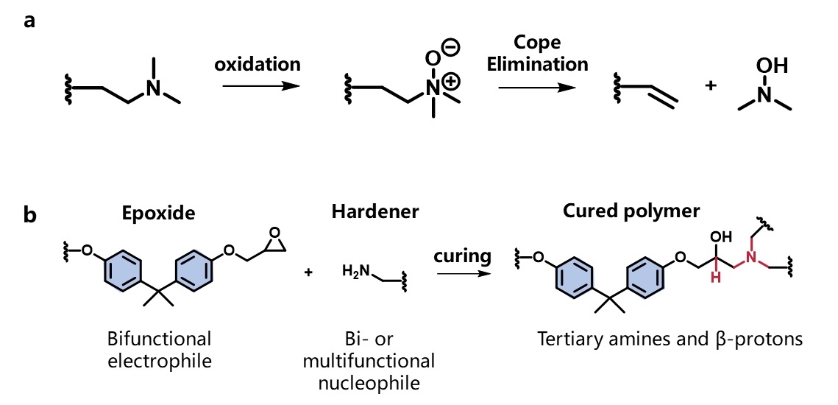

Supplementary Fig. 1.
a, Reaction pathway for the Cope elimination. b, Curing of typical amine-cured epoxy resins.

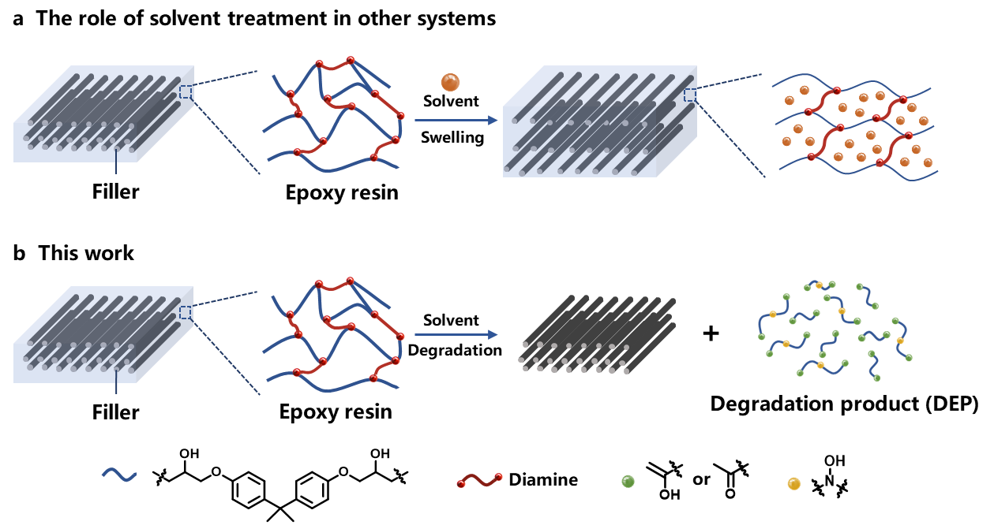

Supplementary Fig. 2.
The role of the solvent (a) as a swelling agent in other systems and (b) as a participant, together with O₂ from air, in the oxidation reaction of epoxy resins in this work.

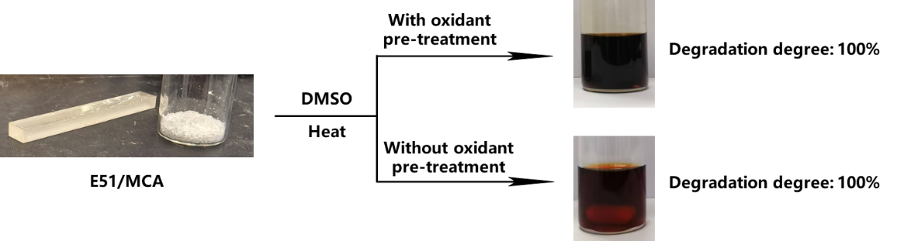

Supplementary Fig. 3.
Degradation of E51/MCA in DMSO with versus without oxidation pre-treatment. Full degradation was seen in both cases.

Supplementary Table 1.
Optimization of conditions for the degradation of E51/MCA in DMSO.

 | Temperature (ºC) | Time h, | Mass ratio  (EP: DMSO) | Degradation degree (%)
E51/MCA | 130 | 20 | 1:20 | 14.7
E51/MCA | 140 | 20 | 1:20 | 25.3
E51/MCA | 150 | 20 | 1:20 | 82.0
E51/MCA | 160 | 20 | 1:20 | 100
E51/MCA | 160 | 20 | 1:40 | 100
E51/MCA | 160 | 20 | 1:10 | 50.4
E51/MCA | 160 | 20 | 1:5 | 5.8

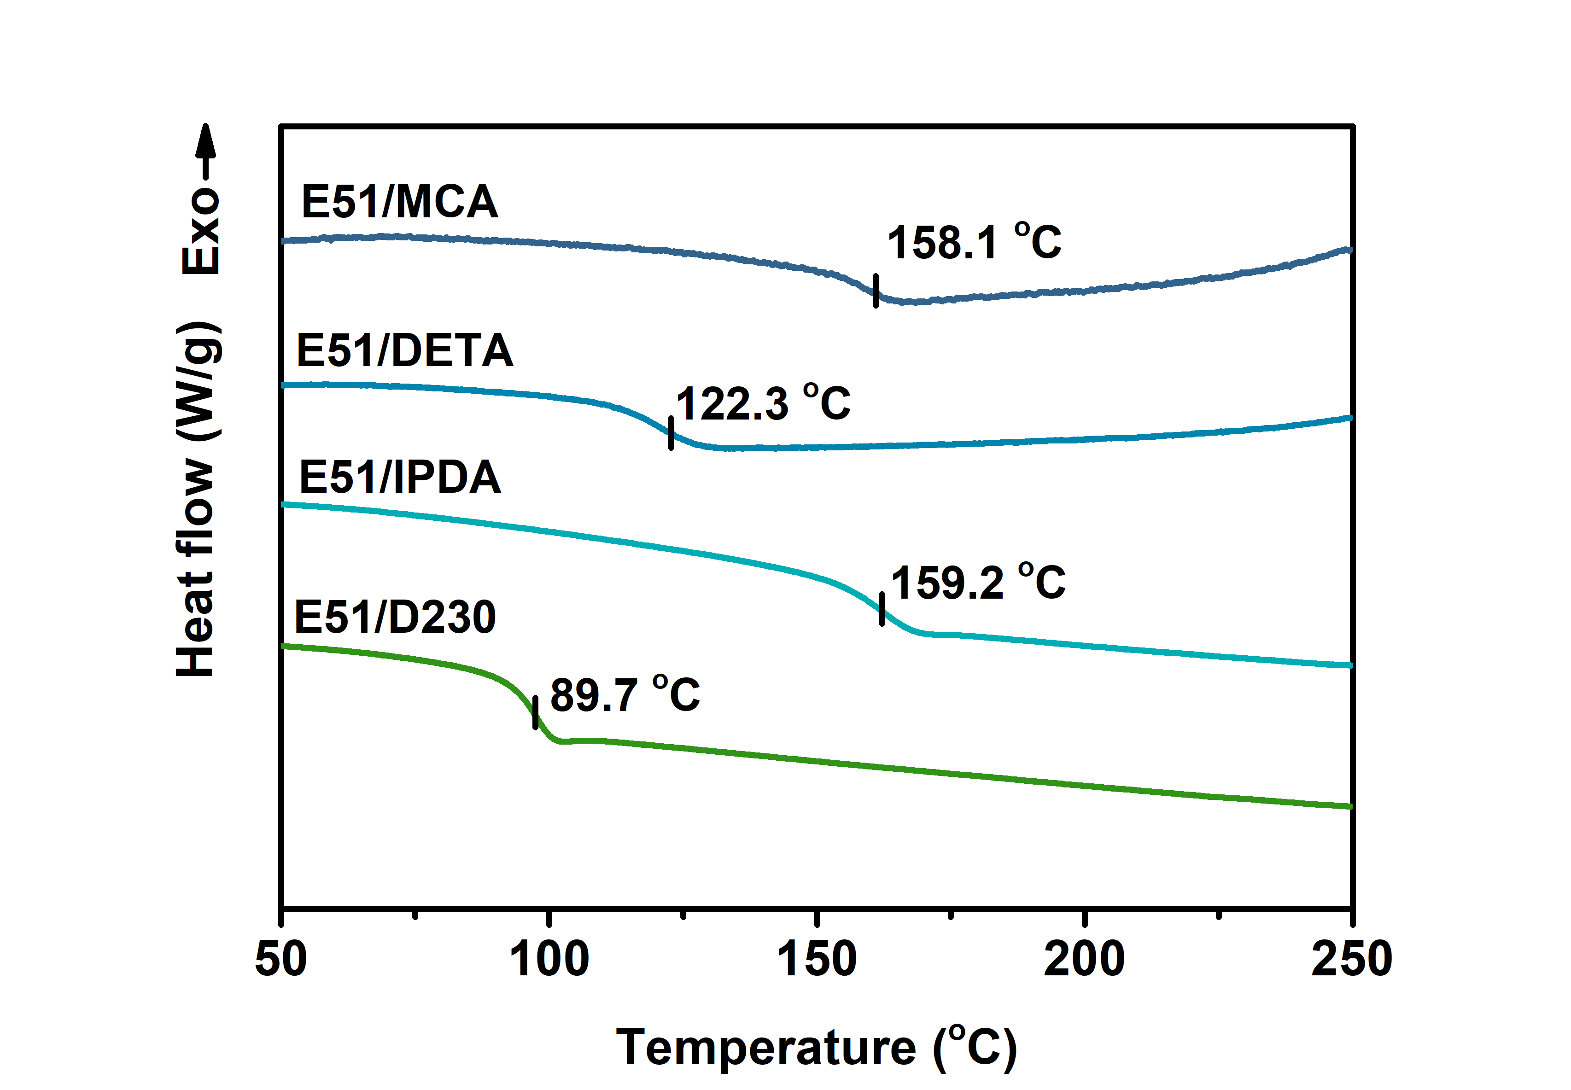

Supplementary Fig. 4.
Differential scanning calorimetry (DSC) curves for E51/MCA, E51/DETA, E51/IPDA and E51/D230, highlighting their different glass transition temperatures.

Supplementary Table 2.
Optimization of conditions for the degradation of E51/DETA, E51/IPDA and E51/D230 in DMSO.

Samples | Temperature (ºC) | Time h, | Mass ratio  (EP: DMSO) | Degradation degree (%)
E51/DETA | 120 | 13 | 1:20 | 6.7
E51/DETA | 130 | 13 | 1:20 | 11.2
E51/DETA | 140 | 13 | 1:20 | 30.3
E51/DETA | 150 | 13 | 1:20 | 100
E51/DETA | 150 | 13 | 1:40 | 100
E51/DETA | 150 | 13 | 1:10 | 89.7
E51/DETA | 150 | 13 | 1:5 | 5.2
E51/IPDA | 130 | 20 | 1:20 | 16.5
E51/IPDA | 140 | 20 | 1:20 | 27.4
E51/IPDA | 150 | 20 | 1:20 | 85.1
E51/IPDA | 160 | 20 | 1:20 | 100
E51/IPDA | 160 | 20 | 1:40 | 100
E51/IPDA | 160 | 20 | 1:10 | 53.2
E51/IPDA | 160 | 20 | 1:5 | 6.4
E51/D230 | 110 | 12 | 1:20 | 8.3
E51/D230 | 120 | 12 | 1:20 | 87.6
E51/D230 | 130 | 12 | 1:20 | 100
E51/D230 | 130 | 12 | 1:40 | 100
E51/D230 | 130 | 12 | 1:10 | 72.6
E51/D230 | 130 | 12 | 1:5 | 5.3

Supplementary Table 3.
Optimized conditions for the degradation of E51/MCA, E51/DETA, E51/IPDA and E51/D230 in DMSO.

 | Temperature (ºC) | Time h, | Mass ratio (EP: DMSO) | Degradation degree (%) | Recovered mass, % (mg)
E51/MCA | 160 | 20 | 1:20 | 100 | 95 (95.3)
E51/DETA | 150 | 13 | 1:20 | 100 | 94 (94.1)
E51/IPDA | 160 | 20 | 1:20 | 100 | 98 (98.4)
E51/D230 | 130 | 12 | 1:20 | 100 | 98 (98.2)

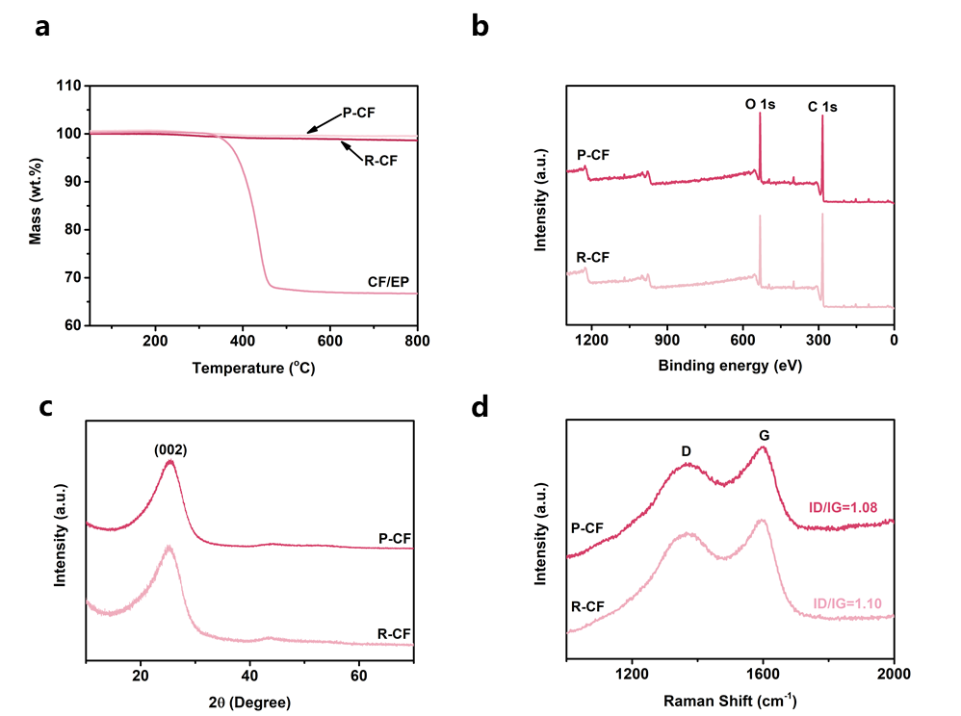

Supplementary Fig. 5.
a, X-ray diffraction (XRD) spectra of pristine carbon fibers (P-CF) and recovered glass fibers (R-CF). b, Thermogravimetric analysis (TGA) curves of carbon fiber reinforced epoxy composite (CF/EP), P-CF and R-CF. c, Raman and d, X-ray photoelectron spectroscopy (XPS) data of P-CF and R-CF.

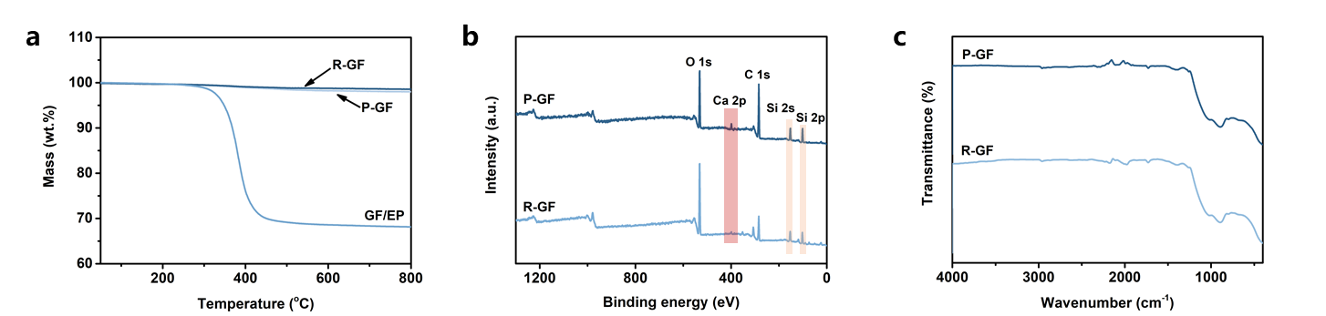

Supplementary Fig. 6.
a, FT-IR spectra of pristine carbon fibers (P-CF) and recovered glass fibers (R-CF). b, TGA curves of glass fiber reinforced epoxy composite (GF/EP), P-GF and R-GF. c, XPS spectra of P-GF and R-GF.

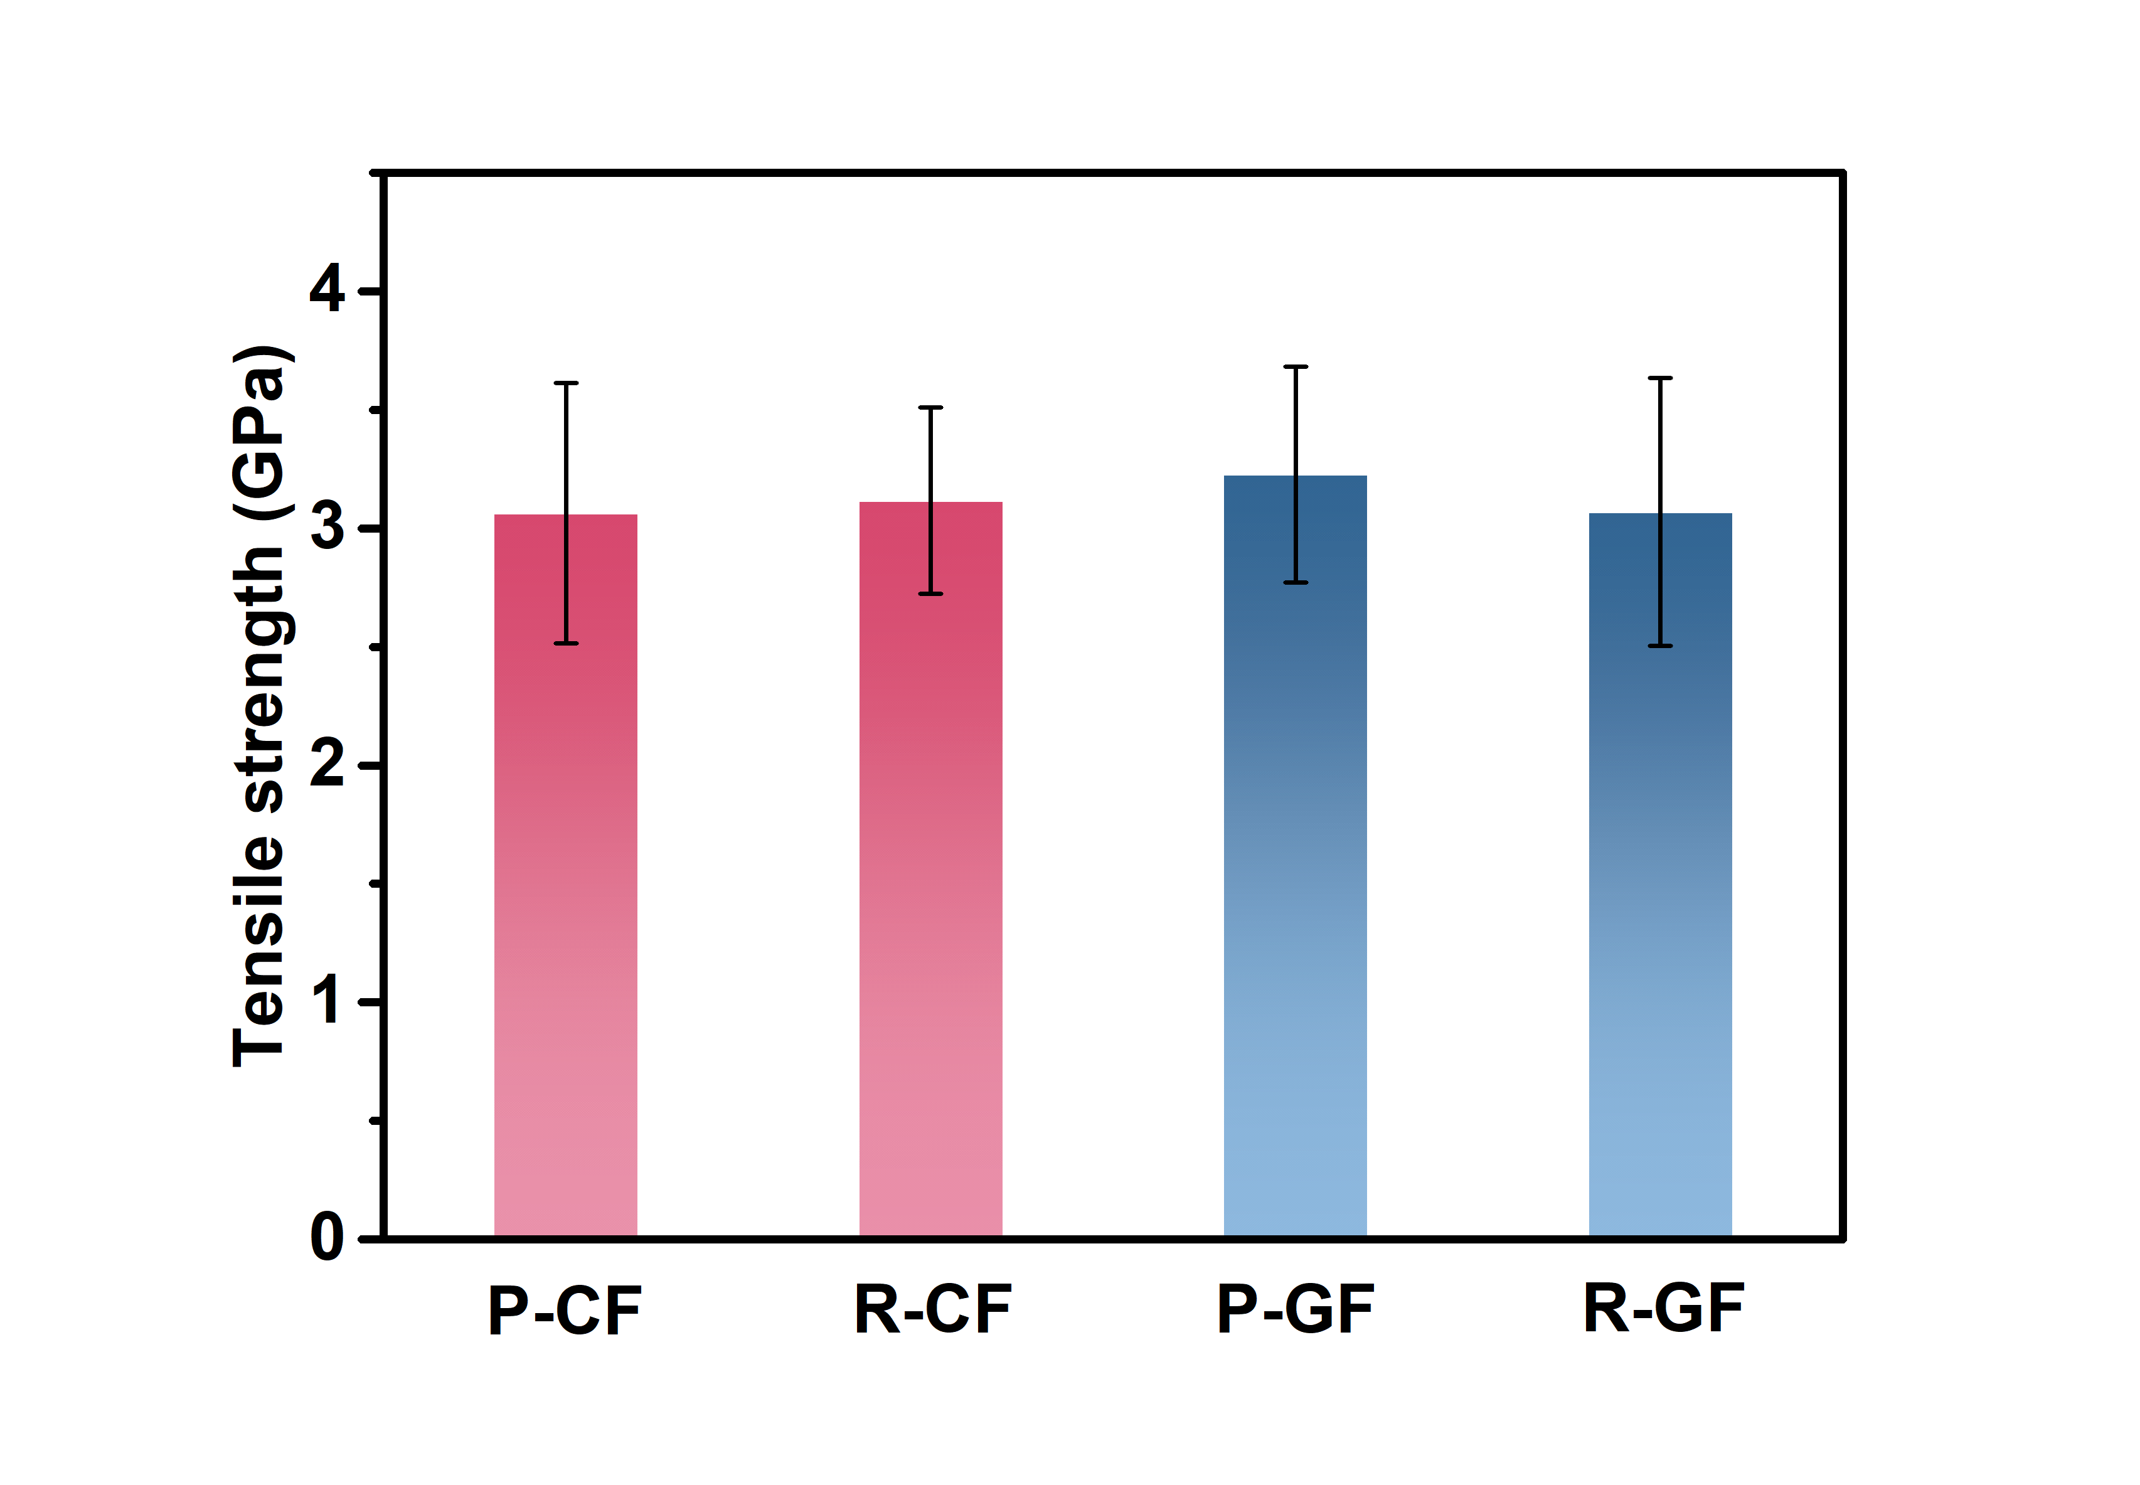

Supplementary Fig. 7.
Monofilament tensile test of the pristine and recycled fibers.

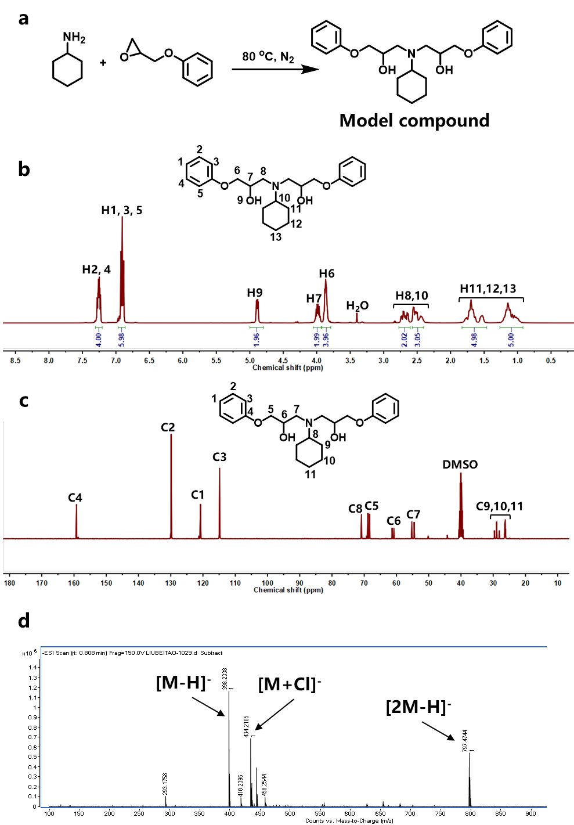

Supplementary Fig. 8.
a, Synthetic pathways for the model compound used to test the Cope elimination mechanism and b, ¹H NMR, c, ¹³C NMR and d, TOF-MS spectra of the model compound.

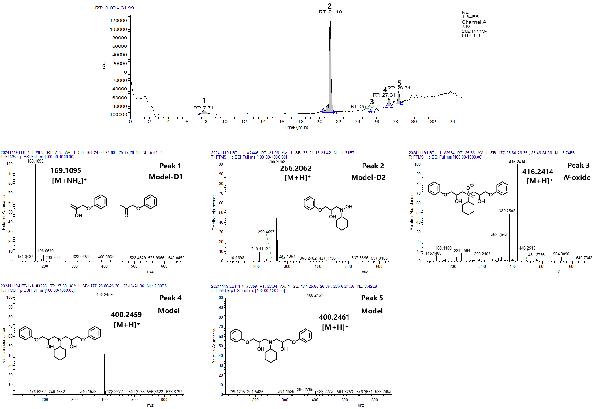

Supplementary Fig. 9.
HRLC-MS analysis of the products obtained from degradation of our model compound after 4 h in DMSO. The top trace is the result from the high-resolution liquid chromatography analysis, the other panels the mass spectra corresponding to the relevant HRLC peaks.

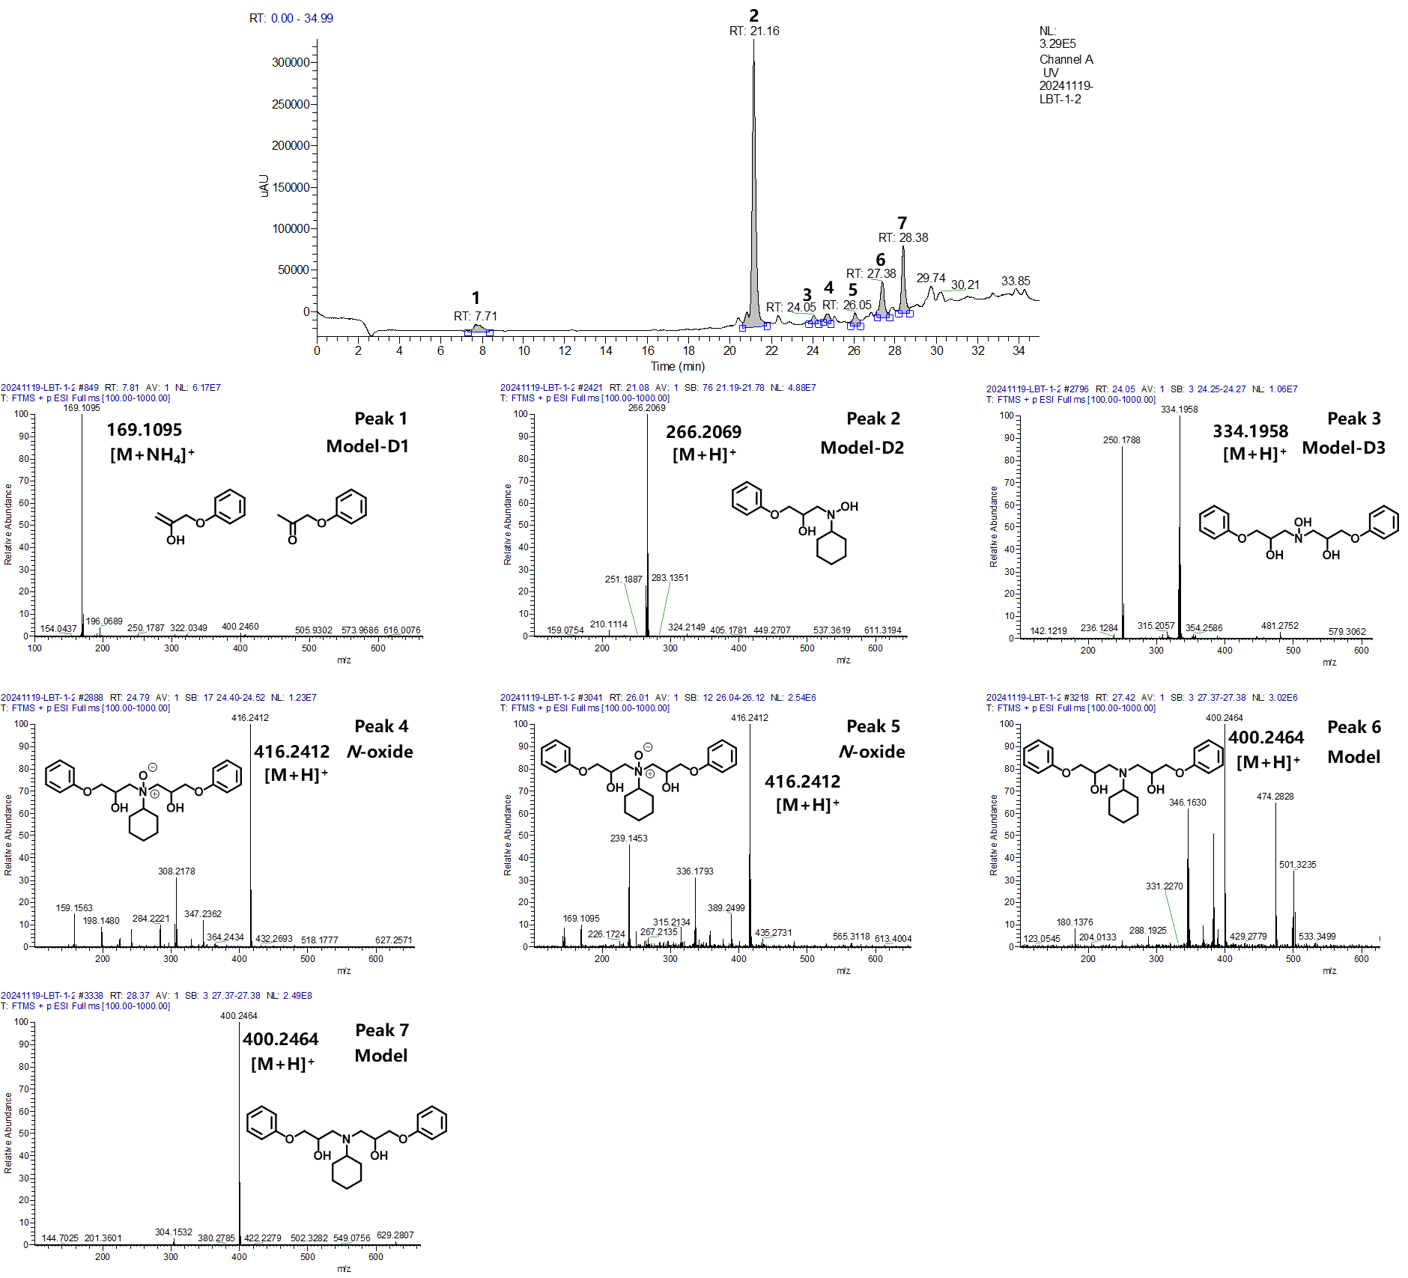

Supplementary Fig. 10.
HRLC-MS analysis of the products obtained from degradation of our model compound after 8 h in DMSO. The top trace is the result from the high-resolution liquid chromatography analysis, the other panels the mass spectra corresponding to the relevant HRLC peaks.

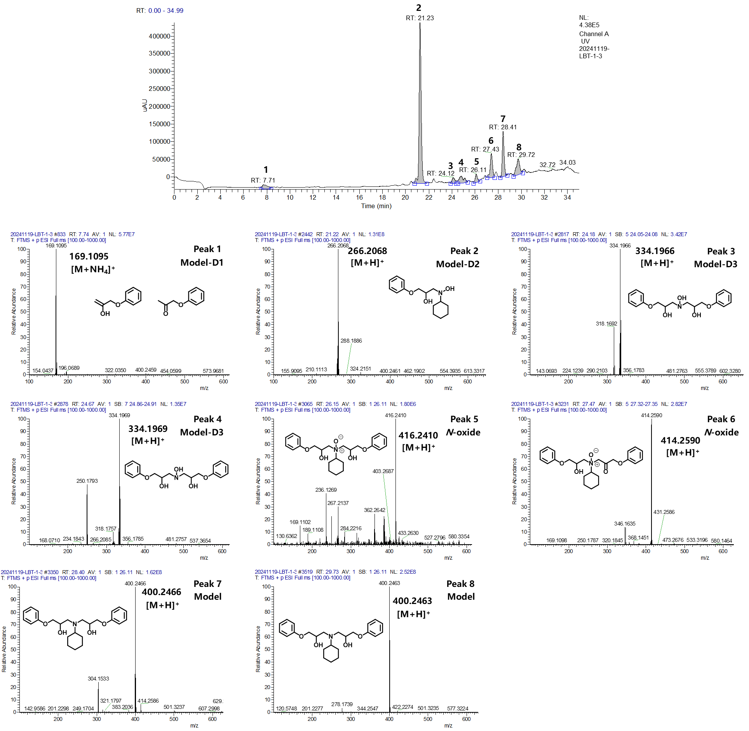

Supplementary Fig. 11.
HRLC-MS analysis of the products obtained from degradation of our model compound after 12 h in DMSO. The top trace is the result from the high-resolution liquid chromatography analysis, the other panels the mass spectra corresponding to the relevant HRLC peaks.

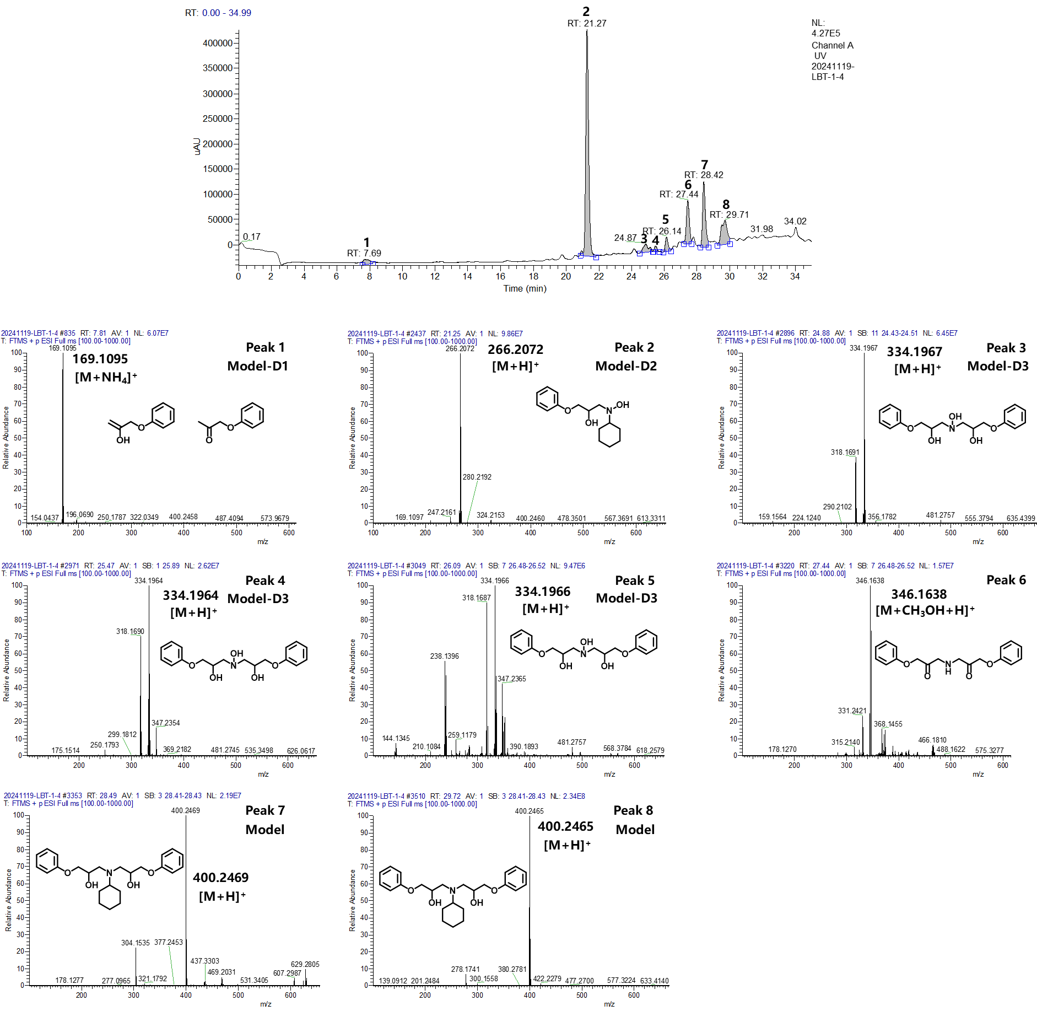

Supplementary Fig. 12.
HRLC-MS analysis of the products obtained from degradation of our model compound after 16 h in DMSO. The top trace is the result from the high-resolution liquid chromatography analysis, the other panels the mass spectra corresponding to the relevant HRLC peaks.

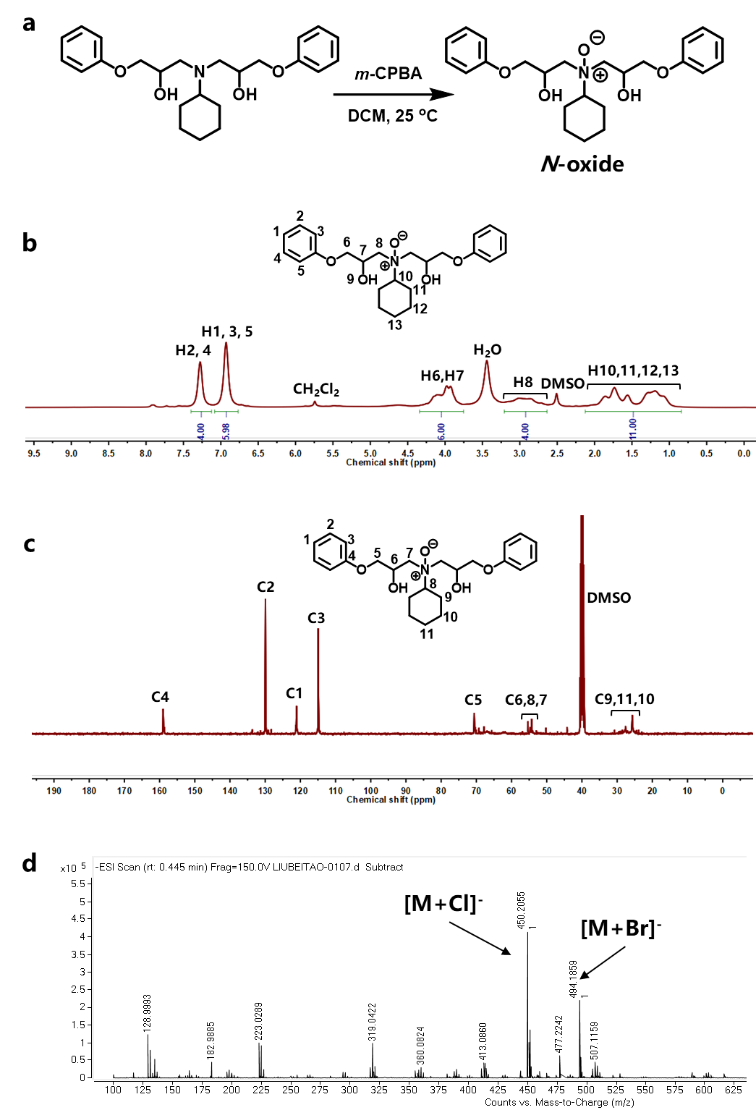

Supplementary Fig. 13.
a, Synthetic pathway and its b, ¹H NMR, c, ¹³C NMR and d, TOF-MS spectra for the N-oxide intermediate.

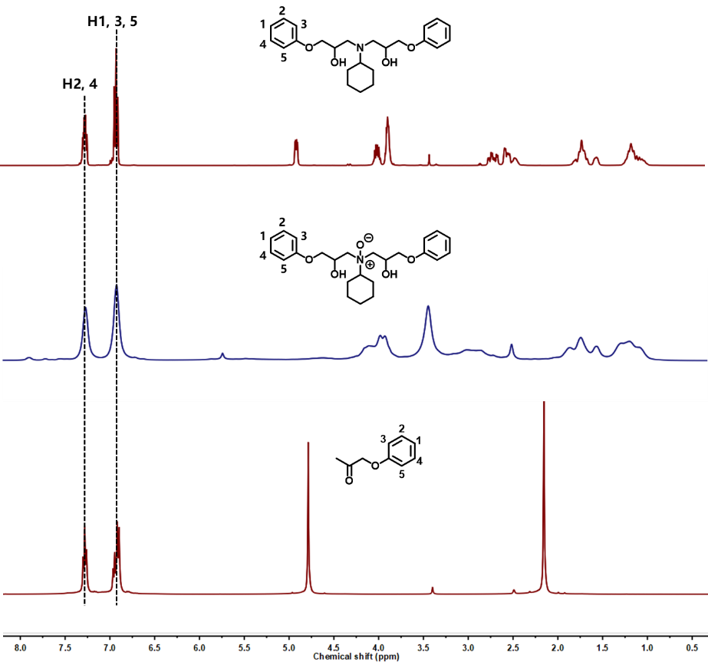

Supplementary Fig. 14.
¹H NMR spectra of the model compound (top), the N-oxide intermediate (middle) and Model-D1 sourced from Macklin biochemical Co., Ltd., Shanghai, China (bottom).

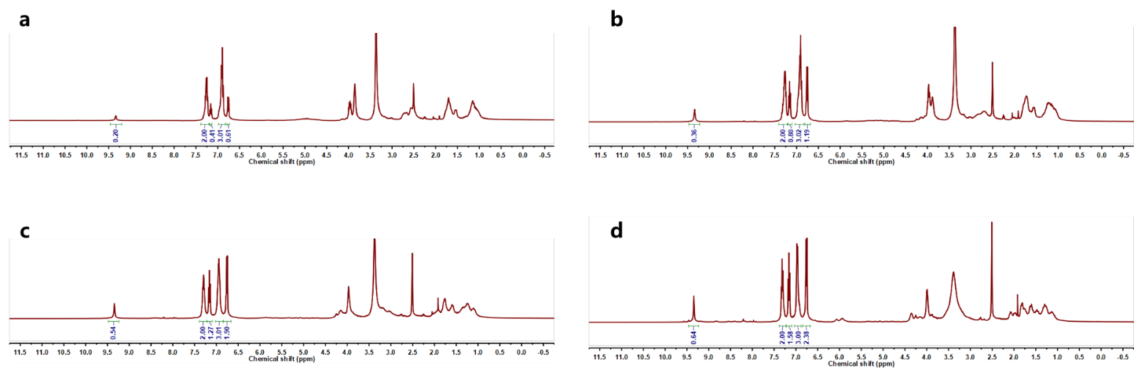

Supplementary Fig. 15.
¹H NMR spectra of the mixture obtained from degradation of the model compound at 160 ºC in DMSO at different reaction times. a, 4 h, b, 8 h, c, 12 h and d, 16 h.

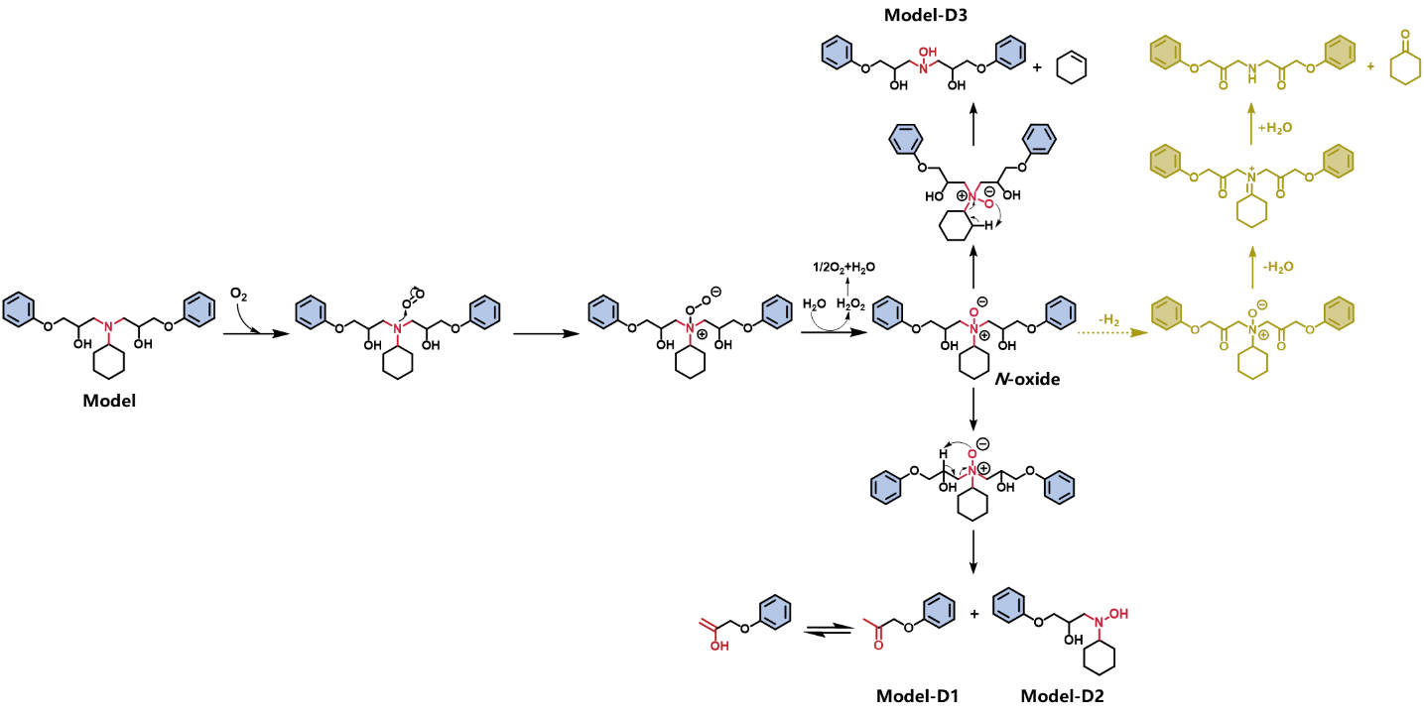

Supplementary Fig. 16.
Proposed degradation mechanism for model compound. The water involved in the third step presumably comes from the trace amount of water present in DMSO.

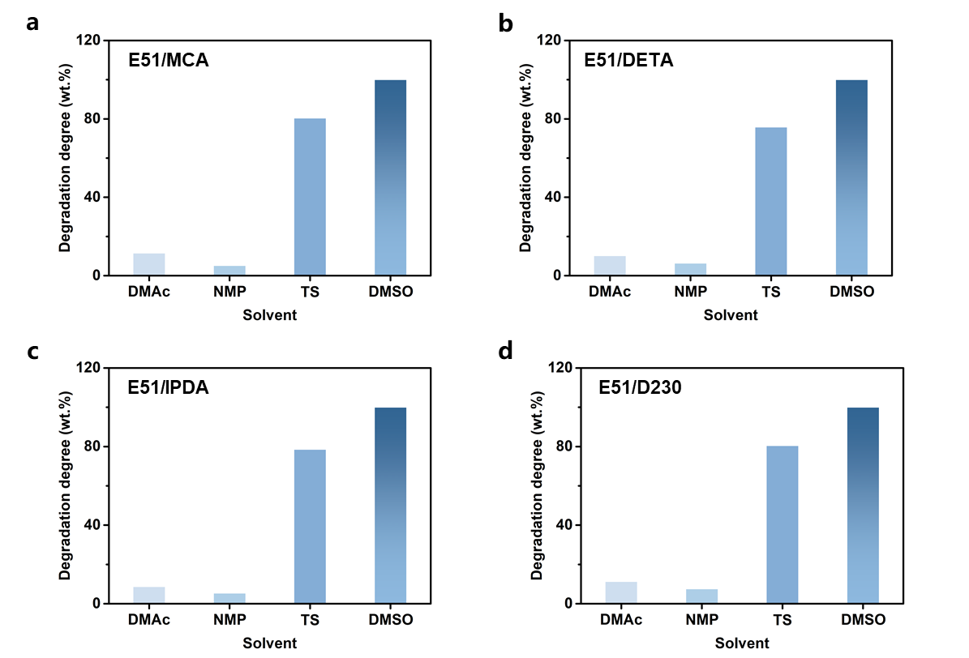

Supplementary Fig. 17.
Effect of solvents on the degradation degree of (a) E51/MCA, (b) E51/DETA, (c) E51/IPDA and (d) E51/D230. Degradation conditions: a, 160 ºC, 20 h, Mass ratio (EP: DMSO)=1: 20, b, 150 ºC, 13 h, Mass ratio (EP: DMSO)=1: 20, c, 160 ºC, 20 h, Mass ratio (EP: DMSO)=1: 20, d, 130 ºC, 12 h, Mass ratio (EP: DMSO)=1: 20.

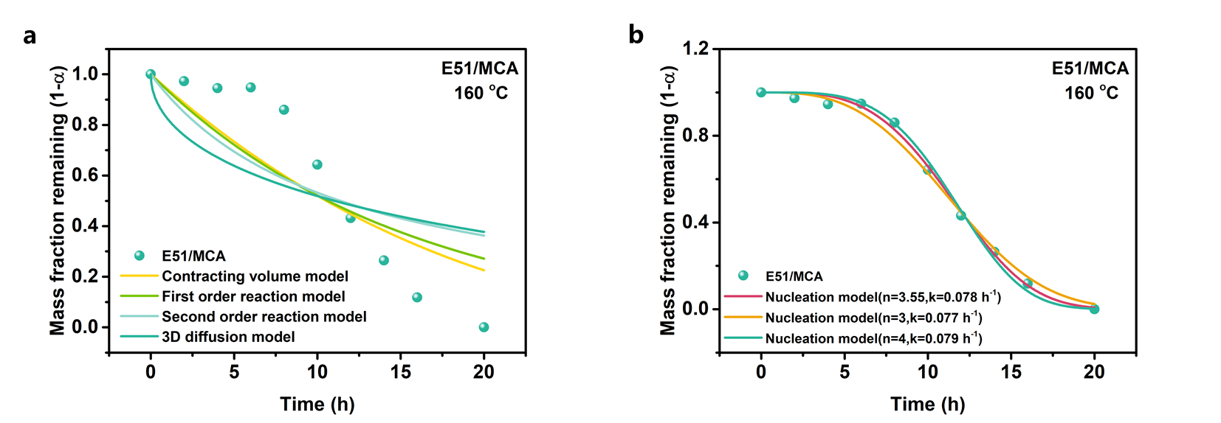

Supplementary Fig. 18.
a, Comparison of fits of the E51/MCA mass loss profile measured experimentally to various solid-state kinetic models (first order, second order, diffusion-based model, the contracting volume model and nucleation model). b, Solid curves show fit of the nucleation model to the data presented in Fig. 4a, with values of n = 3.55, 3 and 4.

Supplementary Table 4.
Rate constant (k) and R² values obtained from fits of the experimental data for the weight loss versus time of E51/MCA in DMSO (Fig. 4a) to various solid-state kinetic models.

Model type | Contracting volume model | First-order reaction model | Second-order reaction model | 3D diffusion model
k (h⁻¹) | 0.01958 | 0.06521 | 0.08791 | 0.00386
R² | 0.7821 | 0.7405 | 0.6364 | 0.5411

Supplementary Table 5.
Rate constant (k) and R² values obtained from fits of the experimental data for the weight loss versus time of E51/MCA in DMSO (Fig. 4a) to the nucleation model.

Fitting parameter | k (h⁻¹) | R²
n=3 | 0.07753 | 0.9922
n=4 | 0.07855 | 0.9946
n=3.55 | 0.07817 | 0.9964

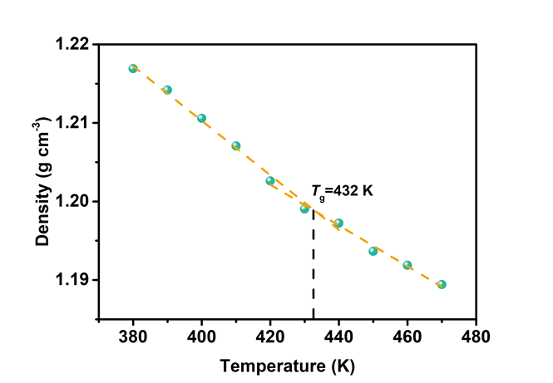

Supplementary Fig. 19.
The curves of the density versus temperature for pure E51/MCA.

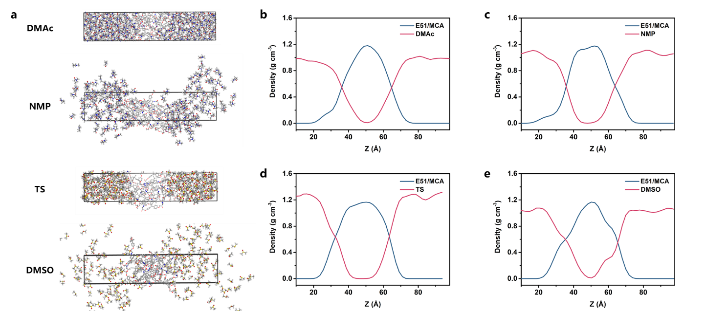

Supplementary Fig. 20.
a, Equilibrium snapshots of the solubilized E51/MCA epoxy resin in different solvents at 160 ºC, as simulated using MD. b, Density profiles of E51/MCA and DMAc along the z axis at 160 ºC. c, Density profiles of E51/MCA and NMP along the z axis at 160 ºC. d, Density profiles of E51/MCA and TS along the z axis at 160 ºC. e, Density profiles of E51/MCA and DMSO along the z axis at 160 ºC.

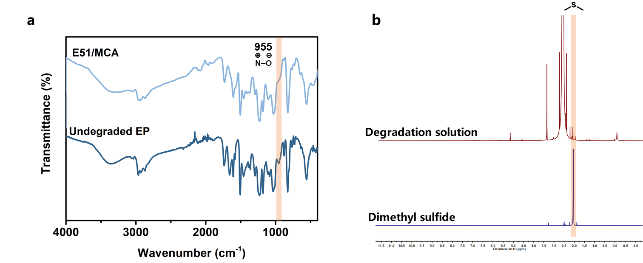

Supplementary Fig. 21.
a, FT-IR spectrum of E51/MCA and the undegraded epoxy resin. b, ¹H NMR spectrum of the degradation solution and pure dimethyl sulfide in DMSO-d₆.

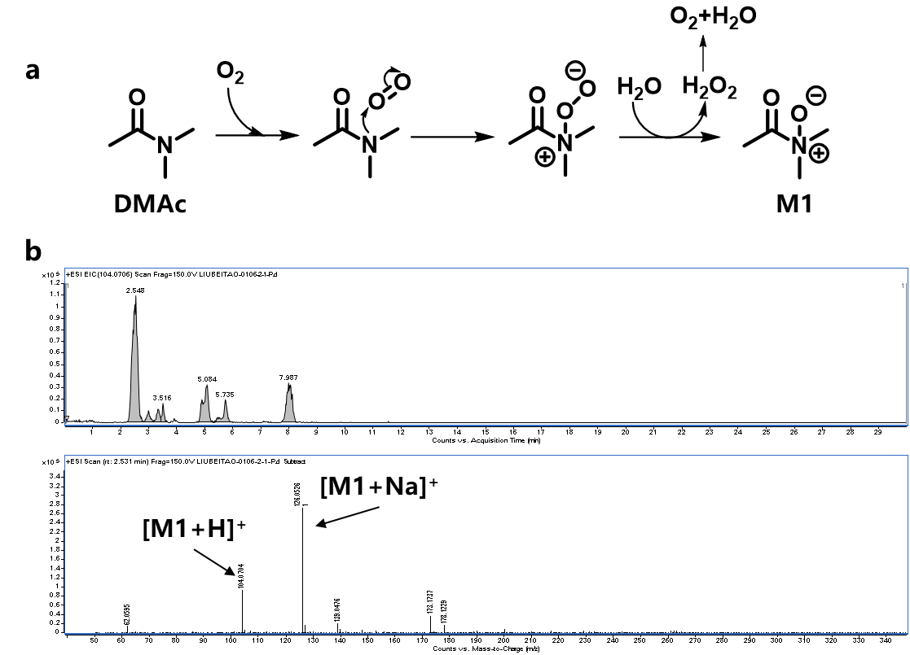

Supplementary Fig. 22.
a, Possible oxidation pathway for DMAc. b, HRLC-MS analysis of the solution collected after degradation of epoxy resin in DMAc at 160 ºC for 20 h.

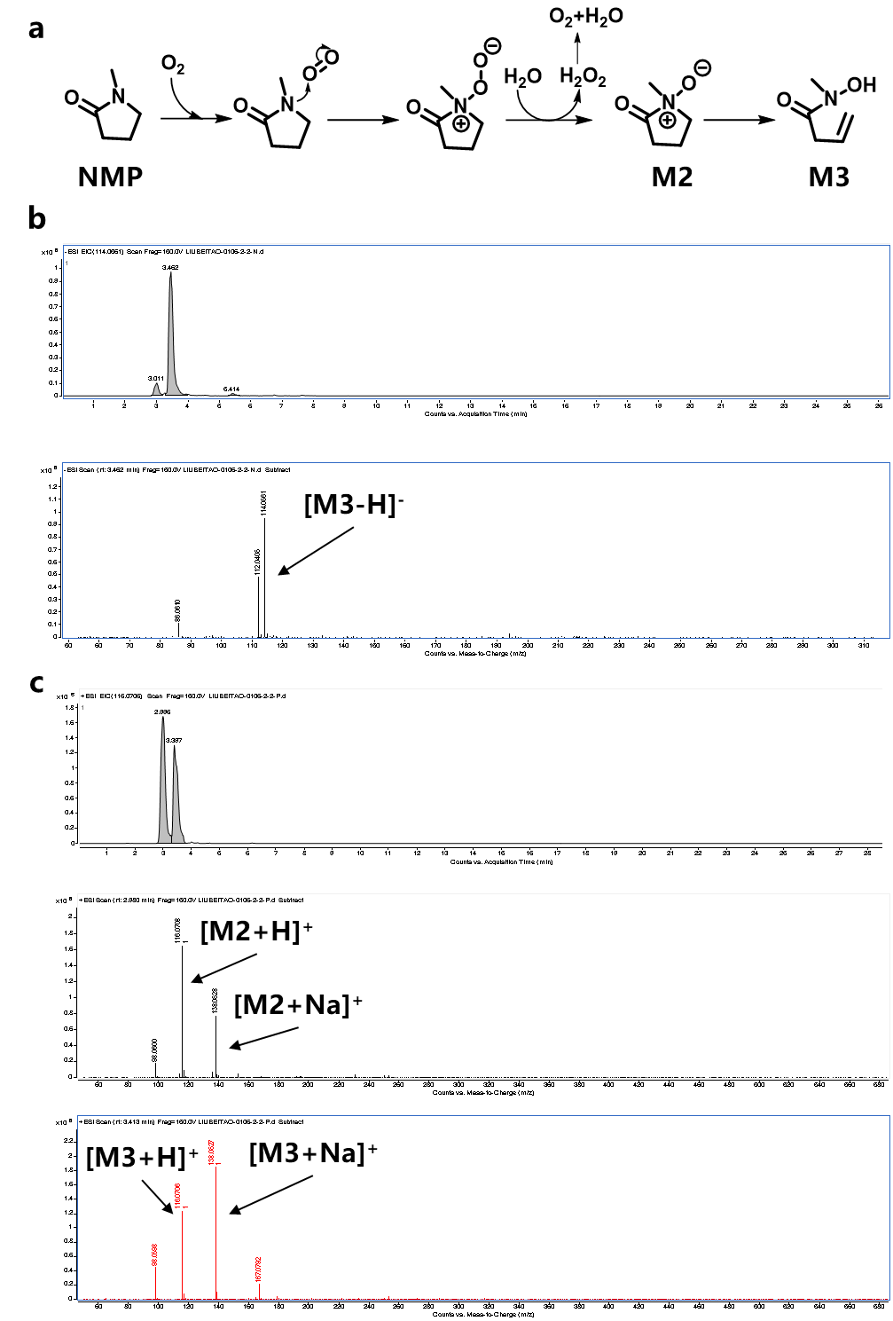

Supplementary Fig. 23.
a, Possible oxidation and degradation pathway for NMP. b, HRLC-MS analysis of the solution collected after degradation of epoxy resin in NMP at 160 ºC for 20 h in negative ionization mode. c, HRLC-MS analysis of the collected solution after degradation of epoxy resin in NMP at 160 ºC for 20 h in positive ionization mode.

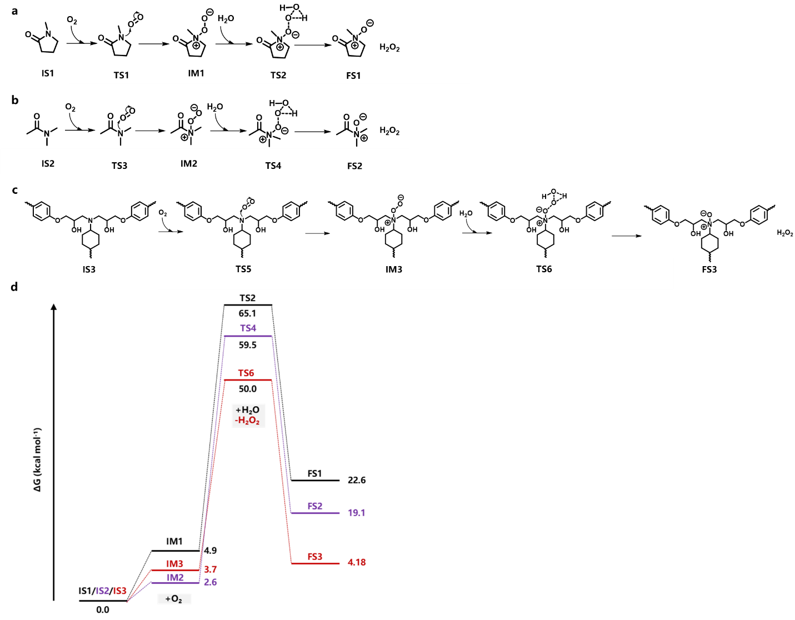

Supplementary Fig. 24.
a, Possible oxidation pathway for NMP. b, Possible oxidation pathway for DMAc. c, Possible oxidation pathway for the structural unit of EP. d, Gibbs free-energy profiles of oxidation reactions for IS1, IS2 and IS3, estimated by using quantum mechanics calculations.

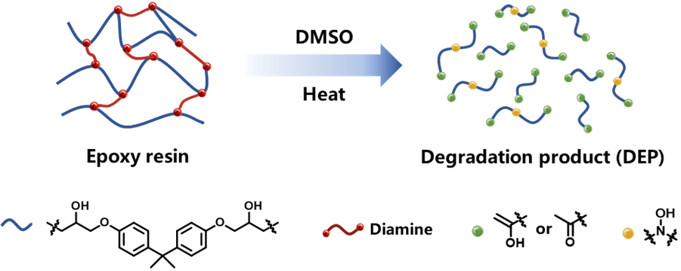

Supplementary Fig. 25.
Schematic diagram of the degradation of epoxy resins via our DMSO-dissolution approach.

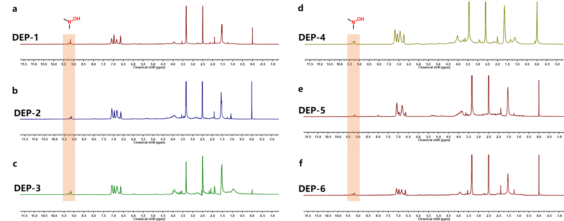

Supplementary Fig. 26.
¹H NMR spectra of a, DEP-1, obtained from E51/MCA, b, DEP-2, obtained from E51/DETA, c, DEP-3, obtained from E51/IPDA, d, DEP-4, obtained from E51/D230, e, DEP-5, obtained from commercial CFRP and f, DEP-6, obtained from commercial GFRP.

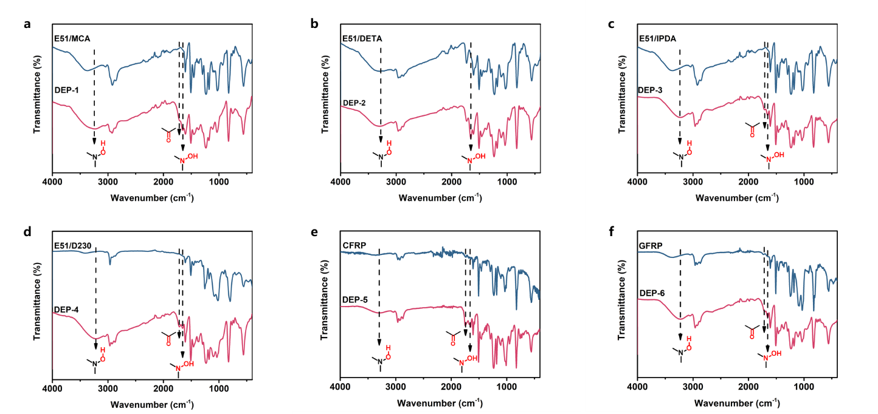

Supplementary Fig. 27.
FT-IR spectra of a, DEP-1, obtained from E51/MCA, b, DEP-2, obtained from E51/DETA, c, DEP-3, obtained from E51/IPDA, d, DEP-4, obtained from E51/D230, e, DEP-5, obtained from commercial CFRP and f, DEP-6, obtained from commercial GFRP.

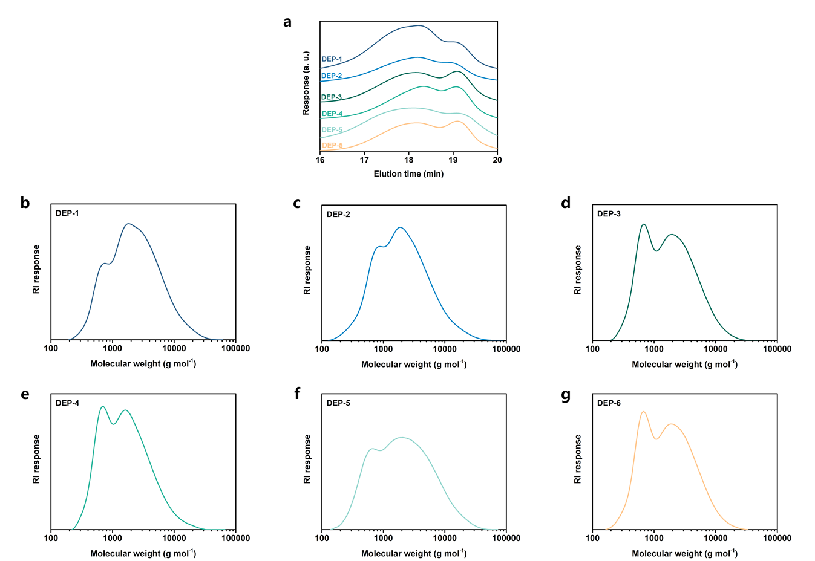

Supplementary Fig. 28.
Gel permeation chromatography (GPC) traces of DEPs obtained from all of our epoxy resins and commercial composites.

Supplementary Table 6.
Number-average molecular weight (M_{n}) and polymer dispersity index (PDI) of the DEPs obtained from epoxy resins and commercial composites.

 | M_{n} (g/mol) | PDI
DEP-1 (from E51/MCA) | 3334 | 2.34
DEP-2 (from E51/DETA) | 3112 | 2.56
DEP-3 (from E51/IPDA) | 2512 | 2.24
DEP-4 (from E51/D230) | 2282 | 2.08
DEP-5 (from commercial CFRP) | 3382 | 2.98
DEP-6 (from commercial GFRP) | 2429 | 2.24

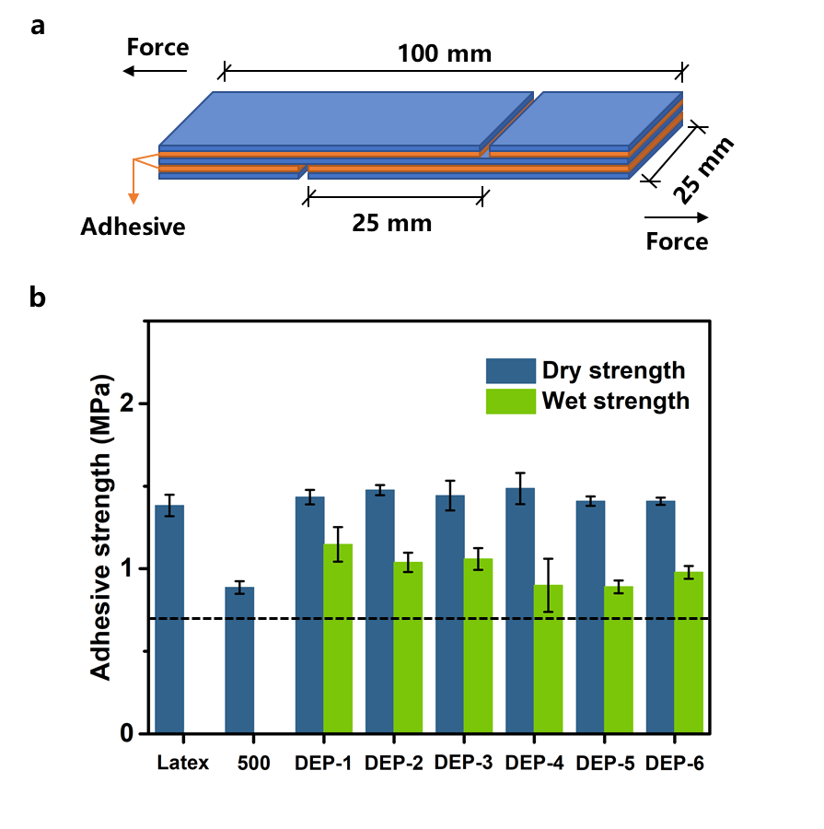

Supplementary Fig. 29.
a, Schematic illustration of the specimens used for the adhesion performance tests. b, Adhesion performance of the adhesives prepared from the DEPs and the two commercial wood adhesives. The dotted line at 0.7 MPa in (b) marks the minimum industrial requirement for the adhesion strength.

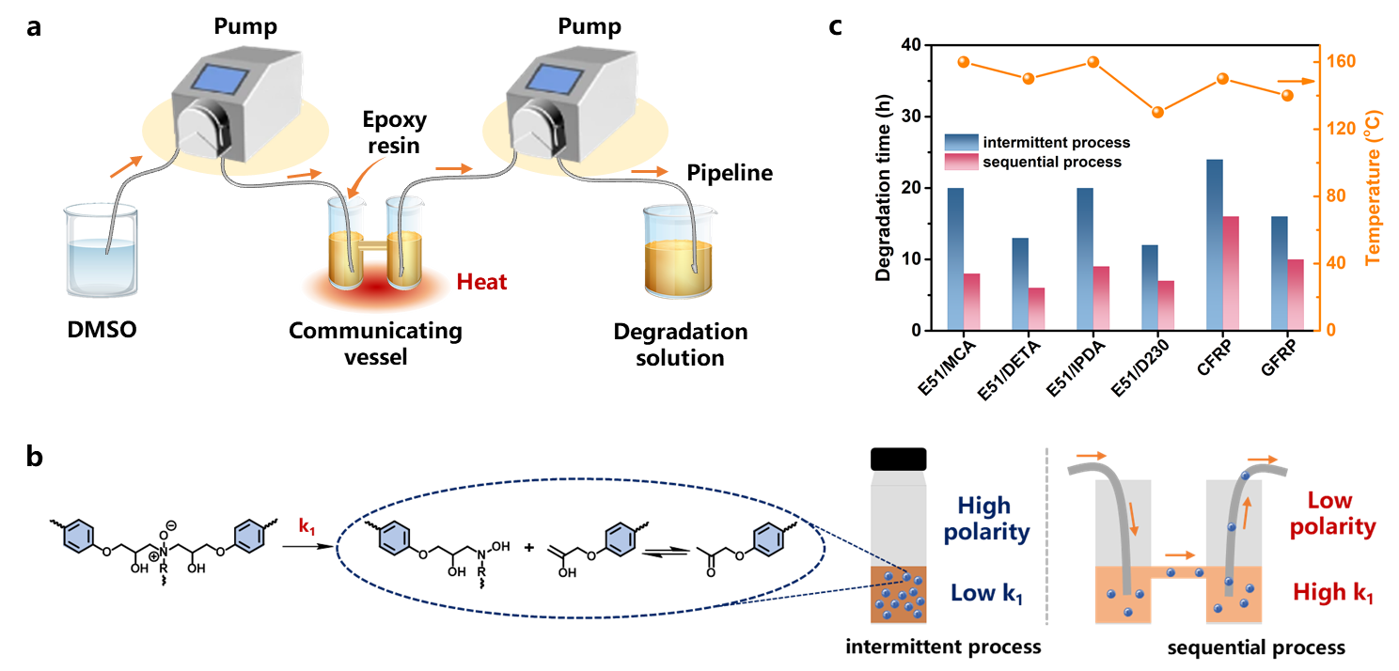

Supplementary Fig. 30.
a, Schematic diagram of our continuous flow reactor. b, Mechanism by which the degradation efficiency is augmented in the sequential process compared to the intermittent process. c, Comparison of degradation times for E51/MCA, E51/DETA, E51/IPDA, E51/D230, CFRP and GFRP through intermittent and sequential processes.

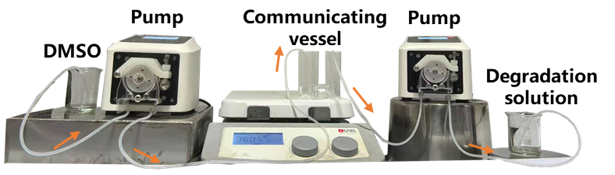

Supplementary Fig. 31.
Photograph of our continuous flow reactor.

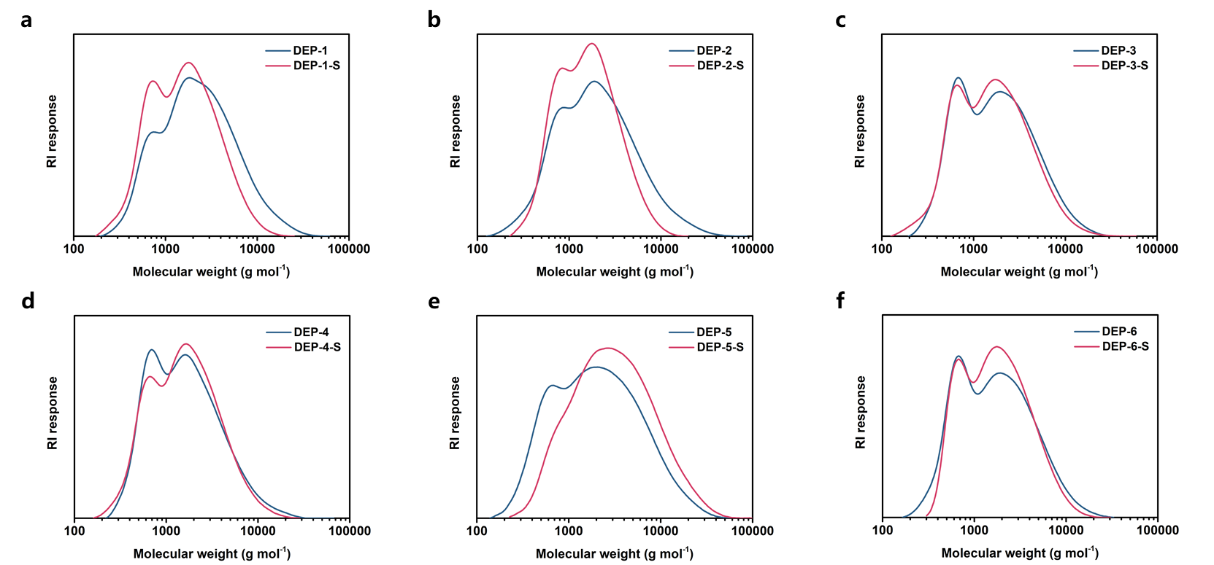

Supplementary Fig. 32.
GPC traces for DEPs obtained by degradation of the epoxy resins and commercial composites through intermittent (DEP-1, DEP-2, DEP-3, DEP-4, DEP-5 and DEP-6) and sequential (DEP-1-S, DEP-2-S, DEP-3-S, DEP-4-S, DEP-5-S and DEP-6-S) processes.

Supplementary Table 7.
Optimized conditions for the degradation of E51/MCA, E51/DETA, E51/IPDA, E51/D230, CFRP and GFRP in DMSO through sequential process, using our flow reactor.

 | Temperature (ºC) | Time h, | Mass ratio (EP: DMSO) | Degradation degree (%) | Recovered mass, % (mg)
E51/MCA | 160 | 8 | 1:20 | 100 | 96 (95.8)
E51/DETA | 150 | 6 | 1:20 | 100 | 95 (94.7)
E51/IPDA | 160 | 9 | 1:20 | 100 | 98 (98.2)
E51/D230 | 130 | 7 | 1:20 | 100 | 98 (98.3)
CFRP | 150 | 16 | 1:20 | 100 | 99（98.9）
GFRP | 140 | 10 | 1:20 | 100 | 99（98.7）

Supplementary Table 8.
Number-average molecular weight (M_{n}) and polymer dispersity index (PDI) of DEPs obtained from degradation of epoxy resins and commercial composites through intermittent (DEP-1, DEP-2, DEP-3, DEP-4, DEP-5 and DEP-6) and sequential (DEP-1-S, DEP-2-S, DEP-3-S, DEP-4-S, DEP-5-S and DEP-6-S) processes.

 | M_{n} (g/mol) | PDI |  | M_{n} (g/mol) | PDI
DEP-1 | 3334 | 2.34 | DEP-1-S | 2107 | 1.93
DEP-2 | 3112 | 2.56 | DEP-2-S | 3369 | 1.70
DEP-3 | 2512 | 2.24 | DEP-3-S | 2263 | 2.20
DEP-4 | 2282 | 2.08 | DEP-4-S | 2143 | 2.00
DEP-5 | 3382 | 2.98 | DEP-5-S | 4751 | 2.62
DEP-6 | 2429 | 2.24 | DEP-6-S | 2275 | 1.87

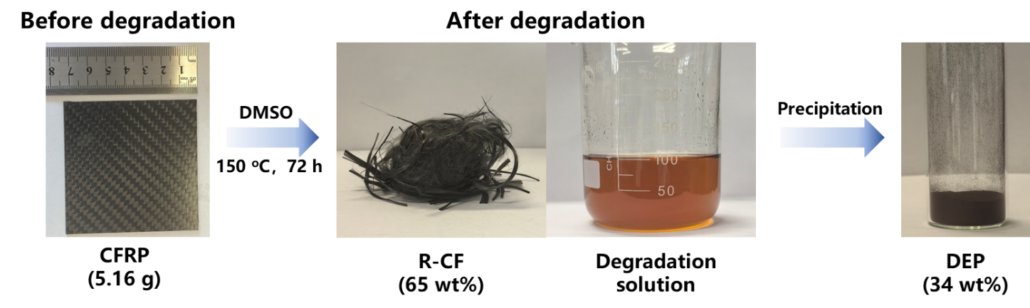

Supplementary Fig. 33.
Upscaling of the recycling of carbon fiber reinforced polymers (CFRP) in DMSO through the sequential process.

Supplementary Table 9.
Materials flow for various scenarios, normalized according to the consumption amounts of GFRP (0.525 tonnes) and CFRP (0.525 tonnes) for the production of 1 tonne of wood adhesive during the DMSO-dissolution process.

Scenario | Oxidative  decomposition  (tonne) | Incineration  (tonne) | This work (tonne)
Nitric acid | 0.4 | 0 | 0
Water | 0.8 | 0 | 0.8
Acetone | 0.04 | 0 | 0
DMSO | 0 | 0 | 0.43
Acid dissolution (GFRP or CFRP) | 1.05 | 0 | 0
Acetone washing (GFRP or CFRP) | 0.75 | 0 | 0
Incineration (GFRP) | 0 | 0.525 | 0
Incineration (CFRP) | 0 | 0.525 | 0
Purification and remolding (GFRP) | 0 | 0.375 | 0
Purification and remolding (CFRP) | 0 | 0 | 0
DMSO dissolution (GFRP or CFRP) | 0 | 0 | 1.05
DMSO washing (GFRP or CFRP) | 0 | 0 | 0.75
Precipitation in water (DEP) | 0 | 0 | 0.3

Supplementary Table 10.
Life cycle inventory.

Impact Category | Energy  consumption (MJ tonne⁻¹) | GHG emission  (kg tonne⁻¹) | Water consumption  (kg tonne⁻¹)
Nitric acid | 10366 | 1961.8 | 4587
Water | 0 | 0 | 1000
Acetone | 65000 | 2548 | 0
DMSO | 7779 | 1480.9 | 25.8
Acid dissolution (GFRP or CFRP) | 21.6 | 2.81 | 0
Acetone washing (GFRP or CFRP) | 2.88 | 0.374 | 0
Incineration (GFRP) | 0 | 1120 | 0
Incineration (CFRP) | 0 | 3390 | 0
Purification and remolding (GFRP) | 85000 | 4654.4 | 12.19
Purification and remolding (CFRP) | 85000 | 4654.4 | 12.19
DMSO dissolution (GFRP or CFRP) | 51.8 | 6.73 | 0
DMSO washing (GFRP or CFRP) | 2.88 | 0.374 | 0
Precipitation in water (DEP) | 2.88 | 0.374 | 0

Supplementary Table 11.
Cumulative energy demand for various scenarios, normalized according to the consumption amounts of GFRP (0.525 tonnes) and CFRP (0.525 tonnes) for the production of 1 tonne of wood adhesive during the DMSO-dissolution process.

Scenario | Oxidative  decomposition  (MJ) | Incineration  (MJ) | This work (MJ)
Nitric acid | 4146.4 | 0 | 0
Water | 0 | 0 | 0
Acetone | 2600 | 0 | 0
DMSO | 0 | 0 | 3344.9
SUM of Materials | 6746.4 | 0 | 3344.9
Acid dissolution (GFRP or CFRP) | 22.68 | 0 | 0
Acetone washing (GFRP or CFRP) | 2.16 | 0 | 0
Incineration (GFRP) | 0 | 0 | 0
Incineration (CFRP) | 0 | 0 | 0
Purification and remolding (GFRP) | 0 | 31875 | 0
Purification and remolding (CFRP) | 0 | 0 | 0
DMSO dissolution (GFRP or CFRP) | 0 | 0 | 54.4
DMSO washing (GFRP or CFRP) | 0 | 0 | 2.16
Precipitation in water (DEP) | 0 | 0 | 0.864
SUM of Process | 24.84 | 31875 | 57.42
SUM | 6771.24 (21.2%) | 31875 (100%) | 3402.32 (10.7%)

Supplementary Table 12.
Cumulative GHG emissions for various scenarios, normalized according to the consumption amounts of GFRP (0.525 tonnes) and CFRP (0.525 tonnes) for the production of 1 tonne of wood adhesive during the DMSO-dissolution process.
Scenario | Oxidative  decomposition  (kg) | Incineration  (kg) | This work (kg)
Nitric acid | 784.7 | 0 | 0
Water | 0 | 0 | 0
Acetone | 101.9 | 0 | 0
DMSO | 0 | 0 | 636.8
SUM of Materials | 886.6 | 0 | 636.8
Acid dissolution (GFRP or CFRP) | 2.95 | 0 | 0
Acetone washing (GFRP or CFRP) | 0.28 | 0 | 0
Incineration (GFRP) | 0 | 588 | 0
Incineration (CFRP) | 0 | 1780 | 0
Purification and remolding (GFRP) | 0 | 1745.4 | 0
Purification and remolding (CFRP) | 0 | 0 | 0
DMSO dissolution (GFRP or CFRP) | 0 | 0 | 7.08
DMSO washing (GFRP or CFRP) | 0 | 0 | 0.28
Precipitation in water (DEP) | 0 | 0 | 0.11
SUM of Process | 3.23 | 4113.4 | 7.47
SUM | 889.83 (21.6%) | 4113.4 (100%) | 644.27 (15.7%)

Supplementary Table 13.
Cumulative water use (CWU) for various scenarios, normalized according to the consumption amounts of GFRP (0.525 tonnes) and CFRP (0.525 tonnes) for the production of 1 tonne of wood adhesive during the DMSO-dissolution process.

Scenario | Oxidative  decomposition  (kg) | Incineration  (kg) | This work (kg)
Nitric acid | 1834.8 | 0 | 0
Water | 800 | 0 | 800
Acetone | 0 | 0 | 0
DMSO | 0 | 0 | 11.1
SUM of Materials | 2634.8 | 0 | 811.1
Acid dissolution (GFRP or CFRP) | 0 | 0 | 0
Acetone washing (GFRP or CFRP) | 0 | 0 | 0
Incineration (GFRP) | 0 | 0 | 0
Incineration (CFRP) | 0 | 0 | 0
Purification and remolding (GFRP) | 0 | 4.57 | 0
Purification and remolding (CFRP) | 0 | 0 | 0
DMSO dissolution (GFRP or CFRP) | 0 | 0 | 0
DMSO washing (GFRP or CFRP) | 0 | 0 | 0
Precipitation in water (DEP) | 0 | 0 | 0
SUM of Process | 0 | 4.57 | 0
SUM | 2634.8  (100%) | 4.57  (0.2%) | 811.1 (30.8%)

Supplementary Table 14.
Materials and energy cost inventory.

Impact Category | Materials cost ($ tonne⁻¹) | Energy cost ($ tonne⁻¹)
Nitric acid | 30000 | 0
Water | 0.5 | 0
Acetone | 1000 | 0
DMSO | 1500 | 0
Acid dissolution (GFRP or CFRP) | 0 | 0.47
Acetone washing (GFRP or CFRP) | 0 | 0.063
Incineration (GFRP) | 0 | 0
Incineration (CFRP) | 0 | 0
Purification and remolding (GFRP) | 0 | 1862.9
Purification and remolding (CFRP) | 0 | 1862.9
DMSO dissolution (GFRP or CFRP) | 0 | 1.14
DMSO washing (GFRP or CFRP) | 0 | 0.063
Precipitation in water (DEP) | 0 | 0.063
Wood glue | -1500 | 0

Supplementary Table 15.
Cost evaluation of various scenarios, normalized according to the consumption amounts of GFRP (0.525 tonnes) and CFRP (0.525 tonnes) for the production of 1 tonne of wood adhesive during the DMSO-dissolution process.

Scenarios | Oxidative  decomposition  ($) | Incineration  ($) | This work ($)
Nitric acid | 12000 | 0 | 0
Water | 0.4 | 0 | 0.4
Acetone | 40 | 0 | 0
DMSO | 0 | 0 | 645
Wood glue | 0 | 0 | -1500
SUM of Materials | 12040.4 | 0 | -854.6
Acid dissolution (GFRP or CFRP) | 0.5 | 0 | 0
Acetone washing (GFRP or CFRP) | 0.047 | 0 | 0
Incineration (GFRP) | 0 | 0 | 0
Incineration (CFRP) | 0 | 0 | 0
Purification and remolding (GFRP) | 0 | 698.6 | 0
Purification and remolding (CFRP) | 0 | 0 | 0
DMSO dissolution (GFRP or CFRP) | 0 | 0 | 1.2
DMSO washing (GFRP or CFRP) | 0 | 0 | 0.047
Precipitation in water (DEP) | 0 | 0 | 0.02
SUM of Process | 0.547 | 698.6 | 1.267
SUM | 12041  (100%) | 698.6 (5.8%) | -853.3  (-7.1%)

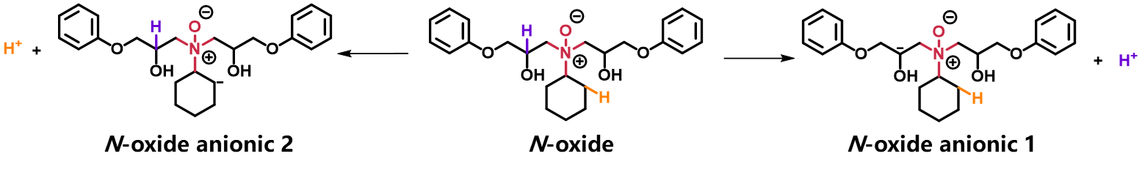

Supplementary Fig. 34.
Hydrogen dissociation pathways of the N-oxide intermediate.

Supplementary Table 16.
Electronic energy and thermal correction to the enthalpy of N-oxide, N-oxide anionic 1, N-oxide anionic 2 and H⁺.

 | Electronic energy (Hartree) | Thermal correction to enthalpy (Hartree)
N-oxide | -1365.504986 | 0.572852
N-oxide anionic 1 | -1364.953110 | 0.553666
N-oxide anionic 2 | -1364.865607 | 0.555152
H⁺ | 0 | 0.002360

Supplementary Table 17.
G, H and E for the structures reported in Supplementary Fig. 24.
 | G (Hartree) | E (Hartree) | H (Hartree)
O₂ | -150.281 | -150.266 | -150.259
H₂O | -76.4191 | -76.422 | -76.397
H₂O₂ | -151.543 | -151.546 | -151.516
IS1 | -325.85 | -325.958 | -325.811
IM1 | -476.123 | -476.233 | -476.077
TS2 | -552.447 | -552.576 | -552.398
FS1 | -400.972 | -401.083 | -400.932
IS2 | -287.740 | -287.840 | -287.703
IM2 | -438.018 | -438.118 | -437.970
TS4 | -514.346 | -514.467 | -514.297
FS2 | -362.868 | -362.970 | -362.826
IS3 | -1407.47 | -1408.02 | -1407.37
IM3 | -1557.75 | -1558.31 | -1557.64
TS6 | -1634.1 | -1634.67 | -1633.98
FS3 | -1482.63 | -1483.18 | -1482.52

Supplementary Table 18.
Gibbs free energy for the oxidation pathways of NMP in Supplementary Fig. 24a.

 | ∆G (Hartree)
IS1+ O₂ | 0
IM1 | 0.007649
TS2 | 0.10294
FS1+ H₂O₂ | 0.035666

Supplementary Table 19.
Gibbs free energy for the oxidation pathways of DMAc in Supplementary Fig. 24b.

 | ∆G (Hartree)
IS2+ O₂ | 0
IM2 | 0.004047
TS4 | 0.094255
FS2+ H₂O₂ | 0.030028

Supplementary Table 20.
Gibbs free energy for the oxidation pathways of the structural unit of EP in Supplementary Fig. 24c.

 | ∆G (Hartree)
IS3+ O₂ | 0
IM3 | 0.005817
TS6 | 0.079027
FS3+ H₂O₂ | 0.006789

Supplementary Fig. 35.
A scan coordinate calculation done for O₂ approaching NMP, and the total energy continued to decrease, indicating that the process is spontaneous and there is no transition state TS1.

Supplementary Fig. 36.
A scan coordinate calculation done for O₂ approaching DMAc, and the total energy continued to decrease, indicating that the process is spontaneous and there is no transition state TS3.

Supplementary Fig. 37.
A scan coordinate calculation done for O₂ approaching structural unit of EP, and the total energy continued to decrease, indicating that the process is spontaneous and there is no transition state TS5.

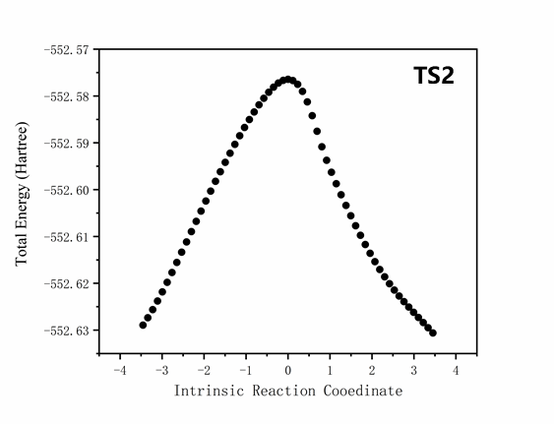
Supplementary Fig. 38.
Intrinsic reaction coordinate (IRC) calculation for TS2.

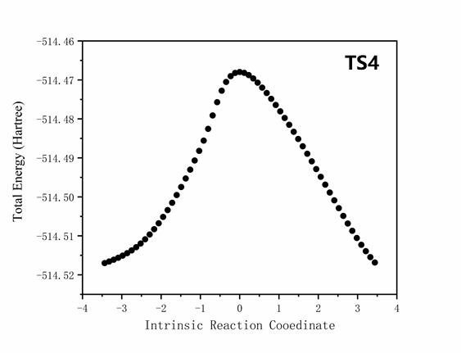
Supplementary Fig. 39.
Intrinsic reaction coordinate (IRC) calculation for TS4.

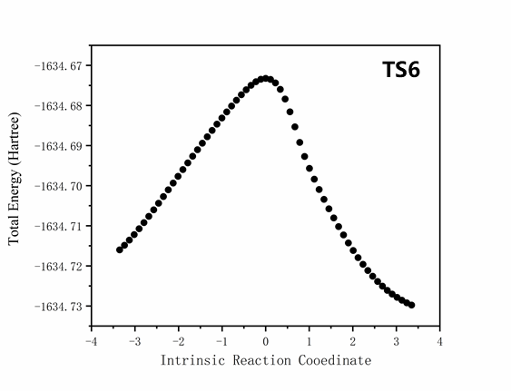
Supplementary Fig. 40.
Intrinsic reaction coordinate (IRC) calculation for TS6.

References
- Graetz, J. & Reilly, J. J. Decomposition kinetics of the AlH₃ polymorphs. J. Phys. Chem. B 109, 22181-22185 (2005).
- Wu, C. et al. Effects of SWNT and metallic catalyst on hydrogen absorption/desorption performance of MgH₂. J. Phys. Chem. B 109, 22217-22221 (2005).
- Hromadova´, M. N., Sokolova´, R., Pospı´Sˇil, L. R. & Fanelli, N. Surface interactions of s-Triazine-type pesticides. An electrochemical impedance study. J. Phys. Chem. B 110, 4869-4874 (2006).
- Peterson, V. K, Neumann, D. A. & Livingston, R. A. Hydration of tricalcium and dicalcium silicate mixtures studied using quasielastic neutron scattering. J. Phys. Chem. B 109, 14449-14453 (2005).
- Khawam, A. & Flanagan, D. R. Complementary use of model-free and modelistic methods in the analysis of solid-state kinetics. J. Phys. Chem. B 109, 10073-10080 (2005).
- Avrami, M. Kinetics of phase change. I general theory. J. Chem. Phys. 7, 1103-1112 (1939).
- Jabłoński, M. & Przepiera, A. Kinetic model for the reaction of ilmenite with sulphuric acid. J. Therm. Anal. Calorim. 65, 583-590 (2001).
- Khawam, A. & Flanagan, D. R. Solid-state kinetic models: basics and mathematical fundamentals. J. Phys. Chem. B 110, 17315-17328 (2006).
- Khawam, A. & Flanagan, D. R. Basics and applications of solid-state kinetics: a pharmaceutical perspective. J. Pharm. Sci. 95, 472-498 (2006).
- Bourg, I. C. & Steefel, C. I. Molecular dynamics simulations of water structure and diffusion in silica nanopores. J. Phys. Chem. C 116, 11556−11564 (2012).
- ISO, 2006. Life cycle assessment-requirements and guidelines (ISO 14044:2006).
- Liu, Y., Meng, L., Huang, Y. & Liu, L. Method of recovering the fibrous fraction of glass/epoxy composites. J. Reinf. Plast. Compos. 25, 1525-1533 (2006).
- Dong, P. A. V., Azzaro-Pantel, C. & Cadene, A.-L. Economic and environmental assessment of recovery and disposal pathways for CFRP waste management. Resour. Conserv. Recycl. 133, 63-75 (2018).

