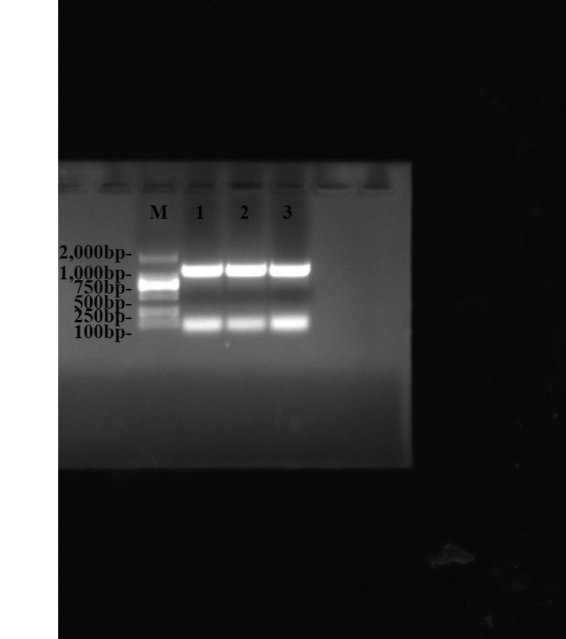
Fig 1A Cloning of CDS region of rabbit KLF12 gene. M: DL2000 DNA Marker, 1-3: PCR product of CDS region of KLF12 gene.

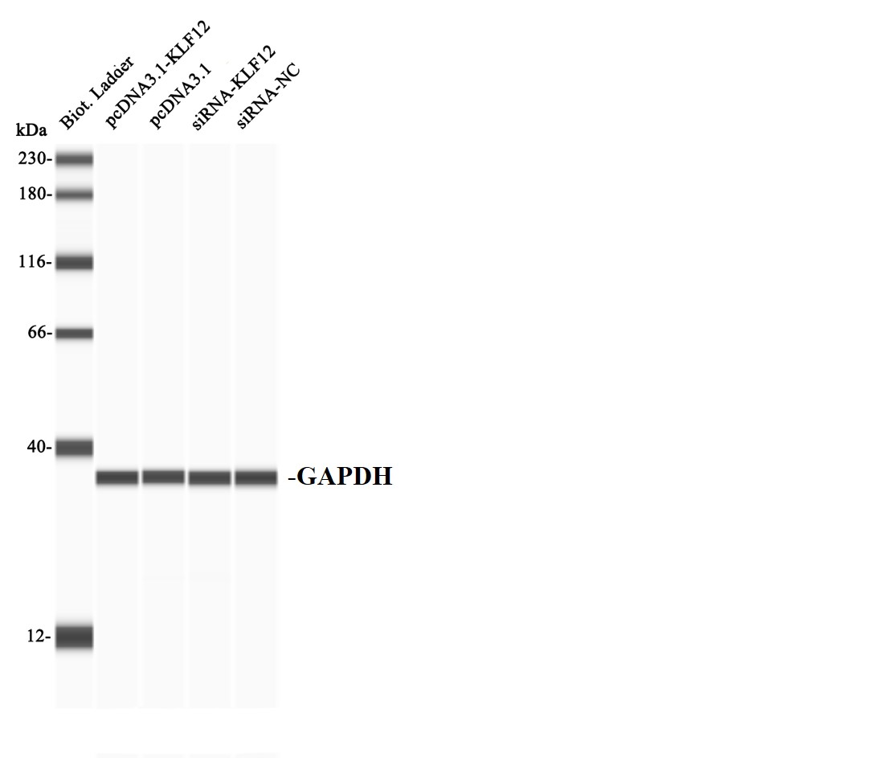
Fig 1D The protein expression of GAPDH.

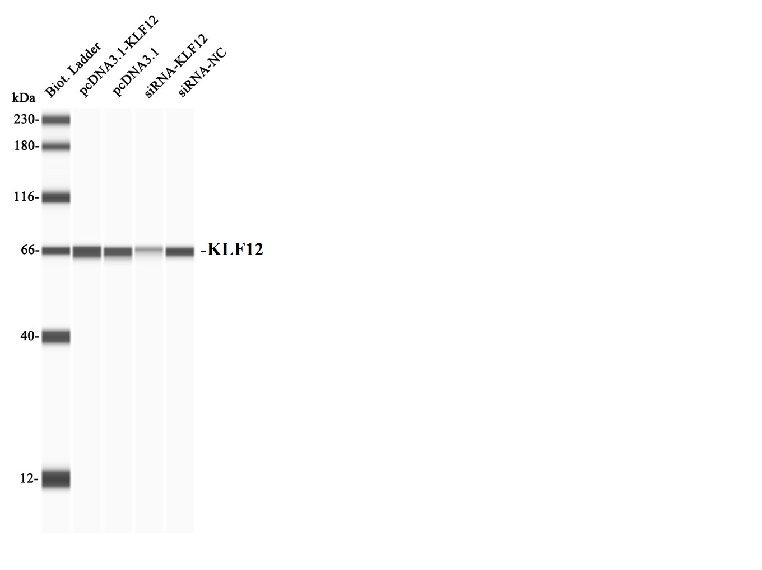
Fig 1D The protein expression of KLF12.

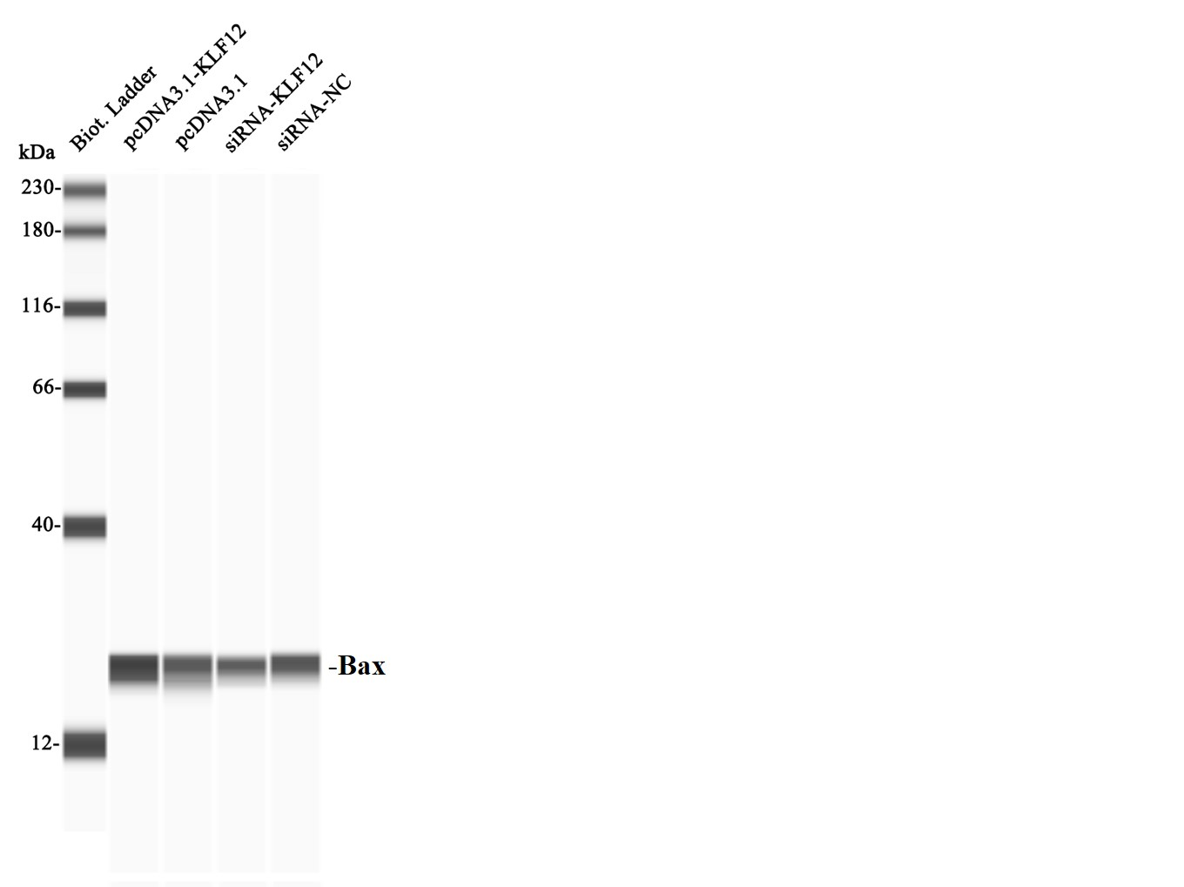
Fig 4B The protein expression of Bax.
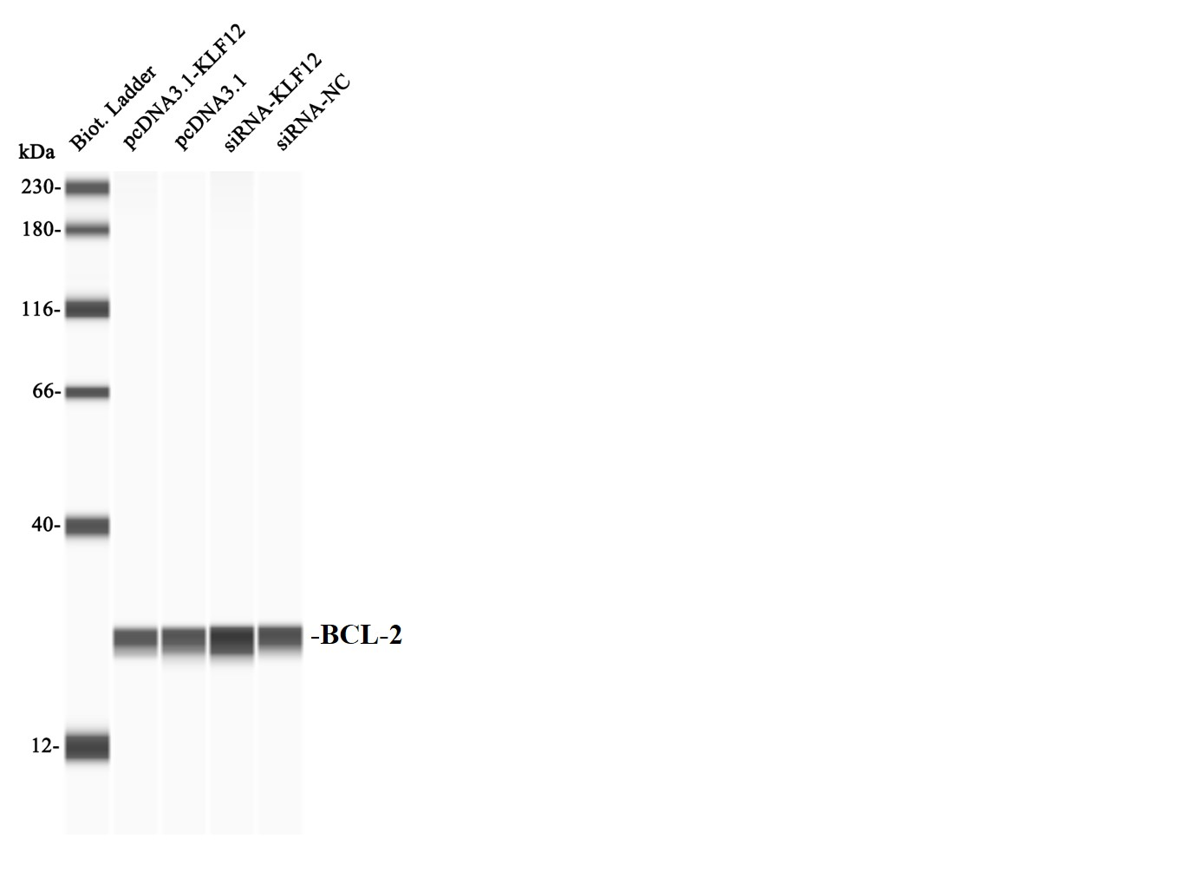
Fig 4B The protein expression of BCL-2.

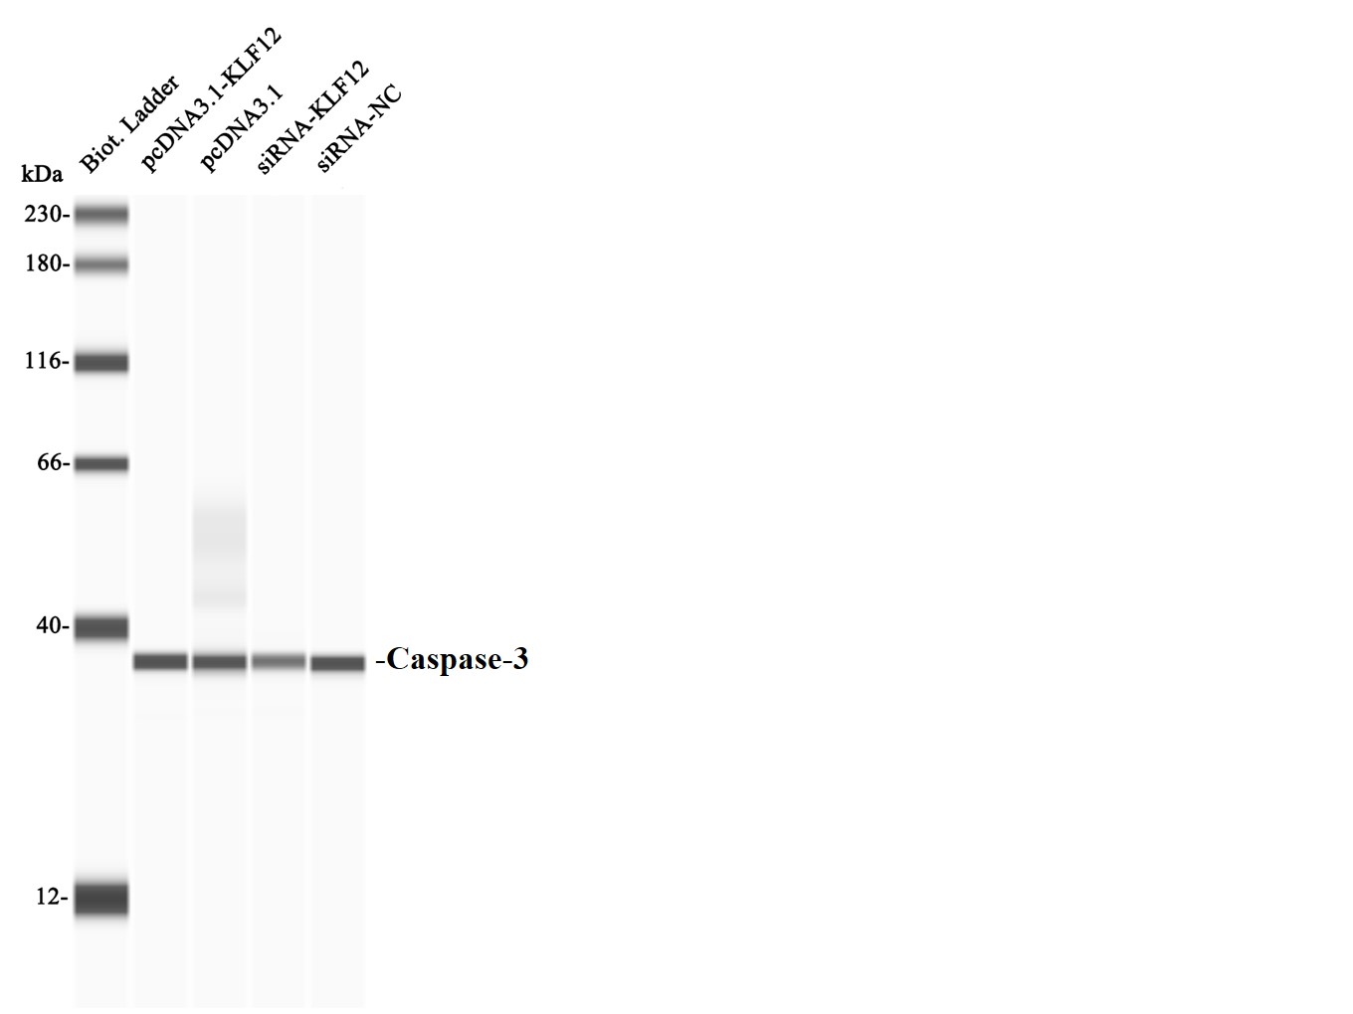
Fig 4B The protein expression of Caspase-3.
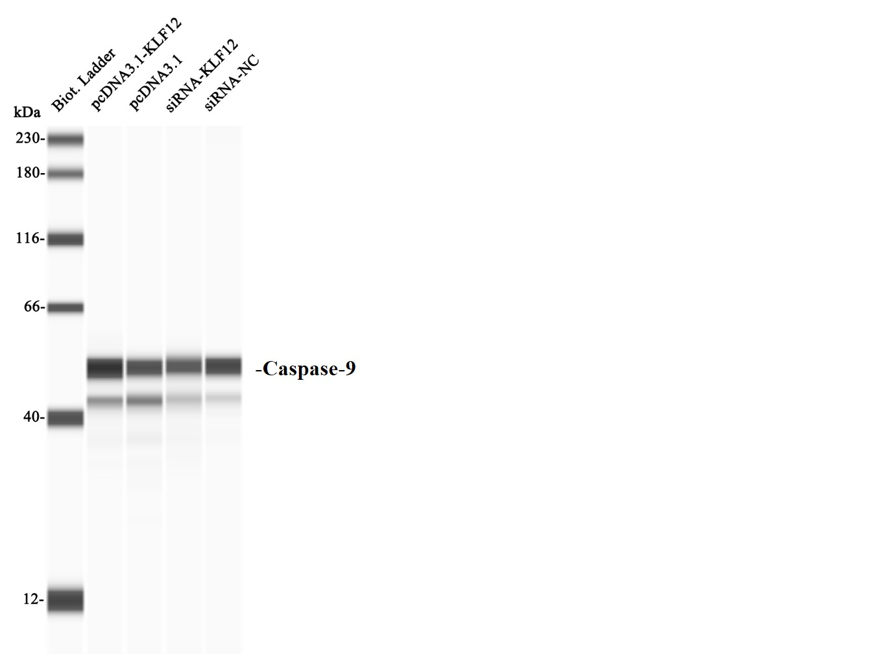
Fig 4B The protein expression of Caspase-9.

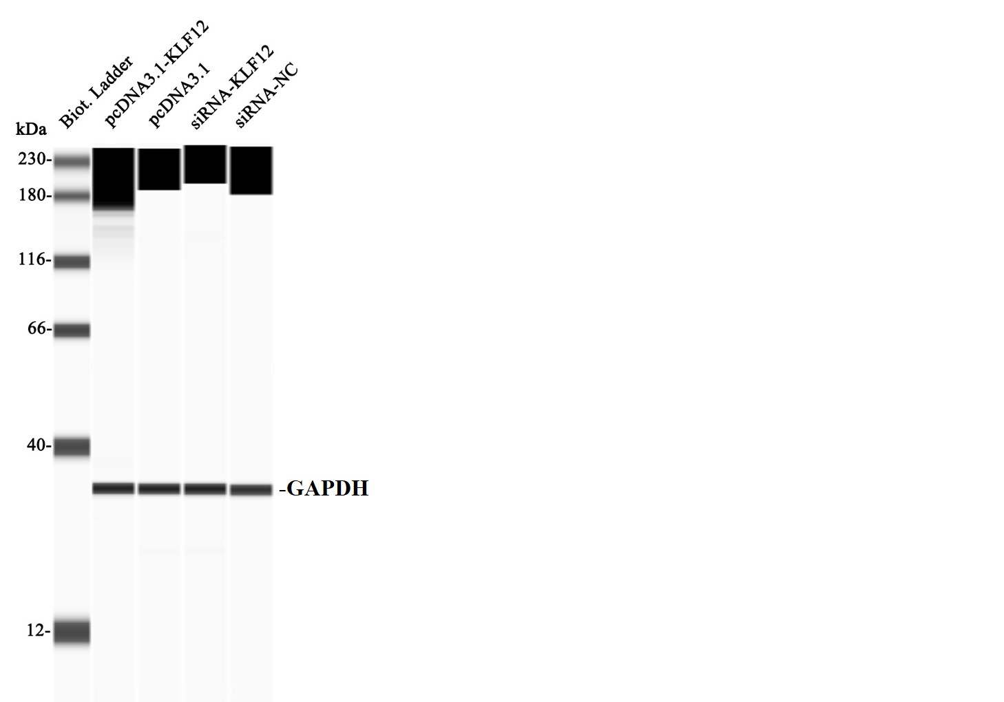
Fig 4B The protein expression of GAPDH.

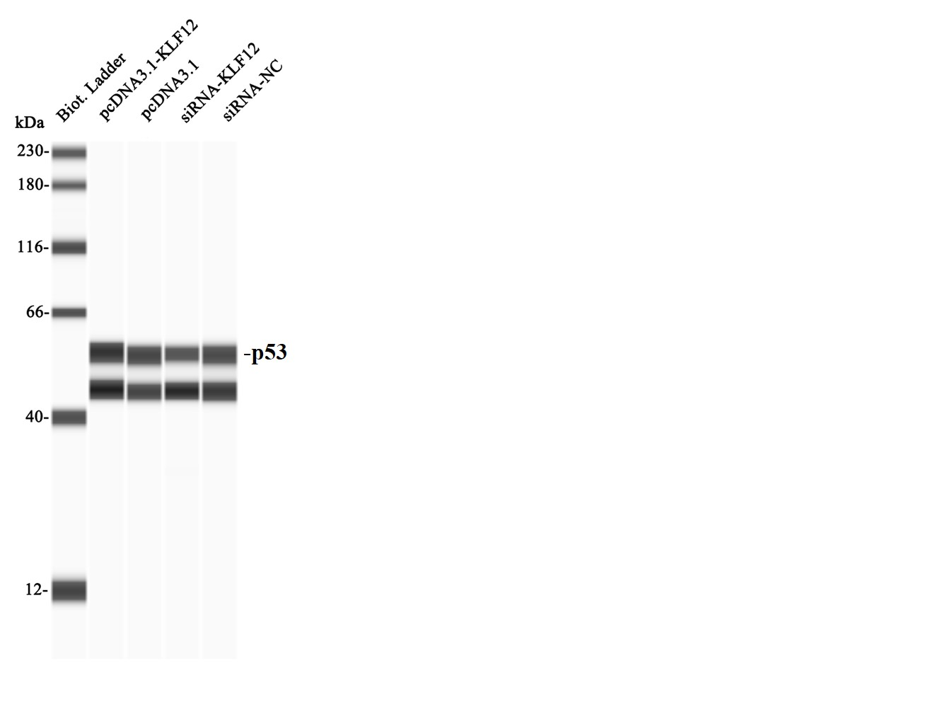
Fig 4B The protein expression of P53.
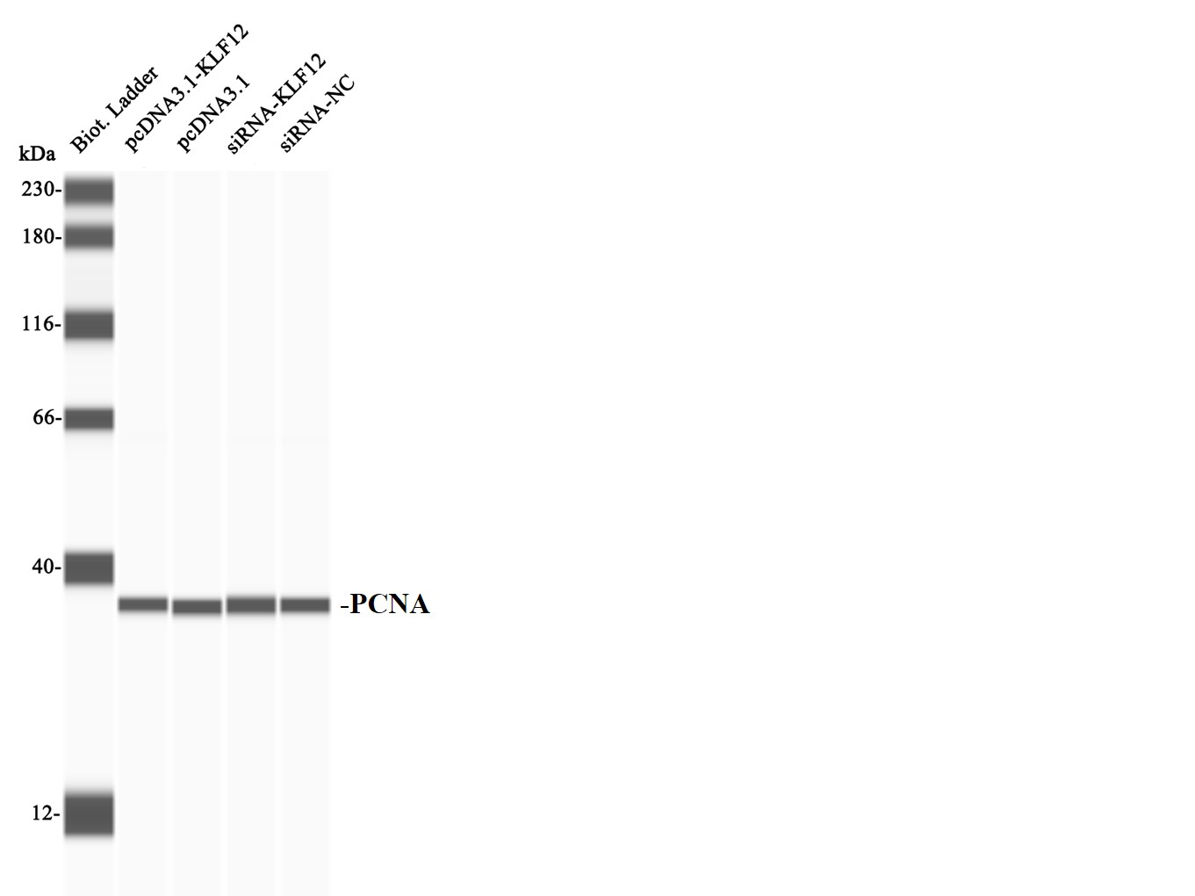
Fig 4B The protein expression of PCNA.

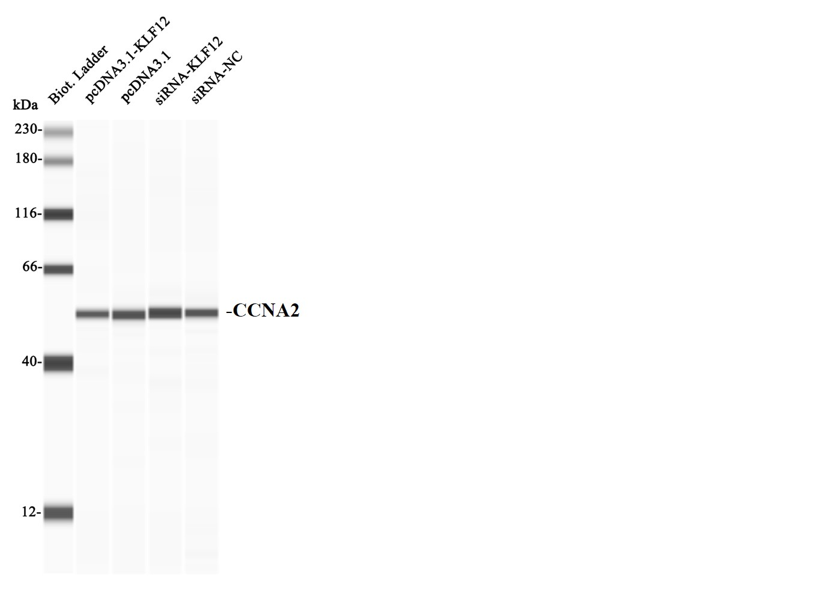
Fig 4D The protein expression of CCNA2.
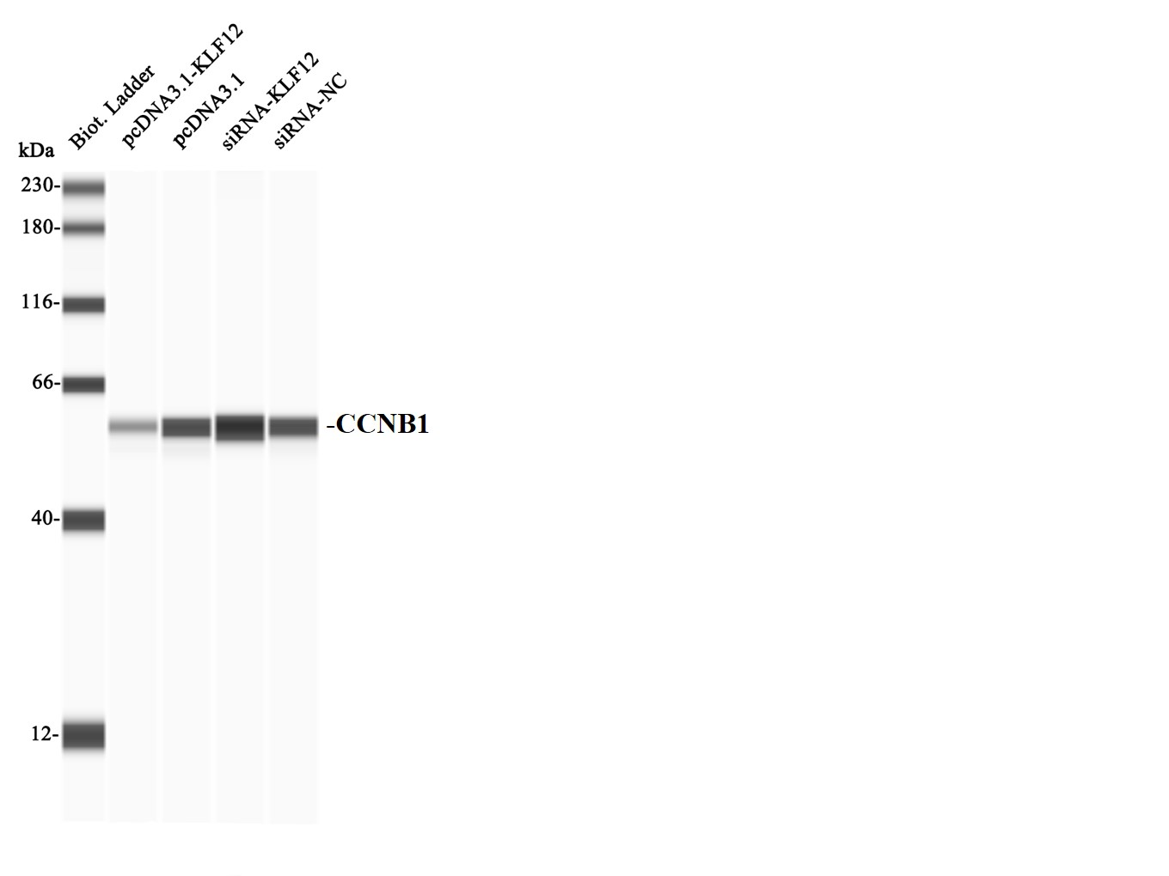
Fig 4D The protein expression of CCNB1.
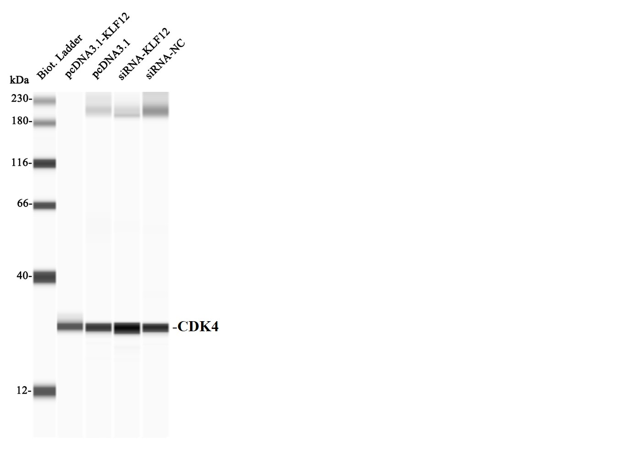
Fig 4D The protein expression of CDK4.

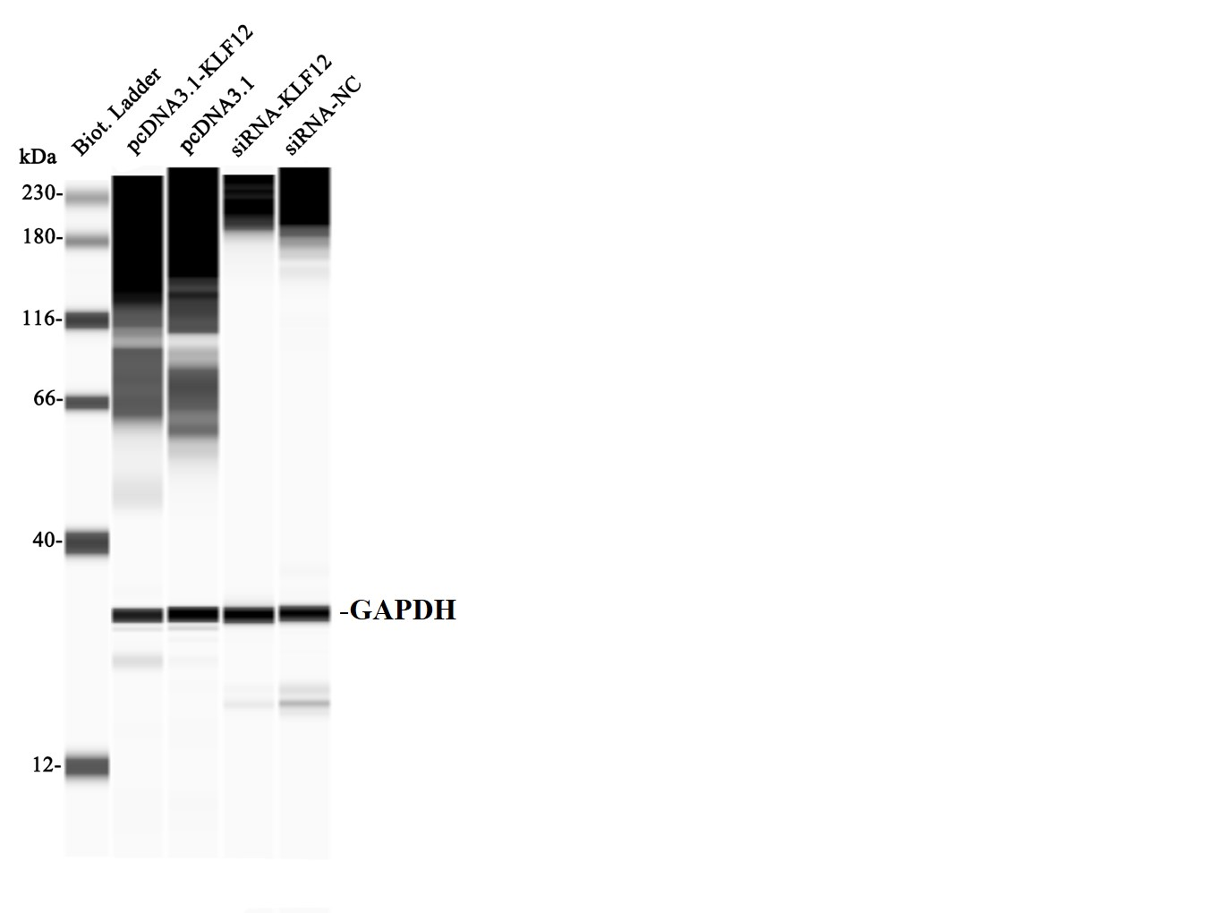
Fig 4D The protein expression of GAPDH.

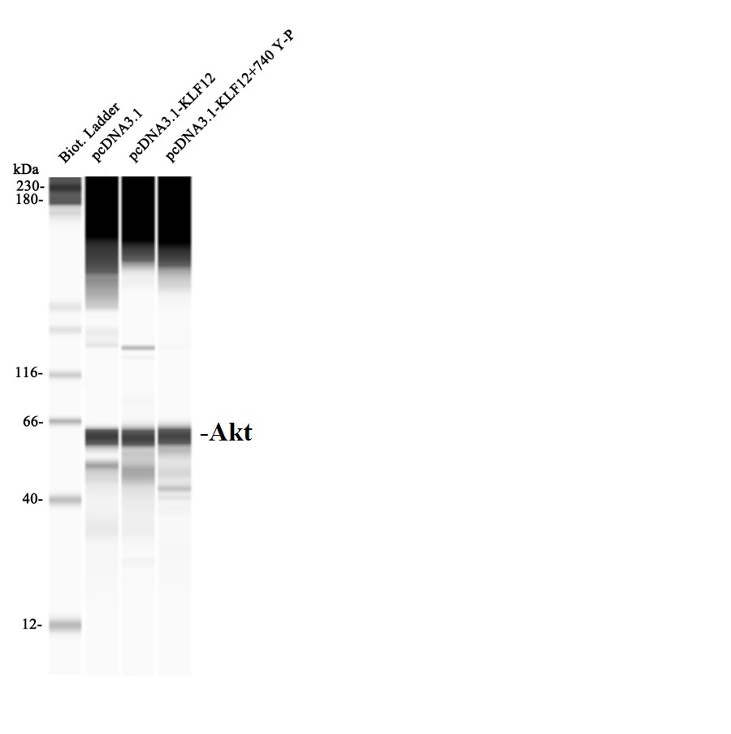
Fig 6A The protein expression of Akt.
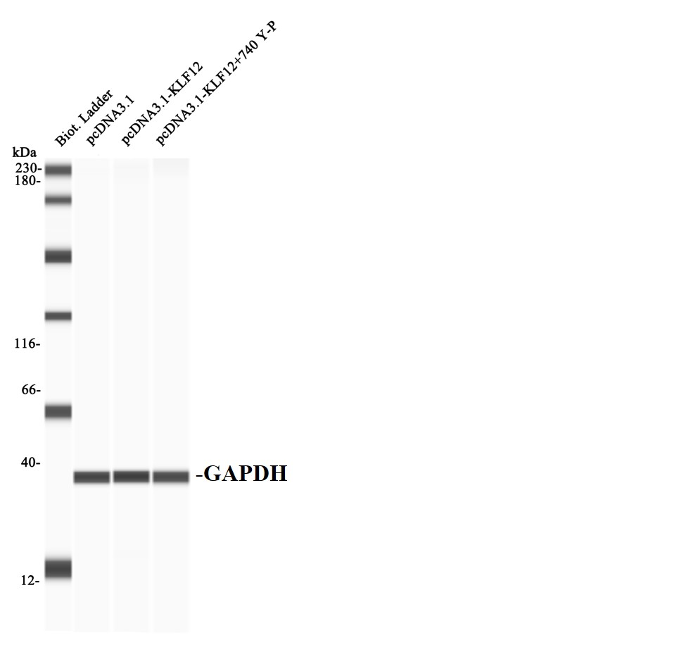
Fig 6A The protein expression of GAPDH.
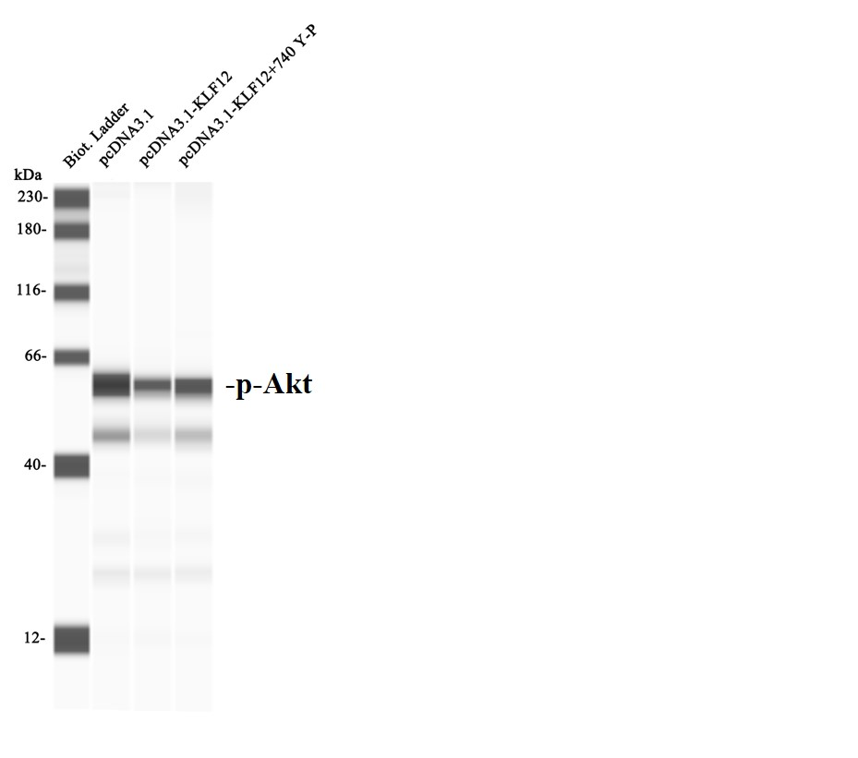
Fig 6A The protein expression of p-Akt.
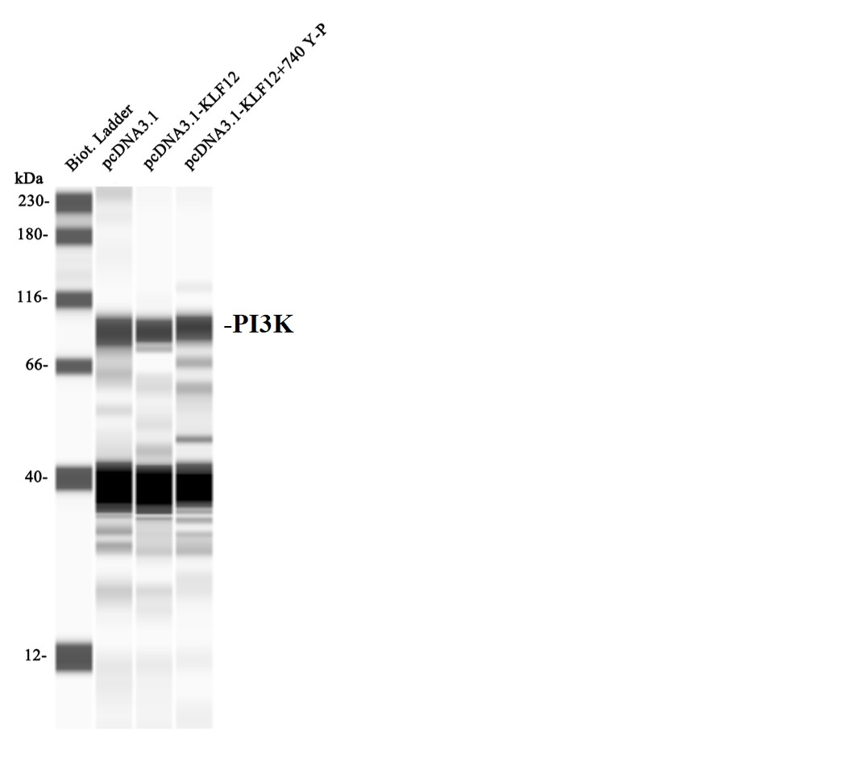
Fig 6A The protein expression of PI3K.
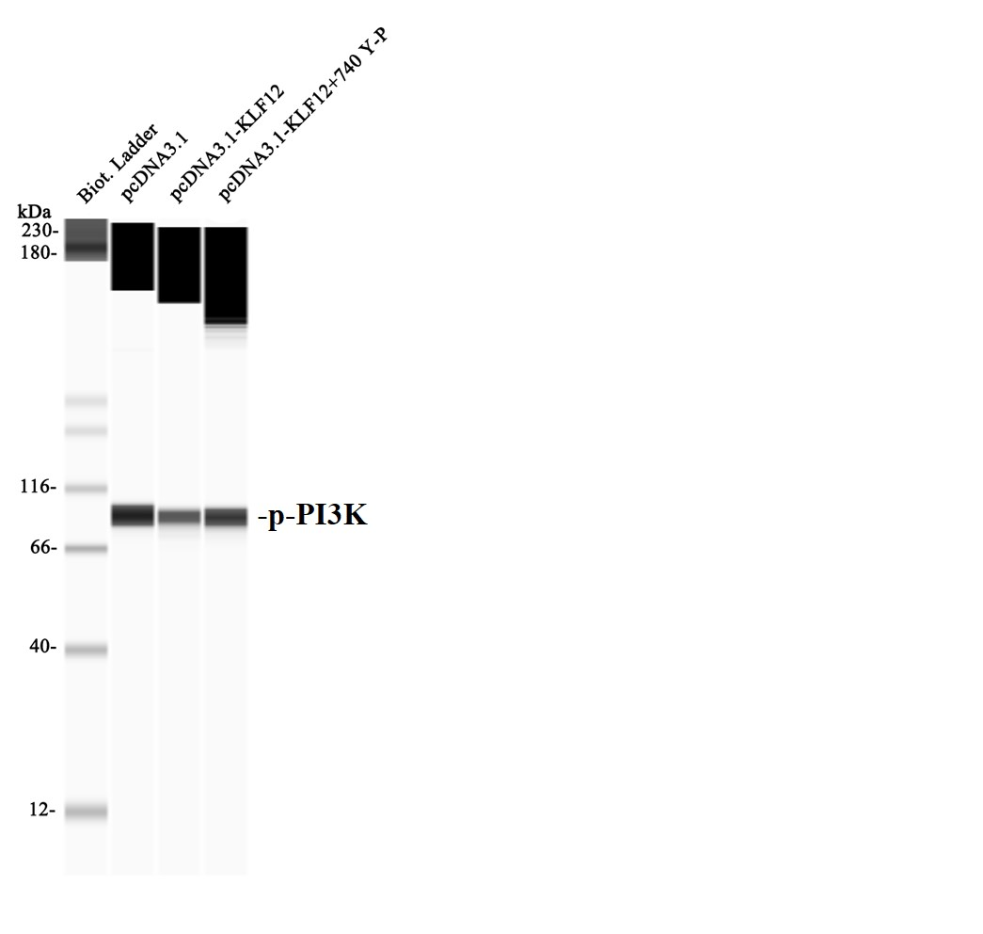
Fig 6A The protein expression of p-PI3K.
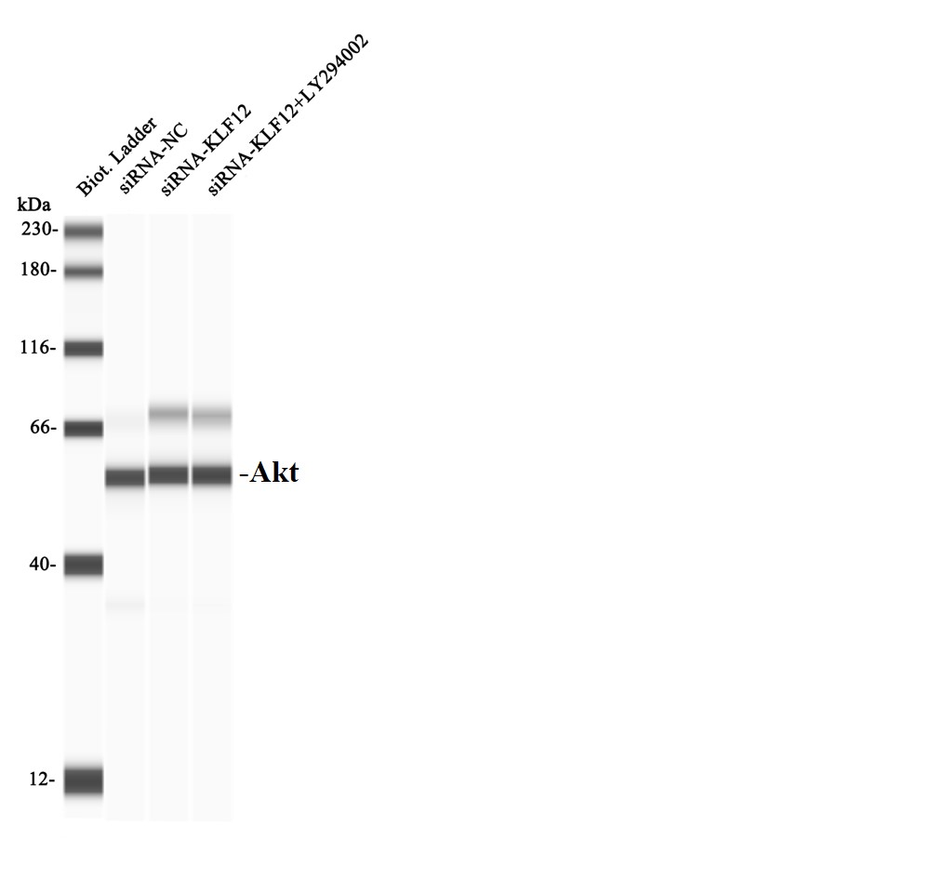
Fig 6B The protein expression of Akt.
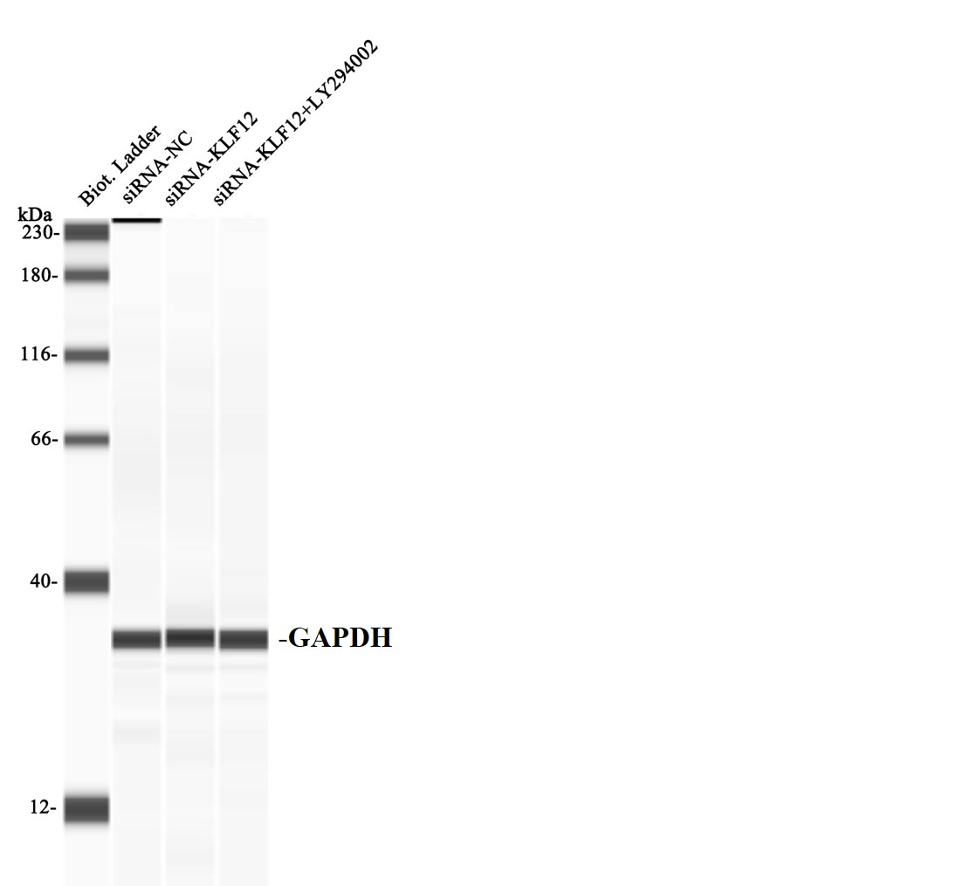
Fig 6B The protein expression of GAPDH.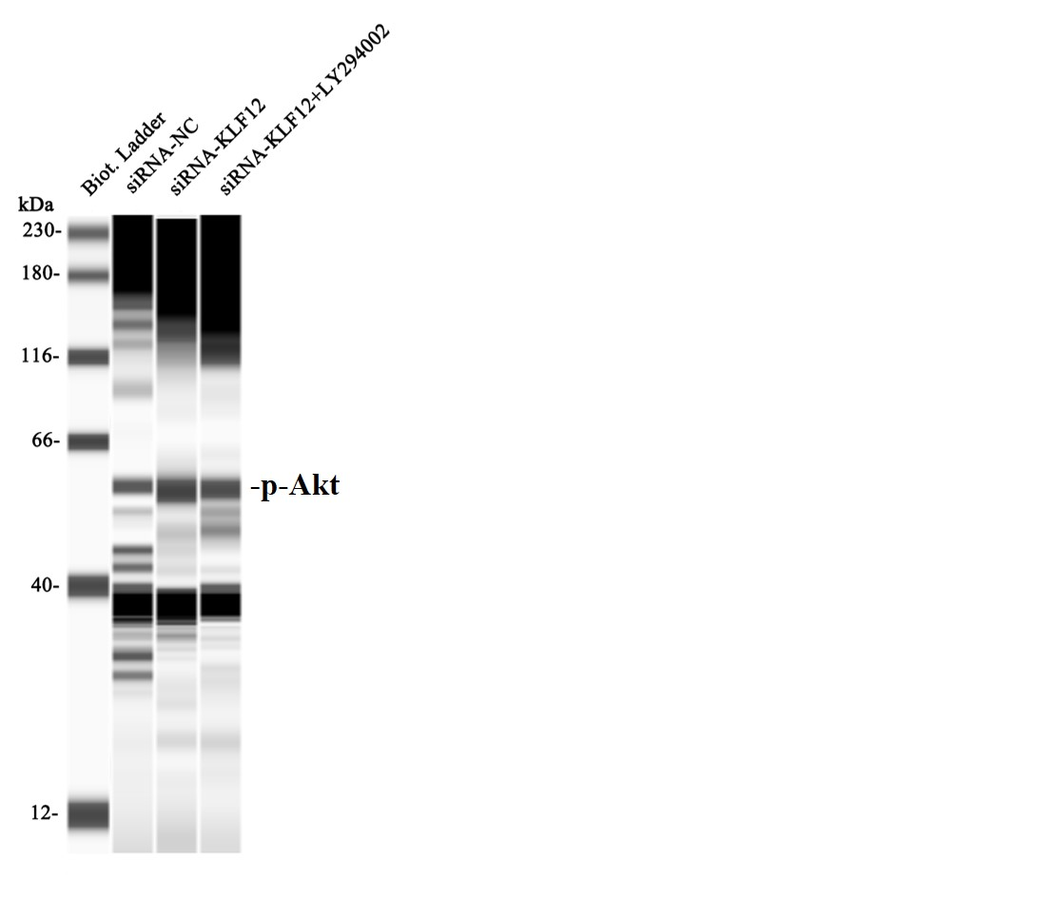
Fig 6B The protein expression of p-Akt.
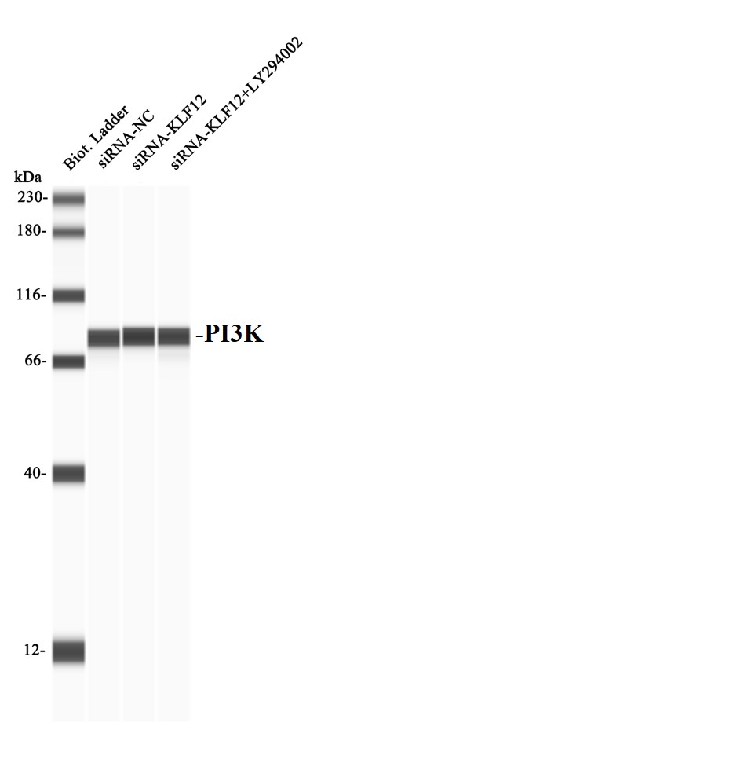
Fig 6B The protein expression of PI3K
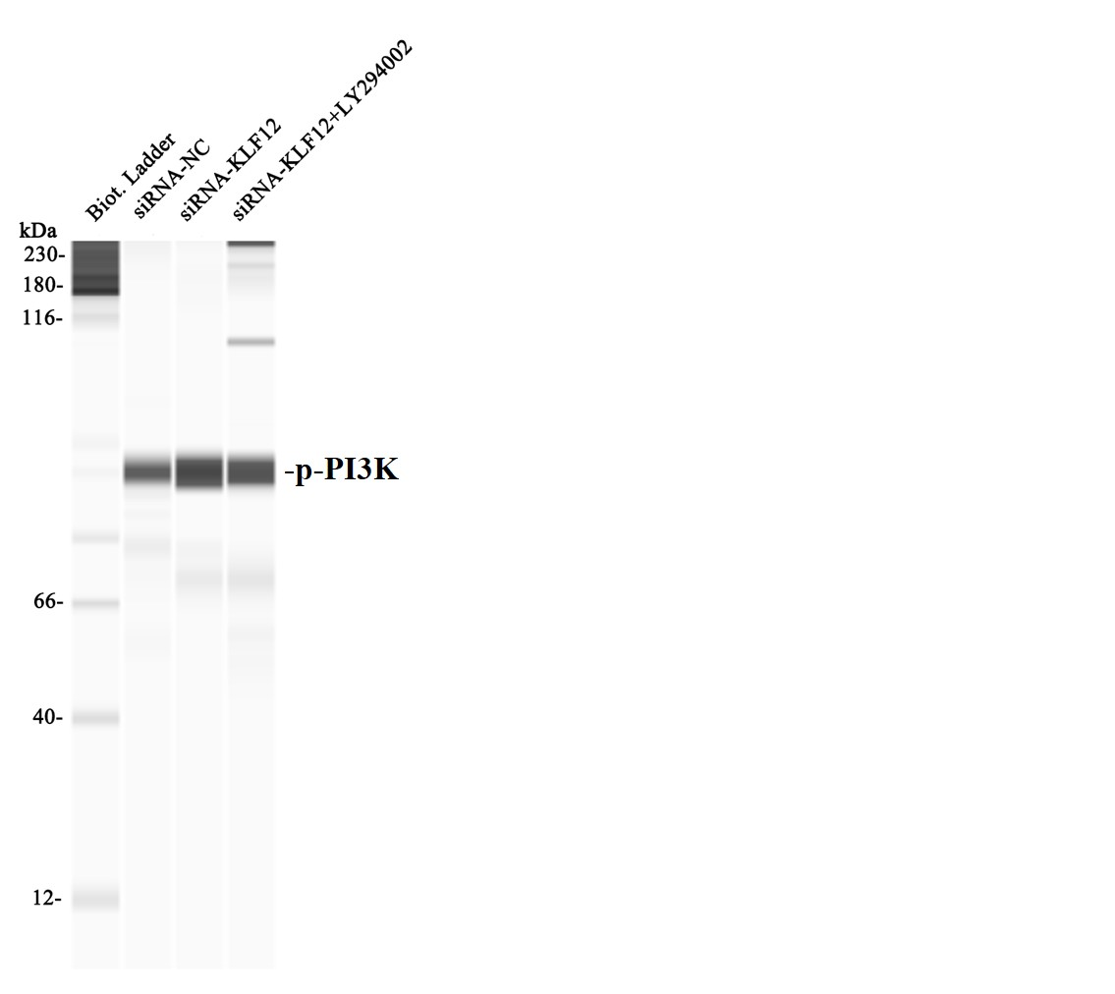
Fig 6B The protein expression of p-PI3K.

